**Exercise 1: Control Structures**

**Introduction**

This document demonstrates the use of PL/SQL control structures in Oracle by implementing three real-world banking scenarios involving customers and loans. We create the required tables, populate them with data, and execute PL/SQL blocks to meet the business requirements.

**Table Design**

**Create CUSTOMERS table**

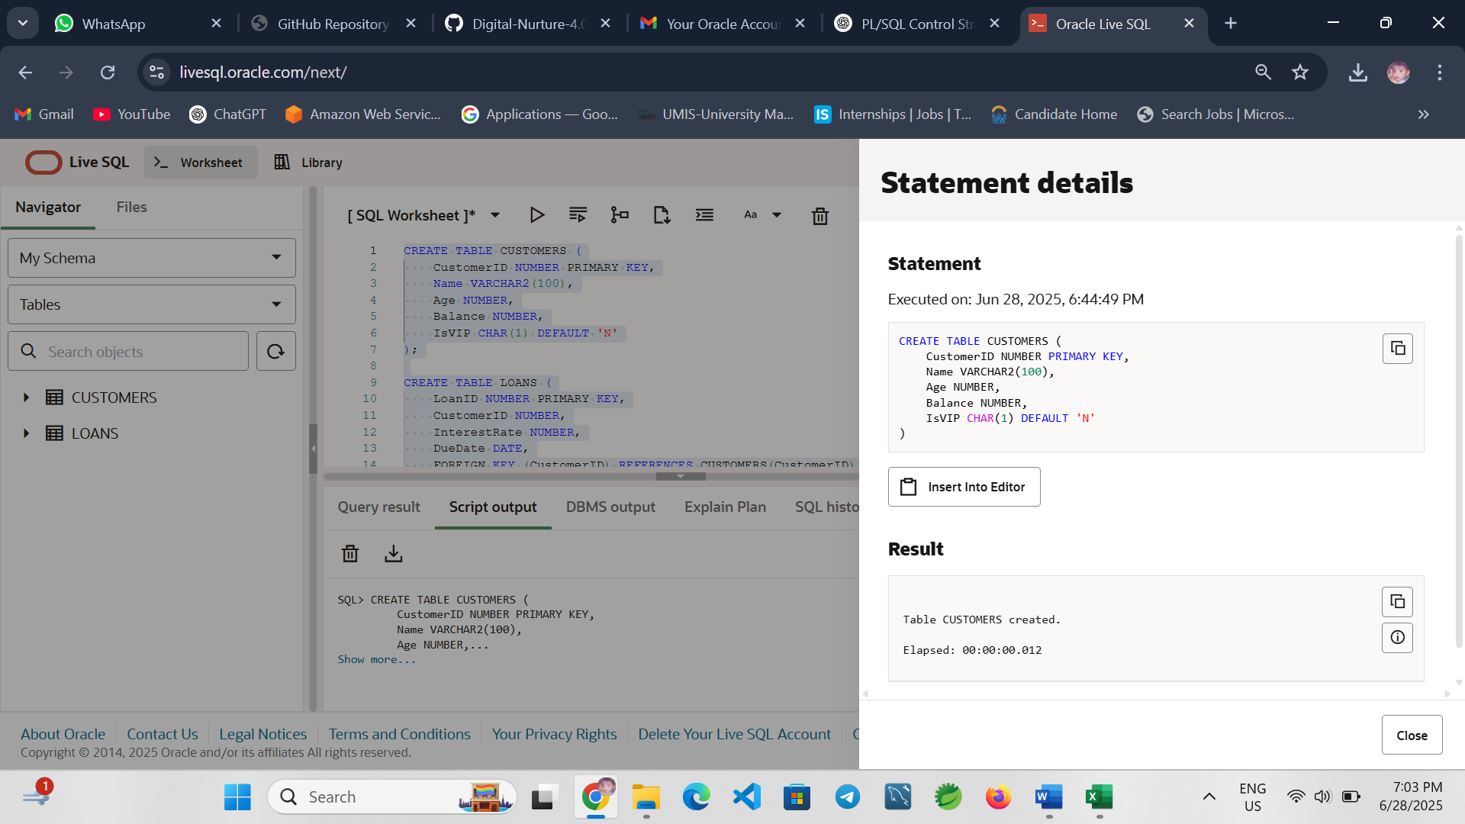

**Create LOANS table**

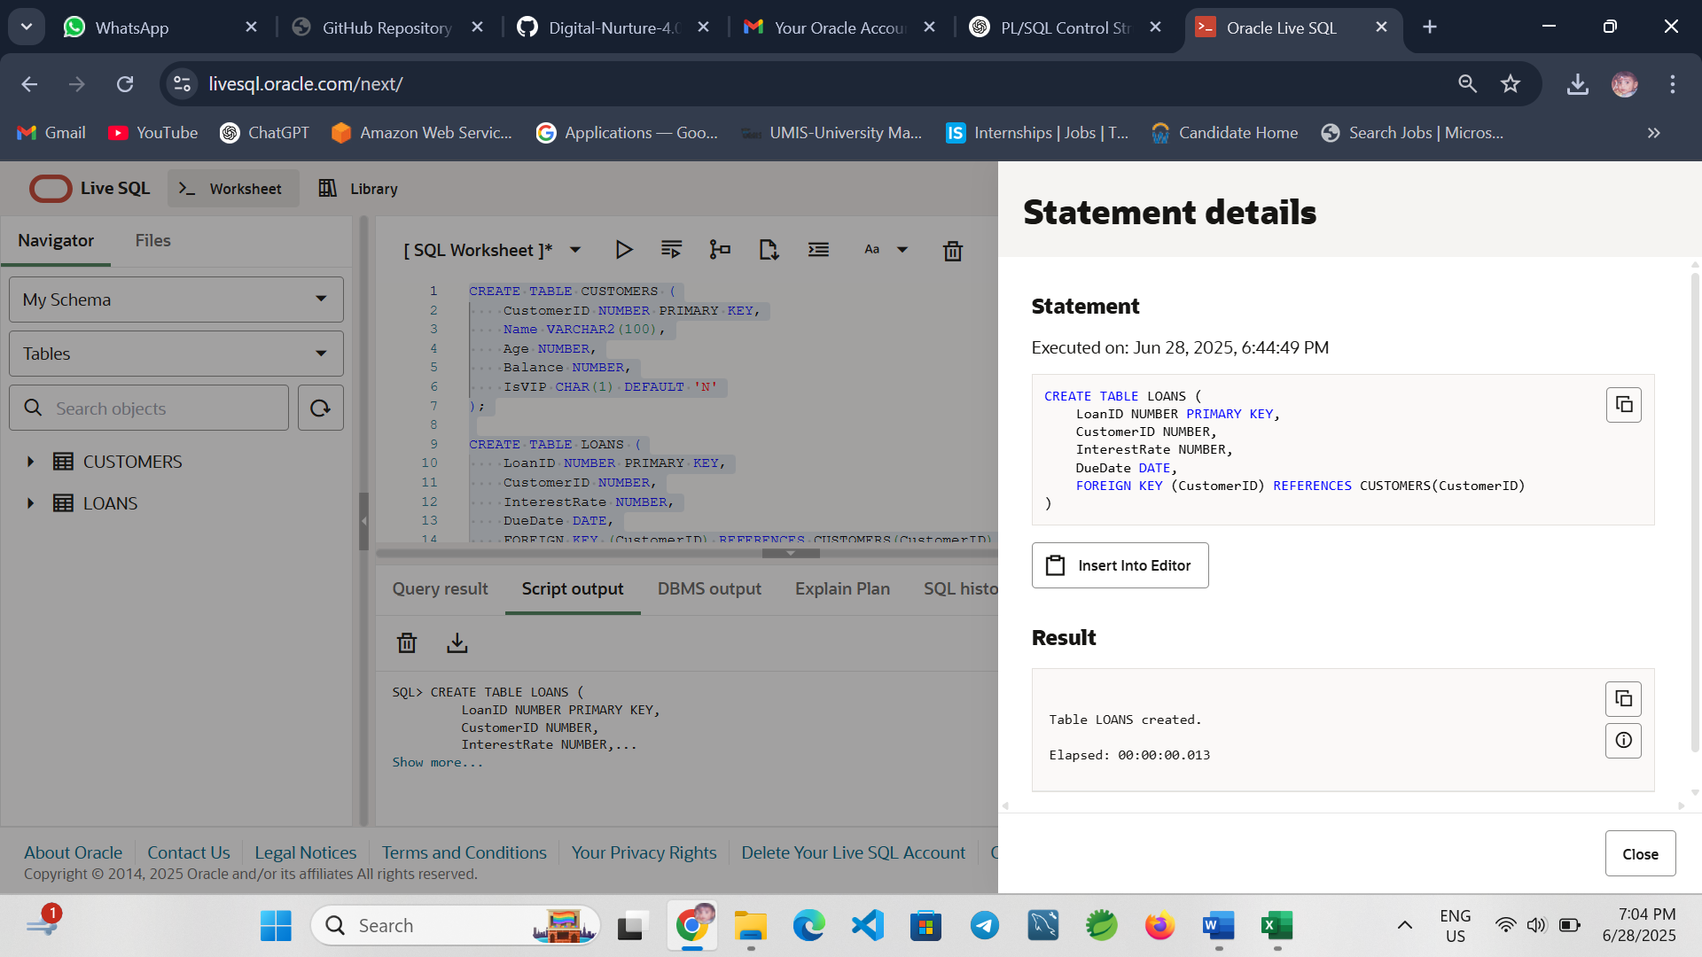

**Scenario 1 – Apply Interest Discount for Customers Over 60**

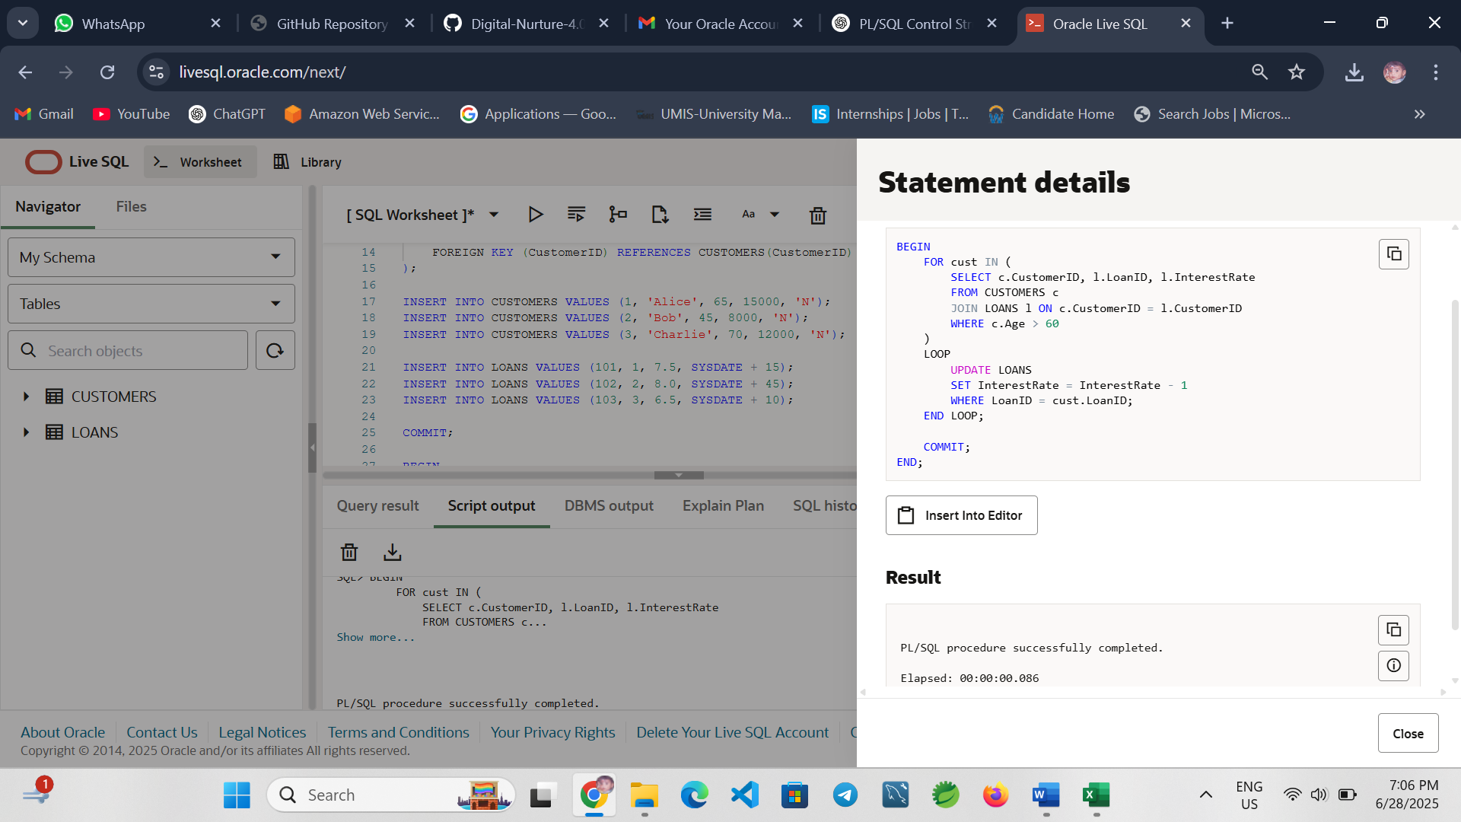

**Explanation:** Loops through each senior customer and applies a 1% interest rate discount.

**Scenario 2 – Mark Customers as VIP Based on Balance**

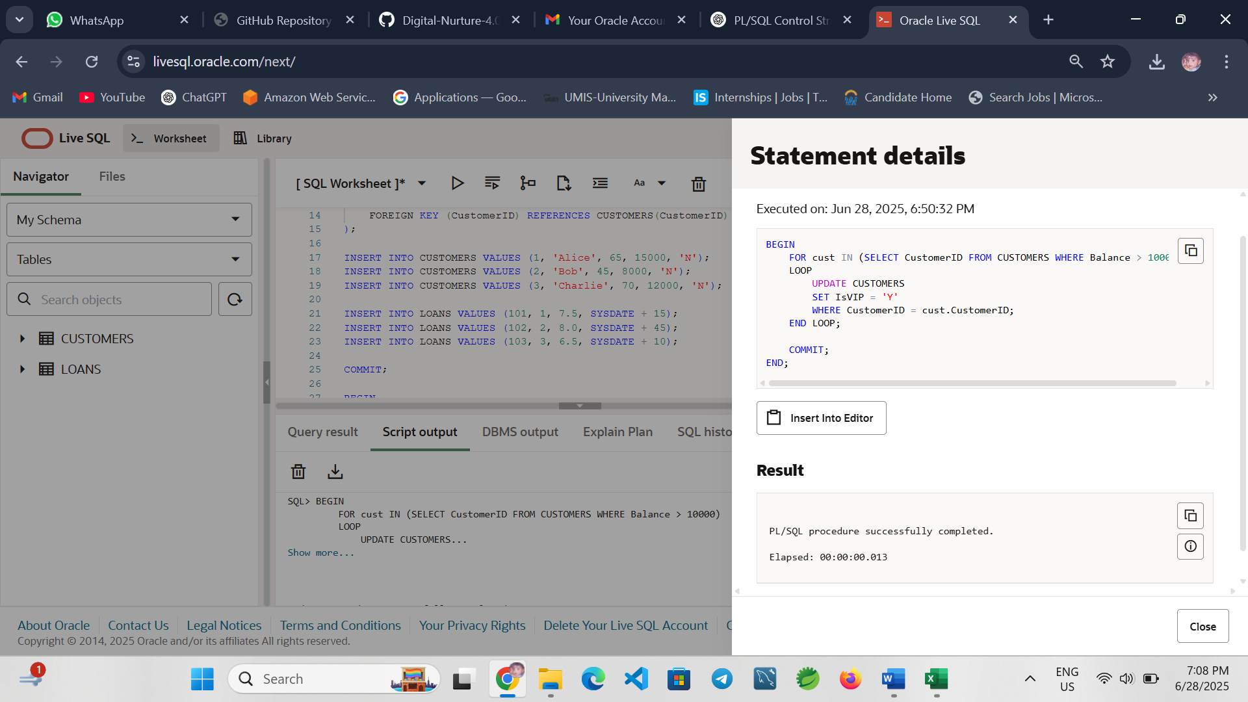

**Explanation:** Promotes customers with a balance greater than $10,000 to VIP status.

**Scenario 3 – Send Loan Due Reminders**

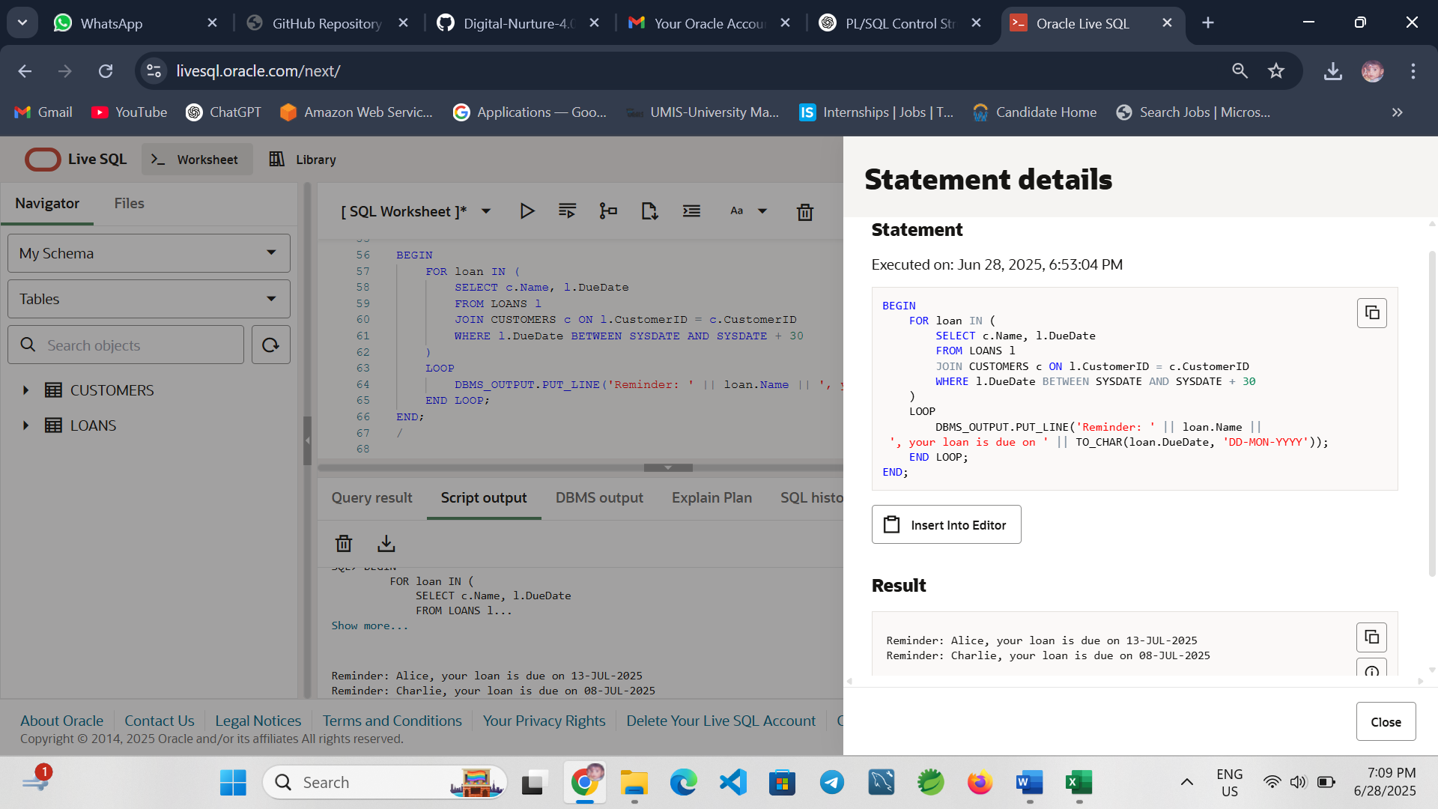

**Explanation:** Prints reminders for loans due in the next 30 days.

**Conclusion**

This exercise demonstrates the use of PL/SQL control structures like loops and conditional logic to perform real-world banking operations such as applying discounts, updating customer status, and printing reminders.

**Exercise 3: Stored Procedures**

**Introduction**

This exercise demonstrates the use of stored procedures in PL/SQL for various banking operations including interest processing, employee bonus updates, and inter-account fund transfers.

**Create Necessary Tables**

**Savings Accounts Table**

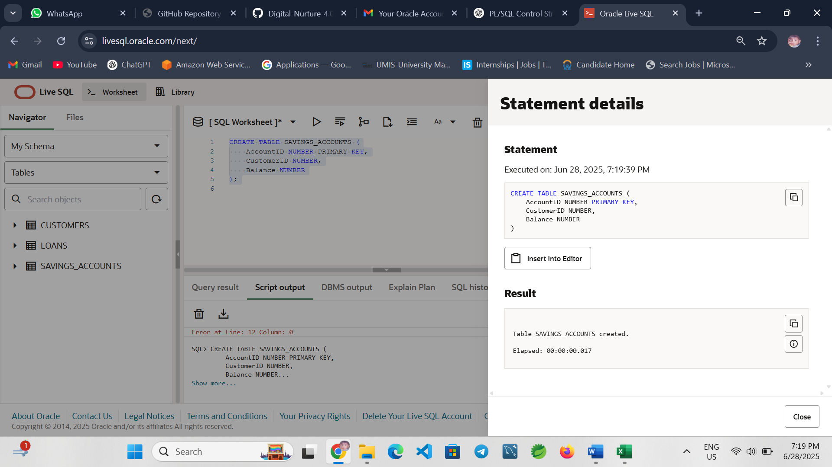

**Employees Table**

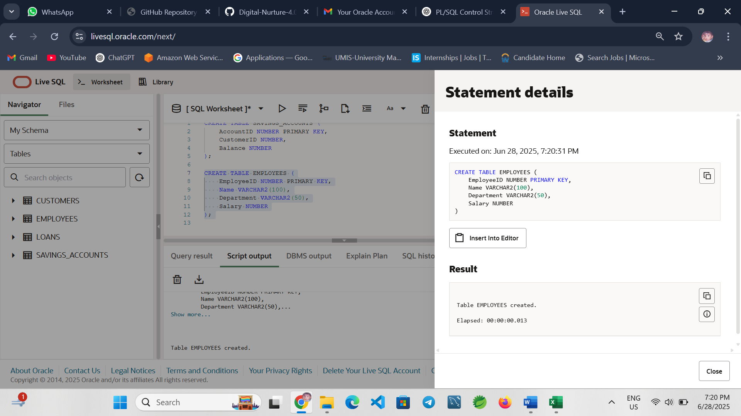

**Accounts Table for Fund Transfer**

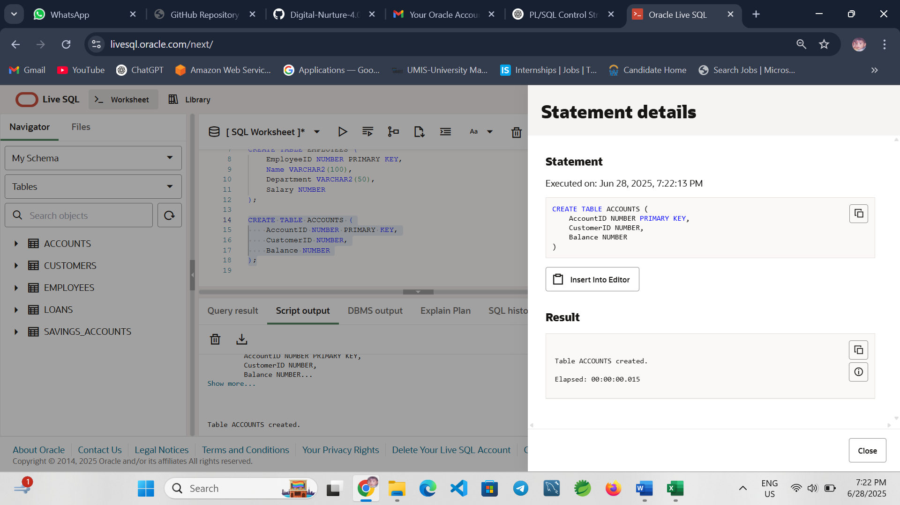

**Write Stored Procedures**

**Scenario 1: ProcessMonthlyInterest**

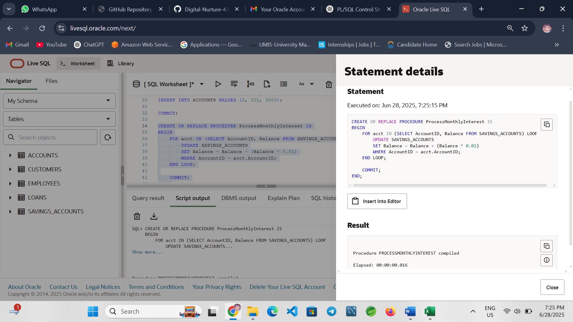

**Explanation:** Adds 1% interest to each savings account balance.

**Scenario 2: UpdateEmployeeBonus**

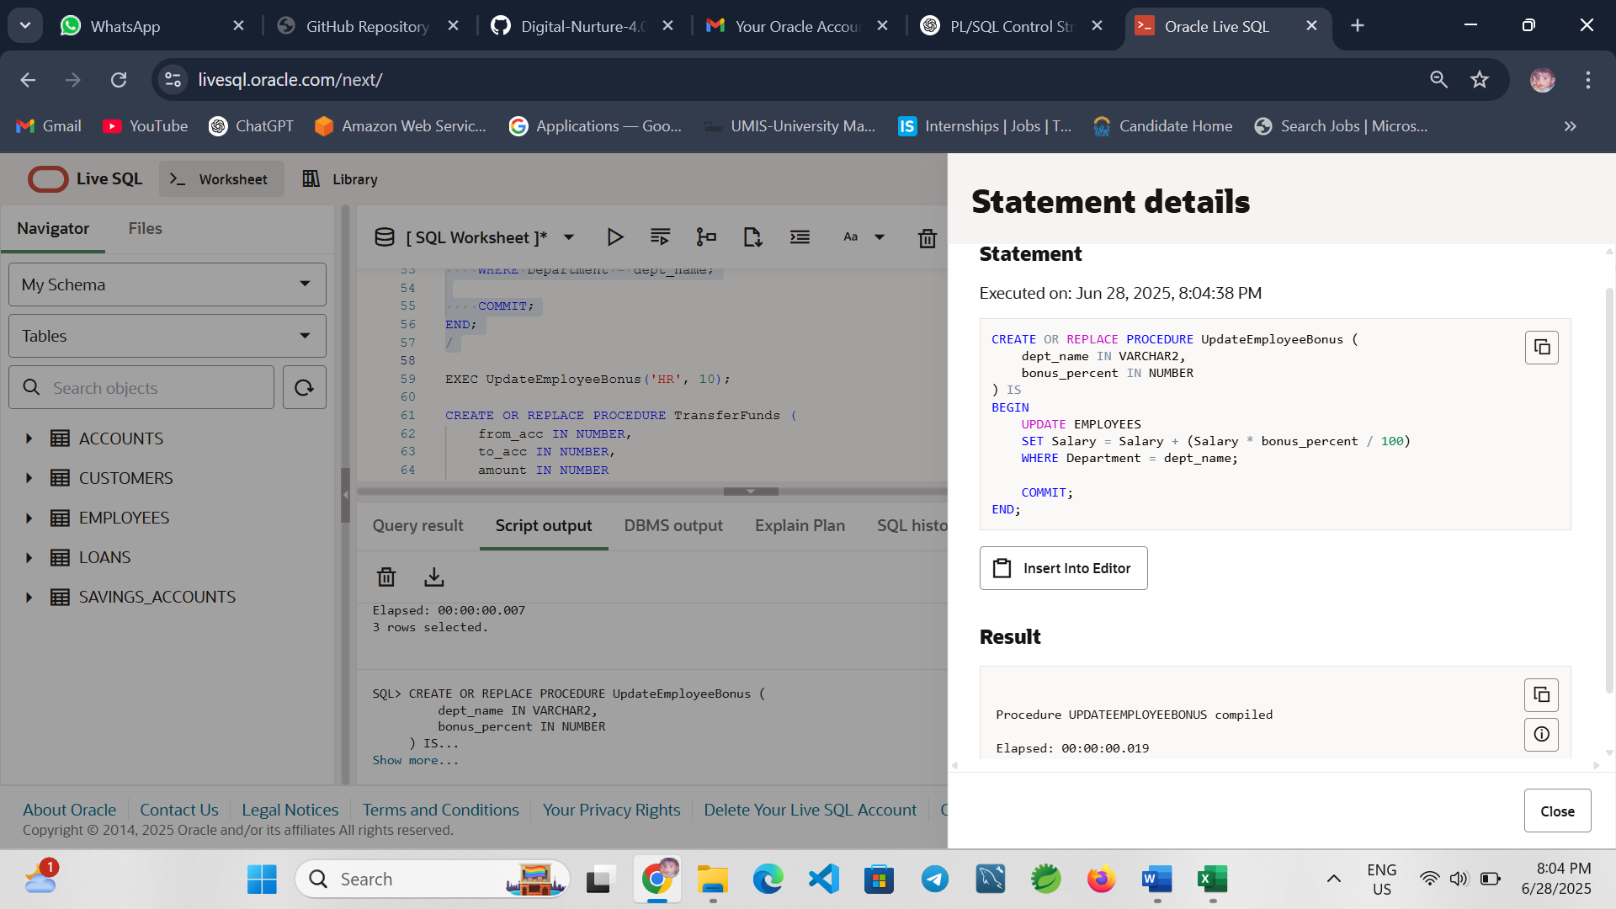

**Explanation:** Adds a percentage bonus to salaries in the given department.

**Scenario 3: TransferFunds**

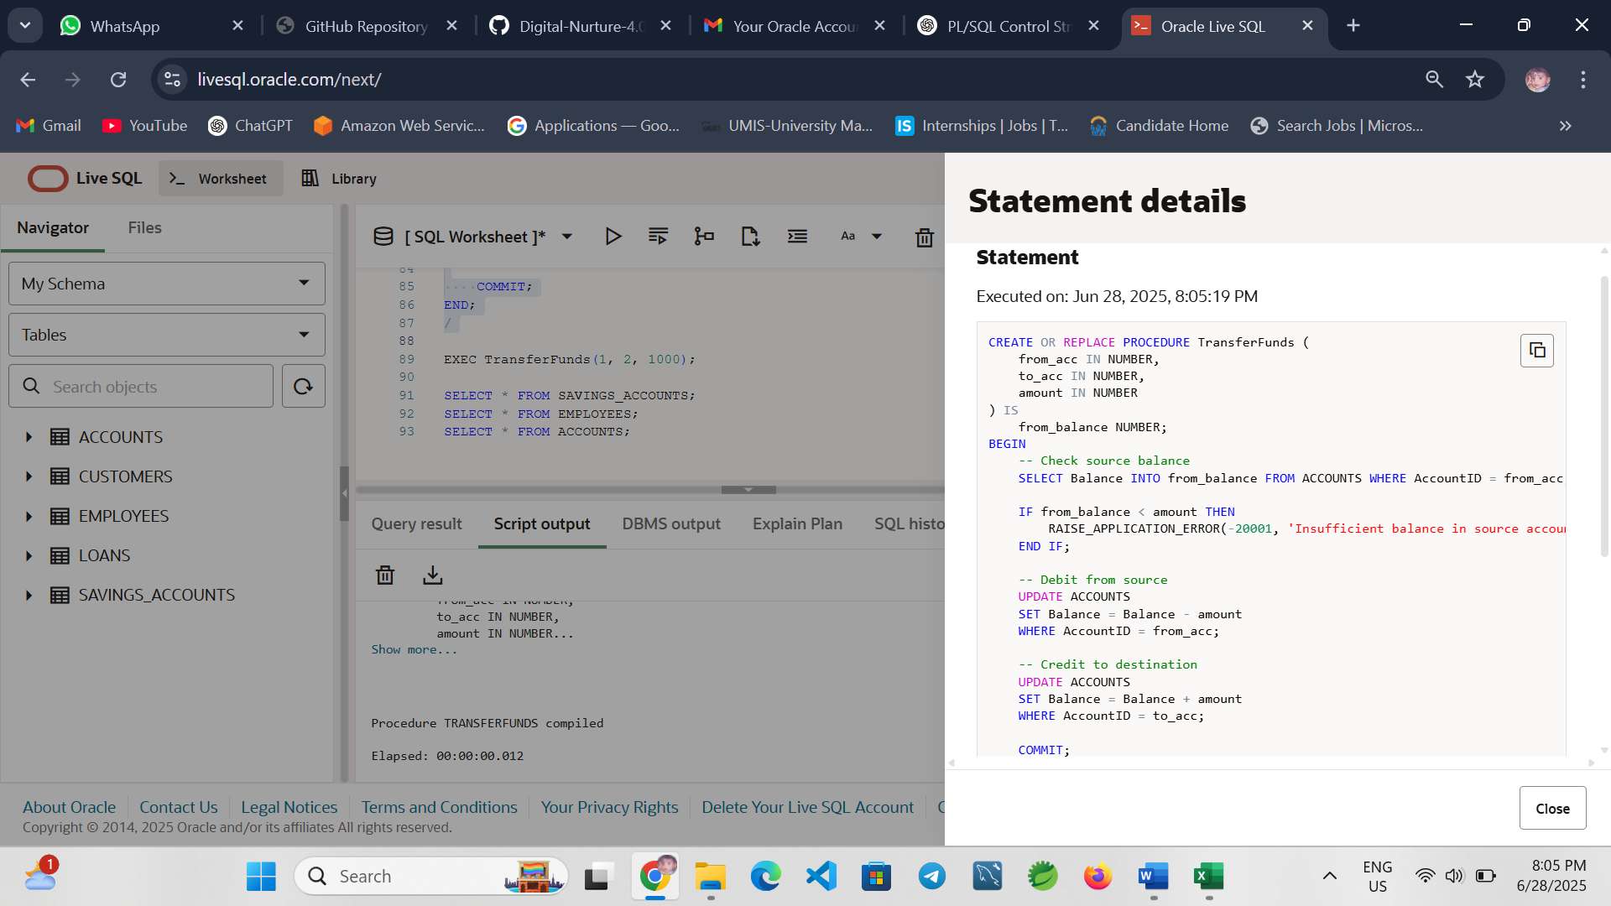

**Conclusion**

This exercise demonstrated how PL/SQL stored procedures can automate key banking tasks like applying interest, updating employee bonuses, and transferring funds securely. These procedures improve efficiency, maintain data integrity, and support scalable banking operations.