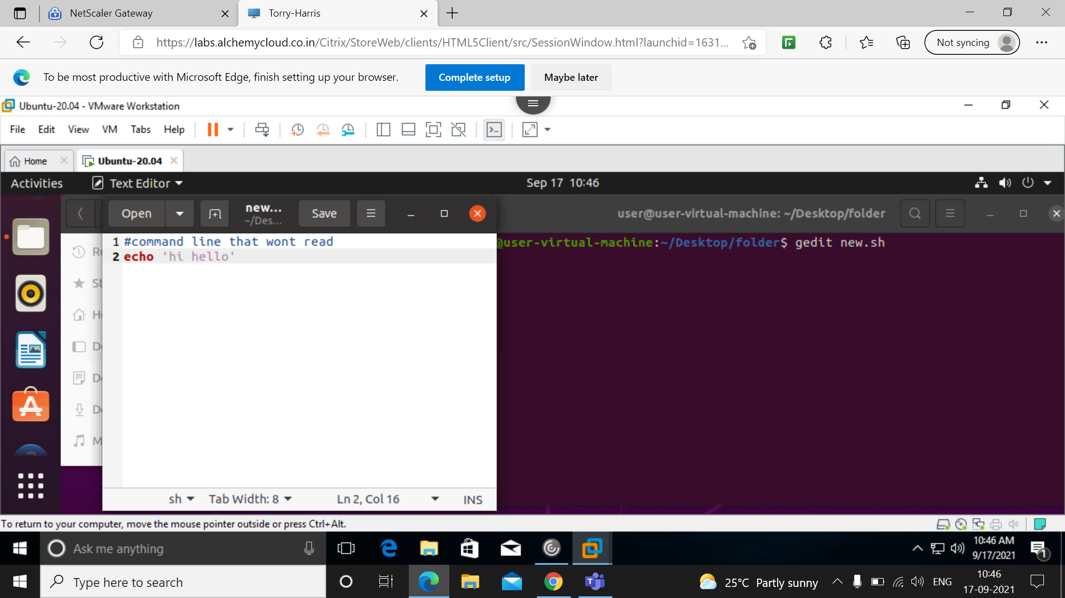
Using this command i have created new.sh folder

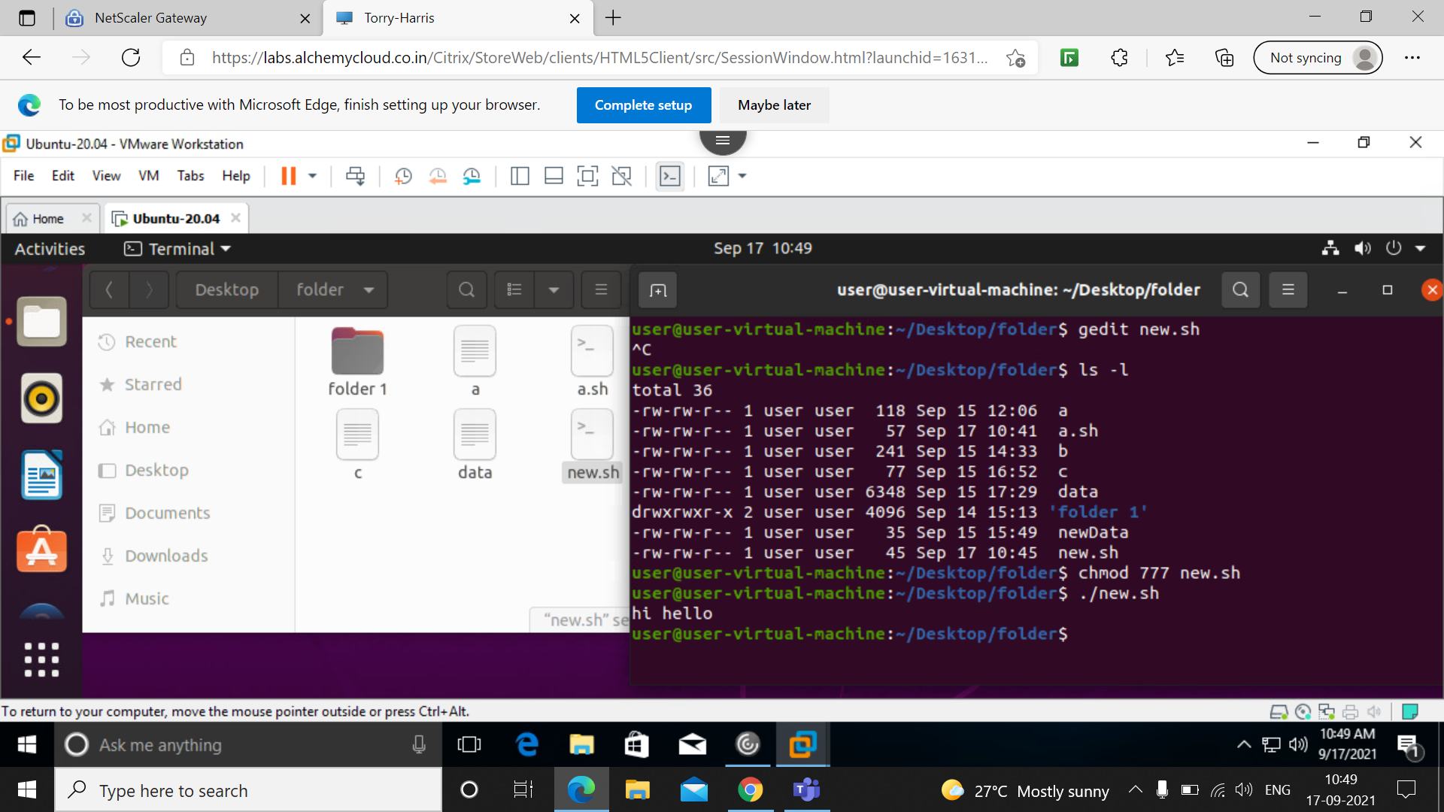
here i have give all permission to all permission to owner,user and group for new.sh folder.
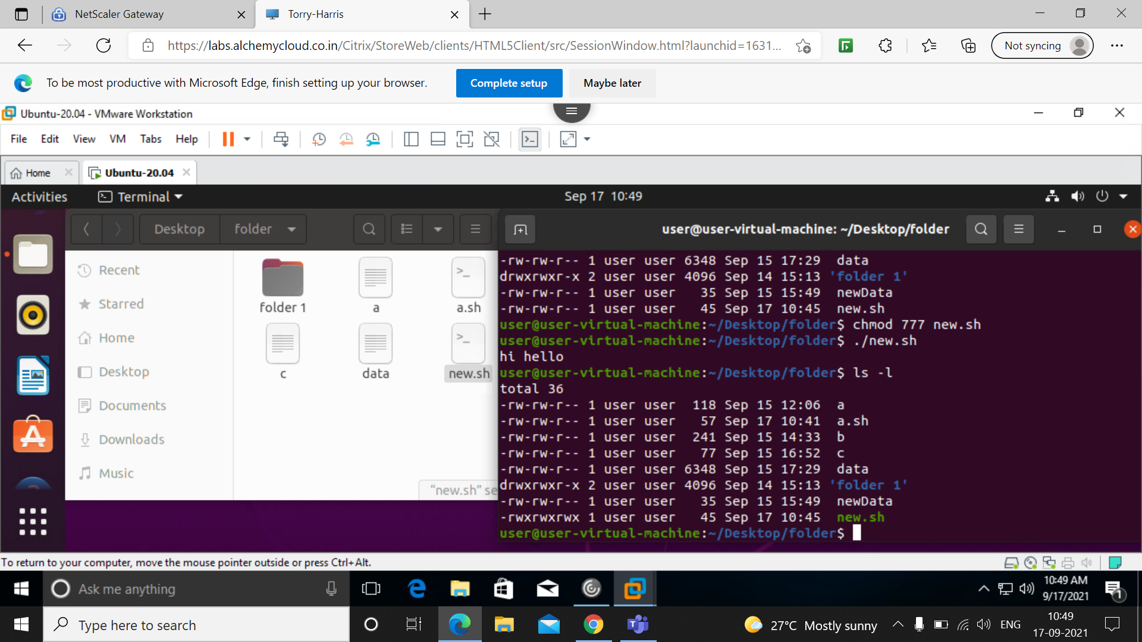
I use ./new.sh to execute the file
and below we can see the permission is changed for new.sh file.

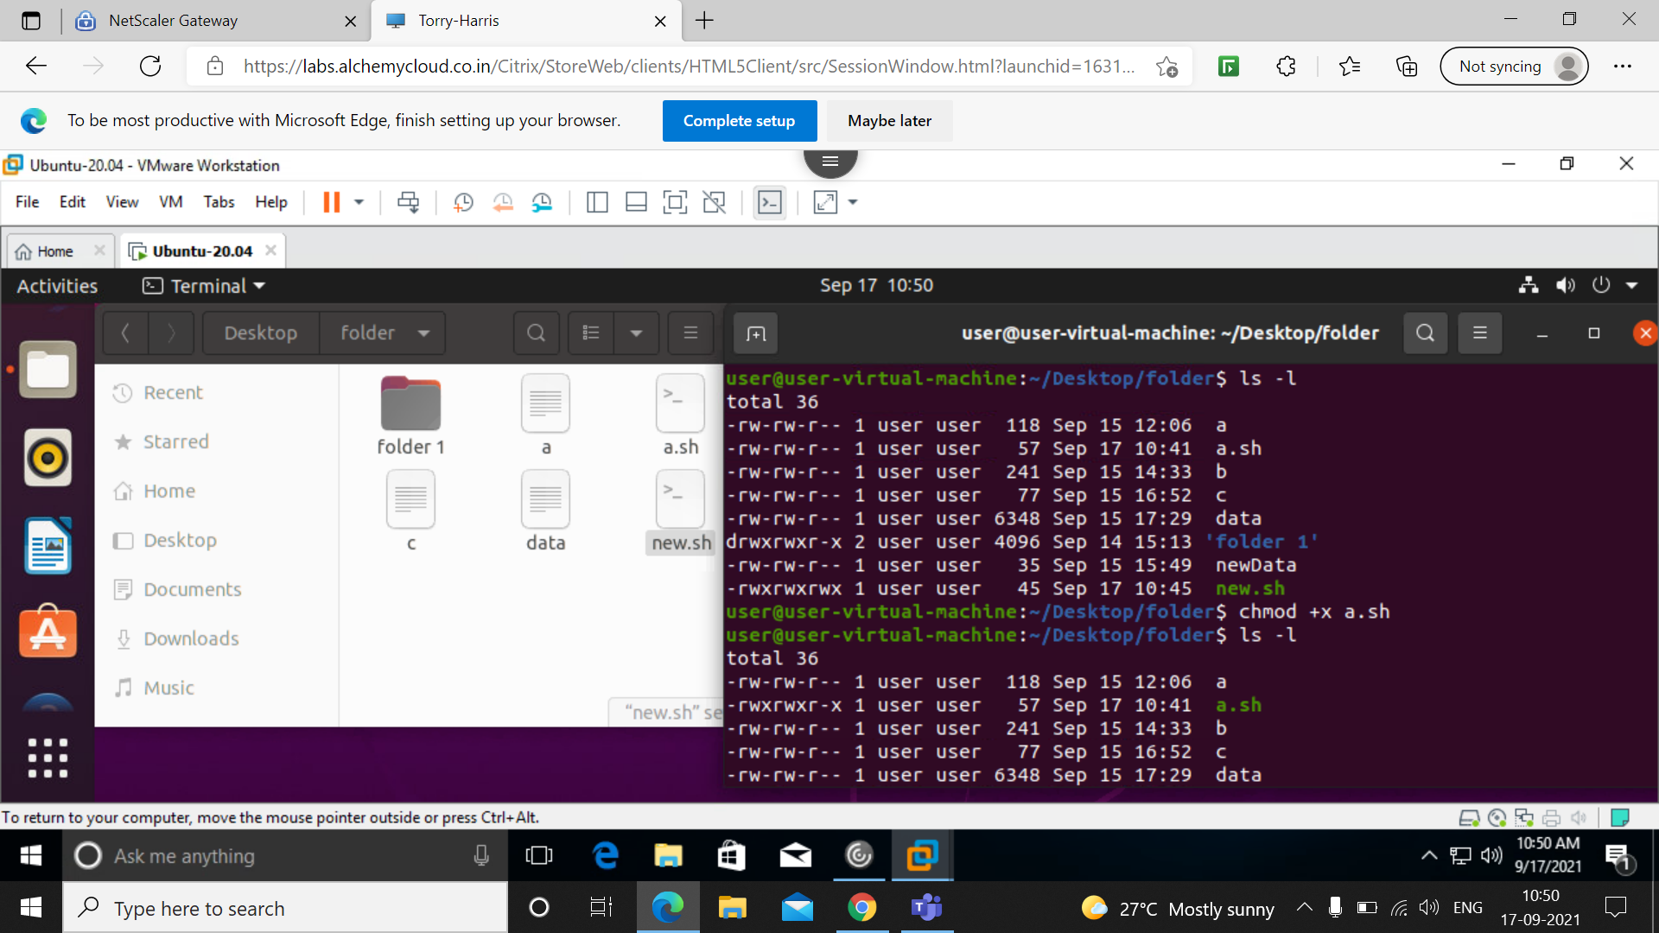
And here im changing permission of user to execute mode of the file a.sh
and below we can see the permission is changed.

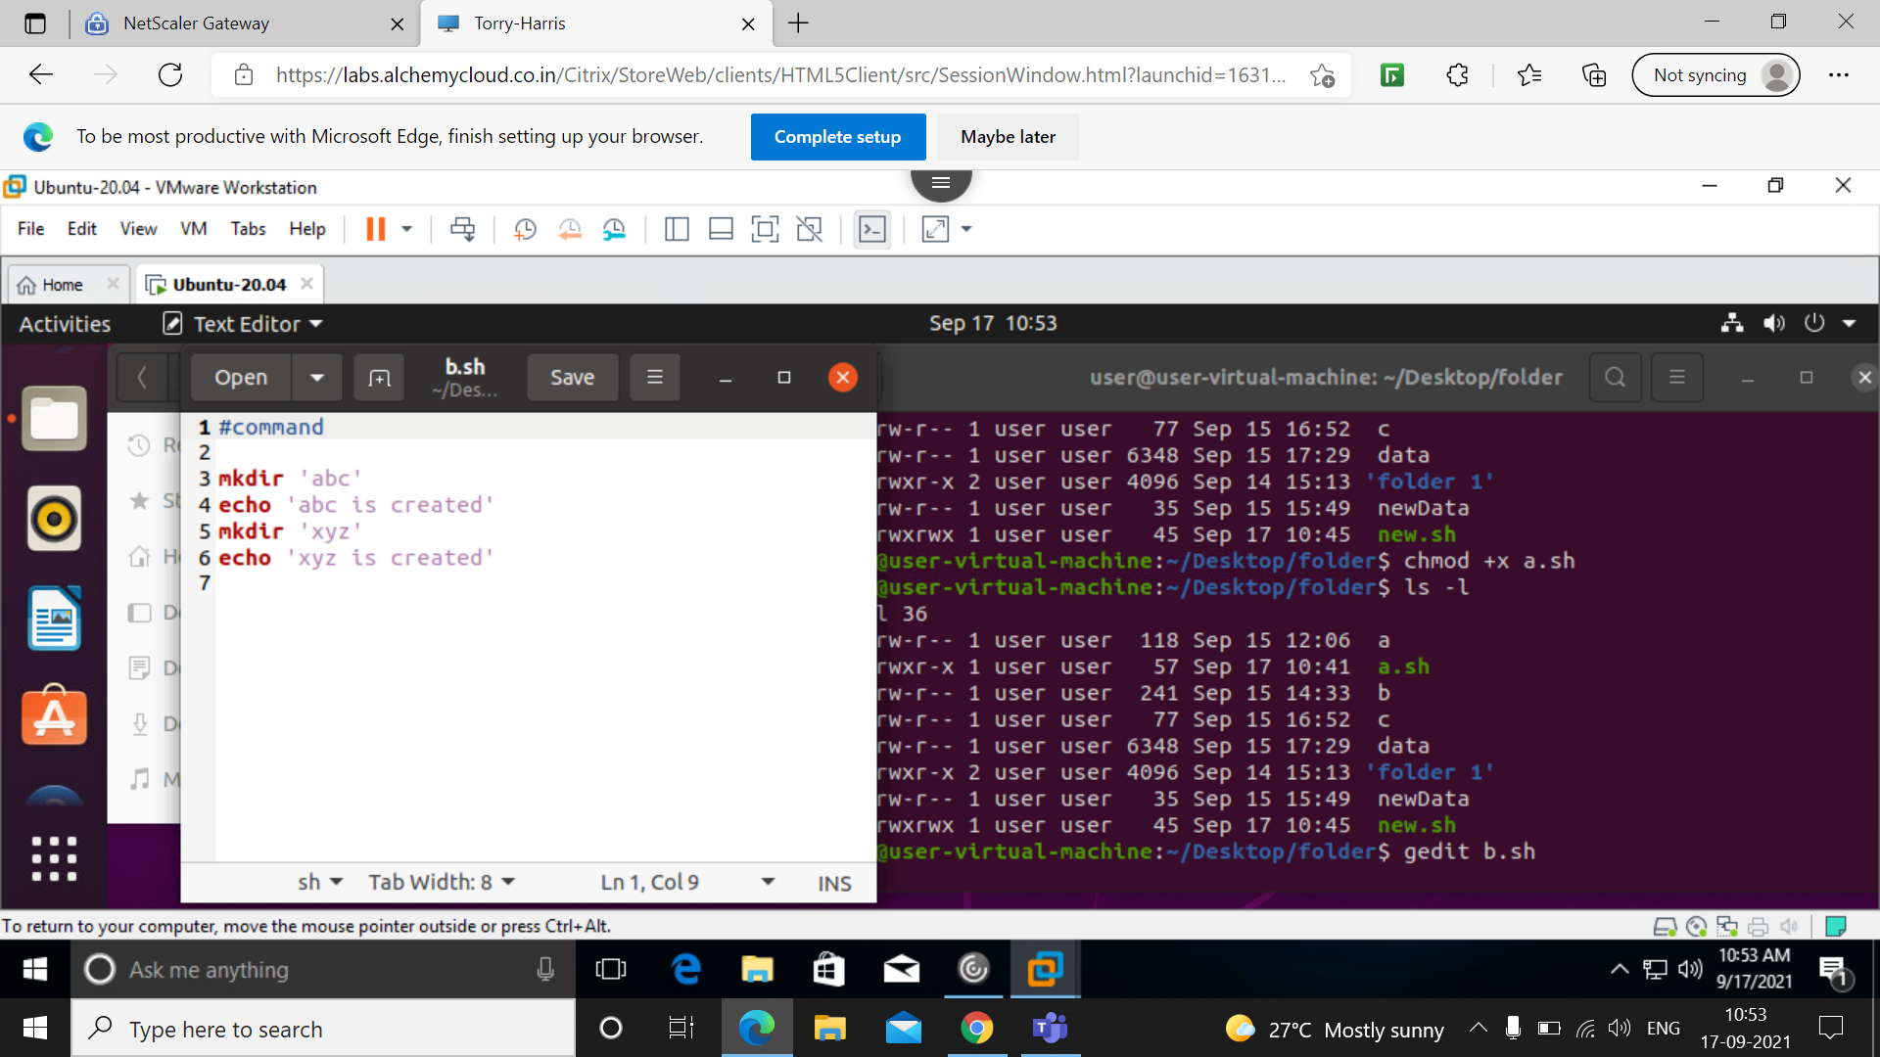
Here the file b.sh is created wher i have to create file ‘abc’ and file ‘xyz’.

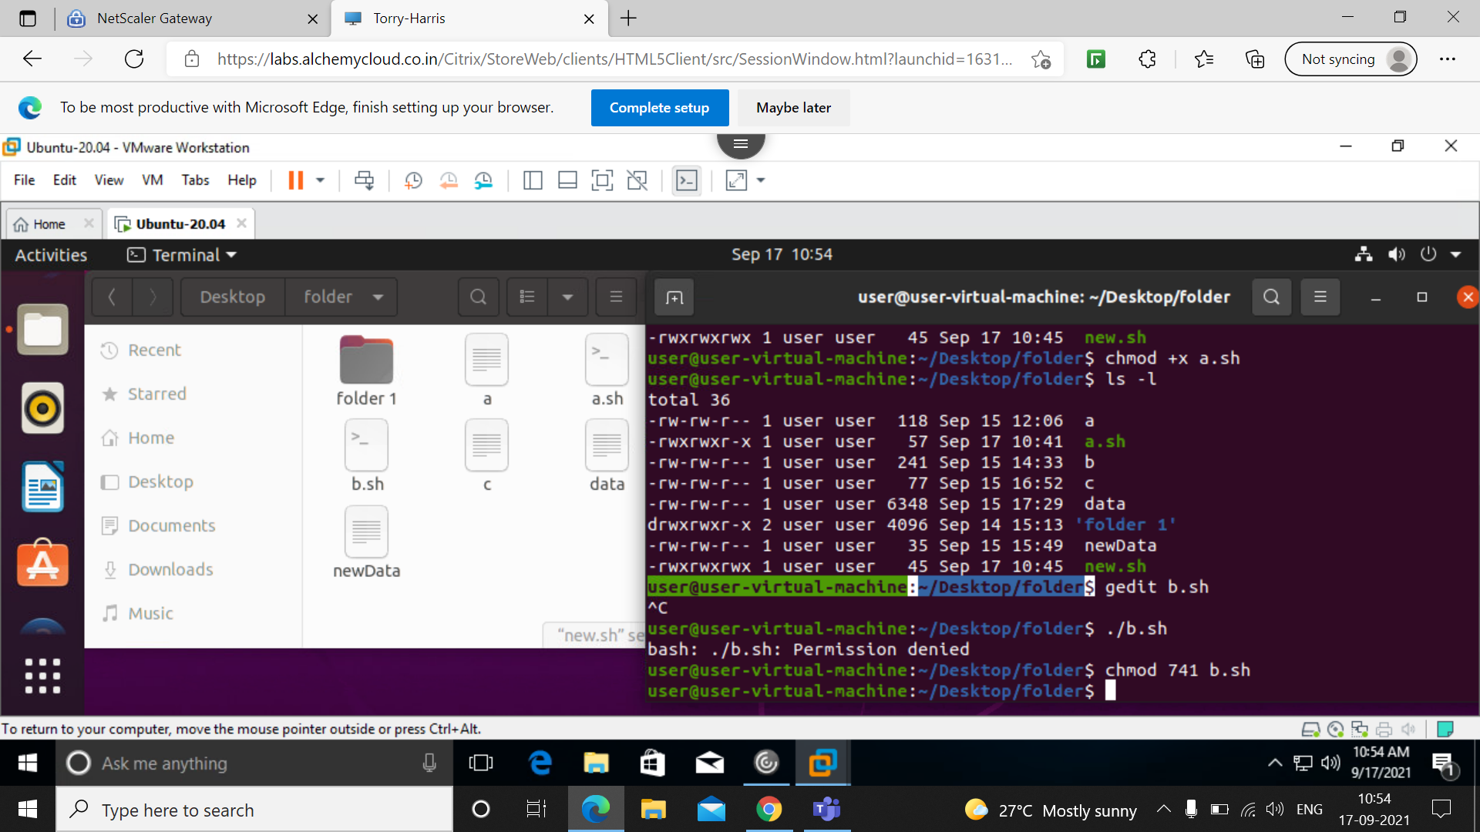
And here i have given all permission to owner and read permission to user and execute permission to others.

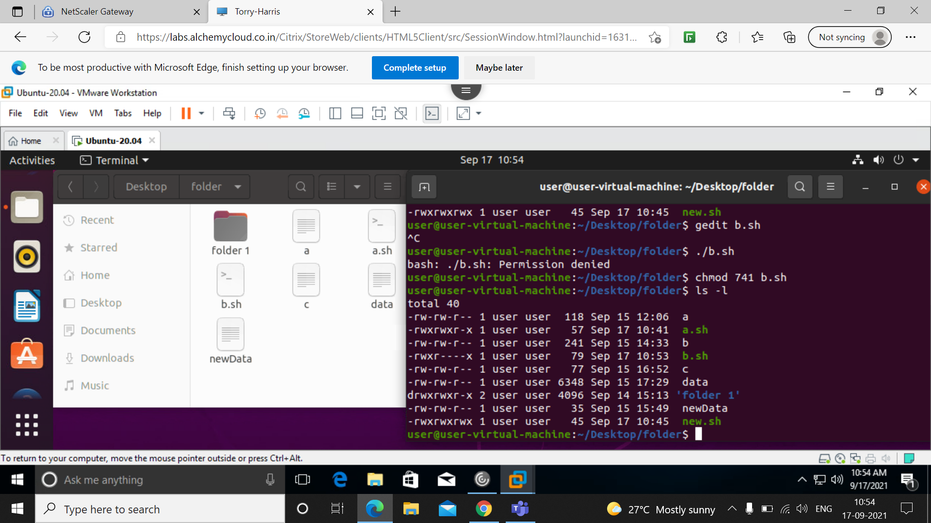
Here we can see permission is changed to b.sh.

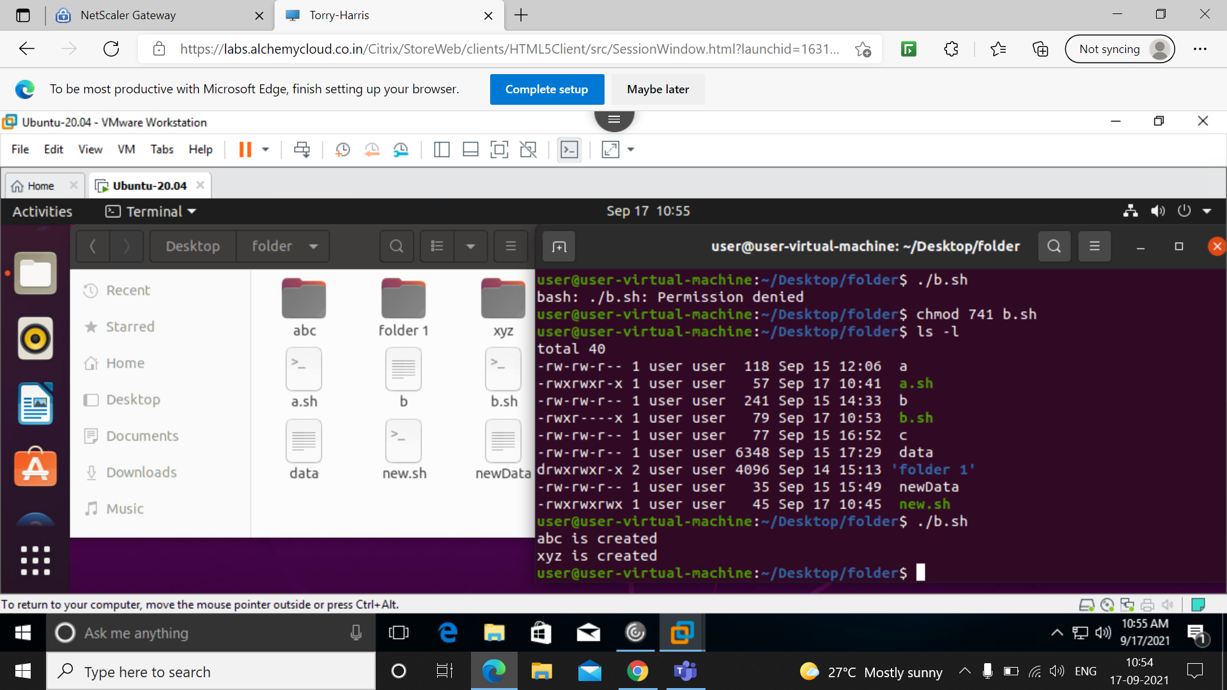
And here when executed ,it displays two files are created.

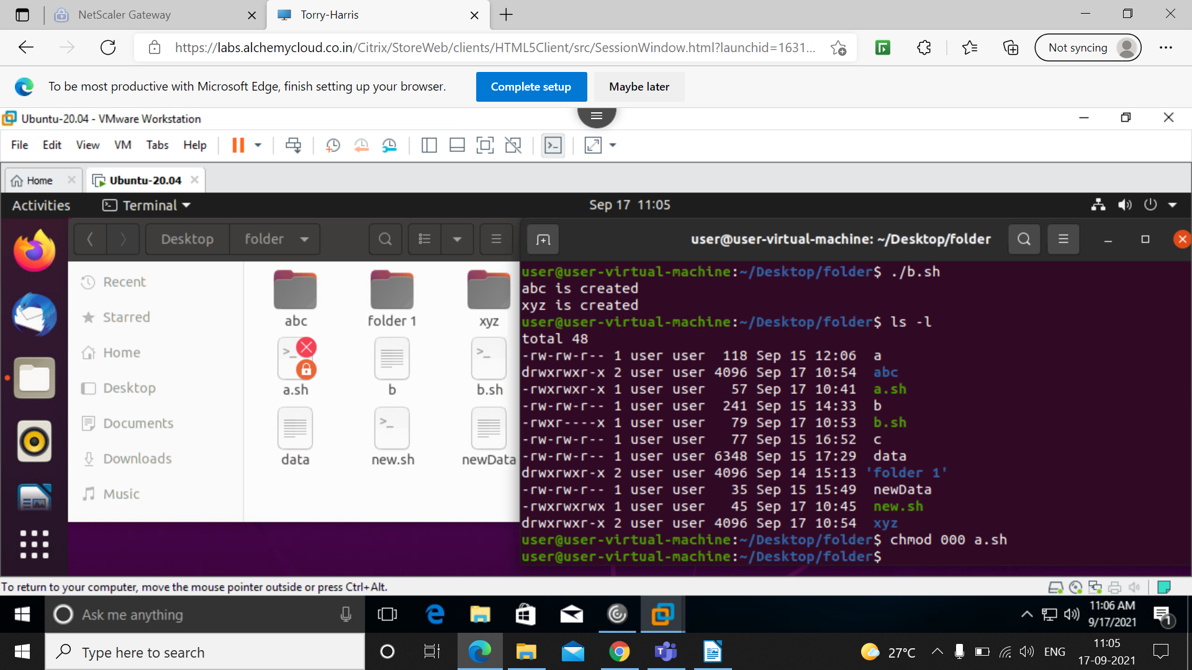
Here i have given no permission to anyone .

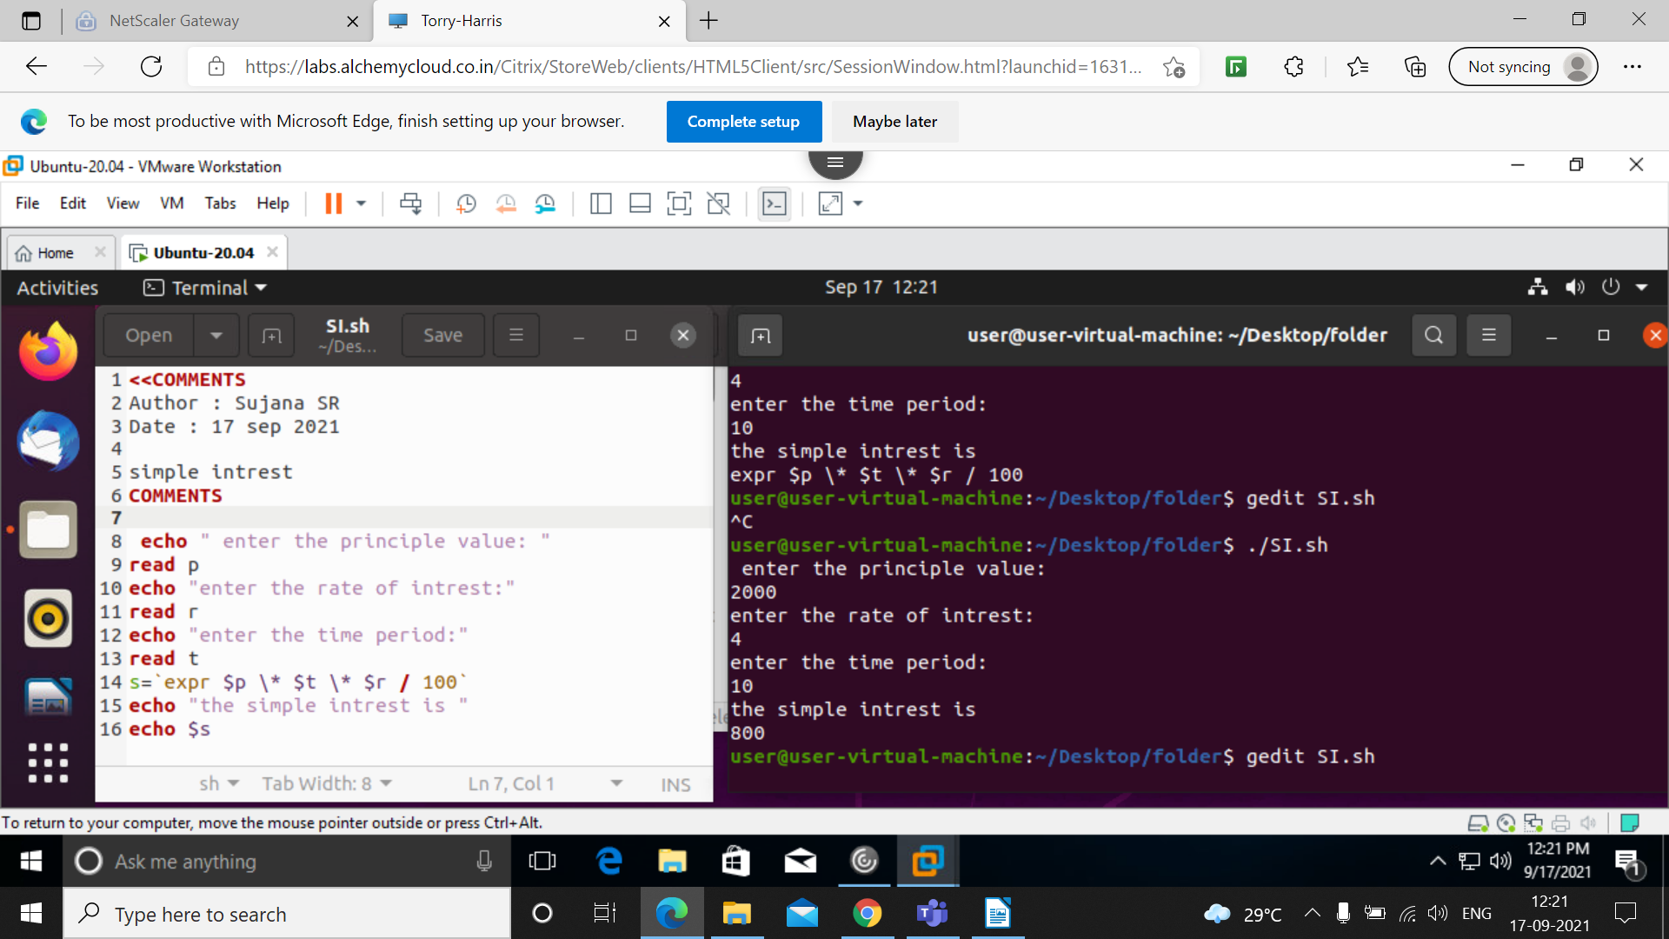
Program to calculate simple intrest.

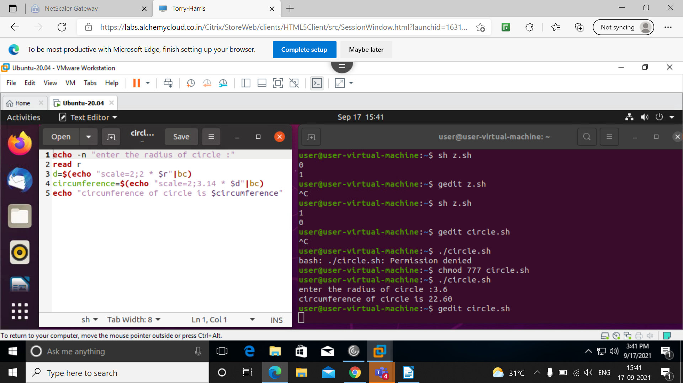
Program to calculate radius of circle.

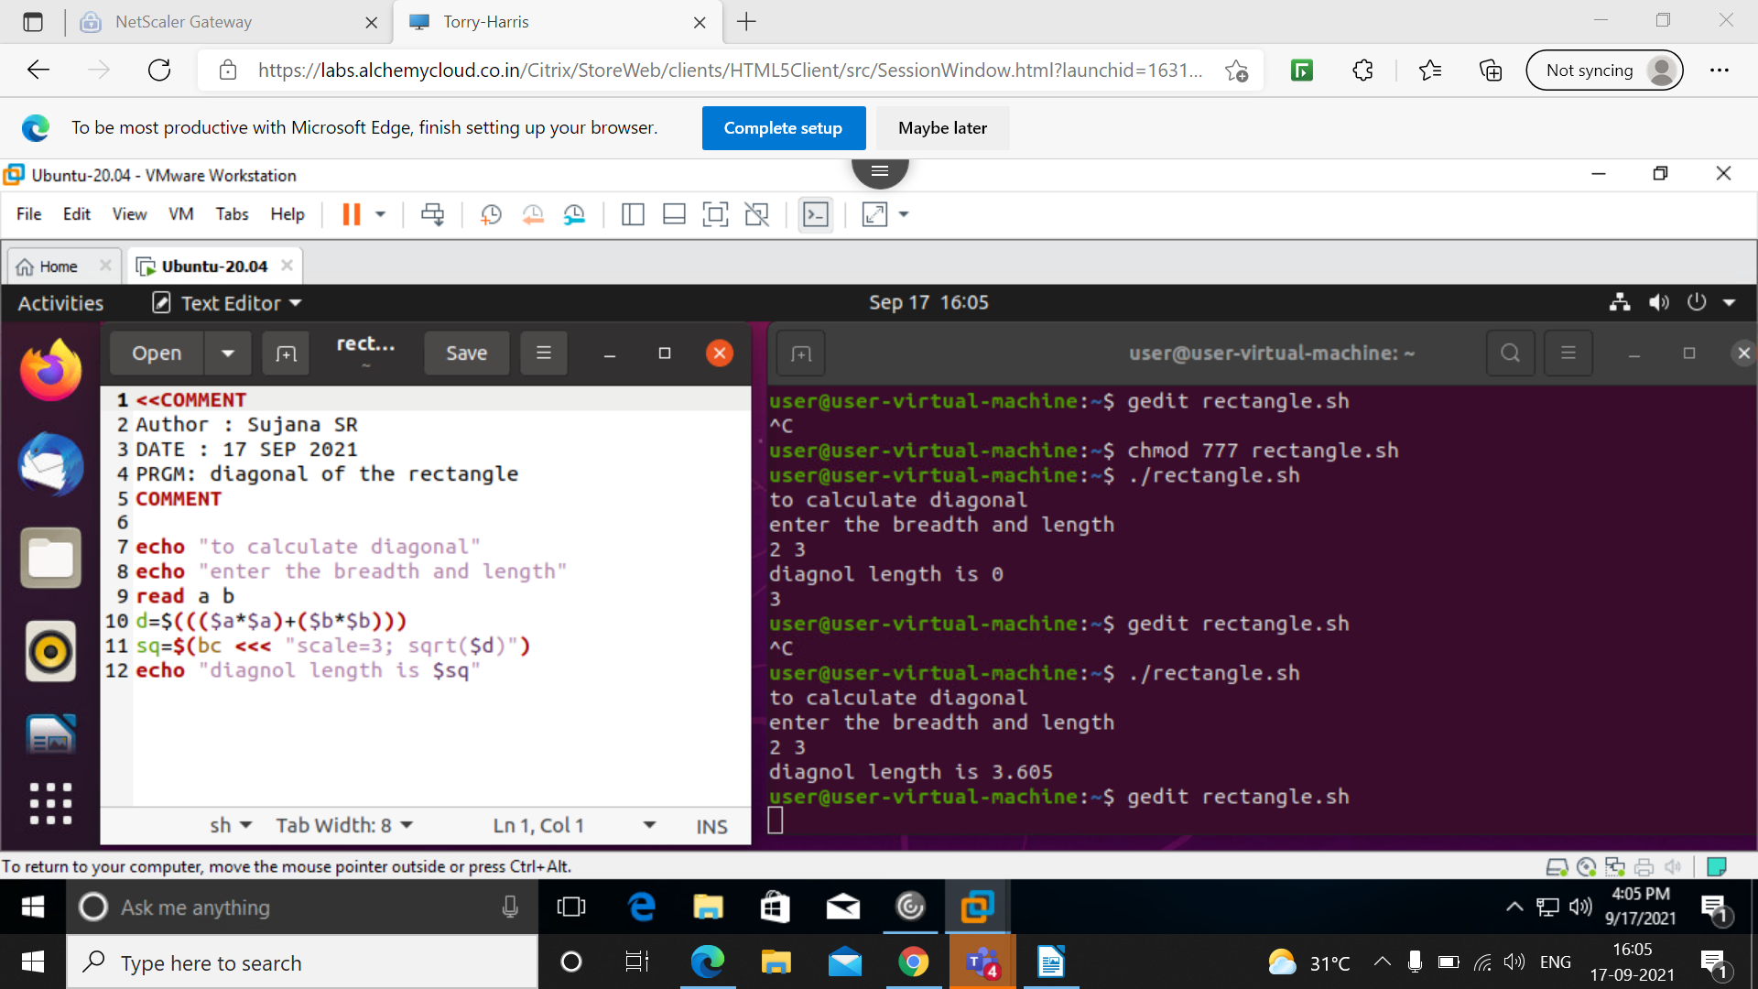
Program to calculate diagonal of rectangle.

