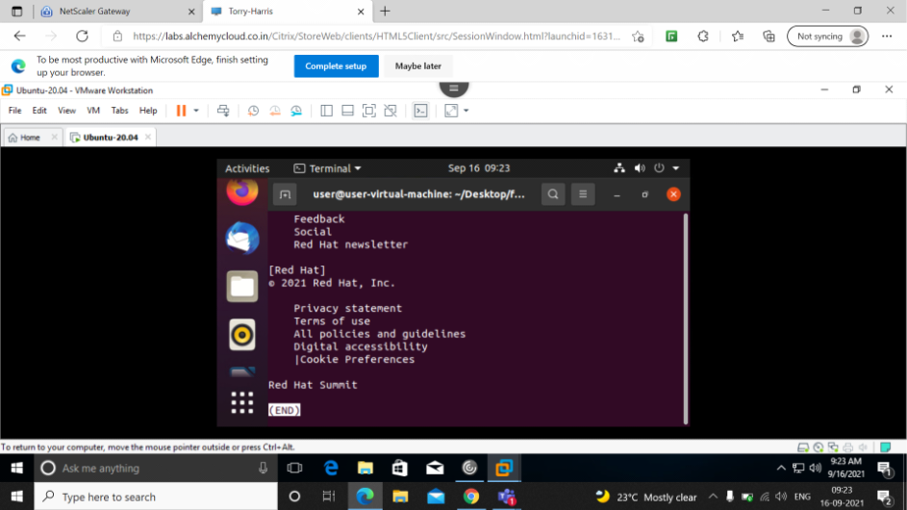
$ less data :- this command is used to load the data page by page,scroll dosent work here, and space is for next page ,enter is for next line and p is for previous page.

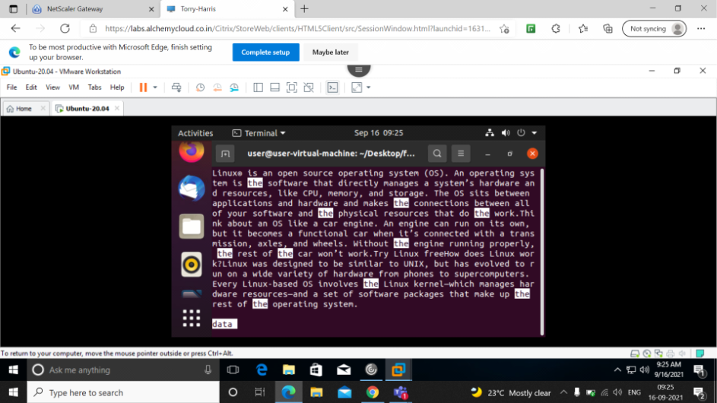
$ less 'the' data :- this command will display from yhe word the.
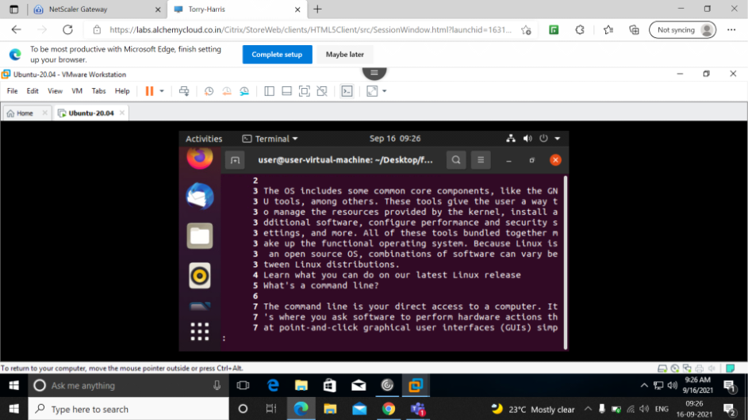
$ less -N data :- this command is used to print the line numbers.
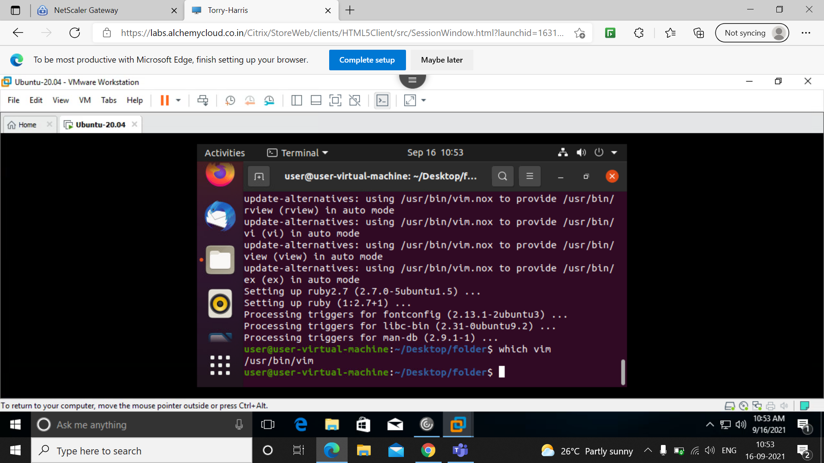
Which vim command displays where vim is present.
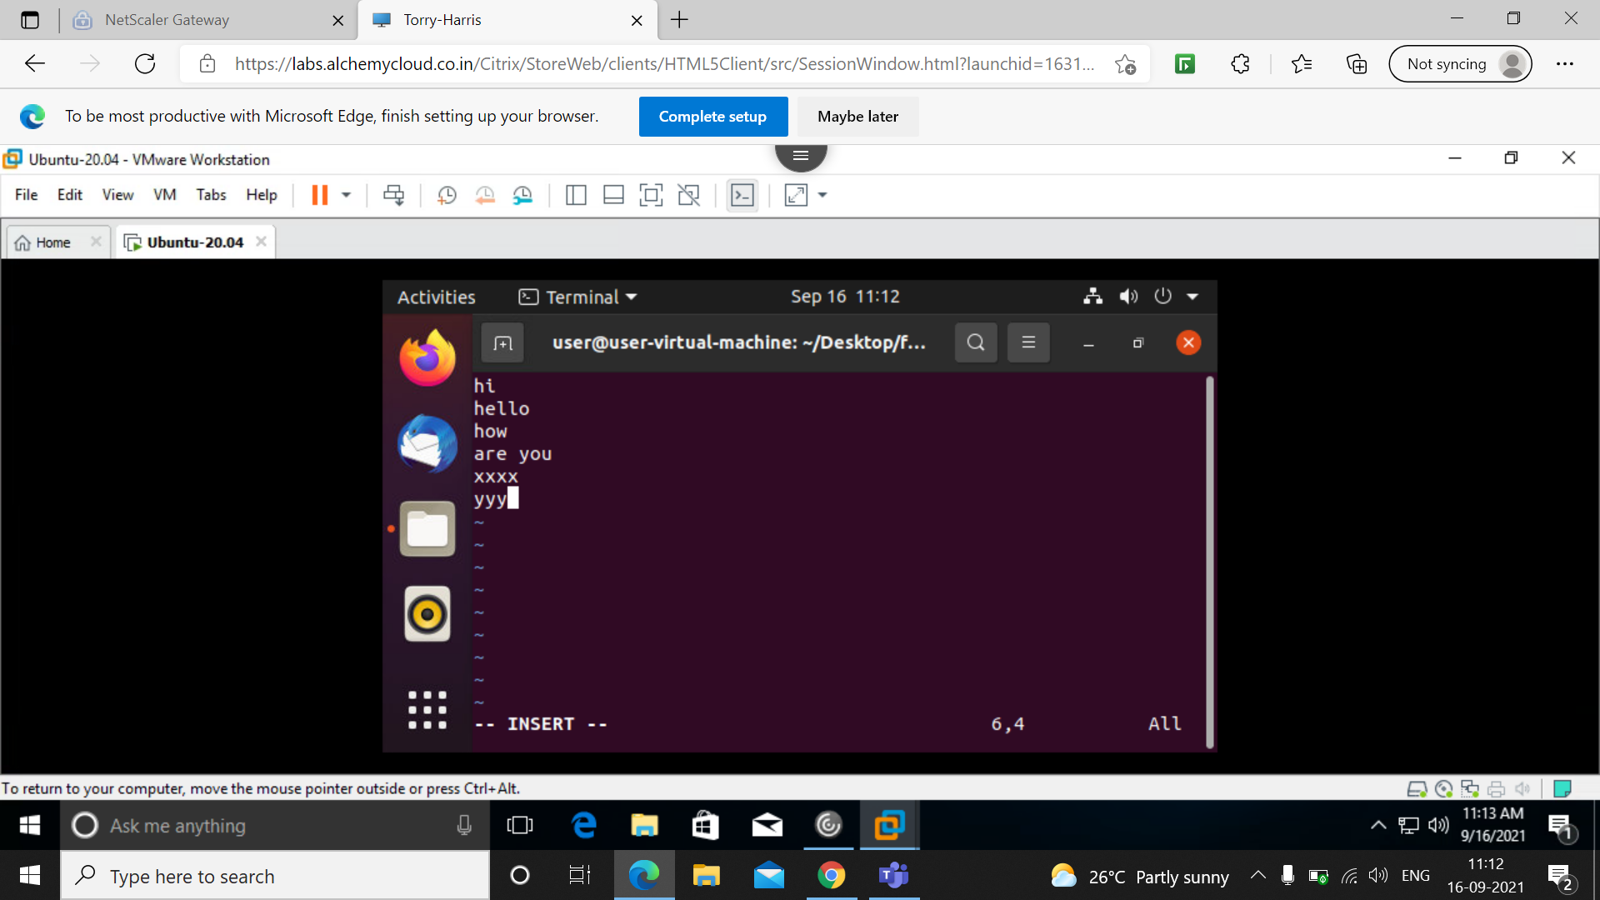

This is the in the insertion mode now ,where you can insert data.

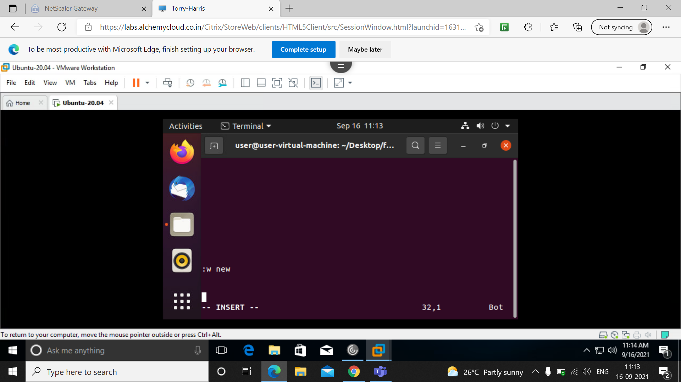
:w is used to save the file once after insertion.

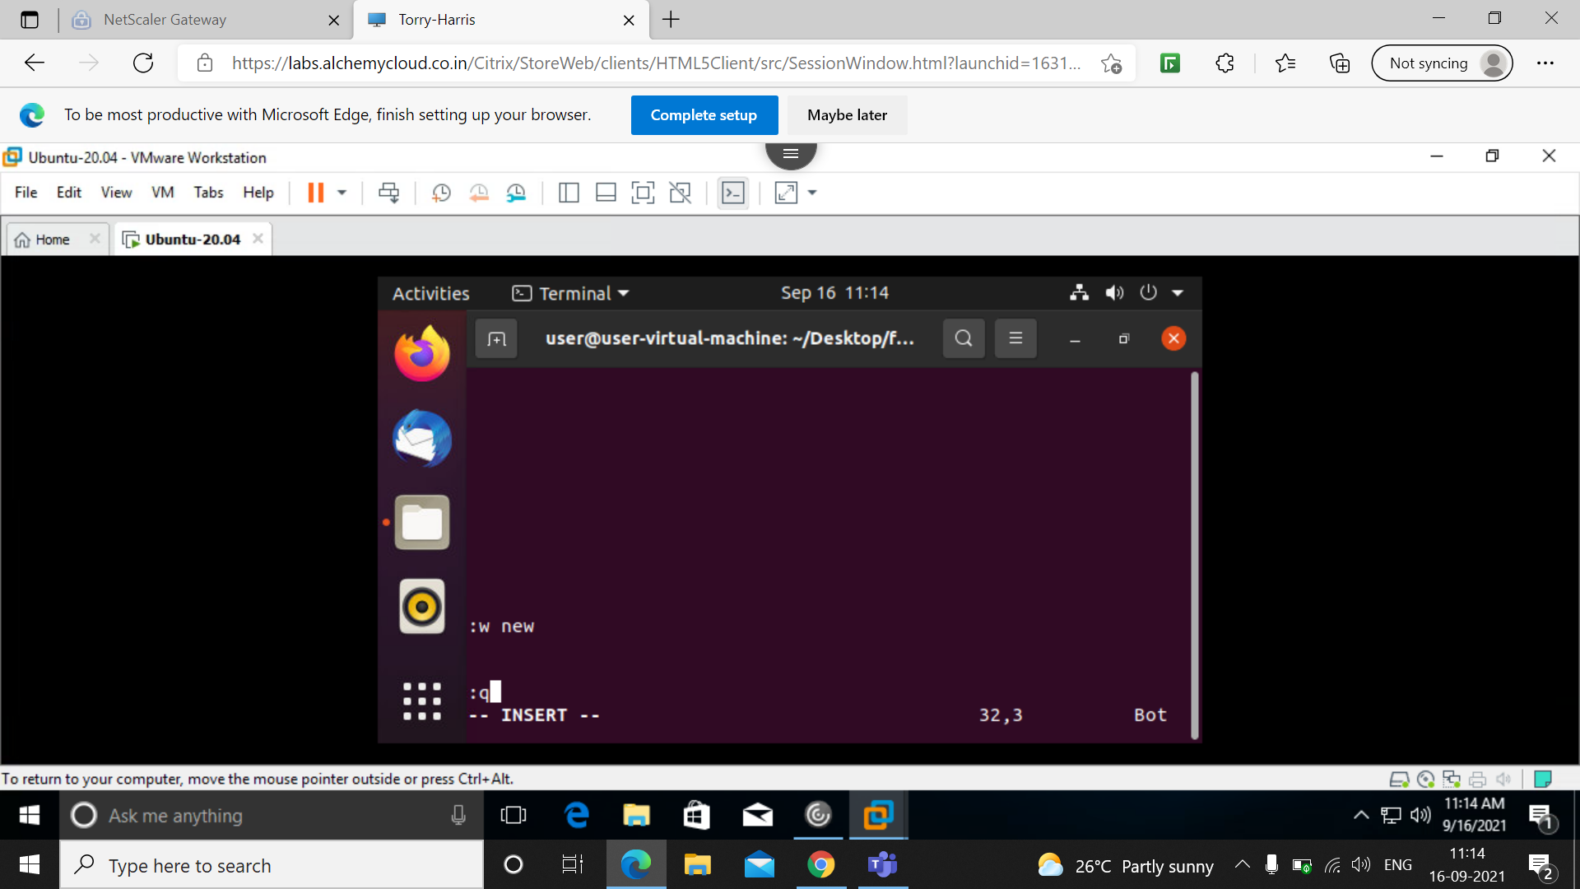
:q is used to quit once after saving the file.

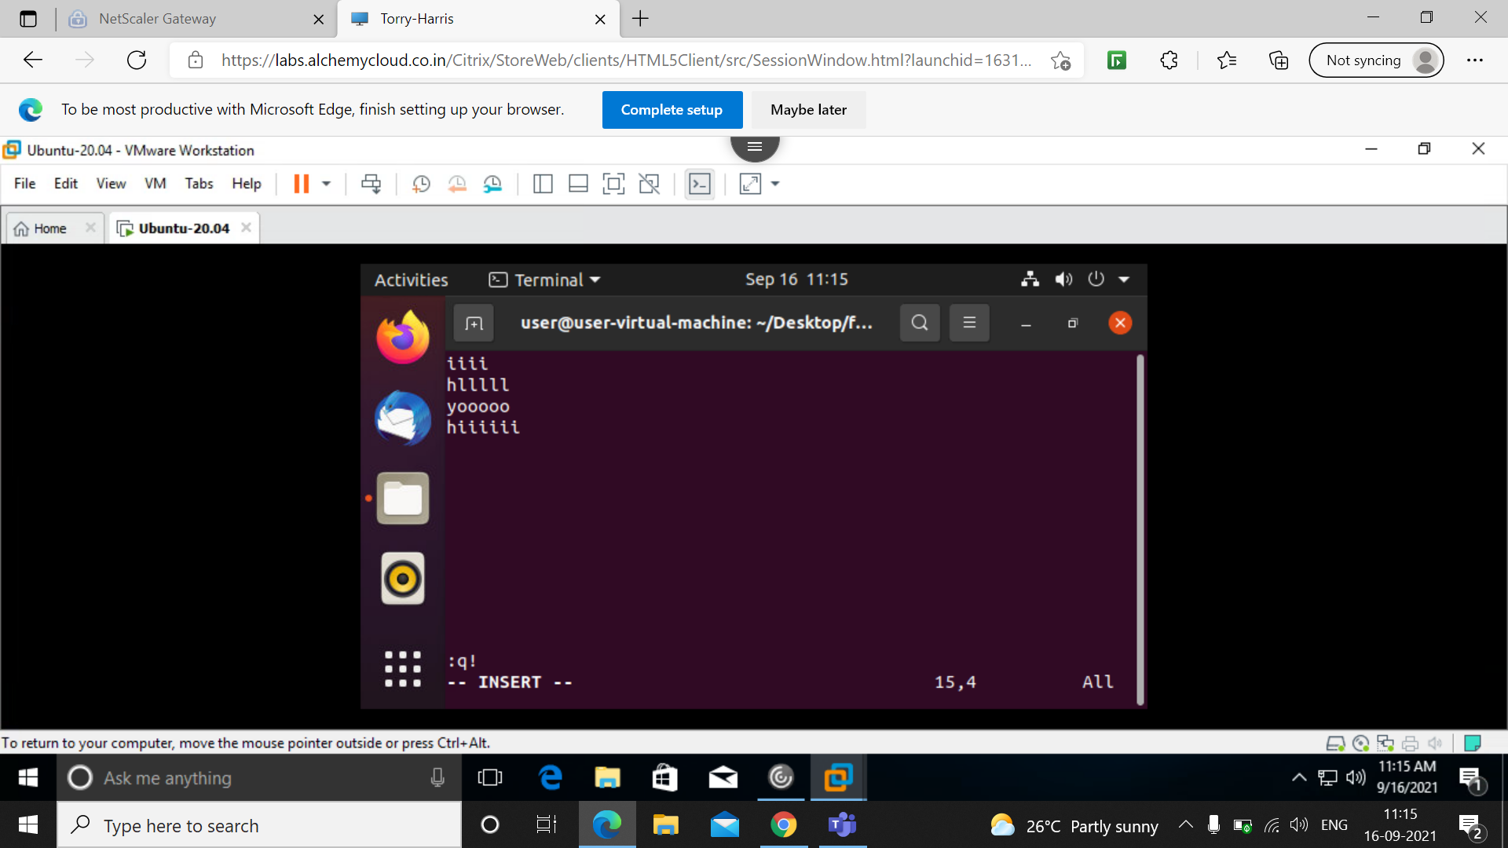
:q! is used to quit without saving the file.

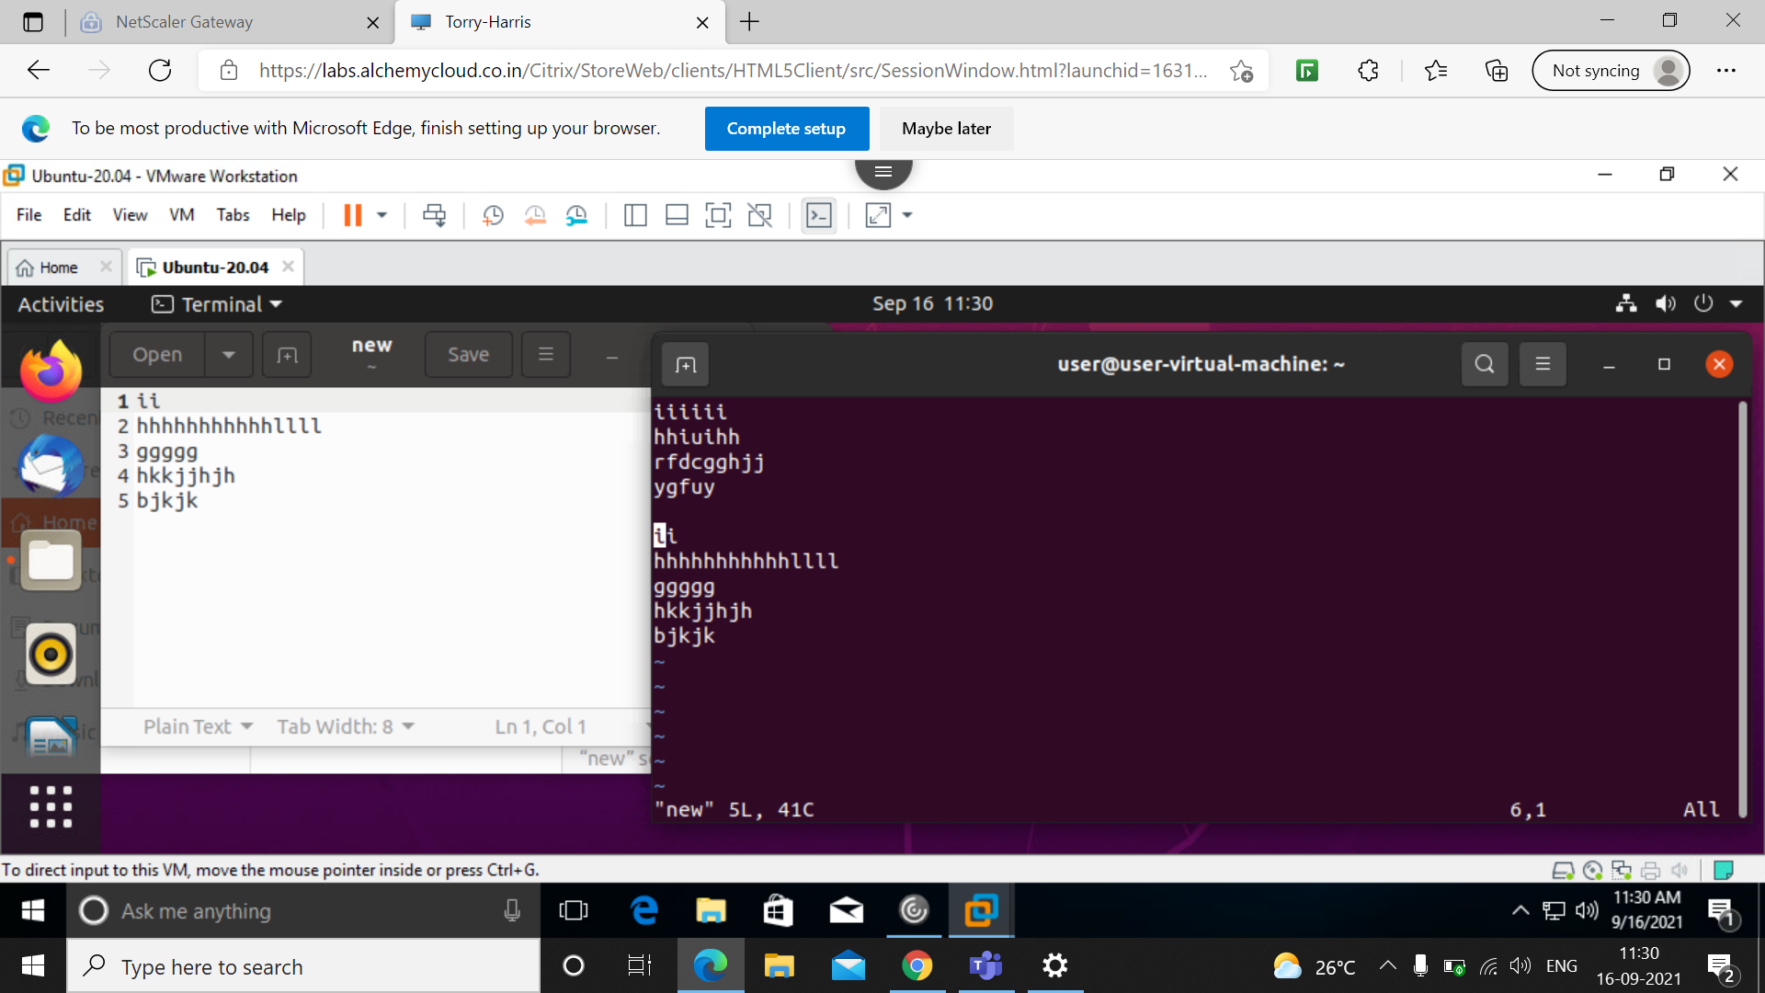
Using :r new command here i have copied the content of new file .

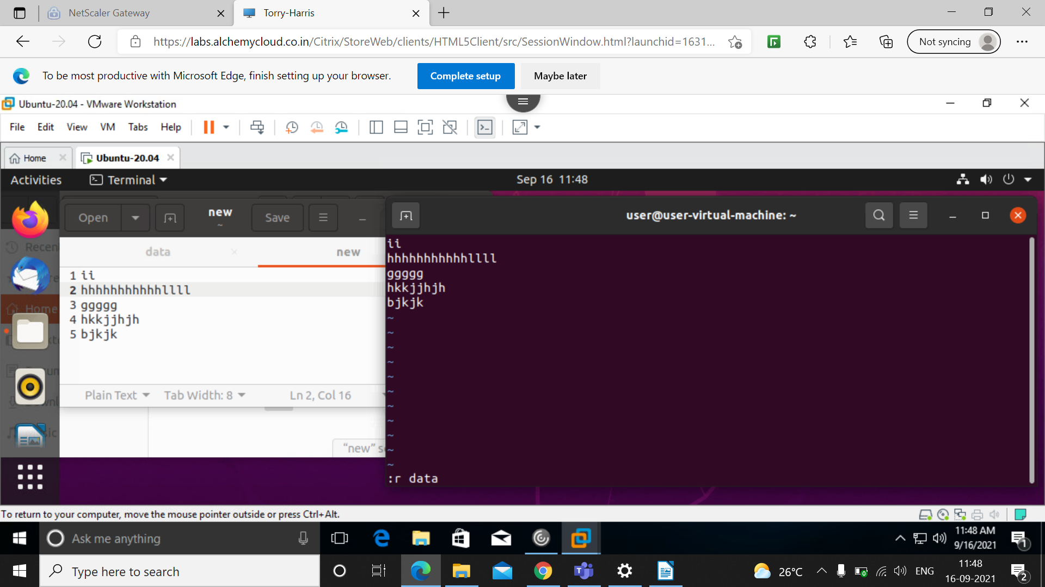
Copying the data from data file to new file.

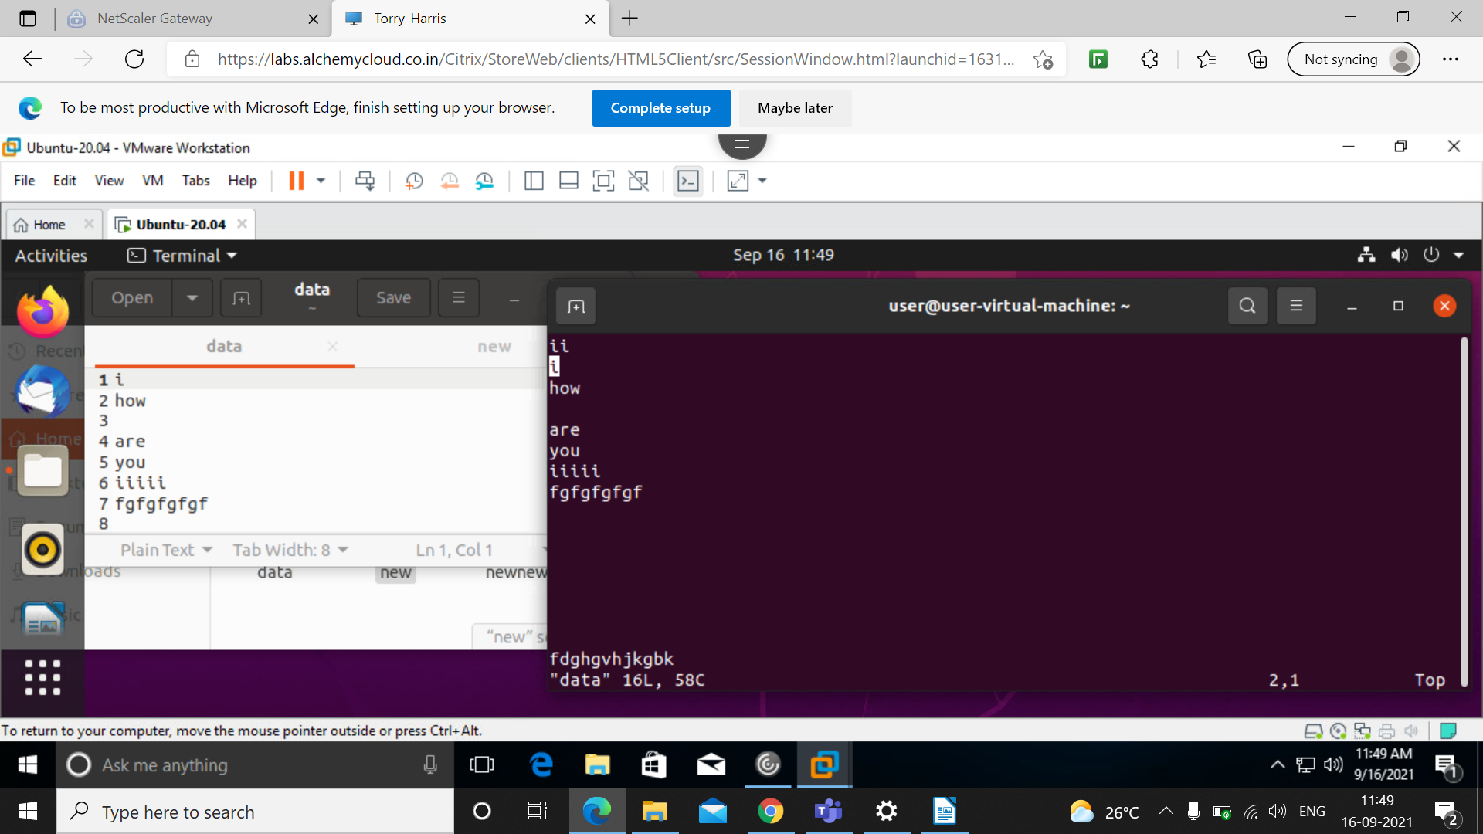
Here the data from data file is copied to new file.

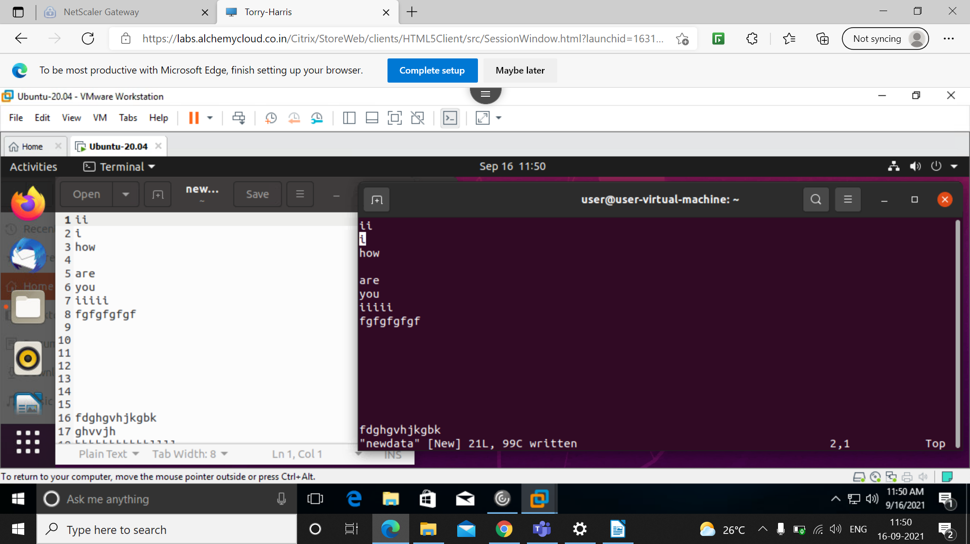
Now saving that copied file as newdata file.

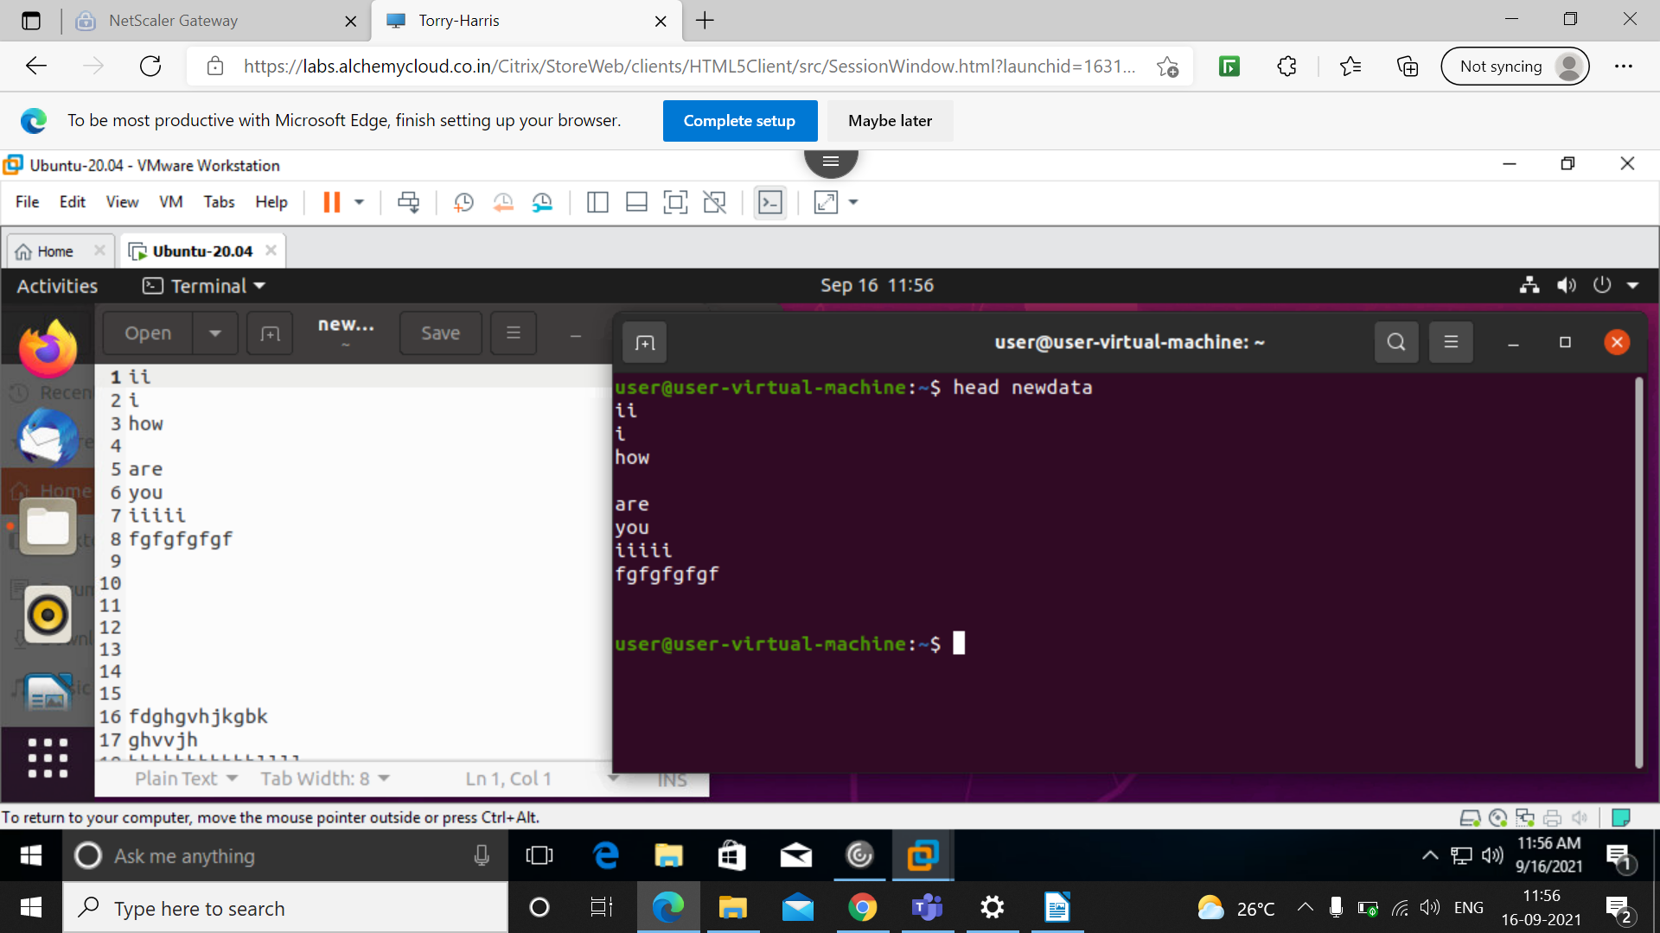
Head command is used to display the starting 10 lines of the file by default.

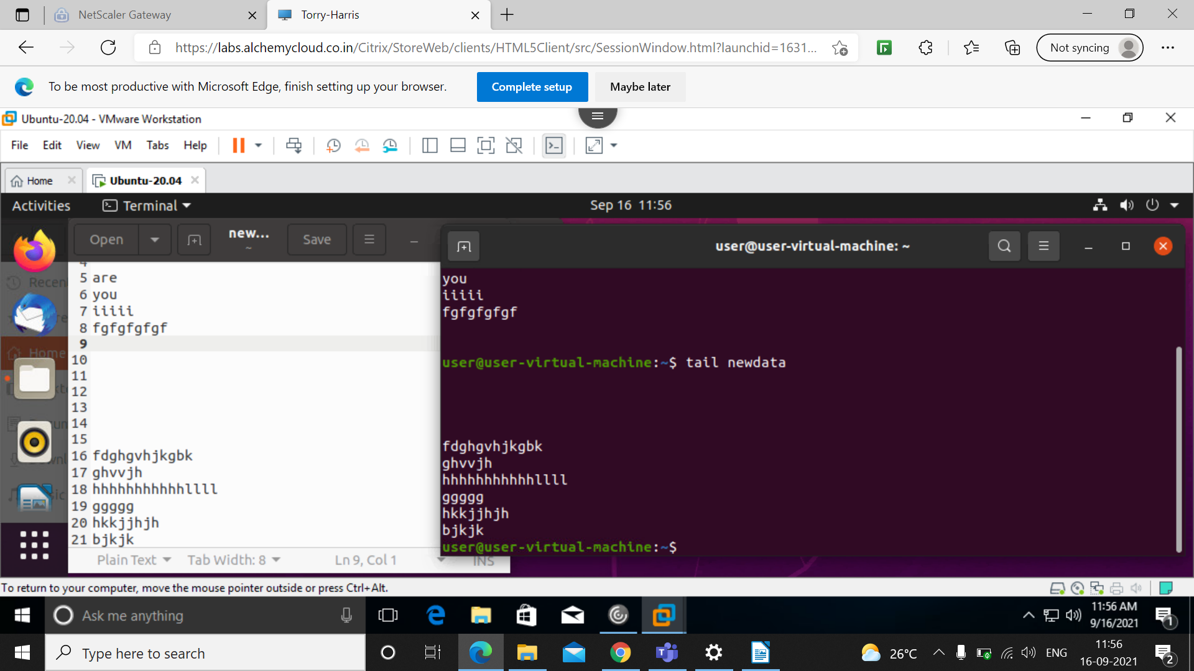
Tail command is used to display the last part of the file.

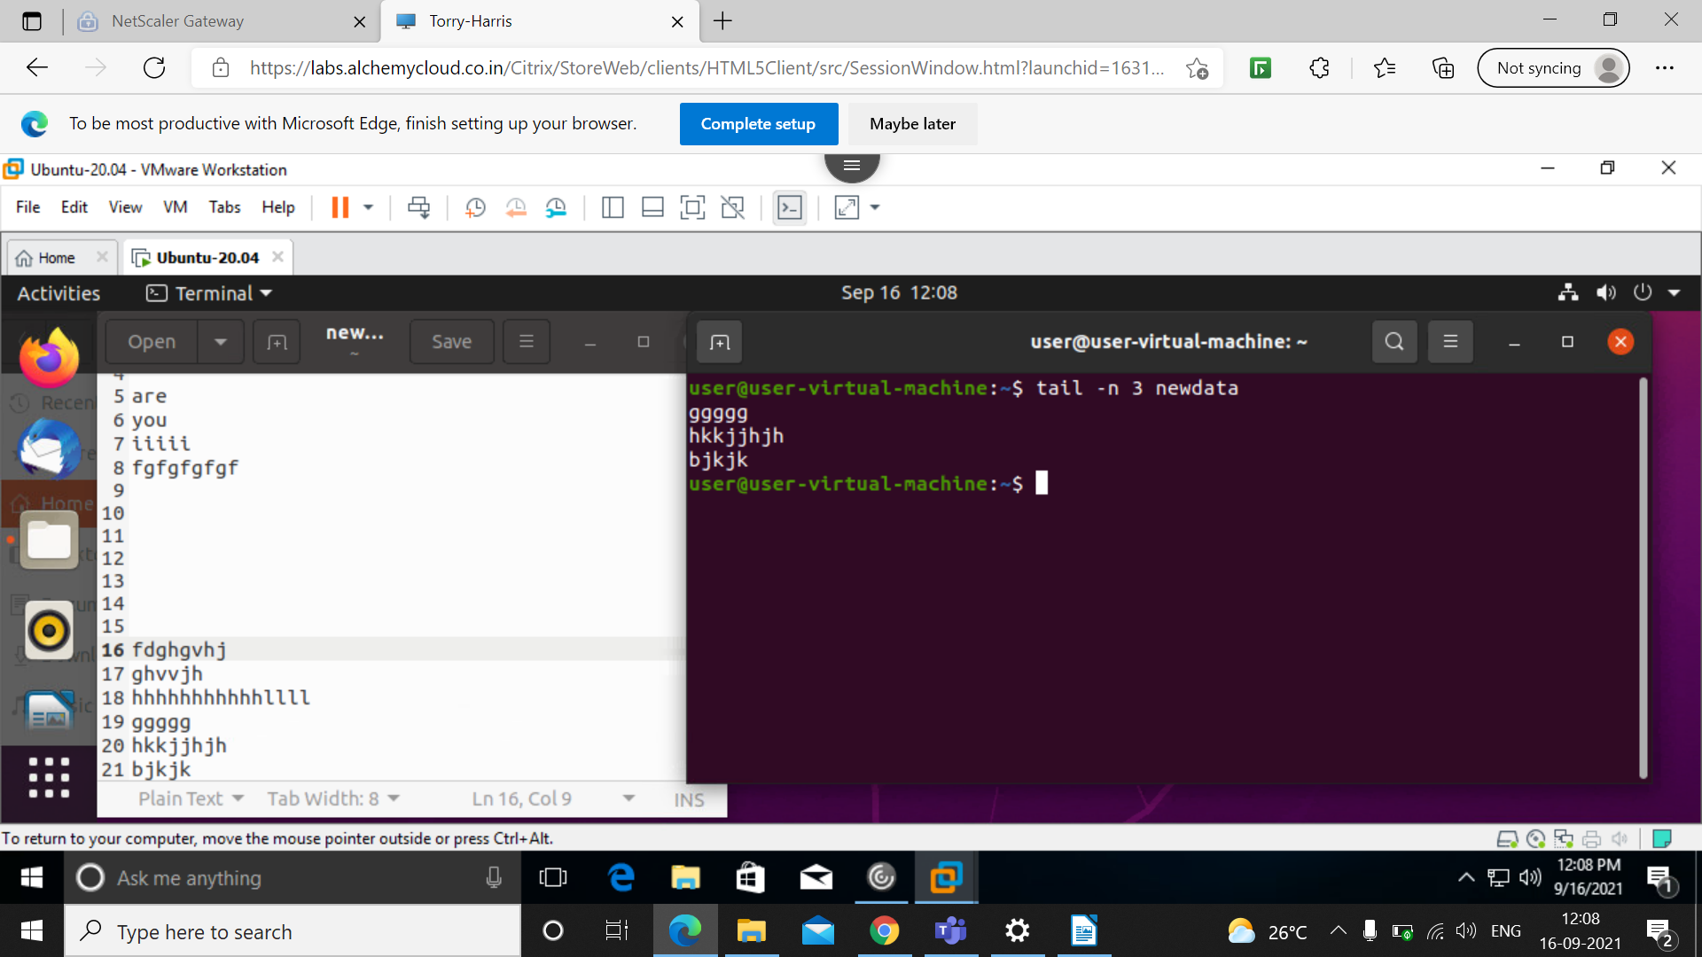
This command will display only last 3 lines of the file.

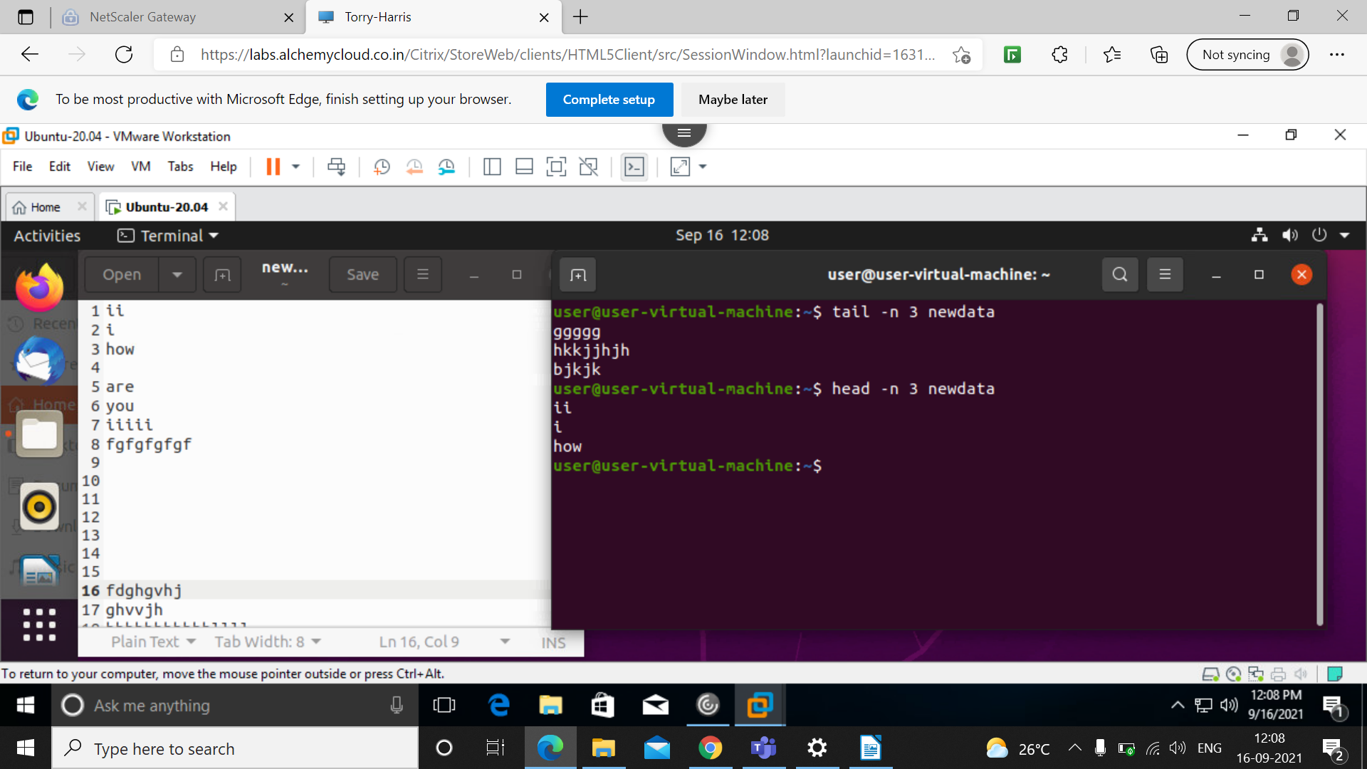
$ head -n 3 newdata:- this command will display only starting 3 lines of the file.

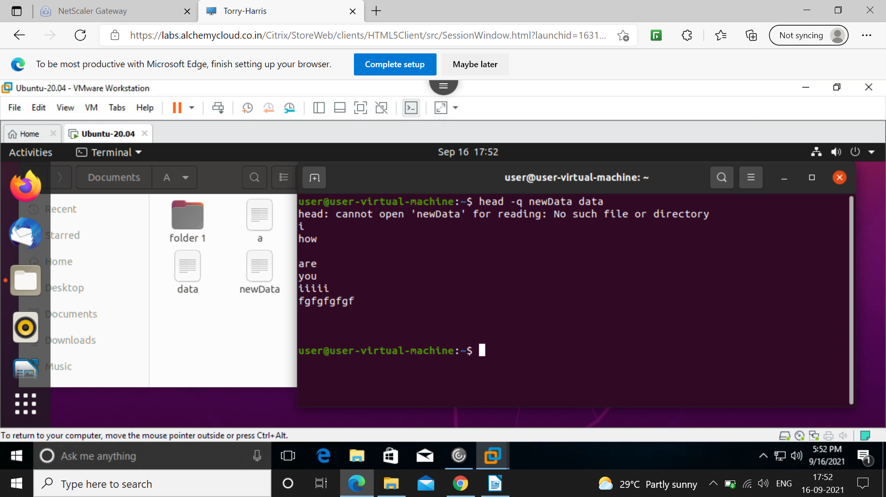
This command is used to combine two files.

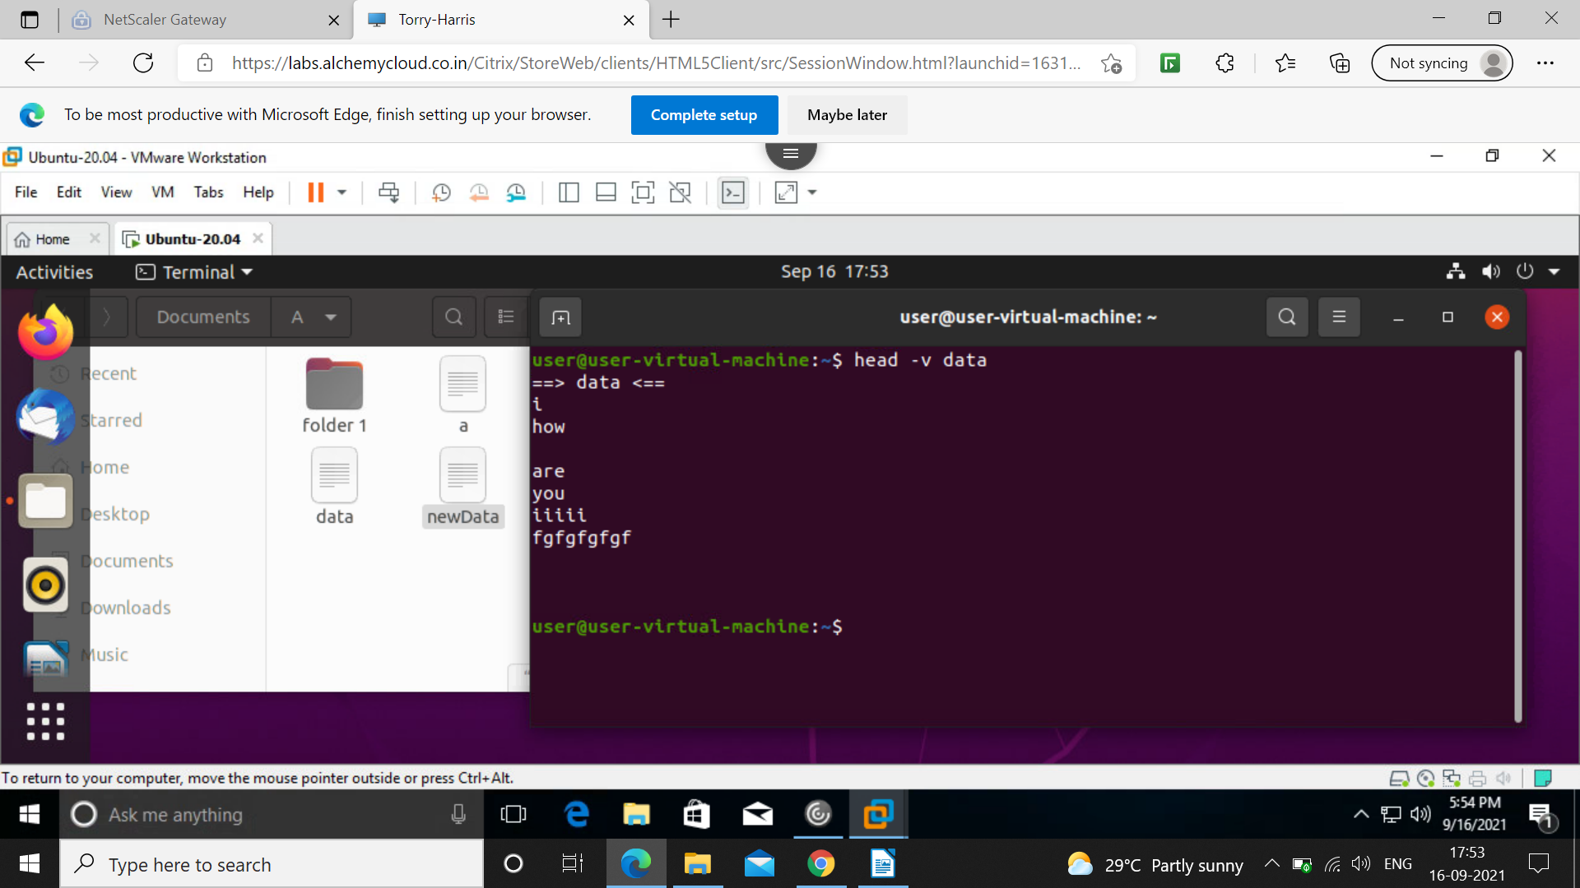
This command displays first 10 lines as well as the file name.

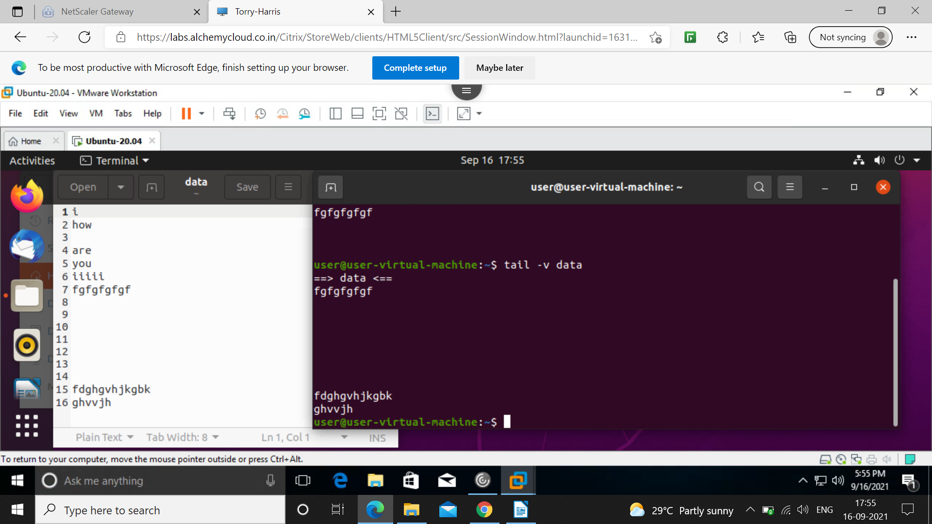
This command in tail will display last 10 lines along with the file name.

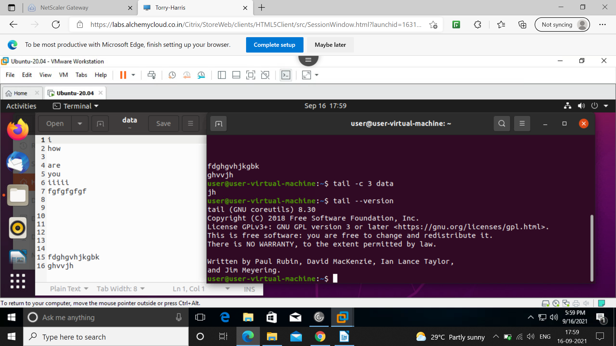
This command will tell the version of tail.

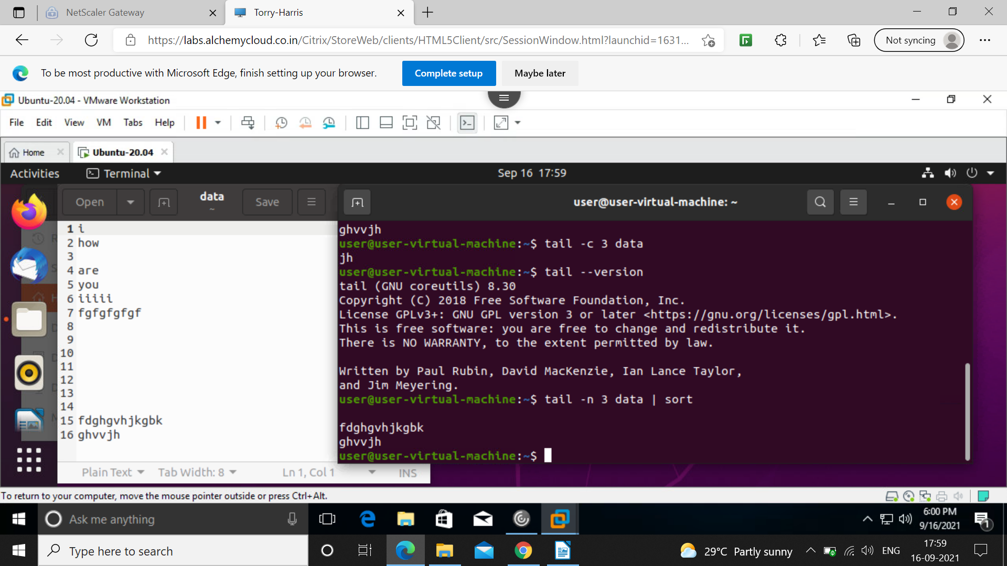
This command sort from the bottom of the file.

