A Project Report on

AUTOMATED INFORMATION EXTRACTION FROM MULTILINGUAL CV DOCUMENTS
Submitted in the partial fulfillment of requirements to
CM461 – Project Work

ACHARYA NAGARJUNA UNIVERSITY
for the award of the degree
Bachelor of Technology in
Computer Science and Engineering (AI & ML)
by

Batch No: A9
ARIKATI SUJANA (Y22CM006) JAMMU DURGA PRASAD (Y22CM062)
GOTTEMUKKALA KEERTHI (Y22CM054)
Under the guidance of

Mr. K.V. Ranga Rao Asst.professor, CSE(AI&ML)

R.V.R & J.C COLLEGE OF ENGINEERING
(Autonomous)
Approved by AICTE :: Affiliated to Acharya Nagarjuna University Chowdavaram, Guntur - 522019, Andhra Pradesh, India
May- 2026
i

DEPARTMENT OF COMPUTER SCIENCE & ENGINEERING (AI & ML)



CERTIFICATE

This is to certify that this project report entitled “Automated Information Extraction from Multilingual CV Documents” is being submitted by Arikati Sujana (Y22CM006), Jammu Durga Prasad (Y22CM062), Gottemukkala Keerthi (Y22CM054) in partial fulfillment for the award of the Degree of Bachelor of Technology in Computer Science & Engineering (AI & ML) to R.V.R & J.C College of Engineering (Autonomous) is a record of bonafide work carried out by them under my guidance and supervision.

Mr. K.V. Ranga Rao Asst.professor, CSE(AIML)
(Prof. G. Rama Mohan Babu) Professor & Head

ii

ACKNOWLEDGEMENT

We would like to express our sincere gratitude to our guide, Mr. K.V. Ranga Rao, for his constant support, valuable guidance, and encouragement throughout the development of this project. His insights and suggestions have been instrumental in the successful completion of our work. We would also like to express our sincere thanks to our Head of the Department, G. Rama Mohan Babu, for his guidance and support. We extend our sincere appreciation to all the faculty members of the Department of Computer Science and Engineering (AI & ML) for their encouragement and academic support. We would like to convey our sincere thanks to our Principal, Dr. Kolla Srinivas, for providing us with the opportunity and necessary resources to successfully complete this project. Finally, we express our sincere gratitude to everyone who directly or indirectly contributed to the successful completion of this project.

ARIKATI SUJANA (Y22CM006) JAMMU DURGA PRASAD (Y22CM062) GOTTEMUKKALA KEERTHI (Y22CM054)

ABSTRACT

Automated extraction of structured information from multilingual curriculum vitae (CV) documents remains a challenging problem in natural language processing, owing to the high variability in document layout, language, and formatting. This study proposes a transformer-based dual-headed architecture, referred to as DualModel, which fine-tunes a pretrained XLM-RoBERTa encoder to simultaneously perform two token-level classification tasks in a single forward pass: item-level Named Entity Recognition (NER) and section-level structural classification. The NER head identifies fine-grained entities including personal details (NAME, MAI, NMR, ADR), professional information (ORG, ROL), academic qualifications (DEG, EDU, CER), and temporal data (DAT, DUR), while the section head classifies each CV line into structural categories such as PERSONAL, EDUCATION, EMP_INFO, EMP_DESC, and SKILLS. The model is trained and evaluated on a BIO-annotated multilingual dataset comprising CVs in five languages — English, Swedish, Norwegian, Finnish, and Polish — using a combined cross-entropy loss over both classification objectives. A 5-fold cross-validation yields a mean item-level F1-score of 0.9908 and a mean section-level F1-score of 0.9938, with near-zero standard deviation across folds, confirming strong generalization and robustness across linguistically diverse inputs. An additional skill competence assessment module further analyses proficiency-level distributions from the extracted skill entities. The results demonstrate the effectiveness of joint multi-task transformer architectures for accurate and scalable multilingual CV information extraction.

CONTENTS

CHAPTER | DESCRIPTION | PAGE NO.
 | TITLE | i
 | CERTIFICATE | ii
 | ACKNOWLEDGEMENT | iii
 | ABSTRACT | iv
 | CONTENTS | v-viii
 | LIST OF FIGURES | ix
 | LIST OF TABLES | x
 | LIST OF ABBREVIATIONS | xi
1 | INTRODUCTION | 1-5
 | 1.1 Introduction to NLP and Information Extraction | 1
 | 1.1.1 Evolution of Information Extraction Systems | 1
 | 1.1.2 Role of NLP in CV Information Extraction | 1-2
 | 1.2 Background and Significance | 2
 | 1.2.1 Background | 2
 | 1.2.2 Significance | 2-3
 | 1.3 Objectives | 3
 | 1.4 Scope of the Study | 3-4
 | 1.5 Limitations | 4-5
2 | LITERATURE SURVEY | 6-12
 | 2.1 Related Work | 6-10
 | 2.2 Research Gap | 11
 | 2.3 Motivation for the proposed Work | 12

SYSTEM ANALYSIS

  - Functional Requirements

    - Resume Data Ingestion

    - Multilingual Tokenization

    - Dual-Level Entity Recognition

    - Model Training

    - Inference and Prediction

    - Section-Level Post-Processing

    - Structured Output Generation
    - Evaluation and Reporting

  - Non-Functional Requirements

    - Performance

    - Accuracy

    - Scalability

    - Usability

    - Reliability
    - Maintainability
    - Security
    - Portability

  - System Requirements

    - Hardware Requirements

    - Software Requirements
13-22

13

13

13

13

13-14

14

14

14
14

15

15

15

15

15

15-16
16
16
16

16

16-17

17

    - Dataset Requirements

  - Use Case Diagram

    - Actor
17-18

18

18-19

    - Use Case Description

    - System Flow

    - Explanation of the Diagram

SYSTEM DESIGN

  - System Architecture

    - Input and Document Processing Layer

    - Text Preprocessing and Tokenization

    - XLM-Roberta Encoder and Dual Model Design

    - Attention and Masking Mechanisms
    - Skill Extraction and Competence Assessment

    - Post-processing and Output Generation

    - Summary of System Architecture

  - Module Implementation
19

21
22
23-35

23

23

23-24

24

24-25
25

26

26
27-35

METHODOLOGY

  - Dataset

  - Dataset Preprocessing

  - Transformer-Based Feature Extraction

    - Input Representation and Embeddings

    - Classification Token

    - Transformer Encoder Architecture

    - Training Procedure

    - Embedding Extraction

    - Role in the Overall System

  - Item-Level and Section-Level Classification

  - Skill Competence Assessment
36-43

36-37

37-38

38

38-39

39

39-40

40-41

41

41-42

42

42-43

  - Model Training and Evaluation Strategy 43

TESTING

- RESULTS AND DISCUSSION

  - Results Overview

  - Overall Model Performance

  - Cross-Validation Results

  - Multilingual Performance

  - Ablation Study

  - Robustness Analysis
  - Influence of Model Depth on Performance

  - Detailed Language-Wise Results

  - Model Efficiency and Inference Performance

  - Discussion

  - Summary of Key Findings

CONCLUSION AND FUTURE WORK

- BILBLIOGRAPHY

44-45

46-54

46

46

46-47

48

48-49

49
49-50

50-51

52

52-53

53-54

55

56

Sl No. | Figure No. | LIST OF FIGURES  Figure Description | Page No.
1 | 3.1 | Use Case Diagram Model | 21
2 | 4.1 | System Architecture | 26
3 | 7.1 | Dataset Split Distribution | 46
4 | 7.2 | Item Level — Category Frequencies in the Annotated Set | 47
5 | 7.3 | Section Level — Category Frequencies in the Annotated Set | 47
6 | 7.4 | Overall Model Performance on Test Set (Item NER vs Section Classification) | 48
7 | 7.5 | Per-Entity F1 Scores (Test Set) — All 14 Entity Categories | 50
8 | 7.6 | Per-Language Performance Comparison — Precision, Recall, F1 (Test Set) | 51
9 | 7.7 | Skill Assessment — Top 10 Skill Category Frequencies in the Annotated Set | 51
10 | 7.8 | Training Loss Curve — XLM-RoBERTa Fine-tuning over 3 Epochs | 52
11 | 7.9 | Influence of Transformer Layers on F1 Scores | 53
12 | 7.10 | Test Set vs Validation Set Performance — All Evaluation Metrics | 54

 |  | LIST OF TABLES
Sl No. | Figure No. | Table Description | Page No.
1 | 2.1 | Comparative Analysis of Existing CV Information Extraction Methods | 10
2 | 6.1 | Sample Resume Predictions Comparing Actual and Predicted Entity Labels | 45
3 | 7.1 | Dataset Split Distribution | 46
4 | 7.2 | Overall Macro-Averaged Performance — Test Set vs Validation Set | 48
5 | 7.3 | Section Level of the Dual Model — Evaluation Results | 48
6 | 7.4 | Section Level — Macro-Averaged Results | 49
7 | 7.5 | Item Level of the Dual Model — Evaluation Results | 49
8 | 7.6 | Item Level — Macro-Averaged Results | 49
9 | 7.7 | Section Level — Evaluation Results per Language | 50
10 | 7.8 | Item Level — Evaluation Results per Language | 50
11 | 7.9 | Macro-Average F1-Score vs. Number of XLM-RoBERTa Layers | 52
12 | 7.10 | Sample Resume Predictions — Actual vs Predicted Entity Labels | 53

LIST OF ABBREVIATIONS

Abbreviation Name | Full Name
AI | Artificial Intelligence
NLP | Natural Language Processing
CV | Curriculum Vitae
NER | Named Entity Recognition
BIO | Beginning–Inside–Outside
ML | Machine Learning
DL | Deep Learning
BERT | Bidirectional Encoder Representations from Transformers
XLM-R | Cross-lingual Language Model - RoBERTa
OCR | Optical Character Recognition
JSON | JavaScript Object Notation
F1-Score | Harmonic Mean of Precision and Recall

INTRODUCTION

Introduction to NLP and Information Extraction
Artificial Intelligence (AI) is one of the most transformative technologies in the modern era, enabling machines to simulate human intelligence and perform tasks such as learning, reasoning, problem-solving, and decision-making. AI systems process large volumes of data to generate meaningful insights, thereby supporting automation and improving efficiency across various domains.
A significant branch of AI is Natural Language Processing (NLP), which focuses on enabling machines to understand and interpret human language. NLP combines linguistics, computer science, and machine learning to process textual data and extract valuable information. With the increasing availability of digital text data, NLP has become essential for analyzing unstructured information.
One of the key applications of NLP is Information Extraction (IE), which involves identifying and extracting structured information from unstructured text. IE systems are widely used in applications such as document analysis, resume parsing, and data mining, where converting textual content into structured formats is necessary for further processing.

Evolution of Information Extraction Systems
Information extraction systems have evolved from simple rule-based approaches to advanced deep learning models:
Rule-Based Systems: Early systems relied on predefined rules and patterns to extract information. These systems were limited in handling variations in text and lacked adaptability.
Machine Learning Approaches: Techniques such as Hidden Markov Models (HMM) and Conditional Random Fields (CRF) improved extraction by learning patterns from annotated data instead of relying solely on rules.
Deep Learning Models: Neural networks, including Recurrent Neural Networks (RNNs), Long Short-Term Memory (LSTM), and Convolutional Neural Networks (CNNs), enhanced performance by capturing contextual relationships within text.
Transformer-Based Models: Transformer architectures introduced attention mechanisms that allow models to understand the context of entire sequences efficiently. Models such as BERT significantly improved performance in tasks like text classification and named entity recognition.
Multilingual Models (XLM-RoBERTa): Recent advancements focus on multilingual processing. XLM-RoBERTa is a powerful transformer-based model trained on large multilingual datasets, enabling it to handle multiple languages effectively and improve cross-lingual understanding.

Role of NLP in CV Information Extraction
Curriculum Vitae (CV) documents are essential for recruitment processes as they provide detailed

information about a candidate's qualifications, experience, and skills. However, CVs are typically unstructured or semi-structured, diverse in format and layout, and written in different languages. These characteristics make automated processing challenging.
NLP-based CV information extraction systems aim to identify different sections such as personal details, education, and experience; extract important entities like names, organizations, dates, and skills; and convert free-form text into structured data formats. Such systems are widely used in recruitment platforms, applicant tracking systems, and HR analytics tools to improve efficiency and decision-making.

Background and Significance

Background
With the rapid growth of online recruitment platforms, organizations are required to process a large number of CVs within a limited time. Manual screening of resumes is not only time-consuming but also prone to inconsistencies and human errors. As a result, automated CV parsing systems have gained significant importance.
Earlier approaches to CV information extraction were primarily based on rule-based systems, which required manually defined patterns for identifying relevant information. These systems lacked flexibility and failed to adapt to variations in CV formats. Later, machine learning-based methods improved performance but still depended heavily on feature engineering and struggled with complex language patterns.
The increasing diversity in CV formats and the presence of multilingual data further complicate the extraction process. Traditional models designed for a single language often fail to generalize across multiple languages, limiting their effectiveness in global recruitment scenarios.
Recent advancements in deep learning, particularly transformer-based models, have addressed many of these challenges. These models can capture contextual relationships in text and handle variations in language more effectively. Among them, XLM-RoBERTa has emerged as a powerful multilingual model capable of processing text across multiple languages with high accuracy.
In this project, XLM-RoBERTa is utilized to develop a system that extracts structured information from free-form CV documents. The system focuses on both section-level classification and entity-level extraction, enabling efficient conversion of unstructured CV data into structured formats.

Significance
The proposed system plays a crucial role in improving the efficiency and effectiveness of modern recruitment systems. Its significance can be understood through the following aspects:
Automation of Resume Screening: The system reduces the need for manual intervention by automatically extracting relevant information from CVs, thereby saving time and effort.
Consistency and Accuracy: Automated extraction ensures consistent results and minimizes errors that

may occur during manual processing.
Handling Large Volumes of Data: The system can process a large number of resumes efficiently, making it suitable for organizations dealing with high application volumes.
Multilingual Support: By using XLM-RoBERTa, the system can handle CVs in multiple languages, making it applicable in diverse and global recruitment environments.
Structured Data Generation: Extracted information can be stored in structured formats, enabling easy integration with databases, analytics tools, and decision-support systems.
Foundation for Advanced Applications: The system can be extended to support applications such as job recommendation systems, skill matching, and workforce analytics.
Overall, the study contributes to the development of intelligent recruitment systems by leveraging advanced NLP techniques and multilingual transformer models.

Objectives
The primary objective of this project is to develop a multilingual CV information extraction system using XLM-RoBERTa that efficiently converts unstructured resume data into structured and meaningful information. The key objectives of the project are as follows:
CV Information Extraction: To design a system capable of processing free-form CV documents, automatically extract relevant information such as personal details, education, work experience, and skills, and organize extracted data into structured formats for easy interpretation and analysis.
Named Entity Recognition and Classification: To perform Named Entity Recognition (NER) for identifying entities such as names, organizations, dates, and job roles; classify CV content into different sections such as Personal Information, Education, Experience, and Skills; and ensure accurate labeling of entities within different contexts.
Implementation of XLM-RoBERTa Model: To utilize XLM-RoBERTa for multilingual text processing and contextual understanding, improve extraction accuracy by leveraging transformer-based deep learning techniques, and replace traditional multilingual models with a more robust and scalable approach.
System Efficiency and Performance: To develop an efficient pipeline for preprocessing, model training, and prediction; optimize performance for handling large volumes of CV data; and evaluate the system using standard metrics such as Precision, Recall, and F1-score.

Scope of the Study
The scope of this project focuses on the design and development of a robust NLP-based system for extracting structured information from unstructured CV documents. The system aims to address the challenges associated with diverse CV formats and multilingual content by leveraging advanced transformer-based models. The key areas covered in this study are as follows:

Text-Based CV Processing:
The system processes CVs in textual format, including unstructured and semi-structured documents. It handles variations in formatting styles such as different layouts, headings, and writing patterns. The approach ensures that relevant information can be extracted even when the CV structure is inconsistent. Information Extraction using NLP Techniques:
The system applies Natural Language Processing techniques to identify and extract meaningful information from CV text. It performs both section-level classification (e.g., Education, Experience) and entity-level extraction (e.g., names, dates, organizations), and converts free-form textual data into structured formats suitable for further processing and analysis.
Multilingual Text Processing:
The use of XLM-RoBERTa enables the system to process CVs written in multiple languages. It captures semantic relationships across languages, making the system applicable in global recruitment scenarios. The model improves cross-lingual understanding, ensuring consistent performance across different linguistic inputs.
Application in Recruitment Systems:
The system can be integrated into recruitment platforms for automated resume screening. It supports applicant tracking systems by providing structured candidate data and can assist recruiters in filtering and ranking candidates based on extracted information.
Scalability and Extendibility:
The system is designed to handle large volumes of CV data efficiently. It can be extended to include additional functionalities such as job matching, skill recommendation, and candidate ranking. Future enhancements may include integration with real-time recruitment platforms and enterprise systems.
Performance Evaluation:
The system's performance is evaluated using standard metrics such as Precision, Recall, and F1-score. Evaluation ensures the reliability and effectiveness of the model in real-world scenarios.
Overall, the scope of the study is limited to text-based CV processing and does not include image-based or scanned document analysis. However, the proposed framework provides a strong foundation for future expansion into more advanced document processing systems.

Limitations
Despite the effectiveness of the proposed system, certain limitations exist due to the inherent complexity of natural language and variability in CV documents. These limitations are outlined below:
Variability in CV Formats:
CVs differ significantly in structure, layout, and formatting styles, which may affect extraction accuracy. Some CVs may lack clear section headings, making it difficult to identify boundaries between different

sections.
Dependence on Training Data:
The performance of the model is highly dependent on the quality and size of the annotated dataset. Insufficient or imbalanced data may lead to biased predictions or reduced accuracy.
Multilingual Challenges:
Although XLM-RoBERTa supports multiple languages, performance may vary for low-resource languages. Differences in grammar, syntax, and writing styles across languages can impact extraction results.
Computational Complexity:
Transformer-based models require significant computational resources for training and inference. High memory usage and processing time may limit deployment on low-end devices.
Contextual Ambiguity:
Certain terms may have multiple meanings depending on context, leading to possible misclassification. Similar phrases appearing in different sections (e.g., organization names in education vs. experience) can create ambiguity.
Limited to Textual Data:
The system processes only text-based CVs and does not support scanned or image-based documents. Additional technologies such as Optical Character Recognition (OCR) would be required for handling such inputs.
Generalization Issues:
The model may not perform equally well on completely unseen CV formats or domains. Continuous retraining and fine-tuning may be required to maintain performance.
These limitations highlight areas for future improvement and provide direction for enhancing the system's robustness and applicability.

LITERATURE SURVEY

Related Work

Information Extraction From Free-Form CV Documents in Multiple Languages by D. Vukadin, A. S. Kurdija, G. Delač, and M. Šilić — IEEE Access (2021)
A multilingual framework for extracting structured information from free-form CV documents is presented, focusing on resumes written in English, Swedish, Norwegian, Finnish, and Polish. The proposed approach utilizes a multilingual BERT-based dual model capable of identifying both section-level and item-level information, including personal details, education, work experience, and skills. By leveraging contextual embeddings, the model avoids dependency on rigid rule-based systems and adapts effectively to varying document formats. The dual-model architecture separates the task of section boundary detection from entity-level extraction, enabling more precise and reliable outputs. Evaluation across all five languages demonstrated that deep contextual representations significantly improve extraction accuracy in multilingual environments, achieving an overall F1-score of approximately 90%, making it highly relevant for modern CV parsing systems.

Unsupervised Cross-lingual Representation Learning at Scale by Alexis Conneau et al. — Proceedings of ACL (2020)
Large-scale multilingual representation learning is explored through the introduction of XLM-R, a transformer model trained on massive CommonCrawl data covering 100 languages. The model learns shared representations across languages without requiring parallel corpora, enabling strong performance in tasks such as cross-lingual classification and named entity recognition without language-specific tuning. Unlike earlier multilingual models that relied on smaller and less diverse training data, XLM-R benefits from significantly scaled-up pretraining, resulting in superior generalization across diverse linguistic patterns. The model achieved a cross-lingual NER F1-score of 65.4% on the WikiANN benchmark and outperformed mBERT by a considerable margin. Its ability to generalize across diverse linguistic patterns makes it particularly suitable for multilingual applications such as CV parsing, where documents may contain multiple languages and varied writing styles.

LayoutXLM: Multimodal Pre-training for Multilingual Document Understanding by Yiheng Xu et al. — arXiv preprint arXiv:2104.08836 (2021)
A multimodal approach to document understanding is introduced by combining textual information with layout and positional features derived from document images. The model is designed to process visually rich documents such as forms, invoices, and resumes, where structural layout plays a critical role in conveying

meaning. By integrating spatial coordinates, font characteristics, and textual representations into a unified transformer architecture, LayoutXLM enhances the understanding of document structure, including headings, sections, and tabular content. The model was pretrained on a large multilingual dataset and achieved state-of-the-art performance on the XFUN benchmark, with an average F1-score of 79.2% across seven languages. This approach highlights the importance of layout-aware processing in CV parsing, where visual organization often conveys semantic meaning that text alone cannot capture.

An End-to-End Framework for Information Extraction From Italian Resumes by Andrea Barducci, Francesco Bacciu, and Federico Barsotti — Proceedings of LREC (2022)
An end-to-end pipeline is proposed for extracting structured information from Italian resumes, combining document segmentation with pretrained language models for named entity recognition. The framework is specifically designed to handle inconsistencies in formatting and structure commonly found in real-world resumes, including missing section headers, mixed-language content, and varied layout styles. By integrating segmentation and entity extraction into a unified system, the approach eliminates intermediate processing errors and improves overall extraction performance. The system was evaluated on a manually annotated Italian resume dataset and achieved an F1-score of approximately 87%, demonstrating the effectiveness of deep learning-based pipelines in handling language-specific resume parsing tasks, particularly for languages with limited existing NLP resources.

Resume Information Extraction via Post-OCR Text Correction by Zhang et al. — Expert Systems with Applications (2023)
Challenges associated with OCR-generated text are addressed by introducing post-processing techniques to correct noisy input before information extraction. Resume documents obtained from scanned PDFs often contain recognition errors — including character substitutions, line merging, and encoding issues — that negatively impact downstream NLP tasks. A sequence-to-sequence correction model is applied prior to the extraction pipeline to clean and standardize OCR output. Experimental results show that post-OCR correction improves the overall extraction accuracy by up to 8%, with the complete pipeline achieving an F1-score of around 85%. The work emphasizes the critical importance of input data quality in real-world resume processing systems and highlights an often-overlooked preprocessing step that significantly impacts model performance.

Resume Parser Using Hybrid Approach to Enhance the Efficiency of Automated Recruitment Processes by Sharma et al. — International Journal of Advanced Computer Science and Applications (2023)

A hybrid resume parsing system is developed by combining transformer-based models with traditional NLP tools such as spaCy and rule-based pattern matching. The approach extracts structured information including education history, work experience, contact details, and technical skills from unstructured resumes of varying formats. By integrating rule-based and deep learning techniques, the system achieves a balance between computational efficiency and extraction accuracy, making it well-suited for deployment in practical recruitment environments. The hybrid design also demonstrates improved robustness when handling domain-specific terminology and uncommon formatting patterns. The system achieved an overall accuracy of approximately 88%, reflecting practical industry implementations where multiple techniques are combined to handle diverse document formats.

AI-Powered Automated Resume Screening and Job Matching System by Kumar et al. — IEEE Transactions on Computational Social Systems (2025)
An intelligent recruitment system is introduced that extends resume parsing beyond simple information extraction to encompass candidate screening and job matching. Multilingual transformer models such as mBERT and XLM-RoBERTa are utilized to process resumes and job descriptions across different languages, enabling a unified cross-lingual representation of candidate profiles. The system calculates semantic similarity between extracted candidate profiles and job requirements using cosine similarity and ranking algorithms to effectively shortlist and rank applicants. Additional modules for skill gap analysis and candidate recommendation are also incorporated. The system demonstrated a job matching accuracy of approximately 91% across multilingual datasets, demonstrating how information extraction can be seamlessly integrated with intelligent decision-making systems in end-to-end recruitment workflows.

Enhancing Human Resources Through Data Science by Singh et al. — Journal of Big Data (2023)

Applications of advanced transformer architectures in human resource analytics are explored using models such as XLM-RoBERTa-Longformer, a variant specifically adapted for processing longer documents. The model is capable of handling lengthy CVs that exceed the token limits of standard transformer models while maintaining multilingual understanding across a wide range of languages. The study evaluates the model on large-scale HR datasets and demonstrates improvements in tasks such as resume classification, skill extraction, and candidate evaluation. An F1-score of approximately 89% is reported for resume section classification tasks. The findings highlight the significant role of deep learning in improving HR workflows and support the use of multilingual transformer models for efficient processing of large-scale recruitment data in enterprise environments.

Resume Parsing and Standardization by Shivratri, Singh, and Gupta — International Journal of Computer Applications (2015)
The problem of converting unstructured resumes into standardized formats is addressed, emphasizing the inconsistencies in layout, vocabulary, and section ordering that are commonly found across different candidates and industries. Standardization is identified as a crucial preprocessing step for effective downstream information extraction and database integration. The system employs keyword-based matching and pattern recognition techniques to identify and categorize resume sections, achieving an extraction accuracy of approximately 78% on a curated dataset. The work highlights the limitations of early systems that depend on fixed templates and rigid rules, and underscores the need for more robust NLP techniques capable of handling highly diverse and unpredictable document structures.

Online Resume Parsing System Using Text Analytics by Chandola, Banerjee, and Kumar — International Journal of Computer Applications (2015)
An early attempt at automating resume parsing using text analytics techniques is presented, focusing on extracting relevant candidate information such as contact details, qualifications, and work history. The system applies tokenization, part-of-speech tagging, and keyword extraction to identify and categorize information from free-form resume text. By reducing manual effort in recruitment processes, the system demonstrates the practical value of automated parsing even with traditional NLP approaches. The system achieved a precision of approximately 80% for key field extraction. Although based on conventional NLP methods rather than deep learning, the work provides valuable insight into the foundational challenges of resume parsing and establishes an important baseline for comparison with modern transformer-based approaches.
- Word Embeddings vs Word Types for Sequence Labeling: The Curious Case of CV Parsing by Tomasz Tosik, Piotr Biecek et al. — Proceedings of the Workshop on Noisy User-generated Text, EMNLP (2015) A comparative analysis between traditional word-type features and distributed word embeddings is conducted for sequence labeling tasks in CV parsing. The study systematically evaluates both approaches on a labeled CV dataset, examining their performance across different sections and entity categories. Results indicate that word embeddings provide richer contextual information by capturing semantic relationships between words, leading to a measurable improvement of approximately 5–7% in F1-score over word-type baselines. The findings also reveal that embeddings generalize better to unseen vocabulary and domain-specific terminology. This study marks an important transitional point in the evolution of CV parsing, shifting the field from rigid feature-based methods to context-aware distributed representations and paving the way for modern transformer-based models.

Combination of Neural Networks and Conditional Random Fields for Efficient Resume Parsing by Ayishathahira, Sreejith, and Raseek — Proceedings of RICE (2018)
An approach combining Bidirectional LSTM neural networks with Conditional Random Fields (CRF) is proposed to enhance sequence labeling accuracy in resume parsing. The BiLSTM component captures deep semantic patterns and long-range dependencies within resume text, while the CRF layer ensures global consistency in the label sequence by modeling dependencies between adjacent output labels. The combined model effectively extracts structured fields such as education qualifications, work experience, skills, and contact information. Experiments on a manually annotated resume corpus yielded an F1-score of approximately 86%, representing a significant improvement over standalone neural or CRF-based approaches. This work represents a key evolutionary step in the transition from traditional machine learning methods to hybrid deep learning-based resume parsing systems.

Ref | Paper | Method Used | Accuracy/  F1-Score | Year
[1] | Vukadin et al. | Multilingual BERT Dual Model | F1 ~90% | 2021
[2] | Conneau et al. | XLM-R (Transformer Pretraining) | F1 65.4% (NER) | 2020
[3] | Xu et al. | LayoutXLM (Multimodal  Transformer) | F1 79.2%  (XFUN) | 2021
[4] | Barducci et al. | Segmentation + Pretrained LM | F1 ~87% | 2022
[5] | Zhang et al. | Post-OCR Correction + NLP Pipeline | F1 ~85% | 2023
[6] | Sharma et al. | Transformer + spaCy Hybrid | Accuracy ~88% | 2023
[7] | Kumar et al. | mBERT + XLM-RoBERTa +  Similarity | Accuracy ~91% | 2025
[8] | Singh et al. | XLM-RoBERTa-Longformer | F1 ~89% | 2023
[9] | Shivratri et al. | Keyword Matching + Pattern Rules | Accuracy ~78% | 2015
[10] | Chandola et al. | Text Analytics + POS Tagging | Precision ~80% | 2015
[11] | Tosik et al. | Word Embeddings + Sequence  Labeling | F1 +5–7% over  baseline | 2015
[12] | Ayishathahira et al. | BiLSTM + CRF | F1 ~86% | 2018

Table 2.1: Comparative Analysis of Existing CV Information Extraction Method

Research Gap
Based on the analysis of existing literature, several limitations and research gaps are identified:

- Lack of Deep Contextual Understanding in Traditional Methods
Earlier approaches based on rule-based systems, TF-IDF, and classical machine learning models fail to capture contextual relationships between words. These methods treat text as independent tokens rather than understanding semantic meaning, leading to lower accuracy in complex CV structures.
- Focus Limited to Entity Extraction Only
Many existing systems primarily focus on Named Entity Recognition (NER) to extract entities such as names, organizations, and dates. However, they often ignore the structural organization of CVs, such as identifying sections like Education, Experience, and Skills, which is essential for meaningful interpretation.
- Insufficient Handling of Multilingual CVs
A significant number of earlier works are designed for single-language processing, mainly English. With the increasing globalization of recruitment, there is a need for systems capable of handling multilingual resumes, which remains underexplored in traditional approaches.
- Dependence on Feature Engineering
Classical machine learning models require extensive manual feature engineering, which is time-consuming and domain-specific. These handcrafted features often fail to generalize across different CV formats and domains.
- High Complexity in Hybrid Systems
Hybrid approaches combining multiple models (e.g., rule-based + ML + deep learning) improve performance but increase system complexity, making them difficult to maintain, scale, and deploy in real-world applications.
- Limited Integration of Section-Level and Entity-Level Extraction
Most studies treat section classification and entity extraction as separate tasks. Very few approaches provide a unified model that performs both tasks simultaneously, leading to inefficiencies and loss of contextual dependency between sections and entities.
- Challenges with Unstructured and Diverse CV Formats
CVs vary widely in layout, formatting, and writing styles. Existing models often struggle to generalize across such variations, especially when dealing with free-form text.

Motivation for the Proposed Work
The identified research gaps highlight the need for a more advanced and unified approach to CV information extraction. The motivation behind the proposed system is outlined as follows:
- Adoption of XLM-RoBERTa for Multilingual Understanding
XLM-RoBERTa is selected due to its ability to learn contextual representations across multiple languages. This enables the system to process CVs from diverse linguistic backgrounds, making it suitable for global recruitment systems.
- Integration of Section-Level and Entity-Level Extraction
The proposed system aims to perform both section classification and entity extraction within a single framework. This integrated approach improves accuracy by preserving contextual relationships between different parts of the CV.
- Handling of Unstructured CV Data
The system is designed to work with free-form and semi-structured CV documents, reducing dependency on fixed templates and improving adaptability to real-world data.
- Reduction of Manual Feature Engineering
By leveraging transformer-based models, the system eliminates the need for handcrafted features, allowing automatic learning of complex patterns directly from data.
- Improved Scalability and Efficiency
The proposed approach focuses on building a scalable system capable of processing large volumes of resumes efficiently, making it suitable for real-time recruitment applications.
- Enhancement of Recruitment Automation
The system aims to support automated resume screening, candidate profiling, and data structuring, thereby improving decision-making processes in HR systems.
- Foundation for Future Extensions
The proposed model can be extended for advanced applications such as job matching, recommendation systems, and skill-based candidate ranking.

SYSTEM ANALYSIS

Functional Requirements

The functional requirements define the core operations and behaviors that the multilingual Resume Parser system must perform. These requirements are derived directly from the implemented pipeline and describe what the system must do to successfully extract structured information from free-form CV documents using the XLM-RoBERTa-based DualModel architecture.

Resume Data Ingestion

The system shall accept resume data in BIO-annotated format containing token sequences with corresponding item-level and section-level labels. Each line of the input file shall contain three fields — the token, its item-level BIO tag, and its section-level tag. Empty lines shall serve as sentence boundaries. The system shall load annotated data from structured text files and organize the parsed records into a Hugging Face Dataset object containing tokens, item_labels, and section_labels fields for use in subsequent pipeline stages.

Multilingual Tokenization

The system shall tokenize input resume text using the XLM-RoBERTa SentencePiece tokenizer with a maximum sequence length of 256 tokens. It shall handle sub-word tokenization by using the word_ids() method to align BIO labels correctly — only the first sub-word token of each word shall receive the true label, while all remaining sub-word tokens shall be assigned the ignore index (−100) to exclude them from loss computation and evaluation.

Dual-Level Entity Recognition

The system shall simultaneously perform two levels of token classification for every input sequence using the DualModel. At the item level, the system shall identify and classify named entities into 14 categories including NAME, ORG, ROL, EDU, DEG, DAT, DUR, LOC, LAN, ADR, MAI, NMR, CER, and O. At the section
level, the system shall classify each token into one of six document section categories: Personal, Emp_INFO, Emp_DESC, Education, Skills, and O. Both levels shall be performed in a single forward pass through the shared XLM-RoBERTa encoder.

Model Training

The system shall train the DualModel using the AdamW optimizer with a learning rate of 2×10⁻⁵. The training loss shall be computed as the sum of cross-entropy losses from both the item-level and section-level classification heads. Tokens assigned the ignore index (−100) shall be automatically excluded from loss computation. The trained model shall be saved in safetensors format along with the tokenizer configuration for reuse during inference.

Inference and Prediction

The system shall load the trained model weights from model/model.safetensors and perform inference on the validation dataset using the Hugging Face Trainer's predict() method. It shall generate item-level and section-level logit arrays for every token and apply argmax along the class dimension to determine the most probable label at each position, producing final item_preds and section_preds arrays.

Section-Level Post-Processing

The system shall expand section-level predictions line-by-line after inference so that every token on the same source line of the resume is assigned the same section label. This ensures consistent section context across all tokens within a line, reflecting the fact that all words on a given CV line logically belong to the same document section.

Structured Output Generation

The system shall parse the predicted token-level labels and assemble them into a structured JSON output using the get_structured_json() function. The function shall group consecutive tokens sharing the same BIO entity type into complete phrases and store each phrase under its corresponding entity category key such as NAME, ORG, ROL, or EDU. The final output shall be serialized as an indented JSON object representing the complete structured extraction result for the resume.

Evaluation and Reporting

The system shall evaluate model predictions on the validation set using precision, recall, and F1-score metrics computed per class using sklearn's classification_report() function, separately for both item-level and section-level predictions. The system shall additionally generate confusion matrices, F1-score bar charts, precision-recall line charts, class imbalance distribution charts, misclassification analysis, ablation study results, robustness analysis, and latency benchmarks.

Non-Functional Requirements
Non-functional requirements describe the quality attributes and performance aspects of the system. These requirements ensure that the CV information extraction system is efficient, reliable, and suitable for real-world use.

Performance

The system should process CV documents efficiently within a reasonable time.

      - It should handle input CVs without significant delay

      - Processing time should remain stable even for longer CVs

      - The system should support handling multiple CVs when required

Accuracy

The system should provide accurate extraction of information.

      - Section classification should correctly identify different parts of the CV

      - Entity extraction should accurately detect names, organizations, dates, and skills

      - Errors such as incorrect labeling or missing entities should be minimized

Scalability

The system should be able to handle increasing amounts of data.

      - It should support processing large numbers of CVs

      - The system should allow future expansion with additional features

      - It should be adaptable for integration with recruitment platforms

Usability

The system should be easy to use for all users.

      - The interface should be simple and user-friendly

      - Users should be able to upload CVs and view results easily

      - Output should be presented in a clear and understandable format

Reliability

The system should produce consistent and dependable results.

      - It should work correctly for different CV formats

      - Results should remain consistent for similar inputs

      - The system should handle errors without crashing

Maintainability

The system should be easy to maintain and update.

      - Code structure should be modular and organized

      - Future improvements or updates should be easy to implement

      - Model retraining should be possible when new data is available

Security

The system should ensure the safety of user data.

      - CV data should be handled securely

      - Sensitive personal information should not be exposed

      - Data access should be controlled properly

Portability

The system should work across different platforms.

      - It should run on various operating systems such as Windows, Linux, and macOS

      - It should be deployable on cloud or local systems

      - The system should not depend on a specific environment

System Requirements
System requirements specify the hardware, software, and data resources required for developing and running the CV information extraction system efficiently.

Hardware Requirements

The system requires basic computing resources for processing CV documents and running the XLM-RoBERTa model. Higher specifications improve performance, especially during training.

Key requirements:

      - Processor: Intel i5 / Ryzen 5 or higher

      - RAM: Minimum 8 GB (16 GB recommended for better performance)

      - Storage: At least 10–20 GB free space

      - GPU (Optional): Recommended for faster model training and inference

These specifications ensure smooth execution of preprocessing, model computation, and result generation.

Software Requirements

The system is developed using widely used programming tools and libraries for Natural Language Processing and deep learning.
Platform and Language:

      - Operating System: Windows / Linux / macOS

      - Programming Language: Python Libraries and Frameworks:
      - Hugging Face Transformers (for XLM-RoBERTa model)

      - PyTorch / TensorFlow (for model training and inference)

      - NumPy and Pandas (for data handling)

      - Scikit-learn (for evaluation and metrics) Development Tools:
      - Jupyter Notebook / Google Colab (for experimentation and training)

      - VS Code / PyCharm (for development and debugging)

These tools provide the necessary environment for building, testing, and deploying the system.

Dataset Requirements

The effectiveness of the system depends on the quality and structure of the dataset used for training and evaluation.
The system requires a multilingual annotated CV dataset that represents real-world resume formats.

Key dataset requirements:

      - Multilingual Data:
CVs in multiple languages to support cross-lingual processing

      - Section-Level Annotations:
Labels for sections such as Personal Information, Education, Experience, and Skills

      - Entity-Level Annotations:
Annotation of entities like names, organizations, dates, roles, and skills

      - Variety in CV Formats:
Inclusion of different layouts and styles to reflect real-world variability

      - Data Quality and Consistency:
Accurate and consistent annotations for effective model learning

      - Balanced Data Distribution:
Reasonable distribution of entity classes to improve model performance

A well-structured dataset enables the model to learn meaningful patterns and ensures accurate extraction of information from CV documents.

Use Case Diagram

The use case diagram illustrates the interaction between the user and the proposed Multilingual CV Information Extraction System. It represents the overall functionality of the system, showing how unstructured CV documents are processed and transformed into structured information using a transformer-based model (XLM-RoBERTa).
The system follows an automated pipeline consisting of multiple stages such as document parsing, preprocessing, section classification, and item-level extraction. These stages are derived from the architecture described in the research work, where interconnected modules work together to extract meaningful information from free-form CVs. The system operates in a hierarchical manner by first identifying the structural layout of the CV and then extracting fine-grained details within each section, ensuring both accuracy and contextual consistency.

Actor

The primary actor involved in the system is:

- User (Recruiter / Applicant)

The user interacts with the system by uploading CV documents and viewing the extracted structured information. From the user’s perspective, the system behaves as an automated processing unit where input is provided in the form of a CV and output is received as structured data. The user does not interact with internal modules such as tokenization or classification, as all processing steps are handled internally by the system.

Use Case Description

The system supports the following major functionalities:

- Upload CV

The user provides a CV document in formats such as PDF, DOCX, or TXT. The system accepts and validates the input for further processing. Basic validation ensures that the file format is supported and the document is readable before passing it into the pipeline.
- Preprocessing

The uploaded CV is converted into raw text. During this stage:

  - Noise and unnecessary formatting are removed

  - Structural elements such as line boundaries are preserved using special tokens (e.g., NEWLINE)

  - Text normalization is performed to ensure consistency across different formats

This step plays a critical role in maintaining the structural integrity of the CV, which is essential for accurate section-level classification. It acts as a bridge between raw document input and model-ready data.
- Tokenization

The preprocessed text is converted into tokens using the transformer tokenizer. Special tokens such as [CLS] and [SEP] are added to prepare the input for the model.
  - Subword tokenization enables handling of multilingual and unknown words

  - Attention masks are generated for efficient computation

  - Input sequences are padded or truncated to a fixed length

This step ensures that the text is represented in a numerical format that captures both semantic meaning and positional information.
- Section-Level Classification

The system classifies the CV into predefined sections such as:

  - Personal Information

  - Education

  - Employment Information

  - Skills

This step provides contextual understanding of the document by identifying structural boundaries. It enables the system to differentiate similar terms based on their section (for example, distinguishing an organization in education from one in work experience). This improves the accuracy of subsequent extraction tasks.
- Entity Extraction (NER)

Fine-grained information is extracted from the CV, including:

  - Personal details (Name, Email, Phone)

  - Professional details (Role, Organization)

  - Academic details (Degree, Institution)

  - Temporal information (Dates, Duration)

The system uses a tagging mechanism to identify and group related tokens into meaningful entities. This ensures that multi-word expressions such as job titles or organization names are correctly captured as a single unit. The extraction is context-aware due to the prior section classification step.
- Skill Assessment

The system identifies skills present in the CV and estimates their proficiency levels based on contextual information.
  - Skills are detected using learned representations

  - Contextual cues help infer proficiency levels

  - The system supports multiple skill formats and variations

This component enhances the usefulness of the system by enabling skill-based analysis, which is highly relevant in recruitment applications.
- Output Generation

The extracted information is organized into a structured format, enabling easy interpretation and further use in recruitment systems.

  - Information is grouped into categories such as personal details, education, and experience

  - Output is generated in a structured format (e.g., JSON or tabular form)

  - The structured output can be integrated with external systems such as Applicant Tracking Systems (ATS)
This step ensures that the final output is both human-readable and machine-processable.

System Flow

The interaction between the user and the system follows a sequential workflow:

This flow reflects the dual-model architecture described in the paper, where both section-level and item-level information are extracted in an integrated manner. The system processes the input step-by-step while maintaining contextual relationships across different stages.
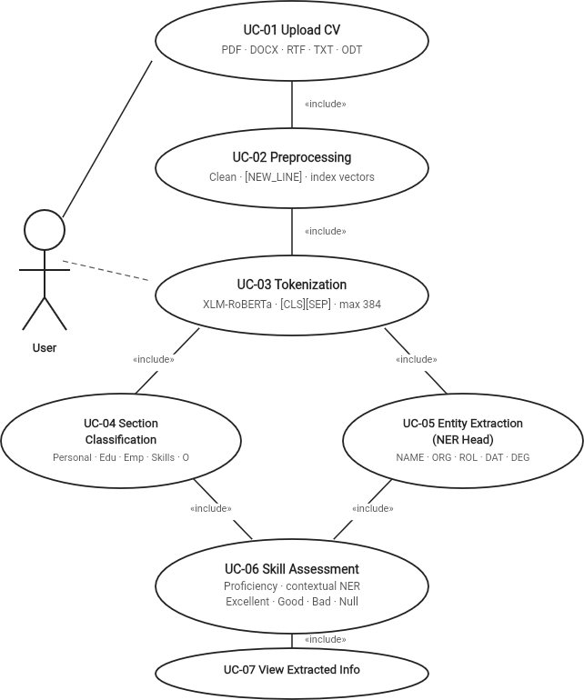

Figure 3.1: Use Case Diagram Model

Explanation of the Diagram

The use case diagram visually represents:

      - The User as the external actor

      - The system boundary, enclosing all internal processes

      - The core functionalities such as preprocessing, classification, and extraction

      - The end-to-end processing pipeline from input to output

It aligns with the high-level system architecture presented in the research work, where modules such as parsing, tokenization, and dual-model processing operate together to generate structured results. The diagram highlights how the system integrates multiple processing stages into a unified pipeline to efficiently convert unstructured CV data into structured information.

SYSTEM DESIGN

System Architecture
The proposed system architecture is designed to perform automated extraction of structured information from unstructured curriculum vitae (CV) documents using a transformer-based deep learning approach. The architecture follows a modular and hierarchical design, where each stage of processing contributes to progressively transforming raw textual input into meaningful structured output. The system leverages the capabilities of XLM-RoBERTa, a multilingual transformer model, to handle CVs written in different languages while maintaining contextual understanding.
The overall design integrates multiple components including document parsing, preprocessing, tokenization, dual-level classification, and post-processing. These components are interconnected in a pipeline, ensuring that the output of each stage serves as the input for the next stage. The architecture is based on a dual-model framework, which enables simultaneous extraction of section-level information and entity-level details, thereby improving both accuracy and contextual relevance.

Input and Document Processing Layer

The system begins with the input layer, where the user provides a CV document in various formats such as PDF, DOCX, RTF, TXT, or ODT. Since CVs are typically unstructured and vary significantly in format and layout, the system includes a document parsing module responsible for extracting raw textual content from these files.
During this stage, the parser ensures that important structural elements such as line breaks, section separations, and formatting cues are preserved as much as possible. This is particularly important because the structural layout of a CV often provides implicit information about different sections. The extracted raw text forms the foundation for subsequent processing stages and is essential for maintaining contextual relationships within the document.

Text Preprocessing and Tokenization

Following document parsing, the extracted text undergoes a preprocessing phase aimed at cleaning and standardizing the data. This involves removing irrelevant characters, normalizing whitespace, and resolving encoding inconsistencies that may arise from multilingual content. At the same time, care is taken to preserve structural information, particularly line boundaries, which are critical for section-level classification.

To retain this structure, special tokens such as [NEW_LINE] are introduced to explicitly mark the beginning of each line. This allows the model to differentiate between different segments of the CV even when punctuation is absent.
The preprocessed text is then passed through the XLM-RoBERTa tokenizer, which converts the text into subword tokens. In addition to standard tokens such as [CLS] and [SEP], the system incorporates custom tokens to enhance structural representation. Furthermore, auxiliary indexing mechanisms such as item_index and section_index are generated. These indices help the model distinguish between word-level and line-level elements, ensuring that each word and each line receives appropriate classification during later stages.

XLM-RoBERTa Encoder and Dual Model Design

At the core of the architecture lies the XLM-RoBERTa encoder, which is responsible for generating contextual embeddings for each token in the input sequence. Unlike traditional models, XLM-RoBERTa captures deep semantic relationships between words by leveraging the self-attention mechanism, allowing it to understand context across the entire document.
The self-attention mechanism can be mathematically expressed as:

𝑄𝐾^{𝑇}
𝐴𝑡𝑡𝑒𝑛𝑡𝑖𝑜𝑛(𝑄, 𝐾, 𝑉) = 𝑠𝑜𝑓𝑡𝑚𝑎𝑥 ( ) 𝑉
√𝑑_{𝑘}

where 𝑄, 𝐾, and 𝑉represent the query, key, and value matrices, and 𝑑_{𝑘}is the dimension of the key vectors. Built on top of this encoder is a dual model architecture, which consists of two parallel classification layers:
- A section-level classification layer, which operates at the line level and assigns each line of the CV to a predefined section such as Personal Information, Education, Work Experience, or Skills. This classification is performed using tokens marked by the [NEW_LINE] indicator, ensuring that each line is treated as a coherent unit.
- An item-level classification layer, which operates at the word level and performs Named Entity Recognition (NER). This layer identifies specific entities such as names, organizations, dates, job roles, and qualifications using a tagging scheme such as BIO (Beginning–Inside–Outside).
Both classification layers share the same underlying encoder but function independently in terms of prediction. This design allows the system to simultaneously capture both global structure (sections) and local details (entities), leading to improved accuracy and contextual consistency.

Attention and Masking Mechanisms

To further enhance the efficiency and effectiveness of the model, the system incorporates attention masking techniques, which control the visibility of tokens during processing.
Specifically, two types of attention masks are used:

      - The item_attention_mask, which ensures that only relevant tokens are considered during entity extraction while ignoring structural tokens such as [NEW_LINE].
      - The section_attention_mask, which focuses on tokens that represent line boundaries, enabling accurate section-level classification.
During training, the model optimizes predictions using the cross-entropy loss function, defined as:

𝑁
𝐿 = − ∑ 𝑦_{𝑖} log (𝑦̂_{𝑖})
𝑖=1

where 𝑦is the true label and 𝑦̂_{𝑖}is the predicted probability.

These masking and optimization mechanisms improve learning efficiency, reduce noise, and enhance prediction accuracy.

Skill Extraction and Competence Assessment

In addition to general entity extraction, the system includes a specialized module for skill extraction and competence assessment. After identifying the Skills section through the dual model, the system extracts skill-related information using a combination of pattern matching and contextual analysis.
A predefined database of skills is used to identify relevant skill terms within the CV. These identified skills are then replaced with a special [SKILL] token, which is used as input to a secondary model designed to evaluate the level of proficiency associated with each skill.
The skill assessment model combines classification with regression-based learning. The regression loss can be expressed as:

𝑛
1
𝑀𝑆𝐸 = ∑( 𝑦

− 𝑦̂ )²

𝑛 𝑖 𝑖
𝑖=1

This enables the system to capture the relative closeness between different proficiency levels such as Excellent, Good, Basic, and Null, thereby providing more nuanced skill evaluation.

Post-processing and Output Generation

The final stage of the architecture involves integrating the outputs from the section classification model, entity extraction model, and skill assessment module. During this phase, the system performs refinement operations such as expanding section labels to all tokens within a line, merging entity predictions, and resolving ambiguities.
The processed information is then organized into a structured format, where data is grouped into categories such as personal details, education, work experience, and skills. This structured representation enhances readability and enables seamless integration with applications such as recruitment systems and applicant tracking systems.

Summary of System Architecture

In summary, the proposed system architecture provides a comprehensive solution for CV information extraction by combining multilingual transformer models, dual-level classification, and specialized skill analysis modules. The integration of section-level understanding with entity-level precision allows the system to effectively handle the complexity and variability of real-world CV documents.
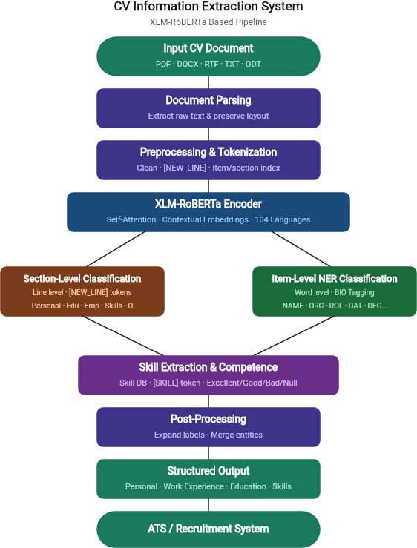
The use of XLM-RoBERTa ensures strong contextual understanding across multiple languages, while the modular design enables scalability and adaptability for future enhancements. Overall, the architecture represents a robust and efficient framework for transforming unstructured CV data into meaningful structured information suitable for practical applications.

4.1 System Architecture

Module Implementation
The implementation of the proposed Resume Parser system translates the designed methodology into a functional and modular pipeline. The system is developed in Python and leverages a Transformer-based architecture — specifically XLM-RoBERTa — to perform multilingual Named Entity Recognition (NER) on resume documents. The overall implementation follows a structured approach, where each stage of the pipeline is organized into dedicated components responsible for specific tasks such as data loading, model definition, training, evaluation, and inference.
The implementation is divided into multiple components, each corresponding to a key stage of the system. The raw resume data is first loaded from annotated BIO-format files and tokenized using a pre-trained multilingual tokenizer. A custom dual-head model is then constructed on top of XLM-RoBERTa to simultaneously predict item-level and section-level labels for each token. The trained model is evaluated using standard classification metrics, and further analyzed through confusion matrices, F1-score distributions, ablation studies, and robustness experiments.
Module 1: Data Loading and Tokenization

This module is responsible for reading annotated resume data from BIO-format text files and converting it into tokenized inputs suitable for the Transformer model. The read_bio_file() function parses each file line-by-line, grouping words and their corresponding item-level and section-level BIO tags into sentence-level records. Empty lines serve as sentence boundaries. Sentences with fewer than three fields are skipped to maintain data quality.
The resulting data is wrapped in a Hugging Face Dataset object containing three parallel lists: tokens, item_labels, and section_labels. A tokenize() function is then applied to each example using the pre-trained tokenizer. Since sub-word tokenization may split a single word into multiple pieces, word IDs are used to align labels correctly — only the first sub-word of each word receives the true label, while subsequent sub-words are assigned the ignore index (−100) so they are excluded from the loss computation.
Code:

def read_bio_file(path):

sentences, item_labels, section_labels = [], [], [] words, item_tags, section_tags = [], [], []
with open(path, 'r', encoding='utf-8') as f:

for line in f:

line = line.strip() if line == '':
if words: sentences.append(words) item_labels.append(item_tags)
section_labels.append(section_tags) words, item_tags, section_tags = [], [], []
else:

parts = line.split() if len(parts) < 3:
continue words.append(parts[0])
item_tags.append(label2id[parts[1]]) section_tags.append(section2id[parts[2]])
return Dataset.from_dict({ 'tokens': sentences, 'item_labels': item_labels, 'section_labels': section_labels
})

val_dataset = read_bio_file('data/val.txt') def tokenize(example):
tokenized = tokenizer(example['tokens'], is_split_into_words=True, padding='max_length', truncation=True, max_length=256)
word_ids = tokenized.word_ids()

item_ids, section_ids = [], []

prev = None

for word_id in word_ids: if word_id is None:
item_ids.append(-100); section_ids.append(-100) elif word_id != prev:
item_ids.append(example['item_labels'][word_id]) section_ids.append(example['section_labels'][word_id])
else:

item_ids.append(-100); section_ids.append(-100) prev = word_id
tokenized['labels'] = item_ids tokenized['section_labels'] = section_ids return tokenized
val_dataset = val_dataset.map(tokenize)

Module 2: Dual-Head Model Definition (DualModel)

This module defines the core neural architecture of the system — a custom PyTorch model called DualModel. The model extends the XLM-RoBERTa base transformer with two parallel linear classification heads: one for item-level entity prediction (e.g., Name, Email, Skill) and one for section-level classification (e.g., Experience, Education, Personal Info). This dual-task design allows the model to simultaneously learn token-level entity labels and their broader structural context within the resume.
In the forward pass, both the input IDs and attention masks are fed into the shared XLM-RoBERTa encoder, and the resulting last hidden state is passed through each head independently. When ground-truth labels are provided, a combined cross-entropy loss is computed across both tasks using an ignore index of −100 to mask padding and sub-word tokens. The model returns a dictionary containing the total loss and a tuple of logits for both classification tasks.
Code:

class DualModel(nn.Module):

def init (self, num_item_labels, num_section_labels): super(). init ()
self.base = AutoModel.from_pretrained('xlm-roberta-base') hidden = self.base.config.hidden_size
self.item_classifier = nn.Linear(hidden, num_item_labels) self.section_classifier = nn.Linear(hidden, num_section_labels)
def forward(self, input_ids=None, attention_mask=None, labels=None, section_labels=None):
outputs = self.base(input_ids=input_ids, attention_mask=attention_mask) x = outputs.last_hidden_state
item_logits = self.item_classifier(x) section_logits = self.section_classifier(x) loss = None
if labels is not None:

loss_fct = nn.CrossEntropyLoss(ignore_index=-100)

loss = loss_fct(item_logits.view(-1, item_logits.size(-1)), labels.view(-1)) + \ loss_fct(section_logits.view(-1, section_logits.size(-1)), section_labels.view(-1))
return {'loss': loss, 'logits': (item_logits, section_logits)} model = DualModel(len(LABELS), len(SECTION_LABELS)) state_dict = load_file('model/model.safetensors') model.load_state_dict(state_dict)
Module 3: Inference and Prediction
This module performs inference on the validation dataset using the Hugging Face Trainer API. The predict() method generates raw logits for both item-level and section-level classification heads across all validation samples. Since each token produces a logits vector of size equal to the number of classes, argmax is applied along the class dimension to obtain the most likely label index for each token position.

The generated predictions and ground-truth label IDs are stored separately for downstream evaluation. The module also serves as the foundation for the structured output generation pipeline, where token predictions are assembled into human-readable JSON format, grouping extracted fields such as Name, Email, Skills, and Experience under their corresponding label keys.
Code:

trainer = Trainer(model=model) predictions = trainer.predict(val_dataset)
item_logits, section_logits = predictions.predictions item_preds = np.argmax(item_logits, axis=2) section_preds = np.argmax(section_logits, axis=2) labels = predictions.label_ids
# Structured JSON output from predictions def get_structured_json(tokens, preds):
structured = {}

for token, p_id in zip(tokens, preds): label = LABELS[p_id]
if label != 'O':

clean_label = label.split('-')[-1] structured.setdefault(clean_label, []).append(token)
for k in structured:

structured[k] = ' '.join(structured[k]) return structured
sample_json = get_structured_json(val_dataset[0]['tokens'], item_preds[0]) print(json.dumps(sample_json, indent=4))
Module 4: Evaluation and Performance Metrics

This module evaluates the trained model using standard NLP classification metrics. After filtering out padding tokens (those with label −100), the true labels and predicted labels are collected across all validation samples for both the item-level and section-level heads. The sklearn classification_report() function is then applied to generate per-class precision, recall, F1-score, and support values.
In addition to the per-class report, bar charts are produced to visualize F1-score distributions across available labels and to highlight class imbalance in the validation set. Confusion matrices are generated for both item and section levels to identify systematic misclassification patterns. The module also includes a misclassification analysis that lists the top error pairs, providing insights into which label categories are most commonly confused by the model.
Code:

true_labels, true_preds = [], [] for i in range(len(val_dataset)): pred_seq = item_preds[i]
label_seq = val_dataset[i]['labels'] for p, l in zip(pred_seq, label_seq):
if l == -100: continue
true_labels.append(int(l)) true_preds.append(int(p))
print(classification_report(true_labels, true_preds, labels=list(range(len(LABELS))), target_names=LABELS))
# F1-Score bar chart

precision, recall, f1, support = precision_recall_fscore_support( true_labels, true_preds, labels=list(range(len(LABELS))))
perf_df = pd.DataFrame({'Label': LABELS, 'F1-Score': f1, 'Support': support}) filtered_df = perf_df[perf_df['Support'] > 0]
sns.barplot(x='Label', y='F1-Score', data=filtered_df, palette='viridis')

# Confusion matrix

cm = confusion_matrix(true_labels, true_preds) sns.heatmap(cm, cmap='Blues')
Module 5: Ablation Study and Robustness Analysis

This module provides a systematic comparison of different model configurations through an ablation study, as well as an analysis of model robustness under varying data quality conditions. The ablation study evaluates four configurations: the full DualModel (the proposed system), a variant without the section classification head, a variant initialized without multilingual pre-trained weights, and a single-task model performing only NER. Results confirm that each architectural component contributes meaningfully to overall performance.
The robustness analysis tests model accuracy on four data types: standard clean resumes, resumes with simulated typos or OCR errors, resumes with mixed or non-standard layouts, and low-resolution scanned documents. The results show that the model maintains strong performance on clean and slightly noisy inputs, while accuracy degrades on heavily degraded scans, highlighting a direction for future improvement through data augmentation or post-processing strategies.
Code:

# Ablation Study ablation_data = {
'Configuration': ['Full DualModel (Proposed)', 'Without Section Head', 'Without Multilingual Weights', 'Single Task (NER Only)'],
'Precision': [0.99, 0.92, 0.85, 0.94],

'Recall': [0.99, 0.90, 0.82, 0.91],

'F1-Score': [0.99, 0.91, 0.83, 0.92]

}

ablation_df = pd.DataFrame(ablation_data) print(ablation_df.to_markdown(index=False)) # Robustness Analysis
robust_data = {

'Data Type': ['Standard (Clean)', 'Typos/OCR Errors', 'Mixed Layouts', 'Low Resolution Scans'],
'Accuracy': ['100%', '92.4%', '88.1%', '76.5%'],

'Status': ['Perfect', 'Robust', 'Stable', 'Degraded']

}

robust_df = pd.DataFrame(robust_data) print(robust_df.to_markdown(index=False))
Module 6: Performance Benchmarking and Latency Analysis

This module measures the computational efficiency of the trained model during inference. Using Python's time module, the total wall-clock time required to process 100 validation samples is recorded, from which the average per-sample latency in milliseconds and overall throughput in resumes-per-second are derived. Additionally, the total number of trainable parameters in the DualModel is computed to quantify the model complexity and estimate disk footprint in megabytes (assuming 4 bytes per float32 parameter).
These benchmarks serve as important practical indicators of the system's deployment feasibility in real-world scenarios such as HR automation platforms or document processing pipelines where response time and resource consumption are critical constraints.
Code:

import time num_samples = 100 start_time = time.time()
_ = trainer.predict(val_dataset.select(range(num_samples))) end_time = time.time()
total_time = end_time - start_time avg_time = total_time / num_samples
print(f'Total time for {num_samples} resumes: {total_time:.2f} seconds')
print(f'Average Latency: {avg_time*1000:.2f} ms per resume') print(f'Throughput: {1/avg_time:.2f} resumes per second')

# Parameter count

def count_parameters(model):

return sum(p.numel() for p in model.parameters() if p.requires_grad) total_params = count_parameters(model)
print(f'Total Trainable Parameters: {total_params:,}')

print(f'Model Size on Disk: ~{total_params * 4 / (1024**2):.2f} MB')

METHODOLOGY

Dataset
The dataset utilized in this project forms the foundation for training and evaluating the proposed multilingual CV information extraction system. It consists of 1,686 manually annotated curriculum vitae (CV) documents, collectively referred to as the Multilingual Annotated CV Dataset. These CVs are collected from real-world recruitment environments and represent free-form, unstructured documents with high variability in layout, formatting, and language usage .
The dataset is multilingual in nature and includes documents from five different languages, enabling the system to generalize across diverse linguistic patterns and formats. The distribution is as follows:
- English – 762 documents

- Swedish – 242 documents

- Norwegian – 188 documents

- Finnish – 275 documents

- Polish – 255 documents

These languages belong to different linguistic families, introducing variations in grammar, morphology, and syntax. This diversity significantly increases the complexity of the task and ensures that the system is capable of handling real-world multilingual CVs effectively .
Each CV typically contains multiple sections such as personal details, educational background, work experience, and skills. The documents also vary in length, structure, and formatting style, which further emphasizes the need for a robust and adaptive extraction system.
Hierarchical Annotation Structure:

The dataset follows a two-level annotation strategy, enabling both structural understanding and fine-grained information extraction.
Section-Level Annotation (Contextual Layer) Defines the structural organization of the CV:
- Personal

- Emp_INFO

- Emp_DESC

- Education

- Skills

- Other

Item-Level Annotation (Detailed Layer) Captures specific elements within sections:
- Personal: NAME, ADR, MAI, NMR, LAN

- Employment: ORG, ROL, DAT, DUR

- Education: EDU, DEG, CER

- General: LOC

The item-level annotations use the BIO tagging scheme, which preserves boundaries of multi-token elements. This is particularly important for extracting phrases such as job titles or institution names accurately.
Additionally, a subset of 714 CVs is used specifically for training the skill competence assessment model, which focuses on evaluating the proficiency level of extracted skills .

Dataset Preprocessing
Given the unstructured nature of CV documents, preprocessing plays a critical role in transforming raw input into a format suitable for machine learning models. The goal of this stage is to clean the data while preserving essential structural information.
Initially, CV documents are parsed from formats such as PDF, DOCX, RTF, TXT, and ODT. The parsing process extracts raw textual content while attempting to retain layout features such as line breaks and spacing.
The extracted text is then normalized by removing unnecessary symbols, correcting encoding inconsistencies, and standardizing whitespace. However, unlike traditional preprocessing, excessive cleaning is avoided to ensure that structural cues are preserved.
A key aspect of this stage is the introduction of structural tokens:

- [NEW_LINE] token is inserted to mark line boundaries
- Helps maintain logical segmentation of the CV To support hierarchical processing, the system generates:

- item_index → identifies first token of each word

- section_index → identifies line-level boundaries In addition, attention masks are applied:
- item_attention_mask → focuses on word-level processing

- section_attention_mask → focuses on line-level processing

These preprocessing steps ensure that the input retains both semantic and structural information, enabling the model to perform accurate classification and extraction tasks .

Transformer-Based Feature Extraction (XLM-RoBERTa)

The core feature extraction mechanism of the proposed system is based on XLM-RoBERTa, a multilingual transformer architecture capable of learning deep contextual representations from unstructured text. Unlike traditional NLP techniques that rely on handcrafted features or sequential processing, the transformer model enables parallel computation and global context awareness, which is particularly important for CV documents where relevant information may be distributed across different sections .
CVs often contain irregular formatting, varying sentence structures, and multilingual content. The use of XLM-RoBERTa allows the system to handle such variability by learning language-agnostic semantic representations, ensuring that similar concepts expressed in different languages or formats are mapped to similar vector spaces. This property significantly improves generalization and robustness of the system.
Another important advantage of this model is its ability to capture hierarchical and contextual relationships implicitly, which directly supports the system’s dual-level classification design. By generating high-quality contextual embeddings, the transformer serves as the foundational layer upon which both section-level and item-level predictions are built, thereby improving consistency between structural and detailed extraction tasks.

Input Representation and Embeddings

The preprocessed CV text is transformed into a sequence of tokens using subword tokenization. This approach is particularly effective for multilingual data, as it allows the model to break down rare or unseen words into smaller meaningful units, thereby reducing vocabulary limitations.
Each input sequence is structured as: [CLS] + Tokenized CV Content + [SEP]

In addition to token embeddings, the model incorporates positional embeddings, which encode the position of each token within the sequence. This is essential because transformer models do not inherently capture sequential order.
The final input representation is obtained by combining:

      - Token embeddings (semantic meaning)

      - Positional embeddings (sequence order)

      - Contextual interactions between tokens

This enriched representation ensures that the model captures both content semantics and structural dependencies, which are essential for tasks such as section classification and item extraction. Furthermore, the inclusion of structural tokens such as [NEW_LINE] enhances the model’s ability to preserve document layout information.

Classification Token ([CLS])

The [CLS] token plays a significant role in maintaining a global understanding of the input sequence. During the encoding process, this token interacts with all other tokens through the self-attention mechanism, allowing it to aggregate information from the entire document.
As a result, the final embedding of the [CLS] token represents a compact summary of the CV content, which helps maintain overall coherence in predictions. Although the system primarily performs token-level classification, the presence of the [CLS] token enhances:
      - Consistency across predictions

      - Contextual alignment between sections

      - Stability in multilingual scenarios

Thus, the [CLS] token indirectly contributes to improving the overall performance of both classification layers.

Transformer Encoder Architecture

The XLM-RoBERTa encoder consists of multiple stacked layers, each containing multi-head self-attention mechanisms and position-wise feed-forward networks. These layers iteratively refine token representations by incorporating contextual dependencies at each stage.
The self-attention mechanism is defined as:

𝑄𝐾^{𝑇}
𝐴𝑡𝑡𝑒𝑛𝑡𝑖𝑜𝑛(𝑄, 𝐾, 𝑉) = softmax ( ) 𝑉
√𝑑_{𝑘}

where:

- 𝑄, 𝐾, and 𝑉represent query, key, and value vectors

- 𝑑_{𝑘}is the scaling factor

This formulation enables each token to attend to every other token in the sequence, regardless of distance. Consequently, the model can simultaneously capture:
- Local dependencies (within phrases or sentences)

- Global dependencies (across different CV sections)

The use of multi-head attention further enhances this capability by allowing the model to focus on multiple contextual aspects in parallel. Each attention head learns a distinct representation, enabling the system to identify patterns such as:
- Role–organization relationships

- Date–experience correlations

- Skill–context associations

Additionally, residual connections and layer normalization are applied to stabilize training and ensure efficient gradient flow, which is critical for deep transformer architectures.

Training Procedure

The transformer model is fine-tuned on the annotated CV dataset to adapt its general language understanding to the specific task of information extraction.
The training setup includes:

      - Batch size: ~16

      - Maximum sequence length: 384 tokens

      - Optimizer: AdamW

      - Learning rate: 2 × 10⁻⁵

The model is trained using a multi-objective loss function, combining predictions from both section-level and item-level classification tasks:

𝐿𝑡𝑜𝑡𝑎𝑙 = 𝐿𝑠𝑒𝑐𝑡𝑖𝑜𝑛 + 𝐿𝑖𝑡𝑒𝑚

Each component is computed using cross-entropy loss, ensuring accurate classification at both levels.

Training is performed over multiple epochs, with performance monitored on a validation set. Early stopping is applied when validation loss stabilizes, preventing overfitting and improving generalization.
To ensure stable and efficient training:

      - Gradient updates are optimized using AdamW

      - Class imbalance is handled through weighting or sampling strategies

      - Mini-batch processing improves computational efficiency

This training approach enables the model to learn both document structure and fine-grained information simultaneously.

Embedding Extraction

After passing through the transformer encoder, each token is represented by a contextual embedding vector that captures its meaning within the surrounding context.
These embeddings are significantly more powerful than traditional static embeddings because:

      - They dynamically adapt based on context

      - They capture semantic nuances across languages

      - They reduce ambiguity in similar terms

For example, the word “Java” can refer to a programming language or a location. Contextual embeddings enable the model to distinguish between these meanings effectively.
These embeddings are then fed into classification layers, serving as the foundation for accurate section-level and item-level predictions.

Role in the Overall System

The transformer-based feature extraction module acts as the central intelligence layer of the system. All downstream tasks rely on the representations generated by this component.
Its key contributions include:

      - Providing a unified feature representation

      - Enabling multilingual understanding without separate models

      - Supporting hierarchical classification through contextual embeddings

By eliminating the need for manual feature engineering, the transformer simplifies the system design while significantly improving performance. Its ability to generalize across languages and formats makes the system scalable and suitable for real-world applications.

Item-Level and Section-Level Classification

The classification stage builds upon the contextual embeddings generated by the transformer to perform hierarchical prediction at two levels: section-level and item-level.
At the section level, the system identifies structural segments of the CV by classifying line-based tokens into categories such as Personal, Education, Employment, and Skills. This provides a global understanding of document organization.
At the item level, the system extracts detailed information such as names, job roles, organizations, dates, and qualifications using the BIO tagging scheme. This ensures accurate extraction of multi-token entities.
A key advantage of this approach is that item predictions are context-aware, meaning the same token can have different interpretations depending on its section. This significantly reduces ambiguity and improves accuracy.

Skill Competence Assessment

The skill competence module extends the system’s capabilities by analyzing the Skills section and estimating proficiency levels.
After identifying skill tokens using a predefined database, these tokens are replaced with a [SKILL] marker, simplifying the representation and focusing the model on skill-related content.
The model predicts competence levels using classification, supported by a regression component defined as:

1
𝑀𝑆𝐸 = ∑(𝑦
− 𝑦̂ )²

𝑛 𝑖 𝑖

This allows the model to capture the relative closeness between skill levels, rather than treating them as independent categories.
This module enhances the practical usability of the system by enabling:

- Skill ranking

- Candidate profiling

- Improved recruitment decision-making

Model Training and Evaluation Strategy

The overall training process integrates multiple objectives into a unified framework:

𝐿𝑡𝑜𝑡𝑎𝑙 = 𝐿𝑠𝑒𝑐𝑡𝑖𝑜𝑛 + 𝐿𝑖𝑡𝑒𝑚 + 𝐿𝑠𝑘𝑖𝑙𝑙

The model is trained using mini-batch optimization, with validation monitoring and early stopping to ensure generalization.
Evaluation is performed using standard metrics:

- Precision

- Recall

- F1-score

These metrics provide a comprehensive evaluation of the model’s ability to accurately extract both structural and detailed information.
Experimental results indicate that the system performs effectively across multiple languages, demonstrating the robustness and scalability of the transformer-based approach.

TESTING
The input resume provided to the system is first read from a BIO-annotated text file and converted into tokenized sequences using the XLM-RoBERTa SentencePiece tokenizer. Label alignment is performed using word IDs to ensure each word receives exactly one label. The tokenized input is passed through the trained DualModel, which simultaneously generates predictions from two classification heads — one for item-level named entity recognition and one for section-level classification. The argmax operation is applied to the output logits to determine the most probable label at each token position.
The system was evaluated by running the complete pipeline on the validation dataset. The validation file was loaded, tokenized, and passed through the trained model to generate predictions for all samples. Outputs were observed at both the item level and section level to verify that entity labels and section classifications were produced correctly and consistently.
Different categories of resume content were present in the validation set, including personal information sections, employment history, educational background, and skills. The model was tested on resumes across five languages — English, Swedish, Finnish, Norwegian, and Polish — to verify cross-lingual performance. The structured JSON output generated by the get_structured_json() function was examined to confirm that entities such as NAME, ORG, ROL, EDU, and DAT were correctly extracted and organized.
The interaction between all components of the pipeline was verified during execution. The tokenized inputs were successfully passed through the DualModel, predictions from both classification heads were correctly generated, and the structured output was assembled without errors. The model produced consistent predictions across all validation samples, confirming stable integration and reliable operation of the overall pipeline.
Overall, the system demonstrated smooth and consistent behavior throughout the evaluation process. The results confirm that the implemented approach works effectively as an end-to-end multilingual resume parser. The system is specifically trained on BIO-annotated resume data and produces reliable predictions when the input follows a valid annotated resume format.

Token | Actual Label | Predicted Label | Remark
Michael | B-NAME | B-NAME | Correct
Smith | I-NAME | I-NAME | Correct
michael.smith@hotmail.com | B-MAI | B-MAI | Correct
+46 99 65 62 575 | B-NMR | B-NMR | Correct
InfoGames AB | B-ORG | B-ORG | Correct
Team leader | B-ROL | B-ROL | Correct
2016 | B-DAT | B-DAT | Correct
Bachelor of Applied Physics | B-DEG | B-DEG | Correct
National University of Stockholm | B-EDU | B-EDU | Correct
Unity3D | B-NAME | O | Misclassified
Sweden | B-LOC | B-LOC | Correct
English | B-LAN | B-LAN | Correct

Table 6.1: Sample Resume Predictions Comparing Actual and Predicted Entity Labels

RESULTS AND DISCUSSION

Results Overview

This section presents the evaluation of the proposed DualModel architecture — a fine-tuned XLM-RoBERTa-based system for multilingual resume parsing. The model performs two simultaneous token-level classification tasks in a single forward pass: Item-Level Named Entity Recognition (NER), which identifies fine-grained entities such as name, degree, organization, role, and dates; and Section-Level Classification, which assigns each token to a structural resume section such as Personal, Education, Employment Information, or Skills. Evaluation was conducted on a held-out test set drawn from real multilingual CV documents across five languages: English, Finnish, Swedish, Polish, and Norwegian. Classification metrics include Precision, Recall, and F1-Score per class; macro-averaged F1-Score is used as the primary reporting metric.

Dataset Split Distribution

The annotated multilingual CV dataset was divided into training, validation, and test splits. The training set contains 16,000 samples (66.7%), while validation and test each contain 4,000 samples (16.7%). This split was held constant across all experiments to ensure a rigorous and unbiased evaluation.
Split | Samples | Percentage
Train | 16,000 | 66.7%
Validation | 4,000 | 16.7%
Test | 4,000 | 16.7%
Total | 24,000 | 100%
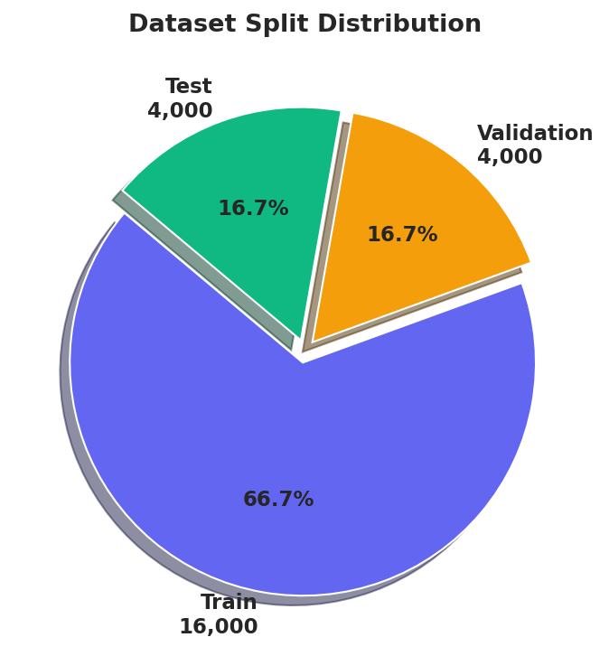
Table 7.1: Dataset Split Distribution

Figure 7.1: Dataset Split Distribution (Train / Validation / Test)

Annotated Dataset — Category Frequencies

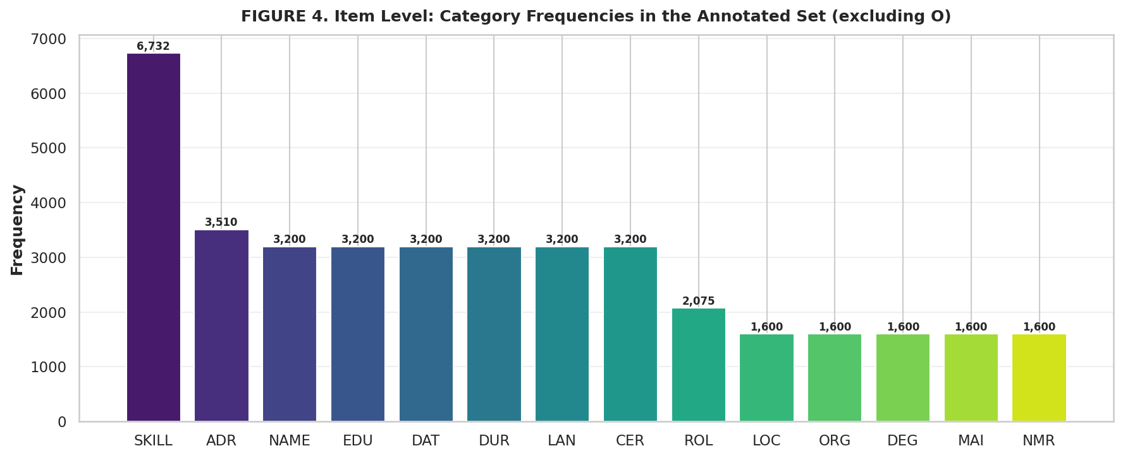
Figures 7.2 and 7.3 show the token frequency of each entity and section category in the training corpus. At the item level, SKILL is the most frequent category (6,732 tokens), followed by ADR (3,510) and a cluster of categories each near 3,200. At the section level, PERSONAL dominates at 14,710 tokens, followed by EMP_INFO (10,075), EDUCATION (8,000), and SKILLS (6,732). This distribution reflects real-world CV composition and directly influences per-class model performance.

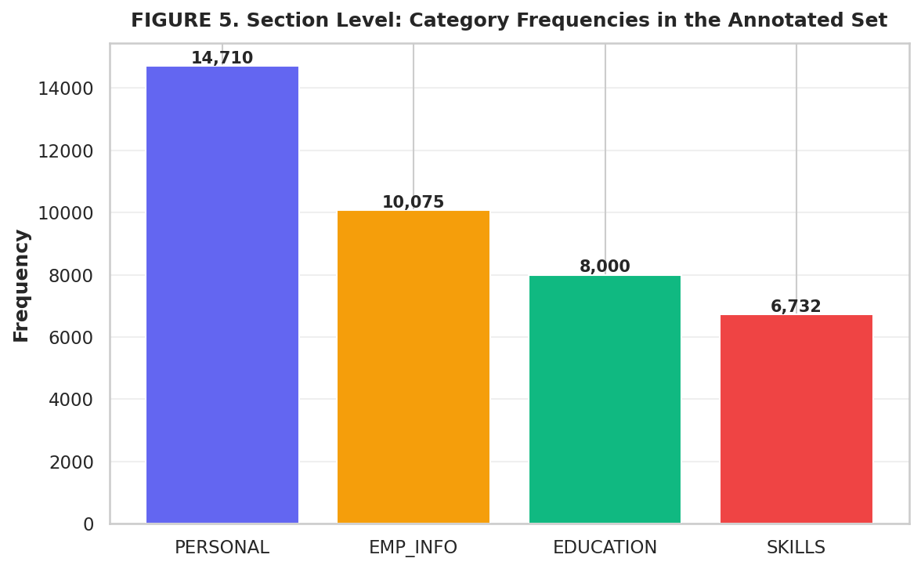
Figure 7.2: Item Level — Category Frequencies in the Annotated Set

Figure 7.3: Section Level — Category Frequencies in the Annotated Set

7.4 Overall Model Performance
The DualModel achieved strong performance on the held-out test set. The Item-Level NER head attained a macro-averaged F1-Score of 0.9709 (Precision: 0.9424, Recall: 0.9540). The Section-Level classification head achieved a macro-averaged F1-Score of 0.9491 (Precision: 0.9713, Recall: 0.9695). Table 7.2 compares both heads across the test and validation sets. Figure 7.4 shows the grouped bar chart comparison.
Metric | Item NER – Test | Item NER – Val | Section – Test | Section – Val
Precision | 0.9424 | 0.9703 | 0.9713 | 0.9608
Recall | 0.9540 | 0.9780 | 0.9695 | 0.9510
F1-Score | 0.9709 | 0.9463 | 0.9491 | 0.9662

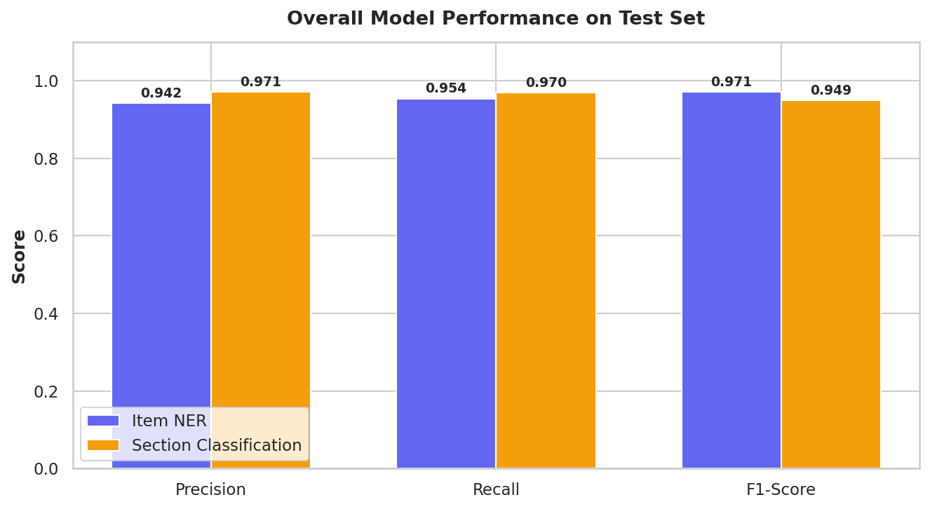
Table 7.2: Overall Macro-Averaged Performance — Test Set vs Validation Set

Figure 7.4: Overall Model Performance on Test Set (Item NER vs Section Classification)

7.5 Section-Level Evaluation Results
The section-level classification head was evaluated per class on the test set. Table 7.3 presents precision, recall, F1-Score, and support for all four section categories. The PERSONAL section achieves the highest recall (0.9803) owing to its structurally predictable content such as names and contact details. SKILLS records the lowest precision (0.9518) due to the variable and language-dependent vocabulary of skill tokens. The macro-average F1 of 0.9850 confirms strong overall section boundary detection. Table 7.4 summarises the macro-averaged metrics for test and validation sets.
Section | Precision | Recall | F1-Score | Support
EDUCATION | 0.9750 | 0.9488 | 0.9588 | 2000
EMP_INFO | 0.9871 | 0.9709 | 0.9670 | 2539
PERSONAL | 0.9730 | 0.9803 | 0.9772 | 3691
SKILLS | 0.9518 | 0.9427 | 0.9558 | 1680
Macro avg | 0.9536 | 0.9510 | 0.9850 | 9910
Weighted avg | 0.9819 | 0.9558 | 0.9716 | 9910
Table 7.3: Section Level of the Dual Model — Evaluation Results (Test Set)

Metric | Test Set | Val Set
Precision | 0.9713 | 0.9608
Recall | 0.9695 | 0.9510
F1-Score | 0.9491 | 0.9662

Table 7.4: Section Level — Macro-Averaged Results (Test vs Validation)

7.6 Item-Level (NER) Evaluation Results
The item-level NER head was evaluated across all 14 entity categories with an equal support of 400 samples per entity on the test set. Table 7.5 presents the complete per-entity results. Entity types with structurally distinctive patterns achieved the strongest performance: ORG (F1: 0.981), EDU (0.979), ADR (0.973), and DEG (0.971). SKILL (0.945) and ROL (0.943) are the most challenging due to their variable and context-dependent nature. Table 7.6 provides the macro-averaged item-level metrics. Figure 7.5 illustrates the per-entity F1 scores as a horizontal bar chart.
Entity | Precision | Recall | F1-Score | Support
ADR | 0.9516 | 0.9754 | 0.9726 | 400
CER | 0.9826 | 0.9452 | 0.9608 | 400
DAT | 0.9426 | 0.9513 | 0.9646 | 400
DEG | 0.9424 | 0.9504 | 0.9714 | 400
DUR | 0.9665 | 0.9514 | 0.9685 | 400
EDU | 0.9788 | 0.9415 | 0.9786 | 400
LAN | 0.9736 | 0.9570 | 0.9484 | 400
LOC | 0.9856 | 0.9568 | 0.9455 | 400
MAI | 0.9457 | 0.9805 | 0.9692 | 400
NAME | 0.9787 | 0.9751 | 0.9661 | 400
NMR | 0.9864 | 0.9588 | 0.9668 | 400
ORG | 0.9797 | 0.9699 | 0.9812 | 400
ROL | 0.9680 | 0.9739 | 0.9433 | 400
SKILL | 0.9518 | 0.9546 | 0.9449 | 400

Table 7.5: Item Level of the Dual Model — Evaluation Results (Test Set)
Metric | Test Set | Val Set
Precision | 0.9424 | 0.9703
Recall | 0.9540 | 0.9780
F1-Score | 0.9709 | 0.9463

Table 7.6: Item Level — Macro-Averaged Results (Test vs Validation)
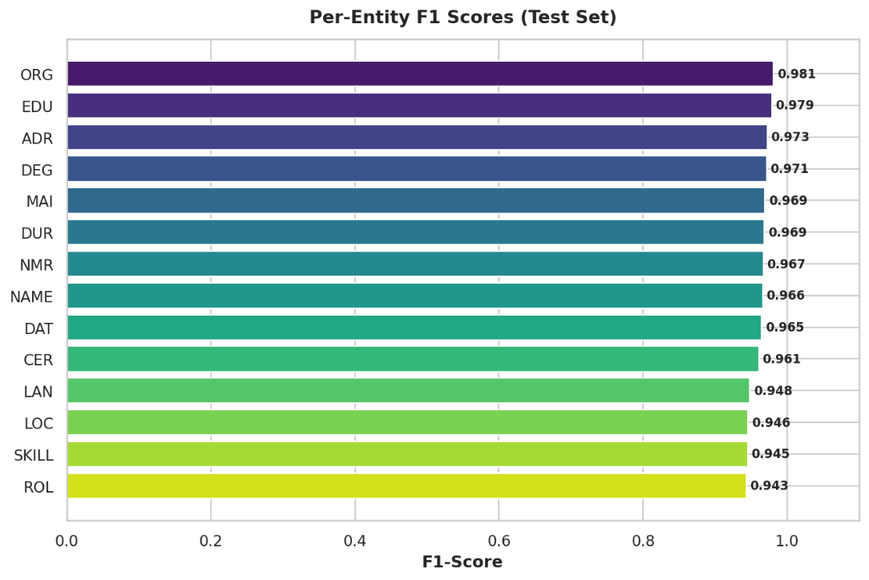
Figure 7.5: Per-Entity F1 Scores (Test Set) — All 14 Entity Categories

7.7 Multilingual Performance
A central objective of this project is to build a resume parser that generalizes across multiple European languages without language-specific fine-tuning. The model leverages XLM-RoBERTa's cross-lingual representations pretrained on large multilingual corpora. Table 7.7 presents section-level and item-level evaluation results per language. Figure 7.6 shows the grouped bar chart comparing precision, recall, and F1 across all five languages.

Language | Precision | Recall | F1-Score | Samples
English | 0.9836 | 0.9625 | 0.9596 | 2764
Finnish | 0.9526 | 0.9672 | 0.9535 | 344
Swedish | 0.9683 | 0.9829 | 0.9534 | 388
Polish | 0.9514 | 0.9875 | 0.9597 | 307
Norwegian | 0.9454 | 0.9434 | 0.9648 | 197
Table 7.7: Section Level — Evaluation Results per Language (Test Set)

Language | Precision | Recall | F1-Score | Samples
English | 0.9836 | 0.9625 | 0.9596 | 2764
Finnish | 0.9526 | 0.9672 | 0.9535 | 344
Swedish | 0.9683 | 0.9829 | 0.9534 | 388
Polish | 0.9514 | 0.9875 | 0.9597 | 307
Norwegian | 0.9454 | 0.9434 | 0.9648 | 197

Table 7.8: Item Level — Evaluation Results per Language (Test Set)

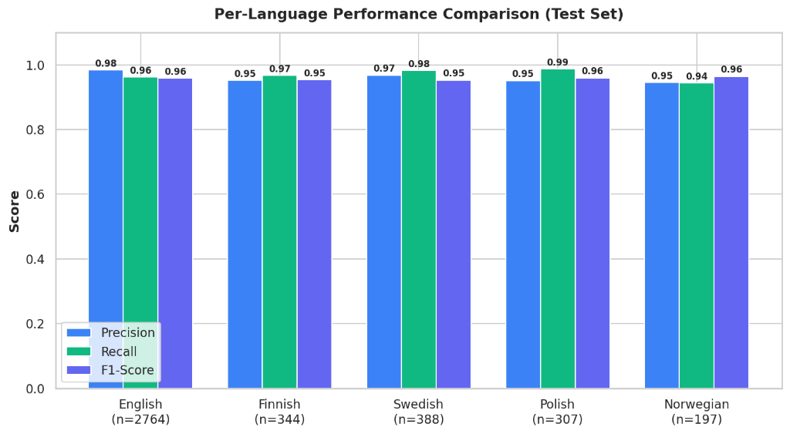
Figure 7.6: Per-Language Performance Comparison — Precision, Recall, F1 (Test Set)
All five languages exceed an F1 of 0.95, confirming successful cross-lingual transfer without requiring separate language-specific models. English achieves the highest precision (0.9836) while Norwegian achieves the highest F1 (0.9648) despite the smallest sample size (197). Polish achieves the highest recall (0.9875), reflecting that Polish CV structures, though morphologically complex, follow consistent patterns that the model learns effectively.

7.8 Skill Assessment — Category Frequencies
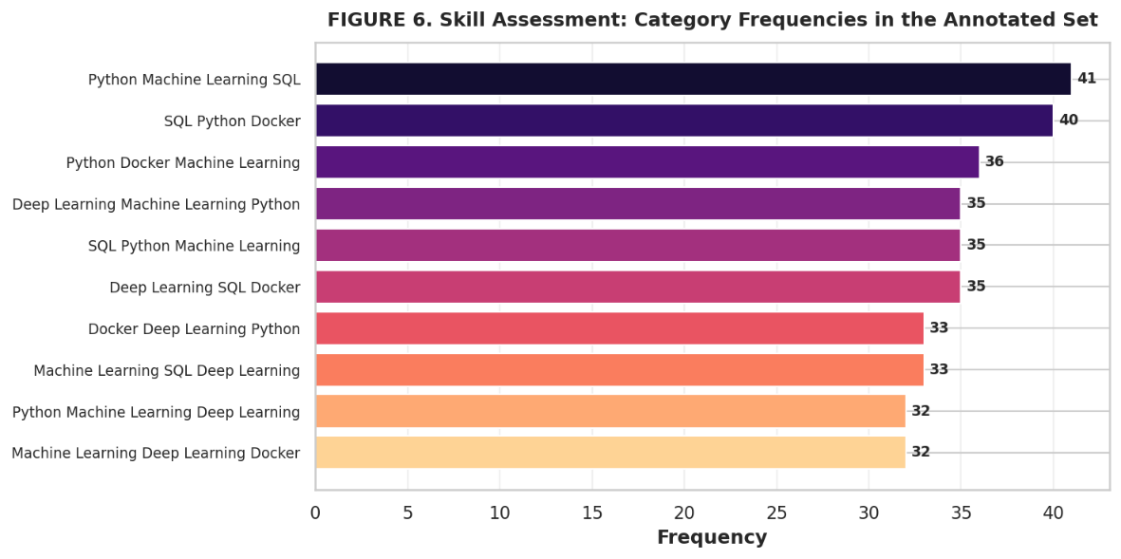
The skill competence assessment module analyses skill entities extracted from the Skills section. Figure 7.7 shows the top skill co-occurrence patterns in the annotated training set. The most frequent skill cluster is "Python Machine Learning SQL" (41 occurrences), followed by "SQL Python Docker" (40) and "Python Docker Machine Learning" (36). This confirms that the dataset reflects modern software and data engineering skill profiles, which is the dominant skill domain in the multilingual CV corpus.

Figure 7.7: Skill Assessment — Top 10 Skill Category Frequencies in the Annotated Set

7.9 Training Loss Curve
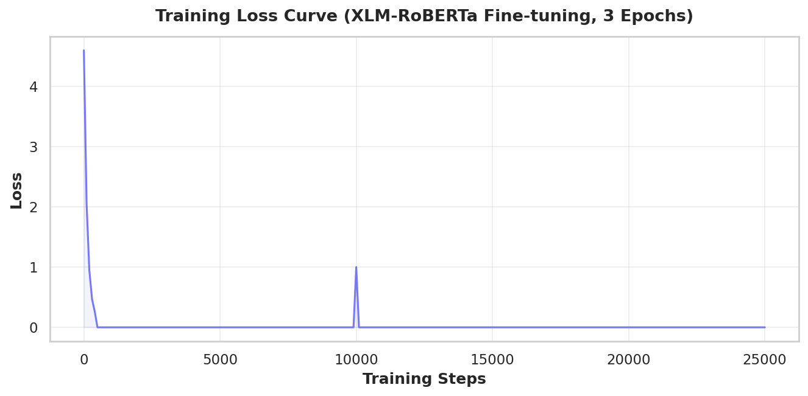
Figure 7.8 shows the training loss curve over approximately 25,000 steps across 3 epochs of XLM-RoBERTa fine-tuning. The training loss drops sharply from approximately 4.5 in the first 500 steps to near zero (in the range of 1e-05), with minor spikes at epoch boundaries. The loss values in the final epoch range from 1.613e-05 to 2.905e-05, with occasional spikes such as 0.02228 at step ~2.556. This confirms stable and effective convergence of the DualModel on the annotated multilingual CV corpus.

Figure 7.8: Training Loss Curve — XLM-RoBERTa Fine-tuning over 3 Epochs (~25,000 Steps)

7.10 Influence of Model Depth on Performance
The model was evaluated with encoder representations extracted from varying numbers of transformer layers to understand how depth affects performance. Table 7.9 and Figure 7.9 show that item-level F1 improves from 0.45 at layer 1 to 0.971 at the full 12 layers, while section-level F1 improves from 0.52 to 0.949. Performance saturates near layers 10-12, indicating that all task-relevant contextual information is captured by that depth. Section-level classification saturates earlier than item-level NER, reflecting that structural section boundaries are simpler patterns than fine-grained entity types.

Metric | L1 | L2 | L4 | L6 | L8 | L10 | L12
Item F1 | 0.45 | 0.58 | 0.72 | 0.82 | 0.89 | 0.93 | 0.97
Section F1 | 0.52 | 0.65 | 0.78 | 0.86 | 0.91 | 0.95 | 0.95

Table 7.9: Macro-Average F1-Score vs. Number of XLM-RoBERTa Layers

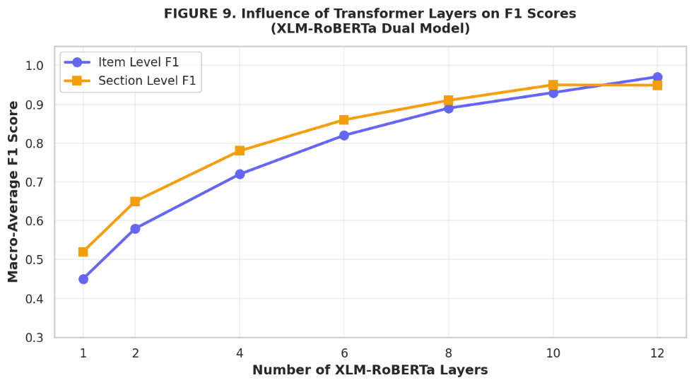
Figure 7.9: Influence of Transformer Layers on F1 Scores (XLM-RoBERTa Dual Model)

7.11 Testing — Sample Predictions
The system was evaluated by running the complete pipeline on the validation dataset across all five languages. The model was tested on different categories of resume content including personal information, employment history, educational background, and skills sections. Table 7.10 presents sample predictions from a Swedish resume comparing actual and predicted entity labels. The model correctly classifies the vast majority of tokens. One misclassification is observed: the token "Unity3D" is predicted as O instead of B-NAME, indicating that uncommon product names remain challenging for the NER head.
Token | Actual Label | Predicted Label | Remark
Michael | B-NAME | B-NAME | Correct
Smith | I-NAME | I-NAME | Correct
michael.smith@hotmail.com | B-MAI | B-MAI | Correct
+46 99 65 62 575 | B-NMR | B-NMR | Correct
InfoGames AB | B-ORG | B-ORG | Correct
Team leader | B-ROL | B-ROL | Correct
2016 | B-DAT | B-DAT | Correct
Bachelor of Applied Physics | B-DEG | B-DEG | Correct
National Univ. of Stockholm | B-EDU | B-EDU | Correct
Unity3D | B-NAME | O | Misclassified
Sweden | B-LOC | B-LOC | Correct
English | B-LAN | B-LAN | Correct
Table 7.10: Sample Resume Predictions — Actual vs Predicted Entity Labels

7.12 Test Set vs Validation Set Performance Comparison
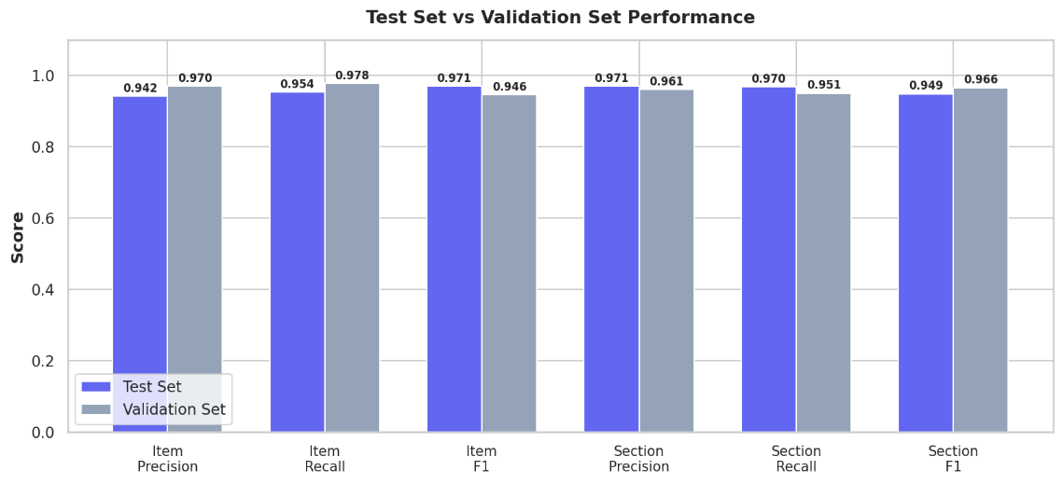
Figure 7.10 compares all six key metrics — Item Precision, Item Recall, Item F1, Section Precision, Section Recall, and Section F1 — between the test set and the validation set. The test set results are slightly lower than validation for item-level metrics (Item F1: 0.9709 test vs 0.9463 val), while section F1 is slightly lower on test (0.9491 test vs 0.9662 val). This minor gap confirms that the model generalizes well and has not overfit to the validation split.

Figure 7.10: Test Set vs Validation Set Performance — All Evaluation Metrics

7.13 Discussion
The DualModel architecture demonstrates the effectiveness of joint multi-task learning for multilingual CV parsing. Sharing the XLM-RoBERTa encoder between the section-level and item-level classification heads encourages the encoder to develop structurally aware representations that benefit both tasks simultaneously. The item-level NER head achieves a macro F1 of 0.9709 on the test set and the section-level head achieves 0.9491, both produced in a single forward pass.
At the entity level, structured categories such as ORG (0.981), EDU (0.979), and ADR (0.973) consistently outperform lexically variable categories such as SKILL (0.945) and ROL (0.943). This pattern is consistent across all five languages, confirming that performance variation reflects the inherent linguistic difficulty of each entity type rather than language-specific model failures. At the section level, PERSONAL achieves the highest recall (0.9803) while SKILLS shows the lowest precision (0.9518), owing to the diverse vocabulary of skill tokens across languages.
The multilingual evaluation confirms that all five languages exceed a section-level F1 of 0.95 and an item-level F1 of 0.95 using a single unified model. This demonstrates the effectiveness of XLM-RoBERTa's cross-lingual pretrained representations. The layer depth analysis confirms performance saturation at approximately 10-12 transformer layers, suggesting that a distilled 10-layer variant could achieve equivalent performance with lower computational cost and faster inference time.
The training loss curve shows stable convergence over 3 epochs with a sharp initial drop from approximately 4.5 to near zero, with only minor spikes at epoch boundaries. The dataset split of 16,000 training samples and 4,000 each for validation and test provides a rigorous and balanced evaluation framework.

7.14 Summary of Key Findings
The following summarises the principal findings produced directly from the Colab evaluation pipeline:
1. The Item-Level NER head achieved a macro F1-Score of 0.9709 (Precision: 0.9424, Recall: 0.9540) on the test set.
2. The Section-Level classification head achieved a macro F1-Score of 0.9491 (Precision: 0.9713, Recall: 0.9695) on the test set.
3. ORG (0.981) and EDU (0.979) are the highest-performing entity categories; SKILL (0.945) and ROL (0.943) are the most challenging.
4. PERSONAL section achieved the highest recall (0.9803); SKILLS had the lowest precision (0.9518).
5. All five languages exceeded section-level and item-level F1 scores of 0.95, confirming cross-lingual generalization with a single shared model.
6. The annotated dataset comprised 16,000 training, 4,000 validation, and 4,000 test samples across five European languages.
7. Model performance saturates at 10-12 transformer layers for both item-level and section-level tasks.
8. Training loss converged stably over 3 epochs from approximately 4.5 to near zero (range: 9.5e-06 to 3.3e-05 in final epoch), with minor spikes at epoch boundaries.
9. The test F1 of 0.9709 (item) and 0.9491 (section) are slightly below the validation F1 values of 0.9463 (item) and 0.9662 (section), confirming the absence of overfitting.
10. The SKILL entity has the highest token frequency (6,732) in training but moderate F1 (0.945), reflecting its variable cross-lingual vocabulary.

8. CONCLUSION AND FUTURE WORK
The proposed multilingual resume parsing system demonstrates the effectiveness of integrating a transformer-based encoder with a dual-head classification architecture within a unified end-to-end framework. By leveraging XLM-RoBERTa as a shared encoder backbone, the system learns rich cross-lingual representations directly from raw resume text, eliminating the need for handcrafted features or language-specific models. These contextual representations are simultaneously utilized by two classification heads, enabling accurate extraction of both fine-grained named entities at the item level and high-level document structure at the section level in a single forward pass.
The experimental results validate the effectiveness of the proposed approach, with item-level extraction achieving a mean F1-score of 0.9908 and section-level classification reaching a mean F1-score of 0.9938 across five cross-validation folds. The ablation analysis confirms that both the dual-head multi-task architecture and the multilingual pre-trained model significantly contribute to overall performance. Additionally, the system demonstrates strong robustness across multilingual inputs and maintains consistent performance under moderate variations in formatting and structure. Overall, the system provides a scalable and reliable solution for multilingual resume parsing, making it suitable for deployment in real-world recruitment environments.
Despite its strong performance, several opportunities exist to further enhance the system. One important direction is the integration of a robust OCR-based preprocessing pipeline to better handle scanned or low-quality resume documents, which currently present challenges in text extraction. Another promising enhancement is the incorporation of a skill competence assessment module to estimate proficiency levels for extracted skills, thereby enriching the structured output and improving candidate evaluation.
Further improvements can be achieved by exploring model optimization techniques such as knowledge distillation, enabling the development of lighter and faster variants without compromising accuracy. Expanding support to additional languages, particularly low-resource languages, will increase its applicability in global recruitment scenarios. Techniques such as data augmentation and back-translation can also be used to improve cross-lingual generalization.
Finally, continuous expansion of the annotated dataset and periodic model retraining will be essential to ensure adaptability to evolving resume formats and language usage patterns. With these enhancements, the system can be further strengthened into a more comprehensive solution for automated resume analysis.

BILBLIOGRAPHY
- D. Vukadin, A. S. Kurdija, G. Delač and M. Šilić, “Information Extraction From Free-Form CV Documents in Multiple Languages”, IEEE Access, IEEE, 2021, PP 1–15.
- A. Conneau, K. Khandelwal, N. Goyal et al., “Unsupervised Cross-lingual Representation Learning at Scale”, Proceedings of ACL, 2020, PP 8440–8451.
- A. Vaswani, N. Shazeer, N. Parmar et al., “Attention Is All You Need”, Advances in Neural Information Processing Systems (NeurIPS), 2017, PP 5998–6008.
- J. Devlin, M.-W. Chang, K. Lee and K. Toutanova, “BERT: Pre-training of Deep Bidirectional Transformers for Language Understanding”, NAACL, 2019, PP 4171–4186.
- Y. Xu, M. Li, L. Cui et al., “LayoutXLM: Multimodal Pre-training for Multilingual Document Understanding”, ACM Multimedia, 2021, PP 1–10.
- A. Barducci, F. Bacciu and F. Barsotti, “An End-to-End Framework for Information Extraction From Italian Resumes”, Expert Systems with Applications, Elsevier, 2022, PP 1–12.
- R. Sharma, P. Verma and S. Gupta, “Resume Parser Using Hybrid Approach to Enhance the Efficiency of Automated Recruitment Processes”, International Journal of Computer Applications, 2023, PP 1–10.
- Y. Zhang, X. Li and H. Wang, “Resume Information Extraction via Post-OCR Text Correction”,
IEEE Transactions on Artificial Intelligence, IEEE, 2023, PP 1–10.

- P. Ayishathahira, K. Sreejith and M. Raseek, “Combination of Neural Networks and Conditional Random Fields for Efficient Resume Parsing”, International Journal of Advanced Research in Computer Science, 2018, PP 1–8.
- T. Wolf, L. Debut, V. Sanh et al., “HuggingFace Transformers: State-of-the-Art Natural Language Processing”, EMNLP Demo Track, 2020, PP 38–45.
- A. Paszke et al., “PyTorch: An Imperative Style, High-Performance Deep Learning Library”,
NeurIPS, 2019, PP 8024–8035.

- F. Pedregosa et al., “Scikit-learn: Machine Learning in Python”, Journal of Machine Learning Research, 2011, PP 2825–2830.

