1) Configure Docker to connect to remote docker container

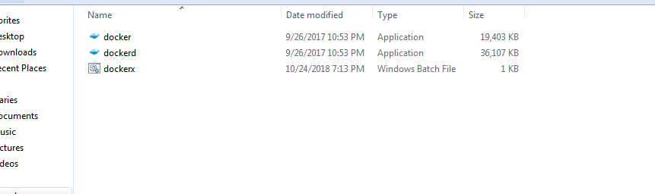

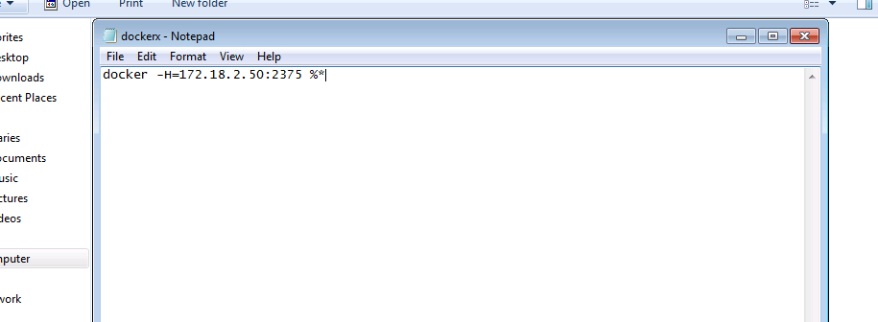

2) Navigate to the folder in command prompt and run the below command to list the available images

dockerx images 397538-project-manager

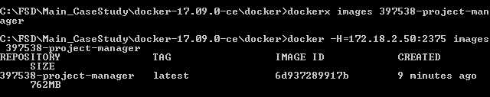

Check if the image is created after the jenkins CI build

397538-project-manager is the image created .

3) Run the created image using the below command

dockerx run -p 8088:8088 397538-project-manager:latest

4) To check whether the image is running in docker[open new cmd prompt and run the cmd]

dockerx ps

