1) Run Jenkins using below command - **java -jar jenkins.war --httpPort=8383**

2) Open the url **http://localhost:8383/**

3) Login with credentials

4) Configure Maven and JDK

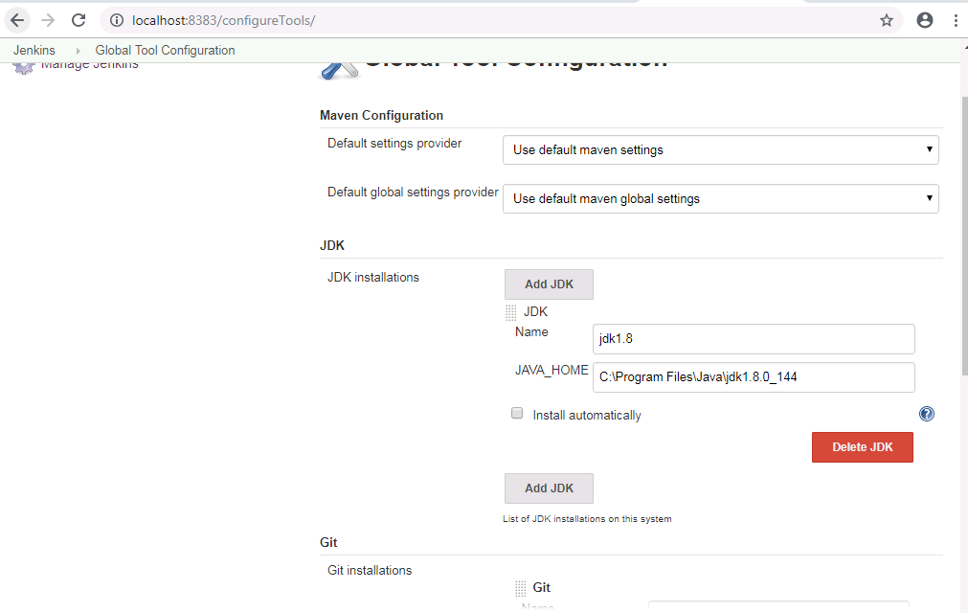

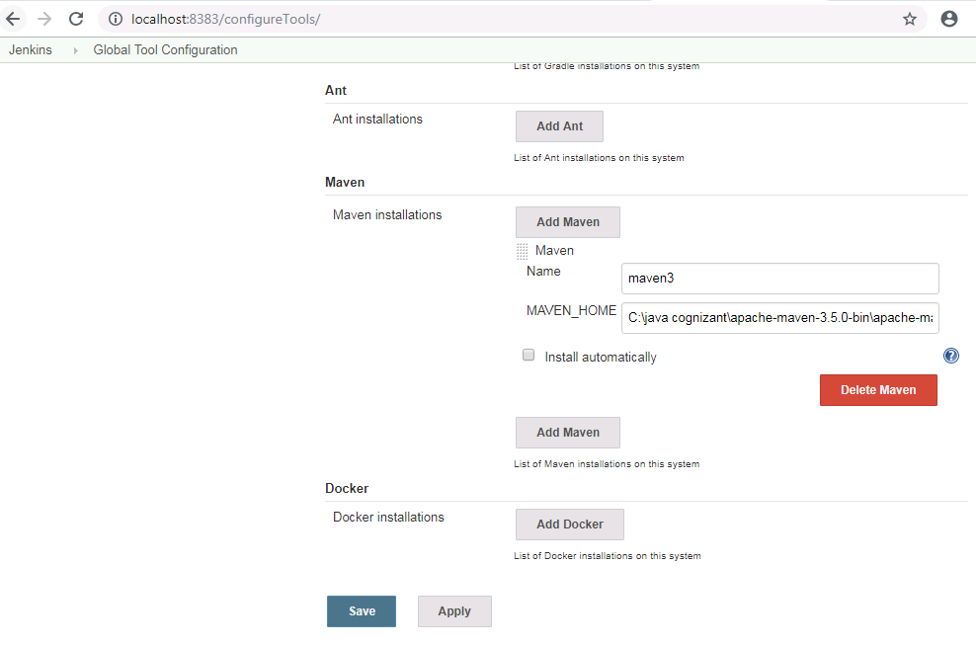

5) Create a new Pipeline project and configure git repository

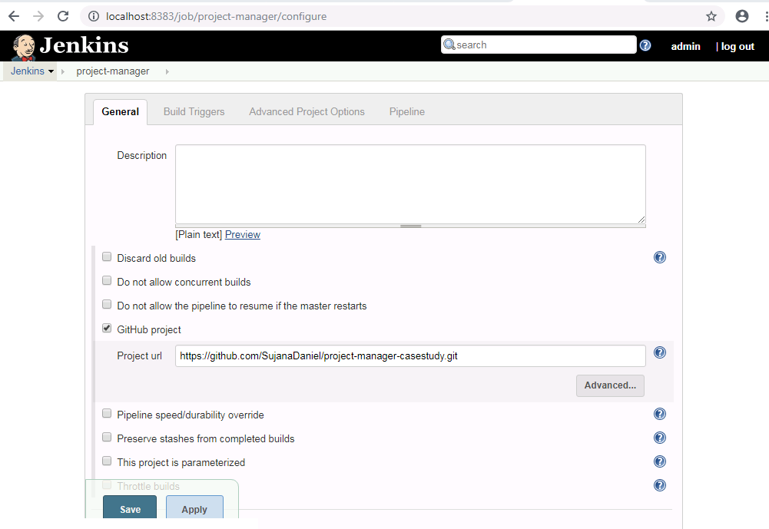

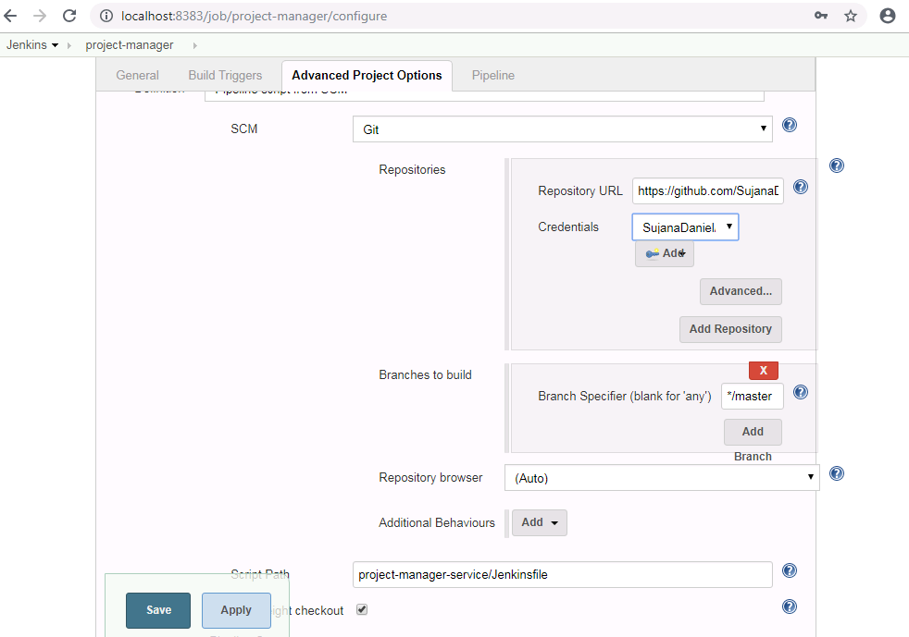

6) Click on Build Now option