Step 1: Login with IAM USER

Note : Make sure you have provided S3 full access to the sure

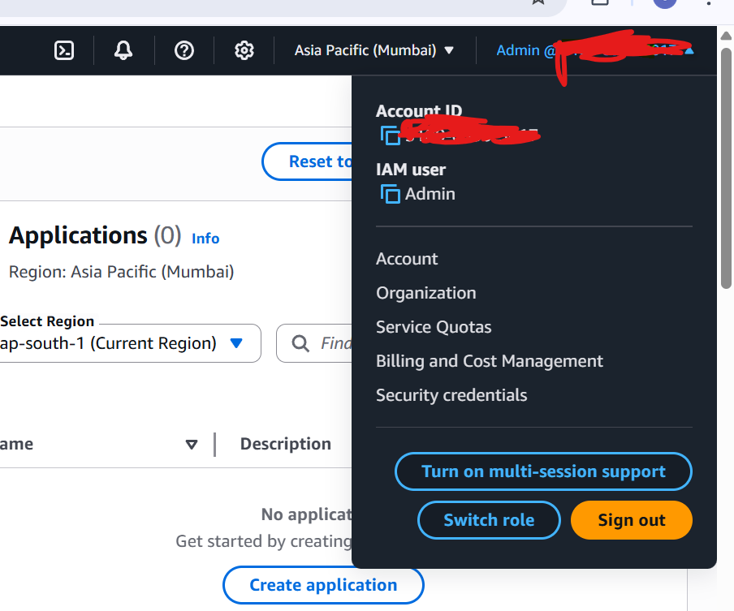

Step 2: Go to Security Credentials

Step 3:

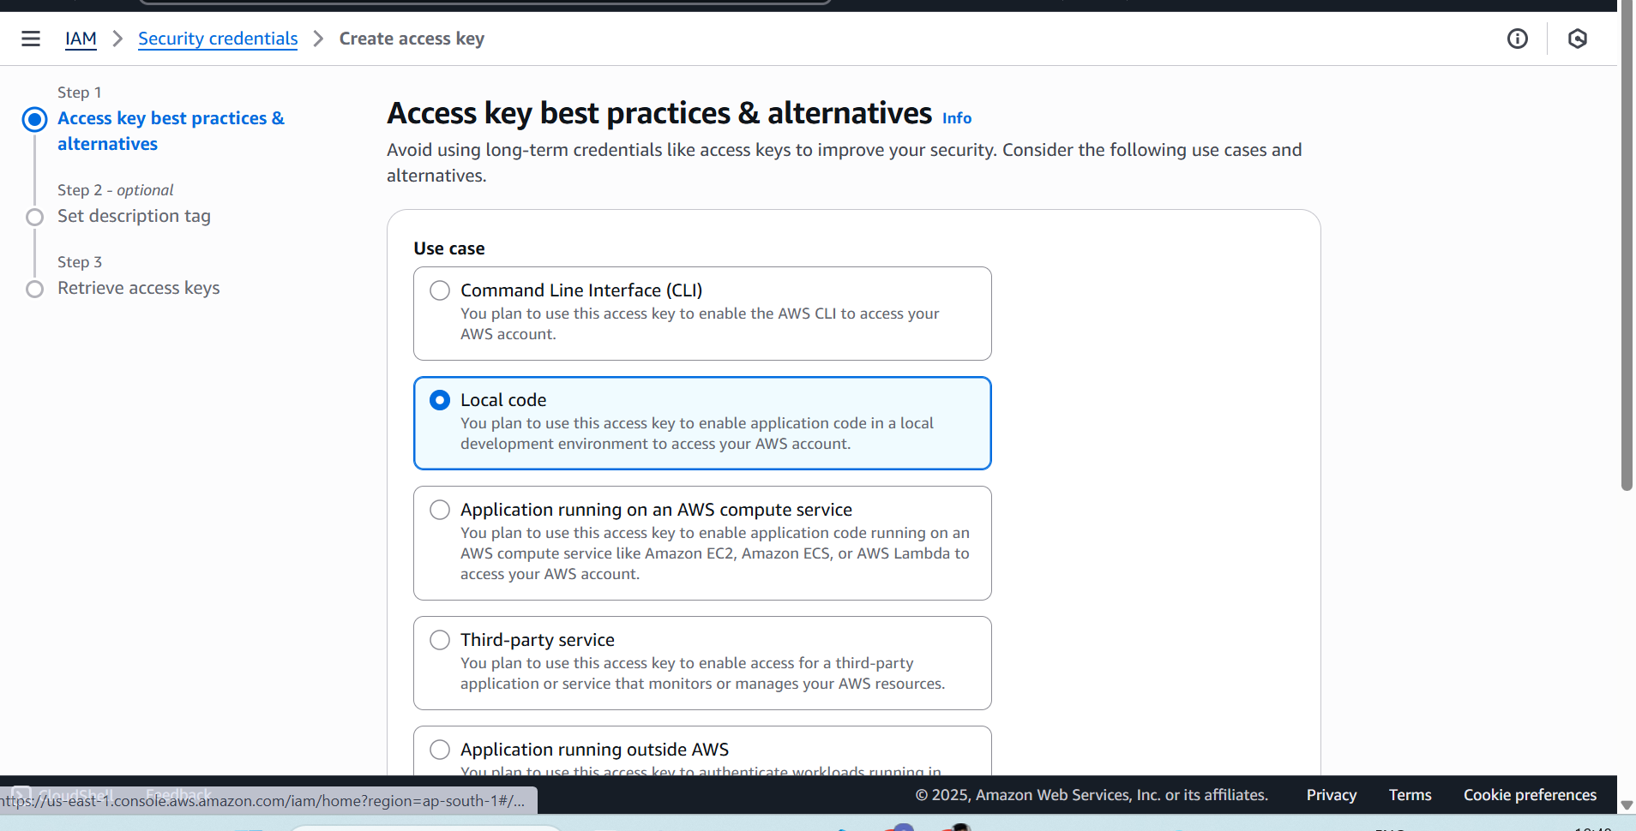

Step 4: After clicking on create access key ,access key and secret access key will be generated.

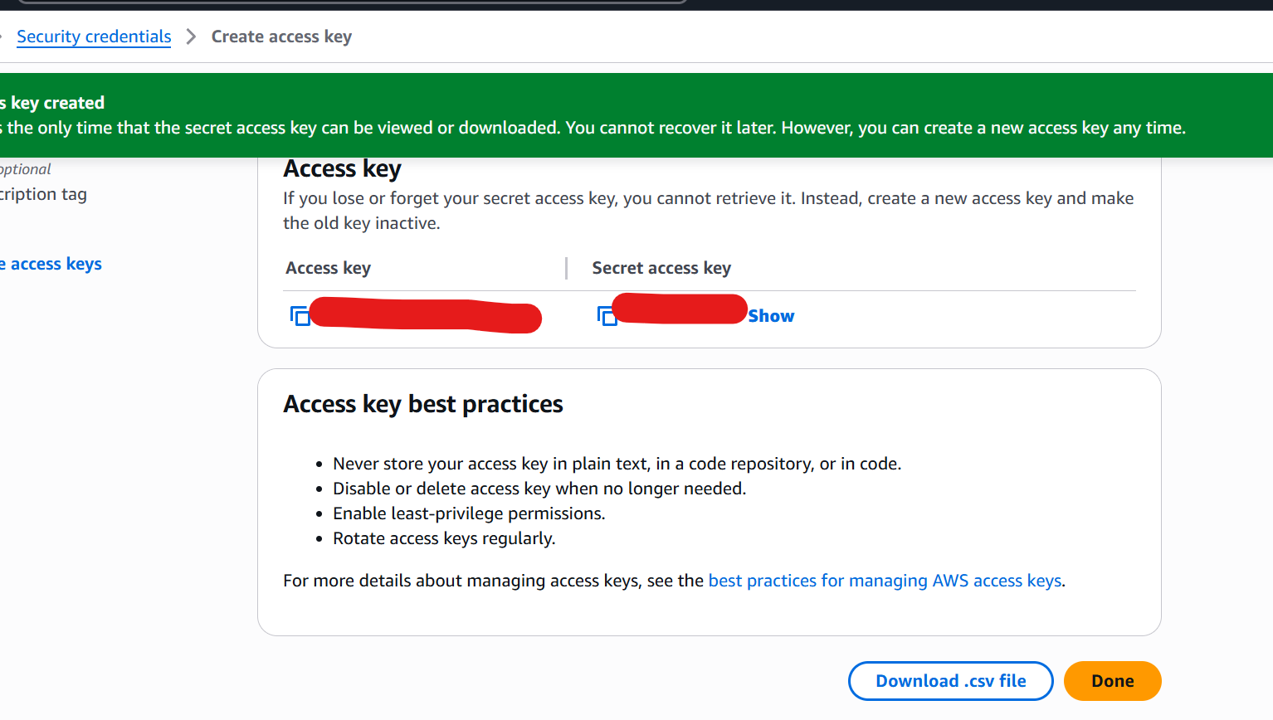

Step 1: terraform init

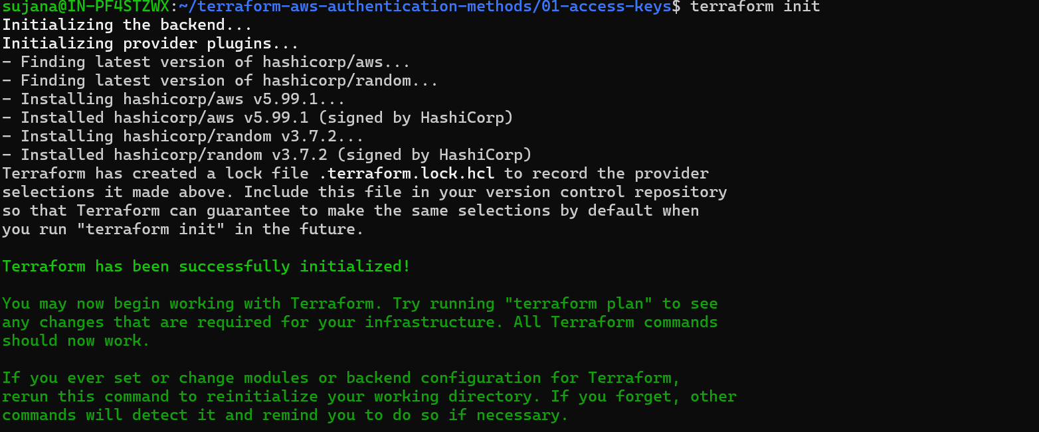

Step 2: terraform plan

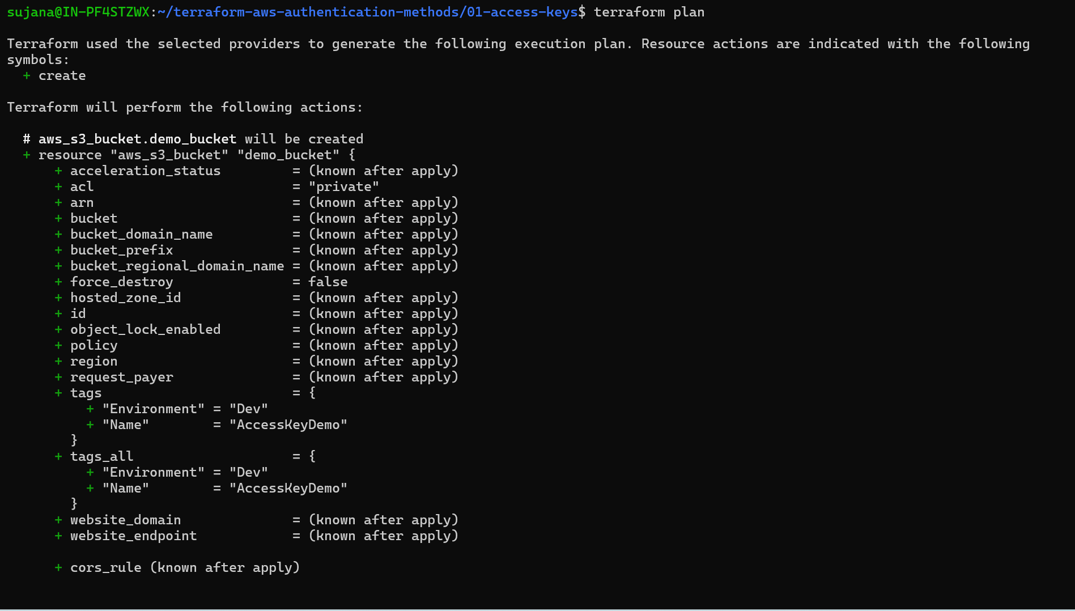

Step 3: terraform apply

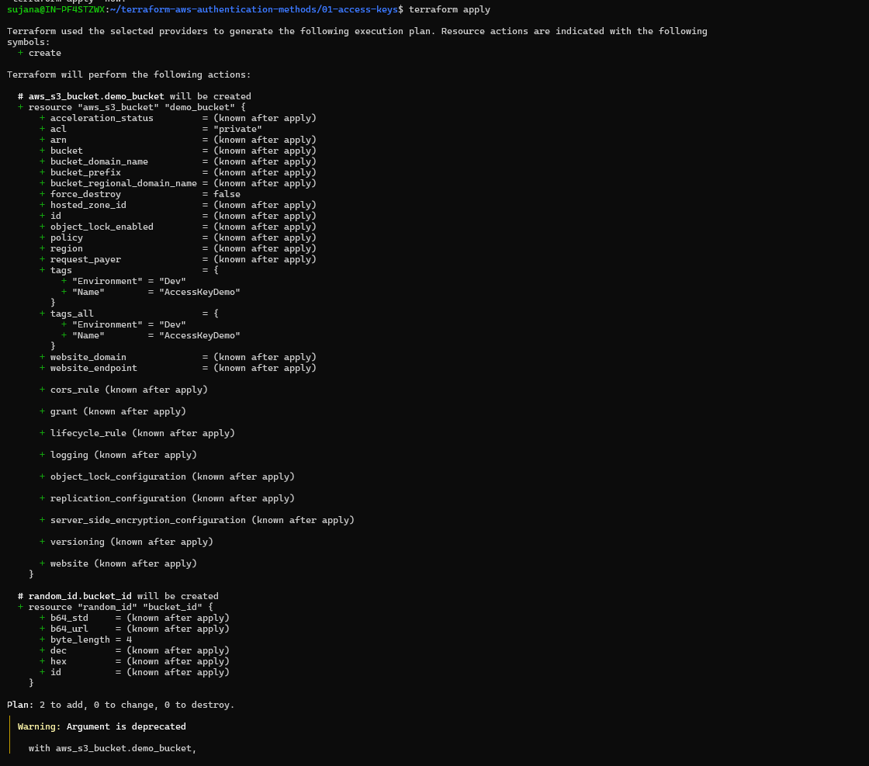

Output: S3 bucket created with terraform

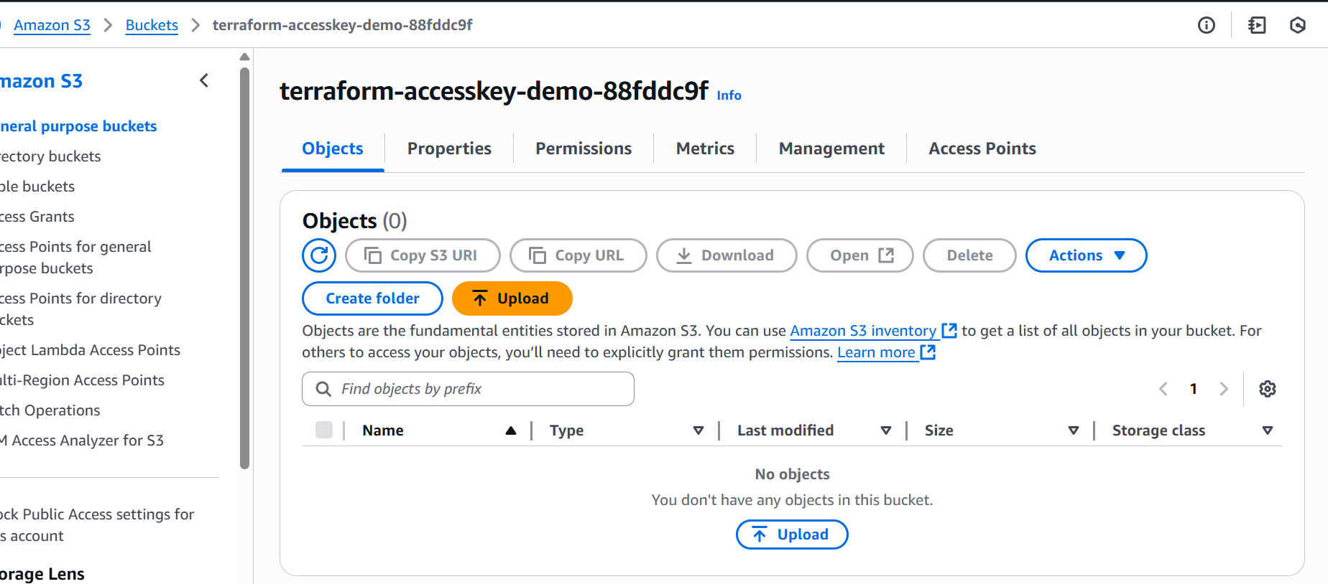



Clean up :

Once the demo is completed destroy the bucket from console

