Step 1: aws configure --profile terraform-user

Step 2:

Give your:

* AWS Access Key
* AWS Secret Key
* Region (e.g., ap-south-1)
* Output format (e.g., json)

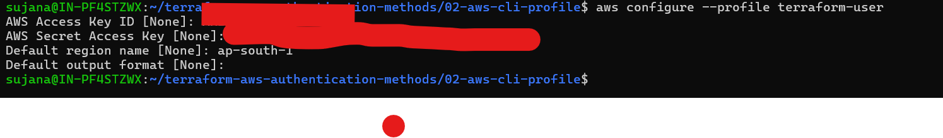

cat ~/.aws/credentials ( access keys are placed here)

Run Terraform

terraform init

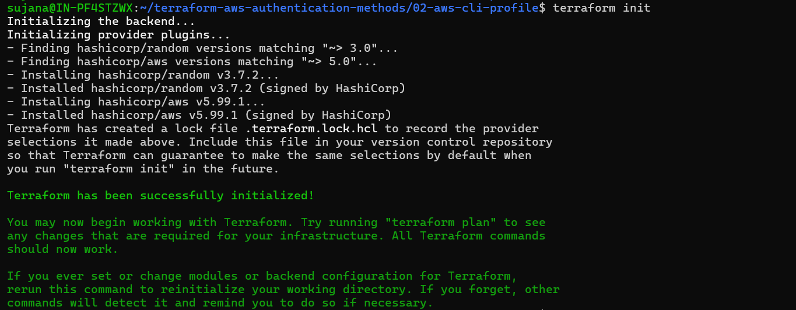

Terraform plan

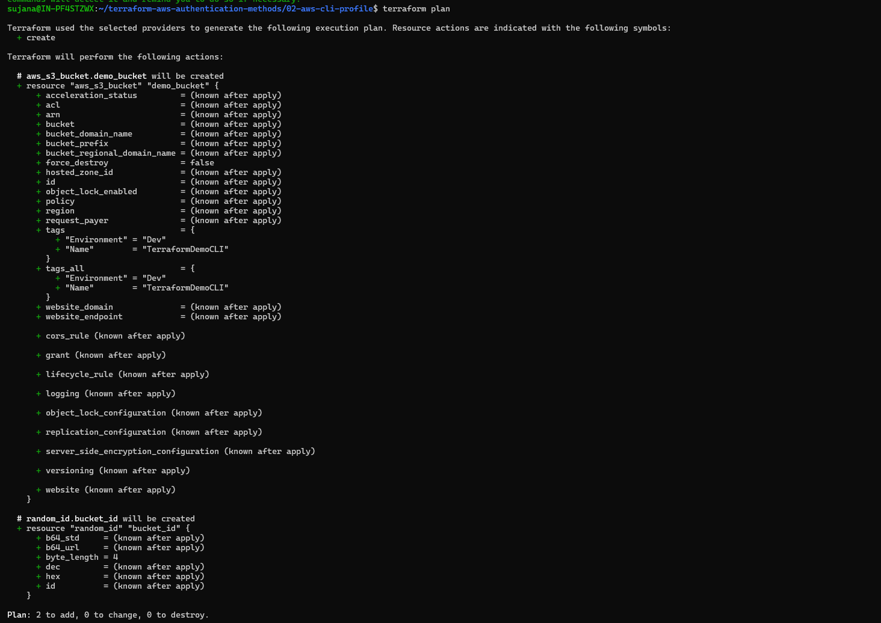

Terraform apply

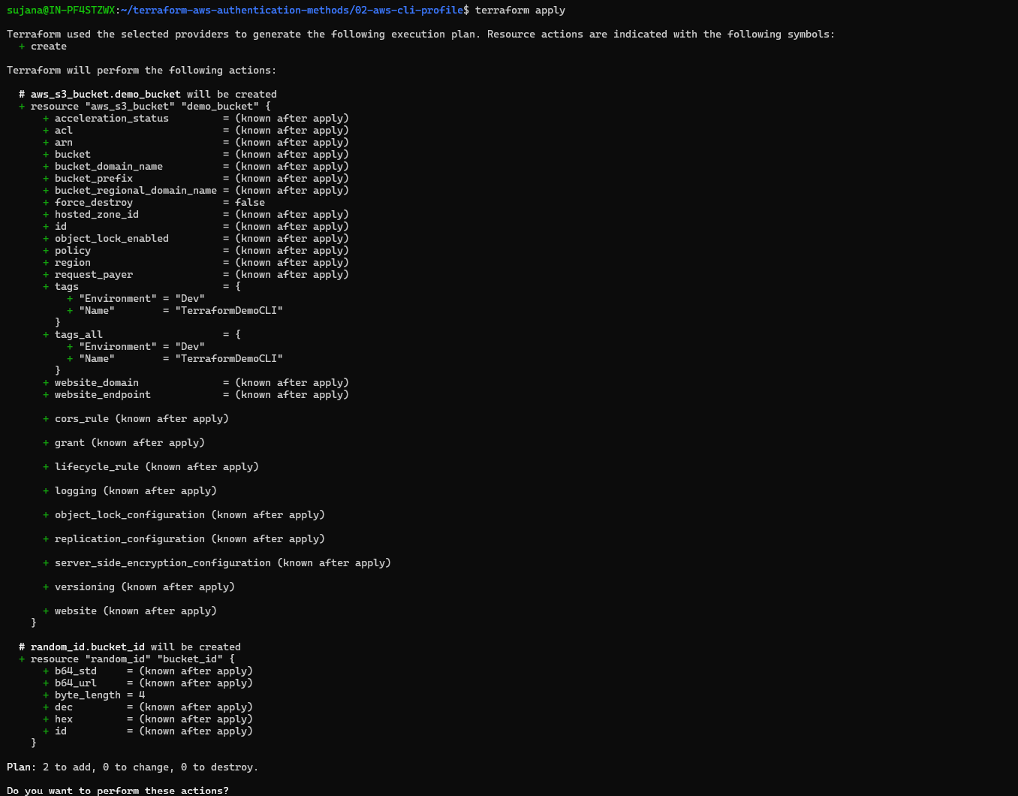

Output:

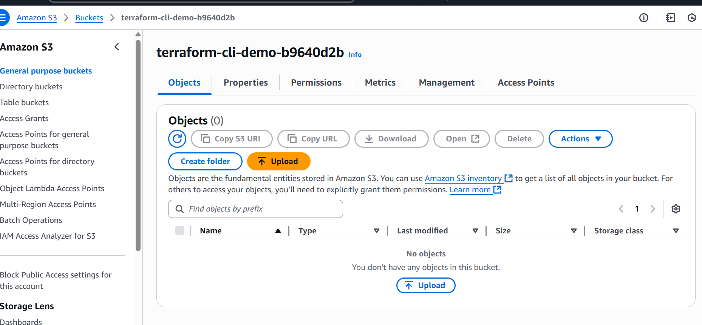

Clean up

Terraform destroy

