Step 1:

Create main.tf file with provider details

Step 2:

Export the access key and secret access key

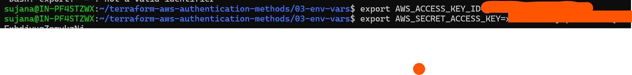

Terraform

Terraform init

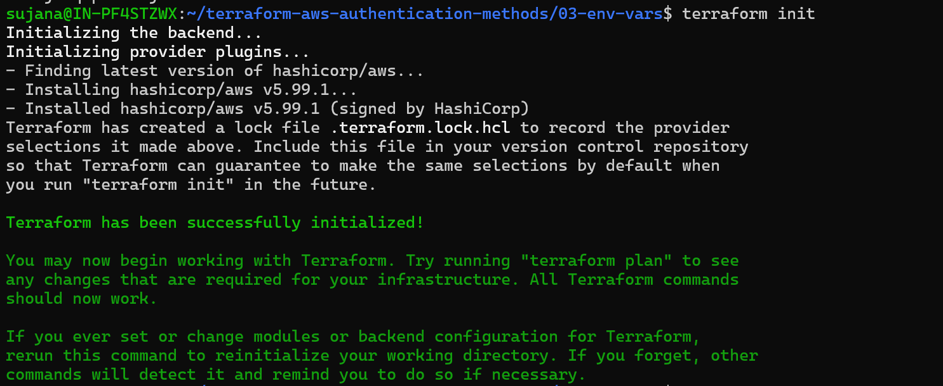

Terraform plan

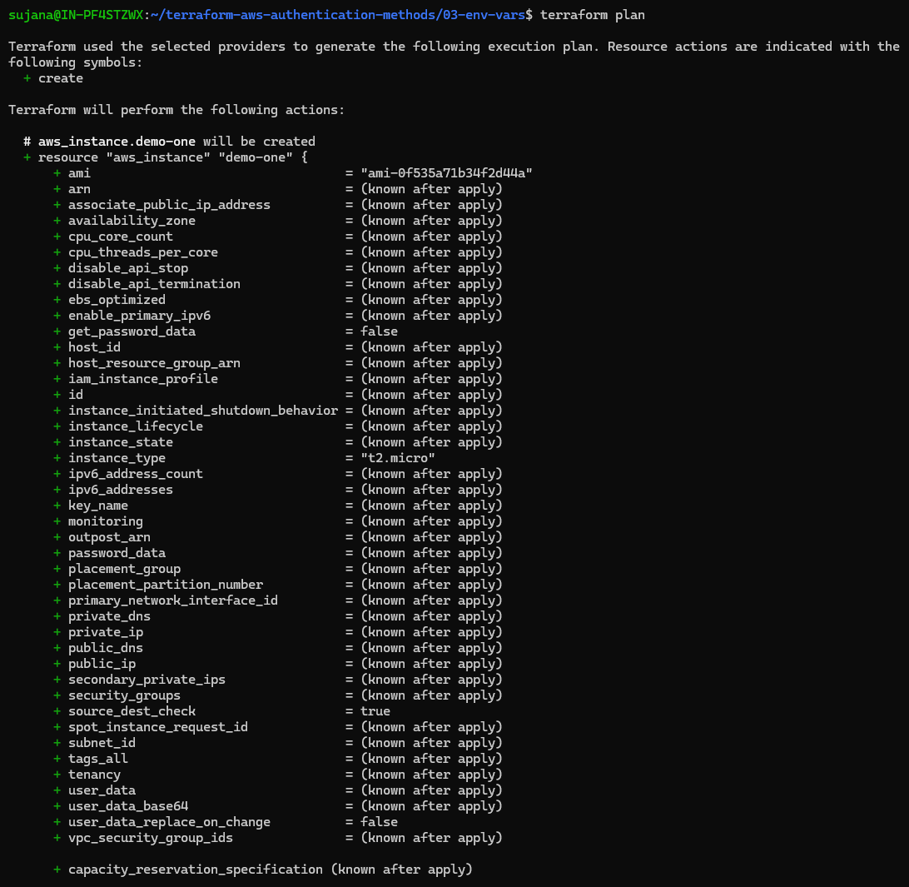

Terraform apply

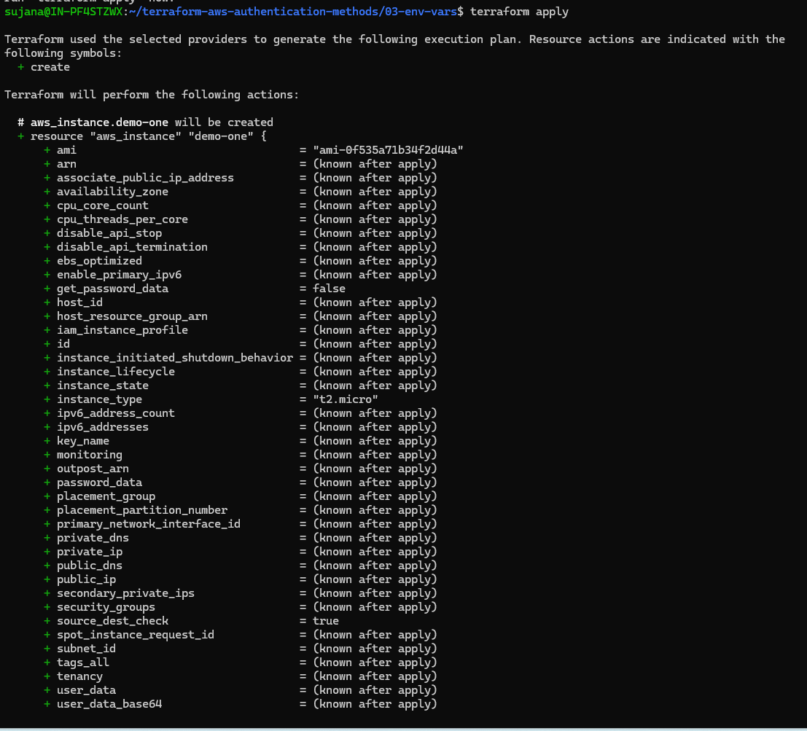

Output

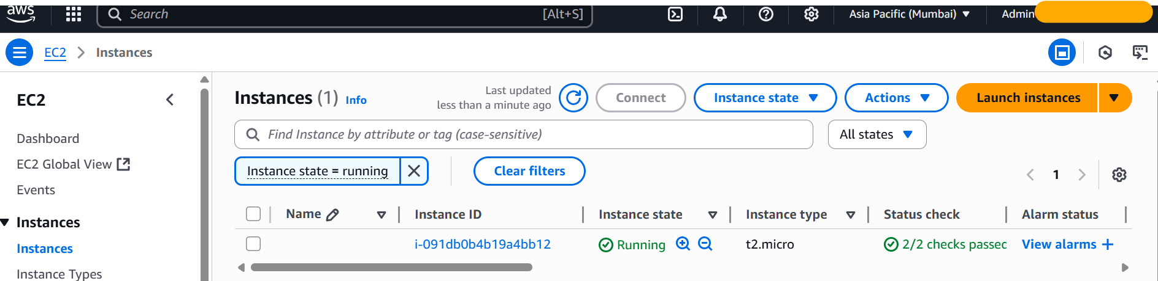

Clean up

Terraform destroy

