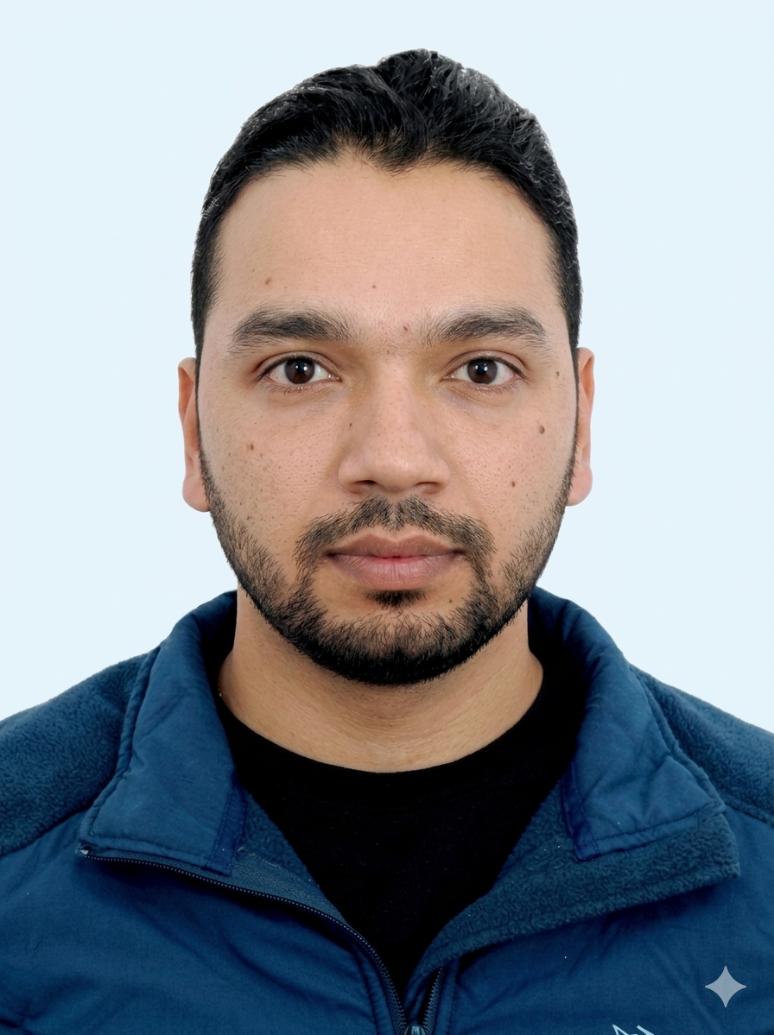 | SUJAN PARAJULI  IT Support&Network Professional  Kathmandu, Nepal | +977-9843641509 | msuzzan119@gmail.com  linkedin.com/in/sujanparajuli7 | sujanparajuli7.com.np

PROFESSIONAL SUMMARY
Dedicated IT Support & Network Professional with over 2 years of hands-on experience managing LAN/WAN infrastructure and configuring network devices. Proven expertise in router and switch configuration, hardware troubleshooting, and system maintenance. Focused on maintaining reliable network uptime and delivering efficient IT solutions in international work environments.
TECHNICAL SKILLS

Networking | LAN/WAN, IP Addressing, Subnetting, VPN Configuration
Hardware | Router & Switch Configuration, Hardware Maintenance, System Upgrades
Support | IT Helpdesk Support, Network Troubleshooting, Software Installation
Systems | Network Administration, Infrastructure Maintenance, User Access Management
PROFESSIONAL EXPERIENCE
IT Support & Network Assistant
- ectivity issues for office staff.
- Provide timely IT support and technical assistance, improving overall system reliability.
Network Administrator
iCash Nepal, Kathmandu May 2024 – Nov 2025
- Managed LAN/WAN infrastructure, overseeing network setup and IP addressing protocols.
- Monitored network performance and troubleshot system outages to ensure continuous operational stability.
- Provided comprehensive end-user IT support, resolving technical tickets related to network performance.
- Implemented regular system maintenance routines to prevent hardware failure and security risks.
EDUCATION
Bachelor of Computer Application (BCA)
Annamalai University 2018 – 2021
CERTIFICATIONS
Network & VPN Engineer
NETWORK WORLD Inc. April 2026
315 hours of intensive training in advanced networking and VPN architecture.

HOBBIES&INTERESTS
- Network Virtualization: Passionate about learning new IT infrastructures through hands-on practice in home lab network virtualization.
- Hiking: Regular trekker; leverages focus and problem-solving mindset from hiking for demanding network administration tasks.
PERSONAL DETAILS
Date of Birth: September 01, 1995 | Passport: PA4202341
Languages: Nepali | English | Hindi

