

User Interface Design
23CSE113

UID PROJECT

Submitted by
Name | P. Sujan Kumar Reddy
Roll no | AV.SC.U4CSE25227
Year/sem/section | 1st year / 1st sem / cse-c
Credits | 03

Submitted to | DR. Raj Kumar Batchu
DESIGNATION | ASST.PROFFESSOR
DEPARTMENT | SCHOOL OF COMPUTING

ABSTRACT :
StayFinder Pro is a web-based hotel discovery platform inspired by Airbnb. The project is designed to provide users with a simple and intuitive interface for exploring accommodations across different locations.
The application allows users to browse hotel listings, view property information, check pricing details, explore images, and locate accommodations using integrated maps. The primary objective of the project is to demonstrate the principles of User Interface Design by creating an attractive, responsive, and user-friendly web application.
The project was developed using HTML, CSS, and JavaScript. Through the implementation of modern web design practices, StayFinder Pro provides a smooth user experience while maintaining a visually appealing interface. The project serves as a practical example of applying UI design principles to solve real-world problems in the travel and accommodation domain.
INTRODUCTION
With the rapid growth of tourism and travel services, finding suitable accommodation has become an important aspect of trip planning. Users often spend considerable time searching across multiple platforms to compare hotels and accommodations.
StayFinder Pro is a web-based hotel discovery application developed to simplify this process. Inspired by Airbnb's clean and intuitive design, the application provides a centralized platform where users can browse accommodations, view details, and locate properties through map integration.
The project focuses on providing an engaging user experience while implementing modern web design principles. It demonstrates how effective user interfaces can improve accessibility and usability for online accommodation platforms.
Reference Website: Airbnb
Airbnb is one of the world's leading online accommodation marketplaces that connects travelers with hosts offering short-term stays and experiences.
Motivation for StayFinder Pro
StayFinder Pro was developed by studying Airbnb's user interface and adopting similar design principles for educational purposes. The project focuses on implementing core accommodation browsing features while maintaining simplicity.

Features Observed in Airbnb
- Modern and attractive user interface
- Property listings with images
- Location-based search functionality
- Interactive maps
- Responsive design
- User-friendly navigation
- Detailed accommodation information

TECHNOLOGIES USED
HTML
HTML is used to create the structure and content of web pages.
CSS
CSS is used to style the application and improve visual appearance.
JavaScript
JavaScript is used to implement dynamic functionality and interactive features.
Maps Integration
Maps are integrated to display hotel locations and improve navigation.
Visual Studio Code
Visual Studio Code is used as the primary development environment.

FEATURES OF STAYFINDER PRO
Hotel Listings
The application displays multiple hotel options along with relevant information.
Property Images
Users can view images associated with accommodations.
Location Visualization
Integrated maps allow users to view property locations.
Responsive Design
The application adapts to different screen sizes and devices.
User-Friendly Navigation
Simple navigation helps users access information efficiently.
Dynamic Content Rendering
Hotel information is displayed dynamically for improved user experience.
Modern Interface Design : The interface follows modern design practices inspired by Airbnb.
PROGRAM ;
INDEX.HTML
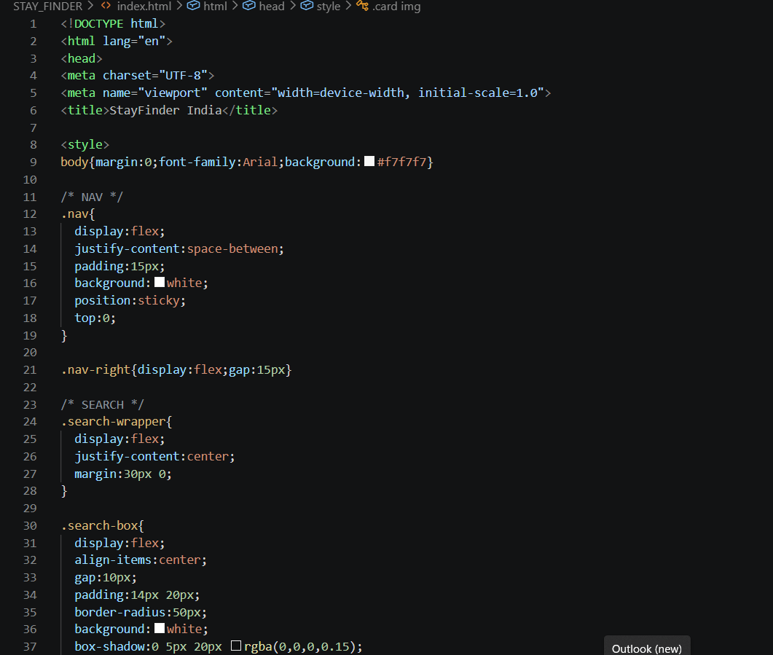

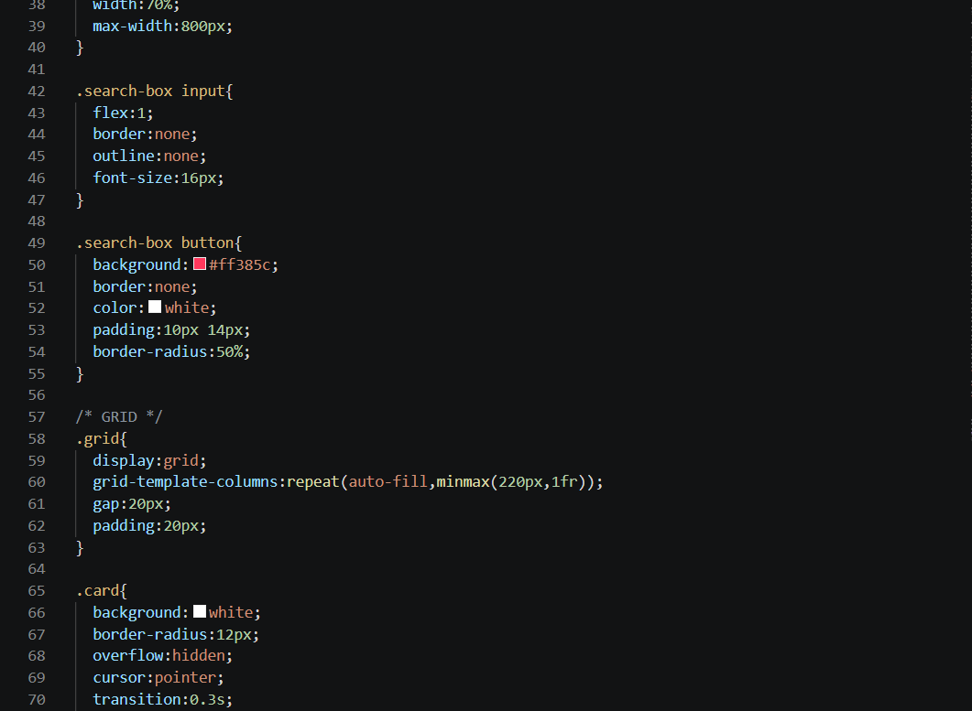

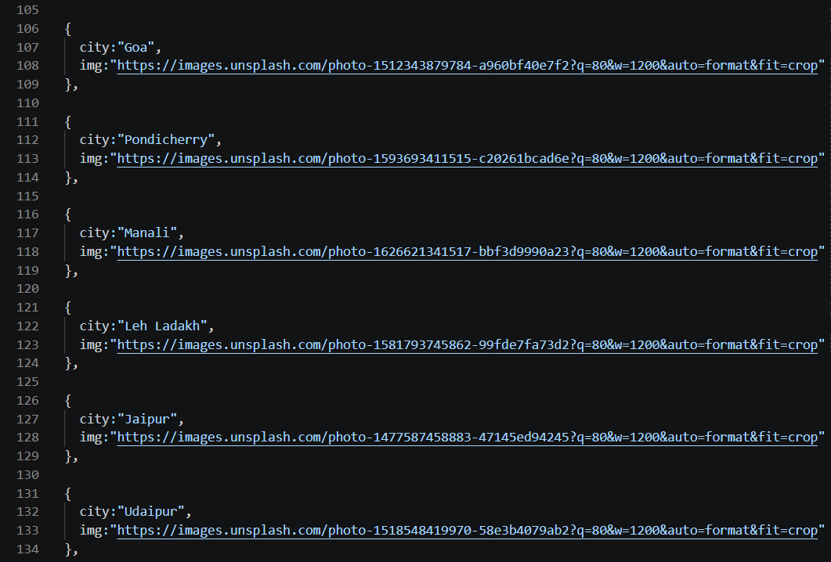
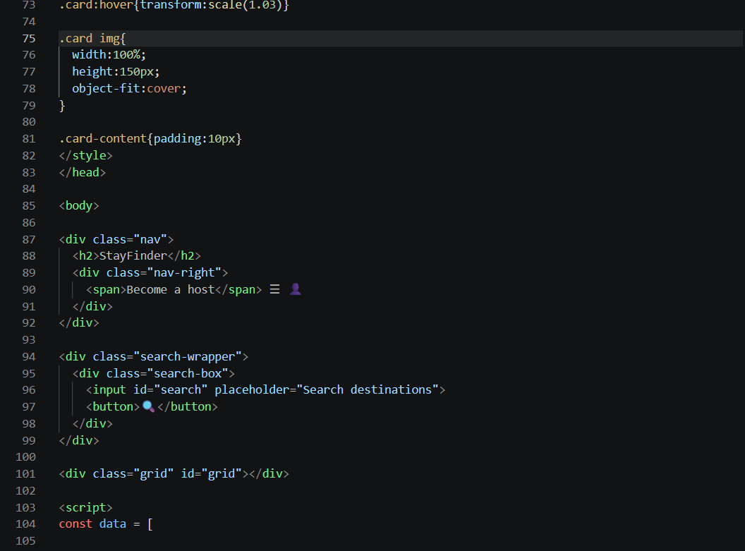

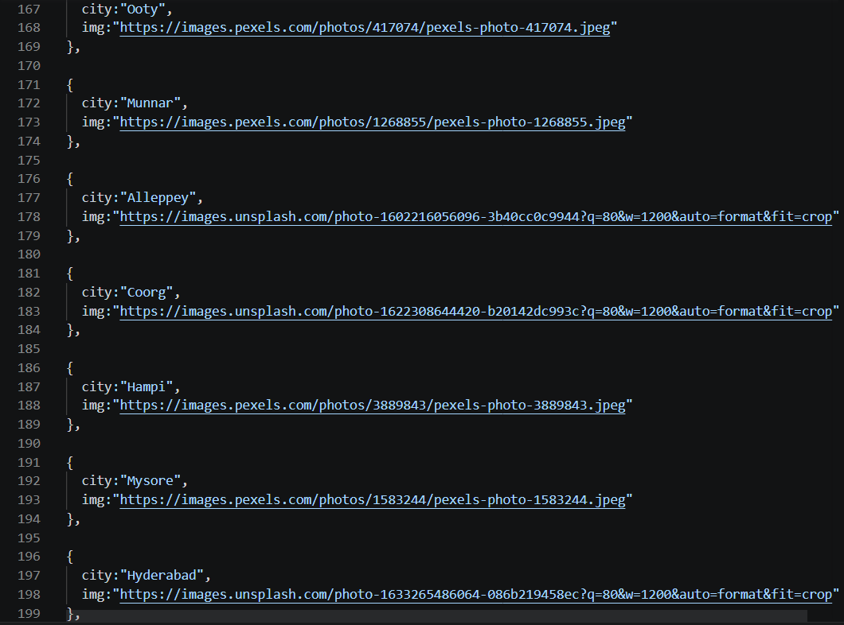
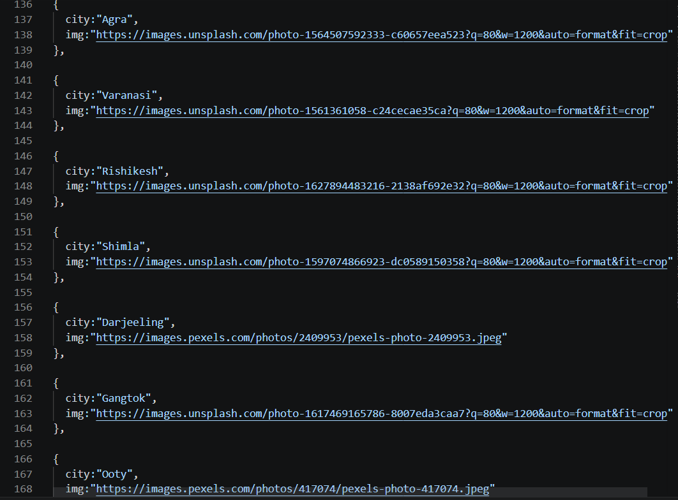

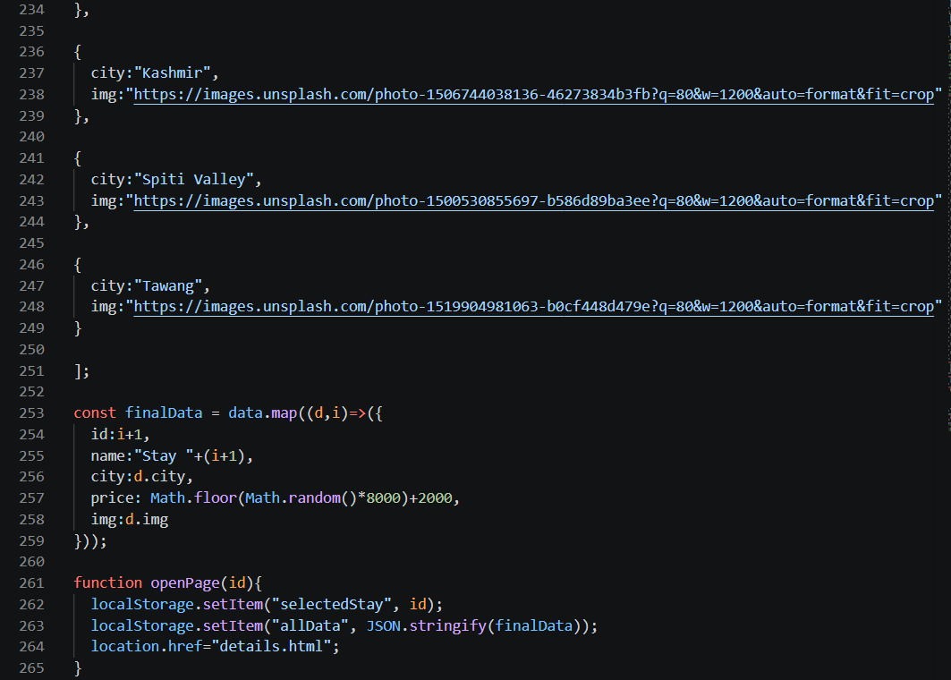
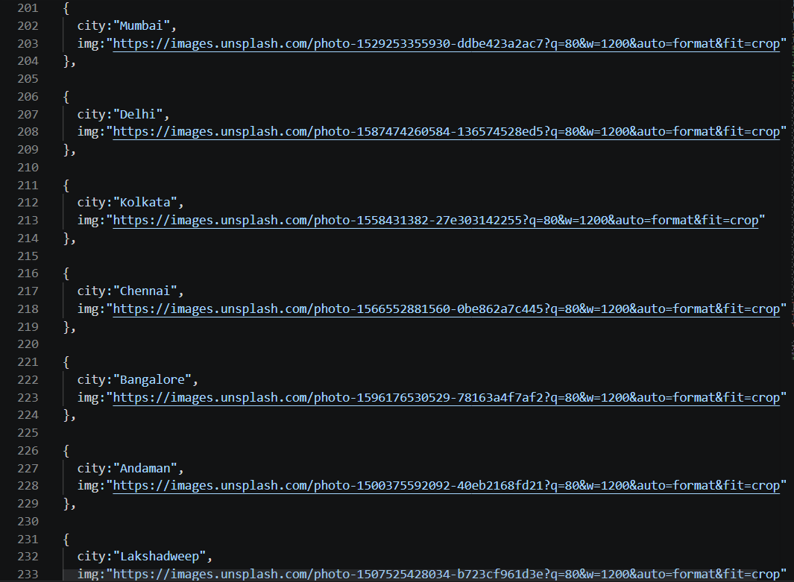

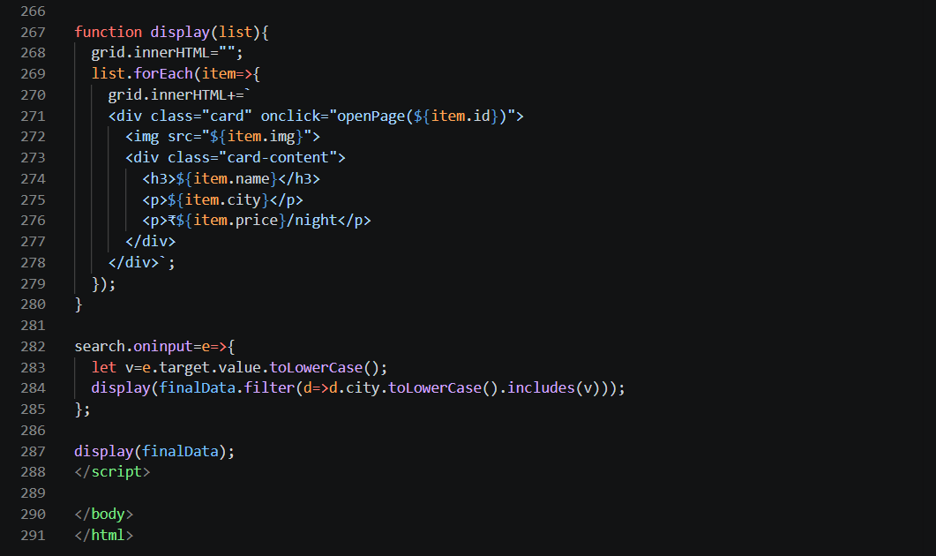

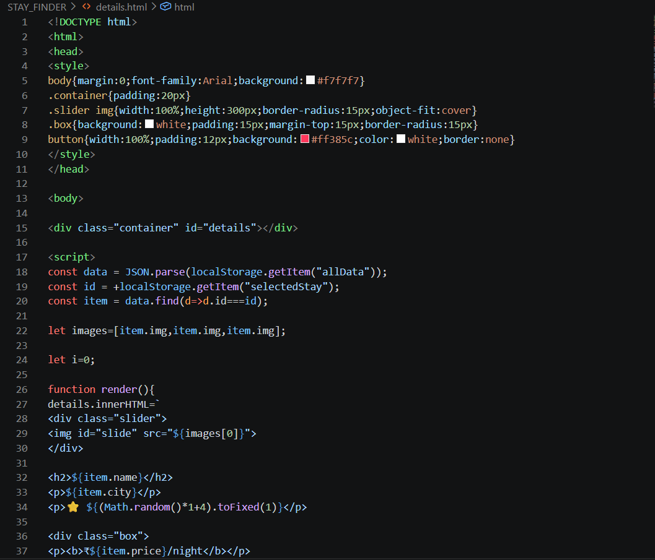
DETAILS.HTML

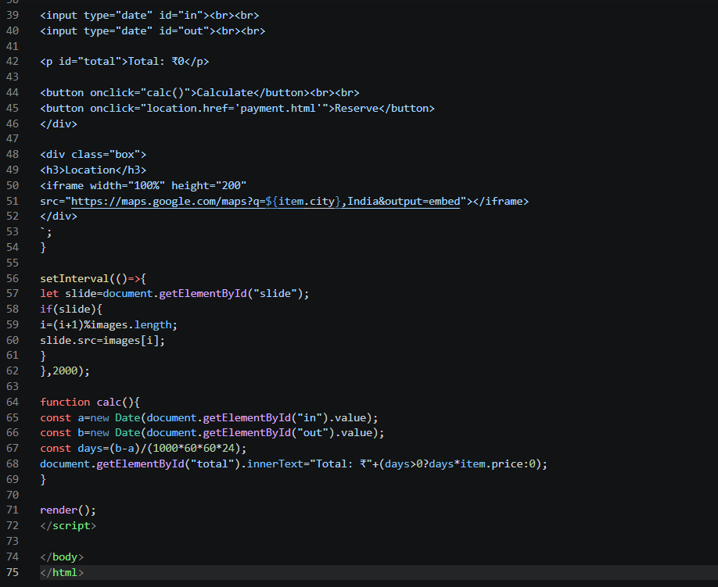

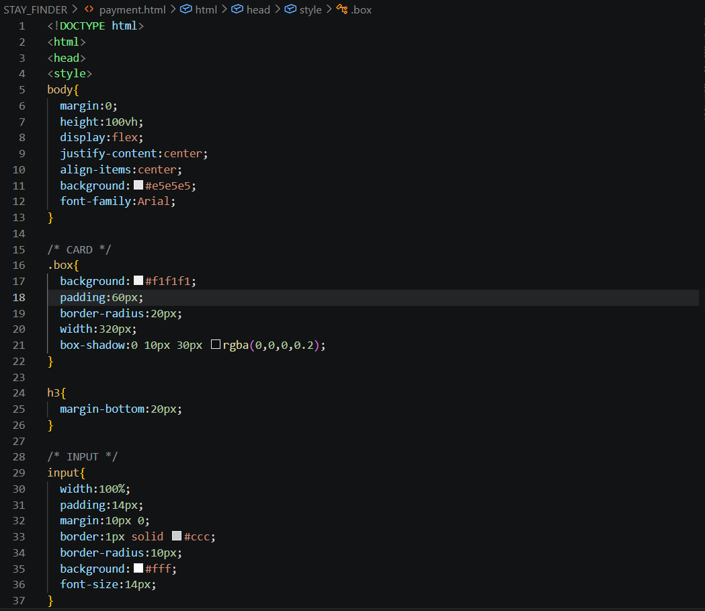
PAYMENT.HTML

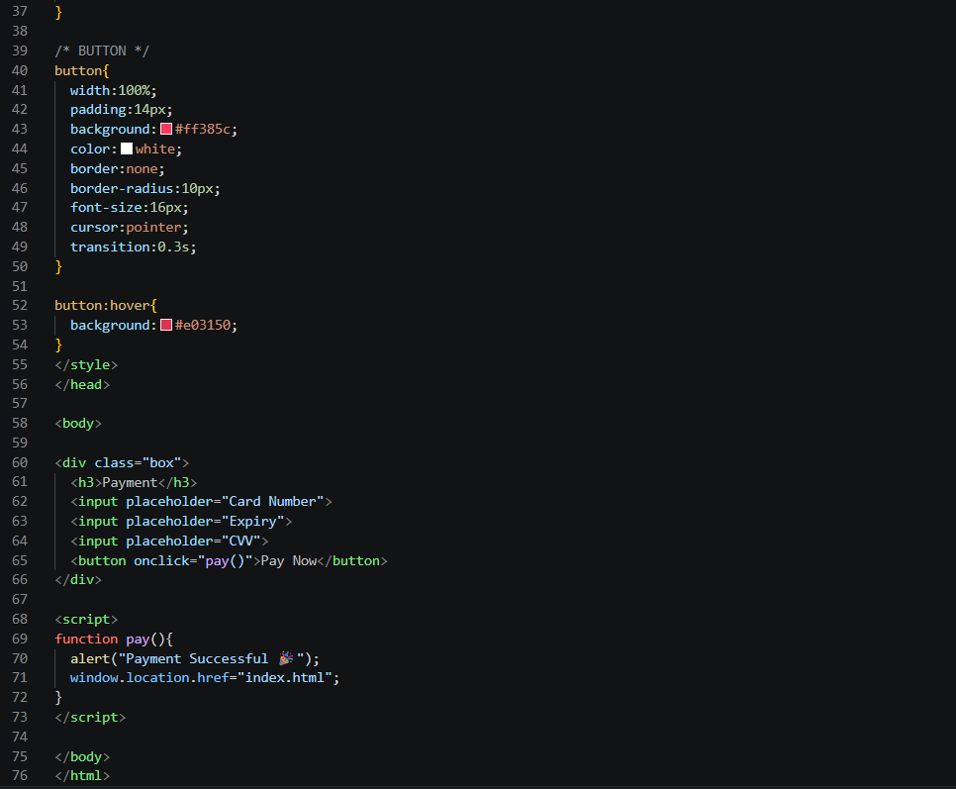

index.html is the home page of StayFinder Pro where users can browse hotel listings, images, ratings, and prices.
details.html displays complete information about a selected hotel, including descriptions, amenities, and location details.
payment.html is the booking and payment page where users can proceed with reservation-related actions.
The pages are connected through navigation links and buttons.
Users first visit index.html to explore available hotels.
After selecting a hotel, they are redirected to details.html for more information.
Finally, they proceed to payment.html to complete the booking process.
OutPut:
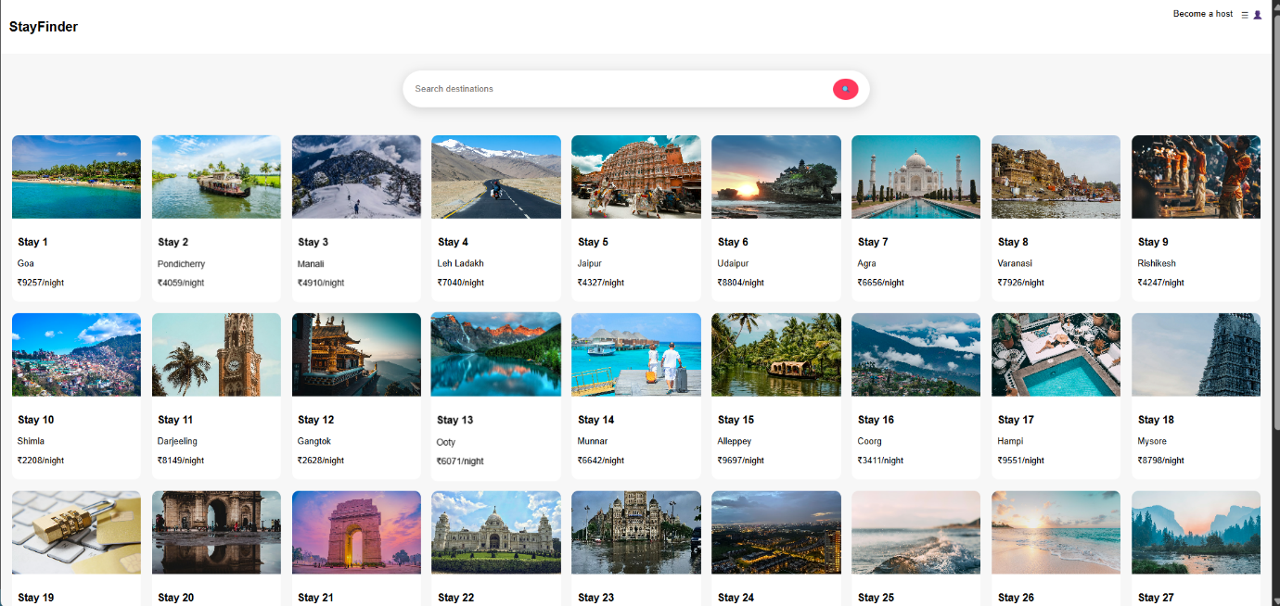

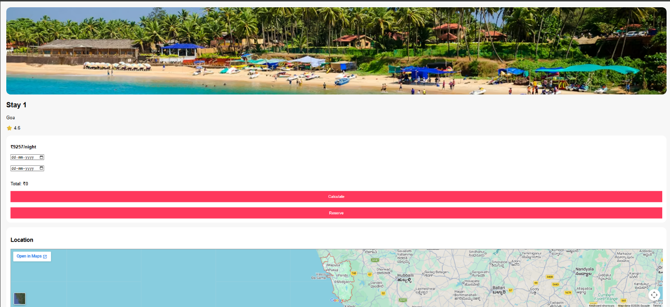

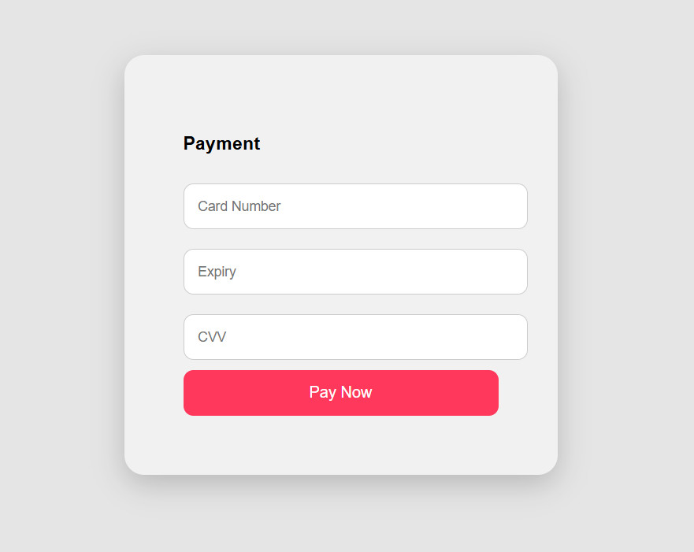

Figure 1:
Home Page
Description:
The home page serves as the landing page and provides access to accommodation listings.
Hotel Cards Section
[Insert Screenshot Here]
Description:
This section displays available hotels along with images and basic information.

Figure 3: Hotel Details Page
[Insert Screenshot Here]
Description:
Users can view detailed information about selected accommodations.
Map Integration
[Insert Screenshot Here]
Description:
The integrated map displays hotel locations for better navigation.
Figure 3: Payment Page
Description:
The Payment Page allows users to proceed with the hotel booking process after reviewing the selected accommodation details. It displays booking information and provides payment-related options for completing the reservation. This page represents the final step in the user journey and ensures a smooth transition from hotel selection to booking confirmation.
CONCLUSION
StayFinder Pro successfully demonstrates the application of User Interface Design principles in developing a modern hotel discovery platform.
Inspired by Airbnb, the project provides an intuitive interface for exploring accommodations while maintaining simplicity and usability. Through the use of HTML, CSS, JavaScript, and map integration, the application offers a smooth user experience and effective presentation of hotel information.
The project helped in understanding web development concepts, responsive design techniques, and practical implementation of UI principles. Overall, StayFinder Pro serves as a successful academic project that combines functionality, usability, and visual appeal.

