

User Interface Design
23CSE113

Lab Manual

Submitted by
Name | P. Sujan Kumar Reddy
Roll no | AV.SC.U4CSE25227
Year/sem/section | 1st year / 1st sem / cse-c
Credits | 03

Submitted to | DR. Raj Kumar Batchu
DESIGNATION | ASST.PROFFESSOR
DEPARTMENT | SCHOOL OF COMPUTING

SN.NO | Title | Page.no | Remarks
1. | WEEK 1 : 1. Installation of VS Code tool.  2. Understanding basic of html  structure.  3. Understanding basic html tags . | 1-12
2. | Week 2 : 1.Design a basic webpage with headings ,paragraph ,pre ,table by adding styles. | 12-25
3. | Week 3 : 1) create a class timetable using  HTML elements.  2) Create a HTML web page that should  display all subjects as an image of all  syllabus. | 25-35
4. | Week4: 1)Design a registration form using  only HTML tags (no CSS) with  proper labels, table alignment,  background color, and borders.  2)Two forms displayed side by side  using iframes .one is login and  another registration | 35-44
5. | Week5: 1)creating a card layout using  tag consider three cards and a button  using html and css .  2)navigation using iframe (mini  website) upon clicking each buttons  the details about that button should  be display on the same page.  3)Design amrita login page by  showing different campus on home  page.upon clicking on each campus  the details about each campus  should be display on the same page  use html and css to design a stylish  webpage. | 45-70
6. | Week-6: (6)Design a responsive e-commerce  application using the grid layout. This  application should contain different categories  of products such as electronics, clothing, home-  appliances, books. Based on the category we  select corresponding products should be  displayed on the sidebar. | 71-88
7. | Week-7 : create a GitHub account and  create a repository in it and push  all the week 6 code files in it. | 89-91
8. | Week-8 : A) create a web page that  displays a square that  continuously rotates 360ing  css animation.  B) create a ball that moves up and  down continuously using css  animation.  C) create a circle that moves  horizontally and rotates At the  same time. | 91-101
9. | Week-9: Create a webpage using  html,css,js based on the give  conditions, create a button for  each program , based on the  button, clicked the corresponding  program has to be executed and  should display the logics for each  button includes finding an even or  odd number , prime or not ,  factorial of a number , Armstrong  or not use appropriate design to  display the output. | 101-111
10. | Week-10: A ) Write a java script conditional  statement to find the sign of  product of three numbers  using functions. Display an  alert box with specified sign.  B) Write a java script conditional  statement to sort three  numbers using functions.  Display an alert box to show  result.  C) Write a java script conditional  statement to find largest of five  numbers using functions.  Disply an alert box to show  result.  D) Write a java script loop that will  iterate from 0 to 15 for each  iteration it will check odd or  even . Disply an a message to  screen.  E) Write a java script program to  read 6 subjects marks from  student then compute the  average marks of student. Then  this average isused to determine  the corresponding grade. | 111-124
11. | Week-11: 1. A website requires users to  enter a username. The system  should display a message  while typing if the username is  less than 5 characters.  2. A registration form should  validate email format before  submission. If invalid, the form  should not be submitted.  3. A system should check  password strength while typing  and display whether it is weak  or strong.  4. A form should validate a  mobile number when the user  leaves the input field. The  number must be exactly 10  digits.  5. Design an HTML page, such  that the registration form must  validate:  Name (not empty)  Email (valid format)  Password (minimum 6 characters) | 124-136
WEEK -1
- Aim : Steps to install VS Code tool.

Procedure:

To download Visual Studio Code on any operating system, open your browser and go to code.visualstudio.com. The website automatically detects whether you’re using Windows, macOS, or Linux and shows the correct download option. Click the download button, run the installer once it finishes downloading, and follow the simple on-screen steps.

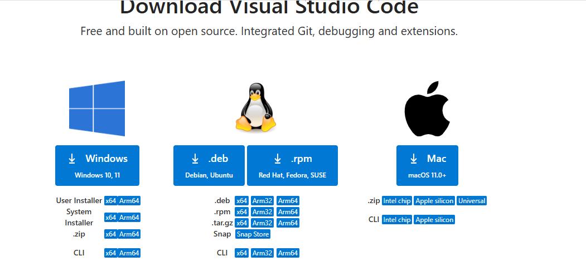

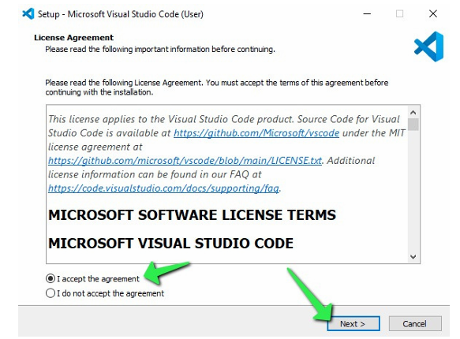

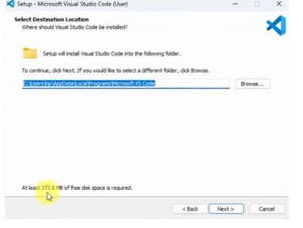

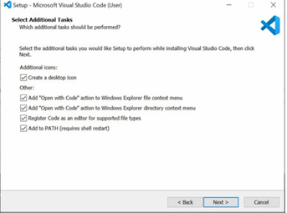

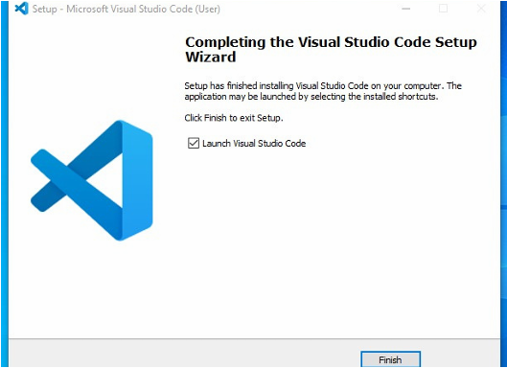

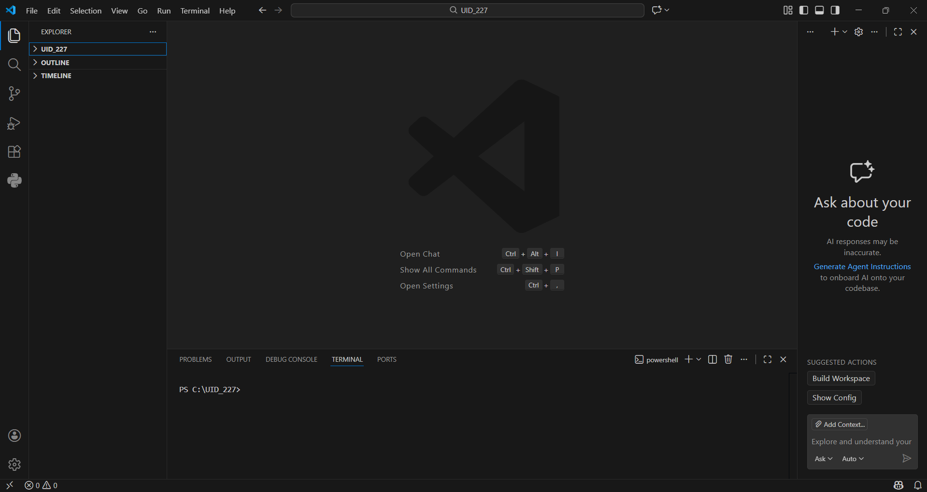

- Aim : Understanding basics of html
Program:

UID25227-Sujan

<!DOCTYPE html>
<html>
</head>
<title>First Web Page</title>
</head>
<body>
<p>name=sujan,rollno=227</p>
<h1>Hppy to learn HTML</h1>
<p>Thia is my first sample code</p>
</body>
</html>

Output:

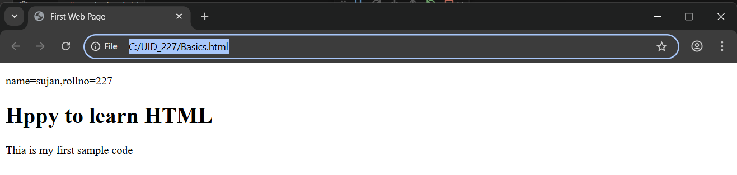

Explanation of the tags :

HTML stands for Hyper Text MarkupLanguage.
HTML is used to create and structure web pages.
It tells the web browser what content to show and how to show it.

<!DOCTYPE html>:
This declaration tells the browser that the document is written in HTML5.

<html>:
The <html> element is the main/root element of an HTML page.

<head>:
The <head> element contains information about the webpage, like title and meta data.

<title>:
The <title> element sets the title of the webpage, shown on the browser tab.

<body>:
The <body> element contains all visible content such as text, images, links, tables, etc.

<h1>:
The <h1> element is used to create a heading

<p>:
The <p> element is used to write a paragraph.

<html>:
This tag starts the HTML document.
</html>:
This tag ends the HTML document.
<head>:
This tag starts the head section which contains page information.
</head>:
This tag ends the head section.
<title>:
This tag starts the title of the webpage.
</title>:
This tag ends the title.
<body>:
This tag starts the visible content of the webpage.
</body>:
This tag ends the visible content.
<h1>:
This tag starts a heading.
</h1>:
This tag ends the heading.
<p>:
This tag starts a paragraph.
</p>:
This tag ends the paragraph.
- Aim : Understanding basic html tags.

Program:

<!DOCTYPE html>
<html>
<head>
<title>LINKS</title>
</head>
<body>
<p>name:sujan , rollno:227</p>
<h1 style="color: darkslategray;">Amrita</h1>
<p style="color: darkcyan;">Amrita Vishwa Vidyapeetham (or Amrita University) is a multi-campus private deemed university in India.[2] It currently has 19 constituent schools spread across ten campuses in Coimbatore, Amritapuri (Kollam), Kochi, Bengaluru, Amaravati, Chennai, Faridabad, Mysore, Nagercoil and Haridwar. Accredited with the highest possible ‘A++’ grade by NAAC and ranked as 7th best university in India in National Institutional Ranking Framework (NIRF) 2024.[3]</p>
<a href="https://www.amrita.edu/">Amrita web page link</a><br>
<img src="https://upload.wikimedia.org/wikipedia/en/3/30/Amrita_Vishwa_Vidyapeetham_-_Logo_Icon.svg"
alt="Amrita University Logo"
width="104"
height="142">

<h2 style="color: black;">SRM</h2>
<p style="color: firebrick;">SRM Institute of Science and Technology (formerly SRM University), established in 1985, is a top-ranked private deemed university based in Chennai, Tamil Nadu, renowned for engineering, medicine, and management programs. Known for its expansive, modern campuses and global accreditations like ABET, it offers high-quality infrastructure, excellent placement opportunities, and diverse research opportunities for its large student body. </p>
<a href="https://www.srmist.edu.in/">SRM web page link</a><br>
<img src="https://encrypted-tbn0.gstatic.com/images?q=tbn:ANd9GcQYihGewCyHaa81vhA7V_Oesqtqz5W08Rfo3g&s"
alt="SRM University Logo"
width="104"
height="142">

</body>
</html>

Output:

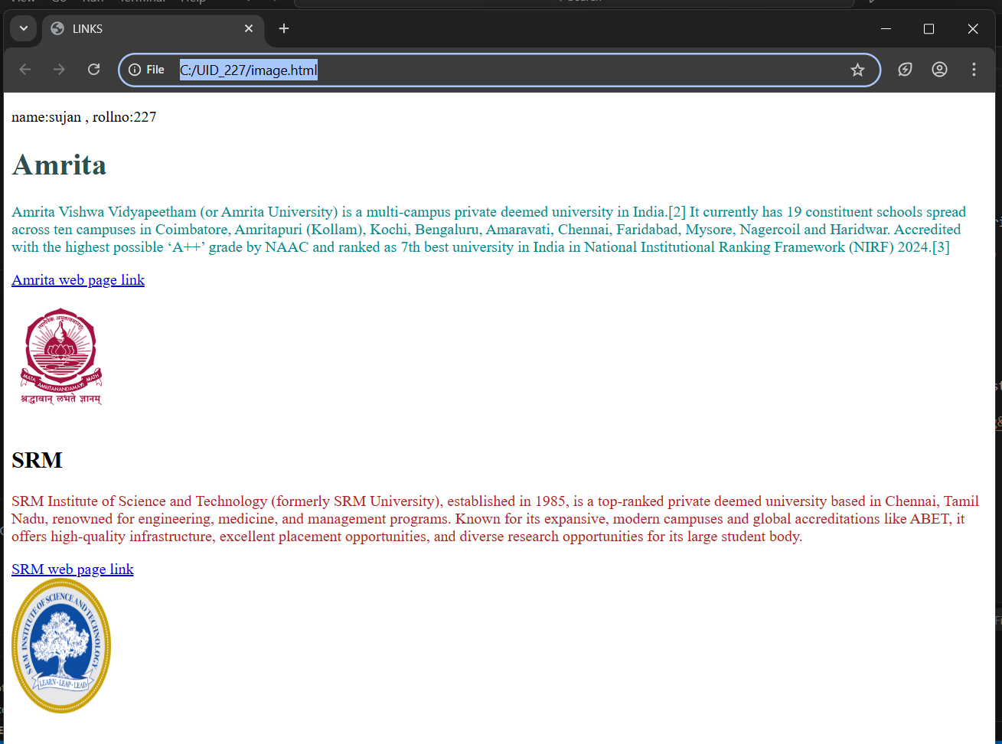

Explanation:

<!DOCTYPE html> :
It tells the browser that this document is written in HTML5. It helps the browser render the page correctly.
<html> :
This is the root element of the HTML document. All other tags are written inside this tag.
<head> :
Used to store metadata of the webpage such as the title. Content inside this tag is not visible on the webpage.
<title> :
Defines the title of the webpage, which appears on the browser tab.
<body> :
Contains all the visible content of the webpage like headings, paragraphs, links, and images.
<h1> and <h2> :
Used for headings.
<h1> represents the main heading and <h2> represents a sub-heading.
The style attribute is used here to apply color to the headings.
<p> :
Used to display text in paragraph format.
The style attribute is used to change the text color.
<a href="URL"> :
The anchor tag is used to create hyperlinks.
href specifies the destination URL and the text inside the tag becomes clickable.
<br> :
Used to insert a line break and move content to the next line.
It does not have a closing tag.
<img> :
Used to display images on the webpage.
It does not require a closing tag.
- src → specifies the image URL
- alt → alternate text if the image fails to load (important for accessibility)
- width → image width in pixels
- height → image height in pixels
style attribute :
Used to apply inline CSS styling such as text color inside tags like <h> and <p>.

Week-2
- AIM : Design a basic webpage with headings ,paragraph ,pre ,table by
adding styles.

CODE:
<html>
<body style="background-image:url(soulsocity.jpg);background-size: cover;
background-color: rgb(31, 9, 9);">
<h1 style="text-align: center;color: #030303;
;border: 2px solid rgba(81, 36, 36, 0.6);">Anime Power Systems</h1>
<p style="color: rgb(12, 12, 12);text-align:center;font-size:large;"><i><mark style="background-color: beige;">A power level system is used in anime to measure and compare the strength of characters in a structured way.<br> It helps viewers understand how powerful a character is, how they grow over time, and how they rank against others in the same universe.<br> These systems are often based on factors like physical strength, energy, skills, experience, and limitations.<br> Power level systems make battles more meaningful by setting clear expectations and showing progression through training, strategy, and sacrifice</mark></i>.</p>
<table width="420" border="2" cellspacing="10" style="text-align: center;color: rgb(253, 245, 250) ;margin-left: 550px;background-size:cover;background-image:url(iconicwalk.jpg)">
<tr>
<th>AnimeName</th>
<th>Power Source </th>
<th>How to obtain</th>
<th>Cost/limitation</th>
<th>Power Scale</th>
</tr>
<tr>
<td>One Piece</td>
<td>Devil Fruits and Haki</td>
<td>Eat fruit / train willpower</td>
<td>Can't swim, stamina drain</td>
<td>9</td>
</tr>
<tr>
<td>Naruto</td>
<td>Chakra</td>
<td>Born with it + training</td>
<td>Chakra exhaustion, death</td>
<td>9</td>
</tr>
<tr>
<td>Bleach</td>
<td>Spiritual Pressure</td>
<td>Being a Soul Reaper</td>
<td>Soul & physical damage</td>
<td>9.5</td>
</tr>
<tr>
<td>Attack on Titan</td>
<td>Titan Power</td>
<td>Inheriting Titans</td>
<td>13-year lifespan</td>
<td>7</td>
</tr>
<tr>
<td>Jujutsu Kaisen</td>
<td>Cursed Energy</td>
<td>Negative emotions</td>
<td>Backfires if uncontrolled</td>
<td>9</td>
</tr>
<tr>
<td>Vinland Saga</td>
<td>Physical Skill</td>
<td>Experience & survival</td>
<td>No superpowers</td>
<td>3</td>
</tr>
</table>

</body>

</html>

OUTPUT:

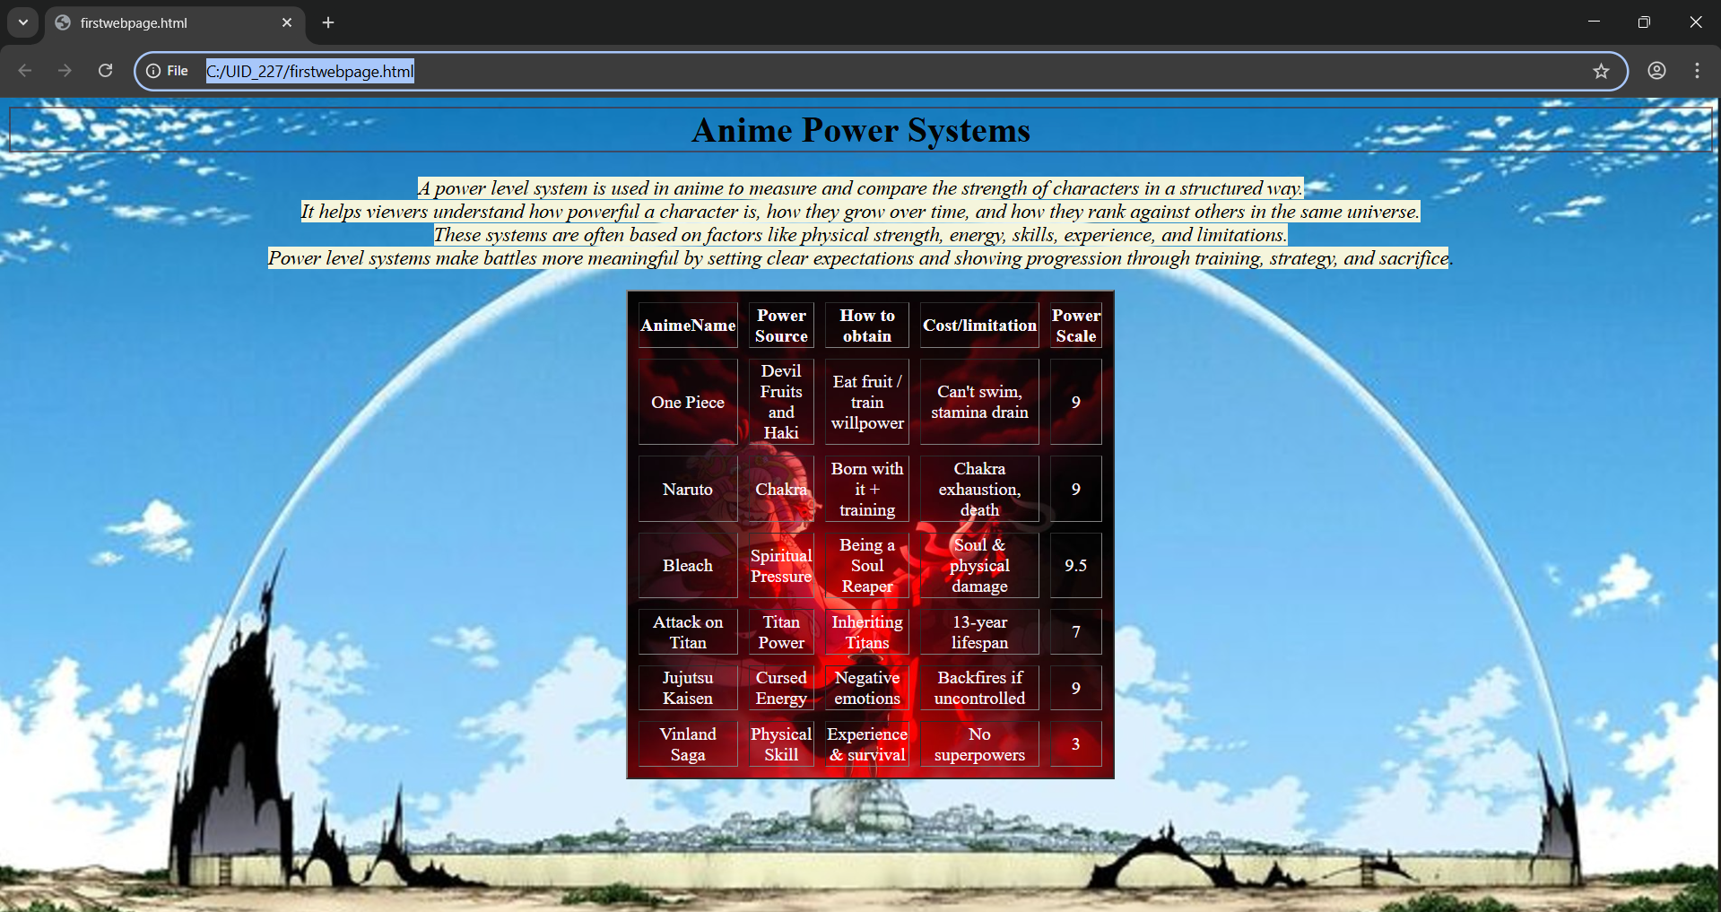

Explanation: (Contains only new tags I used)
1. <table> = the <table> tag is used to arrange data into rows and columns.
2. <tr> = Creates a horizontal row.
3. <th> = Defines a header cell (usually bold and centred by default).
4. <td> = the <td> tag stands for table Data.
5. colspan attribute = It is used to merge multiple columns across horizontally.
6. rowspan attribute = It is used to merge multiple rows across vertically.

Week-3
2. Aim : a) create a class timetable using HTML elements.
b) Create a HTML web page that should display all
subjects as an image of all syllabus.

Code:

<html>
<body>
<title>Time Table</title>
<p>Name:Sujan,Rollno:25227,sec:cse-c</p>

<table border="3" cellspacing="2" cellpadding="6" width="100%" style="border-collapse: collapse; text-align: center;">
<tr>
<td colspan="6" style="text-align: left;">
<b>Dept:</b> CSE<br>
<b>Class:</b> B.Tech<br>
<b>sem:</b> 2 <br>
</td>
<td colspan="6" style="text-align: left;">
<b>class room </b> 512
</td>
</tr>
<tr>
<td colspan="6" style="text-align: left;">
<b>Class Advisors:</b><br>
<b>1. Name: MR.BJNL</b><br>
<b>Email:bj_lashminarayana@av.amrita.edu</b><br>
<b>Mobile Number : +91- 7989795768<b><br>
</td>
<td colspan="6" style="text-align: left;">
<b>Class Advisors:</b><br>
<b>1. Name:MR.Arun Kumar</b><br>
<b>Email:s_arunkumar@av.amrita.edu</b><br>
<b>Mobile Number:+91-89408572202<b><br>
</td>
</tr>
<tr>
<th rowspan="2">Time/Day</th>
<th>Slot-1</th>
<th>Slot-2</th>
<th rowspan="2">10:35<br>10:45</th>
<th>Slot-3</th>
<th>Slot-4</th>
<th>Slot-5</th>
<th rowspan="2">1:15<br>2:05</th>
<th>Slot-6</th>
<th rowspan="2">3:00t<br>3:10</th>
<th>Slot-7</th>
<th>Slot-8</th>
</tr>
<tr>
<th>8:55-9:45</th>
<th>9:45-10:35</th>
<th>10:45-11:35</th>
<th>11:35-12:25</th>
<th>12:25-1:15</th>
<th>2:05-3:00</th>
<th>3:10-4:00</th>
<th>4:00-4:50</th>
</tr>
<tr>
<th>Monday</th>
<th colspan="2">23MAT116 Discrete Mathematics_lab2</th>
<th rowspan="5" style="background-color: yellow;">S<br>h<br>o<br>t<br><br>B<br>r<br>e<br>a<br>k</th>
<th>23PHY115 Modern<br>Physics</th>
<th>23CSE111ObjectOriented<br>Programming</th>
<th>22ADM111Glimpses of<br>Glorious India</th>
<th rowspan="5" style="background-color: yellow;">L<br>u<br>n<br>c<br>h<br>B<br>r<br>e<br>a<br>k</br>a</th>
<th>22ADM111Glimpses of<br>Glorious India(P)</th>
<th rowspan="5" style="background-color: yellow;">S<br>h<br>o<br>t<br><br>B<br>r<br>e<br>a<br>k</th>
<th colspan="2">Library/Sports</th>
</tr>
<tr>
<th>Tuesday</th>
<th colspan="2">23CSE113 User Interface Design LAB(BYOD)</th>
<th>23MAT117 Linear<br>Algebra</th>
<th>23MAT116 Discrete<br>Mathematics</th>
<th style="color: red;">COUNSELLING</th>
<th>23MEE115 Manufacturing<br>Practice LAB</th>
<th colspan="2">23MEE115 Manufacturing<br>Practice LAB</th>
</tr>
<tr>
<th>Wednesday</th>
<th>23PHY115 Modern<br>Physics</th>
<th>23CSE113 User Interface Design</th>
<th colspan="2">23MAT117 Linear Algebra_LAB(BYOD)</th>
<th style="color: red;">COUNSELLING</th>
<th>LIBRARY</th>
<th>22ADM111Glimpses of<br>Glorious India</th>
<th>Library/Sports</th>
</tr>
<tr>
<th>Thursday</th>
<th>23CSE111ObjectOriented<br>Programming</th>
<th>23MAT116 Discrete<br>Mathematics</th>
<th colspan="2">
23CSE111Object Oriented Programming <br>_Lab2
</th>
<th>23MAT117<br>LinearAlgebra</th>
<th>LIBRARY</th>
<th colspan="2">Library/Sports</th>
</tr>
<tr>
<th>Friday</th>
<th>23CSE111ObjectOriented<br>Programming</th>
<th>23MAT116 Discrete<br>Mathematics</th>
<th>23PHY115 Modern<br>Physics</th>
<th>23CSE113 User Interface Design</th>
<th>23MAT117<br>LinearAlgebra</th>
<th>LIBRARY</th>
<th colspan="2">Library/Sports</th>
</tr>
</table>

<br><br>

<h3 style="text-align:center;">Theory & Lab</h3>
<table border="1" cellspacing="2" cellpadding="6" width="100%" style="border-collapse:collapse;">
<tr>
<th>Course Code</th>
<th>Course Name</th>
<th>L-T-P</th>
<th>Credits</th>
<th>Faculty Name</th>
<th>Assisting Faculty</th>
` </tr>
<tr>
<td>23MAT116</td>
<td>Discrete Mathematics</td>
<td>3-0-2</td>
<td>4</td>
<td>Dr. Srivivasa Rao Thota</td>
<td></td>
</tr>
<tr>
<td>23MAT117</td>
<td>Linear Algebra</td>
<td>3-0-2</td>
<td>4</td>
<td>Mr. Sapavat Bixapathi</td>
<td></td>
</tr>
<tr>
<td>23CSE111</td>
<td>Object Oriented Programming</td>
<td>3-0-2</td>
<td>4</td>
<td>Dr. Satya Rajendra Singh R</td>
<td>Dr. Balaji TK</td>
</tr>
<tr>
<td>23PHY115</td>
<td>Modern Physics</td>
<td>2-1-0</td>
<td>3</td>
<td>Dr. Soumya</td>
<td></td>
</tr>
<tr>
<td>23CSE113</td>
<td>User Interface Design</td>
<td>2-0-2</td>
<td>3</td>
<td>Dr. Rajkumar Batchu</td>
<td>Mr. Barge Bharadwaj</td>
</tr>
<tr>
<td>23MEE115</td>
<td>Manufacturing Practice</td>
<td>0-0-3</td>
<td>1</td>
<td>Dr. Sathies S.</td>
<td></td>
</tr>
<tr>
<td>22ADM111</td>
<td>Glimpses of Glorious India</td>
<td>2-0-1</td>
<td>2</td>
<td>Dr. Siva Panuganti</td>
<td></td>
</tr>
<tr>
<td></td>
<td><b>Total (15L + 1Tut + 12P = 28 hrs)</b></td>
<td><b>15-1-12</b></td>
<td><b>21</b></td>
<td></td>
<td></td>
</tr>
</table>
<br>
<br>
<br>
<br>

<h2 style="text-align: center;">Syllabus</h2>
<h3>Discert Maths</h3>
<img src="c:\Users\sujan\OneDrive\Pictures\Screenshots\Screenshot 2026-02-04 221641.png" width="1000" height="400">
<br>
<h3>Linear Algebra</h3>
<img src="c:\Users\sujan\OneDrive\Pictures\Screenshots\Screenshot 2026-02-04 222317.png" width="1000" height="400">
<br>
<h3>Object Oriented Programming</h3>
<img src="c:\Users\sujan\OneDrive\Pictures\Screenshots\Screenshot 2026-02-04 222525.png" width="1000" height="400">
<br>
<h3>Modern Physics</h3>
<img src="c:\Users\sujan\OneDrive\Pictures\Screenshots\Screenshot 2026-02-04 222818.png0" width="1000" height="400">
<br>
<h3>User Interface Design</h3>
<img scr="c:\Users\sujan\OneDrive\Pictures\Screenshots\Screenshot 2026-02-04 223014.png" width="1000" height="400">
<br>
<h3>Manufacturing Practice</h3>
<img src="c:\Users\sujan\OneDrive\Pictures\Screenshots\Screenshot 2026-02-04 223158.png" width="1000" height="400">
<br>
<h3>Glimpses Of Glorious India</h3>
<img scr="c:\Users\sujan\OneDrive\Pictures\Screenshots\Screenshot 2026-02-04 223320.png" width="1000" height="400">
</body>
</html>
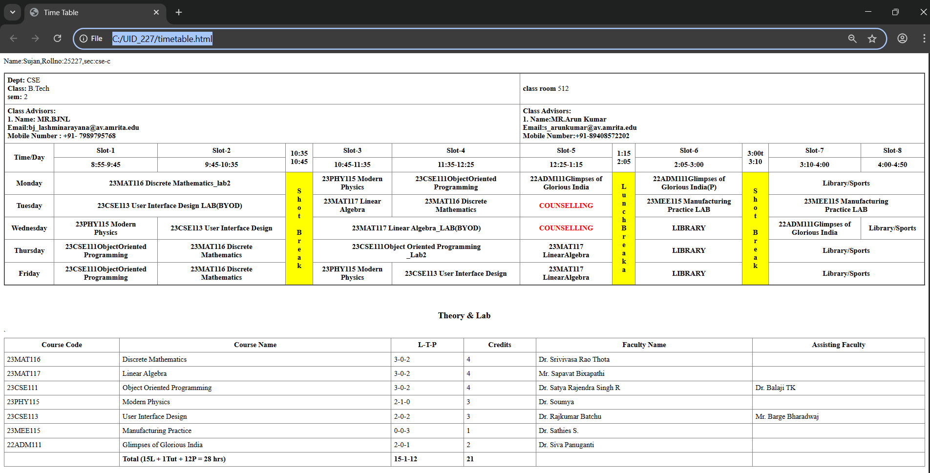
Output:

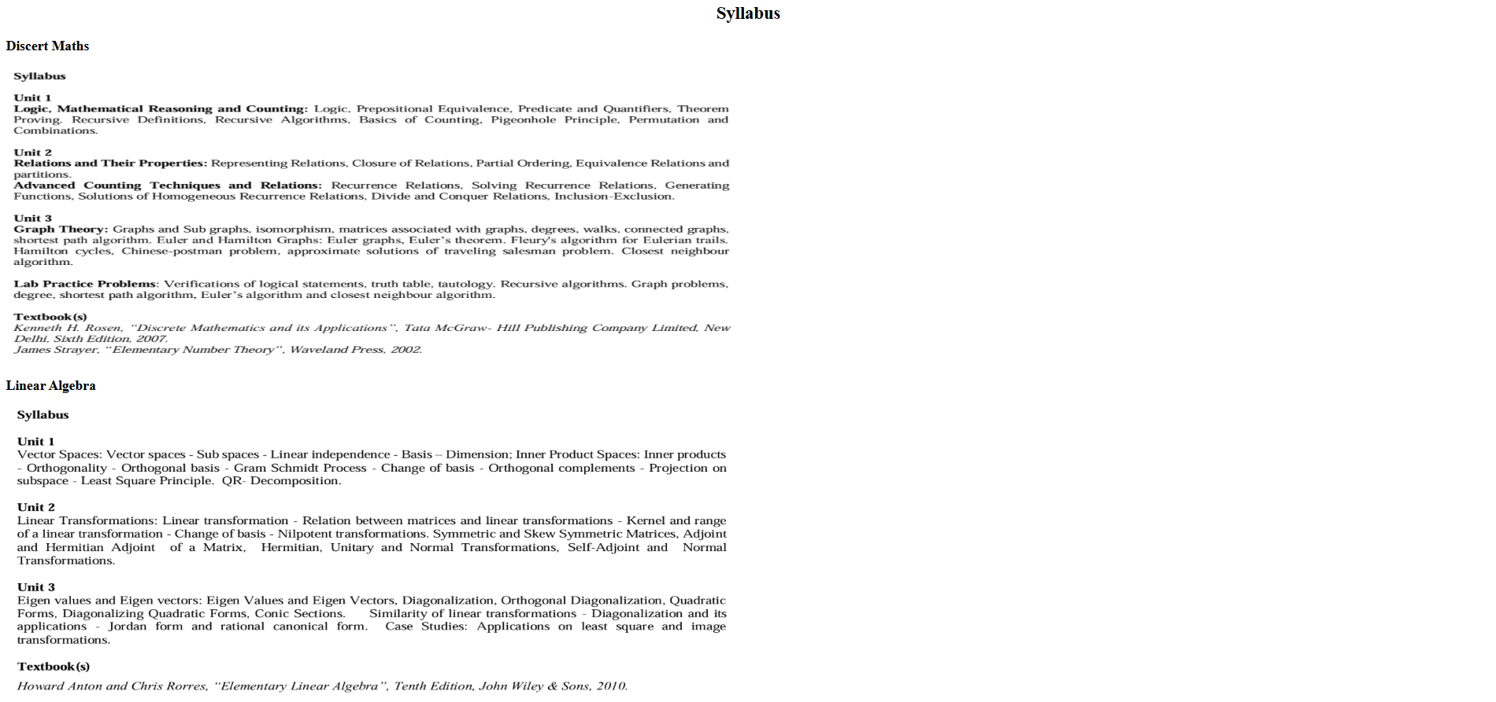

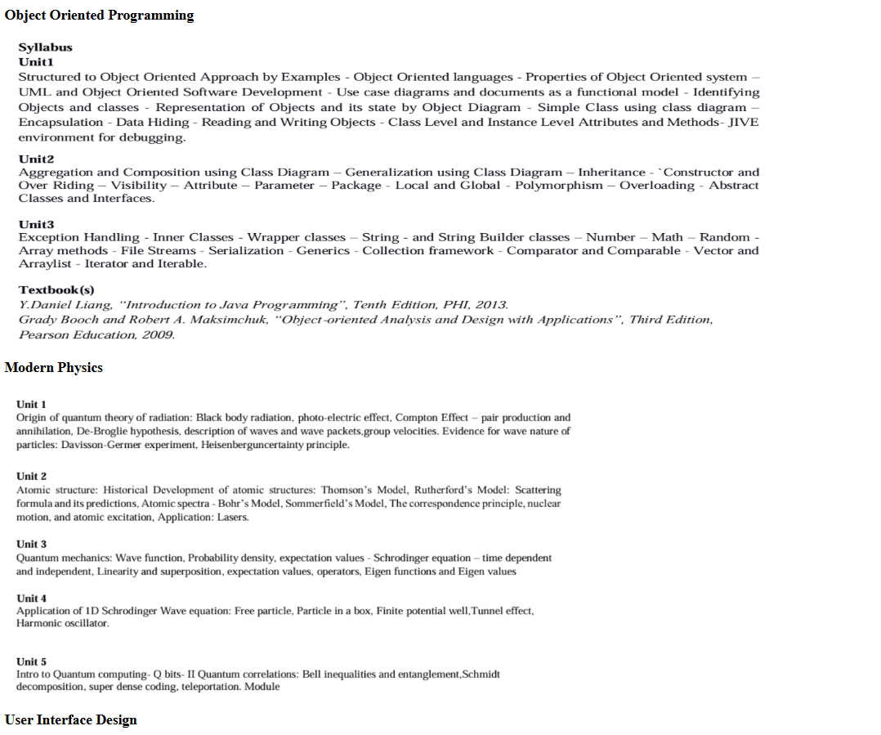

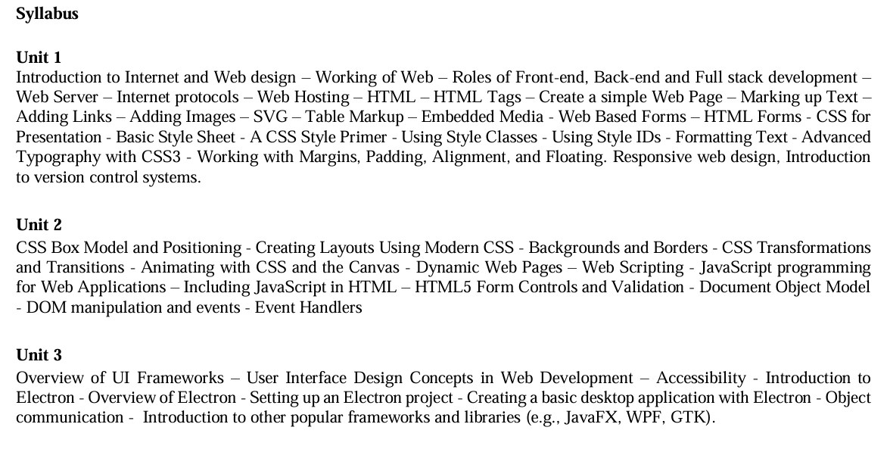

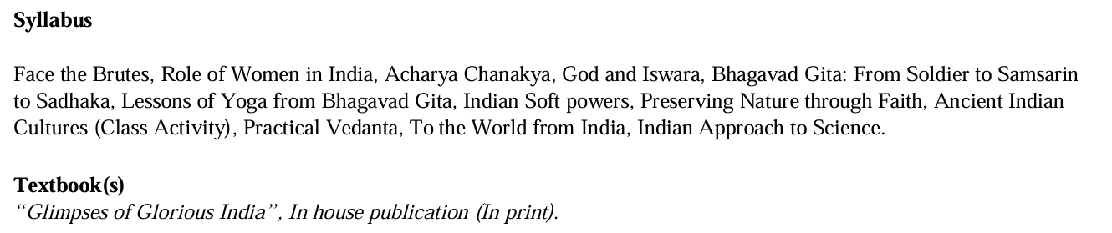
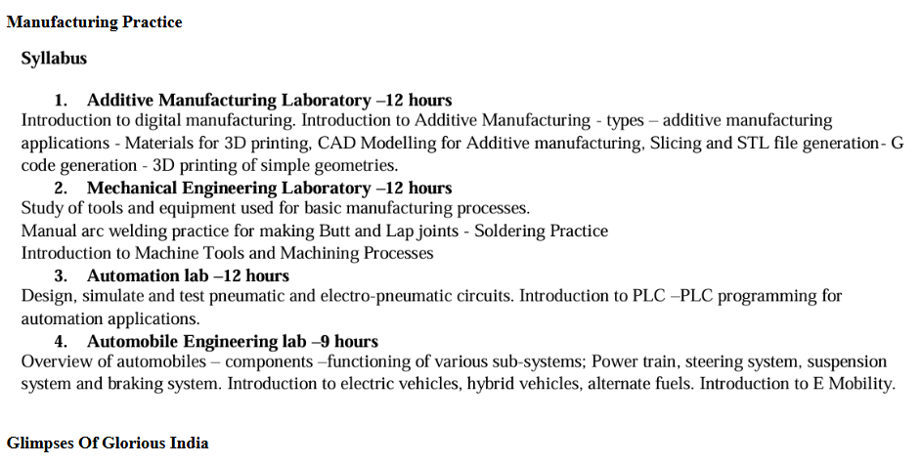

Explanation: (Contains only new tags I used)
1. <table> = the <table> tag is used to arrange data into rows and columns.
2. <tr> = Creates a horizontal row.
3. <th> = Defines a header cell (usually bold and centred by default).
4. <td> = the <td> tag stands for table Data.
5. colspan attribute = It is used to merge multiple columns across horizontally.
6. rowspan attribute = It is used to merge multiple rows across vertically.

Week-4
- Aim: Creating a collage registration form using HTML.
CODE:
<!DOCTYPE html>
<html>
<head>
<title>College Admission Registration</title>
</head>
<body bgcolor="#E6E6FA"> <table border="1" align="center" cellpadding="10" cellspacing="0" bgcolor="white">
<tr>
<th colspan="2">
<h2>College Admission Registration</h2>
</th>
</tr>

<form action="#" method="post">
<tr>
<td><label for="name">Full Name:</label></td>
<td><input type="text" id="name" name="name"></td>
</tr>

<tr>
<td><label for="email">Email:</label></td>
<td><input type="email" id="email" name="email"></td>
</tr>

<tr>
<td><label for="phone">Phone Number:</label></td>
<td><input type="tel" id="phone" name="phone"></td>
</tr>

<tr>
<td>Gender:</td>
<td>
<input type="radio" id="male" name="gender" value="male">
<label for="male">Male</label>
<input type="radio" id="female" name="gender" value="female">
<label for="female">Female</label>
<input type="radio" id="other" name="gender" value="other">
<label for="other">Other</label>
</td>
</tr>

<tr>
<td>Course Applying For:</td>
<td>
<select name="course">
<option value="btech">B.Tech</option>
<option value="mtech">M.Tech</option>
<option value="bsc">B.Sc</option>
</select>
</td>
</tr>

<tr>
<td>Hobbies:</td>
<td>
<input type="checkbox" id="sports" name="hobbies" value="sports">
<label for="sports">Sports</label>
<input type="checkbox" id="music" name="hobbies" value="music">
<label for="music">Music</label>
<input type="checkbox" id="reading" name="hobbies" value="reading">
<label for="reading">Reading</label>
</td>
</tr>

<tr>
<td>Date of Birth:</td>
<td><input type="date" name="dob"></td>
</tr>

<tr>
<td>Upload Certificates:</td>
<td><input type="file" name="certificates"></td>
</tr>

<tr>
<td>Address:</td>
<td>
<textarea name="address" rows="4" cols="30"></textarea>
</td>
</tr>

<tr>
<td colspan="2" align="center">
<input type="submit" value="Submit">
<input type="reset" value="Reset">
</td>
</tr>
</form>
</table>

</body>
</html>

OUTPUT:

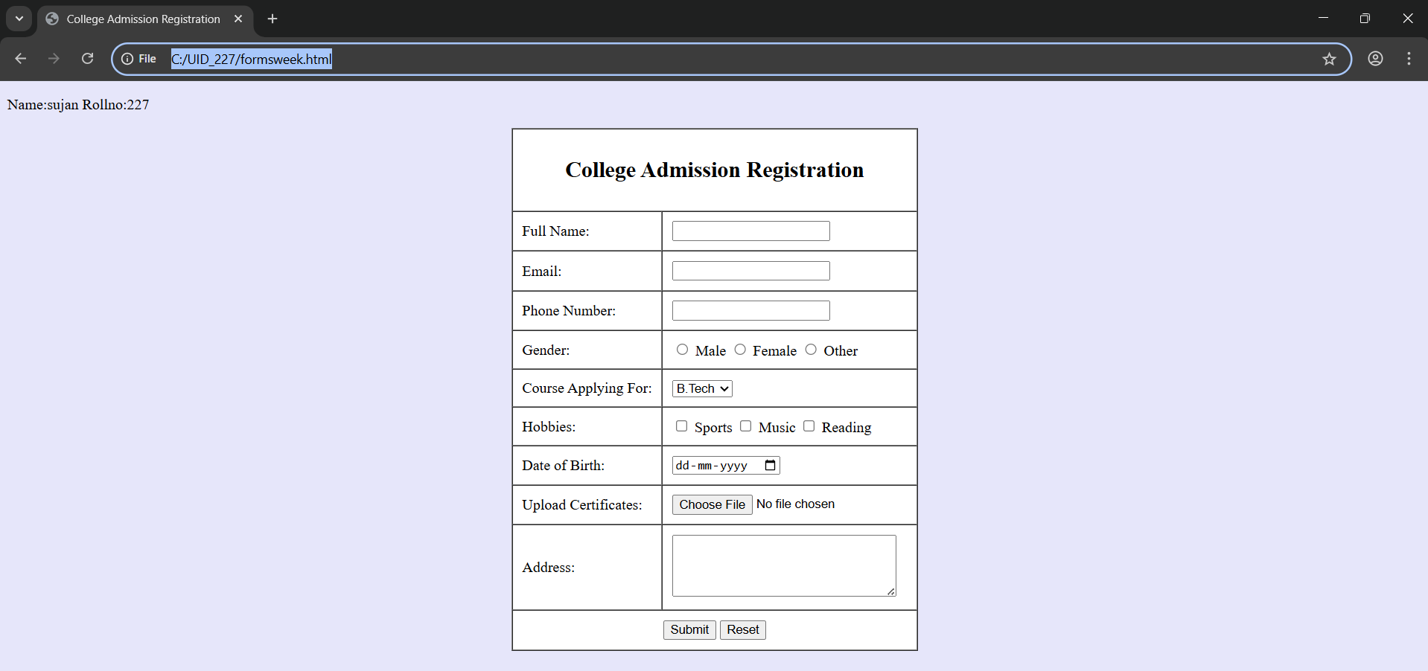

2. Aim : Create two different forms in one webpage using Iframes.

CODE:
<!DOCTYPE html>
<html>
<head>
<title>Two Forms Using Iframes</title>
</head>
<body>
<p>Name:SUJANKR7 Rollno:227</p>

<center>
<h2>Two Forms Using Iframes</h2>

<!-- Login Form Iframe -->
<iframe width="600" height="500"
srcdoc='
<!DOCTYPE html>
<html>
<head>
<title>User Login</title>
</head>
<body>
<center>
<h2>User Login</h2>
<form>
<table width="50" border="1" cellpadding="25" cellspacing="2" style="text-align:center;">

<tr>
<td>
<label for="username">Username:</label>
</td>
<td>
<input type="text" id="username" name="username">
</td>
</tr>

<tr>
<td>
<label for="password">Password:</label>
</td>
<td>
<input type="password" id="password" name="password">
</td>
</tr>

<tr>
<td colspan="2" style="text-align:center;">
<input type="submit" value="Login">
</td>
</tr>

</table>
</form>
</center>
</body>
</html>
'>
</iframe>

<!-- Registration Form Iframe -->
<iframe width="600" height="500"
srcdoc='
<!DOCTYPE html>
<html>
<head>
<title>User Registration</title>
</head>
<body>
<center>
<h2>User Registration</h2>
<form>
<table width="50" border="1" cellpadding="25" cellspacing="2" style="text-align:center;">

<tr>
<td>
<label for="fullname">Full Name:</label>
</td>
<td>
<input type="text" id="fullname" name="fullname">
</td>
</tr>

<tr>
<td>
<label for="email">Email:</label>
</td>
<td>
<input type="email" id="email" name="email">
</td>
</tr>

<tr>
<td>
<label for="phone">Phone:</label>
</td>
<td>
<input type="text" id="phone" name="phone">
</td>
</tr>

<tr>
<td>
<label for="password">Password:</label>
</td>
<td>
<input type="password" id="password" name="password">
</td>
</tr>

<tr>
<td colspan="2" style="text-align:center;">
<input type="submit" value="Register">
<input type="reset" value="Reset">
</td>
</tr>

</table>
</form>
</center>
</body>
</html>
'>
</iframe>

</center>

</body>
</html>

OUTPUT:
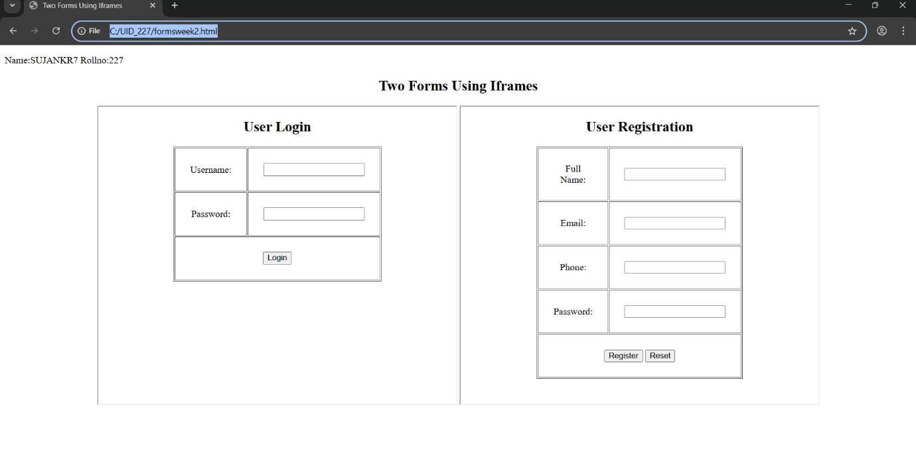

Week-5
- A) Aim: creating a card layout using
tag consider three cards and a button using html and css.

CODE:
<!DOCTYPE html>
<html>
<head>
<title>Anime BIG 3</title>
<style>
body{
font-family:Arial;
background:#0f172a;
text-align:center;
}
h1{
background:#737171;
padding:20px;
}
.container{
display:flex;
flex-wrap:wrap;
justify-content:center;
gap:20px;
padding:30px;
}
.card{
background: gray;
color:black;
width:260px;
padding:20px;
border-radius:12px;
box-shadow:0 5px 15px gray;
}
.hero-img{
width:150px;
height:200px;
object-fit:cover;
border-radius:8px;
}
button{

padding:8px 16px;
border:none;
background:black;
color:white;
border-radius:6px;
}
button:hover{
background:black;
}
</style>
</head>
<body>
<h1>BIG 3 in Anime</h1>
<div class="container">
<div class="card">
<img class="hero-img"
src="c:\Users\sujan\Downloads\Luffy 4k Wallpaper One Piece.jpg">
<h3>One Piece</h3>
<p>Monkey D.Luffy</p>
<button>Know More</button>
</div>
<div class="card">
<img class="hero-img"
src="c:\Users\sujan\Downloads\download (3).jpg">
<h3>Naruto</h3>
<p>Naruto Uzumaki</p>
<button>Know More</button>
</div>
<div class="card">
<img class="hero-img"
src="c:\Users\sujan\Downloads\𝑲𝒖𝒓𝒐𝒔𝒂𝒌𝒊 𝑰𝒄𝒉𝒊𝒈𝒐.jpg">
<h3>Bleach</h3>
<p>Ichigo Kurosaki</p>
<button>Know More</button>
</div>
</div>
</body>
</html>
OutPut:

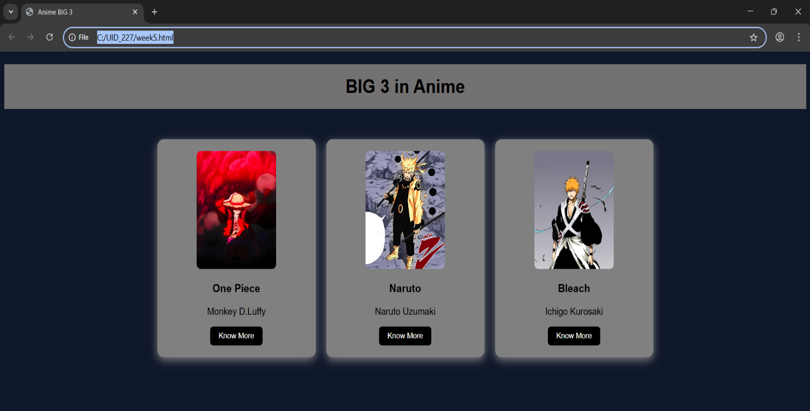

Explanation :
<!DOCTYPE html> : This declaration tells the browser that the document is an HTML5 document and should be rendered using the latest HTML standard.
<html> : This is the root element of the webpage. All other HTML elements are placed inside this tag.
<head> : The <head> section contains metadata about the webpage such as the title and CSS styling. It does not display content directly on the page.
<title> : The <title> tag defines the name of the webpage that appears on the browser tab.
<body> : The <body> tag contains all the visible content of the webpage such as text, images, buttons, and other elements.
<h1> / <h2> / <h3> : Heading tags are used to display titles and subtitles. They help structure the content of the webpage.
<p> : The paragraph tag is used to display blocks of text.
<div> : The <div> element is used to group and organize content into sections. It helps in structuring and styling different parts of the webpage.
<button> : The <button> tag creates a clickable button on the webpage.
<img> : The <img> tag is used to display images. The src attribute specifies the path or location of the image file.
We used internal CSS inside the <style> tag within the <head> section.
Element selectors and class selectors were used to apply styles to specific elements.By using classes and CSS styling, we designed and structured the webpage layout effectively.
- B) Aim: Navigation using iframe (mini website) upon clicking
each buttons the details about that button should
be display on the same page.

CODE:
[Index.html]
<!DOCTYPE html>
<html>
<head>
<title>Luffy - Gear Navigation</title>

<style>
body{
margin:0;
font-family:Arial;
background-color: lightgray;
}

.menu{
background:#e11d48;
padding:15px;
text-align:center;
}

.menu a{
color:white;
margin:0 15px;
text-decoration:none;
background:black;
padding:8px 12px;
}

iframe{
width:100%;
height:400px;
border:none;
}
</style>

</head>

<body>

<h1 style="text-align:center;background:#e11d48;color:white;padding:20px;">
Monkey D. Luffy - 4 Gears
</h1>

<div class="menu">
<a href="gear2.html" target="frame">Gear 2</a>
<a href="gear3.html" target="frame">Gear 3</a>
<a href="gear4.html" target="frame">Gear 4</a>
<a href="gear5.html" target="frame">Gear 5</a>
</div>

<iframe name="frame"></iframe>

</body>
</html>
[gear_2]
<!DOCTYPE html>
<html>
<head>
<style>
body{font-family:Arial;text-align:center;}
.box{
border:2px solid black;
padding:20px;
display:inline-block;
}
h2{color:#ef4444;}
</style>
</head>

<body>
<div class="box">
<h2>Gear 2</h2>
<p>Boosts speed and strength by increasing blood flow.</p>
<img src="luffy.jpg" width="200">
</div>
</body>
</html>
[gear_3]
<!DOCTYPE html>
<html>
<head>
<style>
body{font-family:Arial;text-align:center;}
.box{
border:2px solid black;
padding:20px;
display:inline-block;
}
h2{color:#3b82f6;}
</style>
</head>

<body>
<div class="box">
<h2>Gear 3</h2>
<p>Inflates bones to create giant powerful attacks.</p>
<img src="gear3.jpg.jpg" width="200">
</div>
</body>
</html>
[gear_4]
<!DOCTYPE html>
<html>
<head>
<style>
body{font-family:Arial;text-align:center;}
.box{
border:2px solid black;
padding:20px;
display:inline-block;
}
h2{color:#7c3aed;}
</style>
</head>

<body>
<div class="box">
<h2>Gear 4</h2>
<p>Boundman, Tankman and Snakeman forms using Haki.</p>
<img src="download (4).jpg" width="200">
</div>
</body>
</html>
[gear_5]
<!DOCTYPE html>
<html>
<head>
<style>
body{font-family:Arial;text-align:center;}
.box{
border:2px solid black;
padding:20px;
display:inline-block;
}
h2{color:#9ca3af;}
</style>
</head>

<body>
<div class="box">
<h2>Gear 5 - Sun God Nika</h2>
<p>Ultimate freedom form with reality-bending power.</p>
<img src="gear5.jpg" width="200">
</div>
</body>
</html>

OutPut:
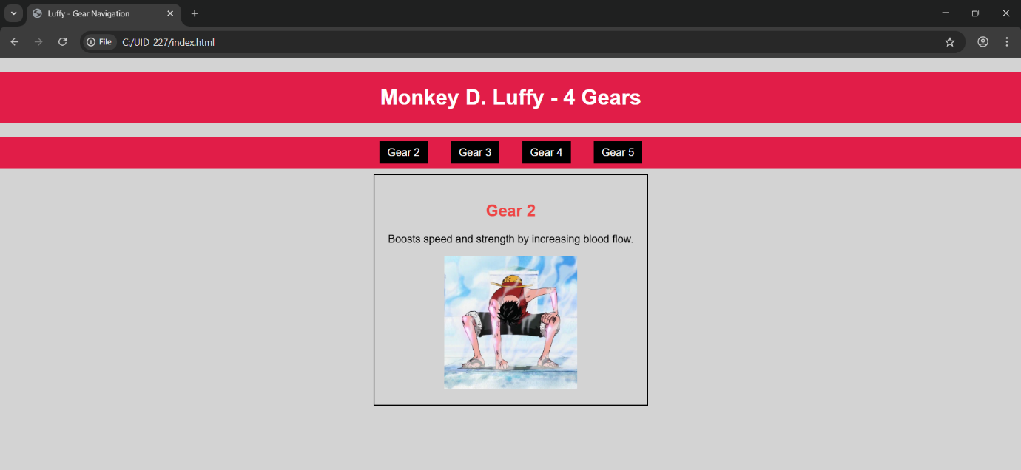

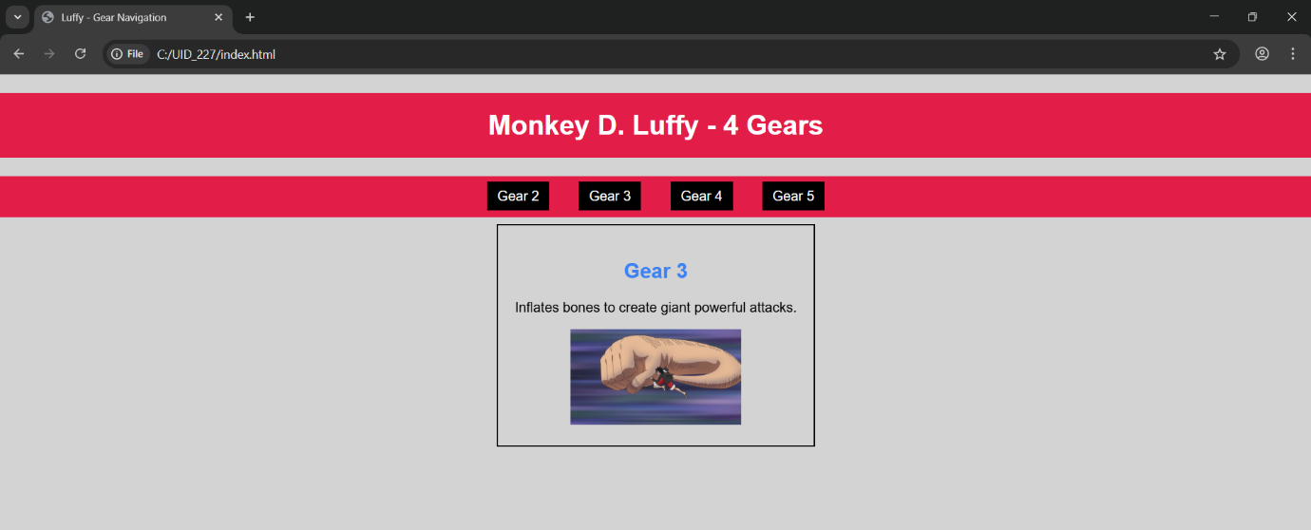

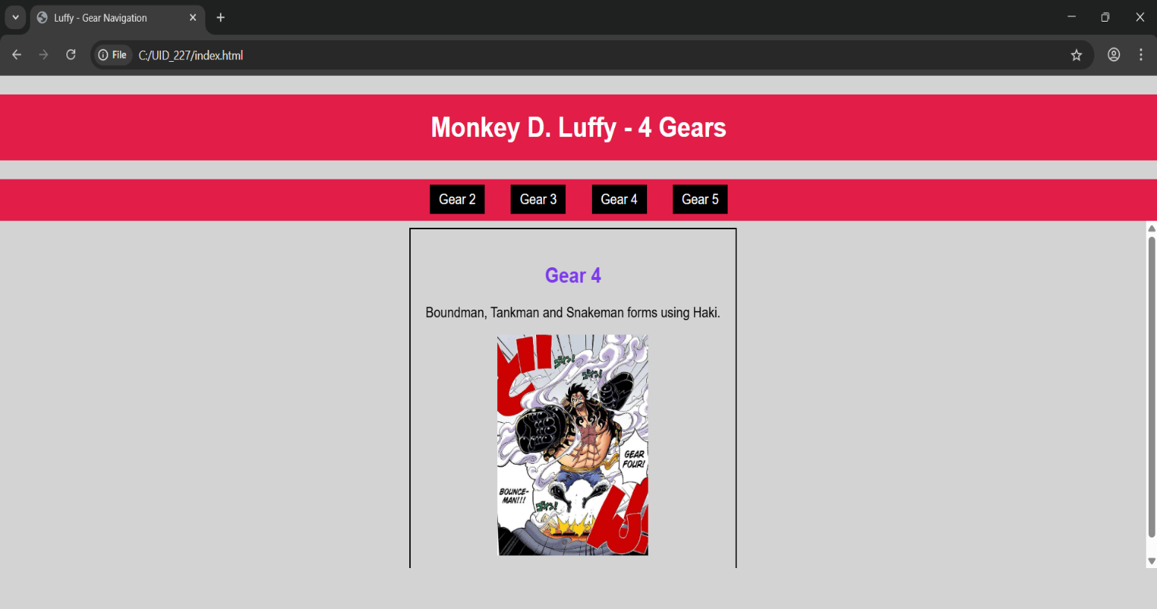

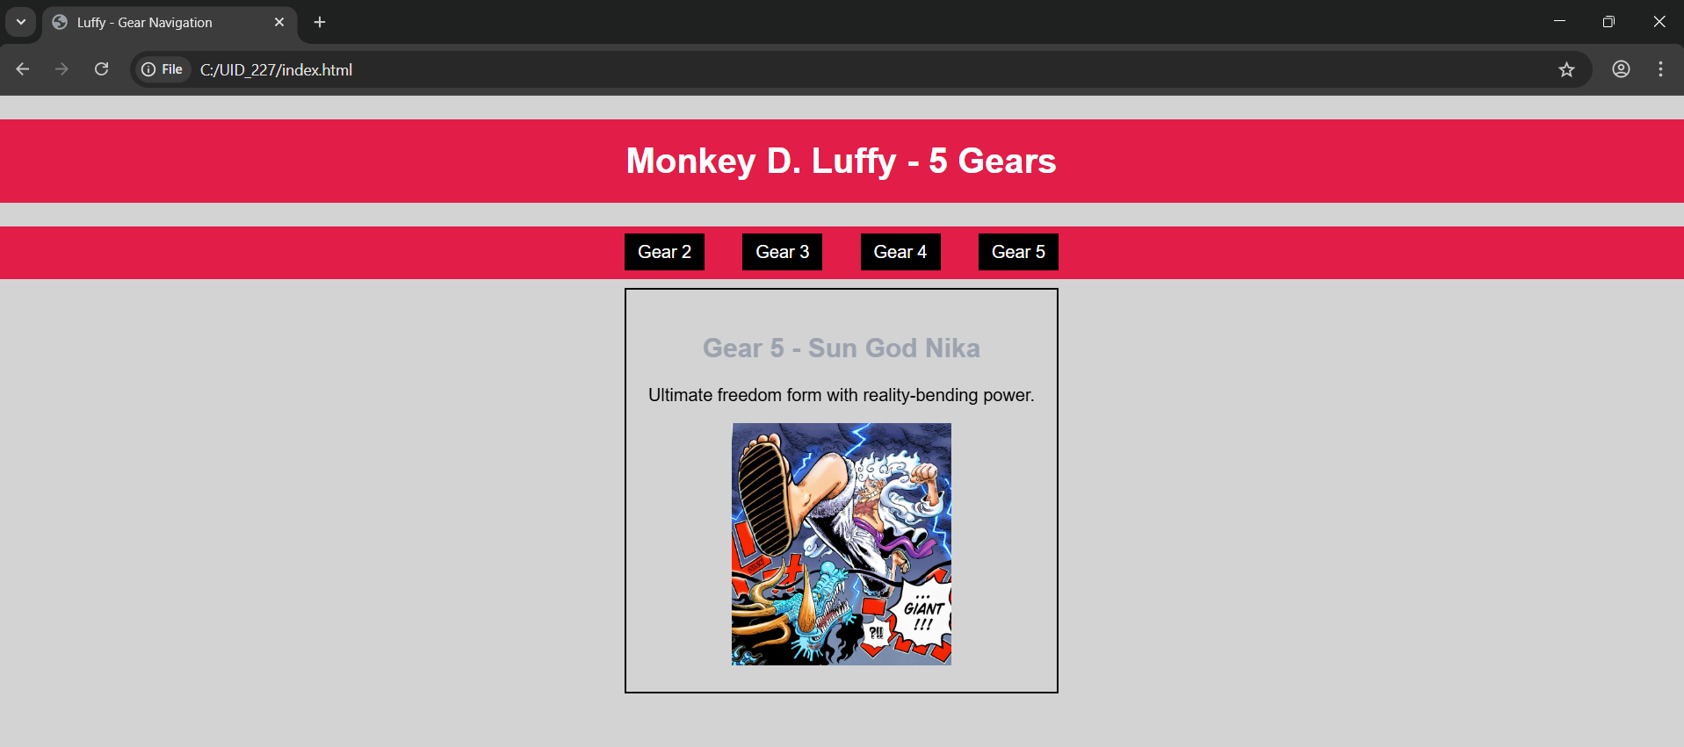

Explanation :
<!DOCTYPE html> : The <!DOCTYPE html> declaration tells the browser that the document is an HTML5 document and helps it display the webpage correctly.
<html> : The <html> element is the root element of the webpage. All other elements are placed inside this tag.
<head> : The <head> section contains metadata about the webpage such as title and styling information.
<title> : The <title> tag defines the title of the webpage, which appears in the browser tab.
<body> : The <body> element contains all the visible content of the webpage like text, images, links, tables, etc.
<h1> / <h2> : The heading tags are used to display headings on the webpage.
<p> : The <p> tag is used to write paragraphs.
<div> : The <div> element is used to group content into sections so that it can be styled or organized easily.
<a> : The <a> (anchor) tag is used to create links between webpages.
<iframe> : The <iframe> element is used to display another HTML page within the main webpage.
<img> : The <img> tag is used to display images on the webpage using the src attribute.
We used internal CSS inside the <style> tag in the head section to design the webpage. Element selectors and class selectors are used to apply styles to different sections. The href attribute in the anchor tag links the other HTML pages to the main page, and the target attribute is used to display those pages inside the iframe. The border styling is applied using inline CSS to create a visible box around the content.
By combining HTML structure and CSS styling, we created a mini website where multiple pages are connected to the main webpage using iframe navigation.
- c) Aim: Design amrita login page by showcampus on home page.upon clicking on each campus the details about each campus should be display on the same page use html and css to design a stylish webpage.

CODE:
[Amrita]
<!DOCTYPE html>
<html>
Name=sujan rollno:227
<head>
<title>Amrita Vishwa Vidhyapeetam</title>
<style>
body{margin:0;font-family:Arial;background:rgb(101, 101, 139);}
header{background:#0a0202;color:#fff;text-align:center;
padding:20px;font-size:36px;}
nav{background:#f7f2f5;text-align:center;padding:10px;}
nav a{color:rgb(231, 23, 169);margin:12px;text-decoration:none;
font-weight:bold;padding:5px;}
nav a:hover{background:#fff;color:#0b5ea6;
border-radius:5px;}
main{display:flex;padding:20px;}
.login{
width:350px;
background:#787676;
padding:15px;
border-radius:10px;
color:rgb(19, 18, 18);
}
.login input[type="email"],
.login input[type="password"]{
width:90%;
padding:6px;
margin:6px 0;
}
.remember{display:flex;align-items:center;gap:6px;margin:8px 0;}
iframe{
flex:1;
margin-left:20px;
height:520px;
border:none;
background:lightskyblue;
border-radius:10px;
}
</style>
</head>
<body>
<header>AMRITA VISHWA VIDHYAPEETAM</header>
<nav>
<a href="amaravati.html" target="campus">AMARAVATI</a>
<a href="amritapuri.html" target="campus">AMRITAPURI</a>
<a href="bengaluru.html" target="campus">BENGALURU</a>
<a href="chennai.html" target="campus">CHENNAI</a>
<a href="coimbatore.html" target="campus">COIMBATORE</a>
<a href="faridabad.html" target="campus">FARIDABAD</a>
<a href="kochi.html" target="campus">KOCHI</a>
<a href="mysuru.html" target="campus">MYSURU</a>
</nav>
<main>
<div class="login">
<h2>Login</h2>
Email
<input type="email">
Password
<input type="password">
<div class="remember">
<input type="checkbox"><label>Save me</label>
</div>
<input type="button" value="Login" style="width:100%;padding:6px;">
<br><br>
<a href="#">Forgot Password?</a><br>
No account? <a href="#">Register</a>
</div>
<iframe name="campus" src="c:\Users\sujan\Downloads\amrita.amaravathi.jpg"></iframe>
</main>
</body>
</html>
[amaravathi]
<!DOCTYPE html>
<html>
<body style="font-family:Arial; text-align:center; padding:30px;">
<h1 style="color:#a00000;">Amaravati Campus</h1>
<p>
Amrita Amaravati campus is located near the Krishna River in Andhra Pradesh.
It provides modern classrooms, research labs, and excellent hostel facilities.
</p>
<p>
Popular Courses: CSE, AI, Data Science<br>
Facilities: Library, Smart Classrooms, Hostel<br>
Focus: Innovation and Research
</p>
<img src="c:\Users\sujan\Downloads\amrita.amaravathi.jpg"
width="450">
</body>
</html>
[Bengaluru]
<!DOCTYPE html>
<html>
<body style="font-family:Arial;text-align:center;padding:30px;">
<h1 style="color:#a00000;">Bengaluru Campus</h1>
<p>
Located in India's tech hub, Bengaluru campus offers advanced
engineering programs with strong industry connections.
</p>
<p>
Popular Courses: Robotics, CSE, ECE<br>
Facilities: Coding Labs, Innovation Centres<br>
Focus: Industry Collaboration
</p>
<img src="c:\Users\sujan\Downloads\amrita.blr.jpg"
width="450">
</body>
</html>
[Amrithapuri]
<!DOCTYPE html>
<html>
<body style="font-family:Arial;text-align:center;padding:30px;">
<h1 style="color:#a00000;">Amritapuri Campus</h1>
<p>
Amritapuri campus in Kerala is the main campus of Amrita University,
located near the Arabian Sea with a peaceful academic atmosphere.
</p>
<p>
Popular Courses: Engineering, Arts, Sciences<br>
Facilities: Research Labs, Beach Campus, Hostel<br>
Focus: Academic Excellence with Values
</p>
<img src="c:\Users\sujan\Downloads\amrithapuri.jpg"
width="450">
</body>
</html>
[Chennai]
<!DOCTYPE html>
<html>
<body style="font-family:Arial;text-align:center;padding:30px;">
<h1 style="color:#a00000;">Chennai Campus</h1>
<p>
Chennai campus provides top-quality computing and management education
with modern infrastructure and placement support.
</p>
<p>
Popular Courses: IT, MBA, Electronics<br>
Facilities: Digital Library, Placement Cell<br>
Focus: Career Development
</p>
<img src="c:\Users\sujan\Downloads\amrita.chennai.jpg"
width="450">
</body>
</html>
[Coiambatore]
<!DOCTYPE html>
<html>
<body style="font-family:Arial;text-align:center;padding:30px;">
<h1 style="color:#a00000;">Coimbatore Campus</h1>
<p>
Coimbatore campus is well known for its engineering excellence
and research-oriented education.
</p>
<p>
Popular Courses: Mechanical, Civil, CSE<br>
Facilities: Workshops, Labs, Hostel<br>
Focus: Core Engineering Skills
</p>
<img src="c:\Users\sujan\Downloads\amrita.chennai.jpg"
width="450">
</body>
</html>
[Fairabadh]
<!DOCTYPE html>
<html>
<body style="font-family:Arial;text-align:center;padding:30px;">
<h1 style="color:#a00000;">Faridabad Campus</h1>
<p>
Faridabad campus focuses on medical and healthcare education
with advanced hospital training facilities.
</p>
<p>
Popular Courses: Medical, Nursing, Allied Health<br>
Facilities: Teaching Hospital, Labs<br>
Focus: Healthcare Research
</p>
<img src="c:\Users\sujan\Downloads\amrita.faridabad.jpg"
width="450">
</body>
</html>
[Kochi]
<!DOCTYPE html>
<html>
<body style="font-family:Arial;text-align:center;padding:30px;">
<h1 style="color:#a00000;">Kochi Campus</h1>
<p>
Kochi campus offers programs in business, commerce,
and applied sciences with modern facilities.
</p>
<p>
Popular Courses: MBA, Commerce, Finance<br>
Facilities: Seminar Halls, Library<br>
Focus: Industry Training
</p>
<img src="c:\Users\sujan\Downloads\amrita.kochi.jpg" width="450">
</body>
</html>
[Mysore]
<!DOCTYPE html>
<html>
<body style="font-family:Arial;text-align:center;padding:30px;">
<h1 style="color:#a00000;">Mysuru Campus</h1>
<p>
Mysuru campus is known for its peaceful environment,
green campus, and quality education.
</p>
<p>
Popular Courses: Arts, Sciences, Engineering<br>
Facilities: Hostel, Library, Sports Complex<br>
Focus: Calm Learning Atmosphere
</p>
<img src="c:\Users\sujan\Downloads\amrita.mysore.jpg" width="450">
</body>
</html>

OutPut;

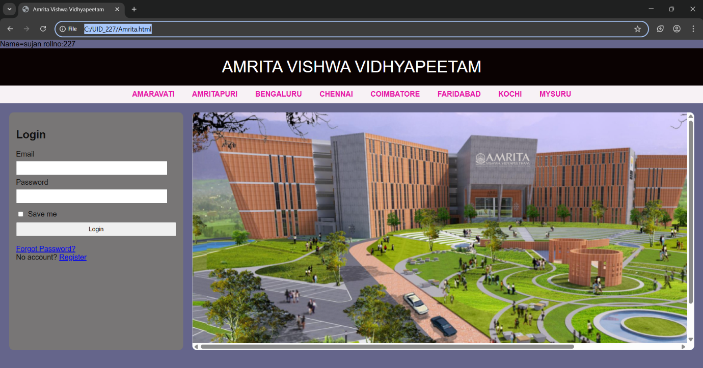

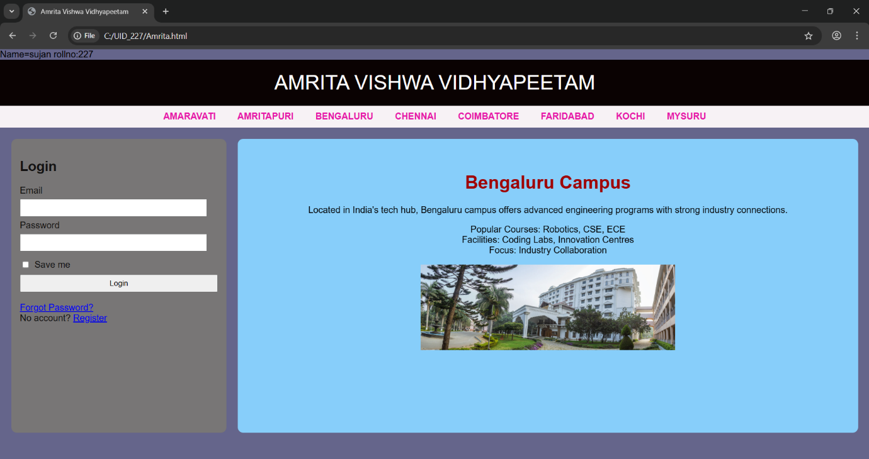

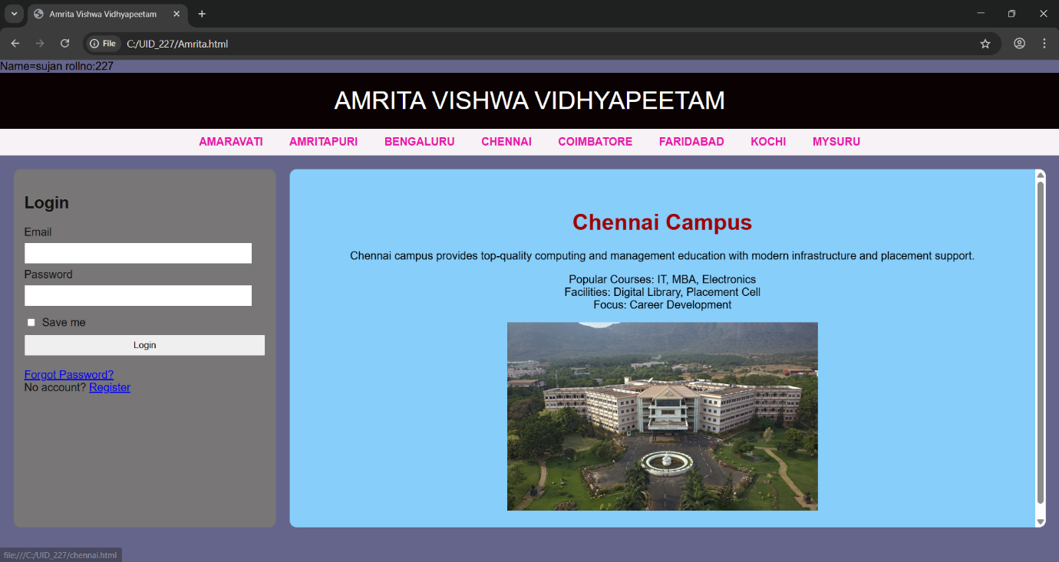

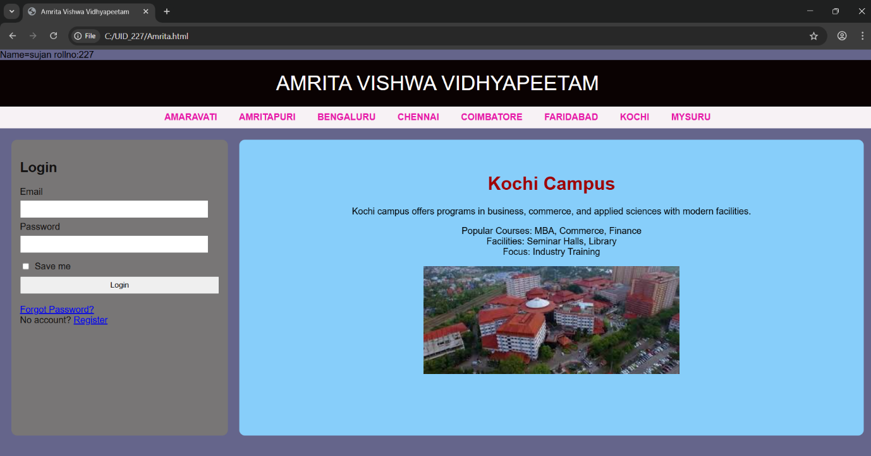

Week-6
6 ) Aim: Design a responsive e-commerc application using the grid layout. This application should contain different categories of products such as electronics, clothing, home-appliances, books. Based on the category we select corresponding products should be displayed on the sidebar.

CODE;
Main:
Name: Sujan
Roll No: 25227
Section: C
<!DOCTYPE html>
<html>
<head>
<title>My Ecommerce Store</title>

<style>

body{
font-family: Arial;
margin:0;
background:#f5f5f7;
}

.header{
background:#0f172a;
color:white;
text-align:center;
padding:20px;
font-size:28px;
}

.sale{
background:#2563eb;
color:white;
text-align:center;
padding:10px;
font-size:18px;
font-weight:bold;
}

.container{
display:flex;
min-height:80vh;
}

.sidebar{
width:200px;
background:#1e293b;
color:white;
padding:20px;
}

.sidebar h3{
margin-top:0;
}

.sidebar a{
display:block;
color:white;
text-decoration:none;
padding:10px 0;
border-bottom:1px solid #334155;
}

.sidebar a:hover{
color:#60a5fa;
}

.frame{
flex:1;
border:none;
}

.footer{
background:#0f172a;
color:white;
text-align:center;
padding:15px;
}

</style>
</head>

<body>

<div class="header">
My Ecommerce Store
</div>

<div class="sale">
Big Sale! Up to 50% Off
</div>

<div class="container">

<div class="sidebar">
<h3>Categories</h3>

<a href="ecomelec.html" target="frame">Electronics</a>
<a href="ecomcloth.html" target="frame">Clothes</a>
<a href="ecomacces.html" target="frame">Accessories</a>

</div>

<iframe class="frame" name="frame" src="electronics.html"></iframe>

</div>

<div class="footer">
© 2026 My Ecommerce Store
</div>

</body>
</html>
Electronics
<!DOCTYPE html>
<html>
<head>
<title>Electronics</title>
<style>
body {
margin: 0;
background-color: aliceblue;
font-family: sans-serif;
}

.products {
grid-area: products;
display: grid;
grid-template-columns: repeat(2, 1fr);
gap: 10px;
padding: 20px;
}

.product-card {
background: white;
border: 1px solid #ddd;
padding: 20px;
text-align: center;
border-radius: 8px;
height: auto;
width: 600px;
}
.p{
text-align: center;
background-color: tomato;
align-items: center;
}
img{
width: 120px;
height: auto;
border-radius: 8px;
}

.button {
background-color: blue;
color: white;
border: none;
padding: 10px 20px;
cursor: pointer;
border-radius: 50px;
margin-top: 10px;
}

.button:hover {
background-color: #7094ff;
}
</style>
</head>
<body>
<div class="products">
<div class="product-card">
<img src="c:\Users\sujan\OneDrive\Pictures\iphone.jpg">
<h3>Iphone 17 pro max</h3>
<p>$899</p>
<p>12GB RAM | 1TB Storage</p>
<button class="button">Add to Cart</button>
</div>
<div class="product-card">
<img src="c:\Users\sujan\OneDrive\Pictures\sams26.jpg">
<h3>Samsung Galaxy S26</h3>
<p>$1199</p>
<p>12GB RAM | 512GB Storage</p>
<button class="button">Add to Cart</button>
</div>
<div class="product-card">
<img src="c:\Users\sujan\OneDrive\Pictures\nord5.avif">
<h3>One PLus Nord 5</h3>
<p>$299</p>
<p>12GB RAM | 256GB Storage</p>
<button class="button">Add to Cart</button>
</div>
<div class="product-card">
<img src="c:\Users\sujan\OneDrive\Pictures\nothing3a.jpg">
<h3>Nothing 3a</h3>
<p>$249</p>
<p>12GB RAM | 256GB Storage</p>
<button class="button">Add to Cart</button>
</div>
</div>
</body>

Clothes:
<!DOCTYPE html>
<html>
<head>
<title>Electronics</title>
<style>
body {
margin: 0;
background-color: aliceblue;
font-family: sans-serif;
}

.products {
grid-area: products;
display: grid;
grid-template-columns: repeat(2, 1fr);
gap: 20px;
padding: 20px;
}

.product-card {
background: white;
border: 1px solid #ddd;
padding: 20px;
text-align: center;
border-radius: 8px;
}
img{
width: 120px;
height: auto;
border-radius: 8px;
}
.p{
text-align: center;
background-color: tomato;
align-items: center;
}

.button {
background-color: blue;
color: white;
border: none;
padding: 10px 20px;
cursor: pointer;
border-radius: 50px;
margin-top: 10px;
}

.button:hover {
background-color: #7094ff;
}
</style>
</head>
<body>
<div class="products">
<div class="product-card">
<img src="c:\Users\sujan\OneDrive\Pictures\blueshirt.avif">
<h3>H&M blue shirt</h3>
<p>$39</p>
<p>Size: S , M , XL , XXL</p>
<button class="button">Add to Cart</button>
</div>
<div class="product-card">
<img src="c:\Users\sujan\OneDrive\Pictures\blackshirt.jpg">
<h3>H&M Black shirt</h3>
<p>$59</p>
<p>Size: S , M , L , XL</p>
<button class="button">Add to Cart</button>
</div>
<div class="product-card">
<img src="c:\Users\sujan\OneDrive\Pictures\black jean.avif">
<h3>H&M black pants</h3>
<p>$49</p>
<p>Size: 28 , 30 , 32 , 34</p>
<button class="button">Add to Cart</button>
</div>
<div class="product-card">
<img src="c:\Users\sujan\OneDrive\Pictures\blue jean.jpg">
<h3>USPA blue pants</h3>
<p>$52</p>
<p>Size: 28 , 30 , 32 , 34</p>
<button class="button">Add to Cart</button>
</div>
</div>
</body>

Accescories:

<!DOCTYPE html>
<html>
<head>
<title>Electronics</title>
<style>
body {
margin: 0;
background-color: aliceblue;
font-family: sans-serif;
}

.products {
grid-area: products;
display: grid;
grid-template-columns: repeat(2, 1fr);
gap: 20px;
padding: 20px;
}

.product-card {
background: white;
border: 1px solid #ddd;
padding: 20px;
text-align: center;
border-radius: 8px;
}
.p{
text-align: center;
background-color: tomato;
align-items: center;
}
img{
width: 120px;
height: auto;
border-radius: 8px;
}

.button {
background-color: blue;
color: white;
border: none;
padding: 10px 20px;
cursor: pointer;
border-radius: 50px;
margin-top: 10px;
}

.button:hover {
background-color: #7094ff;
}
</style>
</head>
<body>
<div class="products">
<div class="product-card">
<img src="c:\Users\sujan\OneDrive\Pictures\Samsung Galaxy Watch 6.jpg">
<h3>Samsung Galaxy Watch 6</h3>
<p>$169</p>
<button class="button">Add to Cart</button>
</div>
<div class="product-card">
<img src="c:\Users\sujan\OneDrive\Pictures\Samsung Galaxy Buds 4.jpg" >
<h3>Samsung Galaxy Buds 4</h3>
<p>$249</p>
<button class="button">Add to Cart</button>
</div>
<div class="product-card">
<img src="c:\Users\sujan\OneDrive\Pictures\Samsung Galaxy ring.avif">
<h3>Samsung Galaxy ring </h3>
<p>$459</p>
<button class="button">Add to Cart</button>
</div>
<div class="product-card">
<img src="c:\Users\sujan\OneDrive\Pictures\i pocket.jpg">
<h3>i pocket </h3>
<p>$59</p>
<button class="button">Add to Cart</button>
</div>
</div>
</body>

Output:

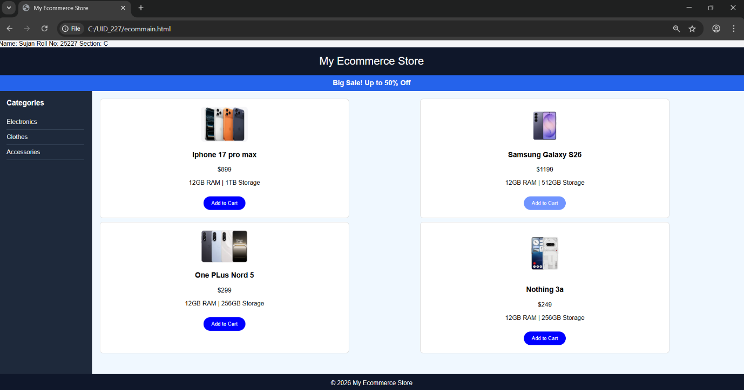

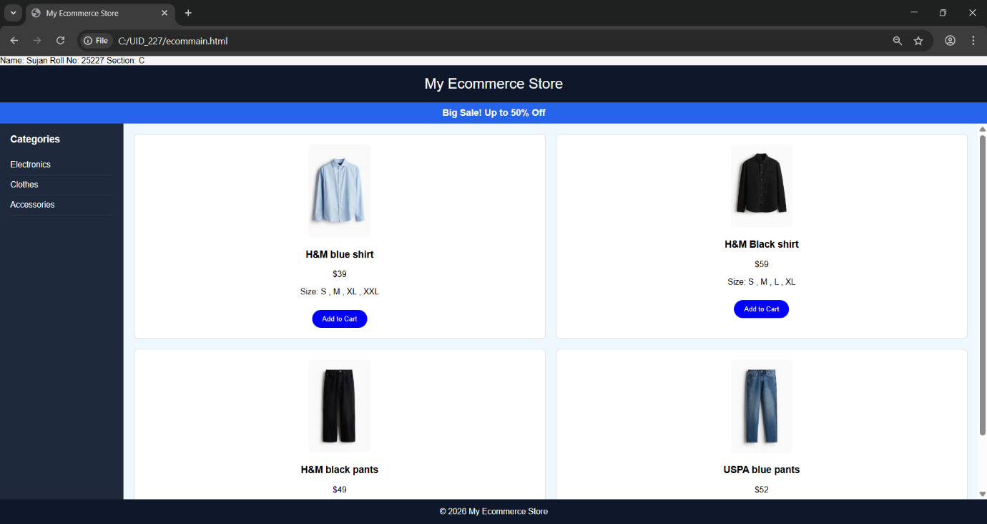

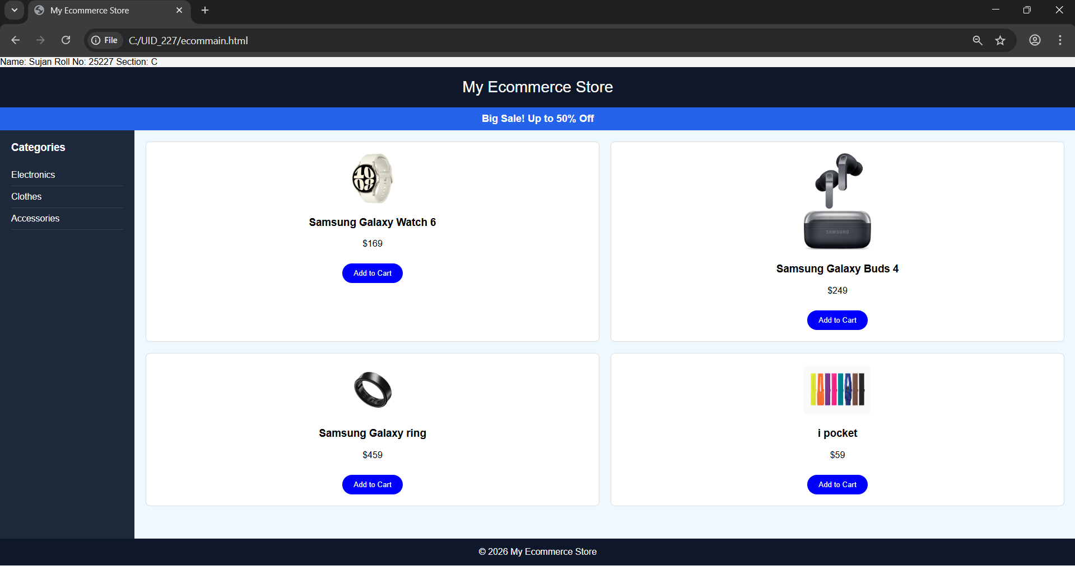

Week-7
7. Aim: create a GitHub account and create a repository in it and push all the week 6 code files in it.

Procedure :
Step 1: browse for GitHub and enter it.
Step 2:login to GitHub account.
Step 3:create a repository after login by clicking new.

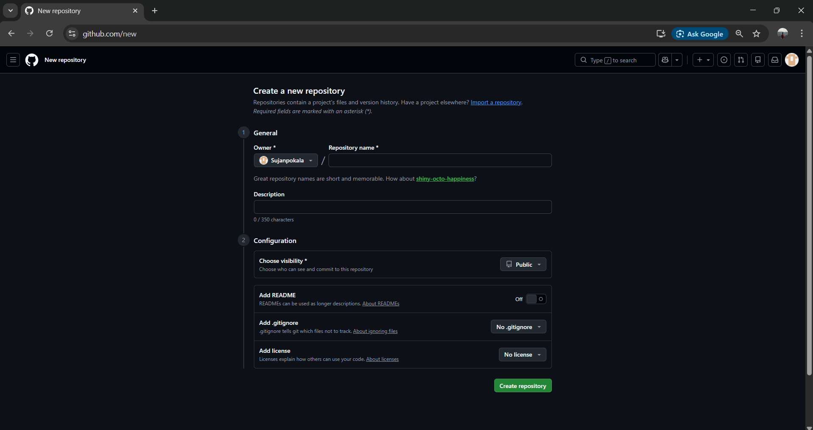

Step 4:specify the repository specifications.
Step 5:download GitHub desktop and Lauch it .
Step 6:add the repository to it .
Step 7:add the vs code file to the GitHub desktop.
Step 8:add commit to it and the files to repository and sync the changes . it automatically pushes the files .
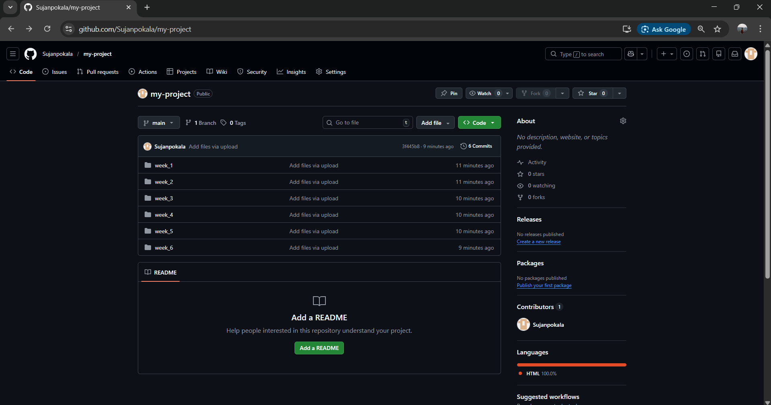

Step 9:now go to browser and check it . it will show all the new added files in the repository .
My repository link for the uid all week’s work:
https://github.com/Sujanpokala/my-project

Week-8
8.A) Aim: create a web page that displays a square that continuously rotates 360 using css animation.
Program :
Name:sujan
Rollno:227
<!DOCTYPE html>
<html>
<head>
<title>Rotating Square</title>
<style>
body {
margin: 0;
height: 100vh;
display: flex;
flex-direction: column;
justify-content: flex-start;
align-items: center;
background-color: #2f3e46;
font-family: Arial, sans-serif;
padding-top: 50px;
}
.square {
width: 120px;
height: 120px;
background: #ffffffcc;
border-radius: 12px;
box-shadow: 0 8px 25px rgba(0, 0, 0, 0.2);
animation: rotate 3s linear infinite;
}
@keyframes rotate {
from {
transform: rotate(0deg);
}
to {
transform: rotate(360deg);
}
}
</style>
</head>
<body>
<h1 style="color: #fff;">Rotating Square</h1>
<div class="square"></div>
</body>
</html>
Output:
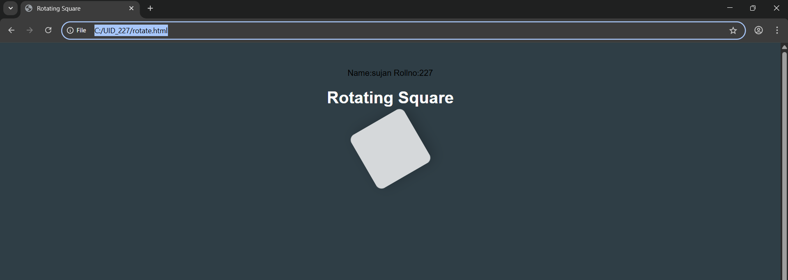

<!DOCTYPE html> :
This declaration tells the browser that the document is written in HTML5 and should be displayed accordingly.
<html> :
This is the root element of an HTML page. All other elements are placed inside it.
<head> :
This section contains metadata about the webpage, such as title, styles, and other information not directly visible on the page.
<title> :
Defines the title of the webpage, which appears on the browser tab.
<body> :
Contains all the visible content of the webpage like text, images, links, tables, etc.
<h1> to <h6> :
Heading tags used to define headings, where <h1> is the largest and <h6> is the smallest.

<div> :
A container element used to group sections of content, making it easier to style and manage layouts.
@keyframes :
Used in CSS to define animations by specifying the changes in styles at different stages (from start to end).
Animation properties :
The animation shorthand property is used to apply animations by combining duration, timing, delay, and other settings in one line.
CSS usage :
Internal CSS is used within the <style> tag to design the webpage, and style attributes are applied to enhance appearance.

8.B) Aim :create a ball that moves up and down continuously using css animation.
Program :
Name:sujan
Roll.no:227
<!DOCTYPE html>
<html>
<head>
<title>Bouncing Ball</title>
<style>
body {
margin: 0;
height: 100vh;
display: flex;
flex-direction: column;
align-items: center;
justify-content: flex-start;
background: #2f3e46;
}
h1 {
margin-top: 20px;
color: #ffffff;
}
.ball {
width: 80px;
height: 80px;
background: #ffffff;
border-radius: 50%;
margin-top: 120px;
animation: bounce 1.5s ease-in-out infinite;
}
@keyframes bounce {
0% {
transform: translateY(0);
}
50% {
transform: translateY(-120px);
}
100% {
transform: translateY(0);
}
}
</style>
</head>
<body>
<h1>Bouncing Ball</h1>
<div class="ball"></div>
</body>
</html>
OutPut:
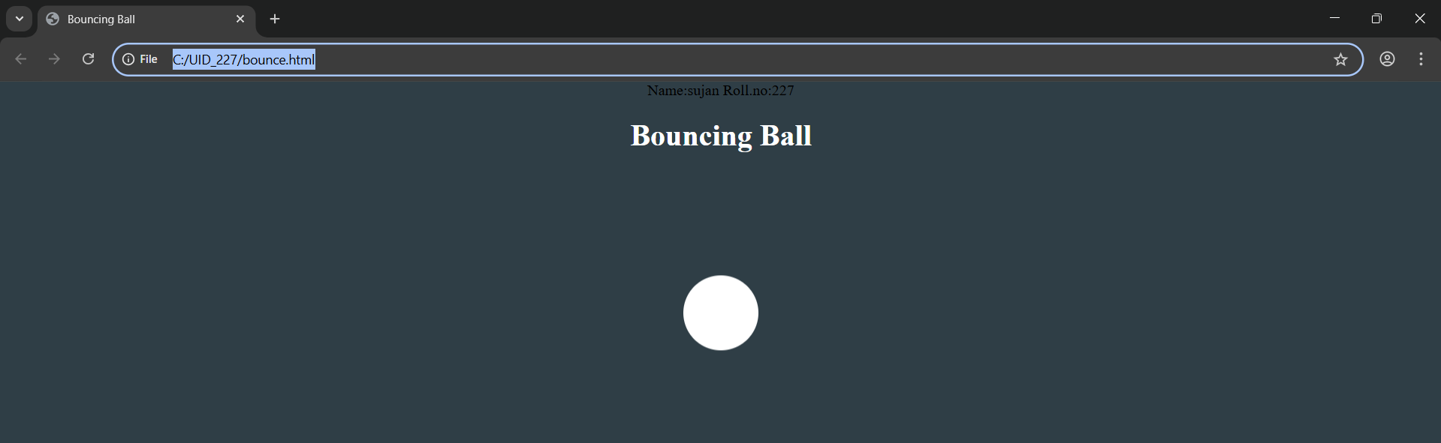

Explanation:
<DOCTYPE html> : the <!DOCTYPE html> element tells the web browser that this an HTML document
or this is the latest version of HTML
<html> : the <html> element is the root element of an HTML web page
<head> : the <head> element will contain meta data about the HTML web page
<title> : the <title> element specifies a title for the HTML Page
<body> : the <body> element contains all visible content all visible content like text , image , links ,
tables , etc
<div>:we use <div> element for encapsulating the the divisions and easy to modify and
@keyframes:we use @keyframes for animation from starting to end transformation.
We used animation shorthand property for these things to mention the animations preferences and
use keyframes for mentioning the positions of the animation and used style attribute and some value
properties for look and we used internal css in it .

8. .
Program:
Name:sujan
Roll.no:227
<!DOCTYPE html>
<html lang="en">
<head>
<title>Moving Rotating Circle</title>
<style>
body {
margin: 0;
height: 100vh;
display: flex;
flex-direction: column;
align-items: center;
justify-content: flex-start;
background: #2f3e46;
overflow: hidden;
}
h1 {
margin-top: 20px;
color: #ffffff;
}
.circle {
width: 80px;
height: 80px;
background: #ffffff;
border-radius: 50%;
margin-top: 120px;
animation: moveRotate 3s linear infinite;
}
@keyframes moveRotate {
0% {
transform: translateX(-150px) rotate(0deg);
}
50% {
transform: translateX(150px) rotate(180deg);
}
100% {
transform: translateX(-150px) rotate(360deg);
}
}
</style>
</head>
<body>
<h1>Moving Rotating Circle</h1>

<div class="circle"></div>
</body>
</html>
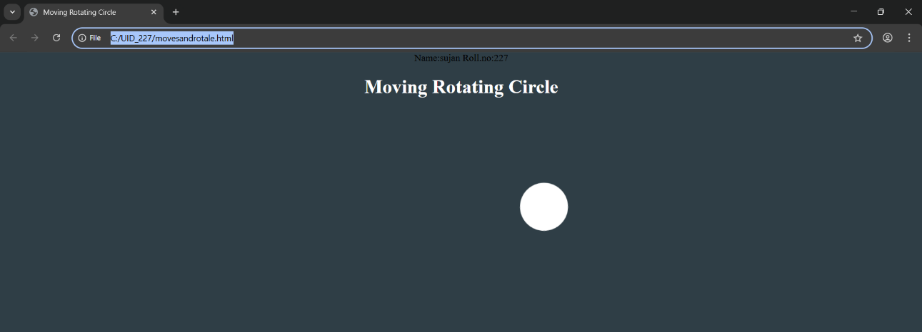
OutPut:

Week-9
9. Aim: Week 9:Create a webpage using html,css,js based on the give conditions, create a button for each program , based on the button, clicked the corresponding program has to be executed and should display the logics for each button includes finding an even or odd number , prime or not , factorial of a number , Armstrong or not use appropriate design to display the output.

Program:
<!DOCTYPE html>
<html>
<head>
<title>Logic Programs</title>
<style>
body {
margin: 0;
font-family: "Segoe UI", Arial, sans-serif;
background: linear-gradient(135deg, #2c2c2c, #3a3a3a);
display: flex;
justify-content: center;
align-items: center;
min-height: 100vh;
}

.container {
background: #ffffff;
border-radius: 16px;
box-shadow: 0 10px 30px rgba(0,0,0,0.25);
padding: 40px;
width: 380px;
text-align: center;
}

h2 {
margin-bottom: 25px;
color: #222;
font-weight: 600;
letter-spacing: 1px;
}

input {
width: 100%;
padding: 12px;
font-size: 16px;
border: 1.5px solid #ccc;
border-radius: 10px;
margin-bottom: 20px;
text-align: center;
transition: all 0.3s ease;
}

input:focus {
outline: none;
border-color: #888;
box-shadow: 0 0 8px rgba(0,0,0,0.1);
}

.buttons {
display: grid;
grid-template-columns: 1fr 1fr;
gap: 12px;
margin-bottom: 24px;
}

button {
padding: 12px;
font-size: 14px;
border: none;
border-radius: 10px;
cursor: pointer;
color: #fff;
font-weight: 500;
background: linear-gradient(135deg, #5a5a5a, #2f2f2f);
transition: all 0.25s ease;
}

button:hover {
transform: translateY(-2px);
box-shadow: 0 6px 12px rgba(0,0,0,0.2);
}

.output {
background: #f5f5f5;
padding: 18px;
border-radius: 10px;
min-height: 60px;
color: #333;
font-size: 16px;
border: 1px solid #ddd;
}
</style>
</head>

<body>

<div class="container">
<h2>Logic Programs</h2>

<input type="number" id="numInput" placeholder="Enter a number" />

<div class="buttons">
<button onclick="checkEvenOdd()">Even / Odd</button>
<button onclick="checkPrime()">Prime / Not</button>
<button onclick="calcFactorial()">Factorial</button>
<button onclick="checkArmstrong()">Armstrong</button>
</div>

<div class="output" id="output">Result will appear here</div>
</div>

<script>
function getInput() {
const val = document.getElementById('numInput').value.trim();
if (val === '' || isNaN(val)) {
document.getElementById('output').textContent = 'Please enter a valid number.';
return null;
}
return parseInt(val);
}

function setOutput(text) {
document.getElementById('output').textContent = text;
}

function checkEvenOdd() {
const n = getInput();
if (n === null) return;
setOutput(n + ' is ' + (n % 2 === 0 ? 'Even' : 'Odd'));
}

function checkPrime() {
const n = getInput();
if (n === null) return;
if (n < 2) { setOutput(n + ' is Not Prime'); return; }
for (let i = 2; i <= Math.sqrt(n); i++) {
if (n % i === 0) {
setOutput(n + ' is Not Prime');
return;
}
}
setOutput(n + ' is Prime');
}

function calcFactorial() {
const n = getInput();
if (n === null) return;
if (n < 0) {
setOutput('Factorial not defined for negative numbers');
return;
}
let result = 1;
for (let i = 2; i <= n; i++) result *= i;
setOutput(n + '! = ' + result);
}
function checkArmstrong() {
const n = getInput();
if (n === null) return;
const digits = String(n).split('');
const power = digits.length;
const sum = digits.reduce((acc, d) => acc + Math.pow(Number(d), power), 0);
setOutput(n + (sum === n ? ' is an Armstrong number' : ' is Not an Armstrong number'));
}
</script>
</body>
</html>
OutPut;
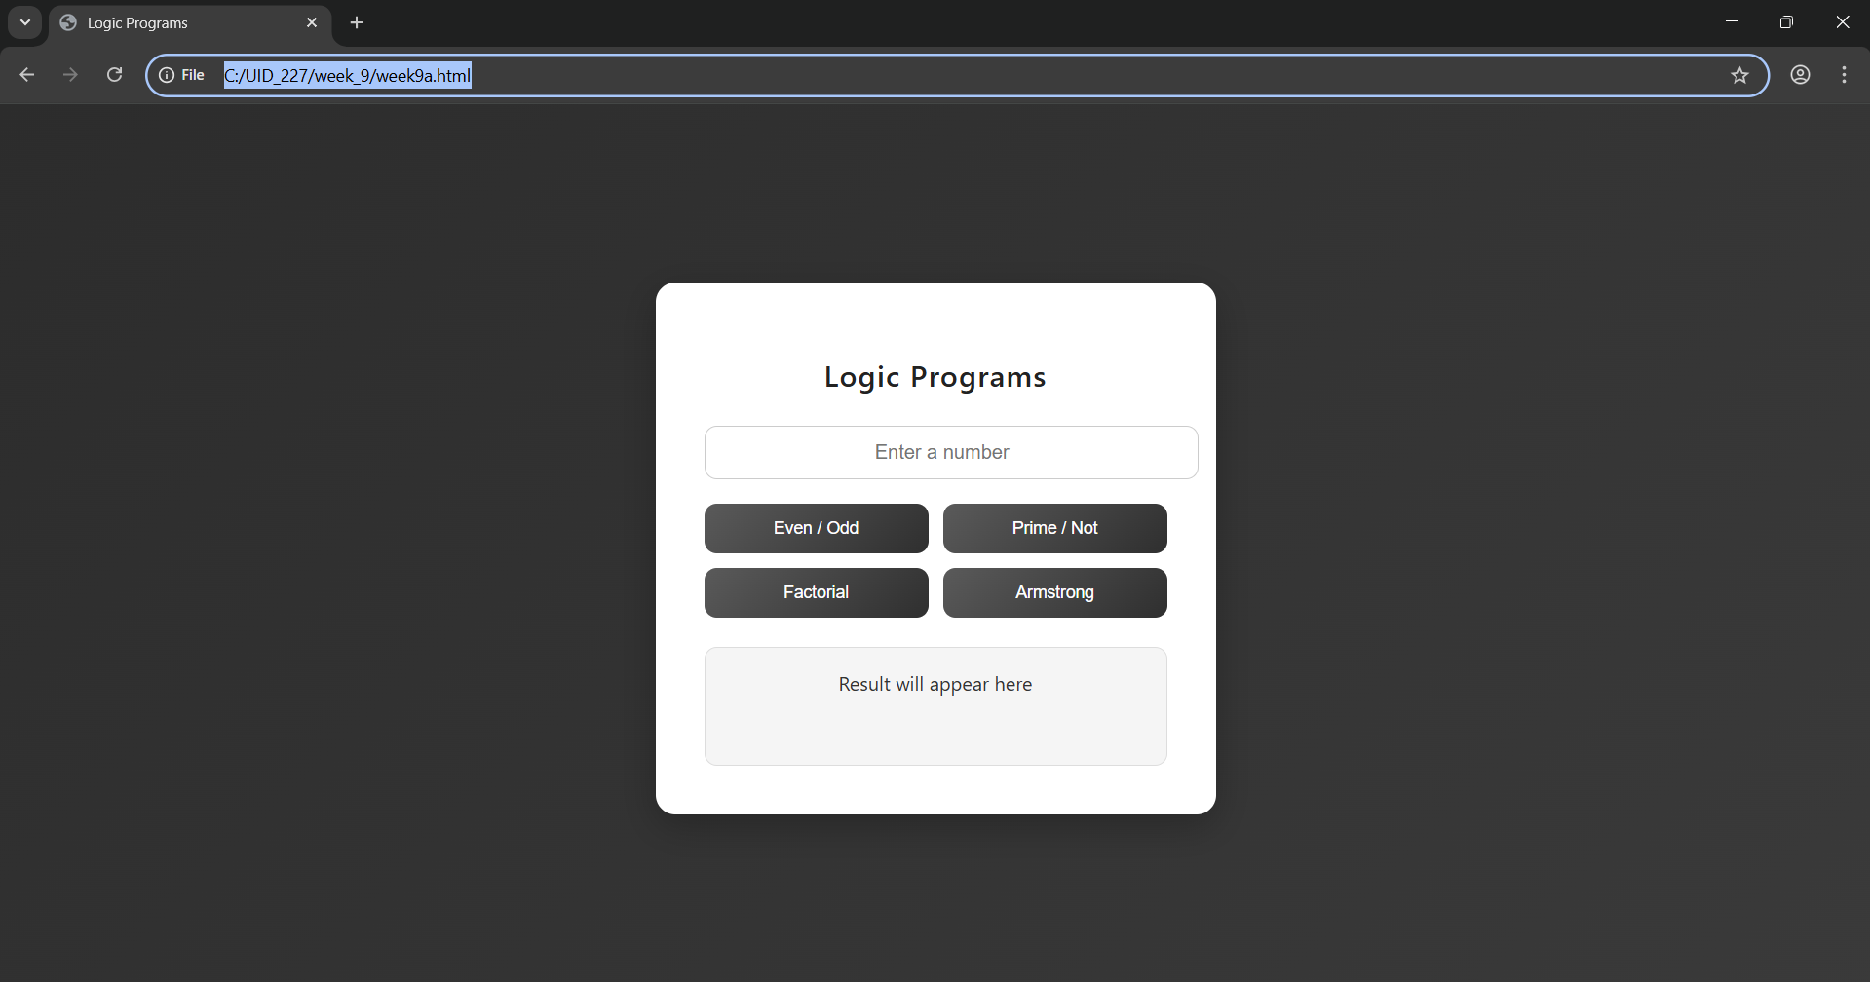

Explaination ;
<!DOCTYPE html> : this tells the browser “yo, this is an HTML5 page”, so it knows how to properly load everything
<html> : this is the main root element — everything inside the webpage sits inside this
<head> : contains background stuff (metadata) like title, styles, etc. — not directly visible on screen
<title> : sets the name of the webpage (the tab name you see in browser)
<body> : this is where all visible stuff comes — text, images, buttons, links, tables, etc.
<h> : used for headings (like titles or section names on the page)
<div> : acts like a container/box — helps group things so styling and layout becomes easier
<style> : used to write CSS — basically controls the look (colors, spacing, layout, design)
body (CSS selector) : used to style the full page — here it sets background and centers content
.container : styles the main card — gives white background, padding, rounded edges and shadow
input : styles the input field — controls size, spacing, border and text alignment
button : styles buttons — sets color, size, border and adds hover effect
.output : styles the result box — where output text will be shown
<input> : used to take user input — type="number" means only numbers allowed, id helps JS access it
<div class="buttons"> : groups all buttons together for layout control
<button> : clickable element — onclick triggers JavaScript functions
<div id="output"> : displays the result — initially shows default message
<script> : used to write JavaScript — adds logic and interactivity to the page
getElementById() : used to select an element using its id
.value : gets the value entered in input field
.textContent : used to update or display text inside an element
function : defines a block of code that runs when called
checkEvenOdd() : checks if number is even or odd using modulus % 2
checkPrime() : checks if number is prime using loop and division logic
calcFactorial() : calculates factorial by multiplying numbers from 1 to n
checkArmstrong() : checks if number is Armstrong (sum of digits^power equals original number)
Math.sqrt() : returns square root (used to optimize prime checking)
parseInt() : converts input (string) into integer
isNaN() : checks whether the value is not a number

Week-10
10. Aim: write JavaScript conditional statement to find the sign of product of three numbers using functions .Display an alert box with specified sign .write a java script conditional statements to sort 3 numbers using functions display an alert box to show the result.write a java script conditional statement to find largest of find largest of five numbers using function and onclick event .display an alert box to show the result .write a java script for loop that will iterate from 0 to 15. For each iteration ,it will check if the current number odd or even , and display a message on screen .write a java script program to read 6 subjects marks from the student then computes the average marks of students then , this average is used to determine the corresponding grade.

Program :
<!DOCTYPE html>
<html>
<head>
<title>Logic Programs</title>
<style>
body {
margin: 0;
font-family: "Segoe UI", Arial, sans-serif;
display: flex;
height: 100vh;
background: #121212;
color: #fff;
}

.left {
width: 30%;
background: #1e1e1e;
padding: 25px;
border-right: 1px solid #333;
box-shadow: inset -5px 0 10px rgba(0,0,0,0.4);
}

.right {
width: 70%;
background: #181818;
padding: 30px;
}

h3 {
margin-top: 0;
font-weight: 500;
color: #e0e0e0;
}

input {
width: 95%;
padding: 12px;
margin-bottom: 15px;
border-radius: 8px;
border: 1px solid #444;
background: #2a2a2a;
color: white;
font-size: 14px;
}

input:focus {
outline: none;
border-color: #888;
box-shadow: 0 0 6px rgba(255,255,255,0.1);
}

button {
width: 100%;
padding: 12px;
margin-bottom: 12px;
background: linear-gradient(135deg, #3a3a3a, #2a2a2a);
border: 1px solid #444;
border-radius: 8px;
color: #fff;
font-weight: 500;
cursor: pointer;
transition: all 0.2s ease;
}

button:hover {
transform: translateY(-2px);
background: #444;
box-shadow: 0 4px 10px rgba(0,0,0,0.4);
}

#output {
background: #222;
padding: 25px;
border-radius: 10px;
min-height: 220px;
white-space: pre-line;
border: 1px solid #333;
font-size: 15px;
color: #e6e6e6;
}
</style>
</head>

<body>

<div class="left">
<h3>Input Panel</h3>
<input type="text" id="numbers" placeholder="Enter values (e.g. 1,2,3)">

<button onclick="signProduct()">Sign of Product</button>
<button onclick="sortNumbers()">Sort Numbers</button>
<button onclick="largestNumber()">Largest Number</button>
<button onclick="oddEvenLoop()">Odd / Even</button>
<button onclick="studentGrade()">Student Grade</button>
</div>

<div class="right">
<h3>Output Console</h3>
<div id="output">Result will appear here</div>
</div>

<script>
function getNumbers() {
let input = document.getElementById("numbers").value;
return input.split(",").map(Number);
}

function signProduct() {
let input = document.getElementById("numbers").value;
if (input === "") {
document.getElementById("output").textContent =
"Enter 3 numbers like: 0,-1,4";
return;
}
let nums = getNumbers();
let negative = 0;
for (let n of nums) {
if (n < 0) negative++;
}
let result = (negative % 2 == 0) ? "+1" : "-1";
alert(result);
document.getElementById("output").textContent = "Sign: " + result;
}

function sortNumbers() {
let input = document.getElementById("numbers").value;
if (input === "") {
document.getElementById("output").textContent =
"Enter 3 numbers like: 0,-1,4";
return;
}
let nums = getNumbers();
nums.sort((a, b) => b - a);
alert(nums.join(", "));
document.getElementById("output").textContent =
"Sorted: " + nums.join(", ");
}

function largestNumber() {
let input = document.getElementById("numbers").value;
if (input === "") {
document.getElementById("output").textContent =
"Enter 5 numbers like: -5,-2,-6,0,-1";
return;
}
let nums = getNumbers();
let max = nums[0];
for (let n of nums) {
if (n > max) max = n;
}
alert("Largest: " + max);
document.getElementById("output").textContent =
"Largest: " + max;
}

function oddEvenLoop() {
let input = document.getElementById("numbers").value;
if (input === "") {
document.getElementById("output").textContent =
"Enter a number like: 15";
return;
}
let n = Number(input);
let result = "";
for (let i = 0; i <= n; i++) {
if (i % 2 == 0)
result += i + " is Even\n";
else
result += i + " is Odd\n";
}

document.getElementById("output").textContent = result;
}

function studentGrade() {
let input = document.getElementById("numbers").value;
if (input === "") {
document.getElementById("output").textContent =
"Enter marks like: 70,80,90,60,75,85";
return;
}
let nums = getNumbers();
let sum = 0;
for (let n of nums) sum += n;
let avg = sum / nums.length;
let grade;

if (avg >= 90) grade = "A";
else if (avg >= 75) grade = "B";
else if (avg >= 60) grade = "C";
else grade = "D";

alert("Average: " + avg + " Grade: " + grade);
document.getElementById("output").textContent =
"Average: " + avg + " | Grade: " + grade;
}
</script>

</body>
</html>

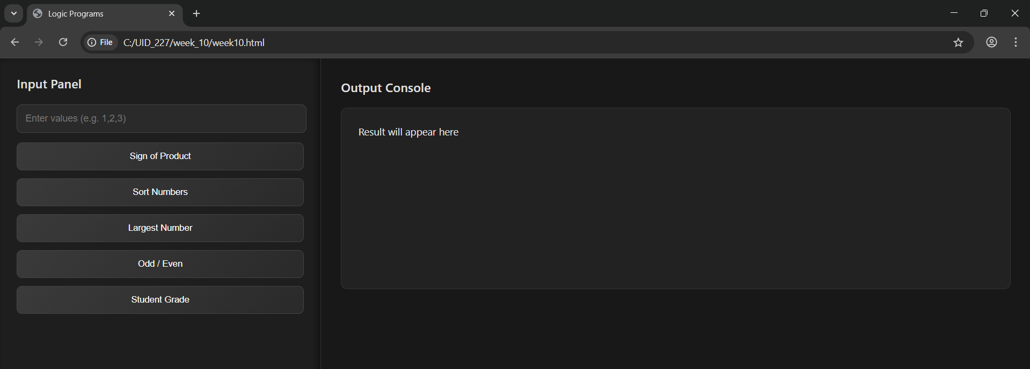
OutPut;

Explaination ;
<!DOCTYPE html> : tells the browser that this file is written in HTML5 so it should render it properly
<html> : this is the root container — everything in the webpage is placed inside this
<head> : contains background info like title and styling (not shown directly on screen)
<title> : sets the name that appears on the browser tab
<style> : used to add CSS — controls how the page looks (colors, layout, spacing, etc.)
body : styles the whole page — here it sets font, uses flex layout and full screen height
.left : designs the left panel — gives width, background color, padding and border
.right : styles the right section — used to display output with background and spacing
input : used to design the text field — controls width, padding and spacing
button : styles all buttons — sets size, color, removes border and makes it clickable
#output : styles the output area — gives background, padding and keeps line breaks visible
<body> : contains everything visible like input box, buttons and output section
<div class="left"> : left side section where user enters input and clicks buttons
<div class="right"> : right side section where results are displayed
<input> : takes user input — here it accepts text like numbers separated by commas
<button> : used for actions — onclick calls specific JavaScript functions
<div id="output"> : area where output is shown — default text appears before execution
<script> : used to write JavaScript — adds functionality to the webpage
getNumbers() : takes input, splits values by comma and converts them into numbers
getElementById() : selects an element using its id
.value : gets the text entered by user
.textContent : used to display or update text inside output box
signProduct() : checks sign of product based on count of negative numbers
sortNumbers() : sorts numbers in descending order using sort function
largestNumber() : finds the biggest number from given list using loop
oddEvenLoop() : prints whether numbers from 0 to given value are odd or even
studentGrade() : calculates average marks and assigns grade based on conditions
split() : breaks string into parts using comma
map(Number) : converts string values into numbers
sort() : used to arrange numbers in order
for...of loop : used to iterate through array elements
if-else : used for decision making
alert() : shows popup message with result
Number() : converts input into number type

Week-11
- Aim: A website requires users to enter a username. The system should display a message while typing if the username is less than 5 characters.

Program:
<!DOCTYPE html>
<html>
<head>
<title>Username Validation</title>
</head>
<body>

<h3>Enter Username:</h3>
<input type="text" id="username" onkeyup="checkUsername()">
<p id="msg"></p>

<script>
function checkUsername() {
let username = document.getElementById("username").value;
let msg = document.getElementById("msg");

if (username.length < 5) {
msg.innerHTML = "Username must be at least 5 characters";
msg.style.color = "red";
} else {
msg.innerHTML = "Valid username";
msg.style.color = "green";
}
}
</script>

</body>
</html>

Output;
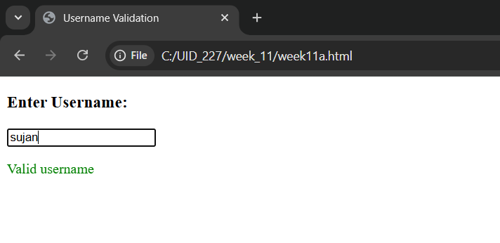

Explanation:
1. document.getElementById("...").value: This reaches into the HTML, finds the input box by its ID, and pulls out whatever the user typed.
2. .innerHTML: Changes the actual text inside the <p> tag.
3. <p id="msg"></p>: An empty paragraph. It acts as a placeholder where your JavaScript will inject error messages like "Minimum 5 letters required”.
4. <input type="text">: Creates a standard text box for user input.
5. id="username": This is a unique identifier. It acts like a "hook" that allows JavaScript to find this specific input box among all other elements on the page.
6. onkeyup="checkUsername()":Every time the user releases a key (after pressing it), the checkUsername() function is triggered.
7. .length: This property counts the number of characters in the string.

- Aim: A registration form should validate email format before submission. If invalid, the form should not be submitted.

Program:
<!DOCTYPE html>
<html>
<head>
<title>Email Validation</title>
</head>
<body>

<form onsubmit="return validateEmail()">
Email: <input type="text" id="email">
<input type="submit" value="Submit">
</form>

<p id="msg"></p>

<script>
function validateEmail() {
let email = document.getElementById("email").value;
let msg = document.getElementById("msg");

let pattern = /^[^ ]+@[^ ]+\.[a-z]{2,3}$/;

if (!email.match(pattern)) {
msg.innerHTML = "Invalid Email Format";
msg.style.color = "red";
return false; // stop submission
}
return true;
}
</script>

</body>
</html>

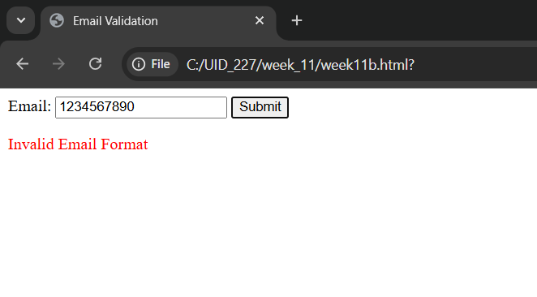
Output:

Explanation:
1. document.getElementById("...").value: This reaches into the HTML, finds the input box by its ID, and pulls out whatever the user typed.
2. .innerHTML: Changes the actual text inside the <p> tag.
3. <p id="msg"></p>: An empty paragraph. It acts as a placeholder where your JavaScript will inject error messages like "Invalid Email."
4. <input type="text" id="mail" placeholder="Enter email">:The placeholder attribute provides a faint hint inside the box that disappears once the user starts typing.
5. ^[a-zA-Z0-9._%+-]+: Matches the username part before the @. It allows letters, numbers, dots, underscores, and plus signs.
6. @[a-zA-Z0-9.-]+: Matches the domain name.
7. \.[a-zA-Z]{2,4}$: Matches the extension (like .com or .in). The {2,4} means the extension must be between 2 and 4 characters long.
8. document.getElementById("msg").style.color : It gives the user immediate visual feedback: Red for a mistake and Green for success.

- Aim: A system should check password strength while typing and display whether it is weak or strong.
Program:
<!DOCTYPE html>
<html>
<head>
<title>Password Strength</title>
</head>
<body>

<h3>Enter Password:</h3>
<input type="password" id="password" onkeyup="checkPassword()">
<p id="msg"></p>

<script>
function checkPassword() {
let pass = document.getElementById("password").value;
let msg = document.getElementById("msg");

if (pass.length < 6) {
msg.innerHTML = "Weak Password";
msg.style.color = "red";
} else {
msg.innerHTML = "Strong Password";
msg.style.color = "green";
}
}
</script>

</body>
</html>

Output:
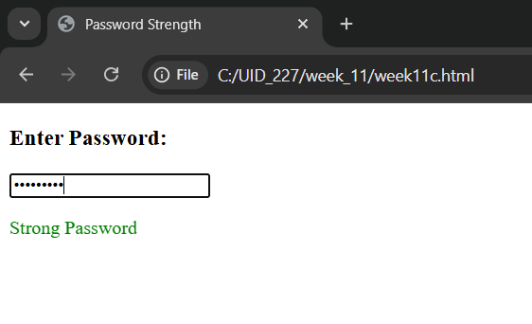

Explanation:
1. document.getElementById("...").value: This reaches into the HTML, finds the input box by its ID, and pulls out whatever the user typed.
2. .innerHTML: Changes the actual text inside the <p> tag.
3. onkeyup: Fires when the user releases the key.
4. .length: This is a built-in JavaScript property that counts how many characters are in the string.
5. document.getElementById("msg").style.color : It gives the user immediate visual feedback: Red for a mistake and Green for success.
6. <input type="password">: Creates a text box where characters are masked.

- Aim: A form should validate a mobile number when the user leaves the input field. The number must be exactly 10 digits.
Program:
<!DOCTYPE html>
<html>
<head>
<title>Mobile Validation</title>
</head>
<body>

<h3>Enter Mobile Number:</h3>
<input type="text" id="mobile" onblur="validateMobile()">
<p id="msg"></p>

<script>
function validateMobile() {
let mobile = document.getElementById("mobile").value;
let msg = document.getElementById("msg");

let pattern = /^[0-9]{10}$/;

if (!mobile.match(pattern)) {
msg.innerHTML = "Enter a valid 10-digit mobile number";
msg.style.color = "red";
} else {
msg.innerHTML = "Valid mobile number";
msg.style.color = "green";
}
}
</script>

</body>
</html>

Output:

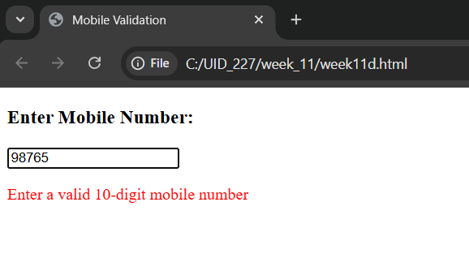

Explanation:
1. document.getElementById("...").value: This reaches into the HTML, finds the input box by its ID, and pulls out whatever the user typed.
2. .innerHTML: Changes the actual text inside the <p> tag.
3. let pattern = /^[0-9]{10}$/; : This is a regular expression.
· ^ : Start of the string.
· [0-9] : Only digits are allowed.
· {10} : Exactly 10 digits required.
· $ : End of the string.
4. document.getElementById("msg").style.color : It gives the user immediate visual feedback: Red for a mistake and Green for success.
5. oninput="Mobilenumber()":fires every single time the value inside the box changes.
6. .match(pattern) : Compares the user's input against the Regex.

- Aim: 5. Design an HTML page, such that the registration form must validate: Name (not empty), Email (valid format),Password (minimum 6 characters).

Program:
<!DOCTYPE html>
<html>
<head>
<title>Registration Form</title>
</head>
<body>

<h2>Registration Form</h2>

<form onsubmit="return validateForm()">
Name: <input type="text" id="name"><br><br>
Email: <input type="text" id="email"><br><br>
Password: <input type="password" id="password"><br><br>
<input type="submit" value="Register">
</form>

<p id="msg"></p>

<script>
function validateForm() {
let name = document.getElementById("name").value;
let email = document.getElementById("email").value;
let password = document.getElementById("password").value;
let msg = document.getElementById("msg");

let emailPattern = /^[^ ]+@[^ ]+\.[a-z]{2,3}$/;

if (name === "") {
msg.innerHTML = "Name cannot be empty";
return false;
}

if (!email.match(emailPattern)) {
msg.innerHTML = "Invalid Email";
return false;
}

if (password.length < 6) {
msg.innerHTML = "Password must be at least 6 characters";
return false;
}

return true;
}
</script>

</body>
</html>

Output:

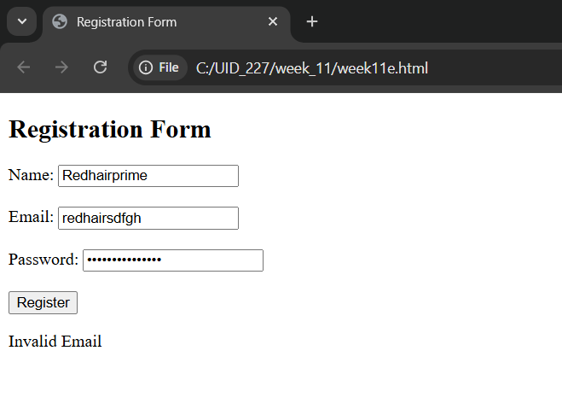

Explanation:
1. document.getElementById("...").value: This reaches into the HTML, finds the input box by its ID, and pulls out whatever the user typed.
2. return false: Returning false stops the form from submitting.
3. return true: Returning true means the data is valid and the form can proceed.
4. <form>: Defines a container for user input.
5. <input>:
· type="text": Creates a basic single-line text box.
· type="password": Creates a text box where characters are masked.
· type="submit": Creates a button that automatically triggers the form's submission.
· id="...": A unique identifier for the element, which the JavaScript uses to "grab" the data entered by the user.
6. <p id="msg"></p>: An empty paragraph. It acts as a placeholder where your JavaScript will inject error messages like "Invalid Email."

