EX:3

a).  
from sklearn.datasets import load_breast_cancer

from sklearn.model_selection import train_test_split,cross_val_score,learning_curve

from sklearn.metrics import accuracy_score

from sklearn.tree import DecisionTreeClassifier

import pandas as pd

import numpy as np

import matplotlib.pyplot as plt

data=load_breast_cancer()

X=data.data

y=data.target

x_train,x_test,y_train,y_test=train_test_split(X,y,random_state=42)

dt=DecisionTreeClassifier(random_state=42,max_de)

dt.fit(x_train,y_train)

train_acc=accuracy_score(y_train,dt.predict(x_train))

test_acc=accuracy_score(y_test,dt.predict(x_test))

print("accuracy:\n1.train accuracy:",train_acc,"\n2.test accuracy",test_acc)

cv_val_score=cross_val_score(dt,X,y,cv=5)

print("cv score:",cv_val_score)

print("average cv score:",np.mean(cv_val_score))

print("std:",np.std(cv_val_score))

train_size,train_score_dt,test_score_dt=learning_curve(dt,X,y,cv=5,scoring='accuracy',train_sizes=np.linspace(0.1,1.0,10),random_state=42)

plt.figure(figsize=(10,6))

plt.plot(train_size,np.mean(train_score_dt,axis=1),'o-', label='training Score')

plt.plot(train_size,np.mean(test_score_dt,axis=1),'o-', label='validation Score')

plt.title("decision tree - learning curve")

plt.xlabel("training Size")

plt.ylabel("accuracy")

plt.legend()

plt.grid(True)

plt.show()  
  
output:  
accuracy:

1.train accuracy: 1.0

2.test accuracy 0.951048951048951

cv score: [0.9122807 0.90350877 0.92982456 0.95614035 0.88495575]

average cv score: 0.9173420276354604

std: 0.02419491828674519  
  
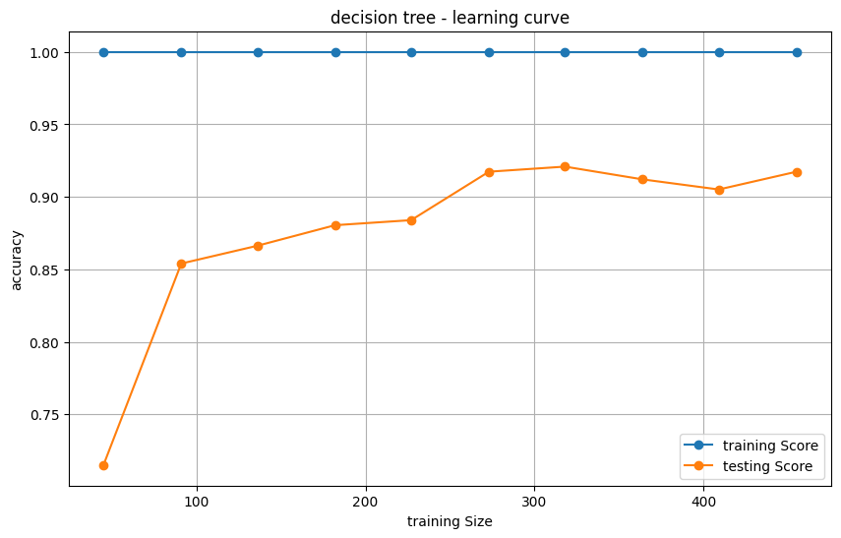  
b).

from sklearn.ensemble import BaggingClassifier

bagging_clf = BaggingClassifier(estimator=DecisionTreeClassifier(), n_estimators=100, random_state=42)

bagging_clf.fit(x_train, y_train)

train_acc=accuracy_score(y_train,bagging_clf.predict(x_train))

test_acc=accuracy_score(y_test,bagging_clf.predict(x_test))

print("accuracy:\n1.train accuracy:",train_acc,"\n2.test accuracy",test_acc)

cv_val_score=cross_val_score(bagging_clf,X,y,cv=5)

print("cv score:",cv_val_score)

print("average cv score:",np.mean(cv_val_score))

train_size,train_score_bc,test_score_bc=learning_curve(bagging_clf,X,y,cv=5,scoring='accuracy',train_sizes=np.linspace(0.1,1.0,10),random_state=42)

plt.figure(figsize=(10,6))

plt.plot(train_size,np.mean(train_score_bc,axis=1),'o-', label='training Score')

plt.plot(train_size,np.mean(test_score_bc,axis=1),'o-', label='validation Score')

plt.title("bagging clf - learning curve")

plt.xlabel("training Size")

plt.ylabel("accuracy")

plt.legend()

plt.grid(True)

plt.show()

output:  
accuracy:

1.train accuracy: 1.0

2.test accuracy 0.958041958041958

cv score: [0.89473684 0.93859649 0.99122807 0.96491228 1. ]

average cv score: 0.9578947368421054  
