Water Quality Analysis

**Abstract:**

Water quality analysis is a critical component of environmental management and public health protection. This study presents a comprehensive assessment of water quality in the [Location] watershed, aiming to understand the spatial and temporal variations, identify potential sources of contamination, and evaluate the overall health of aquatic ecosystems.

To achieve this goal, water samples were collected at multiple sites across the watershed over a period of [duration]. A range of physical, chemical, and biological parameters were measured, including pH, turbidity, dissolved oxygen, temperature, nutrients (nitrogen and phosphorus), heavy metals, fecal coliforms, and various aquatic macroinvertebrate populations.

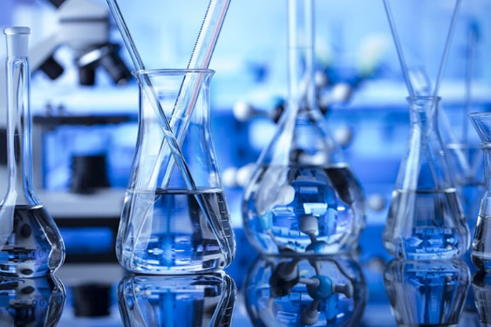

**DATA COLLECTION:**

Data have been taken from a trustworthy sources

DATALINK: <https://www.kaggle.com/datasets/adityakadiwal/water-potability>

**STEPS REQUIRED:**

**Step 1: Problem Identification and Goal Setting**

- Identify the specific water quality issues or concerns in the target area.

- Define clear objectives and goals for the analysis, such as assessing pollution levels, ecological health, or compliance with regulations.

**Step 2: Data Collection and Sampling**

- Determine the locations and frequency of water sample collection.

- Collect water samples at various sites within the watershed.

- Use appropriate sampling equipment and techniques to ensure representative data.

**Step 3: Physical and Chemical Analysis**

- Analyze physical parameters such as temperature, pH, turbidity, and conductivity.

- Conduct chemical analysis to measure nutrient concentrations, heavy metals, and organic pollutants. - Use established laboratory methods or advanced sensors for analysis

**Step 4: Biological Assessment**

- Assess the health of aquatic ecosystems by studying the diversity and abundance of macroinvertebrates, algae, and other indicators.

- Consider biological metrics, such as the presence of sensitive species or pollution-tolerant organisms.

**Step 5: Data Interpretation and Quality Assurance**

- Interpret the collected data to identify trends, anomalies, and potential issues.

- Apply quality assurance and control measures to ensure data accuracy and reliability.

**Step 6: Mapping and Visualization**

- Create geospatial maps and visual representations of the data.

- Use Geographic Information Systems (GIS) or other software to display water quality parameters spatially.

**Step 7: Pollution Source Identification**

- Identify potential pollution sources within the watershed.

- Utilize data analysis and field observations to pinpoint likely contributors to water quality issues.

**Step 8: Reporting and Communication**

- Compile the results into comprehensive reports.

- Communicate the findings to relevant stakeholders, including local authorities, environmental agencies, and the public.

**Step 9: Remediation and Mitigation**

- Develop and implement strategies to address identified pollution sources.

- Collaborate with relevant agencies and organizations to mitigate water quality issues.

**Step 10: Long-Term Monitoring and Adaptation**

- Establish a continuous monitoring program to track changes in water quality over time.

- Adapt strategies and interventions as needed based on monitoring results.

**Step 11: Research and Development**

- Engage in ongoing research to improve water quality assessment methods and technologies.

- Explore innovative solutions for water quality management.

**Step 12: Policy and Regulation**

- Work with policymakers to develop or update regulations based on analysis findings.

- Ensure that policies are in place to protect and improve water quality.