Water Quality Analysis

**AIM:**

Water quality analysis is a critical component of environmental management and public health protection. This study presents a comprehensive assessment of water quality in the [Location] watershed, aiming to understand the spatial and temporal variations, identify potential sources of contamination, and evaluate the overall health of aquatic ecosystems.

To achieve this goal, water samples were collected at multiple sites across the watershed over a period of [duration]. A range of physical, chemical, and biological parameters were measured, including pH, turbidity, dissolved oxygen, temperature, nutrients (nitrogen and phosphorus), heavy metals and various aquatic macroinvertebrate populations.

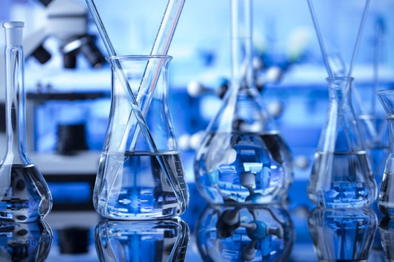

**INTRODUCTION:**

The need for water quality analysis has never been more critical. Water is a finite and precious resource, essential for sustaining life and countless human activities. However, increasing pollution, climate change, and growing demand for water resources pose significant challenges to water quality.To effectively address these challenges, the integration of technology and data analysis is paramount. Python, a versatile and powerful programming language, offers an innovative approach to water quality analysis, enabling data-driven insights and informed decision-making to safeguard our water resources for current and future generations.

**GIVEN DATASET:**

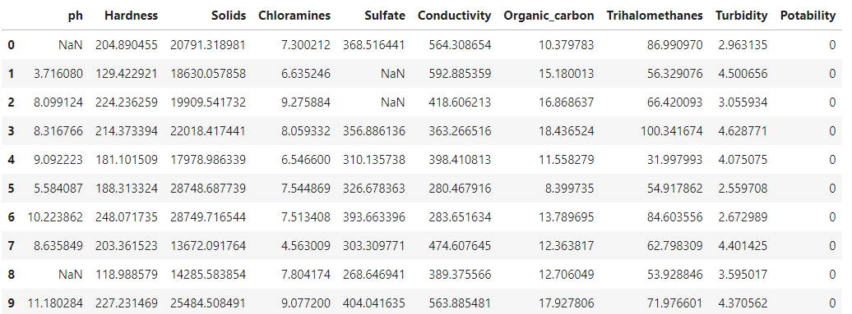

**IMPORTING NESSESARY LIBRARIES:**

# Basic Libraries

import numpy as np

import pandas as pd

from warnings imporfilterwarnings

from collections import Counter

# Visualizations Libraries

import matplotlib.pyplot as plt

import seaborn as sns

import plotly

import plotly.offline as pyo

import plotly.express as px

import plotly.graph_objs as go

pyo.init_notebook_mode()

import plotly.figure_factory as ff

import missingno as msno

# Data Pre-processing Libraries

from sklearn.preprocessing import StandardScaler,MinMaxScaler

from sklearn.model_selection import train_test_split

# Modelling Libraries

from sklearn.linear_model import LogisticRegression,RidgeClassifier,SGDClassifier,PassiveAggressiveClassifier

from sklearn.linear_model import Perceptron

from sklearn.svm import SVC,LinearSVC,NuSVC

from sklearn.neighbors import KNeighborsClassifier,NearestCentroid

from sklearn.tree import DecisionTreeClassifier

from sklearn.ensemble import RandomForestClassifier,AdaBoostClassifier,GradientBoostingClassifier

from sklearn.naive_bayes import GaussianNB,BernoulliNB

from sklearn.ensemble import VotingClassifier

**LOADING THE DATASET:**

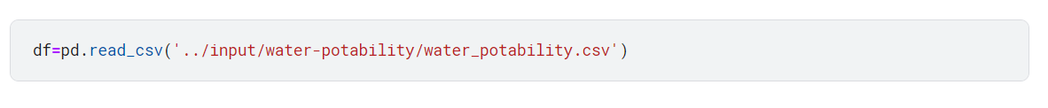

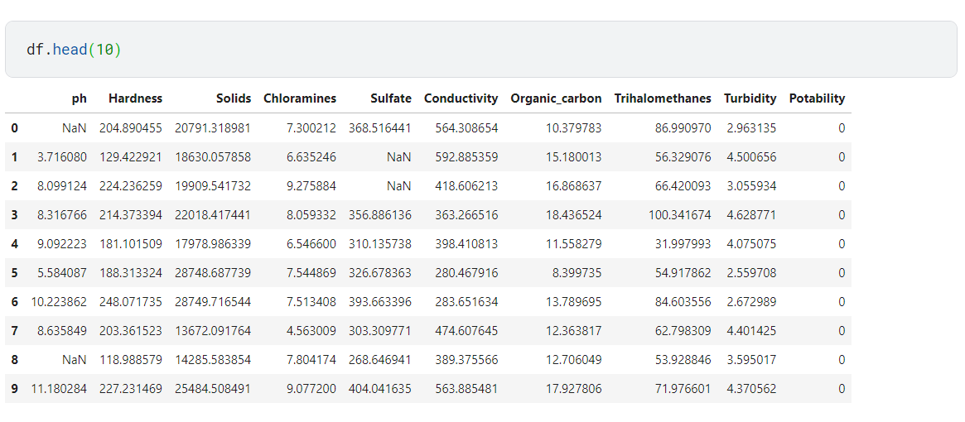

**CHECKING DATA INFO USING .INFO():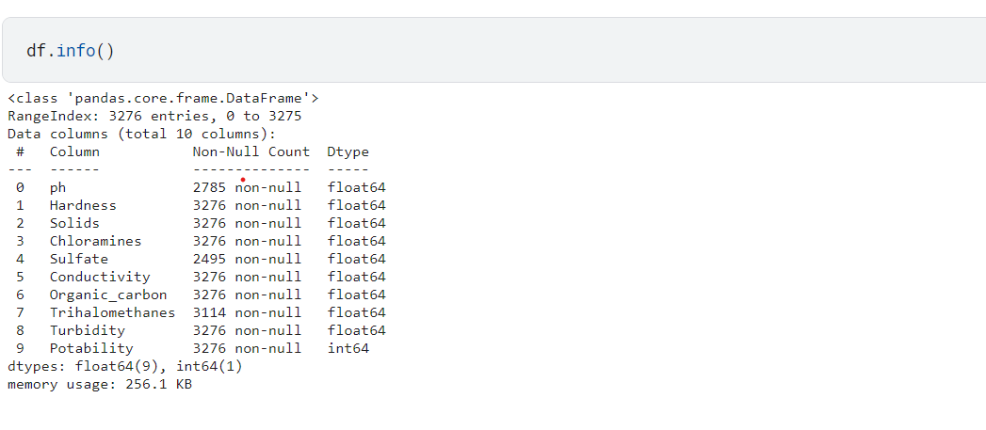HANDLING MISSING DATA:**

Missing values can introduce bias and lead to incorrect conclusions or predictions**.**

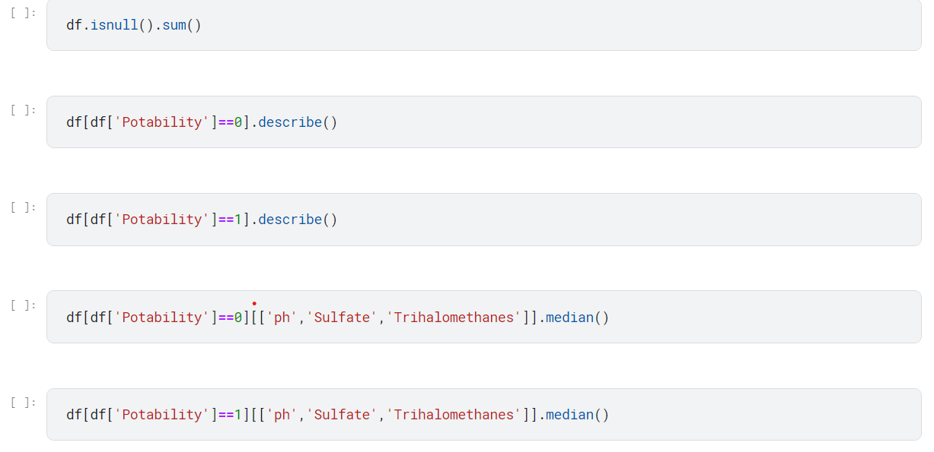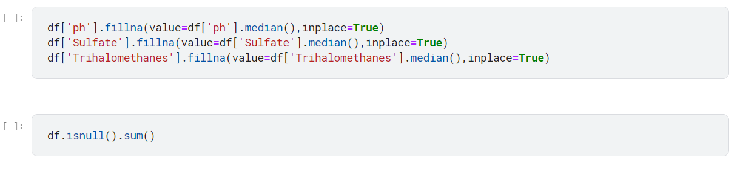

**STANDARDIZING THE DATA:**

Standardizing data is a crucial pre-processing step in data analysis. It involves mean centering and normalizing the variance of features. Standardization improves the performance of machine learning algorithms, aids in faster convergence, and simplifies the interpretation of feature importance. It also makes data less sensitive to outliers and is particularly beneficial for distance-based algorithms and cases with features on different scales.

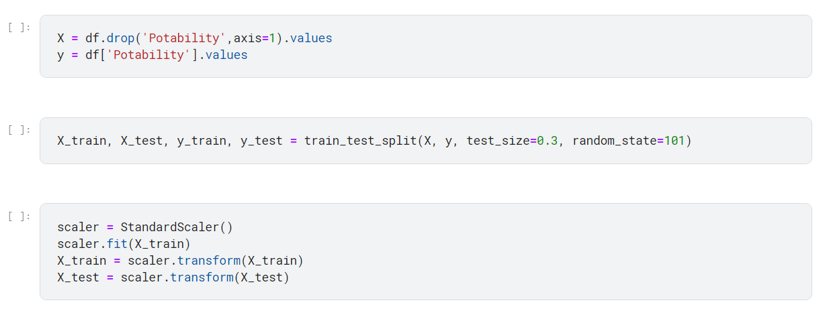

**VISUALIZATION:**

Visualization is essential because it simplifies complex data, aids understanding, and enhances decision-making by revealing patterns and correlations. It facilitates effective communication across diverse audiences and quickly highlights anomalies in the data. Additionally, it leverages the brain's preference for visual information, making data more memorable and supporting better learning**.**

Here are two examples with their respective code:

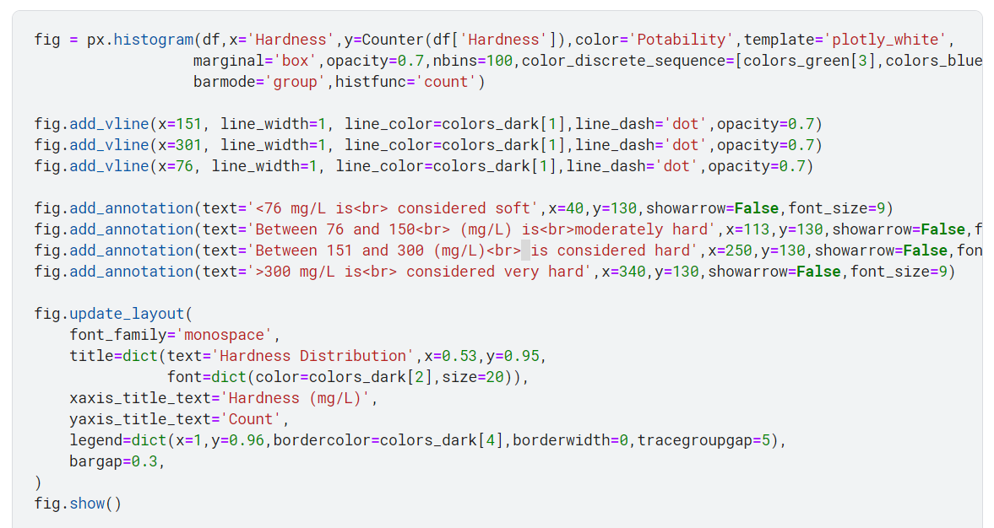

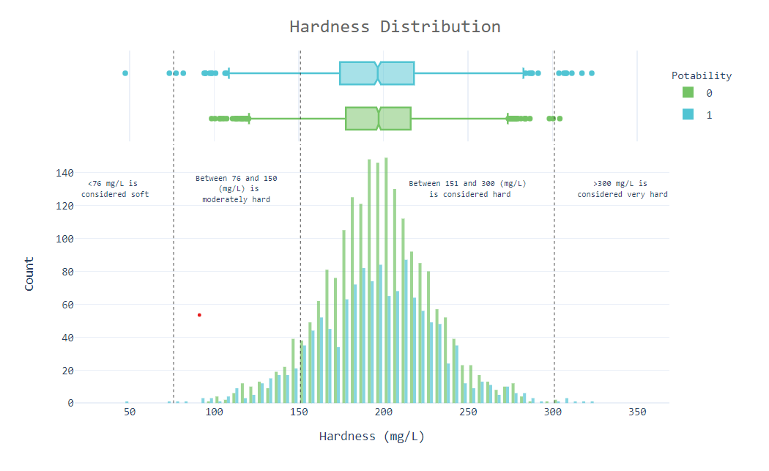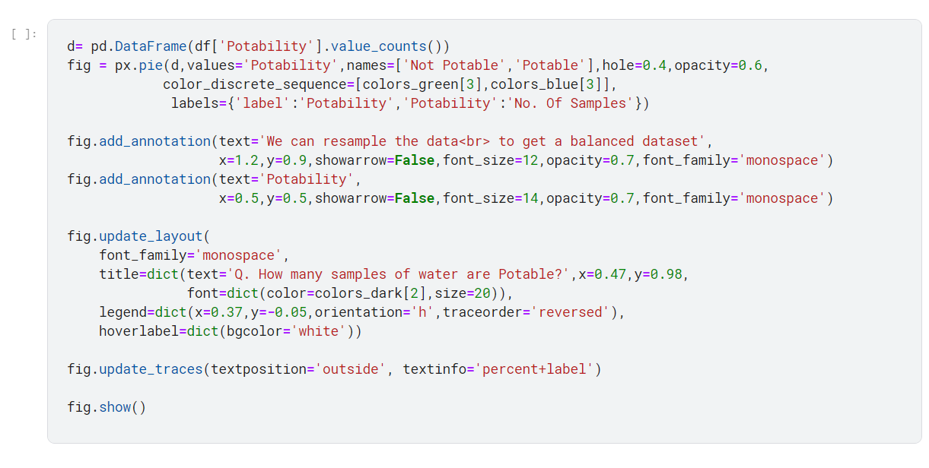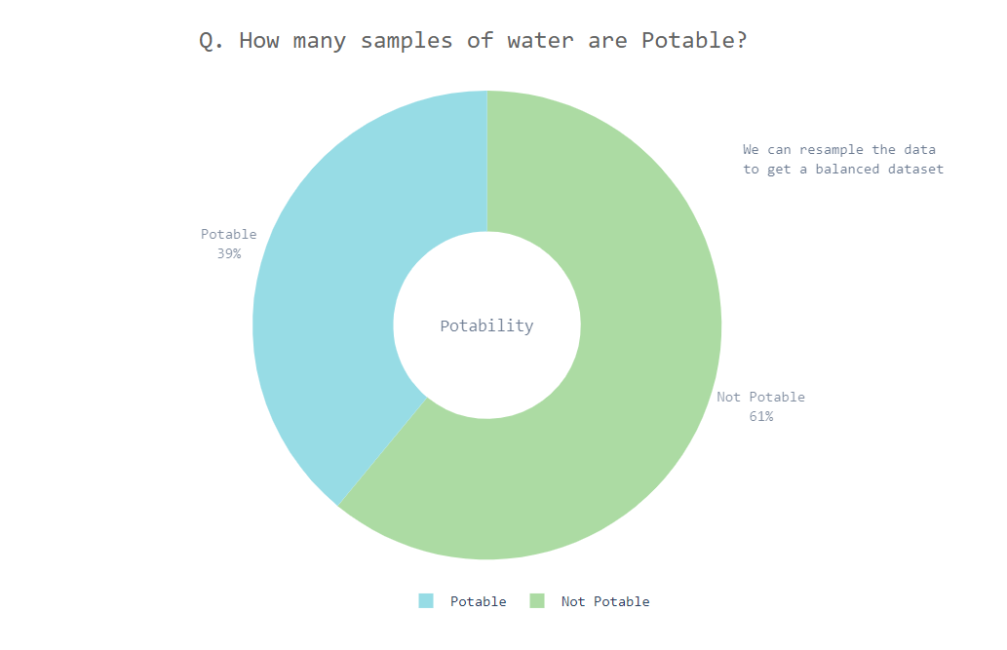

**CONCLUSION:**

Our water quality analysis project using Python has provided valuable insights and tools for safeguarding this vital resource. Through comprehensive data collection, analysis, and visualization, we've gained a deeper understanding of water quality dynamics. By harnessing the power of Python, we've not only uncovered patterns and pollution sources but also empowered stakeholders with actionable information. As we move forward, the project's impact extends beyond this analysis – it contributes to the protection and sustainable management of our water resources. In an era of increasing environmental challenges, our Python-based water quality analysis project stands as a testament to the importance of data-driven solutions in preserving and securing clean and safe water for future generations.