WATER QUALITY ANAYLSIS

**MODELLING**:

Spot-checking is a great method to find out the baseline models for our data. It's quite easy and takes really less time.

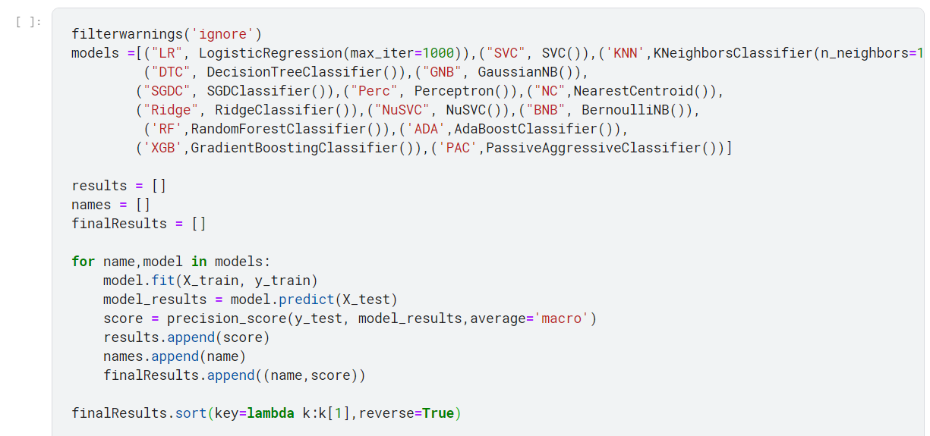



I chose the top five baseline models and performed Hyper parameter tuning to it.

Two models outshined other models and they were Random Forest and XGBoost so I choose them for my final model.

HYPERPARAMETER TUNNING:

Hyper parameter tuning allows data scientists to tweak model performance for optimal results. This process is an essential part of machine learning, and choosing appropriate hyper parameter values is crucial for success.

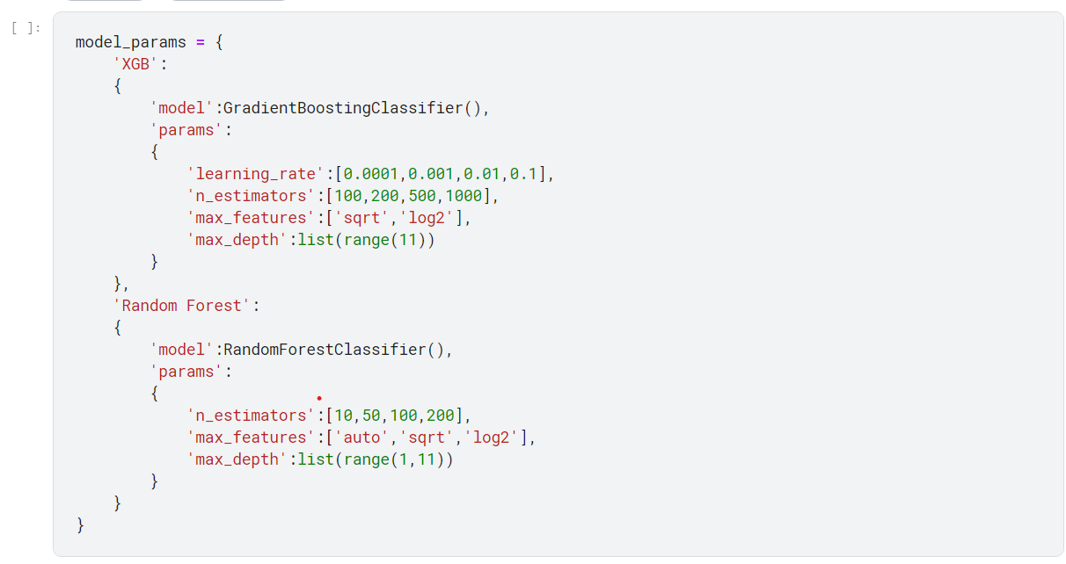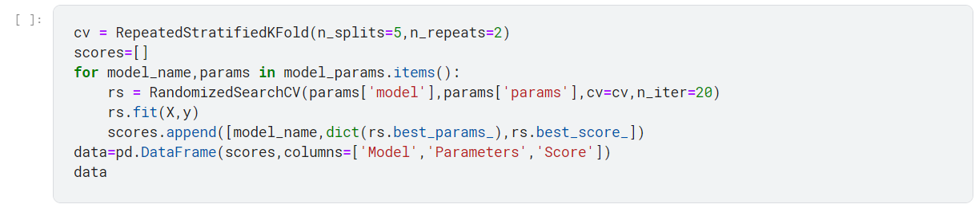

for visual information, making data more memorable and supporting better learning**.**

**VISUALIZATION**:

Visualization is essential because it simplifies complex data, aids understanding, and enhances decision-making by revealing patterns and correlations. It facilitates effective communication across diverse audiences and quickly highlights anomalies in the data. Additionally, it leverages the brain's preference

PH LEVEL**:**

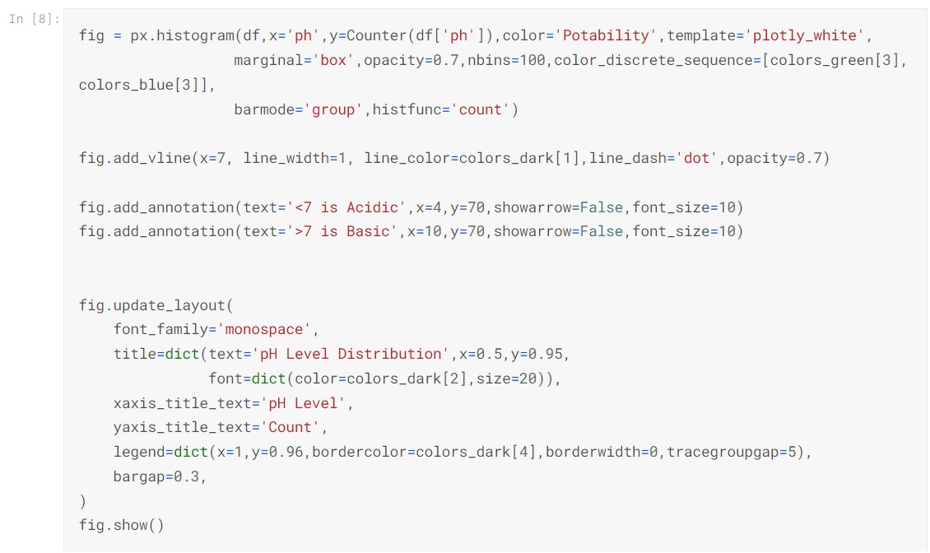

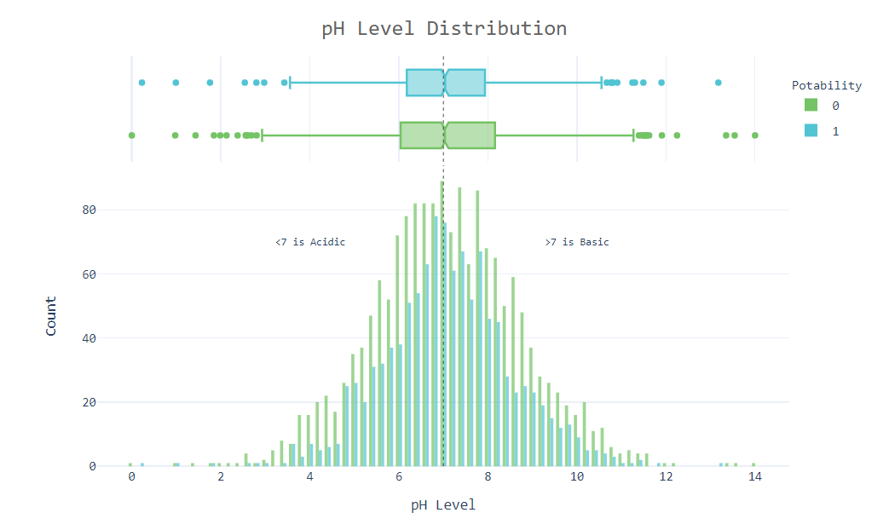

CHLOROAMINES DISTRIBUTION**:**

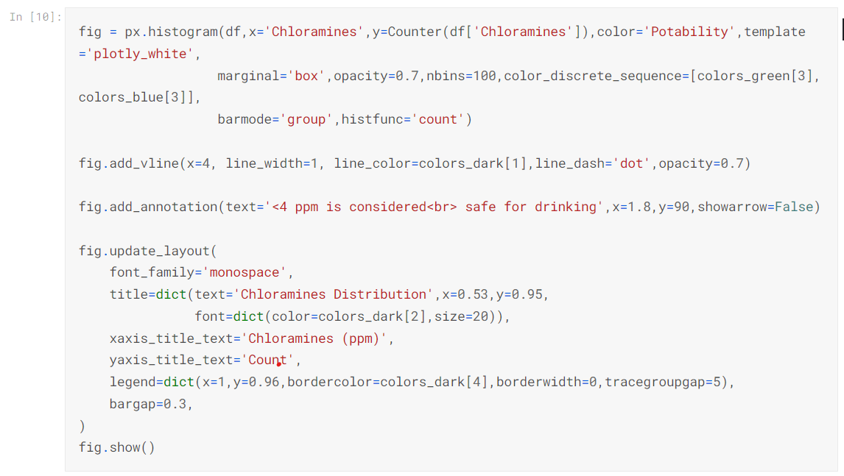

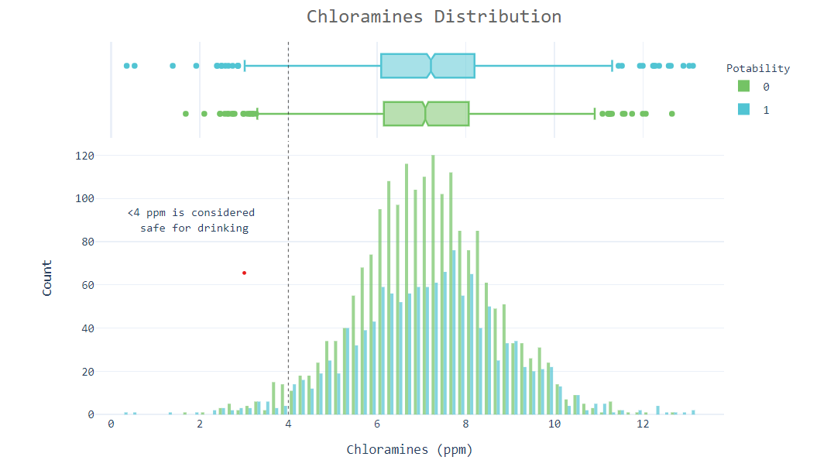

TRIHALOMETHANES DISTRIBUTION:

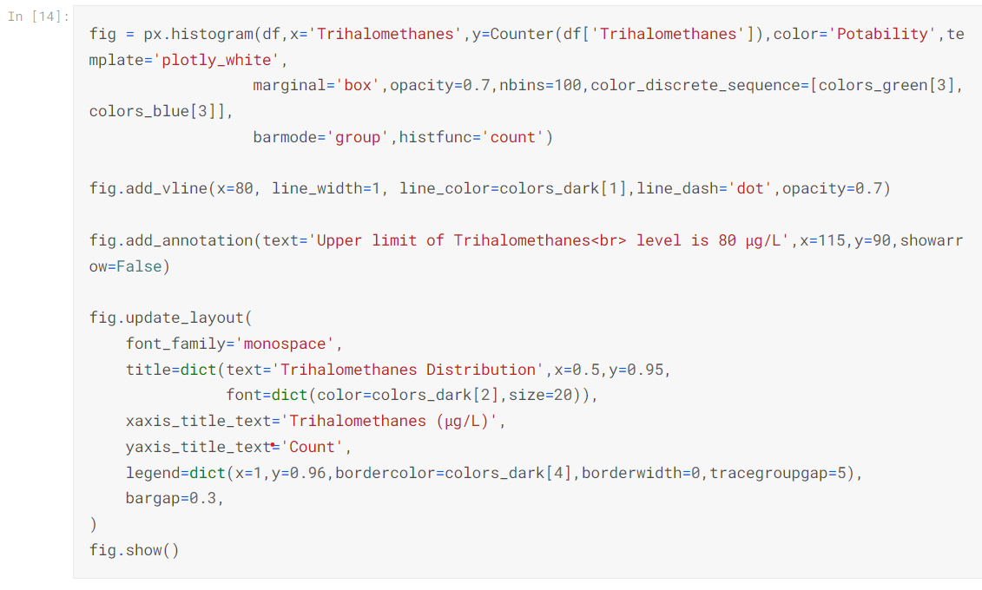

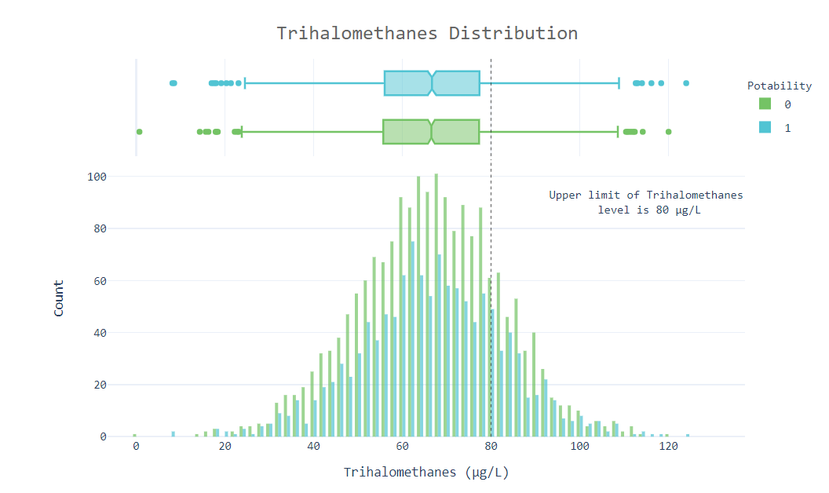

TURBIDITY DISTRIBUTION:

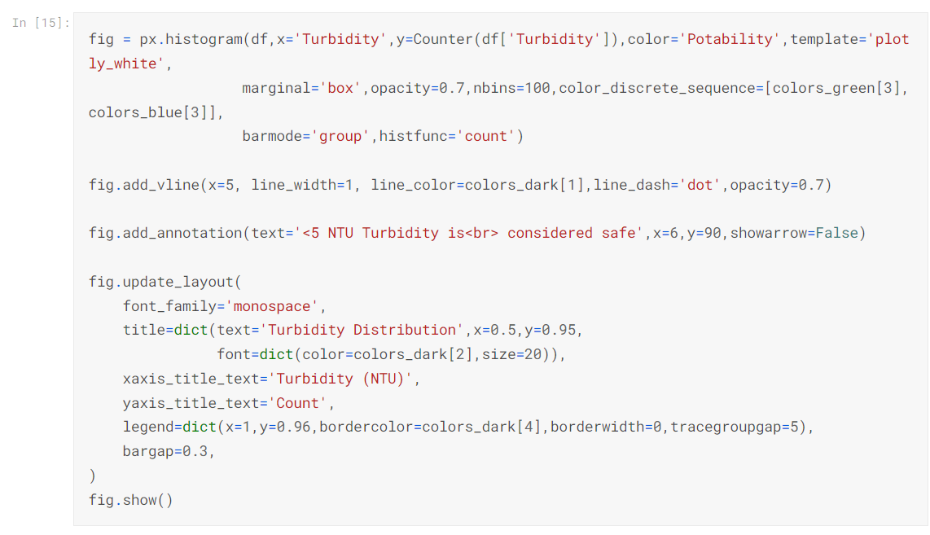

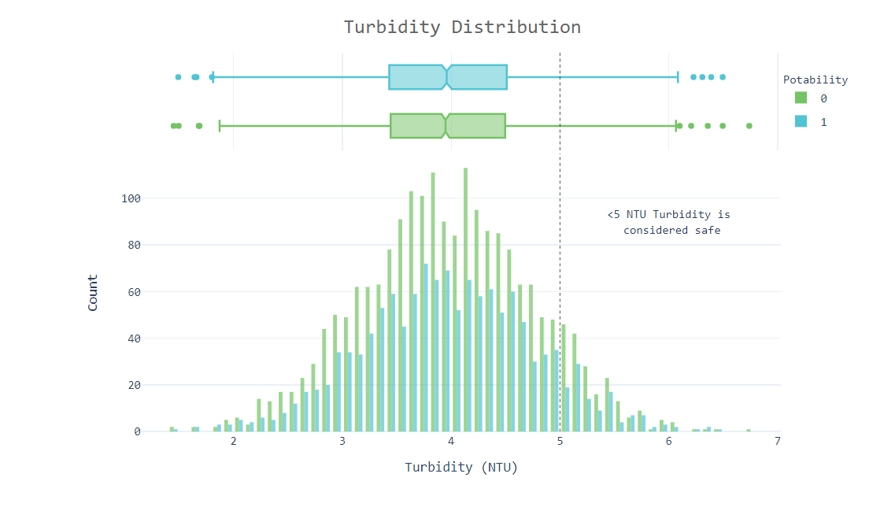

**FINAL MODEL**: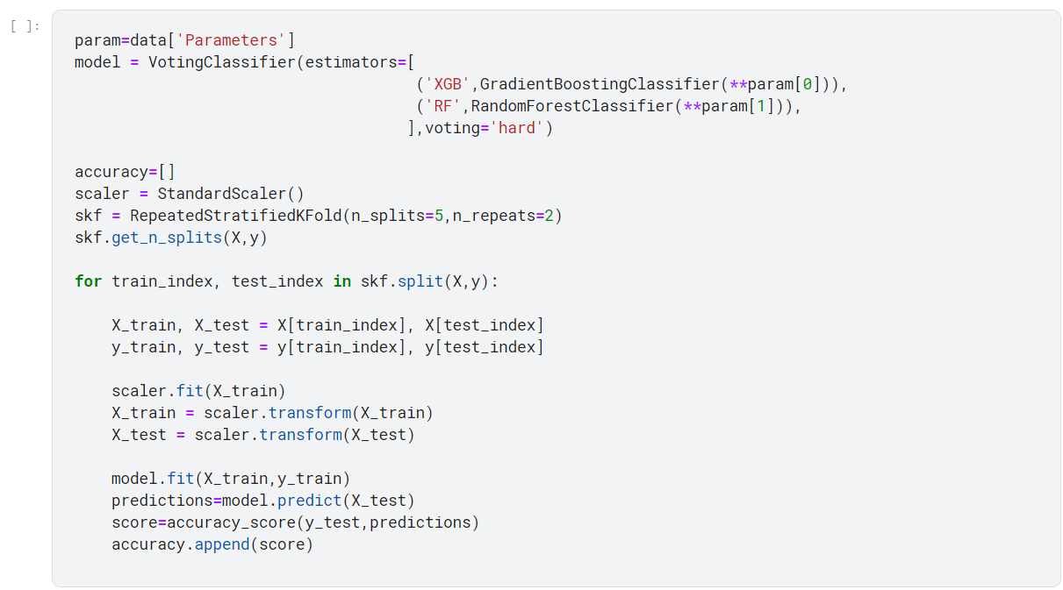:



**CONCLUSION**:

Our water quality analysis project using Python has provided valuable insights and tools for safeguarding this vital resource. Through comprehensive data collection, analysis, and visualization, we have gained a deeper understanding of water quality dynamics. By harnessing the power of Python, we have not only uncovered patterns and pollution sources but also empowered stakeholders with actionable information. As we move forward, the project's impact extends beyond this analysis – it contributes to the protection and sustainable management of our water resources. In an era of increasing environmental challenges, our Python-based water quality analysis project stands as a testament to the importance of data-driven solutions in preserving and securing clean and safe water for future generations.