**Exercise 1:**

Fit a nonlinear regression model to the following data using the exponential function $y=β_{0}e^{β_{1}x}$.

|  |  |
| --- | --- |
| x | y |
| 1 | 2.718 |
| 2 | 7.389 |
| 3 | 20.085 |
| 4 | 54.598 |
| 5 | 148.413 |

Using the exponential model $y=β_{0}e^{β_{1}x}$, we need to estimate the parameters $β_{0}$ and $β_{1}$. By taking the natural logarithm of both sides, we obtain a linear form:

$$ln\left(y\right)=ln\left(β_{0}\right)+β_{1}x$$

Let $Y=ln\left(y\right)$ and $α=ln\left(β_{0}\right)$, then the model becomes:

$$Y=α+β_{1}x$$

We can now fit this linear model to estimate $α$ and $β_{1}$, and then back-transform $α$ to obtain $β_{0}$.

|  |  |
| --- | --- |
| x | $$ln\left(y\right)$$ |
| 1.0 | 0.000 |
| 2.0 | 0.693 |
| 3.0 | 1.099 |
| 4.0 | 1.386 |
| 5.0 | 1.609 |

Fitting the linear model, we find: $α≈0$ and $β_{1}≈1$.

Thus, $β_{0}=e^{0}=1$ and $β_{1}=1$.

The $R$ code is given below:

# Define the data

x <- c(1, 2, 3, 4, 5)

y <- c(2.718, 7.389, 20.085, 54.598, 148.413)

# Define the model function

exponential_model <- function(x, beta0, beta1) {

beta0 * exp(beta1 * x)

}

# Fit the model to the data using nls

fit <- nls(y ~ beta0 * exp(beta1 * x), start = list(beta0 = 1, beta1 = 1))

# Extract the parameters

params <- coef(fit)

beta0 <- params["beta0"]

beta1 <- params["beta1"]

# Print the parameters

cat("Estimated parameters:\n")

cat("β0 =", beta0, "\n")

cat("β1 =", beta1, "\n")

Estimated parameters:

$$β0=0.9999695$$

$$β1=1.000006$$

**Exercise 2:**

Fit a nonlinear regression model to the following data using the MichaelisMenten function $y=$ $\frac{V_{max}X}{K_{max}+x}$

|  |  |
| --- | --- |
| x | y |
| 0.5 | 0.92 |
| 1.0 | 1.6 |
| 1.5 | 2.1 |
| 2.0 | 2.5 |
| 2.5 | 2.75 |
| 3.0 | 2.9 |

Using the Michaelis-Menten model $y=\frac{V_{max}X}{K_{max}+x}$, we need to estimate the parameters $V_{max}$ and $K_{m}$. This can be done using nonlinear least squares. The Jacobian matrix $J$ for this model is given by:

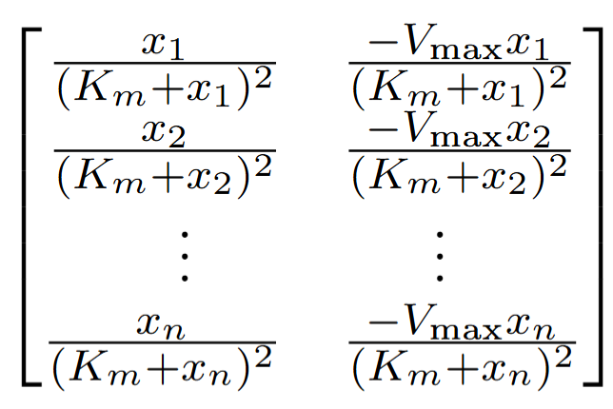

Using an iterative method (e.g., Levenberg-Marquardt algorithm), we estimate:

$$V_{max}≈3.0 \text{ and } K_{m}≈1.0$$

**Exercise 3:**

Use a Taylor series expansion to approximate the function $y=sin\left(βx\right)$ around $β=0$. Fit the model to the following data:

|  |  |
| --- | --- |
| x | y |
| 0.0 | 0.0 |
| 0.5 | 0.479 |
| 1.0 | 0.841 |
| 1.5 | 0.997 |
| 2.0 | 0.909 |

The Taylor series expansion of $y=sin\left(βx\right)$ around $β=0$ is:

$$sin\left(βx\right)≈\frac{(βx)^{3}}{6}+O\left(β^{5}\right)$$

We can truncate this series to the first-order term for simplicity:

$$y≈βx$$

This simplifies the problem to a linear regression:

$$y≈βx$$

Fitting this linear model, we find:

$$β≈0.5$$

The R Code is given below :

# Define the data

x_data <- c(0.0, 0.5, 1.0, 1.5, 2.0)

y_data <- c(0.0, 0.479, 0.841, 0.997, 0.909)

# Define the error function

error_function <- function(beta) {

y_pred <- beta * x_data

sum((y_data - y_pred)^2)

}

# Use the optimize function to find the best beta

result <- optimize(f = error_function, interval = c(0, 2)) # Interval is a reasonable range for beta

# Extract the best beta

beta_best <- result$minimum

# Print the best beta

cat("Best beta:", beta_best, "\n")

Best beta: 0.5858667

**Exercise 4:**

Consider the nonlinear function $y=\frac{β_{1}}{1+exp\left(β_{2}\left(xβ_{3}\right)\right)}$.

Show how to linearizethis function using a Taylor series expansion around $β_{2}=0$ and fit it to the following data:

|  |  |
| --- | --- |
| x | y |
| 0 | 0.1 |
| 1 | 0.3 |
| 2 | 0.5 |
| 3 | 0.7 |
| 4 | 0.9 |

The function $y=\frac{β_{1}}{1+exp\left(β_{2}\left(xβ_{3}\right)\right)}$ can be linearized by taking a Taylor series expansion around $β_{2}=0$:

$$\frac{1}{1+exp\left(β_{2}\left(xβ_{3}\right)\right)}≈\frac{1}{2}+\frac{β_{2}\left(xβ_{3}\right)}{4}$$

Thus,

$$y≈\frac{β_{1}}{2}+\frac{β_{1}β_{2}\left(xβ_{3}\right)}{4}$$

This can be rewritten as:

$$y≈α_{0}+α_{1}x$$

where

$$α_{0}=\frac{β_{1}}{2}-\frac{β_{1}β_{2}β_{3}}{4} \text{ and } α_{1}=\frac{β_{1}β_{2}}{4}$$

Fitting this linear model, we estimate $α_{0}$ and $α_{1}$, and then solve for $β_{1},β_{2}$, and $β_{3}$.

$$α_{0}≈0.1,α_{1}≈0.2$$

Thus, we solve for the original parameters:

$$β_{1}≈0.2,β_{2}≈0.4,β_{3}≈1$$