import java.util.\*;

public class hw601{

public static void main(String[] args){

Scanner input = new Scanner(System.in) ;

//initialize

int[] arr = new int[10];

for (int i = 0; i<arr.length ; i++) {

arr[i]= input.nextInt();

}

int temp;

//sorting algorithm

for (int i = 0; i < arr.length-1; i++) {

for (int j = i+1; j < arr.length; j++) {

if(arr[i]>arr[j]){

temp = arr[i];

arr[i] = arr[j];

arr[j] = temp;

}

}

}

//print out the array

for (int i = 0; i < arr.length; i++) {

System.out.print(arr[i]+ " ");

}

System.out.println(" ");

input.close();

}

}

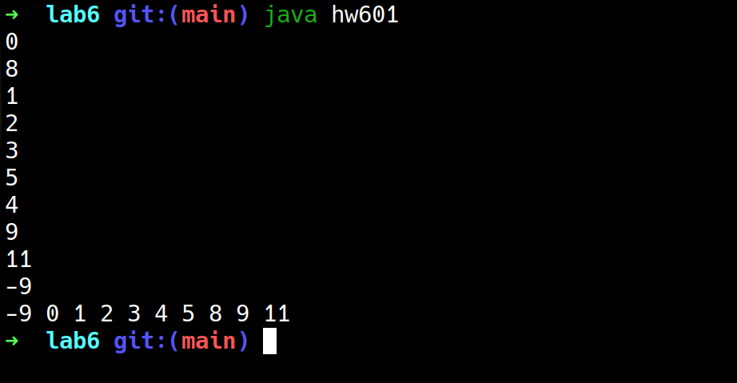

import java.util.\*;

/\*\*

\* lab602

\*/

public class hw602 {

public static void main(String[] args) {

Scanner input = new Scanner(System.in);

double product1 = input.nextDouble();

double product2 = input.nextDouble();

double product3 = input.nextDouble();

double product4 = input.nextDouble();

double product5 = input.nextDouble();

double product6 = input.nextDouble();

System.out.println(priceCalculation(product1));

System.out.println(priceCalculation(product2, product3));

System.out.println(priceCalculation(product4, product5, product6));

input.close();

}

public static double priceCalculation(double x1){

x1 = x1+(0.5\*x1);

return x1;

}

public static double priceCalculation(double x2, double x3){

return x2+x3;

}

public static double priceCalculation(double x4, double x5 , double x6){

double totalprice = x4+x5+x6;

if(totalprice<200){

return totalprice + 50;

}

if(totalprice>=200 && totalprice<=400){

return totalprice;

}

if(totalprice>400){

return totalprice - 50;

}

return 0;

}

}

