**ReactJS - State Management Assignment**

**Problem Statement:**

You work in XYZ Company as a Front End Developer. The company officials want you to build an app using ReactJS

Tasks to be performed:

1. Create a React app using npx create-react-app.

2. Create five components: Main, Cart, Product, ProductList, TotalPrice

3. Main, ProductList and Total Price are top level components and Cart is a child of main and Product is a child of cart

4. Create an array of list of products with id, name and price

5. For each product there must be an add button to add product in ProductList

component

6. Finally, as the product is added to the cart part and bought product should

***Solutions:***

Step1.1: Make a project folder. Open terminal and create a react app by running below command

**npx create-react-app shopping-cart**

Step1.2: run react app by running below command

**cd shopping-cart**

**npm run start**

Step2: creating component. Go to src and Create components folder

src/components

**go to components folder and create below component –Header, Main, Cart**

**Header.js file**

import React from 'react';

export default function Header(props) {

  return (

    <div>Header</div>

  );

}

**Main.js file**

import React from 'react';

export default function Main(props) {

  return (

    <div>Main</div>

  );

}

**Cart.js file**

import React from 'react';

export default function Cart(props) {

  return (

    <div>Cart</div>

  );

}

Step3: Go to App.js and use above created components

import './App.css';

import Cart from './components/Cart';

import Header from './components/Header';

import Main from './components/Main';

function App() {

  return (

    <div className="App">

      <Header />

      <div>

        <Main />

        <Cart />

      </div>

    </div>

  );

}

export default App;

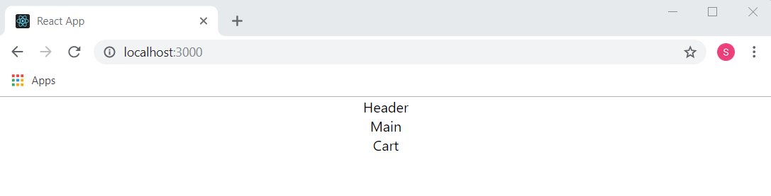

Step4: creating header section of Header component. Also add some styling.

Header.js

import React from 'react';

export default function Header(props) {

  return (

    <header className="block row center">

      <div>

        <a href="#/">

          <h1>Small Shopping Cart</h1>

        </a>

      </div>

      <div>

        <a href="#/cart">Cart</a>

      </div>

    </header>

  );

}

Index.css

body {

  font-family: 'Helvetica';

}

h1,

h2,

h3 {

  margin: 0.5rem 0;

}

h1 {

  font-size: 1.5rem;

}

h2 {

  font-size: 1.2rem;

}

h3 {

  font-size: 1rem;

}

a {

  text-decoration: none;

  color: beige;

}

.row {

  display: flex;

  justify-content: space-between;

}

.row.center {

  align-items: center;

}

.col-1 {

  flex: 1;

}

.col-2 {

  flex: 2;

}

.block {

  background-color:palevioletred;

  padding: 1rem;

  margin: 0.5rem;

  border-radius: 0.5rem;

}

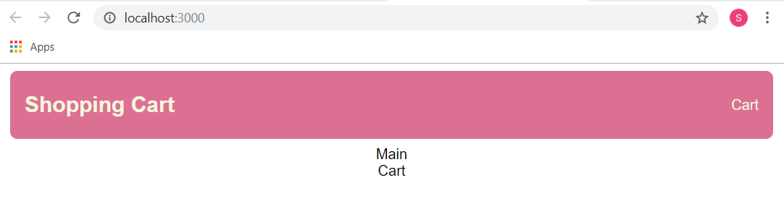

Step5: creating main section of Main component. Also add some styling.

Main.js

import React from 'react';

export default function Main(props) {

  return (

    <main className="block col-2">

        <h2>Products</h2>

        <div className="row"></div>

    </main>

  );

}

Step6: Add <div className="row"> form Main and Cart component div

App.js

import './App.css';

import Cart from './components/Cart';

import Header from './components/Header';

import Main from './components/Main';

function App() {

  return (

    <div className="App">

      <Header />

      <div className="row">

        <Main />

        <Cart />

      </div>

    </div>

  );

}

export default App;

Step7: creating cart section of Cart component. Also add some styling.

Cart.js

import React from 'react';

export default function Cart(props) {

  return (

    <aside className="block col-1">

      <h2>Cart Items</h2>

    </aside>

  );

}

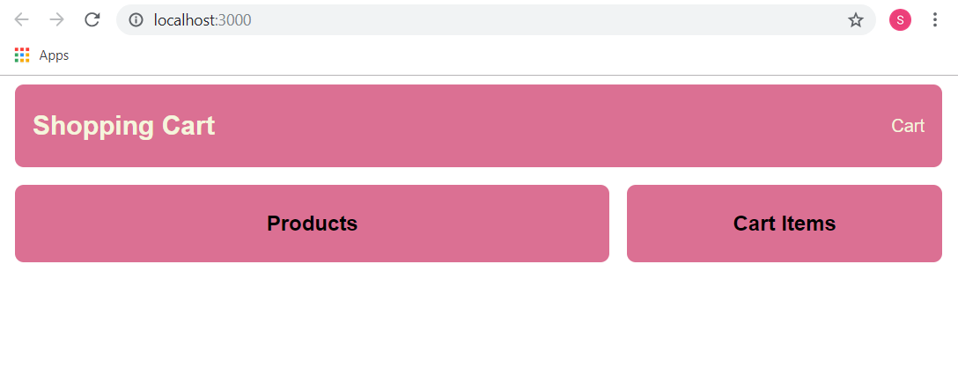

Step8: inside src , create data.js file

const data = {

    products: [

      {

        id: '1',

        name: 'MacBook',

        price: 1400,

        image: 'https://picsum.photos/id/180/2400/1600',

      },

      {

        id: '2',

        name: 'Old Car',

        price: 2400,

        image: 'https://picsum.photos/id/111/4400/2656',

      },

      {

        id: '3',

        name: 'W Shoes',

        price: 1000,

        image: 'https://picsum.photos/id/21/3008/2008',

      },

    ],

  };

  export default data;

Step9.1: import data in App.js . now the modified App.js file code will be

Add below code snippets in App.js

*const { products } = data;*

*<Main products={products}/>*

**App.js code will be**

import Cart from './components/Cart';

import Header from './components/Header';

import Main from './components/Main';

import data from './data';

function App() {

  const { products } = data;

  return (

    <div className="App">

      <Header />

      <div className="row">

        <Main products={products}/>

        <Cart />

      </div>

    </div>

  );

}

export default App;

Step9.2: Add below code snippets in Main.js

*import Product from './Product';*

*const { products } = props;*

*{products.map((product) => (*

*<Product key={product.id} product={product}></Product>*

*))}*

**Main.js code will be**

import React from 'react';

import Product from './Product';

export default function Main(props) {

  const { products } = props;

  return (

    <main className="block col-2">

        <h2>Products</h2>

        <div className="row">

          {products.map((product) => (

            <Product key={product.id} product={product}></Product>

          ))}

        </div>

    </main>

  );

}

Step9.3: Create Product.js file inside components folder and add below code.

import React from 'react'

export default function Product() {

  const { product } = props;

  return (

    <div>

      <img className="small" src={product.image} alt={product.name} />

      <h3>{product.name}</h3>

      <div>&#x20B9{product.price}</div>

      <div>

        <button>Add To Cart</button>

      </div>

    </div>

  )

}

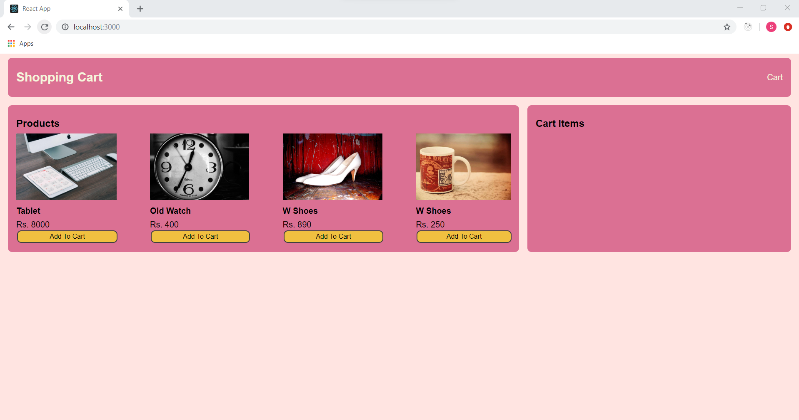

Step10.1: Add to cart and remove from cart functionality implementation

Add below code snippets in App.js

*import { useState } from 'react';*

*//state to manage cart items*

*const [cartItems, setCartItems] = useState([]);*

*const onAdd = (product) => {*

*const exist = cartItems.find((x) => x.id === product.id);*

*if (exist) {*

*setCartItems(*

*cartItems.map((x) =>*

*x.id === product.id ? { ...exist, qty: exist.qty + 1 } : x*

*)*

*);*

*} else {*

*setCartItems([...cartItems, { ...product, qty: 1 }]);*

*}*

*};*

*const onRemove = (product) => {*

*const exist = cartItems.find((x) => x.id === product.id);*

*if (exist.qty === 1) {*

*setCartItems(cartItems.filter((x) => x.id !== product.id));*

*} else {*

*setCartItems(*

*cartItems.map((x) =>*

*x.id === product.id ? { ...exist, qty: exist.qty - 1 } : x*

*)*

*);*

*}*

*};*

*<Main products={products} onAdd={onAdd} />*

*<Cart cartItems={cartItems} onAdd={onAdd} onRemove={onRemove}*

*/>*

**App.js code will be**

import Cart from './components/Cart';

import Header from './components/Header';

import Main from './components/Main';

import data from './data';

import { useState } from 'react';

function App() {

  const { products } = data;

  //state to manage cart items

  const [cartItems, setCartItems] = useState([]);

  const onAdd = (product) => {

    const exist = cartItems.find((x) => x.id === product.id);

    if (exist) {

      setCartItems(

        cartItems.map((x) =>

          x.id === product.id ? { ...exist, qty: exist.qty + 1 } : x

        )

      );

    } else {

      setCartItems([...cartItems, { ...product, qty: 1 }]);

    }

  };

  const onRemove = (product) => {

    const exist = cartItems.find((x) => x.id === product.id);

    if (exist.qty === 1) {

      setCartItems(cartItems.filter((x) => x.id !== product.id));

    } else {

      setCartItems(

        cartItems.map((x) =>

          x.id === product.id ? { ...exist, qty: exist.qty - 1 } : x

        )

      );

    }

  };

  return (

    <div className="App">

      <Header />

      <div className="row">

        <Main products={products} onAdd={onAdd} />

        <Cart cartItems={cartItems} onAdd={onAdd} onRemove={onRemove}/>

      </div>

    </div>

  );

}

export default App;

Step10.2: Add below code snippets in Cart.js

*const { onAdd, onRemove } = props;*

*<div>*

*{cartItems.length === 0 && <div>Cart is empty</div>}*

*</div>*

*//* *To render list of elements in Cart.*

*{cartItems.map((item) => (*

*<div key={item.id} className="row">*

*<div className="col-2">{item.name}</div>*

*<div className="col-2">*

*<button onClick={() => onRemove(item)} className="remove">*

*-*

*</button>{' '}*

*<button onClick={() => onAdd(item)} className="add">*

*+*

*</button>*

*</div>*

*<div className="col-2 text-right">*

*{item.qty} x ${item.price.toFixed(2)}*

*</div>*

*</div>*

*))}*

**Cart.js code will be**

import React from 'react';

export default function Cart(props) {

  const { cartItems, onAdd, onRemove } = props;

  return (

    <aside className="block col-1">

      <h2>Cart Items</h2>

      <div>

      {cartItems.length === 0 && <div>Cart is empty</div>}

      {cartItems.map((item) => (

        <div key={item.id} className="row">

          <div className="col-2">{item.name}</div>

            <div className="col-2">

              <button onClick={() => onAdd(item)} className="add">+</button>

              <button onClick={() => onRemove(item)} className="remove">-</button>{' '}

            </div>

            <div className="col-2 text-right">

              {item.qty} x ${item.price.toFixed(2)}

            </div>

          </div>

        ))}

      </div>

    </aside>

  );

}

Step10.3: Add below code snippets in Product.js

*const { onAdd } = props;*

*<button onClick={() => onAdd(product)}>Add To Cart</button>*

**Product.js code will be**

import React from 'react'

export default function Product(props) {

    const { product, onAdd } = props;

  return (

    <div>

      <img className="small" src={product.image} alt={product.name} />

      <h3>{product.name}</h3>

      <div>Rs. {product.price}</div>

      <div>

      <button onClick={() => onAdd(product)}>Add To Cart</button>

      </div>

    </div>

  )

}

Step10.4: Add below code snippets in Main.js

*const { onAdd } = props;*

*<Product key={product.id} product={product} onAdd={onAdd}></Product>*

**Main.js code will be**

import React from 'react';

import Product from './Product';

export default function Main(props) {

  const { products, onAdd } = props;

  return (

    <main className="block col-2">

        <h2>Products</h2>

        <div className="row">

          {products.map((product) => (

             <Product key={product.id} product={product} onAdd={onAdd}></Product>

          ))}

        </div>

    </main>

  );

}

Step10.5: open browser and type localhost:3000. Here we can add to cart . Increase or decrease the quantity of chosen products.

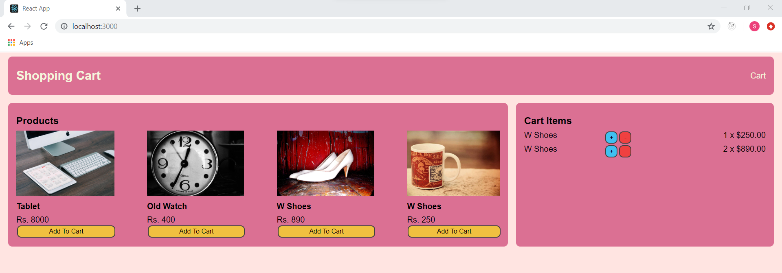

Step11.1: Implementation of order summary. As the product is added to the cart part and bought product should increase and be displayed in Cart and Total Price.

Add below code snippets in Cart.js

*//Defining four variables*

*const itemsPrice = cartItems.reduce((a, c) => a + c.qty * c.price, 0);*

*const taxPrice = itemsPrice * 0.18;*

*const shippingPrice = itemsPrice > 2000 ? 0 : 20;*

*const totalPrice = itemsPrice + taxPrice + shippingPrice;*

*{cartItems.length !== 0 && (*

*<>*

*<hr></hr>*

*<div className="row">*

*<div className="col-2">Items Price</div>*

*<div className="col-1 text-right">Rs. {itemsPrice.toFixed(2)}</div>*

*</div>*

*<div className="row">*

*<div className="col-2">Tax Price</div>*

*<div className="col-1 text-right">Rs. {taxPrice.toFixed(2)}</div>*

*</div>*

*<div className="row">*

*<div className="col-2">Shipping Price</div>*

*<div className="col-1 text-right">*

*Rs. {shippingPrice.toFixed(2)}*

*</div>*

*</div>*

*<div className="row">*

*<div className="col-2">*

*<strong>Total Price</strong>*

*</div>*

*<div className="col-1 text-right">*

*<strong>${totalPrice.toFixed(2)}</strong>*

*</div>*

*</div>*

*<hr />*

*<div className="row">*

*<button onClick={() => alert('Implement Checkout!')}>*

*Checkout*

*</button>*

*</div>*

*</>*

*)}*

**Cart.js code will be**

import React from 'react';

export default function Cart(props) {

  const { cartItems, onAdd, onRemove } = props;

  //Defining four variables

  const itemsPrice = cartItems.reduce((a, c) => a + c.qty * c.price, 0);

  const taxPrice = itemsPrice * 0.18;

  const shippingPrice = itemsPrice > 2000 ? 0 : 20;

  const totalPrice = itemsPrice + taxPrice + shippingPrice;

  return (

    <aside className="block col-1">

      <h2>Cart Items</h2>

      <div>

      {cartItems.length === 0 && <div>Cart is empty</div>}

      {cartItems.map((item) => (

        <div key={item.id} className="row">

          <div className="col-2">{item.name}</div>

            <div className="col-2">

              <button onClick={() => onAdd(item)} className="add">+</button>

              <button onClick={() => onRemove(item)} className="remove">-</button>{' '}

            </div>

            <div className="col-2 text-right">

              {item.qty} x ${item.price.toFixed(2)}

            </div>

          </div>

        ))}

        {cartItems.length !== 0 && (

          <>

            <hr></hr>

            <div className="row">

              <div className="col-2">Items Price</div>

              <div className="col-1 text-right">Rs. {itemsPrice.toFixed(2)}</div>

            </div>

            <div className="row">

              <div className="col-2">Tax Price</div>

              <div className="col-1 text-right">Rs. {taxPrice.toFixed(2)}</div>

            </div>

            <div className="row">

              <div className="col-2">Shipping Price</div>

              <div className="col-1 text-right">

                Rs. {shippingPrice.toFixed(2)}

              </div>

            </div>

            <div className="row">

              <div className="col-2">

                <strong>Total Price</strong>

              </div>

              <div className="col-1 text-right">

                <strong>${totalPrice.toFixed(2)}</strong>

              </div>

            </div>

            <hr />

            <div className="row">

              <button onClick={() => alert('Implement Checkout!')}>

                Checkout

              </button>

            </div>

          </>

        )}

      </div>

    </aside>

  );

}

Step11.2: Add below code snippets in **App.js**

*<Header countCartItems={cartItems.length} />*

**App.js code will be**

import Cart from './components/Cart';

import Header from './components/Header';

import Main from './components/Main';

import data from './data';

import { useState } from 'react';

function App() {

  const { products } = data;

  //state to manage cart items

  const [cartItems, setCartItems] = useState([]);

  const onAdd = (product) => {

    const exist = cartItems.find((x) => x.id === product.id);

    if (exist) {

      setCartItems(

        cartItems.map((x) =>

          x.id === product.id ? { ...exist, qty: exist.qty + 1 } : x

        )

      );

    } else {

      setCartItems([...cartItems, { ...product, qty: 1 }]);

    }

  };

  const onRemove = (product) => {

    const exist = cartItems.find((x) => x.id === product.id);

    if (exist.qty === 1) {

      setCartItems(cartItems.filter((x) => x.id !== product.id));

    } else {

      setCartItems(

        cartItems.map((x) =>

          x.id === product.id ? { ...exist, qty: exist.qty - 1 } : x

        )

      );

    }

  };

  return (

    <div className="App">

      <Header countCartItems={cartItems.length} />

      <div className="row">

        <Main products={products} onAdd={onAdd} />

        <Cart cartItems={cartItems} onAdd={onAdd} onRemove={onRemove}/>

      </div>

    </div>

  );

}

export default App;

Step11.3: Add below code snippets in **Header.js**

*<a href="#/cart">*

*Cart{' '}*

*{props.countCartItems ? (*

*<button className="badge">{props.countCartItems}</button>*

*) : (*

*''*

*)}*

*</a>{' '}*

**Header.js code will be**

import React from 'react';

export default function Header(props) {

  const {countCartItems} = props;

  return (

    <header className="block row center">

      <div>

        <a href="#/">

          <h1>Shopping Cart</h1>

        </a>

      </div>

      <div>

        <a href="#/cart">

            Cart{' '}

            {props.countCartItems ? (

              <button className="badge">{props.countCartItems}</button>

            ) : (

              ''

            )}

          </a>{' '}

      </div>

    </header>

  );

}

Step11.4: The output will be as shown below. Also apply css style in index.js file. As the product is added to the cart part and bought product should increase and be displayed in Cart and Total Price.

