GitHub link :
1. L1 - In EC2 Ubuntu Instance Create a new user and SSH Key pair with an authorized key
Step 1: Connect to AWS EC2 Ubuntu instance.
Step 2: Clear the terminal
Run command: clear 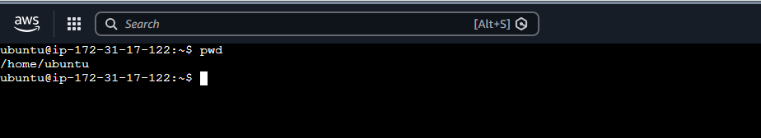
the default ubuntu user
Step 3: Create new user
Run command : sudo adduser <new_user_name>
after this it will ask for password and new value details as shown in below image 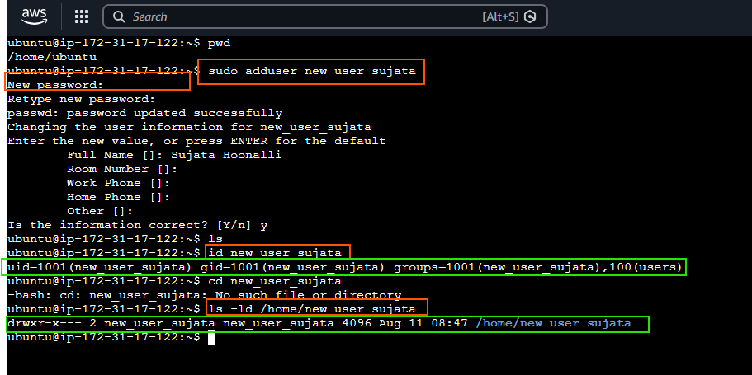
To check whether new user is created or not , Run : id <new_user_name>
Or ls -ld /home/<new_user_name>
If we get a expected result as highlighted in green , it means new user is created properly
Step 4: Now switch to new user
Run command : su <new_user_name>
It will ask for password, enter the password which is already set in “Step 3”
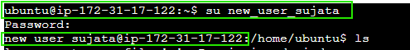
Now observe user is changed from ubutu to new_user_sujata

Step 5: Now generate ssh key pair
Run command : ssh-keygen
It will start generating public and private key
It will ask for file creation path and save path and passphrase.
Here I set it as default .
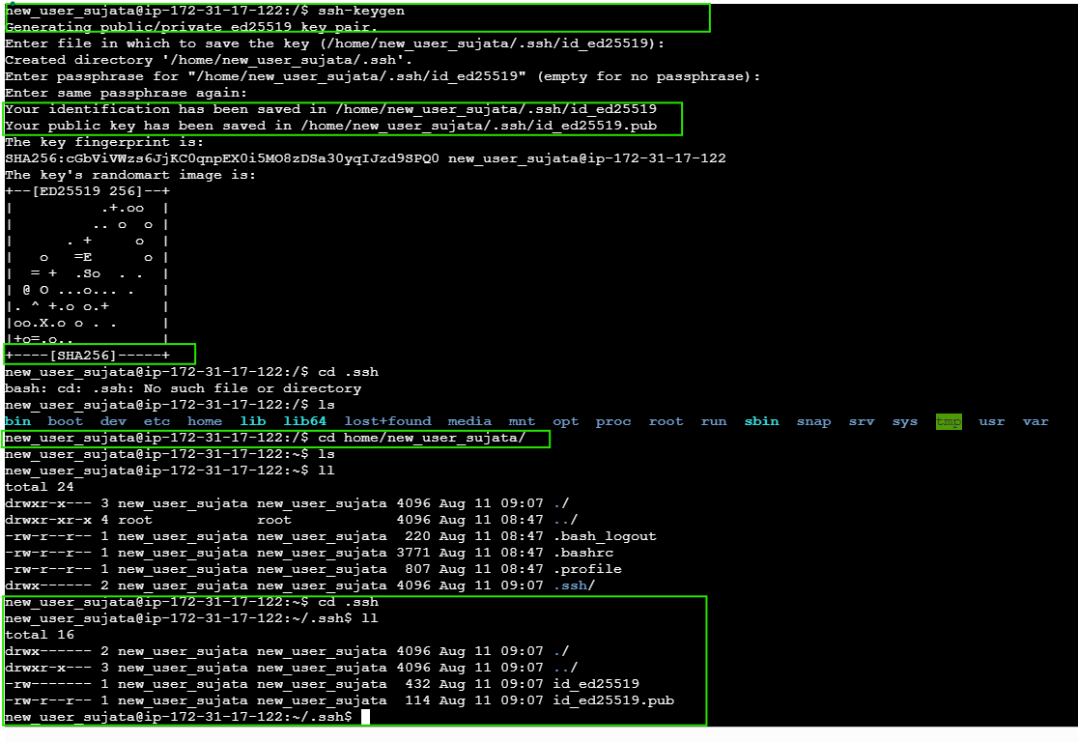
Once key is generated, go to particular path, here cd home/new_user_sujata
We can see .ssh folder is created and inside that private and public key pair also generated.
Step 6: Create the authorized_keys file by copying the public key:
Run the command: cp id_ed25519.pub authorized_keys
If the output matches id_ed25519.pub, then the public key has been authorized
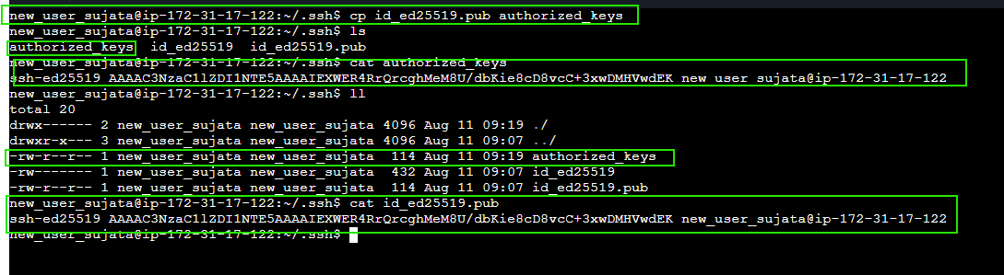

|============================ L1 completed ===============================|

2. L2 - As a Linux root user Create Files/Directory in the same Instance and change the ownership to a new user
Step 1: Connect to AWS EC2 linux instance.
Step 2: Clear the terminal
Run command: clear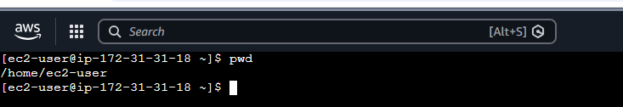

Step 3: Switch to root directory from home directory
Run command: cd /
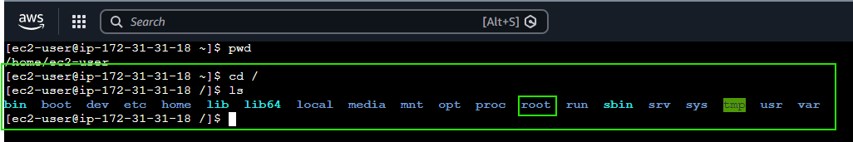

Step 4: Become a root user
Run command: sudo su root
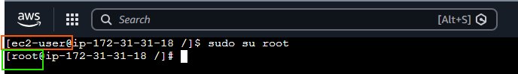
Step 5: Create a main folder and files inside that
Run command : mkdir <folder_name> to create directory
Run command : touch <file_nam1> <file_name2> to crate a files inside the main folder.
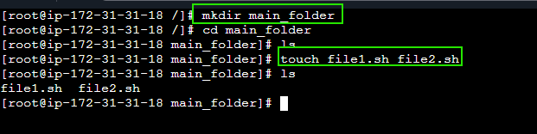
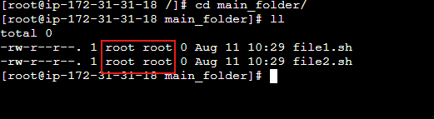
Step 6: change the ownership to a new user
Run command : ls /home
If there is no new user present,
Create a new user by running: sudo adduser <user_name>
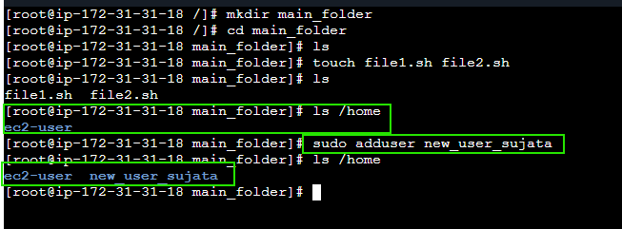

Before :

Run : chown -R new_user_sujata:new_user_sujata /main_folder
To change owner access from root to new_user_sujata
After :
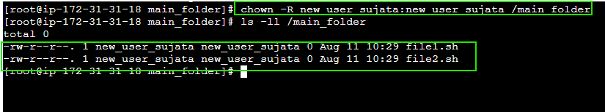
|========================== L2 completed ============================|

