PROCEDURE

1. Create and invoke the ADD_JOB procedure and consider the results.
a. Create a procedure called ADD_JOB to insert a new job into the JOBS table. Provide the ID and title of the job, using two parameters.

b. Compile the code, and invoke the procedure with IT_DBA as job ID and Database
Administrator as job title. Query the JOBS table to view the results.

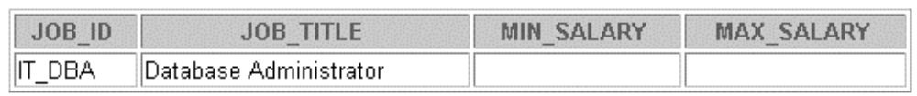

2. Create a procedure called UPD_JOB to modify a job in the JOBS table.
a. Create a procedure called UPD_JOB to update the job title. Provide the job ID and a new title, using two parameters. Include the necessary exception handling if no update occurs.

b. Compile the code; invoke the procedure to change the job title of the job ID IT_DBA to Data Administrator. Query the JOBS table to view the results.

Also check the exception handling by trying to update a job that does not exist (you can
use job ID IT_WEB and job title Web Master).

3. Create a procedure called DEL_JOB to delete a job from the JOBS table.
a. Create a procedure called DEL_JOB to delete a job. Include the necessary exception
handling if no job is deleted.

b. Compile the code; invoke the procedure using job ID IT_DBA. Query the JOBS table to
view the results.



Also, check the exception handling by trying to delete a job that does not exist (use job ID
IT_WEB). You should get the message you used in the exception-handling section of the
procedure as output.

4. Create a procedure called QUERY_EMP to query the EMPLOYEES table, retrieving the salary and job ID for an employee when provided with the employee ID.

a. Create a procedure that returns a value from the SALARY and JOB_ID columns for a
specified employee ID. Use host variables for the two OUT parameters salary and job ID.

b. Compile the code, invoke the procedure to display the salary and job ID for employee ID
120.
