1. Create the DEPT2 table based on the following table instance chart.

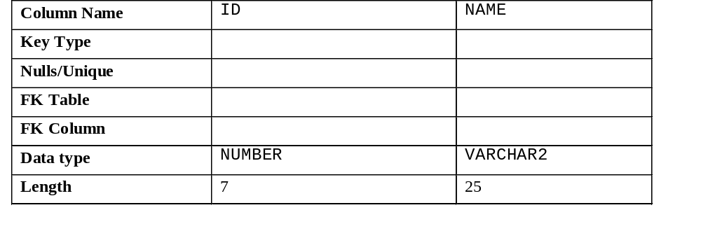

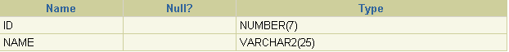
2. Populate the DEPT2 table with data from the DEPARTMENTS table. Include only the columns that you need.
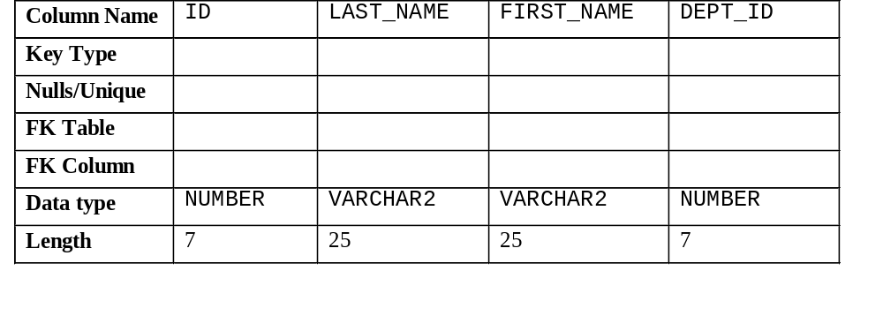3. Create the EMP2 table based on the following table instance chart. Confirm that the table is created.

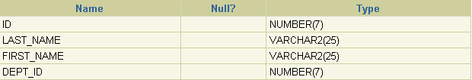
4. Modify the EMP2 table to allow for longer employee last names. Confirm your modification.
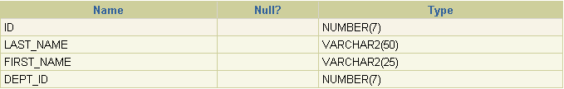
5. Create the EMPLOYEES2 table based on the structure of the EMPLOYEES table. Include only the EMPLOYEE_ID, FIRST_NAME, LAST_NAME, SALARY, and DEPARTMENT_ID columns. Name the columns in your new table ID, FIRST_NAME, LAST_NAME, SALARY, and DEPT_ID, respectively.
6. Drop the EMP2 table.
7. Drop the FIRST_NAME column from the EMPLOYEES2 table. Confirm your modification by checking the description of the table.
8. Add a table-level PRIMARY KEY constraint to the EMP2 table on the ID column. The constraint should be named at creation. Name the constraint my_emp_id_pk.
9. Create a PRIMARY KEY constraint to the DEPT2 table using the ID column. The constraint should be named at creation. Name the constraint my_dept_id_pk.
10. Add a foreign key reference on the EMP2 table that ensures that the employee is not assigned to a nonexistent department. Name the constraint my_emp_dept_id_fk.

