UABAMS Cloud Module Work Summary
Meeting Presentation Document
Project: Unattended Axle Box Level Acceleration Measurement System (UABAMS)
One-line summary
I implemented the cloud-side UABAMS workflow using FastAPI, Render PostgreSQL, and a PyQt5 desktop interface for calibration, threshold management, gateway data storage, and alert monitoring.

1. Work Completed
- Built FastAPI backend APIs for wheel calibration, threshold management, gateway data ingestion, and alerts.
- Connected the backend to a Render PostgreSQL cloud database using SQLAlchemy and psycopg2.
- Built a PyQt5 desktop UI with four tabs: Wheel Calibration, Threshold, Gateway Data, and Alerts.
- Added route-wise threshold support as required by the UABAMS specification.
- Added gateway packet metadata fields: record index, route name, KM marker, meter, status code, and 0.25 m sample distance.
- Implemented wheel wear compensation and corrected speed calculation.
- Implemented alert generation only when corrected speed is above 80 kmph and acceleration crosses the configured threshold.

2. Technology Stack
Layer | Technology | Purpose
Desktop UI | PyQt5 | Operator interface for forms and data tables.
Backend API | Python + FastAPI | Receives gateway data and exposes APIs.
Validation | Pydantic | Validates ranges such as +/-100g and threshold 0-100g.
Database | PostgreSQL on Render | Cloud storage for calibration, thresholds, gateway records, and alerts.
Database Access | SQLAlchemy + psycopg2 | Executes PostgreSQL operations from FastAPI.
API Testing | Swagger / OpenAPI | Documents and tests the backend endpoints.

3. System Architecture
Current architecture:
- PyQt5 desktop app sends user input to FastAPI APIs.
- FastAPI validates and processes calibration, threshold, gateway, and alert data.
- FastAPI stores records in Render PostgreSQL cloud database.
- PyQt5 app refreshes data tables by calling GET APIs.
Architecture flow
Gateway Device -> FastAPI Backend -> Render PostgreSQL Cloud Database -> PyQt5 Desktop App / Web Dashboard

4. Application Workflow
- Operator connects the PyQt5 app to the FastAPI URL.
- Operator enters wheel calibration data for train, axle, wheel position, wheel diameter, and encoder pulses.
- Operator enters route-wise vertical and lateral threshold values.
- Gateway sends spatial peak acceleration data with speed, KM, meter, GPS, and status.
- Backend stores the gateway record in PostgreSQL.
- Backend applies wheel wear correction to calculate corrected speed.
- Backend checks corrected speed above 80 kmph and compares acceleration with route thresholds.
- If limit is crossed, backend stores an alert record.
- PyQt5 UI displays stored gateway data and generated alerts.

5. Screen-by-Screen UI Explanation

Page 1: Wheel Calibration
This page stores wheel wear calibration values. It captures train number, axle number, wheel position, new wheel diameter, current wheel diameter, and encoder pulses per revolution. The backend calculates wheel wear, circumference, distance per pulse, and correction factor.
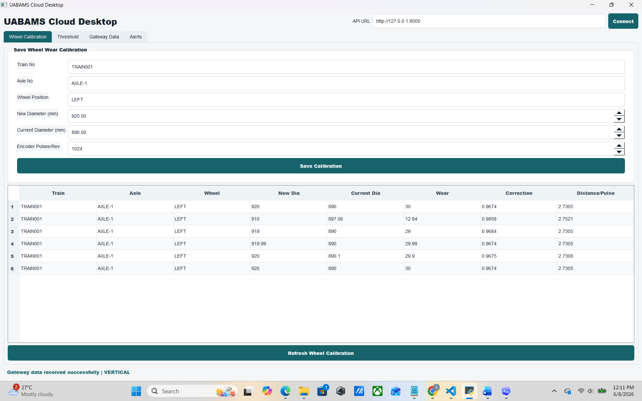

Page 2: Threshold Management
This page stores route-wise vertical and lateral acceleration thresholds. Threshold values are restricted from 0g to 100g.
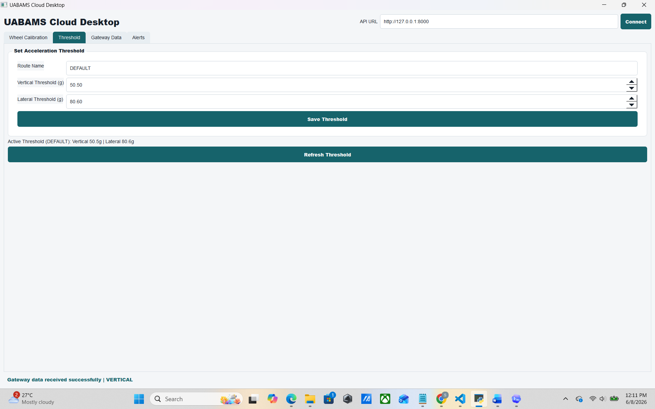

Page 3: Gateway Data
This page simulates/receives gateway data. It stores record index, train number, route, KM marker, meter, vertical/lateral acceleration, speed, GPS location, and status code.
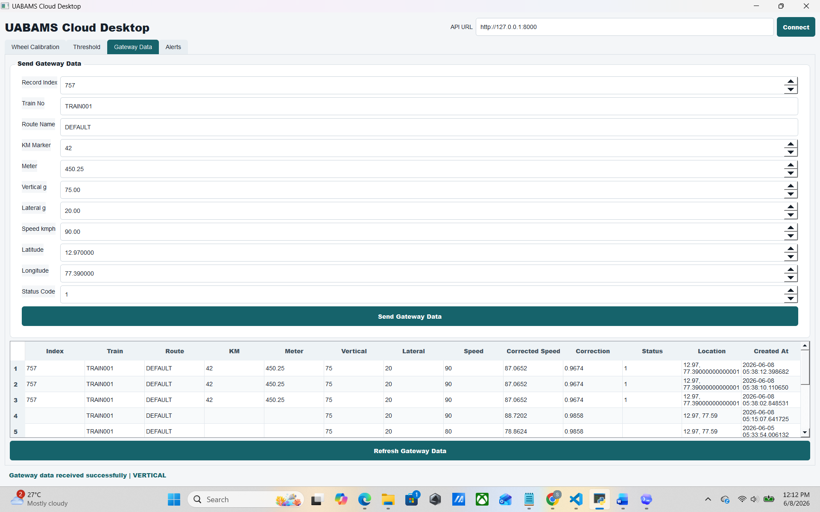

Page 4: Alerts
This page displays generated alerts. Each alert includes train, route, alert type, measured value, threshold value, corrected speed, KM/meter, status, location, and timestamp.
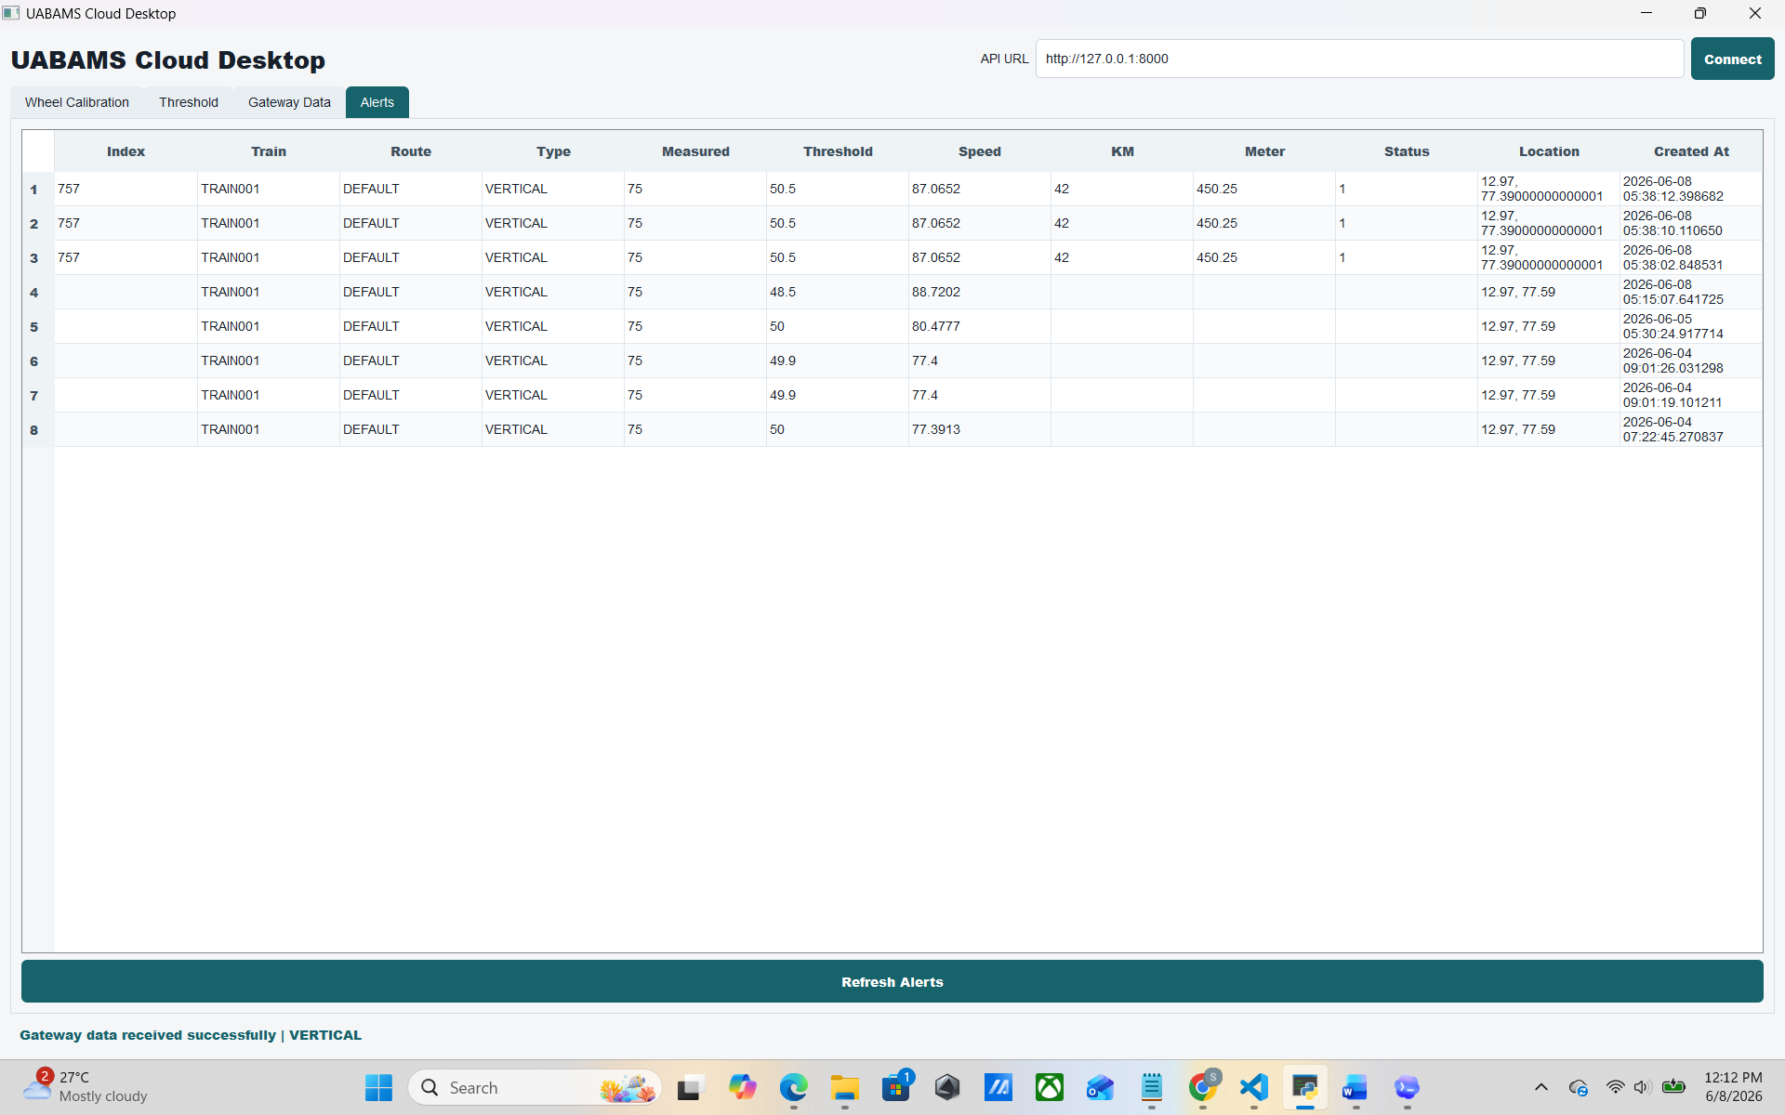

6. Calculations Implemented
Calculation | Formula | Example
Wheel wear | new_diameter - current_diameter | 920 - 890 = 30 mm
Wheel circumference | pi * current_diameter | 3.14159 * 890 = 2796.01 mm
Distance per pulse | circumference / encoder_pulses | 2796.01 / 1024 = 2.73 mm
Correction factor | current_diameter / new_diameter | 890 / 920 = 0.9674
Corrected speed | gateway_speed * correction_factor | 90 * 0.9674 = 87.06 kmph
Vertical alert | corrected_speed > 80 AND abs(vertical_g) > vertical_threshold | 87.06 > 80 and 75 > 50
Lateral alert | corrected_speed > 80 AND abs(lateral_g) > lateral_threshold | Only triggers if lateral value crosses limit

7. Database Work
The backend creates or updates the following database tables automatically:
Table | Purpose
wheel_calibration | Stores train/axle/wheel calibration, wheel wear, correction factor, and distance per pulse.
thresholds | Stores route-wise vertical and lateral acceleration thresholds.
acceleration_data | Stores gateway data, corrected speed, route/KM/meter/status, GPS, and sample distance.
alerts | Stores generated vertical/lateral alerts with measured value, threshold, corrected speed, route/KM/meter, and GPS.

8. API Endpoints Implemented
Endpoint | Method | Purpose
/wheel-calibration | POST/GET | Save and view wheel calibration records.
/threshold | POST/GET | Save and view route-wise threshold values.
/api/data | POST/GET | Receive and view gateway data stored in cloud.
/alerts | GET | View generated alerts.
/docs | GET | Swagger API documentation.

9. Specification Compliance Mapping
Specification Requirement | Implemented Work | Status
Axle acceleration up to +/-100g | Backend validates vertical and lateral values between -100g and +100g. | Completed
Editable predefined limits | Route-wise vertical and lateral threshold management added. | Completed
Alerts above 80 kmph | Alert logic checks corrected_speed_kmph > 80 before generating alert. | Completed
Wheel wear compensation | Correction factor and corrected speed are calculated from wheel diameters. | Completed
Spatial acceleration interval 25 cm | Gateway records store sample_distance_m = 0.25. | Completed
Data stored in database | Render PostgreSQL stores calibration, threshold, gateway, and alert data. | Completed

10. Meeting Script
- I implemented the cloud-side UABAMS module using FastAPI and Render PostgreSQL.
- I added a PyQt5 desktop interface for operators to manage calibration, thresholds, gateway data, and alerts.
- The wheel calibration page calculates wheel wear and correction factor for accurate speed and distance.
- The threshold page supports route-wise vertical and lateral limits from 0g to 100g.
- The gateway page stores spatial gateway data with index, KM, meter, GPS, speed, and status.
- The alert page shows alerts generated only when corrected speed is above 80 kmph and acceleration crosses threshold.
- The database schema is aligned with the specification and supports cloud storage for reports/data.

11. Future Enhancements
- Deploy the FastAPI backend itself on Render so gateway devices can post directly to a public cloud URL.
- Add authentication for operator login and protected API access.
- Add export options for CSV/PDF reports.
- Add SMS/notification integration for generated alerts.
- Add 50 m highest-peak grouping logic if required for final alert notification compliance.
- Add dashboard charts for speed, vertical acceleration, lateral acceleration, and alert trend.

