UABAMS Cloud Handoff - 3 Page Review Note
Purpose: Give Railman/cloud implementers the minimum cloud data contract, storage model, and workflow needed to build their own cloud review implementation.
Key correction: MDB is the preferred TMS data container. MMD is only the physical Maximum Moving Dimension mounting envelope, not a cloud data format.

1. Cloud Workflow
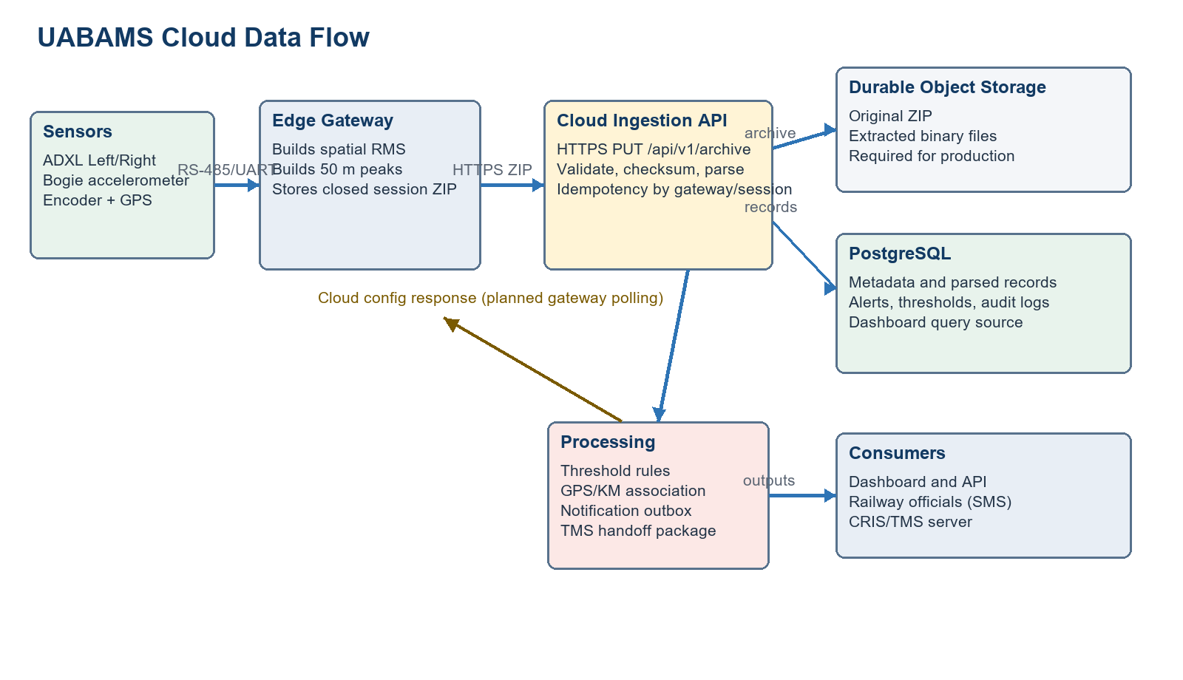
Step | Cloud role | Output
1 | Receive closed-session gateway archive over HTTPS | Archive accepted/rejected
2 | Validate metadata, gateway ID, train ID, session, checksum, required files | Validation audit
3 | Parse spatial acceleration, processed peak, fault and GPS data | Database records
4 | Apply route thresholds and speed gate; attach GPS/KM context | Alert rows
5 | Serve dashboard/API and prepare MDB-preferred TMS handoff | Review UI + TMS ZIP

2. What Cloud Receives, Stores, Processes, Sends
Area | Required structure / data type
Gateway connection | HTTPS PUT/POST to /api/v1/archive. Body is a closed session archive or demo JSON during review. Production must add gateway token/mTLS.
Received metadata JSON | schemaVersion string, gatewayId string, trainId string, sessionName string, sessionStatus string, createdUtc ISO datetime.
Received measurement data | Spatial acceleration records, processed peak records, GPS latitude/longitude, speed, axle ID, metric, timestamp, fault records.
Cloud storage | PostgreSQL tables: gateways, gateway_sessions, axle_records, alerts, threshold_settings, calibration, archives, rms_records, peak_records, fault_records, notification_deliveries, tms_deliveries.
Processing | Validate upload, parse records, calculate dashboard summaries, compare peak values with route-wise vertical/lateral thresholds, generate GPS alerts.
Cloud sends to gateway | Configuration JSON: route threshold, wheel wear/correction factor, sampling rate. Gateway polling/ack should be finalized in production.
Cloud sends to TMS/CRIS | MDB-preferred handoff package containing spatial acceleration data and processed peak data. ASCII text files are included only as open documented fallback/import data.

3. JSON/Data Format Examples
Gateway demo JSON:
{
"gatewayId": "GW001", "trainId": "TRAIN21",
"route": "Bangalore-Chennai",
"gps": {"lat": 13.158, "lon": 77.732},
"speedKmph": 123,
"axleData": [{"axleId": "AX01", "verticalG": 77.2, "lateralG": 35.1,
"rms": 27.0, "peak": 77.2}]
}
Cloud-to-gateway config JSON:
{"gatewayId":"GW001","route":"Bangalore-Chennai","verticalThreshold":50,
"lateralThreshold":80,"samplingRate":2500,"correctionFactor":1.02}

4. Screenshots To Add For Review
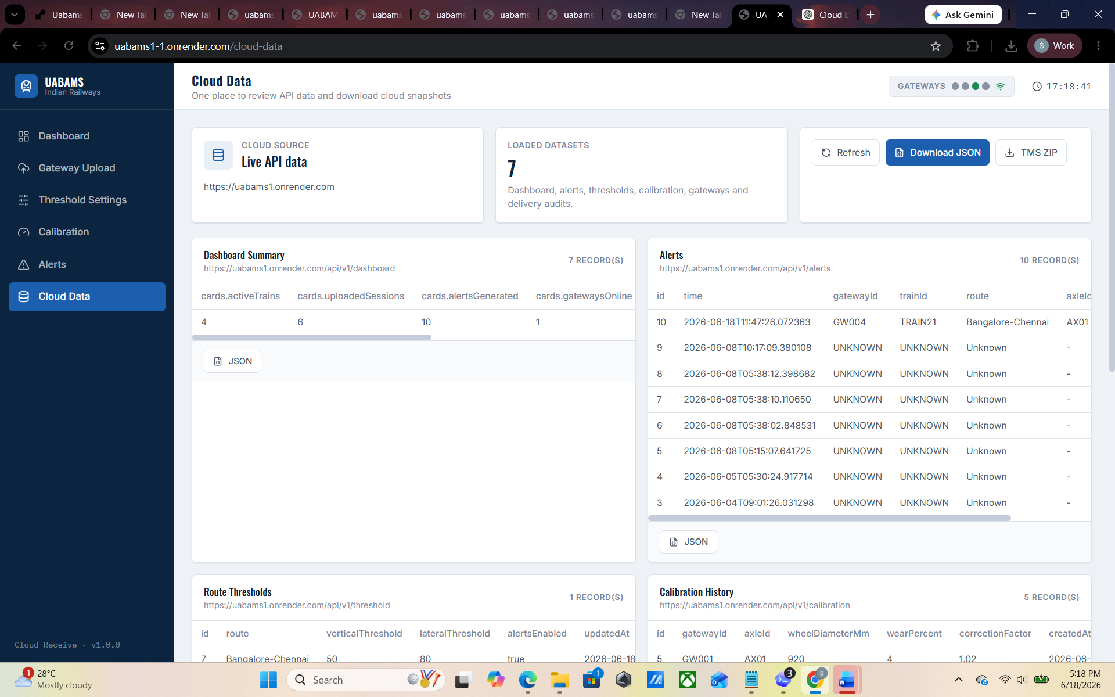
Screenshot | Where to place | Why it helps Railman
Cloud Data page | Page 3, under this section | Shows all cloud API/database data in one place.
Dashboard overview | Optional appendix/email body | Shows graphs, GPS positions, sessions and TMS export button.
Gateway Upload | Optional appendix/email body | Shows how gateway data enters the cloud.
Threshold Settings | Optional appendix/email body | Shows route-wise editable limits from the specification.
Alerts page | Optional appendix/email body | Shows GPS alert map, trend and alert table.

5. Can Railman Implement From This?
Yes, for cloud review/prototype implementation. This document gives the cloud workflow, received/sent data, storage structure, JSON examples, processing responsibilities and gateway connection type.
Before production, Railman still must finalize: authentication, exact MDB schema/import method with CRIS, durable object storage for archives, SMS/notification provider, and hardware MMD/SOD compliance evidence.

