A Hybrid Modelling Approach for Detecting Money Laundering In Banking Sectors
In propose work employing combination of traditional machine learning and deep learning hybrid algorithms to detect money laundering. All existing system were utilizing Rule based techniques to identify weather bank transaction is Fraud or Normal but all those rules are not accurate too distinguish fraud or normal transaction.
To overcome from above issue we are introducing HYBRID ML and DL algorithms which has inbuilt support to distinguish transaction based on user behaviour and its detection accuracy is far more than traditional rule based technique.
To further improve ML algorithms performance we have applied various data processing techniques such as missing features handling, Features shuffling, normalization and imbalance data handling.
To utilize better model we have employed hybrid approach by utilizing multiple algorithms like SVM, Random Forest, Decision Tree, Naïve Bayes, Logistic Regression and CNN2D. Each algorithms performance is evaluated in terms of accuracy, precision, recall and FCSORE. Among all algorithms Random Forest and Logistic Regression is giving high accuracy.
To train and test above algorithm performance we have used AML dataset from KAGGLE repository which contains following values
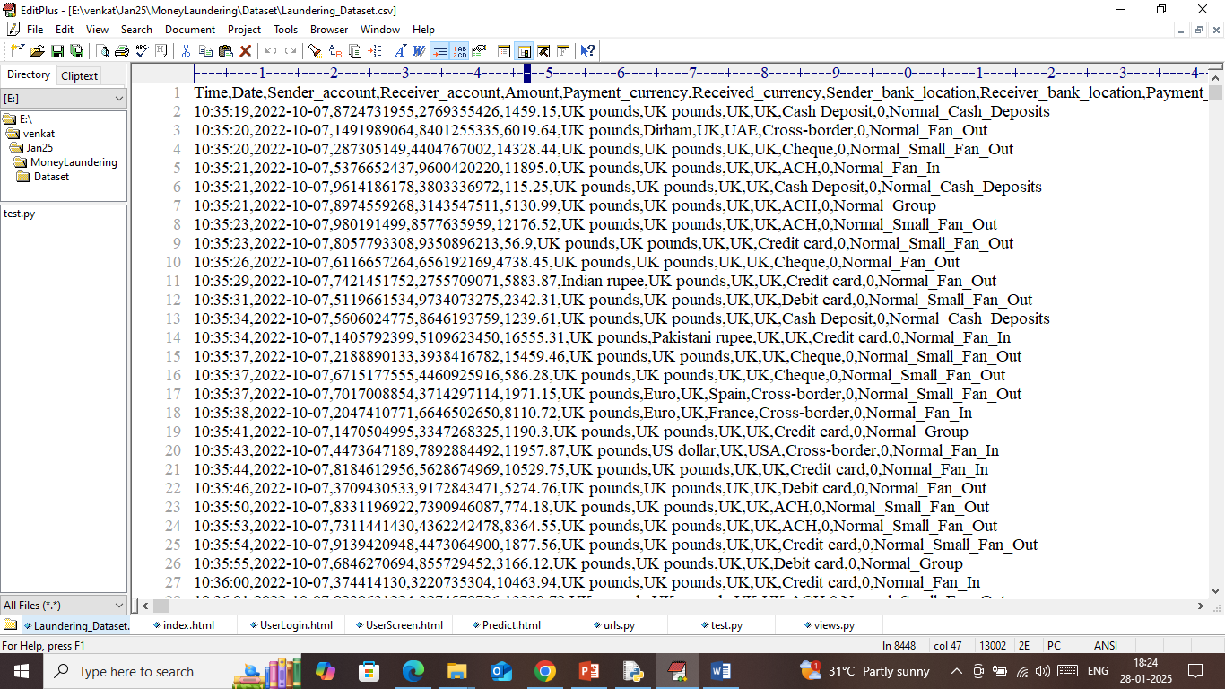
In above dataset screen first row contains dataset column names and remaining rows contains dataset values. So by using above dataset will train and test all algorithms performance.
To implement this project we have designed following modules
- User Login: user can login to system using username and password as ‘admin and admin’.
- Load & Process Dataset: after login user can use this module to load dataset and then process and split dataset into train and test where application using 80% dataset features for training and 20% for testing. As processing system will replace all missing values with mean and then apply SMOTE algorithm to balance dataset records and then shuffle and normalize all dataset values
- Train Hybrid Algorithms: this module will input 80% dataset features to all algorithms to train models and then apply 20% test data on each model to calculate prediction accuracy
- Predict Money Laundering: using this module user will enter transaction amount and other parameters and then Hybrid algorithms will predict risk profiling and suspicious transaction RATIO. Whoever like normal or suspicious got highest ratio then transaction can be predicted based on highest ratio.
SCREEN SHOTS
Install python 3.7.2 and then install all packages given in requiements.txt file and then double click on ‘run.bat’ file to start python server and get below page
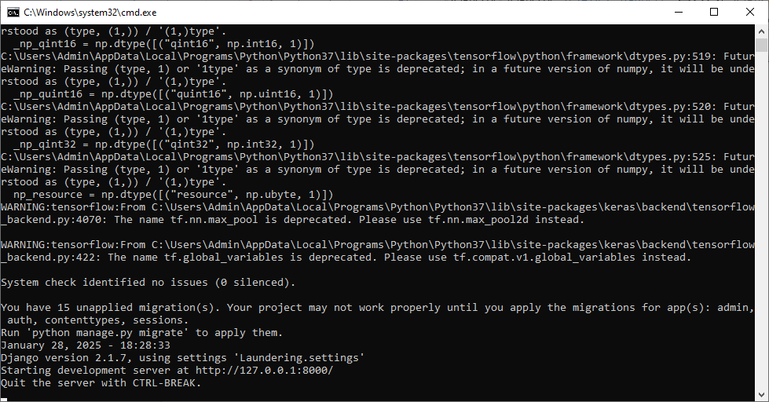
In above screen python server started and now open browser and enter URL as http://127.0.0.1:8000/index.html and then press enter key to get below page
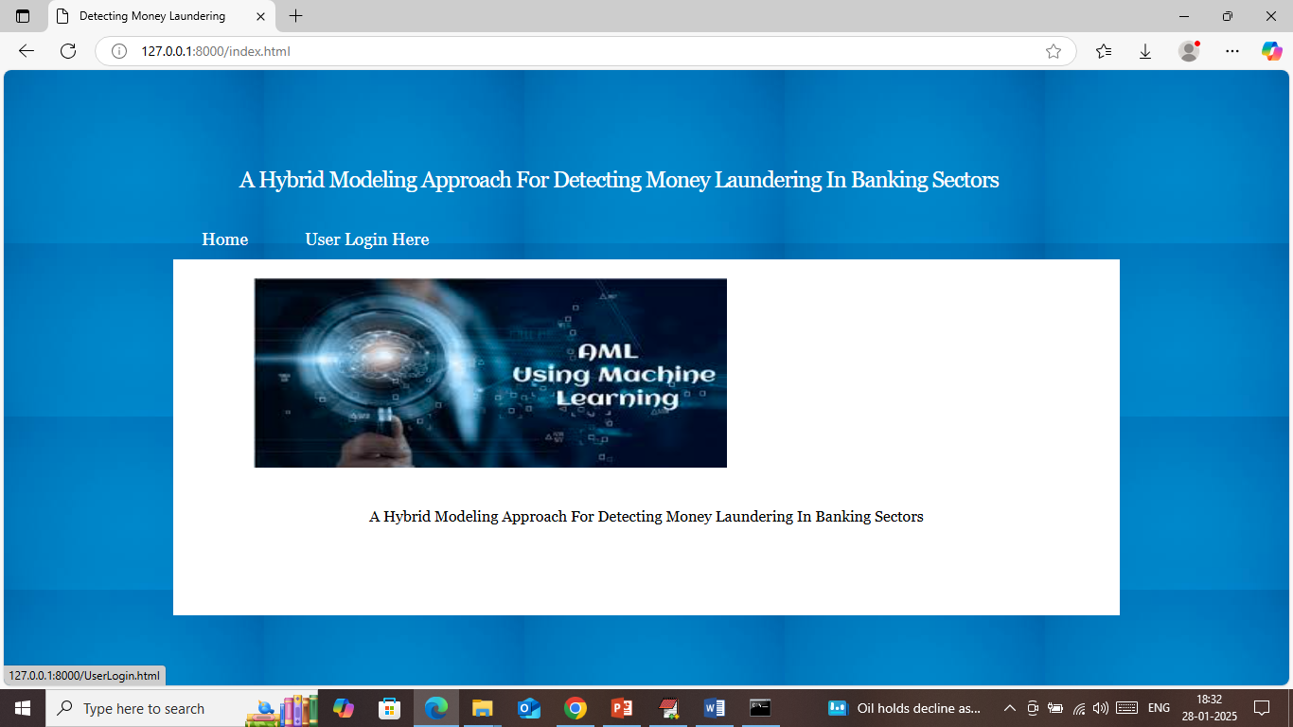
In above screen click on ‘User Login’ link to get below page
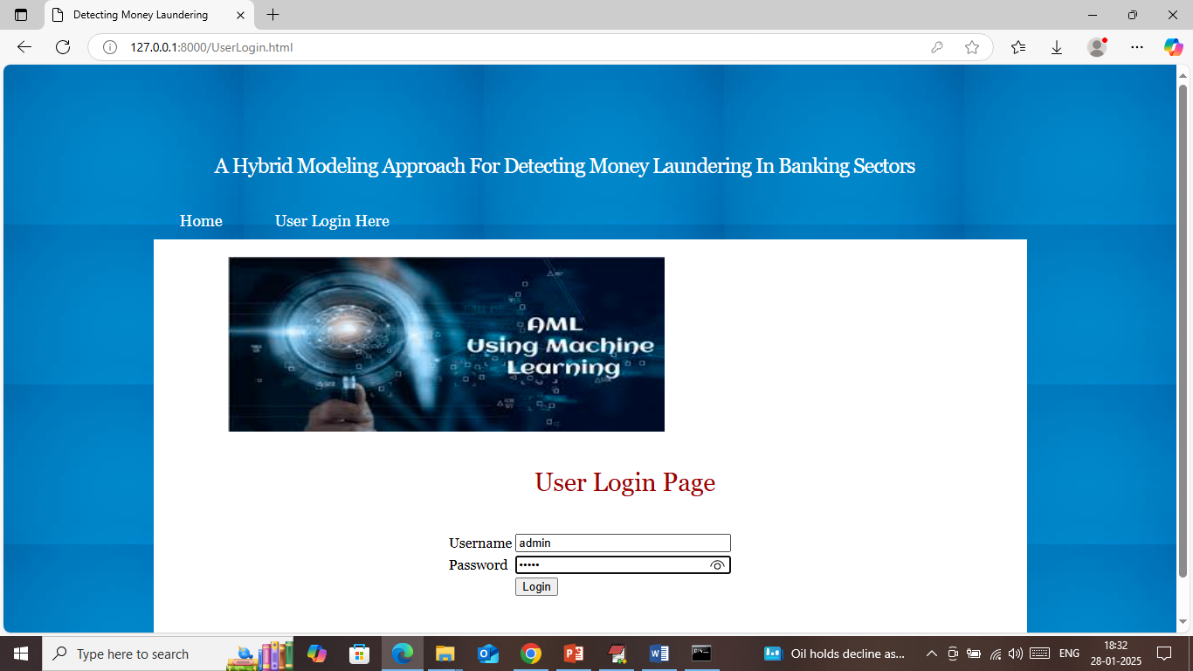
In above screen user is login with username and password as ‘admin and admin’ and then press enter key to get below page
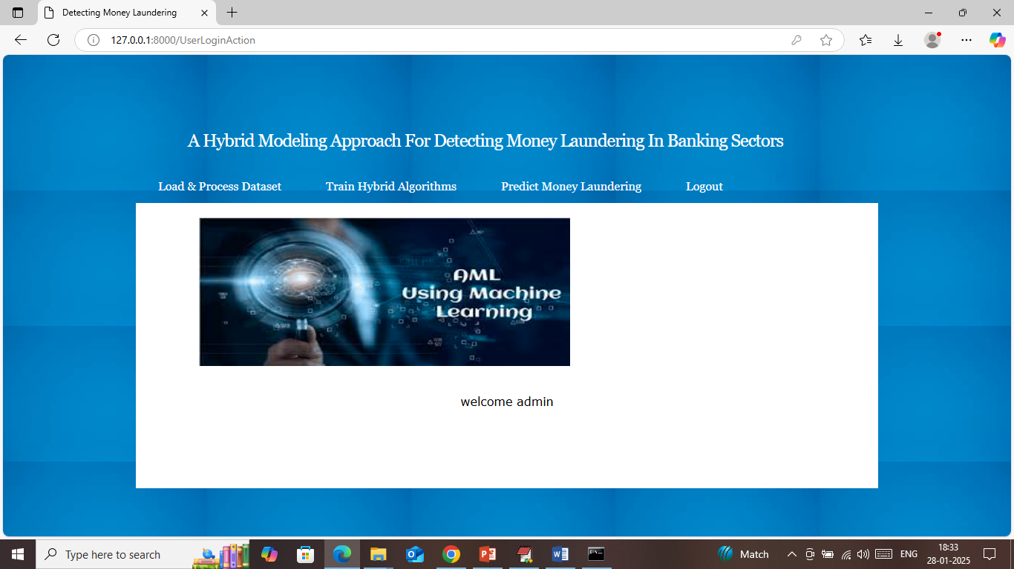
In above screen click on ‘Load & Process Dataset’ link to process dataset and get below values
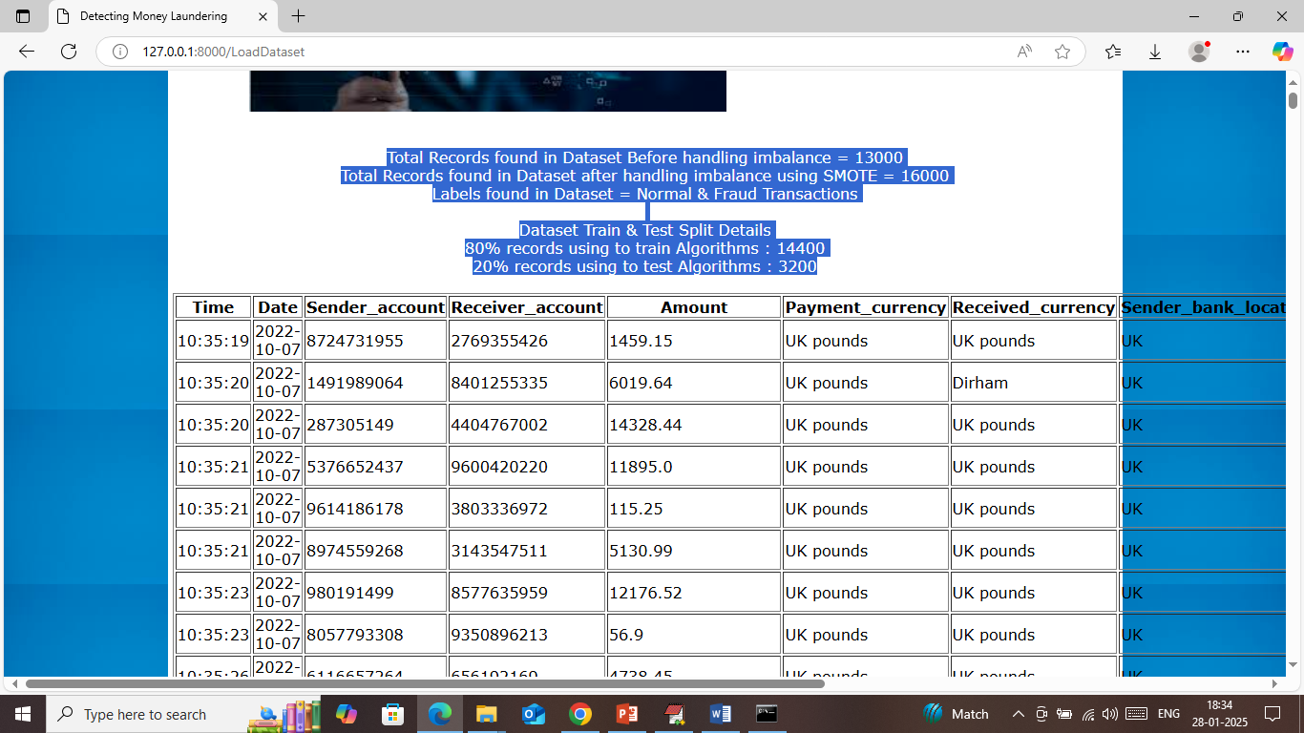
In above screen before applying SMOTE dataset were having 13000 records and then after applying SMOTE dataset got balanced with total records as 16000 and then can see train and test size. In next table can see dataset values and now click on ‘Train Hybrid Algorithms’ link to train algorithms and get below page
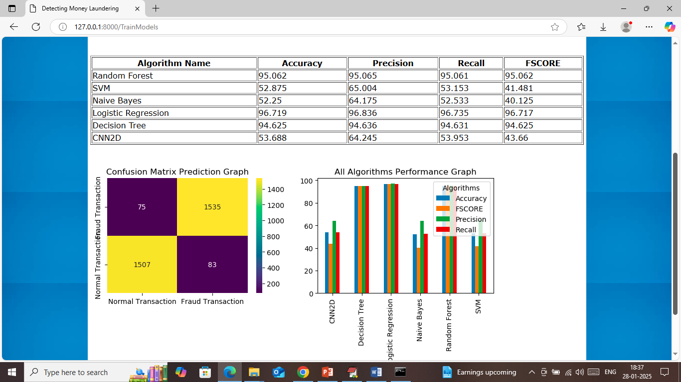
In above screen in table can see each algorithm performance with accuracy, precision, recall and FSCORE and in all algorithms Logistic Regression and Random Forest got high accuracy. In confusion matrix graph x-axis represents Predicted Labels and y-axis represents True Labels and then all yellow boxes represents correct prediction count and blue boxes represents incorrect prediction count which are very few. In second graph can see all algorithms performance in graph format where x-axis represents algorithm names and y-axis represents accuracy and other metrics in different colour bars. Now click on ‘Predict Money Laundering’ link to get below page
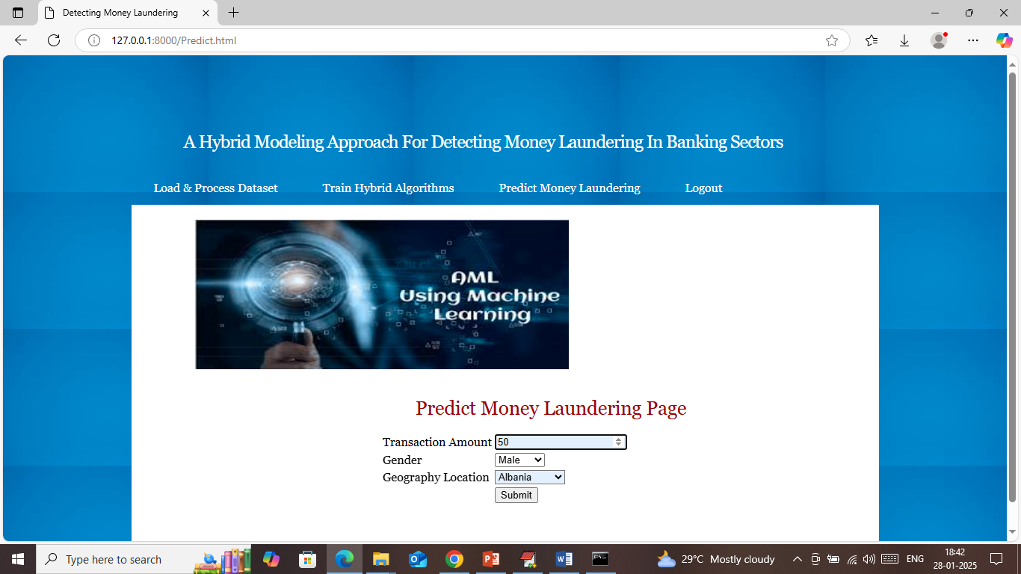
In above screen enter transaction amount along with location and then press button to get below page
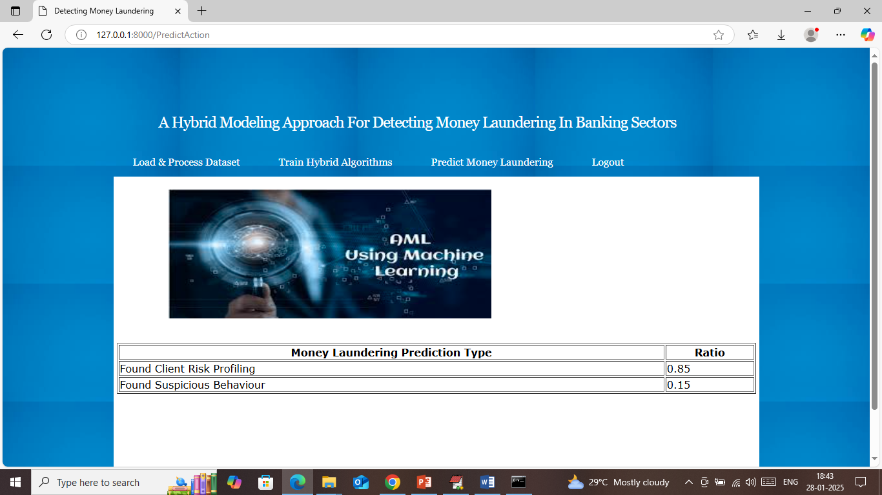
In above screen ‘suspicious behaviour’ got 0.15% and Risk profiling got 85% so transaction can be consider as normal. In below screen testing another sample
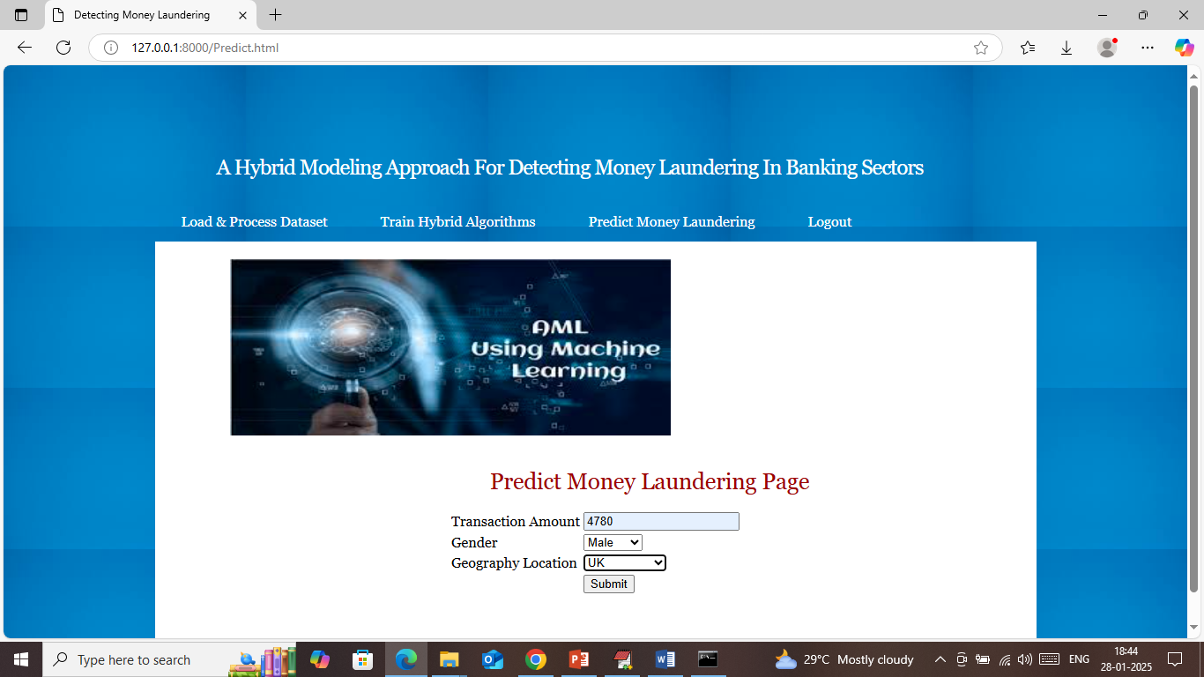
In above screen entered some other values and below is the output
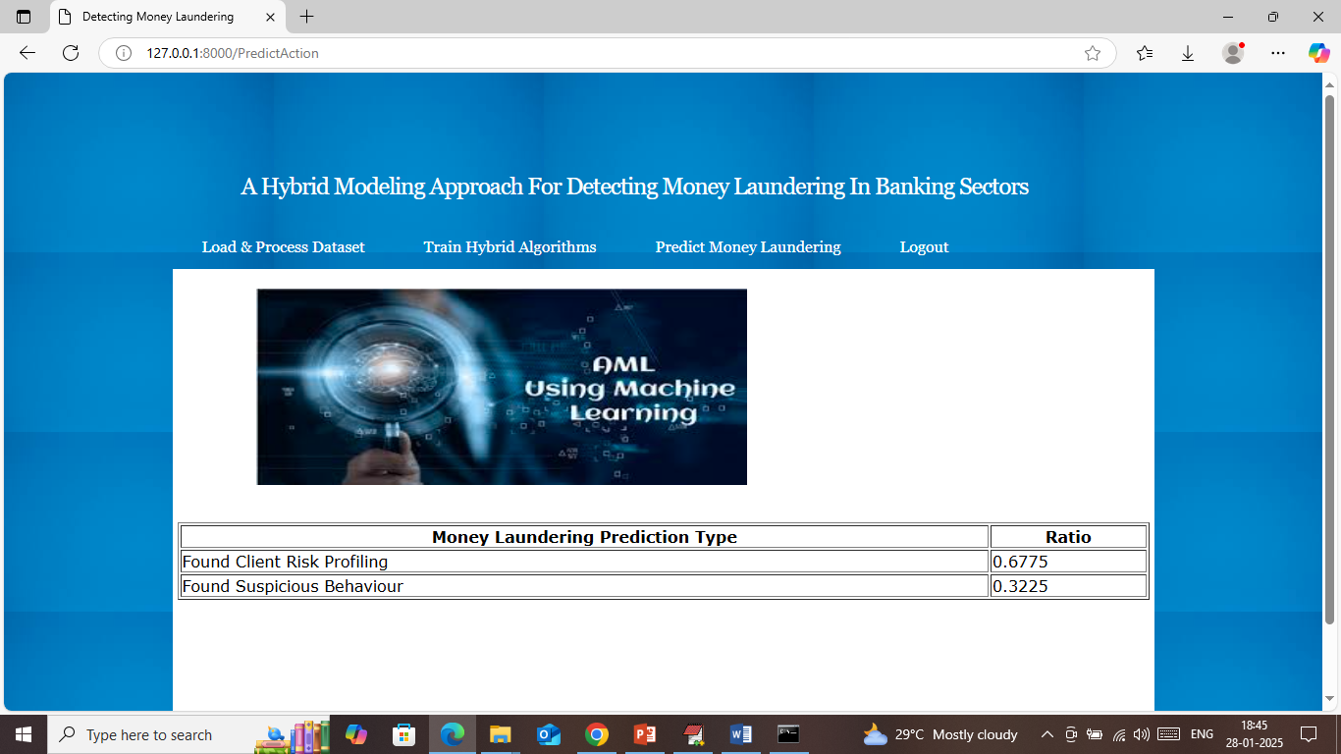
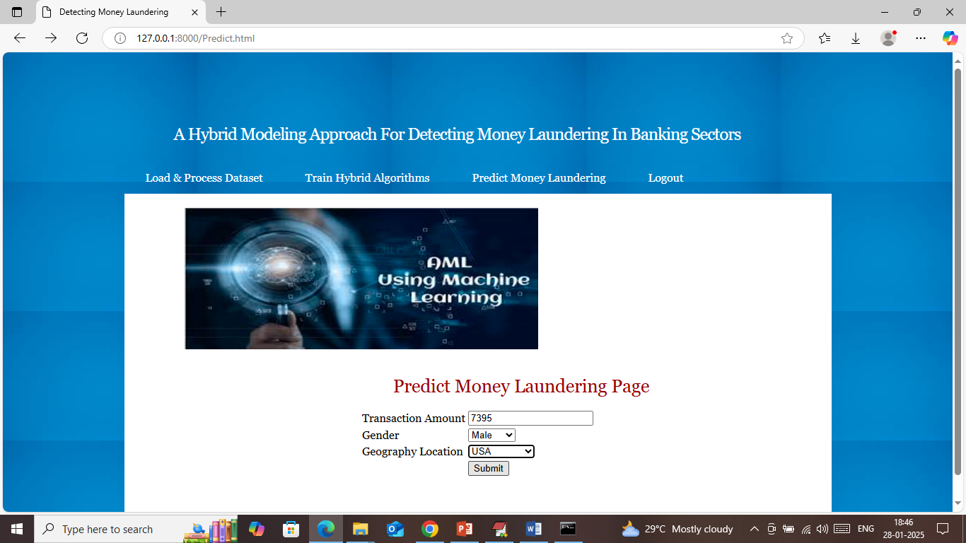
In above screen given some other values and below is the output
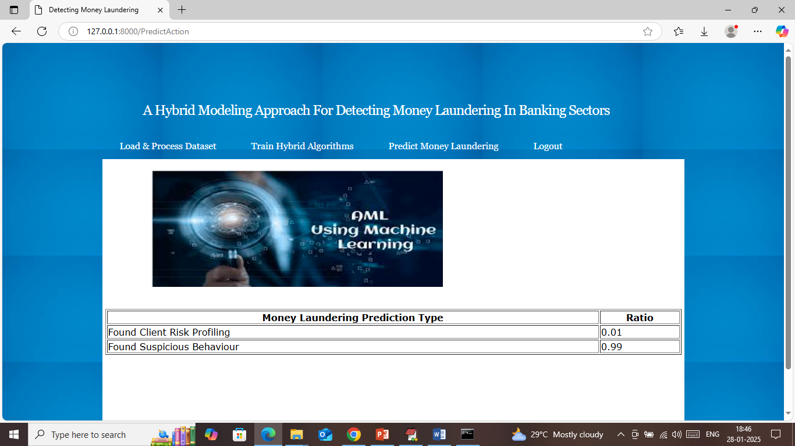
Above transaction output predicted as ‘suspicious’ with high ratio.
Similarly enter some transaction details predict laundering based on behaviour.

