**Cryptocurrency Price Prediction Using Various Machine Learning**

**models including Ensemble Method and Sentiment Analysis**

Name of 1st Author 1, Name of 2nd Author 2 (16 pt, Bold, Title Case)

1 Designation of 1st Author, Name of Department of 1st Author, Name of Organization of 1st Author

2 Designation of 2nd Author, Name of Department of 2nd Author, Name of Organization of 2nd Author

# Abstract

The volatility of cryptocurrency markets poses significant challenges for investors and traders, necessitating robust predictive models to enhance decision-making. This research explores the efficacy of several machine learning models—Long Short-Term Memory (LSTM), Gradient Boosting Machine (GBM) using XGBoost, Random Forest, Artificial Neural Networks (ANN), and an ensemble LSTM-GRU model—in predicting Bitcoin prices. Additionally, the study integrates sentiment analysis of cryptocurrency-related tweets using the VADER sentiment analysis tool to augment predictive accuracy. Historical price data and Twitter sentiment scores underwent rigorous preprocessing before training and evaluation.

The ensemble LSTM-GRU model, leveraging the combined strengths of LSTM and GRU architectures and enriched with sentiment scores, demonstrated superior performance compared to individual models. Our results indicate that integrating sentiment analysis enhances prediction accuracy, offering valuable insights for market participants. This study contributes to the field of financial forecasting by presenting a novel approach that combines advanced machine learning techniques with social media sentiment analysis, thereby providing practical tools for navigating cryptocurrency market volatility.

**Keywords:** Cryptocurrency, Price Prediction, Machine Learning, Sentiment Analysis, Financial Forecasting, Ensemble Models, Neural Networks

# Introduction

Cryptocurrencies have emerged as a transformative force in global financial markets, characterized by their decentralized nature and significant volatility. Bitcoin, the pioneering cryptocurrency, exemplifies this volatility, with price fluctuations often defying traditional market analysis and prediction methods. For investors and traders in these markets, accurate forecasting of cryptocurrency prices is not merely advantageous but imperative for informed decision-making and risk management.

The traditional methods of financial analysis and prediction struggle to capture the complex dynamics inherent in cryptocurrency markets. Factors such as global regulatory shifts, technological advancements, and widespread media coverage contribute to rapid price fluctuations, challenging conventional models. Consequently, there is a growing interest in leveraging advanced computational techniques, particularly machine learning, to enhance the predictive capabilities for cryptocurrencies.

This study focuses on exploring the efficacy of various machine learning models in predicting Bitcoin prices, augmented by sentiment analysis of cryptocurrency-related tweets. Machine learning models such as Long Short-Term Memory (LSTM), Gradient Boosting Machine (GBM) using XGBoost, Random Forest, and Artificial Neural Networks (ANN) are examined alongside an ensemble LSTM-GRU model. These models are chosen for their ability to capture non-linear relationships and patterns in historical price data, which is essential given the volatile nature of cryptocurrency markets.

In addition to historical price data, sentiment analysis from social media platforms, particularly Twitter, is integrated using the VADER sentiment analysis tool. This approach aims to capture the collective sentiment of market participants reflected in social media discussions, which may influence cryptocurrency prices. By combining these two streams of data—historical price trends and sentiment analysis—this study seeks to enhance the accuracy and reliability of cryptocurrency price predictions.

The significance of this research lies in its potential to offer practical insights and tools for investors and traders navigating the unpredictable terrain of cryptocurrency markets. By evaluating and comparing the performance of various machine learning models and assessing the impact of sentiment analysis, this study contributes to advancing the field of financial forecasting in the context of digital assets.

# Literature Review

Several studies have investigated the use of machine learning and deep learning models for cryptocurrency price prediction. Hamayel and Owda (2021) proposed a model using GRU, LSTM, and bi-LSTM algorithms to predict the prices of Bitcoin (BTC), Ethereum (ETH), and Litecoin (LTC). Their results indicated that the GRU model outperformed both LSTM and bi-LSTM in terms of prediction accuracy, with the lowest Mean Absolute Percentage Error (MAPE) and Root Mean Squared Error (RMSE) values​​.

Similarly, a study by Bonde et al. (2024) utilized LSTM neural networks to predict Bitcoin prices and highlighted the effectiveness of LSTM models in capturing long-term dependencies in time-series data. They also incorporated sentiment analysis from social media platforms, demonstrating that public sentiment can significantly impact price movements​​.

In another study, Patel et al. (2020) proposed a deep learning-based cryptocurrency price prediction scheme for financial institutions. Their model used LSTM and GRU networks to analyze historical price data and sentiment from social media, achieving notable prediction accuracy​​.

**Sentiment Analysis in Financial Forecasting**

Sentiment analysis has emerged as a critical component in financial forecasting, particularly in the context of cryptocurrencies. By analyzing public sentiment expressed through social media and news articles, researchers have aimed to capture the psychological and behavioral aspects influencing market trends.

Bonde et al. (2024) emphasized the role of sentiment analysis in their cryptocurrency price prediction model. They used the VADER sentiment analysis tool to classify sentiments in tweets as positive, negative, or neutral, which were then integrated into their predictive models. Their findings underscored the importance of considering market sentiment to enhance the accuracy of price forecasts​​.

Another relevant study by Shah et al. (2022) explored emotion detection on cryptocurrency-related tweets using an ensemble LSTM-GRU model. They found that incorporating sentiment and emotion detection improved the model's predictive performance, providing valuable insights for market participants​​.

**Comparative Studies and Model Evaluation**

Comparative studies have been conducted to evaluate the performance of different predictive models. Hamayel and Owda (2021) compared the performance of GRU, LSTM, and bi-LSTM models, demonstrating that GRU achieved the best results across multiple cryptocurrencies. Their evaluation metrics included MAPE and RMSE, which provided a comprehensive assessment of model accuracy​​.

Rebane et al. (2018) conducted a comparative study using Seq2Seq RNNs and ARIMA models for cryptocurrency prediction. They concluded that deep learning models generally outperformed traditional statistical methods like ARIMA in handling the complexities of cryptocurrency price data​​.

**Gaps and Future Directions**

Despite the advancements in cryptocurrency price prediction, several research gaps remain. One significant gap is the limited comparison of multiple machine learning models within a single study. Most research focuses on a few selected models, but there is a need for comprehensive studies that compare a broader range of models, such as LSTM, GBM/XGBoost, Random Forest, ANN, and hybrid models like LSTM-GRU, as done in this project.

Additionally, the integration of extensive Twitter sentiment analysis into predictive models is relatively underexplored. While sentiment analysis has been incorporated in some studies, a more in-depth and extensive analysis of Twitter data, including the use of more sophisticated natural language processing techniques, could provide richer insights and improve prediction accuracy. Future research should aim to utilize larger datasets of tweets and apply advanced sentiment analysis methods to capture the nuanced sentiments of market participants.

Future research should explore the integration of more diverse data sources, including trading volumes and macroeconomic variables, to improve prediction models. Furthermore, the development of hybrid models that combine the strengths of various machine learning and deep learning techniques could provide more robust predictions.

LSTM-GRU with sentiments

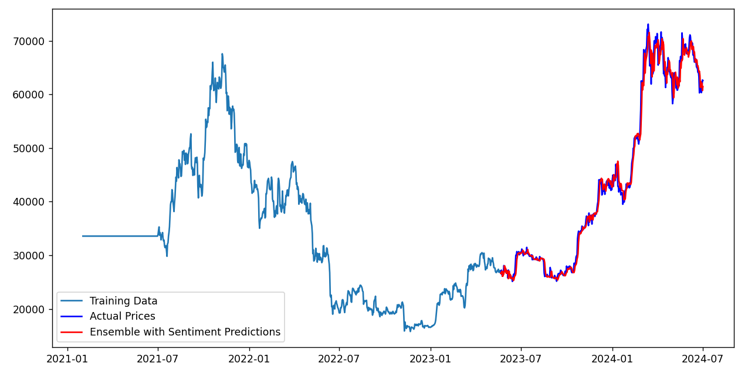

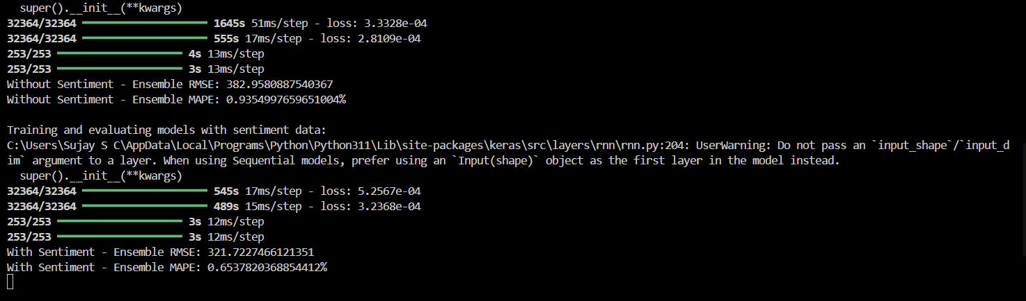

ANN model

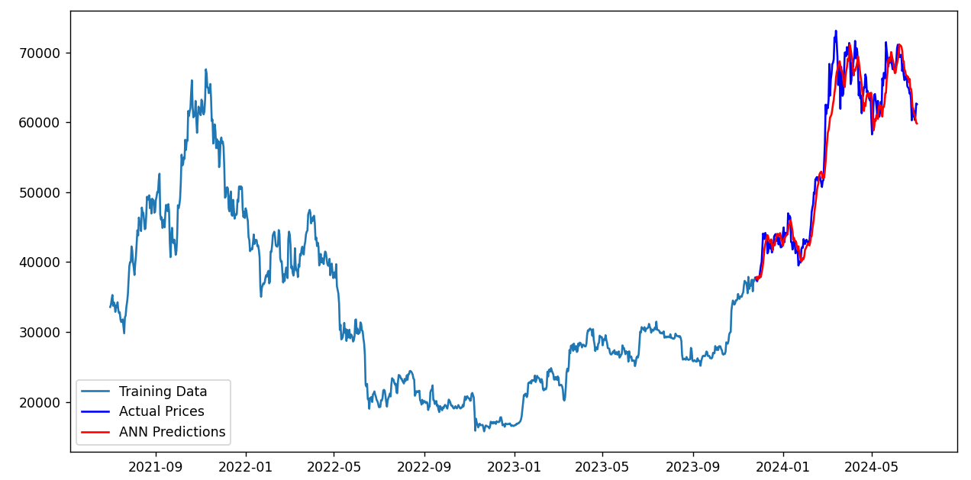

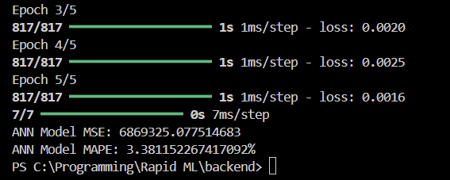

GBM model

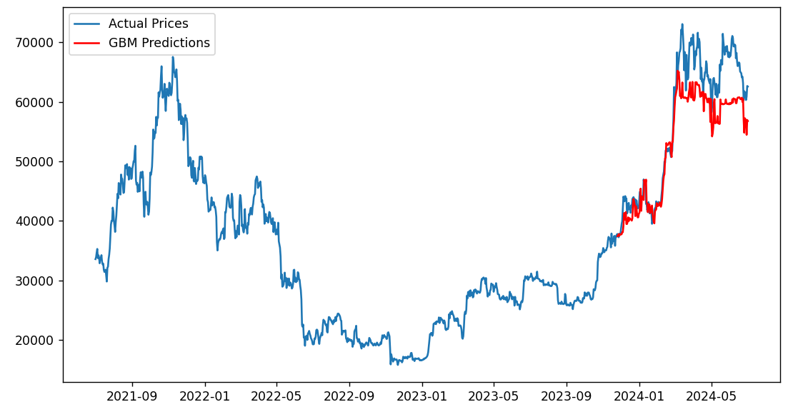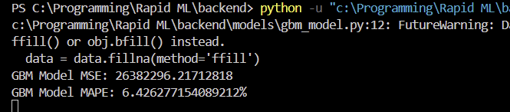

Random forest method

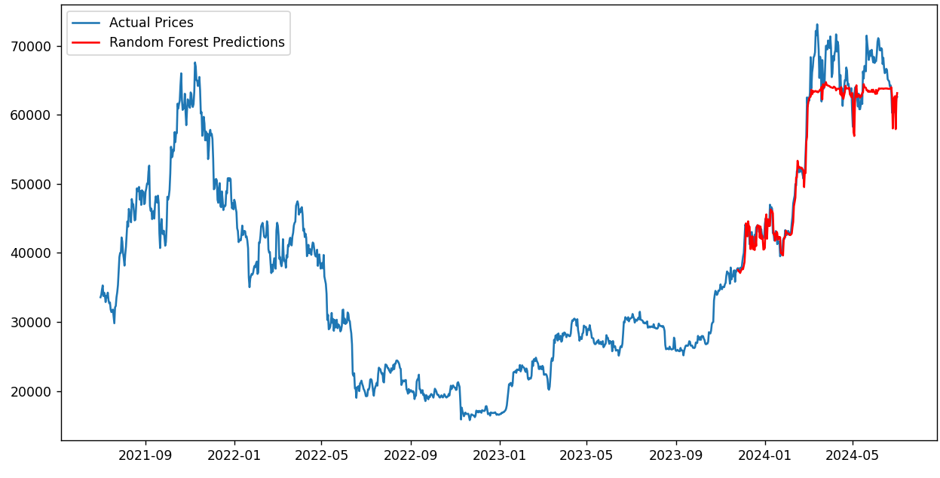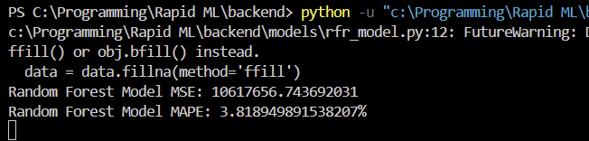

LSTM model

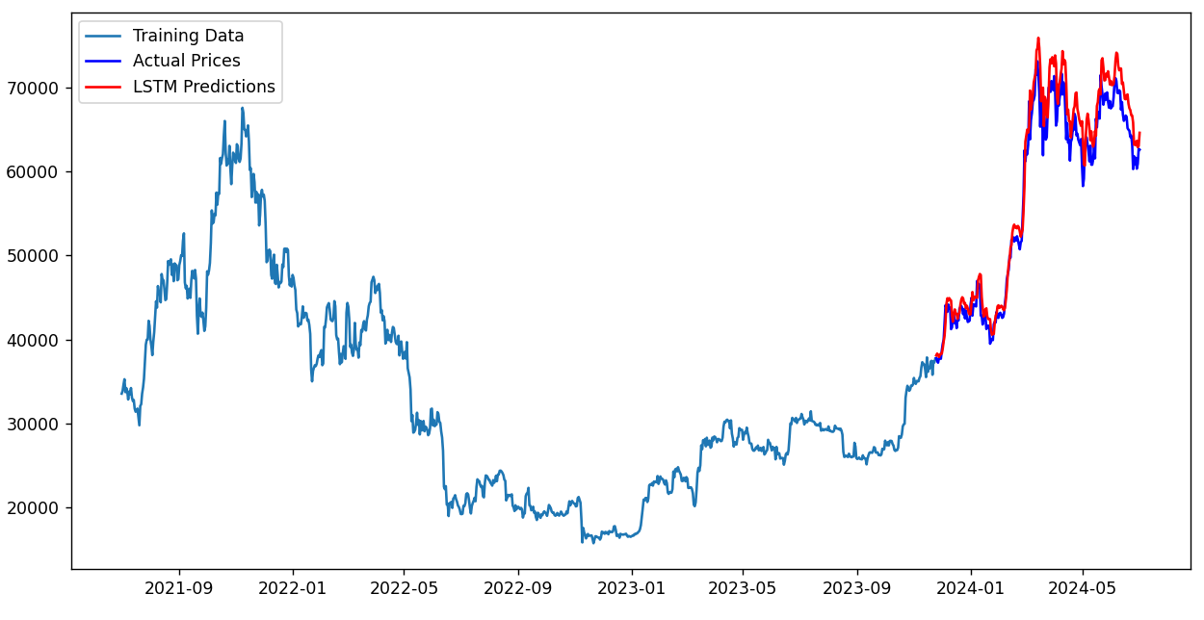

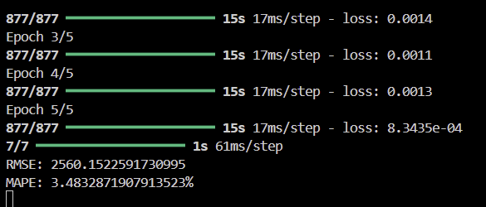

# Abbreviations and Acronyms

Define abbreviations and acronyms the first time they are used in the text, even after they have been defined in the abstract.

# Units

* Use either SI or CGS as primary units. (SI units are preferred.) English units may be used as secondary units (in parentheses). An exception would be the use of English units as identifiers in trade, such as “3.5 inch disk drive”.
* Avoid combining SI and CGS units, such as current in ampere and magnetic field in oersted. This often leads to confusion because equations do not balance dimensionally. If you must use mixed units, clearly state the units for each quantity that you use in an equation.
* Do not mix complete spellings and abbreviations of units: “Wb/m2” or “webers per square meter”, not “webers/m2”. Spell out units when they appear in text: “. . . a few henries”, not “. . . a few H”.
* Use “cm3”, not “cc”.
* Add space between amount and unit; for example - use “12 cm” instead of “12cm”.
* Use upper or lower case properly according to the unit.

# Equations

* Use equation editor feature of your word processing software to create equation if equation contains division, or multiple lines.
* Equations should be left aligned.
* It would be better to give serial numbers for the equations. Equation serial numbers, within parentheses, can be put after half the width of the page.
* If there are multiple equations, and serial numbers are assigned to them, then position all the equation serial numbers at a same tab stop.
* Do not give italic style to equations.
* Use × sign/character for multiplication sign (instead of *), and ÷ sign/character for division sign (instead of /) in equations which are not inserted using an equation editor.
* Add a blank paragraph before and after each equation.
* Use same font size as normal paragraph for the equations.
* Use a zero before decimal points: “0.25”, not “.25”.

(a + b)2 = a2 + b2 + 2ab (1)

(2)

# Headings

* Headings to be formatted with same font family and font size as normal text.
* Only apply bold style to the headings; no underline, no italic.
* Headings can be numbered or without numbering. It is recommended to use only numbers for numbered heading - means - do not use Roman and Alphabets for numbering headings. Hierarchical numbering (for example - 1.1, 1.1.2) may be used for sub-headings.
* Set “Keep with next paragraph” checkbox checked in the paragraph's settings/options for all the headings, to avoid heading in one page and its content on the next page.
* Do not add colon at the end of the headings.

# Figures and Tables

* Add captions/headings for figures and table using their “caption” option/setting.
* Do not format captions with bold or italic or underline style; use same style as normal paragraphs.
* Do not apply background color(s) to cells/rows/columns of tables.
* Center align figures, tables and captions.
* It would be better to give numbers to figures and tables.
* Use Title Case for the captions.
* Set height and width of the cells in tables to minimum required. Tables should be “fit to content”.
* It would be better to provide caption above the figures and tables rather than below them.
* Instead of using short text like “Fig. 1”, use full text like “Figure 1” in captions.
* If figures or images are smaller than half the width of the page then multiple consecutive figures and images may be put in one line. Use table to add multiple figures or images in one line/row.
* Do not write text in the same line as of any figure or table (no wrap).
* Set “bold” style for the column/row headings and footer in the table.
* Use same font size as normal paragraphs for tables' content. However, if table is wider than the available space in the page then set 10 pt font size for the table's content. If table is wider even after setting 10 pt font size then authors may consider breaking the table.
* Specify height and width in the same original proportions for images - they shouldn't be stretched or squeezed disproportionally. And images need to be clear with fine resolution.
* Add blank paragraphs above and below the figures and tables.

Table 1: Table Type Styles

|  | Column Heading 1 | Column Heading 2 | Column Heading 3 |
| --- | --- | --- | --- |
| Row Heading 1 | 184 | 456 | 323 |
| Row Heading 2 | 290 | 234 | 523 |
| Row Heading 3 | 427 | 149 | 785 |
| Total | 901 | 839 | 1631 |

The above data is pictured in the next graph.

Figure 1: Temperature After Each Pass

# Some Common Mistakes

* Using 0 (Zero) or O with superscript formatting for the degree symbol used for temperature (Celsius/Fahrenheit), angle (including latitude-longitude). (Proper usage: Use the degree symbol: °.)
* Add a full-stop/period after “et”. (Proper usage: There is no period after the “et” in the Latin abbreviation “et al.”.)
* Improper use of “i.e.” and “e.g.”. (Proper usage: The abbreviation “i.e.” means “that is”, and the abbreviation “e.g.” means “for example”.)

# Appendix

This section may be added immediately after main content, before acknowledgment, authors' biography and references.

# Conflict of Interest

Authors need to add this section if the research was sponsored, or any other way the research was - influenced by anybody/any organization - not fully neutral. Authors must clarify that whether the results of the research were affected by sponsors/influencers or not. If there is no conflict of interest with anybody/any organization then this section is not required.

# Acknowledgement

Put applicable sponsors acknowledgements in this section; do not place them on the first page of your paper or as a foot-note. Guide's name may be put either here or on the first page. Other supportive people's names can be mentioned in this section.

# Authors' Biography

Short biography of each author may be included, with/without photographs, after main content of the research paper and before references. The biography may only include details related to current position/designation of the authors. No personal detail can be included in biography.

# References

## References within Main Content of the Research Paper

* Enclose the citation number in square brackets, for example: [1].
* Where appropriate, include the names of authors and publication year of the referenced research paper or book, enclosed within round bracket; e.g.: (Rupert Wesley, 2017)
* The reference numbers need to be within same referenced text sentence; i.e., the reference numbers must be before full stop mark of the sentence.
* Multiple reference numbers can be provided in one square bracket: [1, 2]. Add a comma and a space between each reference numbers.
* When referring to a reference, if you want to use its reference number then, do not use “Ref. [3]” or “reference [3]”; only write reference number like this: “[3]”.
* Do not use reference citations as nouns of a sentence; e.g., not “as the author explains in [1]”, specify “as Rupert Wesley (2017) explains”.
* If there are more than one author, write only one author's name, and use “et al.” for other authors; e.g., (Rupert Wesley, et al., 2017).
* If multiple references can be linked with above format then write other author(s) names to distinguish the references.

## References in the Reference List at the End of the Research Paper

* Reference' details may be added in foot-note (at the end of the page on which reference is mentioned) or in end-note (at the end of the research paper). Either use foot-note or end-not, do not mix. Use end-note if any of the references is referred in more than one paragraphs. End-note is most preferred for list of references.
* Use “1.” numbering format.
* Do not format any part of the reference with italic style.
* There must not be any broken link.
* If website address is provided, it must link/point to the exact research paper or book, i.e., do not just provide www.xyzsite.com; provide full URL with “http://” or “https://” and the path to the exact page like https://www.xyzsite.com/books/path/to/book/abc-book. Write URL after all other details of the reference.
* Separate each part (authors' names, title, edition, publisher's name, (month and) year of publication, volume number, issue number, pages to-from) of a reference with commas. Write full-stop at the end of each reference. However, if there is a URL, then write full-stop before the URL. And do not write full-stop after the URL.
* Research papers that have not been published, even if they have been submitted for publication, should be cited as “(unpublished)” [4].
* Research papers that have been submitted for publication, but waiting for being accepted or rejected, should be cited as “submitted for publication”.
* Research papers that have been accepted for publication, but not yet specified for an issue or haven't been published, should be cited as “to be published”.
* Titles of referenced articles need to be either in the Title Case or Sentence case. Do not write any title only in UPPER CASE or only in lower case.
* Any of the below format may be used for authors names (please be consistent for all references) (4th format is most preferred):
  1. Roger Robert Federer, Leonardo Wilhelm DiCaprio, Donald John Trump
  2. Roger R. Federer, Leonardo W. DiCaprio, Donald J. Trump
  3. Roger F., Leonardo D., Donald T.
  4. Roger R.F., Leonardo W.D., Donald J.T.
  5. R.R. Federer, L.W. DiCaprio, D.J. Trump
  6. R. Federer, L. DiCaprio, D. Trump
* Please follow these when specifying names of the authors:
  + The first name first, then a space (only if the first character of the middle name isn't given, full middle name is given or no middle name is given), then optionally middle name, then a space, then the last name.
  + No comma between first name, middle name and last name of each author.
  + Separate the authors' names with a comma and a space. Do not write “and” before the last author's name.
* Please do not write journal/publisher's name with abbreviations, write full name; or acronym may be used if the publisher is well-known with the acronym.

## Example of List of References

1. Roger R.F., Leonardo W.D., Donald J.T., “Title of Our Research Paper”, Name of the Publisher/Journal, April 2015, 7 (3), 129–151.
2. Jack C.M., “Electromagnetic Effects on the Different Kinds of Water”, Journal of Electromagnetic Effects, 1992, 2 (4), 47–76.
3. Samuel J., “Fine Particles, Thin Films and Exchange Anisotropy”, Magnetism, 1963, 3 (1), 271–350.
4. Kate E., Title of the Research Paper. (Unpublished)
5. Andrew S. “Effect of Non-visible Electromagnetic Particles on Photosynthesis”. https://www.example.com/volume-14/issue-5/effect-of-non-visible-electromagnetic-particles-on-photosynthesis

  Licensed under [Creative Commons Attribution-ShareAlike 4.0 International License](http://creativecommons.org/licenses/by-sa/4.0/)