

|  |  |  |
| --- | --- | --- |
| |  | | --- | |  | | **PES University, Bengaluru** |
|  | (Established under Karnataka Act 16 of 2013) |
| **Department of Computer Science & Engineering** | |
| **Session: Jan - May 2022** | |

**UE19CS353 – Object Oriented Analysis and Design with Java**

**Theory ISA (Mini Project)**

Report on

**YouTube Clone**

**By:**

**Suhail Sheikh– PES1UG19CS513**

**Sujay S Ambekar– PES1UG19CS516**

**Sumukh J Bharadwaj– PES1UG19CS518**

**6th Semester ‘H’**

1. **Project Description**

**Github link :** [**https://github.com/SujayAmbekar/Youtube-Clone**](https://github.com/SujayAmbekar/Youtube-Clone)

Our project is a Platform for uploading and watching videos on YouTube

**Functionalities:**

**Login** – Allows users to login to their accounts

**Register** – Allows users to make a new account

**Upload Video** – Users can upload videos

**Download Video** – Users can download videos and store it in internal storage

**Search Video** – Users can search for a video

**Report Video** - This functionality is used by subscribers to report videos uploaded by publishers which violate the rules and regulations of the app.

**Store user information** - User details like username, email, age, phone number and age are stored.

**Store Authentication details** - Used to store user authentication details like username and password.

**Watch later** – Users can select videos which they would like to watch later

**View channel Details** - Channel details like numbers of uploaded videos, number of people who have subscribed to the channel and average watch time.

**Create channel** - Used by publisher to create channels.

**Delete channel** - Used by publisher to delete channels.

**Subscribe to channel** - Used by subscriber to subscribe to channels of publisher

**Publisher** - A user of the app whose main functionality is to create their own channels, view their channel usage details, upload videos and remove the videos uploaded by them.

**Subscriber** - like and dislike videos uploaded by publishers, subscriber can comment on the videos uploaded by publisher

1. **Analysis and Design Models**

**Use Case Model**

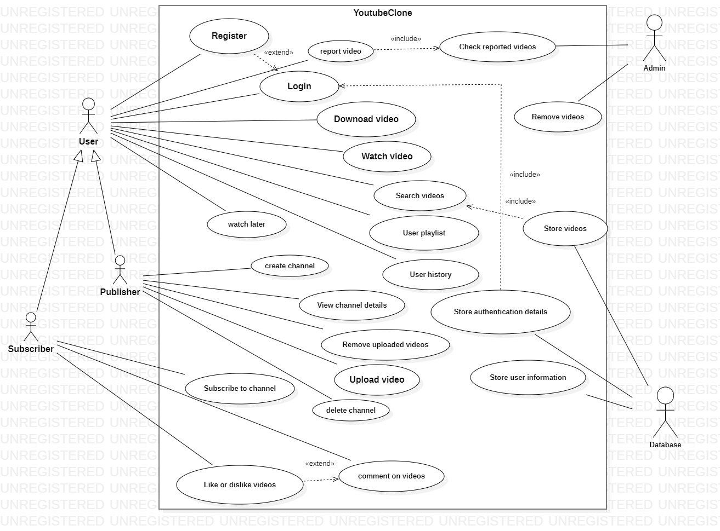

**Class Model**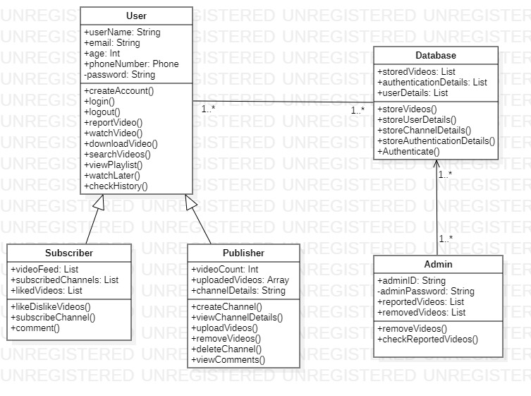

**Activity diagram for Search Videos and Explore**

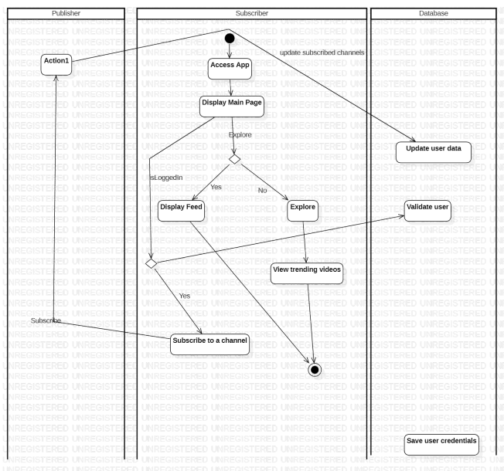

**Activity diagram for Create Channel**

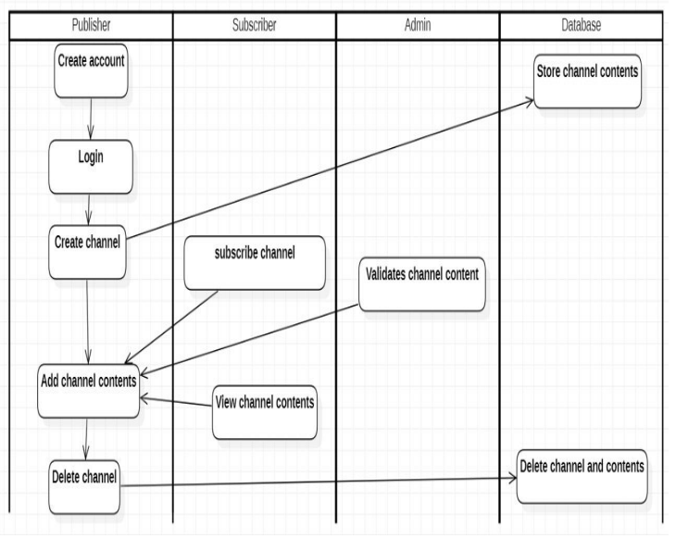

**Activity diagram for Watching and video interaction for subscriber**

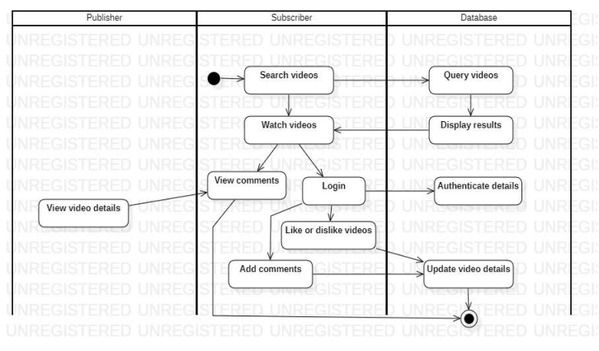

1. **Tools and Frameworks Used**
2. **Android Studio**

**ii. Database – Sqlite**

**iii. YouTube API**

1. **Design Principles and Design Patterns Applied**

**Behavioural pattern :Publisher – Subscriber**

**Publisher** - A user of the app whose main functionality is to create their own channels, view their channel usage details, upload videos and remove the videos uploaded by them.

**Subscriber** - like and dislike videos uploaded by publishers, subscriber can comment on the videos uploaded by publisher

**Structural pattern – Adapter**

The whole application is split int components to which a user can adapt to depending upon their need

**SOLID Principles:**

1. SRP - Achieved by splitting use cases into separate classes
2. OCP – New functionalities can be added without changing existing code
3. LSP – achieved by child classes having functionality like their parent class so that they can replace them
4. ISP – Achieved by separating interfaces
5. DIP – Could not be achieved as many modules are interdependent.
6. **Application Screenshots (3-4 important pages)**
7. **Subscribe/Unsubscribe to a particular channel**

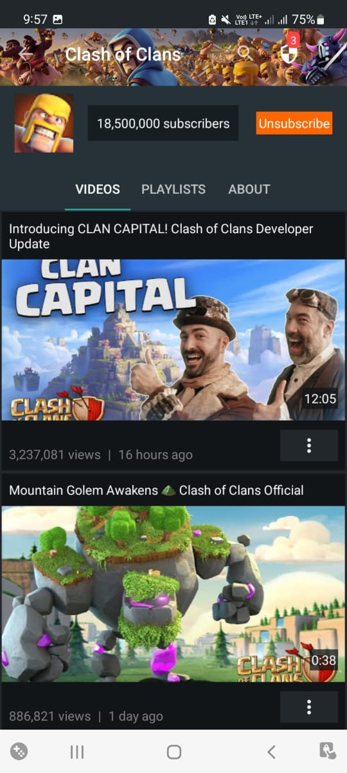

**ii. Video playlist**

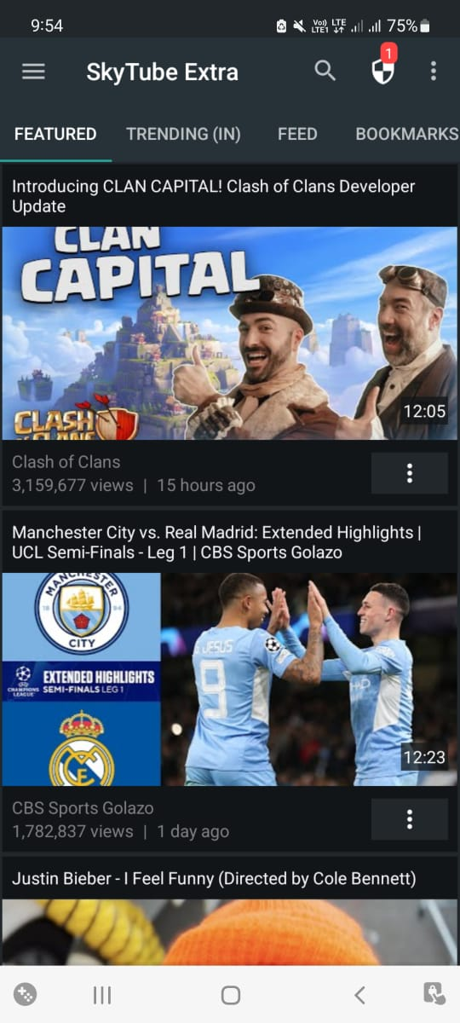

**iii. Feed after subscribing to a channel**

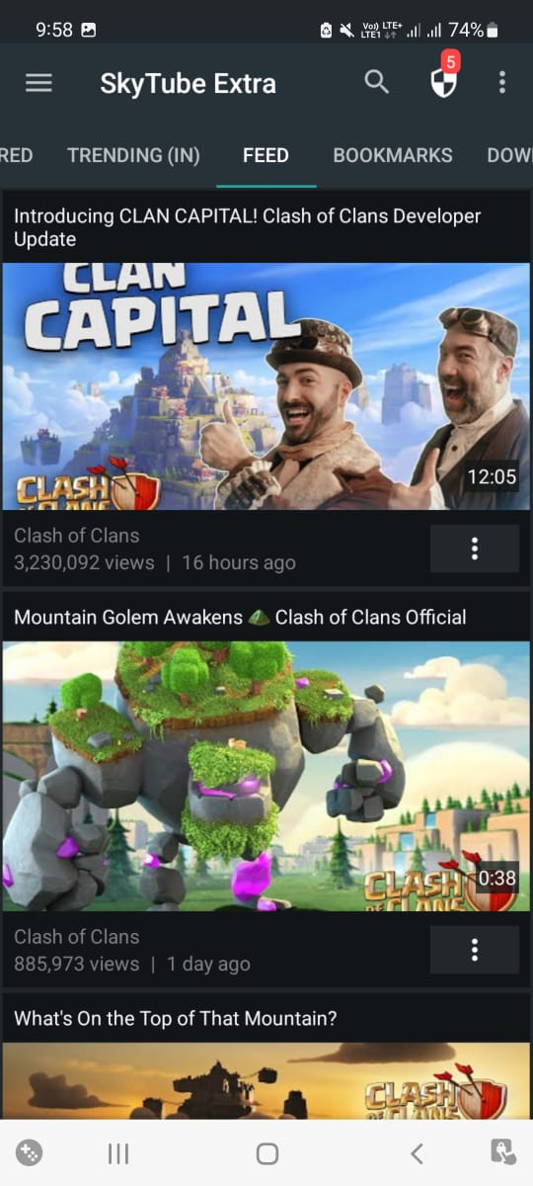

**iv. Playing a video**

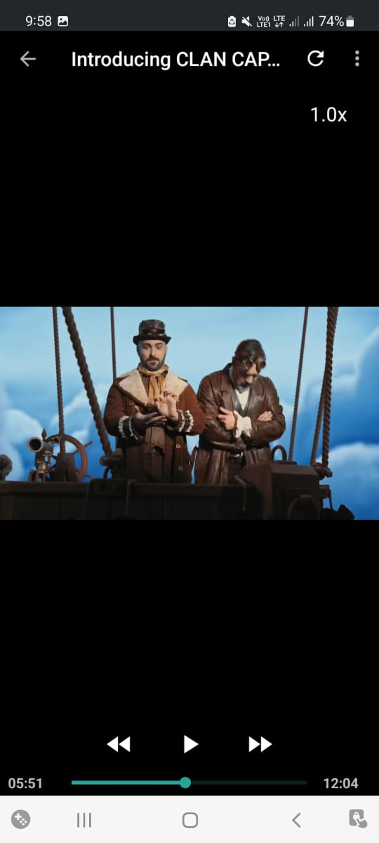

1. **Team member contributions**

|  |  |
| --- | --- |
| **Suhail F Sheikh** | 1. Searching for a video 2. Video Player Controller 3. User history 4. Integrating of modules |
| **Sujay S Ambekar** | 1. Subscribing to a channel 2. Feed and Bookmarks 3. Playlist 4. User Interface |
| **Sumukh J Bharadwaj** | 1. Featured page / Main page 2. Trending videos 3. Downloading a video 4. Database Management |