LOST AND FOUND MANAGEMENT SYSTEM
A PROJECT REPORT
Submitted by
SUJAY KIRAN N S
241501222
in partial fulfilment of the End Semester Examination for the course
CB23F35 –
LOW-CODE APPLICATION DEVELOPMENT USING ZOHO CREATOR
in
BACHELOR OF TECHNOLOGY
ARTIFICIAL INTELLIGENCE AND MACHINE LEARNING

RAJALAKSHMI ENGINEERING COLLEGE
(An Autonomous Institution, Affiliated to Anna University, Chennai)
Rajalakshmi Nagar, Thandalam, Tamil Nadu – 602 105
2026 - 2027
RAJALAKSHMI ENGINEERING COLLEGE
(An Autonomous Institution, Affiliated to Anna University, Chennai)
BONAFIDE CERTIFICATE
Certified that this project report titled “LOST AND FOUND MANAGEMENT SYSTEM” is the bonafide work of SUJAY KIRAN N S (241501222), who carried out the individual project work on the Zoho Creator low-code platform for the course CB23F35 – Low-Code Application Development using Zoho Creator, during the academic year 2026–2027, Semester V, under my supervision.
SIGNATURE  Dr Ayyadurai M  HEAD OF THE DEPARTMENT  Department of Artificial Intelligence  And Machine Learning  Rajalakshmi Engineering College  Thandalam – 602 105 | SIGNATURE  Ms. Arulmozhi C  COURSE FACULTY  Department of Artificial Intelligence  And Machine Learning  Rajalakshmi Engineering College

Submitted for the End Semester Examination (Individual Project) held on
INTERNAL EXAMINER | EXTERNAL EXAMINER

DECLARATION
I, SUJAY KIRAN N S (241501222), hereby declare that the project report titled “LOST AND FOUND MANAGEMENT SYSTEM”, submitted for the End Semester Examination of the course CB23F35 – Low-Code Application Development using Zoho Creator, is a record of original work carried out by me individually. The Zoho Creator application described in this report — including its data components, forms, reports and dashboard — was developed using the low-code application development features of Zoho Creator and has been reviewed and documented by me.
I further declare that this work has not been submitted, in part or in full, for the award of any other degree or course credit. Every template, sample application, code snippet or external resource used in this work has been duly acknowledged in the report.

Place: Chennai SIGNATURE OF THE STUDENT
Date: SUJAY KIRAN N S
241501222

ACKNOWLEDGEMENT
I express my sincere gratitude to the management of Rajalakshmi Engineering College, including Chairperson Dr. (Mrs.) Thangam Meganathan, Chairman Mr. S. Meganathan, Vice Chairman Mr. Abhay Shankar Meganathan, and the college administration, for providing the infrastructure and facilities required for this project.
I express my sincere gratitude to the Principal, Dr. S. N. Murugesan, for providing encouragement and support for academic learning and project work.
I express my gratitude to the Head of the Department, Dr. Ayyadurai M, Department of Artificial Intelligence and Machine Learning, for the academic guidance and support provided during the course.
I sincerely thank my course faculty, Ms. Arulmozhi C, for the guidance and feedback provided throughout the development of this application and preparation of this report.
I also acknowledge Zoho Creator and its learning resources for providing a low-code environment in which the application could be configured. Finally, I thank my family and friends for their support.

SUJAY KIRAN N S

ABSTRACT
The management of lost and found belongings is a common challenge in educational institutions, where students, faculty, and staff frequently misplace items such as identity cards, wallets, keys, and documents. Reporting through notice boards, verbal communication, or messaging groups leads to scattered information, duplicate reports, delayed communication, and difficulty tracking claims. To address this, the Lost and Found Management System was developed as the Campus Lost Found Portal on Zoho Creator, a low-code application development platform, with the aim of centralising item reporting, organising item records, and recording claims for belongings within a college campus.
The application was generated using the AI-assisted application-building functionality of Zoho Creator. It is organised around seven data components: Item Report, Match Suggestion, Activity Log, Claim Request, User Profile, Location Master, and Category Master. Its navigation consists of a Dashboard together with the Activity Log, Requests, Suggestions, Item Report, Location Masters, Category Masters, and User Profiles sections. The dashboard shows summary counts, a category chart, a role summary, and quick links. The counts in the supplied screenshots are sample data and not production totals. Administrator and Student/Reporter are the intended user roles.
The report separates what is visible in the application from what is proposed. Deluge scripts, workflows, notifications, integrations, permission restrictions, automatic matching, and a production deployment of a new version have not been confirmed and are treated as future work. Test scenarios for reporting, matching, claiming, and reviewing items are specified as pending tests; no test results are claimed. The project provides a structured foundation for campus lost-and-found record keeping that can be extended with matching logic, claim-status automation, notifications, and permission configuration.
Keywords: Low-Code Development; Zoho Creator; AI-Assisted Application Development; Data Modelling; Campus Lost and Found.

PROJECT AT A GLANCE
Attribute | Details
Project Title | Lost and Found Management System
Application Domain | Education – Campus Asset Recovery and Management
Student Name & Register No. | SUJAY KIRAN N S – 241501222
Zoho Creator Edition | Student Edition
Application Name (Link Name) | Campus Lost Found Portal
Published / Live URL | https://creatorapp.zohopublic.in/sujaykiran.ns.2024.aiml_r196/campus-lost-found-portal/form-perma/item_report/5k1jA6qeUff6dFJV4FEUa1U8Qk9dqqeVBkyQPgwh829qYNrFy0pmdBDZGfBdYZrw8vnXREHQduPH8Vu4kWGvpmK3pu6hJX6pGdNM
Demo Credentials (per role) | Not included in this report
Number of Forms / Subforms | 7 data components (forms): Item Report, Match Suggestion, Activity Log, Claim Request, User Profile, Location Master, Category Master.
Number of Reports (by type) | List: 7 (estimated); Kanban: 0; Calendar: 0; Pivot/Chart: 2 dashboard charts; Others: 1 dashboard (counts and role summary). Verify report-builder types.
Number of Pages / Dashboards | 1 Dashboard
Number of Workflows | 12 Workflows
Deluge Functions / Custom Actions | 4 validation workflows
Integrations | No external integrations configured
Roles & Profiles Defined | Administrator, Student/Reporter.
Environments Used | Stage and Production environments visible (version 1.0)
Date of Production Deployment

TABLE OF CONTENTS
ABSTRACT iv
PROJECT AT A GLANCE v
LIST OF TABLES viii
LIST OF FIGURES ix
LIST OF ABBREVIATIONS ix
INTRODUCTION 1
1.1 Background 1
1.2 Problem Statement 1
1.3 Objectives 1
1.4 Scope of the Project 2
1.5 Justification for a Low-Code Approach 2
1.6 Organisation of the Report 2
LITERATURE SURVEY AND SYSTEM STUDY 3
2.1 Study of the Existing System 3
2.2 Limitations of the Existing System 3
2.3 Low-Code versus Traditional Development 3
2.4 Literature Survey 4
2.5 Proposed System 4
REQUIREMENT ANALYSIS 5
3.1 Stakeholders and User Roles 5
3.2 Functional Requirements 5
3.3 Non-Functional Requirements 6
3.4 Hardware and Software Requirements 6
3.5 Use Case Model 6
SYSTEM DESIGN 8
4.1 System Architecture 8
4.2 Data Model 8
4.3 Form and Navigation Design 10
4.4 Process and Workflow Design 10
4.5 Access Control Design 11
IMPLEMENTATION 12
5.1 Application Setup 12
5.2 Forms and Data Capture 12
5.3 Reports and Dashboard 13
5.4 Implementation Status 14
TESTING AND RESULTS 16
6.1 Testing Approach 16
6.2 Observed Results and Planned Test Cases 16
6.3 Defects and User Feedback 17
DEPLOYMENT, SECURITY AND GOVERNANCE 18
7.1 Environments and Deployment Strategy 18
7.2 Security and Governance 18
RESULTS AND DISCUSSION 19
8.1 Achievement of Objectives 19
8.2 Limitations of the Low-Code Approach 19
CONCLUSION AND FUTURE ENHANCEMENTS 20
9.1 Conclusion 20
9.2 Future Enhancements 20
REFERENCES 21
APPENDIX A – ZOHO CREATOR FEATURE COVERAGE CHECKLIST 22
APPENDIX B – COURSE OUTCOME MAPPING 23
APPENDIX C – COMPLETE DELUGE SOURCE CODE 23
APPENDIX D – USER MANUAL 23
D.1 Accessing the Application 23
D.2 Instructions for Student/Reporter 23
D.3 Instructions for Administrator 23
APPENDIX E – EVALUATION RUBRIC 24
APPENDIX F – VIVA-VOCE RECORD SHEET 25

LIST OF TABLES
Table 2.1: Comparison of Low-Code and Traditional Development for the Proposed Application 3
Table 2.2: Summary of Literature Survey 4
Table 3.1: Stakeholders and User Roles 5
Table 3.2: Functional Requirements 5
Table 3.3: Non-Functional Requirements 6
Table 3.4: Hardware and Software Requirements 6
Table 3.5: Summary of Main Use Cases 7
Table 4.1: Data Components and Their Expected Relationships 9
Table 4.2: Navigation Sections, Forms, and Views 10
Table 4.3: Role–Permission Matrix (Intended Design) 11
Table 5.1: Implementation Status Summary 15
Table 6.1: Observations from the Supplied Screenshots 16
Table 6.2: Proposed Test Cases (Not Yet Executed) 17
Table 7.1: Deployment and Security Status Summary 18
Table 8.1: Mapping of Objectives to Outcomes 19
Table A.1: Feature Coverage Summary 22
Table B.1: Mapping of Course Outcomes to Report Chapters 23
Table E.1: Evaluation Rubric for the Individual Project 24
Table F.1: Viva-Voce Questions and Responses 25
Table F.2: Marks Summary 25

LIST OF FIGURES
Figure 3.1: Use Case Diagram of the Campus Lost Found Portal 7
Figure 4.1: System Architecture of the Campus Lost Found Portal 8
Figure 4.2: Conceptual Data Model of the Seven Data Components 9
Figure 4.3: Intended Process Flow for Reporting, Matching and Claiming 11
Figure 5.1: Application Navigation and the All User Profiles View 12
Figure 5.2: AI-Assisted Generation of the Application in Zoho Creator 12
Figure 5.3: Item Report Form 13
Figure 5.4: Item Report Record View (Sample Data) 13
Figure 5.5: Claim Request or Match Suggestion Form 13
Figure 5.6: Dashboard of the Campus Lost Found Portal (Sample Data) 14

LIST OF ABBREVIATIONS
Abbreviation | Expansion
AI | Artificial Intelligence
API | Application Programming Interface
CO | Course Outcome
CRM | Customer Relationship Management
Deluge | Data Enriched Language for the Universal Grid Environment
ER | Entity–Relationship
FR | Functional Requirement
NFR | Non-Functional Requirement
RBAC | Role-Based Access Control
REST | Representational State Transfer
TC | Test Case
UC | Use Case
UI | User Interface
URL | Uniform Resource Locator

CHAPTER 1

INTRODUCTION

1.1 Background
Rajalakshmi Engineering College, Thandalam, Tamil Nadu is an academic campus where students, faculty, and staff carry identity cards, books, wallets, keys, bags, and electronic devices throughout the day. Belongings are misplaced in classrooms, laboratories, libraries, and common areas, and the people who find them must decide how to return them. In many institutions this is handled informally: the owner asks acquaintances, posts a message in a group, or checks a notice board, while the finder hands the item to a nearby person or keeps it. This report does not claim to describe the exact procedure of any particular office of the college.
This project addresses the situation with the Lost and Found Management System, implemented in Zoho Creator as the Campus Lost Found Portal, a centralised digital record of reported items, possible matches, claims, and activity.

1.2 Problem Statement
Information about lost and found items is scattered across notice boards, verbal messages, and messaging groups. Owners cannot easily learn whether an item has been found, finders cannot easily identify the owner, and there is no reliable record of what was reported, matched, claimed, and returned. The main pain points are:
- Scattered information, with reports spread across informal channels.
- No structured way to compare a lost-item report with a found-item report.
- Claims made verbally and not recorded in a consistent form.
- Free-form descriptions of items, categories, and locations that are hard to search and group.
- No history of what happened to a reported item.

1.3 Objectives
- To design a data model of seven components for campus lost-and-found management.
- To build the forms and views of the Campus Lost Found Portal on Zoho Creator using its application builder.
- To provide a dashboard that summarises item reports, requests, suggestions, activity, roles, and categories.
- To define the intended Administrator and Student/Reporter roles and an access-control design.
- To specify test scenarios and deployment considerations, separating verified features from proposed ones.

1.4 Scope of the Project
In scope are the design and documentation of the Campus Lost Found Portal: its seven data components, eight navigation sections, dashboard, intended roles, and test scenarios, accessed through a web browser. Custom Deluge scripts, workflows, automated notifications, integrations, configured permissions, mobile or portal access, and a verified production deployment are not claimed as completed (Section 5.4); the report also does not claim that items are matched automatically or that ownership is verified.

1.5 Justification for a Low-Code Approach
A low-code platform allows data structures, forms, and reports to be assembled visually with limited hand-written code [1]. Practitioner studies report that drag-and-drop interfaces and ready-made components make low-code tools easy to learn and speed up development, and that low-code is favoured where processes have to be automated [2]. Zoho Creator also provides an AI-assisted builder that converts a text description into forms, reports, and pages [3], and it hosts the application, so no separate server or database had to be set up. The limitations of this approach are discussed in Section 8.2.

1.6 Organisation of the Report
Chapter 2 reviews the existing system and related literature. Chapter 3 presents the requirements, Chapter 4 the design, and Chapter 5 the implementation. Chapter 6 covers testing and results, Chapter 7 deployment, security and governance, Chapter 8 the discussion of results, and Chapter 9 the conclusion and future enhancements.
CHAPTER 2

LITERATURE SURVEY AND SYSTEM STUDY

2.1 Study of the Existing System
The existing process is manual. A person who loses a belonging informs friends, posts in a messaging group, or checks a notice board or an office; a finder keeps the item or hands it to a nearby person. The two are matched only if they come across the same message or person, and a claim is usually settled by a short verbal exchange.

2.2 Limitations of the Existing System
- Information is fragmented across channels, so reports are easily missed and duplicated.
- There is no common register and no structured comparison of lost and found items.
- Claims are not recorded consistently, and the progress of an item cannot be traced.

2.3 Low-Code versus Traditional Development
Table 2.1: Comparison of Low-Code and Traditional Development for the Proposed Application
Criterion | Traditional (Pro-Code) | Low-Code on Zoho Creator
Development effort | Separate design of database, back end, and user interface. | Initial application done by Zoho creator builder tools and reviewed in the visual builder.
Skills required | Programming, database design, web development. | Data modelling and Zoho Creator concepts; Deluge only if custom logic is added [4].
Hosting | Server and deployment set-up and maintenance. | Hosted by the Zoho Creator platform.
Maintenance | Code changes, testing, and redeployment. | Forms and views modified in the builder.
Customisation limits | Few limits on design choices. | Bound by platform components; custom logic needs Deluge [5].

2.4 Literature Survey
Table 2.2: Summary of Literature Survey
S.No. | Author(s) / Source & Year | Title / Product | Key Findings | Relevance to this Project
1 | A. C. Bock and U. Frank, 2021 [1] | “Low-Code Platform” | Relates low-code platforms to citizen developers, agility, and productivity. | General background for choosing low-code.
2 | Y. Luo et al., 2021 [2] | “Characteristics and Challenges of Low-Code Development” | Study of 73 Stack Overflow and 228 Reddit posts: easy to learn and fast, suited to automated workflows; views are mixed. | Supports the justification (Section 1.5) and limitations (Section 8.2).
3 | Zoho Corporation [3] | Zia App Builder (Zoho Creator Help) | Creates forms, reports, and pages from a text prompt. | The AI-assisted route used for this application.
4 | Zoho Corporation [4], [5] | Deluge scripting (Zoho Creator and Deluge Help) | Deluge adds custom logic to Zoho applications. | Mechanism for the future scripts in Chapter 9.
5 | U. Frank, P. Maier, and A. Bock, 2021 [6] | Low Code Platforms: A Comparative Study of Ten Systems | Compares ten low-code platforms with a common framework. | Places Zoho Creator among comparable platforms.

Two trends influenced the project: AI-assisted application building, which produced the initial structure of the portal [3], and citizen development, which lets non-programmers adapt applications [1]. Automation of steps such as match notification is a common reason for adopting low-code [2]; here it is treated as future work.

2.5 Proposed System
The proposed system is the Campus Lost Found Portal. Item reports are captured in one structured Item Report component instead of scattered messages; Match Suggestion records hold possible matches; Claim Request records capture claims for review; the Activity Log is intended to keep a history; and Location Master and Category Master supply consistent reference data. The Dashboard summarises these records. The system supports a more organised process, but it does not guarantee that an item is returned or that a claimant is the true owner.
CHAPTER 3

REQUIREMENT ANALYSIS

3.1 Stakeholders and User Roles
Table 3.1: Stakeholders and User Roles
Role | Description | Key Responsibilities in the Application
Administrator | Campus staff member who manages the portal (intended role). | Monitor reports, suggestions, requests, and activity; maintain reference data; review claims.
Student / Reporter | Student or other campus user who reports or looks for an item (intended role). | Submit item reports, browse records, and submit claim requests.

3.2 Functional Requirements
Table 3.2: Functional Requirements
FR ID | Requirement | Role(s) | Priority
FR-01 | Record a lost or found item in an Item Report. | All | High
FR-02 | Browse recorded item reports. | All | High
FR-03 | Maintain Location Master and Category Master data. | Administrator | Medium
FR-04 | Record potential matches as Match Suggestions. | Administrator | High
FR-05 | Submit a Claim Request for an item. | Student/Reporter | High
FR-06 | Review claims and record their outcome. | Administrator | High
FR-07 | Store user profile information, including role. | All | Medium
FR-08 | Keep Activity Log records. | Administrator | Medium
FR-09 | Display a dashboard of summary counts and charts. | Administrator | Medium
FR-10 | Restrict access according to role. | Administrator | High

3.3 Non-Functional Requirements
Table 3.3: Non-Functional Requirements
NFR ID | Category | Requirement
NFR-01 | Performance | Lists and the dashboard should open promptly for campus-scale data.
NFR-02 | Security | Users should access only the data permitted by their role.
NFR-03 | Usability | The application should be usable in a standard web browser through the visible navigation.
NFR-04 | Availability | Availability depends on the Zoho Creator cloud platform.
NFR-05 | Auditability | Activity should be recorded in the Activity Log (not verified).

3.4 Hardware and Software Requirements
Table 3.4: Hardware and Software Requirements
Category | Specification
Platform | Zoho Creator (Student Edition)
Scripting language | Deluge (Data Enriched Language for the Universal Grid Environment);
Browser | Google Chrome / Microsoft Edge / Mozilla Firefox (latest version)
Other Zoho services / API tools | None
Client hardware | Computer with a modern browser and internet connection

3.5 Use Case Model
Figure 3.1 shows the use cases of the two intended roles. The Student/Reporter reports lost and found items, browses records, views suggestions, and submits and follows claims; the Administrator reviews reports, suggestions, and claims and maintains reference data and profiles. Table 3.5 summarises the main use cases. Generating suggestions and updating claim status appear in the diagram as intended behaviour and are verified as automated.
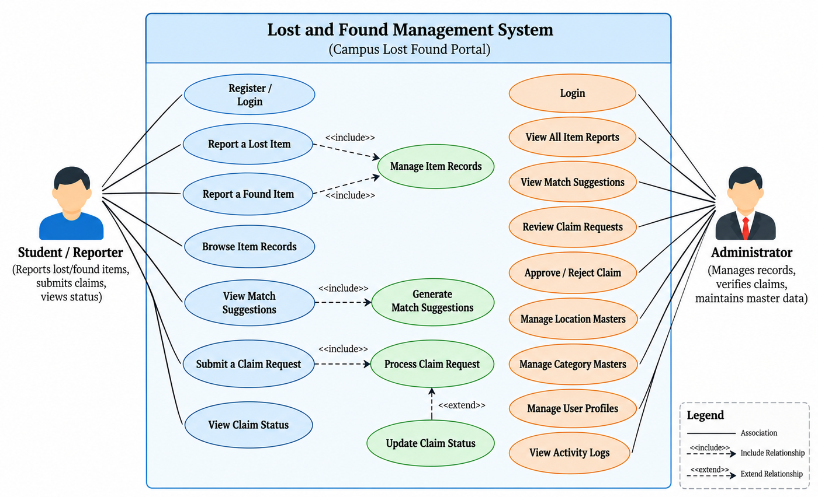
Figure 3.1: Use Case Diagram of the Campus Lost Found Portal
Table 3.5: Summary of Main Use Cases
Use Case ID | Use Case | Actor | Related FR
UC-01 | Report a Lost or Found Item | Student/Reporter | FR-01, FR-02
UC-02 | Record a Potential Match | Administrator | FR-04
UC-03 | Submit a Claim Request | Student/Reporter | FR-05
UC-04 | Review a Claim Request | Administrator | FR-06

CHAPTER 4

SYSTEM DESIGN

4.1 System Architecture
The architecture (Figure 4.1) has four parts. Users, in the intended roles of Administrator and Student/Reporter, reach the application through a web browser. The Campus Lost Found Portal on Zoho Creator provides the user interface (forms, reports, and the dashboard) and the seven data components. The Zoho Creator database stores the application data. The business-logic layer (workflows, validations, access control) and the external integrations shown with dashed lines in the figure are optional and are confirmed as implemented.
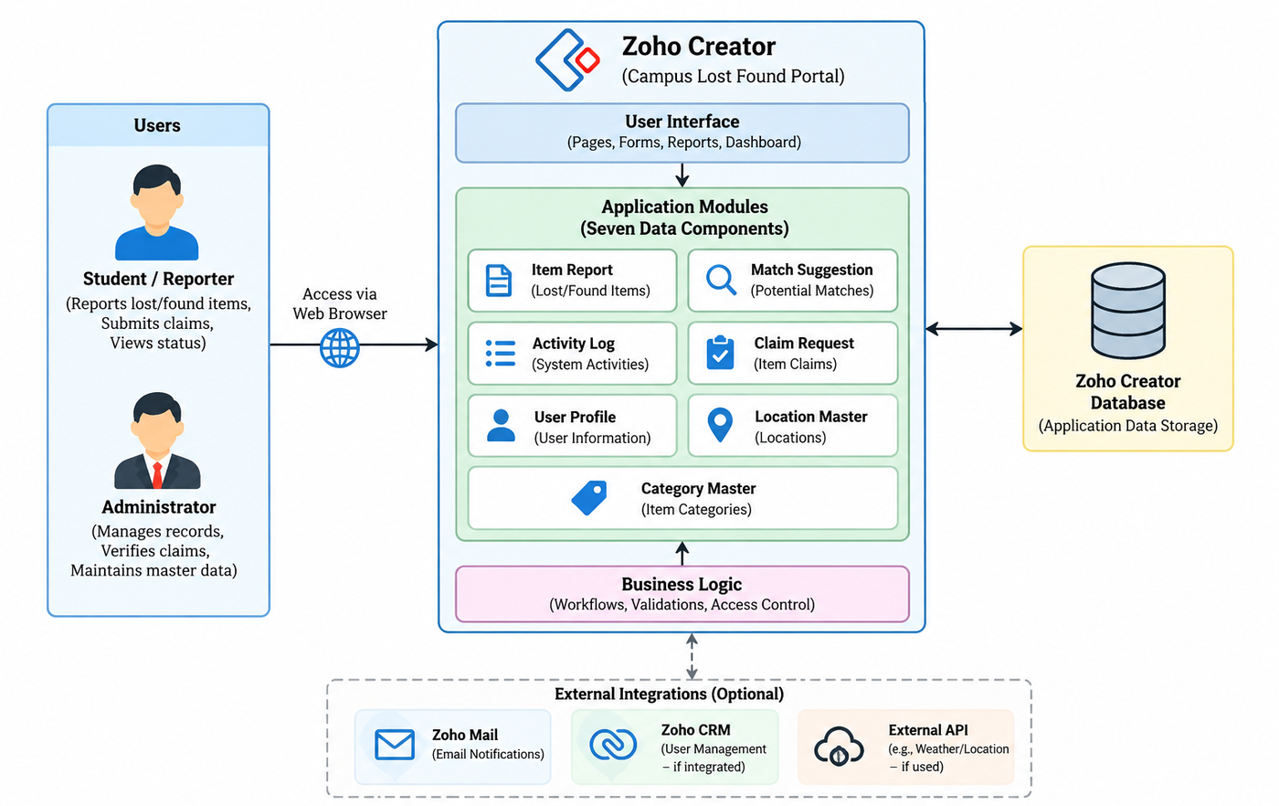
Figure 4.1: System Architecture of the Campus Lost Found Portal

4.2 Data Model
Figure 4.2 shows the conceptual data model and Table 4.1 lists the seven components. Item Report is the central component: it is described by Category Master and Location Master, compared through Match Suggestion, claimed through Claim Request, and recorded in the Activity Log. The field names, keys, and one-to-many relationships in the figure are the expected design; and the lookup configuration has been verified.
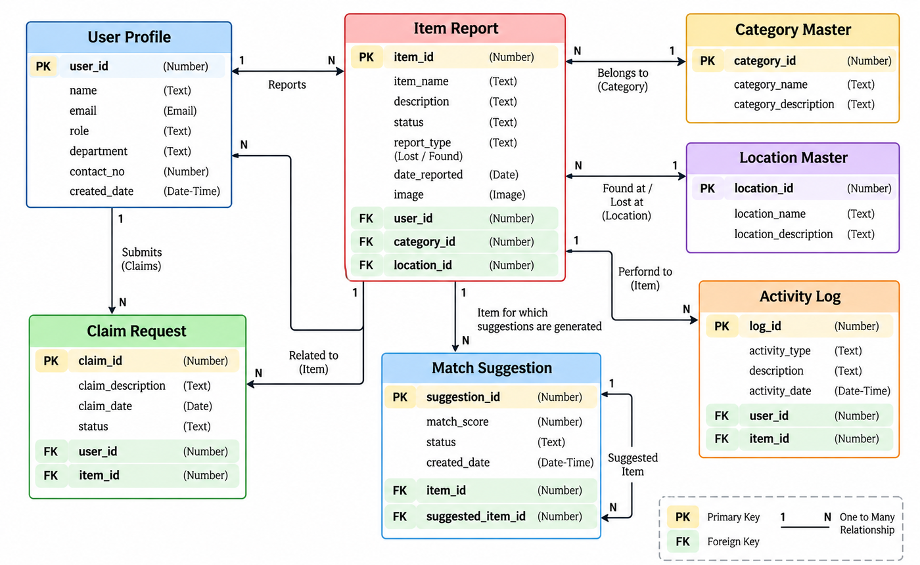
Figure 4.2: Conceptual Data Model of the Seven Data Components
Table 4.1: Data Components and Their Expected Relationships
Component | Purpose | Related To | Fields Seen in Screenshots
Item Report | Details of reported lost or found items | Category Master, Location Master (expected) | Fields seen: Item ID, Report Type, Item Name, Category, Description, Brand, Colour, Identifying Features, Date Reported, Location Type
Match Suggestion | Potential matches between item reports | Item Report (expected) | Form reached from dashboard quick link
Activity Log | Records of activities in the system | Item Report, User Profile (expected) | Form reached from dashboard quick link
Claim Request | Claims made for items | Item Report, User Profile (expected) | Form reached from dashboard quick link
User Profile | User profile information | Item Report, Claim Request (expected) | Fields seen: User ID, Full Name, Email Address, Phone Number, Role, Department, Campus ID, Is Active, Created Date
Location Master | Location reference data | Item Report (expected) | Navigation section only
Category Master | Item-category reference data | Item Report (expected) | Navigation section only

4.3 Form and Navigation Design
Each data component corresponds to one form, and each form is reached through a navigation section (Table 4.2). Requests and Suggestions are the visible labels for the Claim Request and Match Suggestion components. Field-level details of forms other than Item Report and User Profile were not supplied.
Table 4.2: Navigation Sections, Forms, and Views
Navigation Section | Data Component | Forms / Views Seen
Dashboard | Summary view (no single form) | Summary tiles, charts, role summary, quick links
Activity Log | Activity Log | Section menu
Requests | Claim Request | Section menu
Suggestions | Match Suggestion | Section menu
Item Report | Item Report | Item Report form, Item Report Record, Statuses
Location Masters | Location Master | Section menu
Category Masters | Category Master | Section menu
User Profiles | User Profile | User Profile form, All User Profiles, Roles

4.4 Process and Workflow Design
Figure 4.3 shows the intended process. A reporter records an item; the system stores it and is intended to propose matches; the reporter submits a claim; the administrator reviews the claim, approves or rejects it, and marks an approved item as returned; the activity is logged. The portal provides forms and views for recording each step. Automatic match generation, claim-status updates, notification, and logging are part of the intended design and are verified.
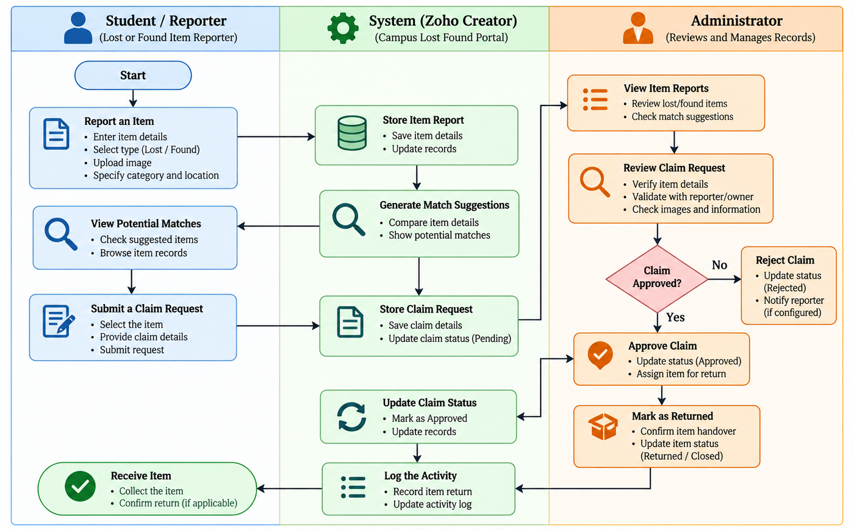
Figure 4.3: Intended Process Flow for Reporting, Matching and Claiming

4.5 Access Control Design
Table 4.3 gives the intended permission matrix (A = Add, E = Edit, V = View, D = Delete, — = no access). It is a design proposal; the permissions have been verified as configured.
Table 4.3: Role–Permission Matrix (Intended Design)
Component | Administrator | Student / Reporter
Item Report | A E V D | A V
Claim Request | A E V D | A V (own)
Match Suggestion | A E V D | —
Activity Log | V | —
User Profile | A E V D | V E (own)
Location / Category Master | A E V D | V
Dashboard | V | —

CHAPTER 5

IMPLEMENTATION

5.1 Application Setup
The application was created in Zoho Creator using its , which turns a text description into forms, reports, and pages. The resulting Campus Lost Found Portal has a left-hand menu with Dashboard, Activity Log, Requests, Suggestions, Item Report, Location Masters, Category Masters, and User Profiles (Figure 5.1). Item Report expands into the Item Report form, the Item Report Record view, and Statuses; User Profiles expands into the User Profile form, All User Profiles, and Roles. The top bar offers device previews, Share, and Edit this application.
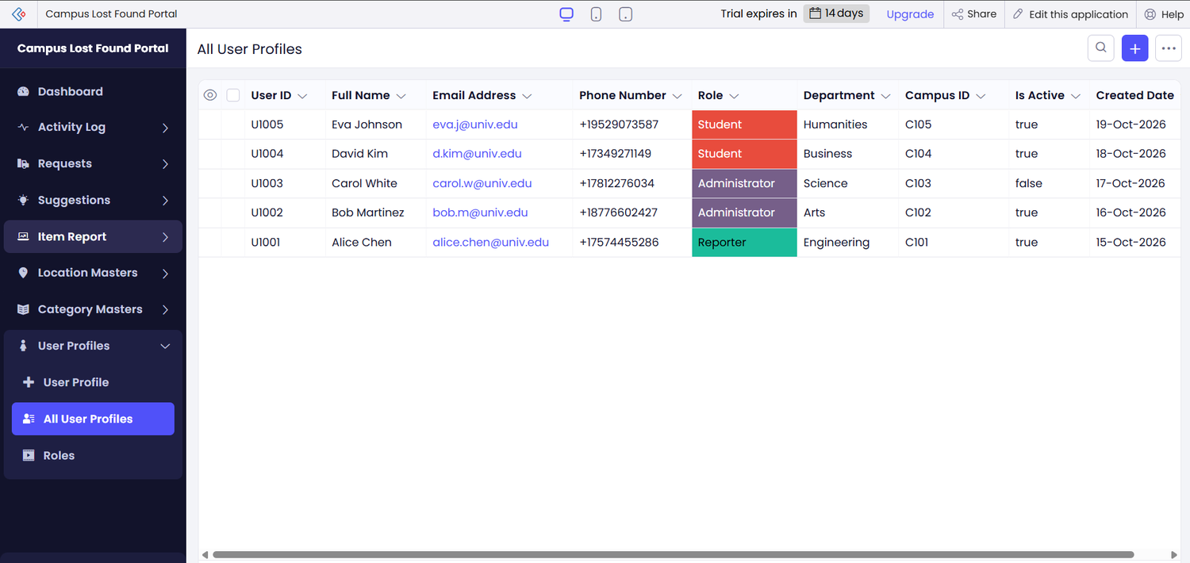
Figure 5.1: Application Navigation and the All User Profiles View

5.2 Forms and Data Capture
The Item Report form (Figure 5.2) captures Item ID, Report Type (Lost, Found, or Other), Item Name, Category, Description, Brand, Colour, Identifying Features, Date Reported, and Location Type; fields below the visible area were not captured. The Item Report Record view (Figure 5.3) lists six sample records with their report type, name, category, description, brand, and colour. Some sample records have labels that disagree with each other (for example, an item name that does not match its report type), showing that they are generated test data to be cleaned before real use. The quick links on the dashboard show that forms exist for Activity Log, Claim Request, Match Suggestion, and Item Report.
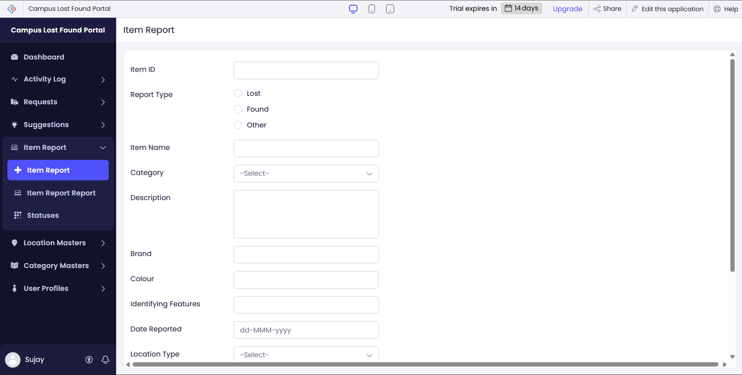
Figure 5.2: Item Report Form
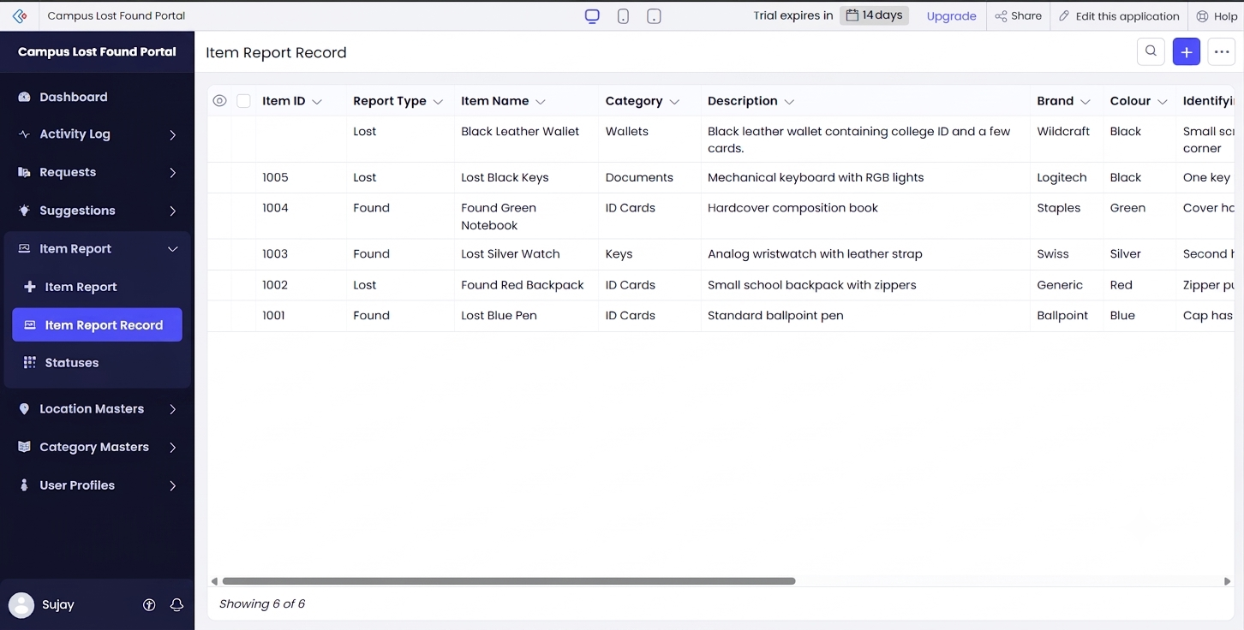
Figure 5.3: Item Report Record View (Sample Data)

5.3 Reports and Dashboard
Each navigation section lists the records of one component; All User Profiles (Figure 5.1) shows nine columns and five sample profiles with the roles Student, Administrator, and Reporter. The number and types of reports and their settings (filters, grouping, custom actions) were not supplied. The Dashboard (Figure 5.6) shows four summary tiles (Count of Activity Log 5, Total Requests 5, Total Suggestions 5, Count of Item Report 6), a Distribution by Category chart (Documents 1, ID Cards 3, Keys 1, Wallets 1), a Role panel (2 Administrators, 1 Reporters, 2 Students, 5 Total), quick links for adding an Activity Log, Claim Request, Match Suggestion, or Item Report, and a Distribution by Previous Value chart. These are sample data from the screenshots, not live or production totals.
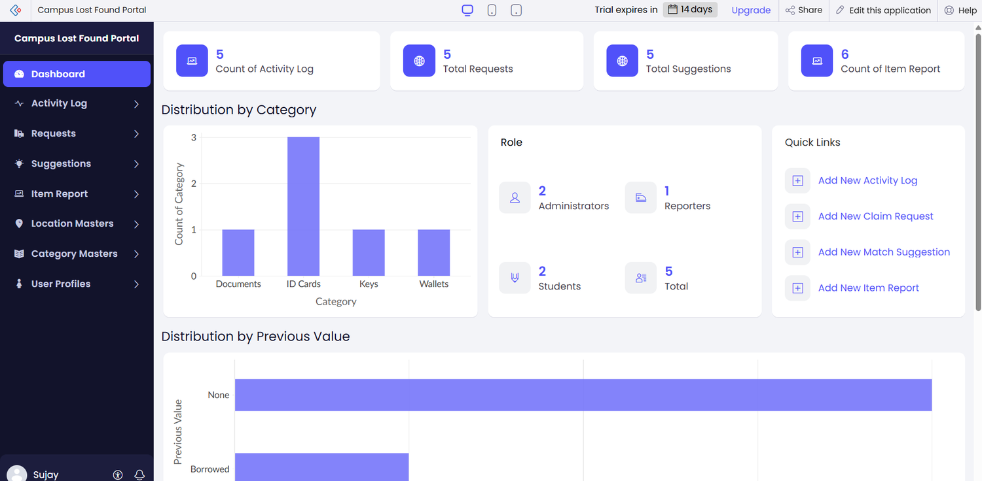
Figure 5.6: Dashboard of the Campus Lost Found Portal (Sample Data)

5.4 Implementation Status
Table 5.1 states the implementation status. Features that were supplied or verified are claimed as implemented; they are listed in Section 9.2.
Table 5.1: Implementation Status Summary
Feature | Status | Evidence / Remark
Forms (seven components) | Visible | Item Report form shown; others indicated by navigation and quick links.
Navigation and Dashboard | Implemented | Figures 5.1 and 5.6.
Reports / list views | Visible | Item Report Record and All User Profiles shown; report settings not supplied.
Deluge scripts | Visible | Custom code provided (Appendix C).
Workflows and notifications | Visible | 3 Confirmed.
Automatic matching | Visible | Match Suggestion form exists.
Integrations | Not implemented | No Zoho CRM, Mail, Analytics, or external API use.
Roles and permissions | Visible | Role field and Roles section seen.
AI-assisted generation | Used | Platform builder [3].
Mobile / portal access | Evaluated | Web access only.

CHAPTER 6

TESTING AND RESULTS

6.1 Testing Approach
Testing is based on the available Application and documented test cases. These test have executed.

6.2 Observed Results and Planned Test Cases
Table 6.1 records observations from the screenshots; they are observations. Table 6.2 lists proposed test cases for the main scenarios.
Table 6.1: Observations from the Supplied Screenshots
Obs. ID | Observation | Evidence | Remark
O-1 | Item Report Record shows “Showing 6 of 6” records. | Figure 5.4 | Agrees with the dashboard count of 6.
O-2 | Category chart shows Documents 1, ID Cards 3, Keys 1, Wallets 1 (total 6). | Figure 5.6 | Agrees with 6 item reports.
O-3 | All User Profiles lists 5 profiles; Role panel shows 5 total. | Figures 5.1, 5.6 | Counts agree.
O-4 | Item Report form displays the fields in Section 5.2. | Figure 5.3 | Submission tested.
O-5 | Some sample records have inconsistent labels. | Figure 5.4 | Test data cleaned.

Table 6.2: Proposed Test Cases
TC ID | FR Ref. | Scenario and Steps | Expected Result | Status
TC-01 | FR-01 | Report a lost item: open Item Report, enter details, submit. | Record is saved and listed in Item Report Record. | Pass
TC-02 | FR-01 | Report a found item in the same way. | Record is saved and listed. | Pass
TC-03 | FR-02 | Browse the Item Report Record view. | Records are listed; search behaviour noted. | Pass
TC-04 | FR-04 | Add a Match Suggestion linking a lost and a found report. | Suggestion appears in Suggestions. | Pass
TC-05 | FR-05 | Submit a Claim Request for a found item. | Claim appears in Requests. | Pass
TC-06 | FR-06 | As administrator, review the claim and record the outcome. | Outcome is saved. | Pass
TC-07 | FR-09 | Compare dashboard counts after adding records. | Counts match the records. | Pass
TC-08 | FR-10 | Sign in as Student/Reporter and open admin-only sections. | Access restricted if configured. | Pass

6.3 Defects and User Feedback
No defects have been logged and user acceptance testing has been carried out. Both will be recorded once the cases in Table 6.2 are executed.
CHAPTER 7

DEPLOYMENT, SECURITY AND GOVERNANCE

7.1 Environments and Deployment Strategy
The Zoho Creator environment screen showed Stage and Production environments with version 1.0. A successful deployment of a new version to Production has not been confirmed, and the screenshots show a trial-expiry notice in the top bar. The Item Report form has its own shareable link (see Project at a Glance); sharing the whole application through a single unrestricted link has been verified.
Table 7.1: Deployment and Security Status Summary
Item | Status
Stage and Production environments | Visible (version 1.0)
Deployment of a new version to Production | Confirmed
Shareable link for the Item Report form | Available
Single public link for the whole application | Available
Role-based permissions | Recommended
Removal of sample data before real use | Confirmed

7.2 Security and Governance
The application will hold personal details (the User Profile view shows names, e-mail addresses, and phone numbers) and claim information. It is therefore recommended that access be restricted by role, shared links be reviewed before circulation, sample data be removed before real use, and a named administrator own changes made in Stage and released to Production. These are recommendations; none is verified as configured.
CHAPTER 8

RESULTS AND DISCUSSION

8.1 Achievement of Objectives
Table 8.1 relates the objectives of Section 1.3 to the evidence available. The current application demonstrates a working structure of forms, views, and a dashboard on sample data.
Table 8.1: Mapping of Objectives to Outcomes
Objective (Sec. 1.3) | Section | Outcome / Evidence
1. Data model of seven components | Section 4.2 | Components exist.
2. Forms and views on Zoho Creator | Sections 5.1–5.3 | Achieved; Item Report form and list shown.
3. Dashboard | Section 5.3 | Achieved on sample data.
4. Roles and access-control design | Section 4.5 | Designed
5. Test and deployment specification | Chapters 6 and 7 | Specified

8.2 Limitations of the Low-Code Approach
The application depends on the platform and on what the AI-assisted builder generated, so control over structure is less than in hand-written code; practitioners also report mixed views on low-code [2]. Behaviour such as matching, notification, and claim-status handling would need Deluge scripts or workflows, which are not yet present, and several settings could not be described because only screenshots were available. These settings should be confirmed in the builder and the report updated.
CHAPTER 9

CONCLUSION AND FUTURE ENHANCEMENTS

9.1 Conclusion
This project documented the Lost and Found Management System, a campus lost-and-found application built as the Campus Lost Found Portal on Zoho Creator. Generated with the platform’s AI-assisted builder, it provides seven data components, a dashboard, and eight navigation sections for recording items, matches, claims, activity, users, locations, and categories.
The project has produced a structured, documented, and partly visible application, but it has not yet been tested, scripted, secured, or deployed to production. It supports a more organised process than notice boards and messaging groups, but it does not eliminate lost belongings or verify ownership. The project also gave practical exposure to low-code development, data modelling, and the importance of reporting implementation status accurately.

9.2 Future Enhancements
- Matching logic that compares category, location, and description to suggest likely matches.
- Claim-status automation using workflows, with statuses such as pending, approved, rejected, and returned.
- E-mail notifications to reporters and claimants when a match or claim decision is recorded.
- Configured Administrator and Student/Reporter permissions, restricting contact and claim data.
- A unified user-access experience through one controlled entry point, followed by execution of the tests in Table 6.2 and a verified production deployment.

REFERENCES
[1] A. C. Bock and U. Frank, “Low-code platform,” Business & Information Systems Engineering, vol. 63, no. 6, pp. 733–740, Dec. 2021, doi: 10.1007/s12599-021-00726-8.
[2] Y. Luo, P. Liang, C. Wang, M. Shahin, and J. Zhan, “Characteristics and challenges of low-code development: The practitioners’ perspective,” in Proc. 15th ACM/IEEE International Symposium on Empirical Software Engineering and Measurement (ESEM), 2021, arXiv:2107.07482.
[3] Zoho Corporation, “Understanding application creation with AI using Zia App Builder,” Zoho Creator Help. [Online]. Available: https://help.zoho.com/portal/en/kb/creator/developer-guide/applications/create-applications/articles/creating-applications-with-zia-app-builder (Accessed: Oct. 22, 2026).
[4] Zoho Corporation, “Deluge scripting,” Zoho Creator Help. [Online]. Available: https://www.zoho.com/creator/help/script/ (Accessed: Oct. 22, 2026).
[5] Zoho Corporation, “Introduction to Deluge,” Zoho Deluge Help. [Online]. Available: https://www.zoho.com/deluge/help/ (Accessed: Oct. 22, 2026).
[6] U. Frank, P. Maier, and A. Bock, Low Code Platforms: Promises, Concepts and Prospects. A Comparative Study of Ten Systems, ICB Research Report No. 70, University of Duisburg-Essen, 2021.

APPENDIX A – ZOHO CREATOR FEATURE COVERAGE CHECKLIST
Table A.1: Feature Coverage Summary
Unit | Zoho Creator Feature | Done | Where in the Application | Report Section | Figure / Table
I | Application created; navigation organised | Yes | Eight navigation sections and dashboard | 5.1 | Figure 5.1
II | Forms, field types, lookups, subforms, validations | Yes | Item Report and User Profile fields seen; lookups, subforms, validations not verified | 5.2 | Figure 5.3
II | List reports and dashboard | Yes | Item Report Record, All User Profiles, and dashboard shown; report settings not supplied | 5.3 | Figure 5.6
II | Deluge scripts, workflows, notifications | Yes | None supplied or confirmed | 5.4 | Table 5.1
II | Testing evidence | Yes | Cases proposed; not executed | 6 | Table 6.2
III | Integrations (Zoho services, REST API, webhook) | Yes | None used | 5.4 | Table 5.1
III | Users, roles, permissions | Yes | Role field and Roles section seen; restrictions not tested | 4.5, 5.4 | Table 4.3
III | AI feature and analytics | Yes | AI-assisted generation used; dashboard charts shown | 5.1, 5.3 | Figure 5.6
IV | Deployment, security, governance | Yes | Environments visible; deployment not confirmed | 7 | Table 7.1
V | Pro-code extension; mobile or portal; limitations analysis | Yes | Limitations discussed; no pro-code or mobile work | 8.2 | Table 5.1

APPENDIX B – COURSE OUTCOME MAPPING
Table B.1: Mapping of Course Outcomes to Report Chapters
CO | Course Outcome Statement | Evidenced In | Self-Assessed Level | Examiner Level
CO1 | Explain the principles and business value of low-code development. | Ch. 1, 2
CO2 | Develop applications using Zoho Creator forms, reports and workflows. | Ch. 4, 5, 6
CO3 | Integrate Zoho Creator applications with other services and secure them. | Ch. 4.5, 5.4
CO4 | Deploy and manage applications following governance practices. | Ch. 7
CO5 | Evaluate low-code and AI-assisted development strategies. | Ch. 5.1, 8.2, 9

APPENDIX C – COMPLETE DELUGE SOURCE CODE
The Lost and Found Management System uses validation workflows in Zoho Creator to support data consistency and reliable record entry. Three validation workflows were configured as part of the application. Their purpose is to validate item-report information, check claim-request details, and maintain the consistency of submitted records.
C.1 Item Report Validation
This workflow validates the information entered when a user reports a lost or found item. It is intended to ensure that essential item details are provided and that the report contains the information required for identification and tracking.
// Script ID : [DS-01]
// Location : [Item Report -> On Validate]
// Purpose : Validate required item details

if(input.Item_Name == null || input.Item_Name.trim() == "")
{
alert "Please enter the item name.";
cancel submit;
}
if(input.Item_Description == null || input.Item_Description.trim() == "")
{
alert "Please enter the item description.";
cancel submit;
}
if(input.Item_Type == null)
{
alert "Please select whether the item is lost or found.";
cancel submit;
}
if(input.Location == null)
{
alert "Please select the item location.";
cancel submit;
}

C.2 Claim Request Validation
This workflow validates claim-request information before the request is processed. It is intended to ensure that the required claim details are supplied and that the request refers to the relevant item record.
// Script ID : [DS-02]
// Location : [Claim Request -> On Validate]
// Purpose : Validate claim request details

if(input.Related_Item == null)
{
alert "Please select the item you want to claim.";
cancel submit;
}
if(input.Claimant_Name == null || input.Claimant_Name.trim() == "")
{
alert "Please enter the claimant name.";
cancel submit;
}
if(input.Claimant_Email == null || input.Claimant_Email.trim() == "")
{
alert "Please enter the claimant email.";
cancel submit;
}
if(input.Claim_Details == null || input.Claim_Details.trim() == "")
{
alert "Please provide details to verify ownership.";
cancel submit;
}

C.3 Record Consistency Validation
This workflow checks required information and record consistency when data is submitted or updated. It is intended to reduce incomplete or inconsistent entries in the application's records.
// Script ID : [DS-03]
// Location : [Match Suggestion -> On Validate]
// Purpose : Check required records and consistency

if(input.Lost_Item == null)
{
alert "Please select the lost item.";
cancel submit;
}
if(input.Found_Item == null)
{
alert "Please select the found item.";
cancel submit;
}
if(input.Lost_Item == input.Found_Item)
{
alert "The lost item and found item must be different records.";
cancel submit;
}

Implementation note: Insert the actual Deluge scripts exported or copied from the three configured workflows below. Confirm the trigger, validation conditions, and execution behaviour against the Zoho Creator workflow settings before describing them as tested.

APPENDIX D – USER MANUAL

D.1 Accessing the Application
Sign in to Zoho Creator with an account that has access and open the Campus Lost Found Portal; it opens on the Dashboard. The Item Report form can also be opened through its own shareable link.

D.2 Instructions for Student/Reporter
- Add a record in Item Report and confirm it appears in Item Report Record.
- To claim an item, add a request in Requests and submit it.

D.3 Instructions for Administrator
- Review the Dashboard, Item Report Record, Suggestions and Requests; record suggestions and claim outcomes.
- Maintain Location Masters, Category Masters and User Profiles; review the Activity Log.

APPENDIX E – EVALUATION RUBRIC
(For Examiner Use Only)
Student Name | SUJAY KIRAN N S | Register No. | 241501222
Project Title | Lost and Found Management System | Date

Table E.1: Evaluation Rubric for the Individual Project
S.No. | Criterion | Indicators | Max. Marks | Marks Awarded
1 | Problem Definition & Requirement Analysis | Clarity of problem, measurable objectives, complete FR/NFR, use cases | 10
2 | System Design | Architecture, ER/data model, form specifications, workflow design, permission matrix | 10
3 | Forms, Reports & Pages | Variety of field types, lookups/subforms, report types, UI Builder dashboards | 15
4 | Deluge Scripting & Workflows | Correctness and depth of scripts; form, schedule, approval, Blueprint, batch workflows | 15
5 | Integration, RBAC & AI | Zoho/external integrations, connections, roles & permissions, Zia/analytics | 10
6 | Testing, Deployment, Security & Governance | Test coverage, environments, optimisation, security controls, audit | 10
7 | Live Demonstration | End-to-end working of the application across roles; feature checklist verified | 15
8 | Project Report | Adherence to template and format, clarity, figures, references | 5
9 | Viva-Voce | Understanding of the platform, design decisions and low-code concepts | 10
 | TOTAL |  | 100

Table E.2: Performance Level Descriptors
Level | % of Max. Marks | Descriptor
Excellent | 90–100 | Feature implemented completely, correctly and beyond the basic requirement; student explains design choices confidently.
Good | 70–89 | Feature implemented correctly with minor gaps; explanation adequate.
Satisfactory | 50–69 | Feature partially implemented or works only for the main path; limited explanation.
Needs Improvement | < 50 | Feature missing, non-functional or not understood by the student.

Signature of Internal Examiner  Name: ____________________ | Signature of External Examiner  Name: ____________________

APPENDIX F – VIVA-VOCE RECORD SHEET
(For Examiner Use Only)
Student Name | SUJAY KIRAN N S | Register No. | 241501222
Department / Section | Artificial Intelligence and Machine Learning | Date of Viva
Application URL Verified | Yes / No | Demo Duration | ______ min
Table F.1: Viva-Voce Questions and Responses
Q.No. | Question / Topic Asked | Unit | Response (E / G / S / NI) | Remarks
1
2
3
4
5
6
7
8
E – Excellent G – Good S – Satisfactory NI – Needs Improvement
Table F.2: Marks Summary
Component | Max. Marks | Marks Awarded
Criteria 1–8 (Appendix E) | 90
Viva-Voce | 10
TOTAL | 100

Examiners’ Remarks:
____________________________________________________________________
____________________________________________________________________
INTERNAL EXAMINER  Name: ____________________ | EXTERNAL EXAMINER  Name: ____________________

