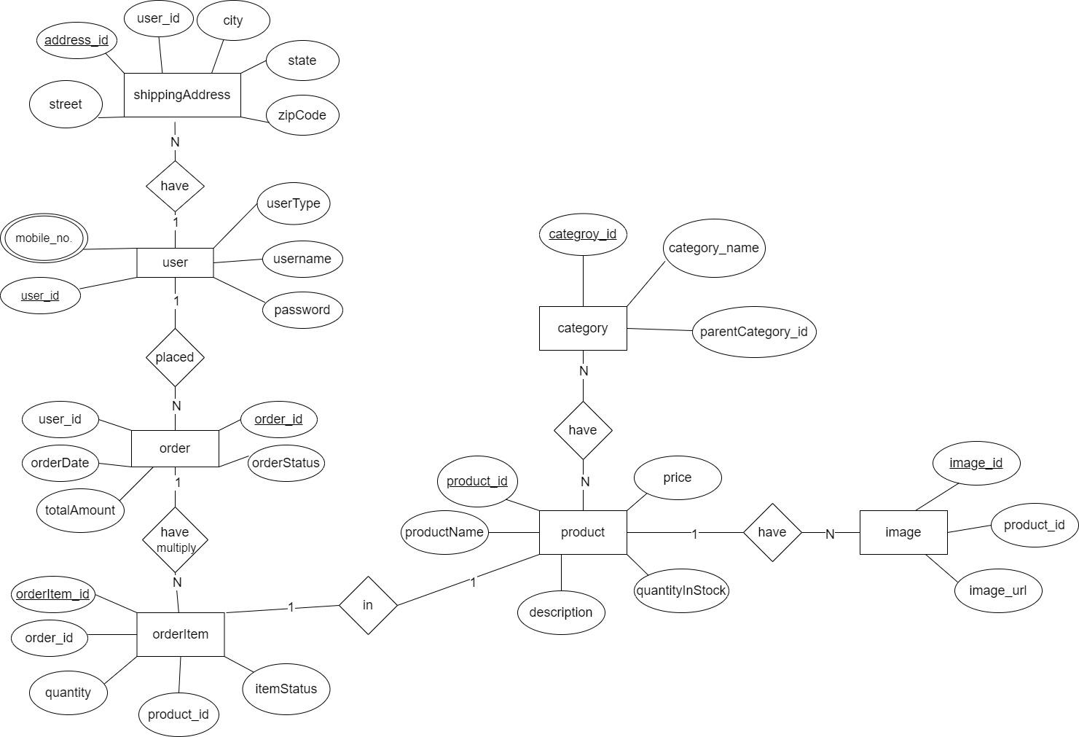

**Participating Entities**

1. user
2. product
3. image
4. category
5. order
6. orderItem
7. shippingAddress

**Relationship Present**

1. product to image - One to Many
2. product to category - Many to Many
3. user to order - One to Many
4. order to orderItem- One to Many
5. user to shippingAddress - One to Many
6. product to orderItem - one to one

**Key Attributes**

1. user_id
2. product_id
3. image_id
4. category_id
5. order_id
6. orderItem_id
7. address_id