**Normalization**

Types of Normalization

1. First Normal Form (1NF)
2. Second Normal Form (2NF)
3. Third Normal Form (3NF)
4. Boyce Codd Normal Form (BCNF)

**1. First Normal Form (1NF)**

* A relation will be in 1NF if it contains atomic value.
* It states that an attribute of the table cannot hold multiple values. It must hold only a single valued attribute.

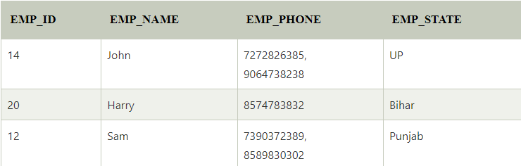

The decomposition of the Employee table into 1NF has been shown below.

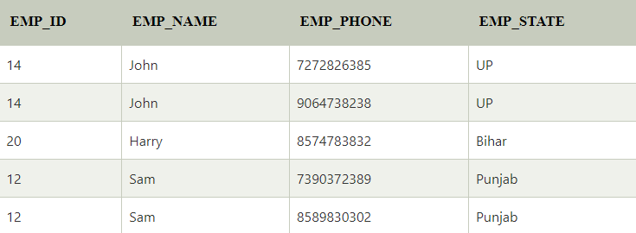

**2. Second Normal Form (2NF)**

* In the 2NF, relation must be in 1NF.
* In Second Normal Form, all non-key attributes are fully functional dependency on the primary key.

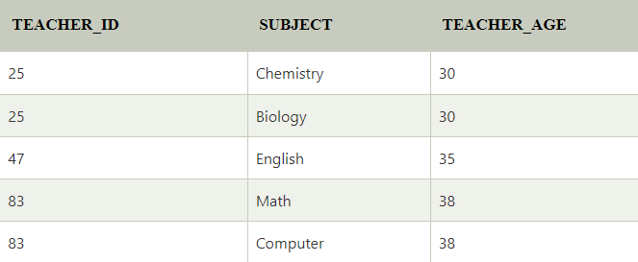

In the given table, non-prime attribute TEACHER_AGE is dependent on TEACHER_ID which is a proper subset of a candidate key. That's why it violates the rule for 2NF.





**3. Third Normal Form (3NF)**

* A relation will be in 3NF if it is in 2NF and does not contain any transitive partial dependencies.
* 3NF is used to reduce data duplication. It is also used to achieve data integrity.
* If there is no transitive dependency for non-prime attributes, then the relation must be in the third normal form.

A relation is in third normal form if it holds at least one of the following conditions for every non-trivial functional dependency X → Y.

1. X is a super key.
2. Y is a prime attribute, i.e., each element of Y is part of some candidate key.

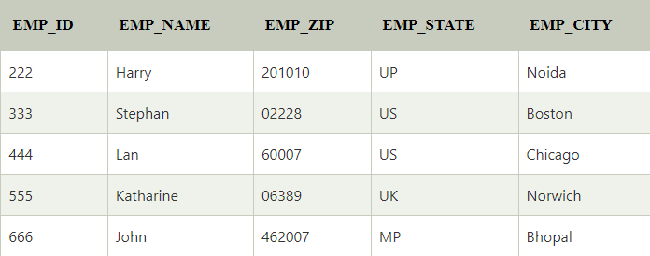

In the given table, all attributes except EMP_ID are non-prime.

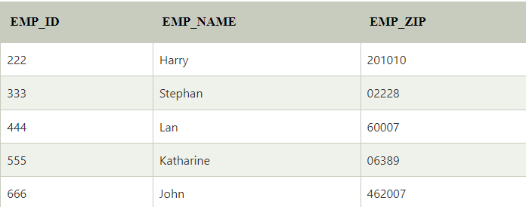

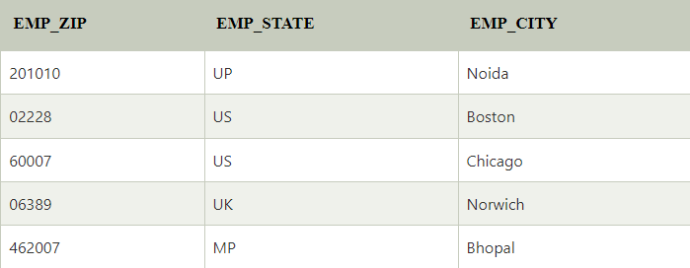

**4. Boyce Codd Normal Form (BCNF)**

* BCNF is the advanced version of 3NF. It is stricter than 3NF.
* A table is in BCNF if every functional dependency X → Y, X is the super key of the table.
* For BCNF, the table should be in 3NF, and for every FD, LHS is a super key.

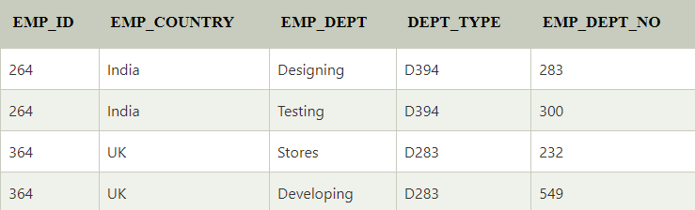

EMP_ID → EMP_COUNTRY

EMP_DEPT → {DEPT_TYPE, EMP_DEPT_NO}

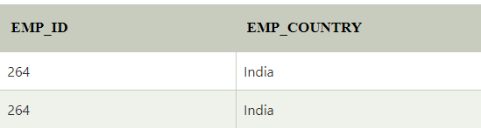

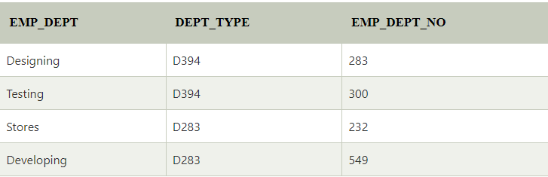

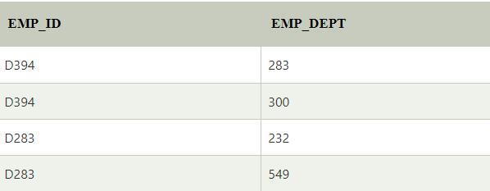

**Candidate keys:**

**For the first table:** EMP_ID  
**For the second table:** EMP_DEPT  
**For the third table:** {EMP_ID, EMP_DEPT}

Now, this is in BCNF because the left side part of both the functional dependencies is a key.