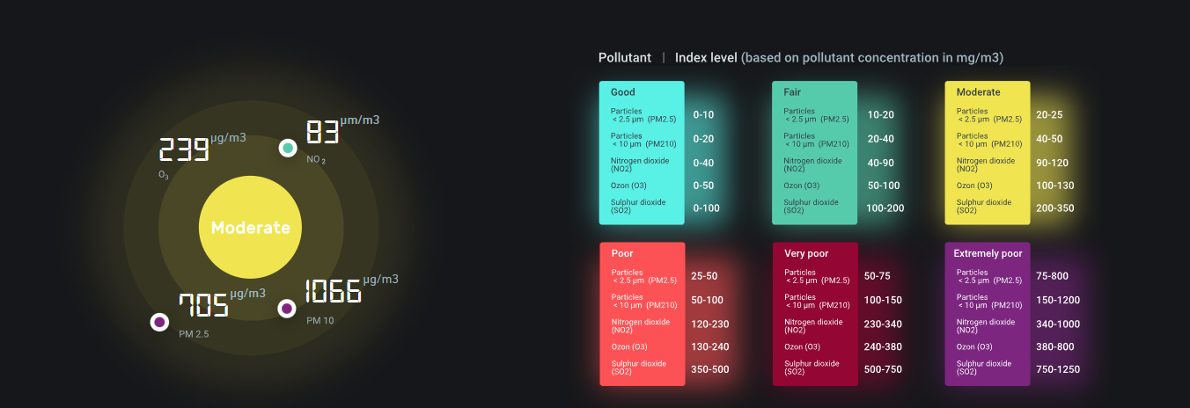

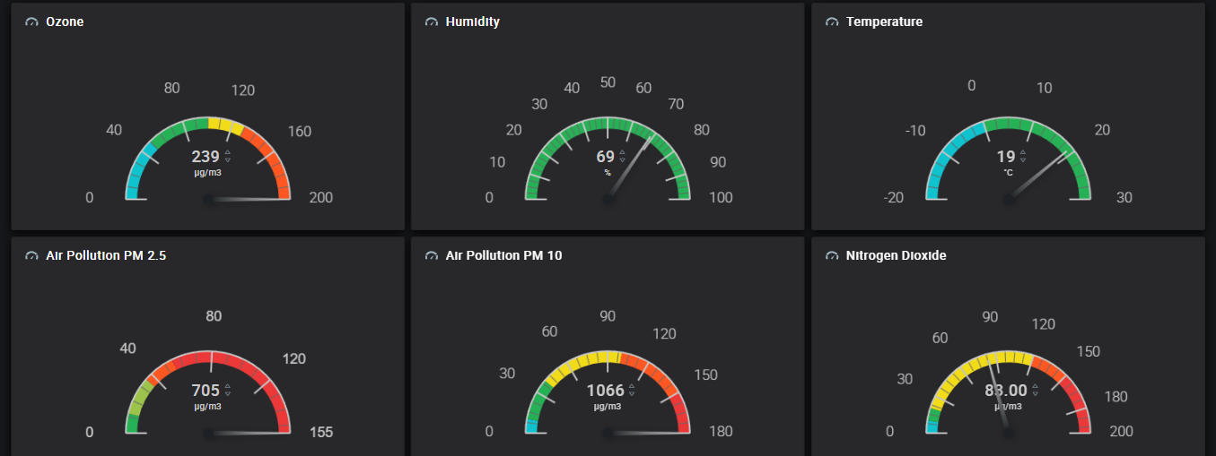

[https://cloud.kaaiot.com/wd-public/c1hod7irqa51r8l340ug/dashboards/f8c93298-f471-4b94-85c2-022bfc854aee/e549b359-6fe2-4398-bb31-4aafa299a8dd?public_id=ac620680-6c4c-4a91-bb66-342ed76f8841&_gl=1*d8t0ut*_ga*NjcyMDg2MTk0LjE2ODgzMTEwODY.*_ga_KBN5VJ1LHK*MTY4ODMxMTA4Ni4xLjEuMTY4ODMxMTI1NC4wLjAuMA..&_ga=2.40382498.1450576166.1688311086-672086194.1688311086](https://cloud.kaaiot.com/wd-public/c1hod7irqa51r8l340ug/dashboards/f8c93298-f471-4b94-85c2-022bfc854aee/e549b359-6fe2-4398-bb31-4aafa299a8dd?public_id=ac620680-6c4c-4a91-bb66-342ed76f8841&_gl=1*d8t0ut*_ga*NjcyMDg2MTk0LjE2ODgzMTEwODY.*_ga_KBN5VJ1LHK*MTY4ODMxMTA4Ni4xLjEuMTY4ODMxMTI1NC4wLjAuMA..&_ga=2.40382498.1450576166.1688311086-672086194.1688311086)

