**AI Chemist:**

Pioneering the Future of Chemical Science with Gemini Vision Pro

**Category:** Generative AI

**Skills Required:**

* Python
* Deep Learning
* Streamlit

**Project Overview**

**AI Chemist** is an advanced mobile application engineered to elevate the field of chemical research through the deployment of cutting-edge artificial intelligence. Utilizing the state-of-the-art Gemini Pro model, AI Chemist is designed to deliver bespoke chemical solutions and experimental methodologies. The application integrates AI-driven analytics to assess user inputs, laboratory conditions, and research objectives, thereby providing optimized experimental designs, chemical synthesis routes, and comprehensive data analysis. The principal aim of AI Chemist is to enhance research efficiency and foster innovation in chemical sciences by delivering intelligent, data-centric support.

**Key Features:**

* **Customized Recommendations:** AI Chemist offers tailored suggestions for chemical synthesis and experimental designs based on user-specific data and research goals.
* **Real-Time Laboratory Monitoring:** The app facilitates continuous monitoring of experimental conditions, enabling dynamic adjustments to optimize reaction outcomes.
* **Advanced Data Analytics:** Provides detailed analysis on yield, purity, and other critical metrics to support the refinement and optimization of research processes.
* **Sustainable Chemistry Solutions:** Incorporates eco-friendly alternatives and methodologies, aligning with principles of green chemistry.

**Use Cases:**

**Use Case 1: Pharmaceutical Research**

* **Researcher:** Dr. Alvarez, 35-year-old pharmaceutical scientist
* **Objective:** Develop a novel antimicrobial agent targeting a resistant bacterial strain.
* **Process:**
  1. Dr. Alvarez inputs data on target bacterial enzymes and chemical structures into AI Chemist.
  2. AI Chemist employs machine learning algorithms to analyze the input data and propose potential compounds and synthetic pathways.
  3. In the laboratory, Dr. Alvarez synthesizes the recommended compounds, using the app’s real-time monitoring features to adjust experimental parameters as necessary.
  4. The application provides feedback on reaction yield and compound purity, suggesting further optimizations to enhance the drug development process.
* **Outcome:** Accelerated drug discovery process with efficient identification and optimization of viable drug candidates.

**Use Case 2: Green Chemistry**

* **Researcher:** James, 40-year-old environmental chemist
* **Objective:** Formulate an environmentally benign pesticide.
* **Process:**
  1. James inputs the desired chemical properties and environmental constraints into AI Chemist.
  2. The app generates a list of candidate compounds and eco-friendly synthesis methods based on input parameters.
  3. James uses the real-time monitoring capabilities of AI Chemist to oversee reaction progress, focusing on minimizing waste and energy consumption.
  4. AI Chemist also provides data on the biodegradability and toxicity of the products, aiding in the development of a sustainable and compliant pesticide.
* **Outcome:** Successful development of a pesticide that meets environmental regulations and safety standards.

**Use Case 3: Polymer Science**

* **Researcher:** Dr. Liu, 32-year-old materials scientist
* **Objective:** Synthesize a polymer with enhanced tensile strength for aerospace applications.
* **Process:**
  1. Dr. Liu inputs specifications for mechanical properties and chemical stability into AI Chemist.
  2. The app utilizes predictive modeling to suggest suitable monomers and polymerization techniques.
  3. Dr. Liu follows the app’s recommendations to synthesize polymers, using real-time data to fine-tune reaction conditions and achieve desired material properties.
  4. AI Chemist provides immediate feedback on mechanical properties such as tensile strength and thermal stability, enabling iterative refinement of the polymer.
* **Outcome:** Efficient achievement of desired polymer properties through rapid iteration and optimization.

**Technological Stack:**

* **Python:** Core programming language for developing algorithms and managing backend processes.
* **Deep Learning:** Employed for advanced data analysis and prediction modeling, enhancing the accuracy of recommendations.
* **Streamlit:** Utilized to create an interactive and user-friendly interface for seamless user experience.

**Technical Architecture:**

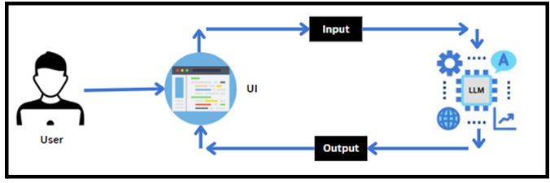

**AI Chemist** represents a significant advancement in chemical research technology, leveraging artificial intelligence to streamline experimental workflows, enhance data-driven decision-making, and promote sustainable practices in chemistry.