Blinkit Grocery Data Analysis
Project Report | SQL • Python • Power BI • Excel

1. Executive Summary
This project analyzes a Blinkit grocery dataset using a multi-tool workflow. MySQL is used to inspect and aggregate the data; Python is used for data cleaning, exploratory analysis, filtering, and charting; Power BI is used to create an interactive dashboard; and Excel is used to transform the data and build a comparable dashboard. The goal is to summarize sales performance across item and outlet dimensions.

2. Project Objectives
- Understand the dataset structure and key business measures.
- Standardize inconsistent Item_Fat_Content labels before comparing categories.
- Use SQL aggregation and filtering to explore sales, average sales, item counts, ratings, and outlet segments.
- Perform exploratory data analysis and visualizations in Python.
- Present business metrics in Power BI and Excel dashboards.

3. Dataset Overview
The uploaded workbook contains 8,523 records and 13 columns in the BlinkIT_Grocery_Data sheet. Fields include item identifiers and types, item fat content, item visibility and weight, sales, ratings, outlet identifiers, outlet establishment year, outlet location tier, outlet size, and outlet type. The workbook data inspected for this report has no missing values in these 13 columns.
Note: the notebook reads a CSV with 12 columns (without the workbook's Sr No. field). The analysis here uses the uploaded workbook as the source for chart calculations and key metrics.

4. Tools and Workflow

4.1 MySQL
The SQL script creates blinkitdb, checks row counts and sample records, standardizes Item_Fat_Content labels, and calculates total sales, average sales, record/item count, and average rating. Additional GROUP BY queries compare sales by fat content, item type, outlet location, outlet establishment year, outlet size, and outlet type. A CTE and window-function calculation is used to derive each outlet segment's share of total sales.

4.2 Python EDA
The notebook imports pandas, NumPy, Matplotlib, and Seaborn, loads the raw CSV, checks sample rows, dimensions, column names, and data types, then normalizes the fat-content labels: 'low fat' and 'LF' become 'Low Fat', while 'reg' becomes 'Regular'. It calculates KPI values and includes a chart-requirements section. The uploaded notebook does not contain completed chart code cells, so the charts in this report were generated from the uploaded workbook data to illustrate the same analysis dimensions.

4.3 Power BI
The uploaded Blinkit.pbix file is included as the Power BI dashboard artifact. The workflow described for the project uses the analyzed data to present headline KPIs and breakdowns. The PBIX file itself is not rendered as a screenshot in this report, so the report does not claim unverified visual details beyond the project workflow and data measures.

4.4 Excel
The workbook includes a 'Sheet Design' sheet with eight charts and a 'Dashboard' sheet containing dashboard visuals/images, alongside the raw BlinkIT_Grocery_Data sheet. The workbook supports a parallel Excel dashboard workflow using transformations, summary tables, and charts.

5. Key Metrics
Metric | Value
Total sales | $1,201,681.49
Average sales per record | $140.99
Number of records/items counted | 8,523
Average rating | 3.97 / 5
These figures are calculated from the uploaded workbook. The SQL notebook formats some metrics for display, but the values above are presented with precision from the source data.

6. Exploratory Analysis

6.1 Sales by Item Type
The largest item-type sales totals in the uploaded data are Fruits and Vegetables ($178,124.08) and Snack Foods ($175,433.92). The chart below compares the eight highest-selling item types.
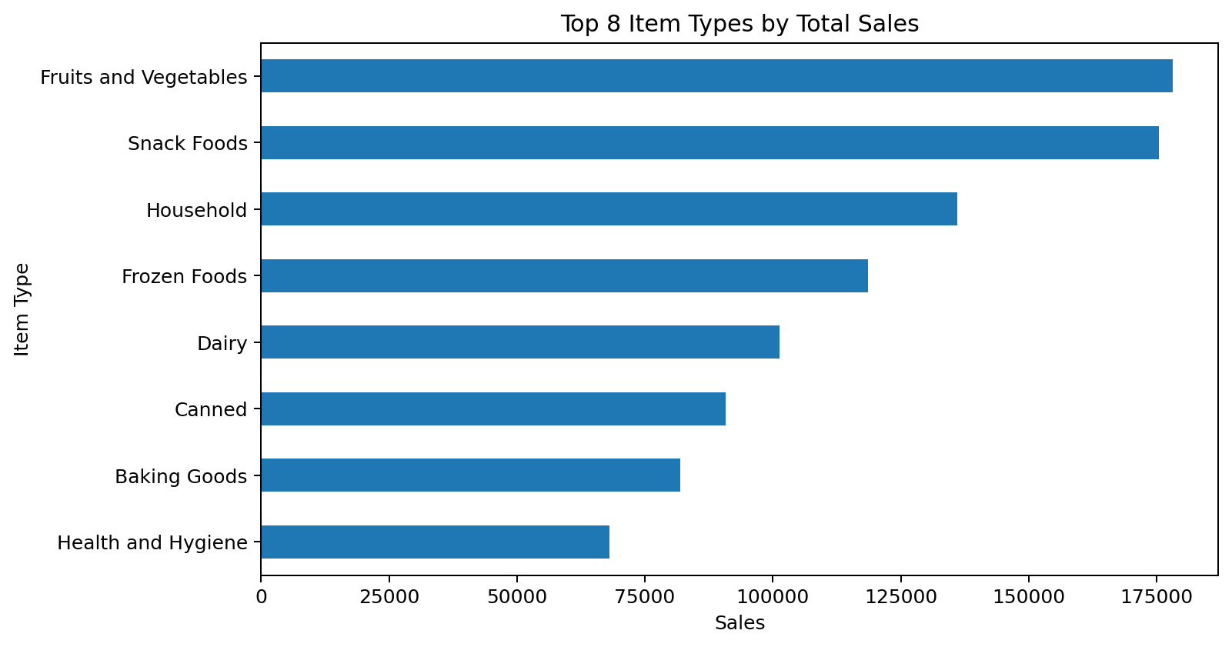

6.2 Sales by Outlet Type
Supermarket Type1 has the highest total sales in the dataset ($787,549.89). The chart compares the four outlet types.
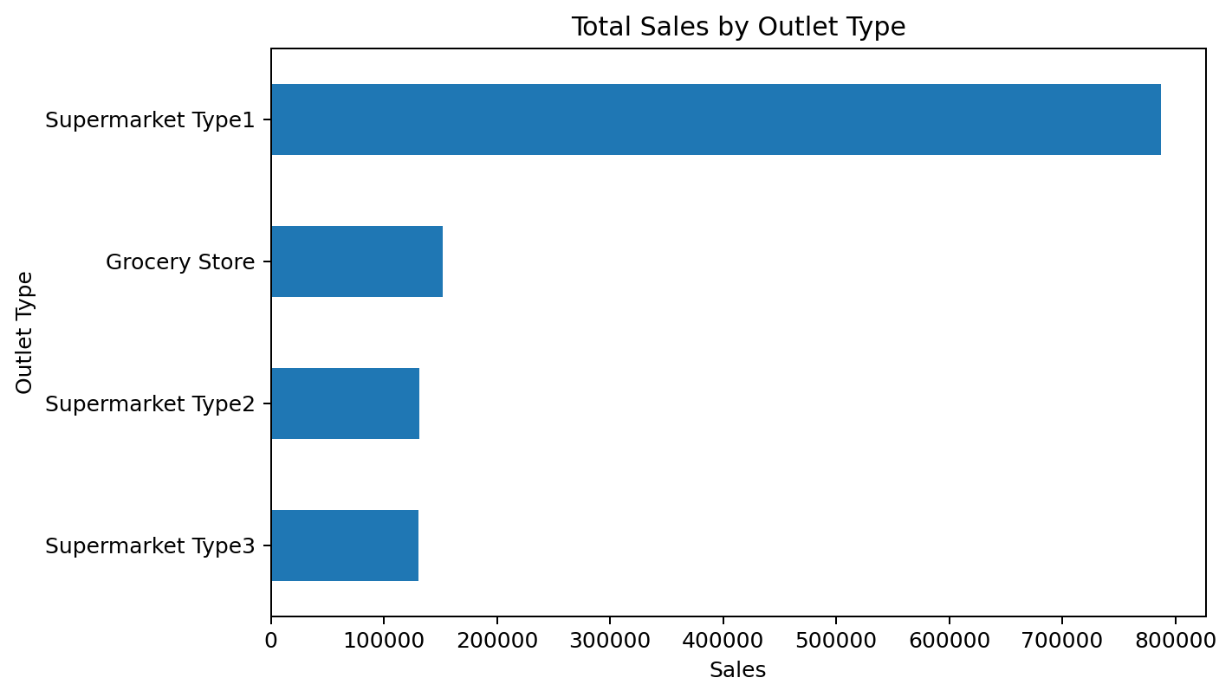

6.3 Sales by Item Fat Content
The categories were standardized before aggregation so alternate labels do not appear as separate groups.
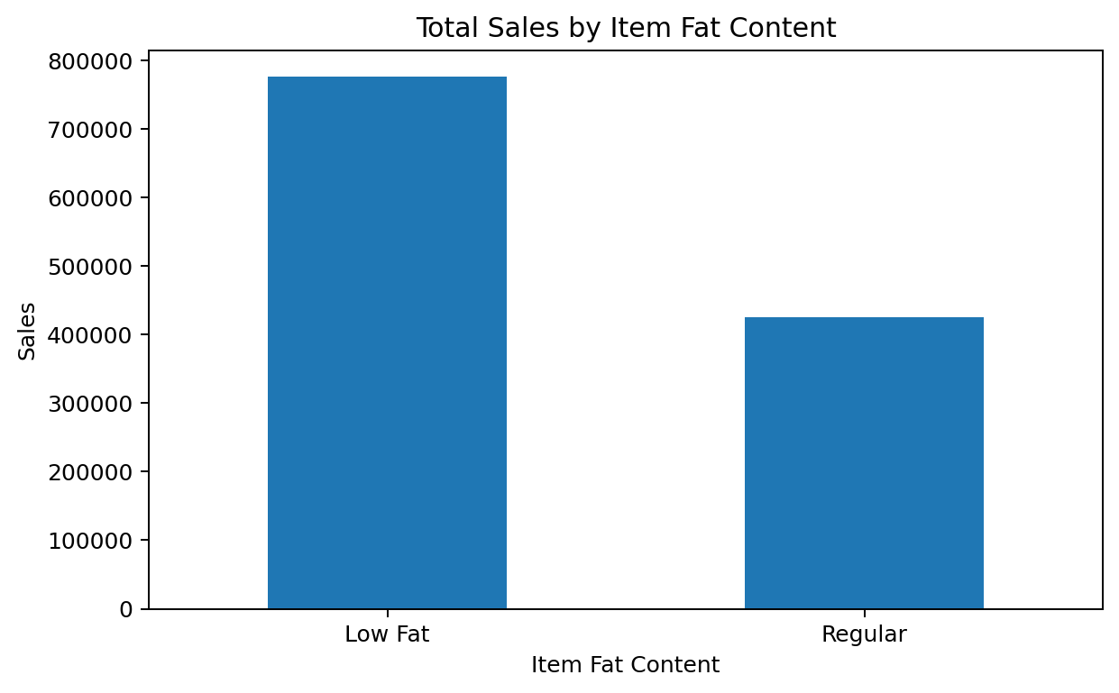

6.4 Sales by Outlet Establishment Year
The year-wise chart provides a descriptive comparison of sales across outlet establishment years; it should not be interpreted as a time-series trend in sales transactions, because the year field describes outlet establishment.
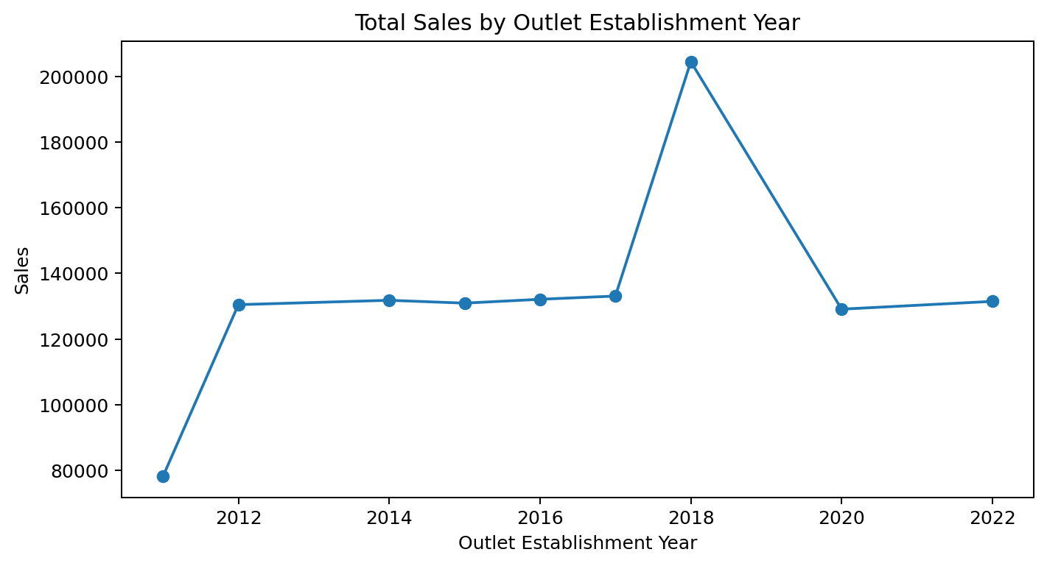

7. Key Observations
- Total sales in the uploaded workbook are $1,201,681.49 across 8,523 records.
- Average sales per record are $140.99, and the average rating is 3.97/5.
- Fruits and Vegetables and Snack Foods are the top two item types by total sales in this dataset.
- Supermarket Type1 contributes the most sales among the outlet types shown.
- Standardizing categorical labels is important before grouping; otherwise, 'Low Fat', 'low fat', and 'LF' would be counted separately.

8. Conclusion
The project demonstrates an end-to-end analytics workflow: querying data in MySQL, exploring and visualizing it in Python, and communicating metrics through Power BI and Excel dashboards. The same dataset and core measures across tools make it easier to compare results and build a portfolio project that shows SQL, Python EDA, spreadsheet transformation, and BI reporting skills.

9. Files Included
- BlinkIT_Grocery_Data_PROGRESS.xlsx — source workbook, Excel dashboard sheets, and raw data.
- blinkit.sql — SQL queries for cleaning, KPI calculations, and segment analysis.
- Blinkit Analysis-checkpoint.ipynb — Python EDA notebook.
- Blinkit.pbix — Power BI dashboard project.

