Tab 1

 System Architecture Document
Project Name: Rover Payload Mass Estimation System
Module: Simulink Model & Design

Version | Date | Author | Description
1.0 | 24/01/2026 | Sujeeth B | Initial Draft

TABLE OF CONTENTS
1. INTRODUCTION
1.1 Purpose of Document
1.2 Project Scope
2. SYSTEM OVERVIEW
2.1 Project Background (Rover Payload System)
2.2 System Context
3. NON-FUNCTIONAL PARAMETERS
3.1 Accuracy & Error Margins
3.2 Sensor Resolution
4. Challenges and Scalability
4.1 Impact of Temperature on Tyre Pressure
4.2 Tyre Pressure Calibration
5. Model for SIngle Tyre System

1. Introduction

1.1 Purpose of Document
The purpose of this document is to define the functional requirements and display the basic architecture for the Rover Payload Estimation System. This system utilizes Tyre Pressure Monitoring System (TPMS) sensors to estimate the mass of loaded materials (e.g., sand, bricks) when the rover is in a stationary state. This document is a primary reference for the development of the model and the subsequent control logic at a grassroot level.

1.2 Project Scope
The scope of this project is limited to estimating the payload mass of a rover type vehicle only when the vehicle is stationary and by correlating changes in tyre pressure.
- Simulation-Based Modeling of Tyre Behavior
- Static Load Estimation using TPMS Signals

2. Basic System Overview

2.1 Project Background
The model shows an indirect mass estimation by leveraging the physical relationship between tyre compression and internal pressure.
2.2 System Context
When a payload is placed on the rover, the external load is represented by a step input that shows the sudden addition of mass. The system relies on the physical law where increased mass on the chassis compresses the tyre, which leads to a proportional increase in internal tyre pressure. Here, adding 50 kg of mass results in a specific pressure rise based on the tyre's stiffness.
Once the pressure changes, it is monitored by a Tyre Pressure Monitoring Sensor. Only two specific imperfections have been added even though in real cases there are a lot of other elements to be added which have been mentioned in the scalability tab of this document. First, random interference such as noise. Second, the sensor is quantized to rounding values to the nearest 0.1 psi (whereas in real time 0.5psi will be required). This was done to mimic what a real rover would receive.
The logic first performs a subtraction, removing the static tyre pressure (here 30 psi) to obtain only the pressure change caused by the new load. A digital low pass filter is applied to smooth out the electronic noise. The result is a mass reading (50.33 kg) that allows the control unit to verify the payload weight without the need for dedicated load cells.

3. Non Functional Parameters

3.1 Accuracy & Error Margins
The accuracy of the proposed system is evaluated by comparing real time tyre pressure data with the output of the developed simulation model. Since certain physical parameters such as tyre stiffness and exact volume change under specific loads are not known, there is still a lot of tuning required.
To overcome this limitation, a calibration approach can be adopted. Lookup tables are generated by manually observing the change in tyre pressure for known static payloads. These lookup tables capture the combined effects of tyre deformation (change in contact area), volume change will help in improving accuracy.

3.2 Sensor Resolution
Through initial research,the pressure resolution of TPMS sensors is limited to approx. 0.5 PSI. This resolution can be a constraint on the minimum detectable change in payload mass.Combining factors such as temperature variation and tyre volume change influence the measured pressure. According to Boyle’s Law, even small changes in volume or temperature can result in noticeable pressure variation. When combined with sensor resolution limits, these effects introduce uncertainty into the payload estimation process. Despite these challenges, a nearby payload mass can be obtained.
4. Challenges and Scalability

4.1 Impact of Temperature on Tyre Pressure
Temperature variations directly affect tyre pressure independent of payload. An increase in temperature causes an increase in internal pressure, which will be misinterpreted as a change in load. This leads to estimation errors in TPMS payload measurement systems. In this project, the effect of temperature is minimized by performing payload estimation only under stationary conditions and we can introduce a Taring system just before the payload is added to the system.

4.2 Verification of Payload Through External Systems
To improve confidence in the estimated payload mass, the results obtained from the TPMS system can be verified using independent vehicle subsystems.
- Motor Current Measurement: can provide an indication of payload weight as increased load results in higher torque demand and corresponds to higher motor current, especially during startup or low speed/stable terrain operation.
- Vision Based Systems: can be used to observe the payload volume and distribution within the rover. Offers qualitative validation of loading conditions.
- Hydraulic Systems (Existing): actuator force can be utilized to corroborate the estimated payload mass, as these values are directly influenced by the applied load.
Together, all these external systems can serve as complementary validation mechanisms, increasing overall accuracy and reliability of the payload estimation. Multi wheel model extension, lookup table based calibration and hardware validation can collectively enhance the accuracy of the system.

5. Model for Single Tyre System
The simulation models a quarter car system (single tire assembly) to check the sensing principle. In a full scale model, this logic would be replicated for all wheels and the results averaged to determine the total rover payload
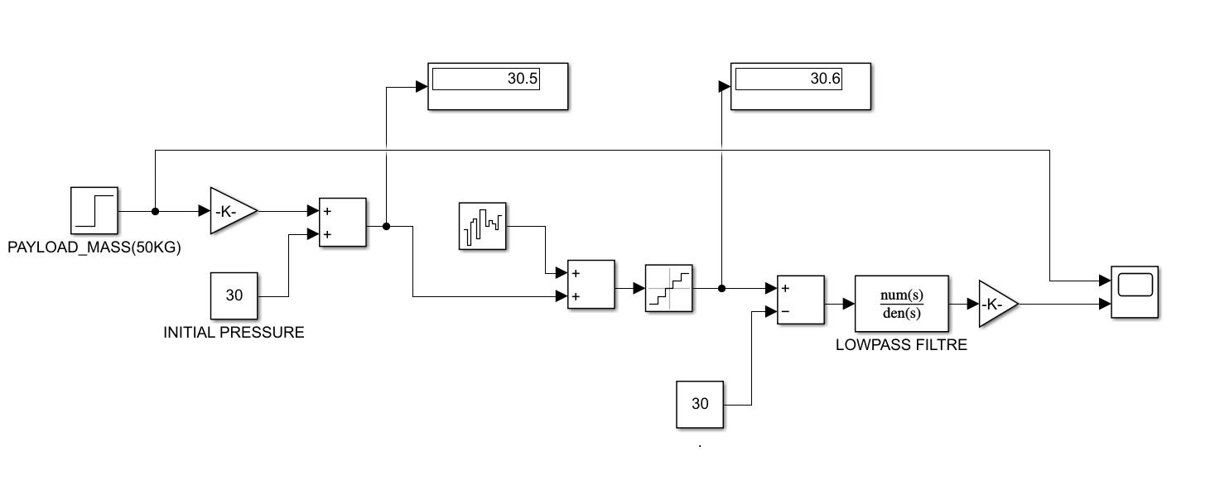

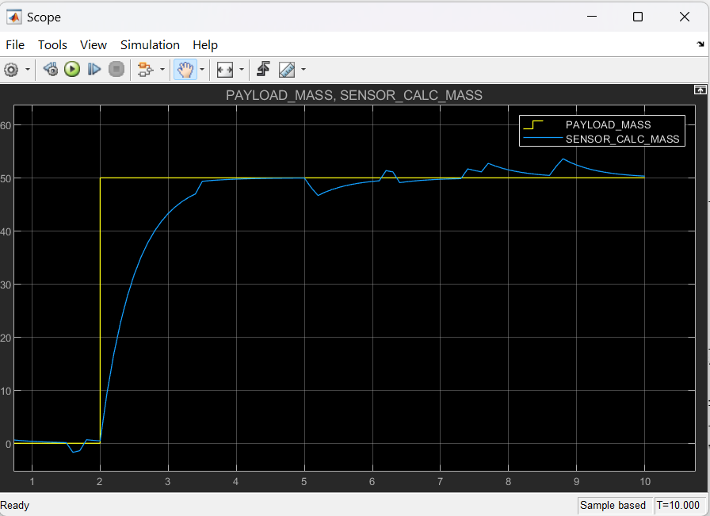

Tab 2
Integrate only with CAN to avoid additional convertors
Scalability: to achieve something in future where we can dev an algorithm to feed the motor controller to push the current values to validate the whole system

Dynamic driving conditions and real time vehicle control are outside the scope of this project.

