**Keywords:**

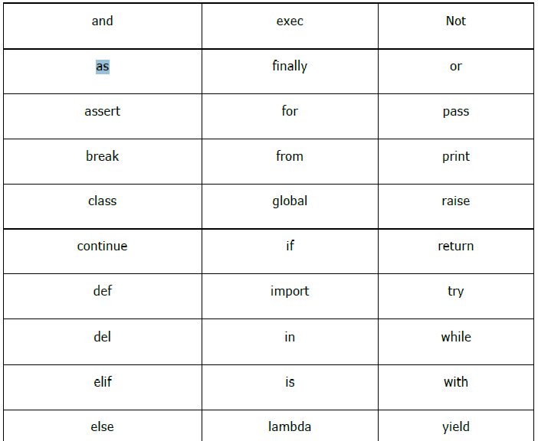

Build-In Functions:

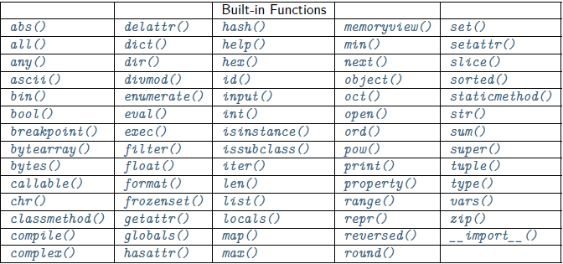

**Numbers**:

|  |  |  |
| --- | --- | --- |
| **Function Name** | **Description** | **Example** |
| **Mathematical** |  |  |
| abs(x) | The absolute value of x: the positive distance between x and zero. | print(abs(10)) >> 10  print(abs(-10)) >> 10  print(abs(10.2)) >> 10.2 |
| ceil(x) | The ceiling of x: the smallest integer not less than x. |  |
| exp(x) | The exponential of x: ex |  |
| fabs(x) | The absolute value of x. |  |
| floor(x) | The floor of x: the largest integer not greater than x. |  |
| log(x) | The natural logarithm of x, for x> 0. |  |
| log10(x) | The base-10 logarithm of x for x> 0. |  |
| max(x1, x2,...) | The largest of its arguments: the value closest to positive infinity. |  |
| min(x1, x2,...) | The smallest of its arguments: the value closest to negative infinity. |  |
| modf(x) | The fractional and integer parts of x in a two-item tuple. Both parts have the same sign as x. The integer part is returned as a float. |  |
| pow(x, y) | The value of x**y. |  |
| round(x [,n]) | x rounded to n digits from the decimal point. Python rounds away from zero as a tie-breaker: round(0.5) is 1.0 and round(-0.5) is 1.0. |  |
| sqrt(x) | The square root of x for x > 0. |  |
|  |  |  |
|  |  |  |
|  |  |  |
|  |  |  |
|  |  |  |

|  |  |  |
| --- | --- | --- |
| **Category** | **Type** | **Description** |
| Number | Int | Immutable |
|  | Float | Immutable |
|  | complex | Immutable , x+ay |
|  | Boolean | True or False |
| Sequences | String | Immutable |
|  | List | Mutable, ordered |
|  | tuple | Immutable, Read only |
| Mapping | Dict | Mutable |
| Set | Set | Mutable, unique, unordered |
|  | Frozen Set | Immutable |
| None | NoneType | A= None |