Find all products in the "Electronics" category that have more than 50 items in stock.
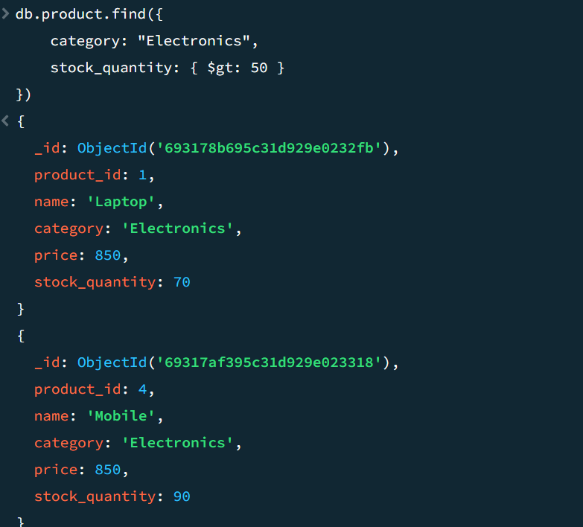

Find the total number of orders placed by a user (given their user_id), including the total amount spent.
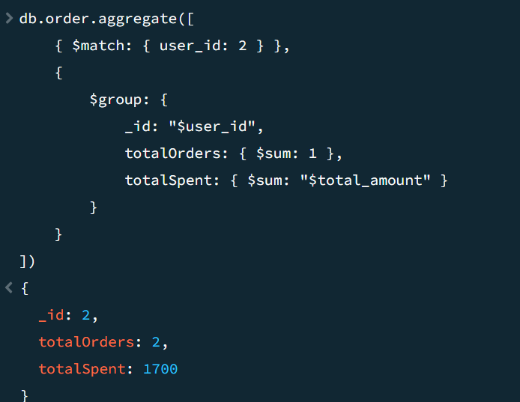

List all users who have purchased a specific product (given its product_id), including their name and email address.
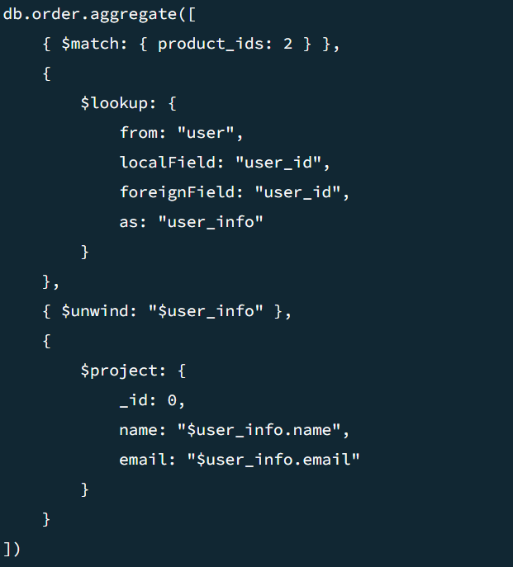

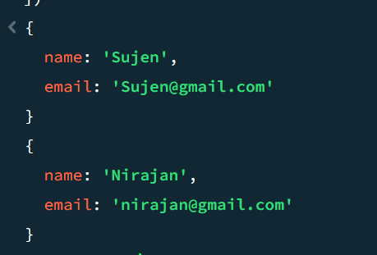

Update the stock quantity of a product (given its product_id) after an order is placed, considering the quantity of the product purchased in the order.
