**Phase1**

**Defining the Problem Statement**

**Project Name : CREATE A CHATBOT IN PYTHON**

**Team ID : 8932**

**Project Description:**

The project aims on creating chatbot to assist in learning python and helps novice programmers to understand Python’s basic syntactic structures and semantics . This chatbot supports in self learning and administrative tasks in python . We will outline the problem statement, steps involved in it, and a design thinking approach to guide our project.

**Problem Statement:**

The problem is to build an AI-powered chatbot that uses Natural language processing to convers with the user and answer their queries on learning python programming . The system aims to provide knowledge and information about python in a brief and crisp way to the learners for easy and effective understanding of the language , provide study tools and feedback.

Objective: To answer inquiries, provide study tools, provide feedback and provide a more interesting and interactive learning environment for learners for learning python.

Data: We have access to a dataset containing queries and their answers and website pages with people’s questions in various topics of python. This data set is used to train put chatbot

**Key Challenges:**

**Content Knowledge:**

Ensuring the chatbot has a comprehensive understanding of Python, including its syntax, libraries, and best practices, is crucial. It requires continuous updates to stay current with Python’s evolving ecosystem.

**Natural Language Processing (NLP):**

Developing robust NLP capabilities to understand and generate human language accurately can be challenging, particularly in the context of code explanations and examples.

**Error Handling:**

The chatbot needs to identify and address common coding errors and misconceptions, providing clear explanations and guidance on how to fix them.

**Interactivity:**

Creating an engaging and interactive learning experience, including code execution and visualizations, can be complex to implement.

**Scalability and Performance**:

Ensuring the chatbot can handle a large user base, respond quickly, and scale with increasing demand is a technical challenge.

**Feedback and Adaptation:**

Implementing mechanisms for gathering user feedback and using it to improve the chatbot’s performance and content is an ongoing challenge.

**Multimodal Learning:**

Supporting various learning modes, such as text, images, videos, or voice interactions, can enhance the chatbot’s usability but also adds complexity.

**Maintenance and Updates:**

Python evolves, and so does the best practice .Keeping the chatbot’s content and capabilities up-to-date is an ongoing effort.

**User Engagement:**

Maintaining user interest and motivation to continue learning Python through the chatbot is a significant challenge.

**Integration:**

If the chatbot is part of a broader educational platform, integrating it with other tools and systems seamlessly is essential.

**Design Thinking Approach:**

**Functionality:**

The scope of this chatbot is to provide knowledge and information about python in a brief and crisp way to the learners for easy and effective understanding of the language, provide study tools and feedback.

**User Interface:**

The chatbot will be integrated in website, this design is a user-friendly interface for interactions which includes text box for text queries and camera lens for image type queries.

**Natural Language Processing (NLP):**

Using NLP techniques such as keyword extraction, intent recognition, and sentiment analysis, the chatbot is trained to comprehend and respond to user queries.

**Response:**

Correct error in code, provide definition, provide brief description about various topics in python, provide and explain output for given code type queries, explain logic of the given code.

**Testing and Improvement:**

The chatbot is tested and refine continuously with the help of various queries and questions on python from different websites and queries dataset.

**Integration:**

Creating a web interface for users to interact with the chatbot. Building a custom web interface using web development technologies like HTML,CSS and JavaScript, or use existing platforms and tools and appending the chatbot to website.

**Before Chatbot**

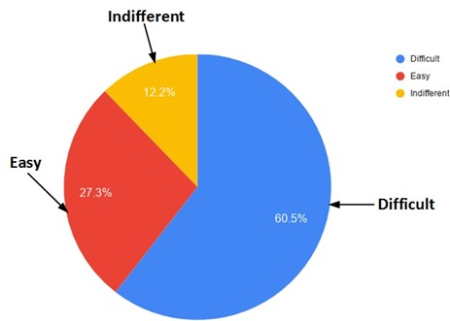

**After Chatbot**

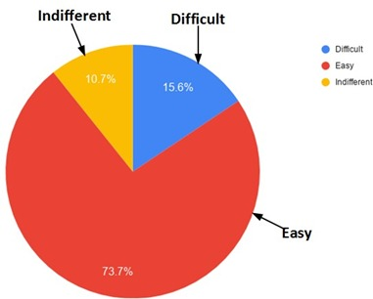

**Conclusion:**

The introduction of Chatbots in python teaching can be seen as a significant advancement and an innovative solution for improving learning of python. Using Chatbots can change the pace at which students can learn without being compelled to. novice programmers struggle due to lack of adequate learning aids that can support the students. The use of Chatbots in learning enables students to be more agile, customised, engaged and inspired.