**Project** **report** **template**

**Overview:**

Our team working on the project of retail management application using Salesforce. We are CRM product owner . We created two applications one is sales app for sales reps to use this application and store customers data and the second application is a service app for service reps / agents to provide support to customers in dealing the cases to generate business on top of the customers .

**Purpose:**

Our project can be so useful for customer to track the sales product about company to track orders managing inventory levels.

2.). **Problem** **definition** **and** **design** **thinking**

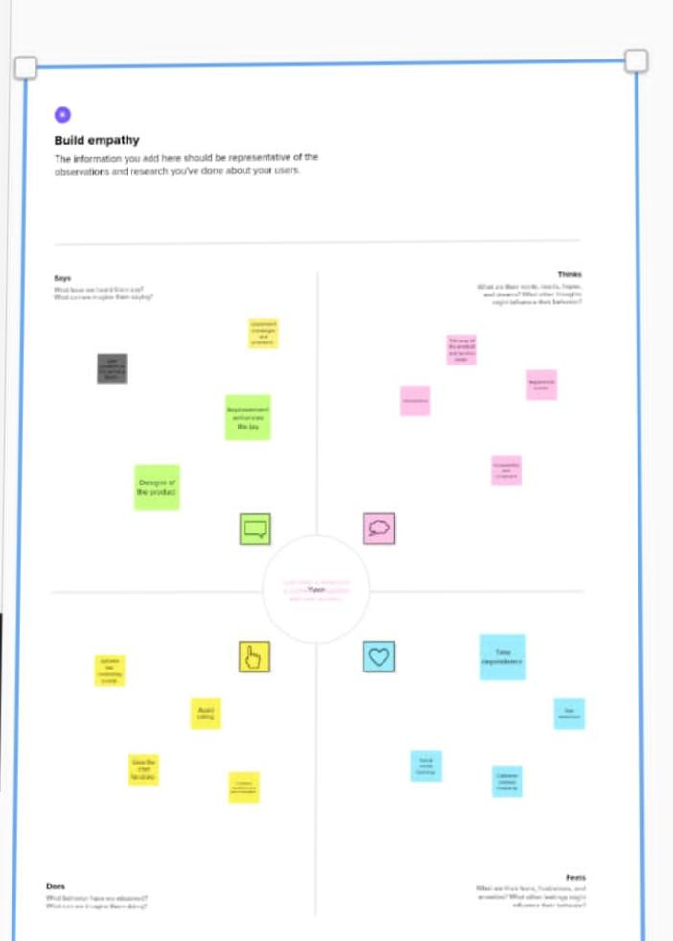* **Empathy** **Map** :

* **Ideation** **and** **brainstorm** **map** :

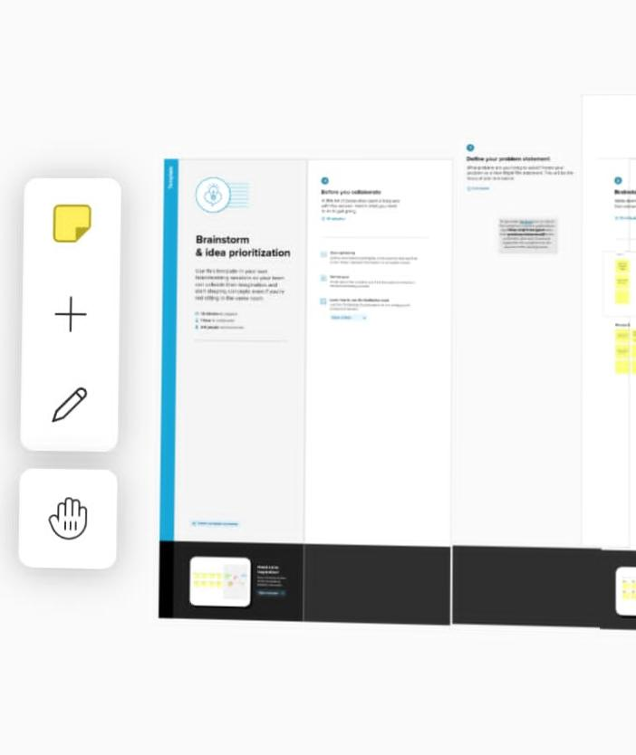

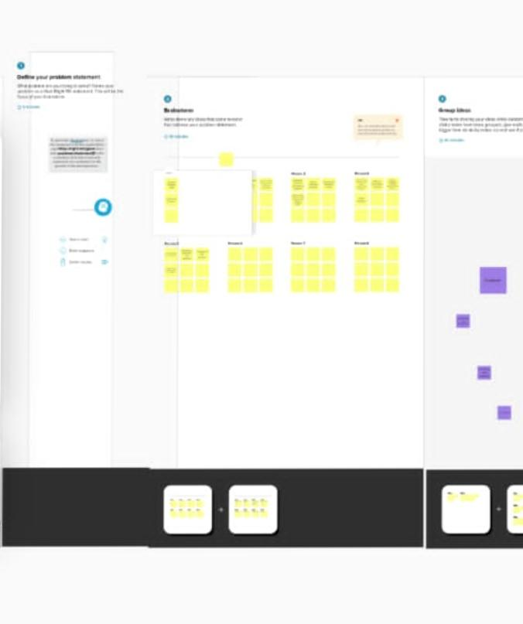

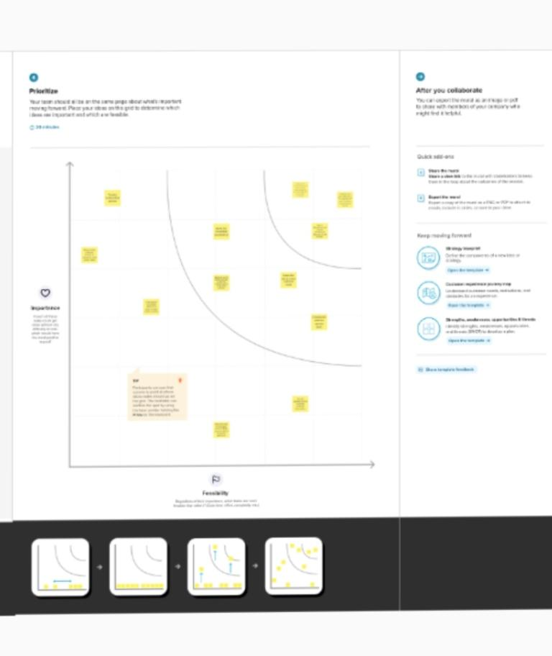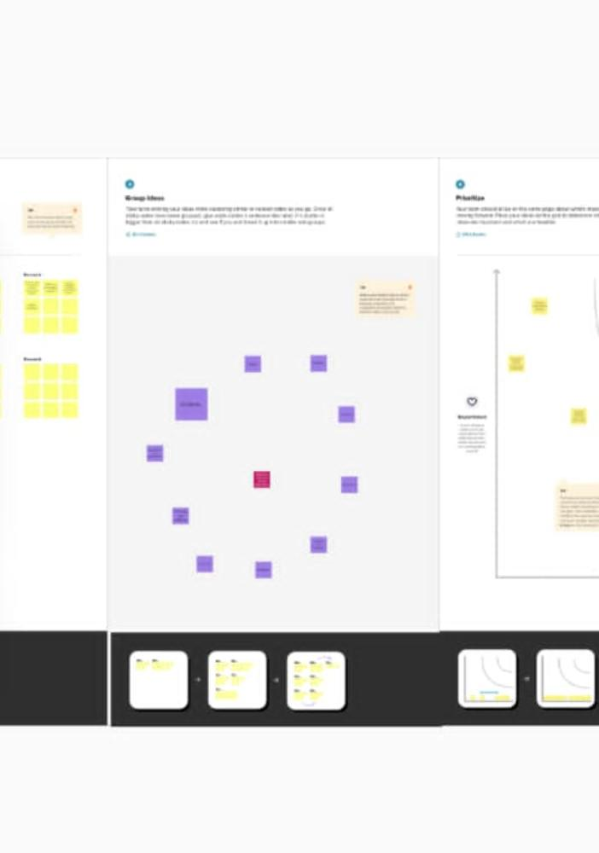

**3) Result:**

**Data model:**

**Standard object: standard objects such as account, contact lead and opportunity these objects which can be provided by Salesforce out of the box .**

**Custom object: custom objects can be created to store specific information that cannot be stored in standard object.**

**Standard object: Standard fields such as name, I’d and created date are created by default.**

**Custom field: create custom fields of different data types to store additional information.if you want to store information related to employ birth date and address, you can create custom fields in order to store this data.**

* **Activity and screenshot**

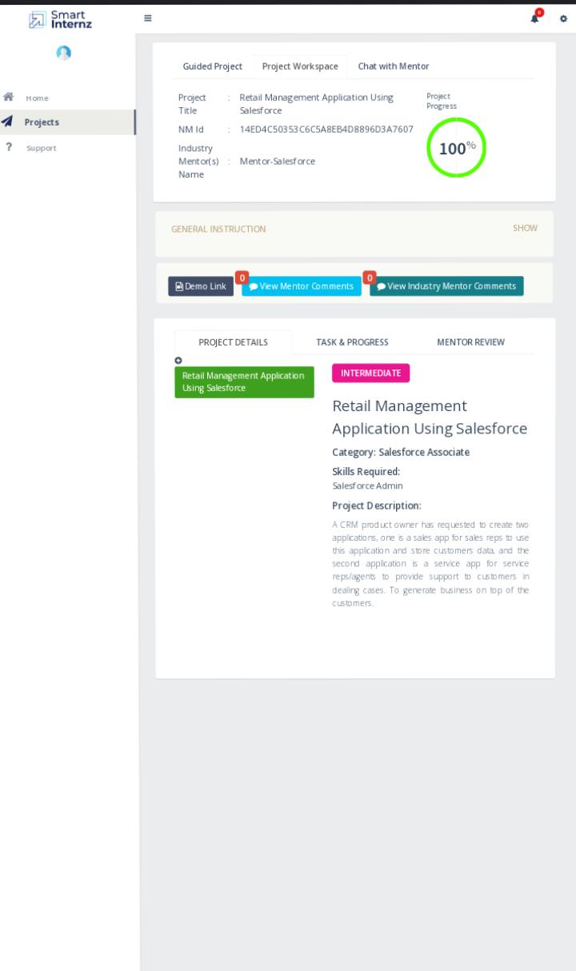

**4) trail head profile public URL:**

**Team leader -** [**https://trailblazer.me/id/sujia8**](https://trailblazer.me/id/sujia8)

**Team member 1 -** [**https://trailblazer.me/id/yyuva21**](https://trailblazer.me/id/yyuva21)

**Team member 2-** [**https://trailblazer.me/id/vends2**](https://trailblazer.me/id/vends2)

**Team member 3-** [**https://trailblazer.me/id/vpriya193**](https://trailblazer.me/id/vpriya193)

**Team member 4-** [**https://trailblazer.me/id/yuvak16**](https://trailblazer.me/id/yuvak16)

**5) advantages and disadvantage**

**Pros**

* **Incredibly powerful CRM platform**
* **You can add / remove features to suit your needs.**
* **As the most popular CRM platform it’s easy to find sales reps who know how to use the Salesforce.**

**Cons**

* **Expensive.**
* **The learning curve seems to end .**
* **Customer support has a poor reputation.**
* **You have to pay for add ons to get the most out of the software.**

**6) application :**

**Salesforce service cloud allows retailer’s to provide personalized customer service through multiple channels such as phone, email and social media .it also store customers and prospects contact information identify sales opportunities, record service issues and manage marketing campaigns all in one central location.**

**7), conclusion:**

**In this project the terms retailing, marketing and marketing communities and also the importance of marketing mix and identified the different communication tools that a retailes can interact and communicates with the Target customers.**

**8). Future scope:**

**Demand for Salesforce developer will skyrocket in 2023 and the manufacturing and banking sectors and the manufacturing and banking sectors and the two that are growing fast .to integrate data science and big data capabilities to its services cloud and marketing cloud.**