# Chapter -1 Introduction

**1.1 INTRODUCTION:**

The AUTOMIZATION OF COMPUTER SCIENCE DEPARTMENT system has developed to override the problem prevailing in the practicing the manual system. This software is supported to eliminate and in some cases reduces the hardships faced by this existing system. Moreover, this system is designed for the particular need of company to carry out operation in a smooth and effective manner.

The application is reduced as much as possible to avoid errors while entering the data. It also provides error message while entering the invalid data. No formal knowledge is needed to use this system. Thus, by this all it proves it is user-friendly. Automization of CS department, has described above can lead to error free, secure, reliable and fast management system. This system can be used to store and manage all data of the student and faculty information like subject handling, minutes of meeting and other curricular activities etc. using this system user can retrieve any information related to student and staff. Admin can create report regarding any faculty any time using this system. Using this system, you can register new student and their course details. It can assist the user to concentrate on their other activities rather to concentrate on the record keeping. Thus, it will help organization in better utilization of resource.

This system is computerized and to fulfill their study requirements so, that their valuable information can be stored for a longer period with easy accessing and manipulating of the same. The required software and hardware are easily available and easy to work with. This system can lead to error free, secure, reliable and fast management system. This system can be accessed easily at anytime and anywhere.

**1.2 STATEMENT OF PROBLEM:**

We observed the Automization of Computer Science Department system going through it, we get to know that there are many operations, which they have to do manually. It takes a lot of time and causing many challenges like workload, co-curricular activities and updating awards, attended workshop etc. required more man power and there is some set of procedure to do managerial requirements. Due to this, user need to waste a lot of time and physical effort in finding the student who have attended SDP, Workshops, Paper Publications, co-curricular activities and won the prizes. To solve this above problem, and further maintaining records for students and faculty, this system maintains the record regarding to those students who have attended Workshop, SDP, Paper Publications, co -curricular activities and won the awards.

**1.3 OBJECTIVE OF THE STUDY:**

The main aim of the project is to automate all functionalities of a college. It allows the faculty to fetch the details regarding department activities and also keep up to date his profile. It’ll also facilitate keeping all the records of students, such as their id, name, mailing address, phone number, DOB etc. So, all the information about a student will be available in a few seconds. It allows the administrator of any organization to edit and find out the personal details of a student. Using this application system, you can view or update data and information about students and staff easily. Admin can also retrieve information of employee student.

Overall, it’ll make information management an easier job for the administrator of any organization. This project will fulfill the changing user requirements. The user needs to login with a valid password, after a valid, user logs he/she can login.

**1.4 SCOPE OF THE STUDY:**

The intention of developing “Automization of Computer Science Department ” application is aimed to computerizing and developed system was found to work out the operations effectively. This software takes care of all the requirements of a students and faculty to provide easy and effective storage of information related to department activities . Reports automatically, at the end of the session or in the between of the session as they require. This application involves almost all the features of the information system; It will be very useful for the users to obtain information.

This system provides access to the student’s record and get the desired information which may require. It maintains the records of Student records, Student Details, Faculty details , etc. It makes the faculty and student information management more secure, effective, convenient and accessible.It co-ordinate information across the system to simplify student across to University resources

**1.5 FEASIBILITY STUDY:**

**1.5.1 Software Specification:**

Software requirements for this system are as listed follow:-

* FRONTEND : Microsoft VB.NET
* BACKEND : MYSQL
* OPERATING SYSTEM : Windows 10

**1.5.2 Hardware Specifications:-**

Minimum hardware requirements for this System are listed below:

* + - * PROCESSOR : Intel(R) Core(TM) i3-1005G1 CPU @ 1.20GHz 1.19GHz
      * RAM : 4.00 GB
      * HARD DISK : 80GB CD-ROM Driver

# Chapter -2 SYSTEM STUDY

**2.1 EXISTING SYSTEM:**

* Each file is maintained based on the year.
* The department is maintaining the records in manual way
* In case of manual system, they need a lot of time, manpower, etc.
* Finding out details regarding any information is very difficult as the user has to go through all the books manually. Major problem was losing of the data. Information overload
* The old system of filing is not portable.
* Accessibility issues experienced by a user or administrator.

**2.1.1 Limitations of Existing system:**

* Not user friendly: The existing system is not user friendly because the retrieval of data is very slow and data is not maintained efficiently.
* Time consuming: Every work is done manually so we cannot generate report in the middle of the session or as per the requirement because it is very time consuming.
* Lack of security of data.
* In order to find the file based on the year is very difficult and time consuming.
* They are maintaining different files for different category.
* Data is lost if the file is lost.
* Slow response about refunding amount.
* Low quality customer service.
* No direct role for the higher officials.
* Troll fee is not available for customer enquiries.
* Needs manual calculations.

**2.2 PROPOSED SYSTEM:**

The aim of the proposed system is to develop a system of improved facilities. The proposed system can overcome all the limitations of the existing system. The system provides proper security and reduces the manual work and it is very simple in design and to implement. The system requires very low system resources and the system will work in almost all configurations. It has got following features:

* Ensure data accuracy.
* Data security.
* Records are efficiently maintained by DBMS.
* DBMS also provides security for the information.
* Proper control of the higher officials.
* Greater efficiency.
* Minimum time needed for the various processing.
* Better service.
* User friendliness and interactive.
* Minimize manual data entry.
* Minimum time required

**2.2.1 Advantages of proposed system:**

* **User friendly:** The proposed system is user friendly because the retrieval and storing of data is fast and data is maintained efficiently. Moreover the graphical user interface is provided in the proposed system, which provides user to deal with the system very easily.
* **Very less paper work :** The proposed system requires very less paper work. All the records of each fields is fetched into the computer immediately and reports can be generated through computers. Moreover hardware copy will be reduced.
* **Computer operator control:** The computer operator control will be there so no chance of errors. Moreover storing and retrieving of information is easy. So work can be done speedily and in time.

**2.3 PROBLEM FORMULATION:**

In the existing system it was very difficult to maintain the information and to store each record of each student and faculty, various details process and very difficult to access the information which was stored manually. So to overcome this problem of existing system, this proposed system is aimed at reducing paper work for the college management and hence improving its efficiency and speeding up of all processes. The database can be accessed by the admin from any computer terminal connected through LAN to a server where the system has been installed. To generate the reports reduces the time by various options and also the development of the design has well equipped. Hence, all the related information about a student and faculty is available to Admin. Thus this software saves the faculty time.

**2.4 SYSTEM ANALYSIS:**

**2.4.1 Functional - Requirements:**

* Requirement analysis is a software engineering task that bridges the gap between system level software allocation and software design.
* It enables the system engineer to specify software interface with other system elements, and establish design constraints that the software must meet.
* It provides the software designs with a representation of information and function that can be translate to data, architectural and procedural design.

**2.4.2 System functionalities:**

Automization of Computer Science Department, that were suggested till now, are not up to the desired level. There is no single system which automates all the process.

* In order to build the system, all the processes in the business should be studied, System study helps us under the problem and needs of the application.
* System study aims at establishing requests for the system to be acquired, development and installed. It involves studying and analyzing the ways of an organization currently processing the data to produce information.
* Analyzing the problem thoroughly forms the vital part of the system study. In system analysis, prevailing situation of problem is carefully examined by breaking them into sub problems. Problematic areas are identified and information is collected.
* Data gathering is essential to any analysis of requests. It is necessary that this analysis familiarizes the designer with objectives, activities and the function of the organization in which the system is to be implemented.

**2.4.3 Non-Functional Requirements:**

* **Security:**

Project level security is set. User needs to login when they start the program option is also provided to create the additional user and level security. Presently user level security is not set but can be implemented with few modifications.

* **Reliability, Availability, Maintainability:**

It is very user friendly, software is secure and there is not much maintenance. Project can be upgraded as per the requirement step by step.

* **Configuration and Compatibility:**

Describes requirements such as those connected with individual customization or operation in specific competing environments.

* **Usability:**

Describes items that will ensure the user friendliness of the software.

Example: - Includes error messages that direct the user to a solution, input range checking as soon as entries are made and order of choices and screen corresponding to user performances.

**2.5 METHODOLOGY:**

This project is designed and developed based on the waterfall model. This model particularly expresses the interaction between subsequent phases. In each phase of the software development process, we have to compare results obtained against that which is required. In all quality has to be assessed and controlled.

Waterfall approach was first SDLC Model to be used widely in Software Engineering to ensure success of the project. In “The Waterfall” approach, the whole process of software development is divided into separate phases.

Main following is a diagrammatic representation of different phases of waterfall model.

**WATERFALL MODEL**

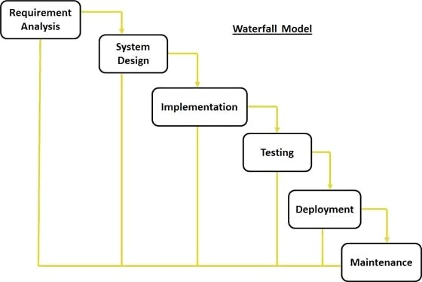

* The requirements specification of the project has collected with equipped manner.
* The project has designed with html pages to develop by using various commands.
* Implementation can be done with the basis of design and conceptual data with codes and scripts.
* Testing plays a important role to the process of verification and validation.
* Development is done implement for future references.

# Chapter – 3

# System Design and Development

**DATA FLOW DIAGRAM:**

## DFD Level 0

**STUDENT**

**ADMIN**

**FACULTY**

**name, dob, mob, email-id**

**Course details**

**workload**

**Faculty details**

**Processed data**

**Faculty details, student details**

**activity details**

**awards details**

**DATA FLOW DIAGRAM:**

## DFD Level 1

Sid, name

Student Details

Usname ,pwd

ADMIN

1

LOGIN

1.1

Student Reg.

Fname,desgn,mob

Faculty Details

2

NAAC

1.2

Faculty Reg.

Placements Details

NAAC Details

3

Workload

WORKLOAD

4

Placements.

Course Details

Alloted Details

5

Organizes ORGANISES

Organise Details

5.2

Events

5.3

Awards

5.1

Attended

Attended Details

Awards Details

Events Details

**ER DIAGRAM:**

**ADMIN**

**logins**

**LOGIN PAGE**

**handles**

**manages**

**NAAC**

**manages**

**DEPARTMENT**

**FACULTY**

**STUDENT**

**attends**

**PLACEMENTS**

**WORKLOAD**

**handles**

**EVENTS**

**WORKSHOP**

**Minutes of meetings**

**attends**

**organizes**

**AWARDS**

**COURSE DETAILS**

DATABASE DESIGN:

**🡪 LOGIN :**

|  |  |  |  |  |  |
| --- | --- | --- | --- | --- | --- |
| **Field** | **Type** | **Null** | **Key** | **Default** | **Extra** |
| Username | varchar(40) | YES |  | NULL |  |
| Password | varchar(30) | YES |  | NULL |  |

**🡪 FACULTY REGISTRATION:**

|  |  |  |  |  |  |
| --- | --- | --- | --- | --- | --- |
| **Field** | **Type** | **Null** | **Key** | **Default** | **Extra** |
| fid | int(30) | Yes |  | Null |  |
| fname | varchar (30) | Yes |  | Null |  |
| fdept | varchar(30) | Yes |  | Null |  |
| doj | varchar(15) | Yes |  | Null |  |
| mob | varchar(30) | Yes |  | Null |  |
| email | varchar(30) | Yes |  | Null |  |
| desgn | varchar(30) | Yes |  | Null |  |
| gender | varchar(30) | Yes |  | Null |  |

**🡪STUDENT REGISTRATION :**

|  |  |  |  |  |  |
| --- | --- | --- | --- | --- | --- |
| **Field** | **Type** | **Null** | **Key** | **Default** | **Extra** |
| Sid | varchar(15) | NO | PRI | NULL |  |
| Sname | varchar(30) | YES |  | NULL |  |
| Fname | varchar(30) | YES |  | NULL |  |
| Address | varchar(60) | YES |  | NULL |  |
| DOB | varchar(30) | YES |  | NULL |  |
| Email | varchar(30) | YES |  | NULL |  |
| Admin | varchar(30) | YES |  | NULL |  |
| Course | varchar(30) | YES |  | NULL |  |
| Sem | varchar(30) | YES |  | NULL |  |
| Gender | varchar(30) | YES |  | NULL |  |
| MOB | varchar(30) | YES |  | NULL |  |

**ACTIVITY :**

|  |  |  |  |  |  |
| --- | --- | --- | --- | --- | --- |
| **Field** | **Type** | **Null** | **Key** | **Default** | **Extra** |
| Regno | varchar(20) | YES |  | NULL |  |
| Name | varchar(30) | YES |  | NULL |  |
| Cname | varchar(30) | YES |  | NULL |  |
| Ename | varchar(50) | YES |  | NULL |  |
| Descp | varchar(50) | YES |  | NULL |  |
| Org | varchar(30) | YES |  | NULL |  |
| Date | varchar(10) | YES |  | NULL |  |
| Type | varchar(30) | YES |  | NULL |  |

**ATTENDED :**

|  |  |  |  |  |  |
| --- | --- | --- | --- | --- | --- |
| **Field** | **Type** | **Null** | **Key** | **Default** | **Extra** |
| Name | varchar(30) | YES |  | NULL |  |
| Topic | varchar(30) | YES |  | NULL |  |
| Rperson | varchar(30) | YES |  | NULL |  |
| Organisation | varchar(30) | YES |  | NULL |  |
| Date | varchar(10) | YES |  | NULL |  |
| Type | varchar(30) | YES |  | NULL |  |
| Category | varchar(30) | YES |  | NULL |  |
| file | varchar(50) | YES |  | NULL |  |

**AWARDS :**

|  |  |  |  |  |  |
| --- | --- | --- | --- | --- | --- |
| **Field** | **Type** | **Null** | **Key** | **Default** | **Extra** |
| Regno | varchar(15) | NO | PRI | NULL |  |
| Name | varchar(30) | YES |  | NULL |  |
| Type | varchar(30) | YES |  | NULL |  |
| Eventname | varchar(30) | YES |  | NULL |  |
| Organisation | varchar(30) | YES |  | NULL |  |
| College | varchar(30) | YES |  | NULL |  |
| Date | varchar(10) | YES |  | NULL |  |
| Gender | varchar(10) | YES |  | NULL |  |
| Prize | varchar(20) | YES |  | NULL |  |
| certi | varchar(100) | YES |  | NULL |  |

**COURSE :**

|  |  |  |  |  |  |
| --- | --- | --- | --- | --- | --- |
| **Field** | **Type** | **Null** | **Key** | **Default** | **Extra** |
| COURSE | varchar(30) | NO |  | Null |  |
| YEAR | varchar(30) | NO |  | Null |  |
| SEM | varchar(20) | NO |  | Null |  |
| SUBJECT | varchar(30) | NO |  | Null |  |
| SUBJECTCODE | varchar(20) | NO |  |  |  |
| DESCRIPTION | varchar(50) | NO |  |  |  |
| STRENGTH | int(255) | NO | PRI |  |  |

**MINUTES :**

|  |  |  |  |  |  |
| --- | --- | --- | --- | --- | --- |
| **Field** | **Type** | **Null** | **Key** | **Default** | **Extra** |
| id | int(20) | NO | PRI | NULL |  |
| date | varchar(30) | YES |  | NULL |  |
| agenda | varchar(100) | YES |  | NULL |  |
| plan | varchar(30) | YES |  | NULL |  |
| file | varchar(100) | YES |  | NULL |  |

**ORGANISE :**

|  |  |  |  |  |  |
| --- | --- | --- | --- | --- | --- |
| **Field** | **Type** | **Null** | **Key** | **Default** | **Extra** |
| Topic | varchar(30) | YES |  | NULL |  |
| Name | varchar(30) | YES |  | NULL |  |
| Rperson | varchar(30) | YES |  | NULL |  |
| Org | varchar(30) | YES |  | NULL |  |
| doj | varchar(30) | NO |  |  |  |
| Category | varchar(15) | YES |  | NULL |  |
| gender | varchar(10) | YES |  | NULL |  |
| Expense | varchar(5) | YES |  | NULL |  |
| file | varchar(60) | YES |  | NULL |  |

**PAPER PUBLICATION :**

|  |  |  |  |  |  |
| --- | --- | --- | --- | --- | --- |
| **Field** | **Type** | **Null** | **Key** | **Default** | **Extra** |
| Pid | Int(100) | NO | PRI |  |  |
| Pub | varchar(20) | YES |  | NULL |  |
| Name | varchar(30) | YES |  | NULL |  |
| Org | varchar(30) | YES |  | NULL |  |
| doj | varchar(30) | NO |  | NULL |  |
| Issn | Varchar(30) | YES |  | NULL |  |
| Conference | varchar(30) | YES |  | NULL |  |
| Presentation | varchar(30) | YES |  | NULL |  |
| gender | varchar(10) | YES |  | NULL |  |
| file | varchar(100) | YES |  |  |  |

**PLACEMNTS :**

|  |  |  |  |  |  |
| --- | --- | --- | --- | --- | --- |
| **Field** | **Type** | **Null** | **Key** | **Default** | **Extra** |
| Id | int(30) | NO | PRI |  |  |
| Name | varchar(30) | YES |  | NULL |  |
| Company | varchar(20) | YES |  | NULL |  |
| Designation | varchar(30) | YES |  | NULL |  |
| Eid | varchar(20) | YES |  | NULL |  |
| Gender | Varchar(30) | YES |  | NULL |  |
| file | varchar(100) | YES |  | NULL |  |

**SUBJECTS :**

|  |  |  |  |  |  |
| --- | --- | --- | --- | --- | --- |
| **Field** | **Type** | **Null** | **Key** | **Default** | **Extra** |
| id | int(10) | NO | PRI | NULL |  |
| year | varchar(10) | YES |  | NULL |  |
| course | varchar(10) | YES |  | NULL |  |
| sem | varchar(5) | YES |  | NULL |  |
| subjectcode | varchar(10) | YES |  | NULL |  |
| subjectname | varchar(25) | YES |  | NULL |  |
| file | varchar(100) | YES |  | NULL |  |

**WORKLOAD :**

|  |  |  |  |  |  |
| --- | --- | --- | --- | --- | --- |
| **Field** | **Type** | **Null** | **Key** | **Default** | **Extra** |
| Name | varchar(10) | NO | PRI | NULL |  |
| Year | varchar(10) | YES |  | NULL |  |
| Course | varchar(10) | YES |  | NULL |  |
| Subject | varchar(5) | YES |  | NULL |  |
| Sem | varchar(10) | YES |  | NULL |  |
| Department | varchar(25) | YES |  | NULL |  |
| Theoryhrs | varchar(100) | YES |  | NULL |  |
| Practicalhrs | varchar(10) | YES |  | NULL |  |
| timetable | varchar(10) | YES |  | NULL |  |

**NAAC :**

|  |  |  |  |  |  |
| --- | --- | --- | --- | --- | --- |
| **Field** | **Type** | **Null** | **Key** | **Default** | **Extra** |
| Academic | varchar(30) | YES |  | NULL |  |
| file | varchar(30) | YES |  | NULL |  |

**CODE:**

**LOGIN: ublic Class Login**

**Private Sub Form1_Load(sender As Object, e As EventArgs) Handles MyBase.Load**

**con_open()**

**TextBox1.Text**

Private Sub Command1_Click() Dim username, password As String username = "admin" password = "67890"

If Text1.Text = username And Text2.Text = password Then MsgBox ("sign in sucessful")

form2.Show

ElseIf Text1.Text <> username Or Text2.Text <> password Then

MsgBox ("sign in failed")

End If

End Sub

Private Sub Command2_Click()

Unload Me

End Sub

Private Sub Form_Load() con_open

Text1.Text = ""

Text2.Text = "" Adodc1.Visible = False form1.WindowState = 2

WindowsMediaPlayer1.URL = "C:\Users\Namitha\Desktop\wedding planner project\wedding\Vinnaithandi Varuvaya Jessie s Land HD.mp3"

End Sub

Private Sub Text1_keypress(keyascii As Integer)

If (keyascii >= 65 And keyascii >= 97 And keyascii <= 123 Or keyascii <= 8) Then Else keyascii = 0

MsgBox ("enter only alphabets")

End If

End Sub

Private Sub Text2_keypress(keyascii As Integer)

If (keyascii >= 48 And keyascii <= 57) Then Else keyascii = 0

MsgBox ("enter only numbers")

End If

End Sub

**REGISTRATION:**

Private Sub Command1_Click() Dim temp As Integer rec_open ("select regid from registration order by regid desc LIMIT 1")

If Not rs.EOF Then

Text1.Text = rs(0) + 1

Else

Text1.Text = 1

End If

'Text1.Text = rs(0) + 1

'On Error GoTo errmsg

'Adodc1.Recordset.AddNew

'MsgBox "sucessfully added"

'Exit Sub

'errmsg:

'MsgBox "error in adding"

End Sub

Private Sub Command2_Click()

rec_open ("insert into registration values('" & Val(Text1.Text) & "','" & Text2.Text & "','" &

Text3.Text & "','" & Text4.Text & "','" & Val(Text5.Text) & "','" & Text6.Text & "','" & Text7.Text & "','" & Text8.Text & "','" & Text9.Text & "')")

MsgBox ("record inserted")

Adodc1.Refresh

DataGrid1.Refresh

Text1.Text = ""

Text2.Text = ""

Text3.Text = ""

Text4.Text = ""

Text5.Text = ""

Text6.Text = ""

Text7.Text = ""

Text8.Text = ""

Text9.Text = ""

Command1.Enabled = True

End Sub

Private Sub Command3_Click()

rec_open ("delete from registration where regid='" & Text1.Text & "' ")

MsgBox ("record deleted")

Adodc1.Refresh

DataGrid1.Refresh

End Sub

Private Sub Command4_Click()

Text1.Text = ""

Text2.Text = ""

Text3.Text = ""

Text4.Text = ""

Text5.Text = ""

Text6.Text = ""

Text7.Text = ""

Text8.Text = ""

Text9.Text = ""

End Sub

Private Sub Command5_Click()

Unload Me

End Sub

Private Sub Command6_Click()

MDIForm1.Show

End Sub

Private Sub DataGrid1_Click() rec_open ("select*from registration") Text1.Text = DataGrid1.Columns(0)

Text2.Text = DataGrid1.Columns(1)

Text3.Text = DataGrid1.Columns(2)

Text4.Text = DataGrid1.Columns(3)

Text5.Text = DataGrid1.Columns(4)

Text6.Text = DataGrid1.Columns(5)

Text7.Text = DataGrid1.Columns(6)

Text8.Text = DataGrid1.Columns(7) Text9.Text = DataGrid1.Columns(8)

End Sub

Private Sub Form_Load() con_open

'homepage.WindowState = 2

WindowsMediaPlayer1.URL = "C:\Users\Namitha\Desktop\wedding planner project\wedding\Love You Chinna Love Mocktail Violin.mp3"

End Sub

Private Sub Text9_Validate(Cancel As Boolean)

If (StrComp(Text8.Text, Text9.Text) <> 0) Then

MsgBox "Password Doesn't Match"

End If

End Sub

Private Sub Text1_keypress(keyascii As Integer)

If (keyascii >= 48 And keyascii <= 57) Then Else keyascii = 0

MsgBox ("enter only numbers")

End If

End Sub

Private Sub Text2_keypress(keyascii As Integer)

If (keyascii >= 65 And keyascii >= 97 And keyascii <= 123 Or keyascii <= 8) Then Else keyascii = 0

MsgBox ("enter only alphabets")

End If

End Sub

Private Sub Text3_keypress(keyascii As Integer)

If (keyascii >= 65 And keyascii >= 97 And keyascii <= 123 Or keyascii <= 8) Then Else keyascii = 0

MsgBox ("enter only alphabets")

End If

End Sub

Private Sub Text5_keypress(keyascii As Integer)

If (keyascii >= 48 And keyascii <= 57) Then Else keyascii = 0

MsgBox ("enter only numbers")

End If

End Sub

Private Sub Text7_keypress(keyascii As Integer)

If (keyascii >= 65 And keyascii >= 97 And keyascii <= 123 Or keyascii <= 8) Then Else keyascii = 0

MsgBox ("enter only alphabets")

End If

End Sub

**MDI FORM:**

Private Sub aboutus_Click()

form4.Show

End Sub

Private Sub Addtocart_Click()

Form6.Show

End Sub

Private Sub beautician_Click()

form11.Show

End Sub

Private Sub Christainsstyle_Click()

Form16.Show

End Sub

Private Sub contactus_Click()

form13.Show

End Sub

Private Sub decoration_Click()

form7.Show

End Sub

Private Sub feedbackform_Click() form12.Show

End Sub

Private Sub Hindustyle_Click()

Form8.Show

End Sub Private Sub logout_Click()

form14.Show

End Sub

Private Sub ourstorypictures_Click()

form3.Show

End Sub

Private Sub photography_Click() form10.Show

End Sub

Private Sub registration_Click()

form2.Show End Sub Private Sub theme_Click() form9.Show End Sub

Private Sub twentylakh_Click()

Form5.Show

End Sub

**SERVICES:**

**A. TWENTY LAKH**

Private Sub Command1_Click() rec_open ("select tl_id from twentylakh order by tl_id desc LIMIT 1")

If Not rs.EOF Then

Text1.Text = rs(0) + 1

Else

Text1.Text = 1

End If

End Sub

Private Sub Command2_Click()

rec_open ("insert into twentylakh values(" & Text1.Text & ",'" & Combo1.Text & "','" & Combo2.Text & "','" & Format(DTPicker1.Value, "yyyy-mm-dd") & "')")

MsgBox ("Thank you for registering")

Adodc1.Refresh

DataGrid1.Refresh

End Sub

Private Sub Command3_Click() rec_open ("delete from twentylakh where tl_id='" & Text1.Text & "' ") MsgBox ("record deleted")

Adodc1.Refresh

DataGrid1.Refresh

End Sub

Private Sub Command4_Click() form12.Show

End Sub

Private Sub Command5_Click()

Text1.Text = ""

Combo1.Text = ""

Combo2.Text = ""

Text2.Text = ""

End Sub

Private Sub Command6_Click()

Dim dt, dt1 As String Dim flag As Boolean dt = CDate(Format(DTPicker1.Value, "yyyy-mm-dd")) rec_open ("select date_of_marriage from twentylakh") While Not rs.EOF dt1 = CDate(rs(0)) If dt <> dt1 Then flag = True Else flag = False End If

'Exit Sub

rs.MoveNext Wend

If flag = True Then

MsgBox ("Our service is available on " & dt & " date!!")

Else

MsgBox ("we regret this service is temporarily unavailable,choose another date for service")

End If

End Sub

Private Sub Command7_Click()

MDIForm1.Show

End Sub

Private Sub DataGrid1_Click() rec_open ("select * from twentylakh") Text1.Text = DataGrid1.Columns(0)

Combo1.Text = DataGrid1.Columns(1)

Combo2.Text = DataGrid1.Columns(2)

Text2.Text = DataGrid1.Columns(3)

End Sub

Private Sub Form_Load() con_open

DTPicker1.Value = Now

End Sub

Private Sub Text1_keypress(keyascii As Integer)

If (keyascii >= 48 And keyascii <= 57) Then

Else keyascii = 0

MsgBox ("enter only numbers")

End If

End Sub

1. **CUSTOMIZED:**

**B.1 ADMIN DECORATION**:

Private Sub Command1_Click()

rec_open ("select decoration_id from admindecoration order by decoration_id desc LIMIT 1")

If Not rs.EOF Then

Text1.Text = rs(0) + 1

Else

Text1.Text = 1

End If

End Sub

Private Sub Command2_Click()

rec_open ("insert into admindecoration values(" & Text1.Text & ",'" & Combo1.Text &

"','" & dlgFilePath.FileName & "'," & Text2.Text & ")")

MsgBox ("record saved")

Adodc1.Refresh

DataGrid1.Refresh

End Sub

Private Sub Command3_Click()

rec_open ("delete from admindecoration where decoration_id='" & Text1.Text & "' ")

MsgBox ("record deleted")

Adodc1.Refresh

DataGrid1.Refresh

End Sub

Private Sub Command4_Click() rec_open ("update admindecoration set decoration_type='" & Combo1.Text & "',picture='" & dlgFilePath.FileName & "',price=" & Text2.Text & " where decoration_id=" & Text1.Text & " ")

MsgBox ("record updated")

Adodc1.Refresh

DataGrid1.Refresh

End Sub

Private Sub Command5_Click()

Text1.Text = ""

Combo1.Text = ""

Image2.Picture = Nothing

Text2.Text = ""

End Sub

Private Sub Command6_Click() dlgFilePath.InitDir = App.Path dlgFilePath.FileName = ""

dlgFilePath.Filter = "All Picture Files|*.bmp;*.jpg;*.gif;*.png|JPEG

(*.jpg)|*.jpg|Bitmap (*.bmp)|*.bmp|Graphics Interchange Format (*.gif)|*.gif|Portable

Network Graphic (*.png)|*.png" dlgFilePath.DialogTitle = "Open Image..." dlgFilePath.ShowOpen

If dlgFilePath.FileName <> "" Then

Image2.Picture = LoadPicture(dlgFilePath.FileName)

Image2.Width = 4815

Image2.Height = 3975

End If

End Sub

Private Sub Command7_Click()

form9.Show

End Sub

Private Sub Command8_Click()

Form6.List1.AddItem Text1.Text

Form6.List2.AddItem "DECORATION"

Form6.List3.AddItem Text2.Text

MsgBox "Added to cart sucessfully"

End Sub

Private Sub DataGrid1_Click() Dim str, f, final As String

rec_open ("select * from admindecoration") Text1.Text = DataGrid1.Columns(0) Combo1.Text = DataGrid1.Columns(1) f = DataGrid1.Columns(2)

a = Mid(f, 1, 2) b = Mid(f, 3, 6) c = Mid(f, 9) final = a + "\" + b + "\" + c Image2.Picture = LoadPicture(final)

'MsgBox final

Text2.Text = DataGrid1.Columns(3)

End Sub Private Sub Form_Load() con_open

'Admintheme.WindowState = 2

Combo1.AddItem "Flowering"

Combo1.AddItem "Lighting"

Combo1.AddItem "Backdrop"

End Sub

Private Sub Combo1_Click()

If Combo1.Text = "Flowering" Then

Text2.Text = 50000

ElseIf Combo1.Text = "Lighting" Then

Text2.Text = 69000

ElseIf Combo1.Text = "Backdrop" Then

Text2.Text = 86000

End If

End Sub

Private Sub Text1_keypress(keyascii As Integer)

If (keyascii >= 48 And keyascii <= 57) Then Else keyascii = 0 MsgBox ("enter only numbers")

End If

End Sub

Private Sub Text2_keypress(keyascii As Integer)

If (keyascii >= 48 And keyascii <= 57) Then Else keyascii = 0 MsgBox ("enter only numbers")

End If

End Sub

**B2. ADMINTHEME:**

Private Sub Command1_Click()

rec_open ("select theme_id from admintheme order by theme_id desc LIMIT 1")

If Not rs.EOF Then

Text1.Text = rs(0) + 1

Else

Text1.Text = 1

End If

End Sub

Private Sub Command2_Click()

rec_open ("insert into admintheme values(" & Text1.Text & ",'" & Combo1.Text & "','"

& dlgFilePath.FileName & "'," & Text2.Text & ")")

MsgBox "Saved Successfully"

Adodc1.Refresh

DataGrid1.Refresh

End Sub

Private Sub Command3_Click()

rec_open ("delete from admintheme where theme_id='" & Text1.Text & "' ")

MsgBox ("record deleted")

Adodc1.Refresh

DataGrid1.Refresh

End Sub

Private Sub Command4_Click()

rec_open ("update admintheme set theme='" & Combo1.Text & "',picture='" & dlgFilePath.FileName & "',price='" & Text2.Text & "' where theme_id=" & Text1.Text &

" ")

MsgBox ("record updated")

Adodc1.Refresh

DataGrid1.Refresh

End Sub

Private Sub Command5_Click()

Text1.Text = ""

Combo1.Text = ""

Image2.Picture = Nothing

Text2.Text = ""

End Sub

Private Sub Command6_Click() form10.Show End Sub

Private Sub Command7_Click() dlgFilePath.InitDir = App.Path dlgFilePath.FileName = ""

dlgFilePath.Filter = "All Picture Files|*.bmp;*.jpg;*.gif;*.png|JPEG

(*.jpg)|*.jpg|Bitmap (*.bmp)|*.bmp|Graphics Interchange Format (*.gif)|*.gif|Portable

Network Graphic (*.png)|*.png" dlgFilePath.DialogTitle = "Open Image..." dlgFilePath.ShowOpen

If dlgFilePath.FileName <> "" Then

Image2.Picture = LoadPicture(dlgFilePath.FileName)

Image2.Width = 4815

Image2.Height = 3975

End If

End Sub

Private Sub Command8_Click()

Form6.List1.AddItem Text1.Text

Form6.List2.AddItem "THEME"

Form6.List3.AddItem Text2.Text

MsgBox "Added to cart sucessfully"

End Sub

Private Sub DataGrid1_Click() Dim str, f, final As String rec_open ("select * from admintheme") Text1.Text = DataGrid1.Columns(0) Combo1.Text = DataGrid1.Columns(1) f = DataGrid1.Columns(2)

a = Mid(f, 1, 2) b = Mid(f, 3, 6) c = Mid(f, 9)

final = a + "\" + b + "\" + c Image2.Picture = LoadPicture(final)

'MsgBox final

Text2.Text = DataGrid1.Columns(3)

End Sub

Private Sub Form_Load() con_open

'Beautician.WindowState = 2

Combo1.AddItem "Hindustyle"

Combo1.AddItem "Christianstyle"

End Sub

Private Sub Text2_click()

Combo1.Text = Val(Text2.Text)

End Sub

Private Sub Combo1_Click()

If Combo1.Text = "Hindustyle" Then

Text2.Text = 110000

ElseIf Combo1.Text = "Christianstyle" Then

Text2.Text = 100000

End If

End Sub

Private Sub Text1_keypress(keyascii As Integer)

If (keyascii >= 48 And keyascii <= 57) Then Else keyascii = 0

MsgBox ("enter only numbers")

End If

End Sub

Private Sub Text2_keypress(keyascii As Integer)

If (keyascii >= 48 And keyascii <= 57) Then Else keyascii = 0

MsgBox ("enter only numbers")

End If

End Sub

**B3. PHOTOGRAPHY:**

Private Sub Combo2_Click()

If Combo2.Text = "A Mixed-Media Wedding Video" Then

Text3.Text = 8900

ElseIf Combo2.Text = "A Proposal Video" Then

Text3.Text = 9900

ElseIf Combo2.Text = "A Wedding Music Video" Then

Text3.Text = 11600

ElseIf Combo2.Text = "A Wedding Video Trailer" Then

Text3.Text = 13600

End If

End Sub

Private Sub Command1_Click()

rec_open ("select id from photography order by id desc LIMIT 1")

If Not rs.EOF Then

Text1.Text = rs(0) + 1

Else

Text1.Text = 1

End If

End Sub

Private Sub Command2_Click()

rec_open ("insert into photography values(" & Text1.Text & ",'" & Combo1.Text & "','"

& Combo2.Text & "'," & Text4.Text & ")")

MsgBox ("record saved")

Adodc1.Refresh

DataGrid1.Refresh

End Sub

Private Sub Command3_Click()

rec_open ("delete from photography where id='" & Text1.Text & "' ")

MsgBox ("record deleted")

Adodc1.Refresh

DataGrid1.Refresh

End Sub

Private Sub Command4_Click() rec_open ("update photography set photostyle='" & Combo1.Text & "',videostyle='" &

Combo2.Text & "',price='" & Text4.Text & "' where id='" & Text1.Text & "' ")

MsgBox ("record Updated")

Adodc1.Refresh

DataGrid1.Refresh

End Sub

Private Sub Command5_Click()

Text1.Text = ""

Combo1.Text = ""

Combo2.Text = ""

Text2.Text = ""

Text3.Text = ""

Text4.Text = ""

End Sub

Private Sub Command6_Click() form11.Show End Sub

Private Sub Command7_Click()

Form6.List1.AddItem Text1.Text

Form6.List2.AddItem "PHOTOGRAPHY"

Form6.List3.AddItem Text4.Text

MsgBox "Added to cart sucessfully"

End Sub

Private Sub DataGrid1_Click() rec_open ("select * from photography") Text1.Text = DataGrid1.Columns(0)

Combo1.Text = DataGrid1.Columns(1)

If Combo1.Text = "Traditional Wedding Photography" Then

Text2.Text = 22000

ElseIf Combo1.Text = " Dark and Moody Wedding Photography" Then

Text2.Text = 36400

ElseIf Combo1.Text = "Light and Airy Wedding Photography" Then

Text2.Text = 26300

ElseIf Combo1.Text = "Underwater Wedding Photography" Then

Text2.Text = 36000

ElseIf Combo1.Text = "Illustrative Wedding Photography" Then

Text2.Text = 46600

ElseIf Combo1.Text = "HDR Wedding Photography" Then

Text2.Text = 66800

End If

Combo2.Text = DataGrid1.Columns(2)

If Combo2.Text = "A Mixed-Media Wedding Video" Then

Text3.Text = 8900

ElseIf Combo2.Text = "A Proposal Video" Then

Text3.Text = 9900

ElseIf Combo2.Text = "A Wedding Music Video" Then

Text3.Text = 11600

ElseIf Combo2.Text = "A Wedding Video Trailer" Then

Text3.Text = 13600

End If

Text4.Text = DataGrid1.Columns(3)

End Sub

Private Sub Combo1_Click()

If Combo1.Text = "Traditional Wedding Photography" Then

Text2.Text = 22000

ElseIf Combo1.Text = " Dark and Moody Wedding Photography" Then Text2.Text = 36400

ElseIf Combo1.Text = "Light and Airy Wedding Photography" Then

Text2.Text = 26300

ElseIf Combo1.Text = "Underwater Wedding Photography" Then

Text2.Text = 36000

ElseIf Combo1.Text = "Illustrative Wedding Photography" Then

Text2.Text = 46600

ElseIf Combo1.Text = "HDR Wedding Photography" Then

Text2.Text = 66800

End If

End Sub

Private Sub Form_Load() con_open

End Sub

Private Sub Text4_click()

Text4.Text = Val(Text2.Text) + Val(Text3.Text) End Sub

Private Sub Text1_keypress(keyascii As Integer)

If (keyascii >= 48 And keyascii <= 57) Then Else keyascii = 0

MsgBox ("enter only numbers")

End If

End Sub

Private Sub Text4_keypress(keyascii As Integer)

If (keyascii >= 48 And keyascii <= 57) Then Else keyascii = 0

MsgBox ("enter only numbers")

End If

End Sub

Private Sub Text2_keypress(keyascii As Integer)

If (keyascii >= 48 And keyascii <= 57) Then Else keyascii = 0

MsgBox ("enter only numbers")

End If

End Sub

Private Sub Text3_keypress(keyascii As Integer)

If (keyascii >= 48 And keyascii <= 57) Then

Else keyascii = 0

MsgBox ("enter only numbers")

End If

End Sub

**B4. BEAUTICIAN**:

Private Sub Combo1_Click()

Text2.Text = 15000

End Sub

Private Sub Combo2_Click()

If Combo2.Text = "Gold Jewellery" Then

Text4.Text = 49000

ElseIf Combo2.Text = "Stone Studded" Then

Text4.Text = 56000

ElseIf Combo2.Text = "Diamond" Then

Text4.Text = 65000

ElseIf Combo2.Text = "Pearls" Then

Text4.Text = 49000

ElseIf Combo2.Text = "Antique Jewellery" Then

Text4.Text = 75000

End If

End Sub

Private Sub Combo3_Click() Dim rate As Integer rate = 1

Text3.Text = Val(Combo3.Text) * 2000

End Sub

Private Sub Combo4_click()

If Combo4.Text = "Christian Wedding Bridal Hairstyle" Then

Text6.Text = 5200

ElseIf Combo4.Text = "Half Curls Reception" Then

Text6.Text = 6400

ElseIf Combo4.Text = "Floral Curly Dramatic Look" Then

Text6.Text = 5100

ElseIf Combo4.Text = "Bumped up Curls" Then

Text6.Text = 6300

ElseIf Combo4.Text = "Simple Half up Curls" Then

Text6.Text = 7000

ElseIf Combo4.Text = "Elegant Rose Petals Bun" Then

Text6.Text = 6800

ElseIf Combo4.Text = "Centered Rose Petals Bun" Then

Text6.Text = 5600

ElseIf Combo4.Text = "Jasmine Flower Bouquet Bun" Then

Text6.Text = 6500

ElseIf Combo4.Text = "Bun with Curls & Flowers" Then

Text6.Text = 5500

ElseIf Combo4.Text = "French Plait with Curls for Round face" Then

Text6.Text = 7300

ElseIf Combo4.Text = "Trending latest hairdo" Then

Text6.Text = 6500

End If

End Sub

Private Sub Command1_Click()

rec_open ("select b_id from beautician order by b_id desc LIMIT 1")

If Not rs.EOF Then

Text1.Text = rs(0) + 1

Else

Text1.Text = 1

End If

End Sub

Private Sub Command2_Click() rec_open ("insert into beautician values(" & Text1.Text & ",'" & Combo1.Text & "','" & Combo3.Text & "','" & Combo2.Text & "','" & Combo4.Text & "','" & Text5.Text & " ')

")

MsgBox ("record saved")

Adodc1.Refresh

DataGrid1.Refresh

End Sub

Private Sub Command3_Click()

rec_open ("delete from beautician where b_id='" & Text1.Text & "' ")

MsgBox ("record deleted")

Adodc1.Refresh

DataGrid1.Refresh

End Sub

Private Sub Command4_Click()

rec_open ("update beautician set b_type='" & Combo1.Text & "',other_makeup='" & Combo3.Text & "',jewels_of_makeup='" & Combo2.Text & "',hairstyle='" &

Combo4.Text & "',price='" & Text5.Text & "' where b_id=" & Text1.Text & " ") MsgBox ("Record updated")

Adodc1.Refresh

DataGrid1.Refresh

End Sub

Private Sub Command5_Click()

Text1.Text = ""

Combo1.Text = ""

Combo3.Text = ""

Combo2.Text = ""

Combo4.Text = ""

Text2.Text = ""

Text3.Text = ""

Text4.Text = ""

Text5.Text = ""

Text6.Text = ""

End Sub

Private Sub Command6_Click()

Form6.Show

End Sub

Private Sub Command7_Click()

Form6.List1.AddItem Text1.Text

Form6.List2.AddItem "BEAUTICIAN"

Form6.List3.AddItem Text5.Text

MsgBox "Added to cart sucessfully"

End Sub

Private Sub DataGrid1_Click() rec_open ("select*from beautician") Text1.Text = DataGrid1.Columns(0)

Combo1.Text = DataGrid1.Columns(1)

Combo3.Text = DataGrid1.Columns(2)

Combo2.Text = DataGrid1.Columns(3)

If Combo2.Text = "Gold Jewellery" Then

Text4.Text = 49000

ElseIf Combo2.Text = "Stone Studded" Then

Text4.Text = 56000

ElseIf Combo2.Text = "Diamond" Then

Text4.Text = 65000

ElseIf Combo2.Text = "Pearls" Then

Text4.Text = 49000

ElseIf Combo2.Text = "Antique Jewellery" Then Text4.Text = 75000

End If

Combo4.Text = DataGrid1.Columns(4)

If Combo4.Text = "Christian Wedding Bridal Hairstyle" Then

Text6.Text = 5200

ElseIf Combo4.Text = "Half Curls Reception" Then

Text6.Text = 6400

ElseIf Combo4.Text = "Floral Curly Dramatic Look" Then

Text6.Text = 5100

ElseIf Combo4.Text = "Bumped up Curls" Then

Text6.Text = 6300

ElseIf Combo4.Text = "Simple Half up Curls" Then

Text6.Text = 7000

ElseIf Combo4.Text = "Elegant Rose Petals Bun" Then

Text6.Text = 6800

ElseIf Combo4.Text = "Centered Rose Petals Bun" Then

Text6.Text = 5600

ElseIf Combo4.Text = "Jasmine Flower Bouquet Bun" Then

Text6.Text = 6500

ElseIf Combo4.Text = "Bun with Curls & Flowers" Then

Text6.Text = 5500

ElseIf Combo4.Text = "French Plait with Curls for Round face" Then

Text6.Text = 7300

ElseIf Combo4.Text = "Trending latest hairdo" Then

Text6.Text = 6500

End If

Text5.Text = DataGrid1.Columns(5)

End Sub

Private Sub Form_Load() con_open

End Sub

Private Sub Text5_Click()

Text5.Text = Val(Text2.Text) + Val(Text3.Text) + Val(Text4.Text) + Val(Text6.Text) End Sub

Private Sub Text1_keypress(keyascii As Integer)

If (keyascii >= 48 And keyascii <= 57) Then Else keyascii = 0

MsgBox ("enter only numbers")

End If

End Sub

Private Sub Text2_keypress(keyascii As Integer)

If (keyascii >= 48 And keyascii <= 57) Then Else keyascii = 0 MsgBox ("enter only numbers")

End If

End Sub

Private Sub Text3_keypress(keyascii As Integer)

If (keyascii >= 48 And keyascii <= 57) Then Else keyascii = 0 MsgBox ("enter only numbers")

End If

End Sub

Private Sub Text4_keypress(keyascii As Integer)

If (keyascii >= 48 And keyascii <= 57) Then Else keyascii = 0 MsgBox ("enter only numbers")

End If

End Sub

Private Sub Text5_keypress(keyascii As Integer)

If (keyascii >= 48 And keyascii <= 57) Then Else keyascii = 0 MsgBox ("enter only numbers")

End If

End Sub

Private Sub Text6_keypress(keyascii As Integer)

If (keyascii >= 48 And keyascii <= 57) Then Else keyascii = 0 MsgBox ("enter only numbers")

End If

End Sub

**FEEDBACK:**

Private Sub Combo1_Click()

rec_open ("select username,mailid,phonenumber from registration where regid=" &

Combo1.Text & " ")

If Not rs.EOF Then

Text2.Text = rs(0)

Text4.Text = rs(1)

Text5.Text = rs(2)

End If

End Sub

Private Sub Command2_Click()

Text2.Text = ""

Text3.Text = ""

Text4.Text = ""

Text5.Text = ""

End Sub

Private Sub Command3_Click()

form14.Show

End Sub

Private Sub Form_Load() con_open

rec_open ("select regid from registration")

While Not rs.EOF Combo1.AddItem rs(0) rs.MoveNext Wend

Set rs = Nothing

End Sub

**SLIDESHOW(HINDU STYLE)**

Private Sub Command1_Click()

MDIForm1.Show

End Sub

Private Sub Command2_Click()

Form16.Show

End Sub

Private Sub Form_Load()

WindowsMediaPlayer1.URL = "C:\Users\Namitha\Desktop\wedding planner

project\wedding\Bangalore Best wedding.mp4"

End Sub

**SLIDESHOW(CHRISTAIN STYLE)**

Private Sub Command1_Click()

MDIForm1.Show

End Sub

Private Sub Command2_Click()

form4.Show

End Sub

Private Sub Form_Load()

WindowsMediaPlayer1.URL = "C:\Users\Namitha\Desktop\wedding planner project\wedding\Kerala Best Christian Wedding.mp4"

# CHAPTER – 4 SYSTEM

# IMPLEMENTATION

**Hardware and SoftwareRequirements:-**

**Hardware Requirements:-**

 System : Microsoft Windows10

 Processor :Intel (R) core 15.3230M CPU

 RAM :@2.60GHz

 Monitor

 Keyboard

 Mouse

 Hard disk capacity:

**Software Requirements:-**

 · Operating System : Windows 10 pro

 · FrontEnd : Visual Studio 2015

 · Back End : My SQL

## 4.1 TESTING:

**4.2.1 INTRODUCTION:**

Testing is a process, which reveals errors in the program. It is the major quality measure employed during software development.

A series of tests are performed for the proposed system before the system was ready for the implementation. The various types of testing done on the system are:

* Unit Testing
* Integration Testing
* Validation Testing
* Output Testing
* User Acceptance Testing
* **UNIT TESTING :**

Unit testing focuses verification effort on the smallest unit of software design module. The testing was carried out during the coding stage itself. In this testing step each module is found to be working satisfactory as regards to expected from module.

* **INTEGRATED TESTING :**

Integration testing is a systematic technique for constructing the program structure

while at the same time conducting tests to uncover errors associated with in the interface. All the errors found in the system were corrected for the next testing steps.

* **VALIDATION TESTING :**

Validation testing can be defined as the testing which succeeds when the software function in a manner that can be reasonable accepted by the user or the customer. Software validation is achieved through a series of black box tests. The proposed system under consideration has been tested by using validation testing and found to be working satisfactorily.

* **OUTPUT TESTING :**

After performing validation testing, the next step is output testing of the proposed system.The output generated or displayed by system under consideration is tested by comparing with format required by user. Hence, output testing does not result any correction in the system.

* **USER ACCEPTANCE TESTING :**

User acceptance of a system is a key factor for the success of any system. The system under consideration was tested for user acceptance by constantly keeping in touch with the prospective system users at the time of developing and making change wherever required.

## 4.3 SYSTEM MAINTAINENCE

**VISUAL STUDIO 2015 COMMUNITY VERSION**

**Introduction to Visual Studio :**

Microsoft Visual Studio is an integrated development environment (IDE) from Microsoft. It is used to develop computer programs, as well as websites, web apps, web services and mobile apps. Visual Studio uses Microsoft software development platforms such as Windows API, Windows Forms, Windows Presentation Foundation, Windows Store and Microsoft Silverlight. It can produce both native code and managed code.

Visual Studio includes a code editor supporting IntelliSense (the code completion component) as well as code refactoring. The integrated debugger works both as a source-level debugger and a machine-level debugger. Other built-in tools include a code profiler, designer for building GUI applications, web designer, class designer, and database schema designer. It accepts plug-ins that expand the functionality at almost every level—including adding support for source control systems (like Subversion and Git) and adding new toolsets like editors and visual designers for domain-specific languages or toolsets for other aspects of the software development lifecycle (like the Azure DevOps client: Team Explorer).

Visual Studio supports 36 different programming languages and allows the code editor and debugger to support (to varying degrees) nearly any programming language, provided a language-specific service exists. Built-in languages include C, C++, C++/CLI, Visual Basic .NET, C#, F#,JavaScript, Typescript, XML, XSLT, HTML, and CSS. Support for other languages such as Python, Ruby, Node.js, and M among others is available via plug-ins. Java (and J#) were supported in the past.

The most basic edition of Visual Studio, the Community edition, is available free of charge. The slogan for Visual Studio Community edition is "Free, fully-featured IDE for students, open-source and individual developers".

**Features:**

* **Code editor:**

Visual Studio (like any other IDE) includes a code editor that supports syntax highlighting and code completion using IntelliSense for variables, functions, methods, loops, and LINQ queries.[23] IntelliSense is supported for the included languages, as well as for XML, Cascading Style Sheets, and JavaScript when developing web sites and web applications.[24][25] Autocomplete suggestions appear in a modeless list box over the code editor window, in proximity of the editing cursor. In Visual Studio 2008 onwards, it can be made temporarily semi-transparent to see the code obstructed by it.[23] The code editor is used for all supported languages.

* **Debugger:**

Visual Studio includes a debugger that works both as a source-level debugger and as a machine-level debugger. It works with both managed code as well as native code and can be used for debugging applications written in any language supported by Visual Studio. In addition, it can also attach to running processes, monitor, and debug those processes. If source code for the running process is available, it displays the code as it is being run.

* **Designer :**
* **Windows Forms Designer**
* **WPF Designer**
* **Web designer/development**
* **Class designer**
* **Data designer**
* **Mapping designer**

## MYSQL:-

**Introduction to MYSQL 5.0**

MYSQL is high-performance, multi-threaded, multi-user RDBMS built around clientserver architecture. Designed specifically for speed and stability, it has, over the last few years,become one of the most popular RDBMS for database-driven software applications, both on and off the web. Today, more than million web sites create, use, and deploy MYSQLbased applications; that number rises daily(as stated on the official MYSQL web site, athttp//www/[mysql.com/)](http://mysql.com/).

**The MYSQL RDBMS consists of the following two components:**

* **Server-side tools:** These include the MYSQL database server, which is the core software engine responsible for creating and managing security, together with additional toolsto manage multiple

MYSQL servers, optimize and repair MYSQL tables and create bugreports.

* C**lient-side tools:** These include a command-line MYSQL client, tools to manage MYSQL user permissions, and utilities to import and export MYSQL databases. Alsoincluded are command-line tools to view and copy MYSQL databases and tables, maintain tables, and retrieve server statusinformation.

**History and Evolution**

MYSQL came into being in 1979, when Michael “Monty” Widenius created a database system named UNIREG for the Swedish company TcX. UNIREG didn’t, however, have a structured query language (SQL) interface- something that caused it to fall out of favor with TCX in the mid-1990. So TcX began looking for alternatives. One if tgise akterbatuves was MYSQL, a Competing DBMS created by Dabid Hughes.

**Features:**

MYSQL has always been designed around three fundamental principles: performance, reliability and ease of use.

**Following are discussions of MYSQL’s most compelling features:-**

**Speed:**

In an RDBMS, s0ped- the time to execute a query and return the results to the caller-is everything. Benchmarks available on the MYSQL web show that MYSQL outperforms almost every other database currently available, including commercial counterparts like Microsoft SQL server 2000 and IBM DB2.

**Reliability:**

The system is designed to offer maximum reliability and uptime, and it has been tested and certifies for use in high-volume, mission-critical applications. MYSQL’s large user base assists in rapidly locating and resolving bugs an in testing the software in a variety of environments- this proactive approach has resulted in software that is virtually bug-free.

**Ease of Use:**

MYSQL is so easy to use that even a novice can pick up the basics in a few hours, and the software is well-supported by a detailed manual, a large number of free online tutorials, a knowledge developer community and a fair number of books. For commercial environment, MYSQL is further supported by MYSQL AB, which offers professional training courses, consultancy serves and technical support.

**Multi-user Supports:**

MYSQL is a full multi-user system, which means that multiple clients can accessand use one (or more) MYSQL database(s) simultaneously; this is of particular significance during development of web-based applications, which are required to support simultaneous connections by multiple remoteclients.

**Scalability:**

MYSQL can handle extremely large and complex databases without too much of a performance drop. Tables of several gigabytes containing hundreds of thousands of records are not uncommon, and the MYSQL web site itself claims to use databases containing 50 million records.

**Portability:**

MYSQL is available for both UNIX and non-UNIX operating systems, including Linux, Solaris, FreeBSD, OS/2, MacOS, and window 95, 98, Me, 2000, XP and NT. It runs on the range of architectures, including Intel x86, Alpha, SPARC, PowerPC and IA64 and it supports many hardware configurations, from low-end Pentium machines and IBM z series mainframes.

**Applications:**

To quote its official web site, MYSQL is “the world’s most popular open source database”. No small claim, that, but the numbers certainly seem to bear it out: according to recent statistics published on the MYSQL web site, MYSQL is used in more than 4 million systems worldwide, with more than 25,000 copies of the MYSQL database server downloaded.

# CHAPTER - 5

# A SESSION WITH SOFTWARE

**SCREENSHOT:**

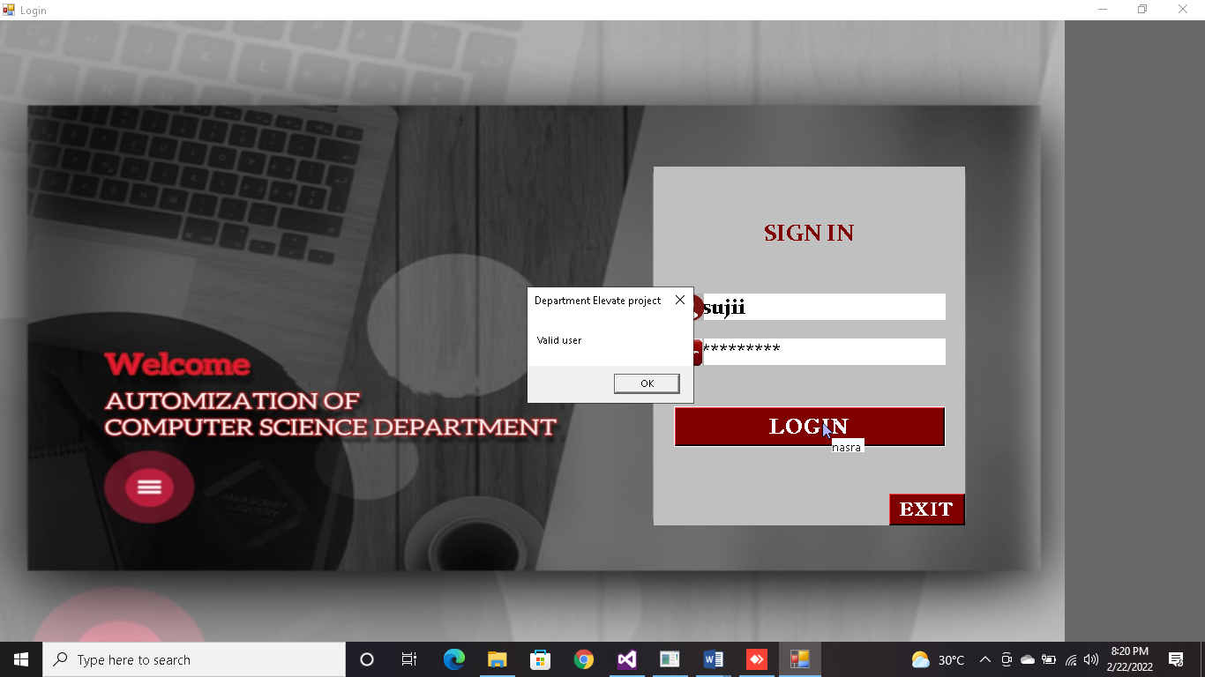**1.LOGIN**

**2. HOMEPAGE**

**REGISTRATION**

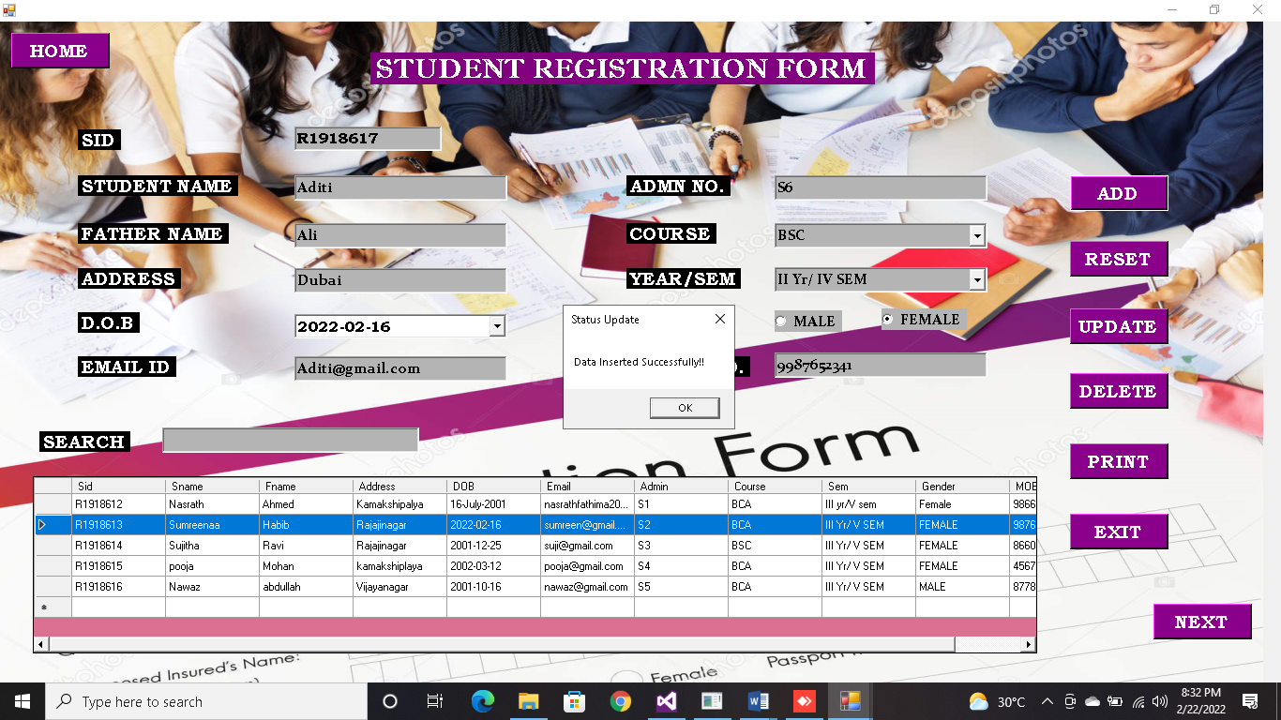 **STUDENT**

**FACULTY**

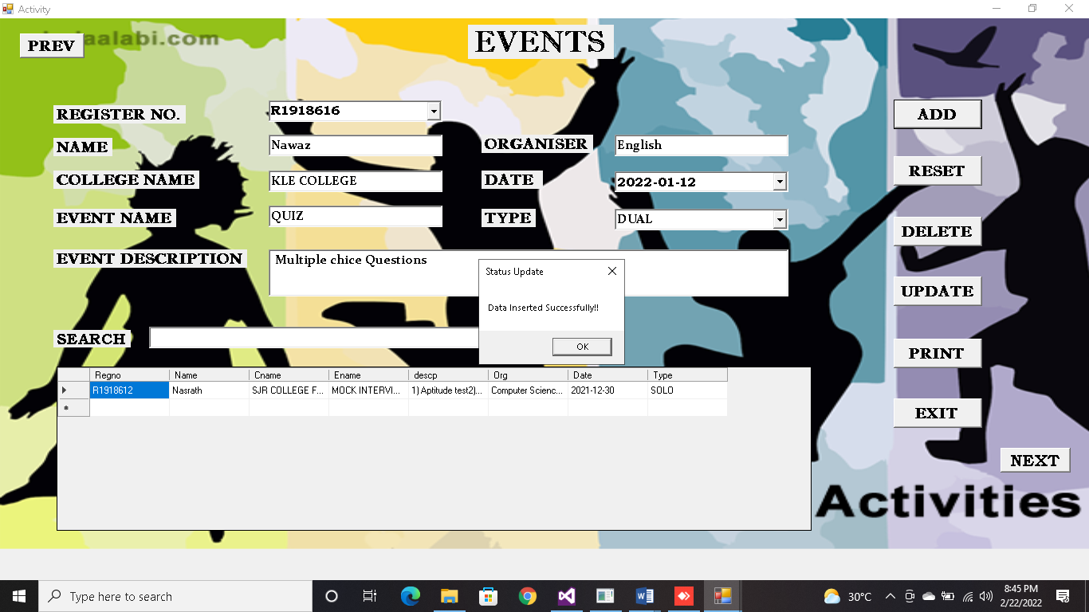 **ACTIVITY**

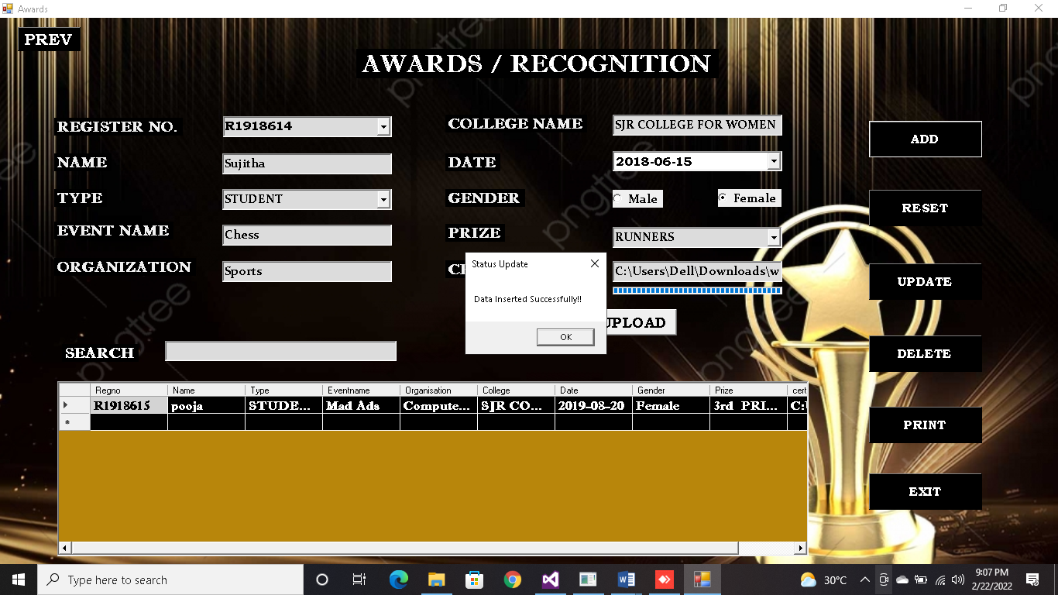**AWARDS**

**REPORT:**

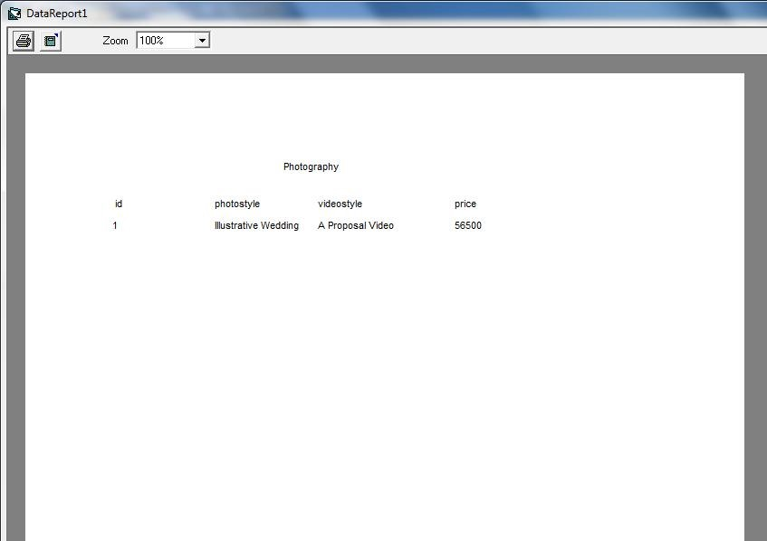

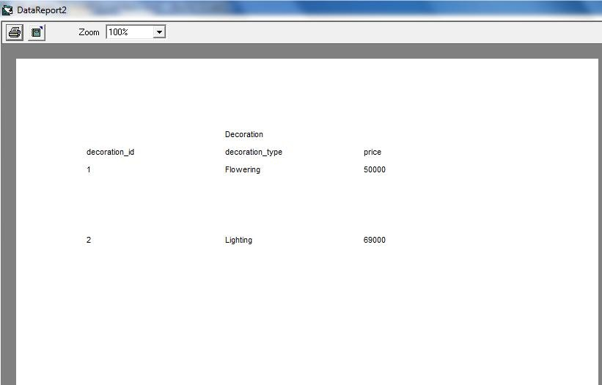

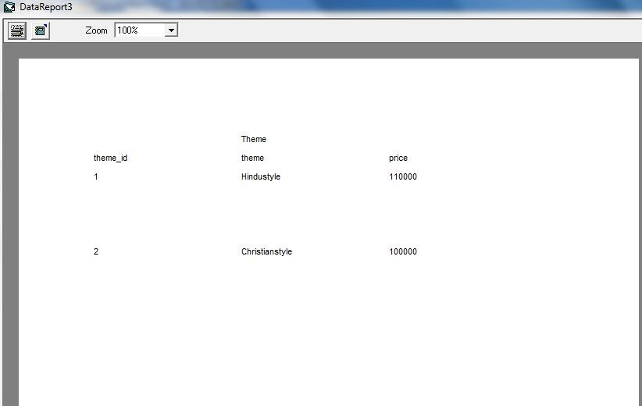

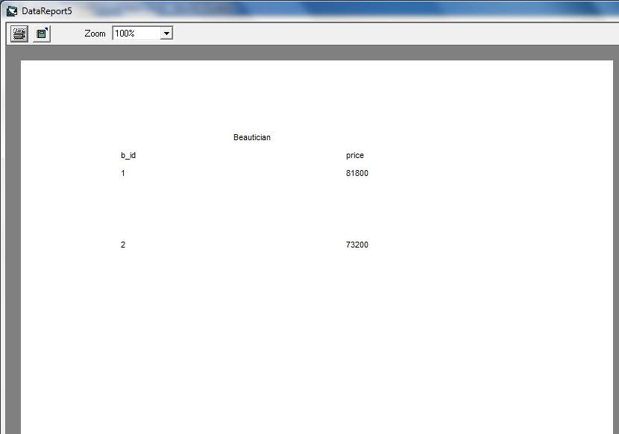

**CHAPTER – 6**

**CONCLUSION**

**CONCLUSION:**

The “AUTOMIZATION OFCOMPUTER SCIENCE DEPARTMENT” has been developed to overcome the problems faced by the existing system. The developed system was found to work out the operations efficiently. Objective of the system has been achieved easily track the information of students and faculty. The main goal of the software is to build a good management tool for the organization. The main purpose of this software is to reduce the time taken through manual system order to maintain all the record.

**The Goals That Have Achieved Are:**

* Ensuring process tie and increasing throughput.
* Simplifies the operation.
* Avoids manual work.
* Reduced data redundancy and inconsistency.
* User friendly input screen to enter data.

A consistent and efficient system has been successfully developed using Visual Basic.Net and MYSQL in windows 10. The system is very flexible and user friendly so that further changes can be incorporated into the system easily.

**FUTURE ENCHACMENTS:**

Booking with Accommodation facilities and other services can be included.

A specialized software’s and efficient process can be introduced.

SMS and alert message make the system more interactive.

**References:**

Visual Basic.Net Programming **BLACK BOOK** (Steven Holzner)

DBMS author (Srikanth)