A Project Report

On

Workers Hub

Submitted in partial fulfilment of the requirement of

Project-VIII (BCA544CO)

Of

Bachelor of Computer Applications

**Submitted to**



Purbanchal University

Biratnagar, Nepal

**Submitted By**

Anoj Gosai(381912)

Sujeen Rajak (381938)

Susmita Dhital (381940)

**KANTIPUR CITY COLLEGE**

Putalisadak, Kathmandu

July 22, 2021

A Project Report

On

Workers Hub

Submitted in partial fulfilment of the requirement of

Project-VIII (BCA544CO)

Of

Bachelor of Computer Application

**Submitted to**

Purbanchal University

**Submitted By**

Anoj Gosai (381912)

Sujeen Rajak (381938)

Susmita Dhital (381940)

**Project Supervisor**

**Ashim KC**

**Program Coordinate, BCA/BIT**

**KANTIPUR CITY COLLEGE**

Putalisadak, Kathmandu

July 22, 2021

# Topic Approval Sheet

It is hereby informed that the topic selected by Anoj Gosai (381912) Sujeen Rajak (381938) and Susmita Dhital (381940) of Bachelors of Computer Application VIII semester for their semester project has been found suitable and as per the credit assigned by Purbanchal University (PU), Biratnagar, Nepal.

The Project Committee has approved the following topic and supervisor for the above-mentioned students.

Topic Approved: Workers Hub

_ _ _ _ _ _ _ _

**Ashim Kc**

Program Coordinator, BCA/BIT

_ _ _ _ _ _ _ _

Asst. Professor

**Saroj Pandey**

**D.HOD, Department of IT**

# Certificate from Supervisor

This is to certify that the project entitled “**Workers Hub**” submitted by Anoj Gosai (381912) Sujeen Rajak (381938) and Susmita Dhital (381940) to the Department of Information Technology, School of Science and Technology at Kantipur City College, Kathmandu, Nepal towards the requirement for BCA544CO of is an original work carried out by them under my supervision and guidance.

Signature: ……………………

Ashim Kc

Program Coordinator,

Department of Information Technology

Kantipur City College

(Project Supervisor)

**Place**: Kantipur City College, Putalisadak, Kathmandu.

**Date**: July 22, 2021

# Acknowledgements

The project members would like to express the deepest appreciations to our head of department, professor Raju Kattel;, who has the attitude and the substances of genius: he continually and convincingly conveyed a spirit of adventure in regard of research and scholarship, and an excitement in regard to guiding to study and prepared this project. Without his guidance’s and persistence help this project would not have been possible.

The project members would like to thank our class members, Professor Bikash Neupane whose work demonstrated to the project members about the meaning and importance supported by engagement in competitive research and use of modern technology should always be addressed provide a frame work for the project members. In addition, the project members also thank instructor Saroj Pandey of Kantipur City College who introduced the project members to Computer Application and whose enthusiasm for the “underlying characteristics of software development” had lasting effect.

The project members thank the University of Purbanchal press for permission to include format of the project.

The project members would like to express sincere gratitude to the selection committee for considering correct subject for the project.

# Abstract

This website creates a platform for the workers where they can showcase their experience and skills. Any hiring manager who is willing to hire new workers according to their requirements of their work can view workers profiles and can choose the right workers.

All the workers within Nepal can create their account and fill in the necessary information that can attract the right manager to hire them. Workers can input the necessary information that will make them hireable.

Both the hiring manager and workers can create their own separate account and make necessary changes as per their needs. If you are looking for a worker for your project then you can create a hiring manager account while if you are a worker looking for job then you can create a worker account.

Table of Contents

Topic Approval Sheet ii

Certificate from Supervisor iii

Acknowledgements i

Abstract ii

List of Figures v

List of Tables v

Abbreviations vii

CHAPTER 1: INTRODUCTION 1

1.1 Introduction 1

1.2 Problem Statement 1

1.3 Objectives 2

1.4 Significance 2

1.5 Features 2

1.6 Assignment of Roles and Responsibilities 3

1.7 Organizations of the document 4

CHAPTER 2: LITERATURE REVIEW 6

2.1 Overview of existing systems 6

2.1.1 **Sriyog.com** 6

2.1.2 **Kathmandujobs.com** 7

CHAPTER 3: SYSTEM ANALYSIS 8

3.1 System Development Model 8

3.2 Requirement Specification 8

3.2.1 Functional Requirements 8

3.2.2 Non-functional Requirements 8

3.3 Feasibility Study 9

3.3.1 Technical Feasibility 9

3.3.2 Economic Feasibility 9

3.3.3. Resource and Time Feasibility 10

CHAPTER 4: SYSTEM DESIGN 11

4.1 System Architecture 11

4.2 Context Diagram and Data Flow Diagram 11

11

4.2.1 Context Diagram 11

4.2.2 DFD Level 0 Diagram 12

4.2.3 DFD Level 1 Diagram 13

4.3 Use Case Diagram 13

4.4 Sequence Diagram 14

4.4.1 User Login Sequence Diagram 14

4.5 Activity Diagram 15

4.6 Database Design 15

4.6.1 Entity Relationship Diagram 15

4.6.2 Relational Data Structure 15

4.6.3 Data Dictionary 16

CHAPTER 5: SYSTEM DEVELOPMENT AND IMPLEMENTATION 17

5.1 Programming platform and implementation (Tools and technologies) 17

5.2 Operating Environment 17

5.3 Testing and Debugging 18

5.4 Implementation and Result Analysis 22

CHAPTER 6: CONCLUSION AND FUTURE ENHANCEMENT 24

6.1 Conclusions 24

6.2 Limitation 24

6.3 Future Enhancement 24

REFERENCES 25

Appendixes 25

Appendix 1: Screenshots 25

Appendix 2: Project Completion Gantt chart 26

Gantt chart: 26

# List of Figures

|  |  |  |
| --- | --- | --- |
| **Table no:** | **Table name:** | **Page no:** |
| 1 | System Diagram | 11 |
| 2 | Context Diagram | 11 |
| 3 | DFD Level 1 Diagram | 12 |
| 5 | Use Case Diagram | 13 |
| 6 | Sequence Diagram | 14 |
| 7 | Activity Diagram | 15 |
| 9 | ER Diagram | 16 |
| 10 | Relational Diagram | 17 |
| 11 | Gantt Chart | 33 |

# 

Table no. 1: List of Figures

# List of Tables

|  |  |  |
| --- | --- | --- |
| **Table no:** | **Table name:** | **Page no:** |
| 1 | List of Figures | v |
| 2 | List of Tables | vi |
| 3 | Abbreviation | vii |
| 4 | Roles & Responsibility | 3 |
| 5 | Organization of Document | 4,5 |

Table no. 2: List of Tables

# Abbreviations

|  |  |
| --- | --- |
| **Abbreviation** | **Full Form** |
| HTML | Hyper Text Mark-Up Language |
| SQL | Structure Query Language |
| SSMS | SQL Server Management Studio |
| ASP | Active Server page |
| GUI | Graphical User Interface |
| ER | Entity Relationship |
| DFD | Data Flow Diagram |
| CV | Curriculum Vitae |

Table no. 3: Abbreviations

# CHAPTER 1: INTRODUCTION

## 1.1 Introduction

The development of technology has made our life easier and comfortable. We can do our work online without stepping outside of the home. Following the same trend, we have developed a web app that helps citizens to find the workers as per their requirements as well as to the skilled workers to find the job according to their skills.

Workers Hub is a web based application, developed to maintain the details of employees working in any organization. The Workers Hub has been developed to utilize the skills and knowledge of the skilled resources. It maintains the information about the personal and official details of the workers.

Workers hub is a digital platform that provides opportunities for the local job seekers to search for a job so that they can make use of their skills and knowledge. It is a versatile platform developed to ease the task of seeking a job and hiring a professional, and the best part of it is, that there are no middle men involved.

## 1.2 Problem Statement

We have researched other websites that are simliar to ours and found a major issue. The existing system does not provide any information related to their achievements such as certificates or any other related stuffs which will may create the trust issues in the hiring manager before reaching out to the worker.

So in order to avoid such issues and delay before the hiring process we have made the achievement information a must fill information. This will help the workers to back up every information he/she filled in his/her profile.

The other feature that we came up with is that the information related with the availability of the worker or not. This will allow the hiring manager to easily choose the right candidate who is actually available for the given time.

## 1.3 Objectives

The objectives of our project are listed below:

* To provide platform for clients to showcase their skillset.
* To provide the platform for hiring manager to search for the right candidates that suites their job requirement.

## 1.4 Significance

The significances of our project are listed below:

* Hiring managers can easily get the necessary information about the workers.
* Hiring manager can select the right candidate from the wide variety of candidates.
* Workers can fill in the hire centric information only.
* Hiring manager can select the suitable workers according to their profile ratings.

## 1.5 Features

Features of this website include the following:

* Manage the CV of the workers
* User can upload their photo.
* The system allows users to edit their profile, change password.
* Login system to provide user’s data security.
* Profiles of the users can be rated.
* Account can be deactivated and activated as per user’s will.
* Hire workers in one click.

## 1.6 Assignment of Roles and Responsibilities

|  |  |  |
| --- | --- | --- |
| **S.N** | **Project Member** | **Roles & Responsibilities** |
| 1 | Anoj Gosai | * Leader * UI/UX design * Documentation * Research * Testing and debugging * Planning |
| 2 | Sujin Rajak | * Member * Project Organization & management * Business logic and back-end programming * Core Programming |
| 2 | Susmita Dhital | * Member * Research * Planning * Documentation |

Table no. 4: Roles & Responsibility

## 1.7 Organizations of the document

|  |  |  |
| --- | --- | --- |
| Chapter | Heading | Contents |
| Chapter 1 | Introductions | * 1. Introduction   2. Problem Statement   3. Objectives   4. Significance   5. Features   6. Assignment of roles and   Responsibilities |
| Chapter 2 | Literature Review | 2.1 Overview of existing system |
| Chapter 3 | System Analysis | 3.1 System Development Model  3.2 Requirement Specification  3.3 Feasibility Study |
| Chapter 4 | System Design | 4.1 System Architecture  4.2 Context and Data flow diagram  4.3 Use-Case diagram  4.4 Sequence diagram  4.5 Activity diagram  4.6 Database design |
| Chapter 5 | System development and implementation | 5.1 Programming platform and implementation, Tools and technologies  5.2 Operating Environment  5.3 Testing and debugging  5.3 Implementation and Result Analysis |
| Chapter 6 | Conclusion and Future Enhancement | 6.1 Conclusion  6.2 Limitation  6.3 Future Enhancements |

Table no. 5: Organization of the document

# CHAPTER 2: LITERATURE REVIEW

## 2.1 Overview of existing systems

### 2.1.1 Sriyog.com

#### 2.1.1.1 Introduction

Sriyog.com focuses on creating employment opportunities, consulting, and, training as well as to provide professionals of several fields to various users around the nation through a digital platform.

#### 2.1.1.2 Pros

1. Sriyog.com assures information security.
2. Reduces the paperwork.
3. There are multiple categories of work.
4. Helps to save time.
5. Easily locate the candidates that are within your reach.

#### 2.1.1.3 Cons

1. No chatting system in the application for enhancing better performance.
2. No certificates can be provided by the system.

### 2.1.2 Kathmandujobs.com

#### 2.1.2.1 Introduction

Kathmandu Jobs.com is an online job portal that aims to connect IT professionals to the right employment opportunities and foster their career advancement. Kathmandu Jobs are dedicated to facilitating hiring and recruitment processes through forming a pool of potential employers and talented employees to satisfy requirements on both sides.

#### 2.1.2.2 Pros

1. Kathmandu Jobs provides login facilities as an employee and employers.
2. Facility to promote the job
3. There are multiple categories of work.
4. Helps to save time.

#### 2.1.2.3 Cons

1. Involvement of middlemen.
2. Employers have to certain amount of money to hire employee.

### Rojgari

#### 2.1.3.1 Introduction

Rojgari, is a national employment agency working to empower job seekers with a wide range of employment related information and service, particularly jobs counselling, soft skills training, and employment match-making. Rojgari enlists and connects job seekers and employers in Nepal through an online portal www.rojgari.com.

#### 2.1.3.2 Pros

* Has the content in both English and in Devanagari language.
* Able to search for the jobs as well
* Has blogs on various topics
* Has a mobile app and also launches motivational programs across the nation.

#### 2.1.3.3 Cons

# CHAPTER 3: SYSTEM ANALYSIS

## 3.1 System Development Model

This software is developed following the concept of the incremental model. According to the nature of the system, an incremental model seemed to be an appropriate model. The requirements of the system are not clear and precise. This software is probably going to be big; it is simple to understand and we have many unknown and hidden requirements.

## 3.2 Requirement Specification

### 3.2.1 Functional Requirements

* + The system must have a log-in system.
  + Hiring manager should be able to search the workers.
  + The system must enable users to add, edit and delete their profile.

### 3.2.2 Non-functional Requirements

* Smooth transitions and proper layout must be implemented in order to make it simple and attractive.
* The system should have good security measures for protecting credentials of registered users.
* The system should provide robust authentication.
* The system should not be heavy on browser.

## 3.3 Feasibility Study

Various factors which dictate whether the project can be performed successfully. It also determines whether those proposed requirements and solutions are feasible in software or system.

### 3.3.1 Technical Feasibility

Workers Hub is an online work searching site where people who falls in this category can visit this site. The main technologies associated with this project are HTML, CSS, JavaScript, and Bootstrap, Razor pages, SQL Server, ASP.Net Core and C #.Net. Most of these tools are freely available and technical skills that are required are manageable. While in development phase website will be hosted locally and tested and later it will be hosted in a free and paid web hosting service gradually. Thus, it’s clear that it is technically feasible.

### 3.3.2 Economic Feasibility

Being a web based application; Workers Hub will have high hosting cost. Since the system consists of multimedia contents and data transfer, bandwidth required for the operation will be high. This system will follow freeware software standards. Bugs fixes and maintaining cost will have high cost too. It will also allow for advertisement to gain revenue. Thus, it is clear that system is economically feasible.

### 

### 3.3.3. Resource and Time Feasibility

Resources required for Workers Hub project includes: programming device (laptop), hosting space (some of which are freely available), programming tools (freely available), and programming individuals. Time required for this project is about 45 hours of work which is manageable. Thus, it has the required resource and time feasibility.

# CHAPTER 4: SYSTEM DESIGN

## 4.1 System Architecture

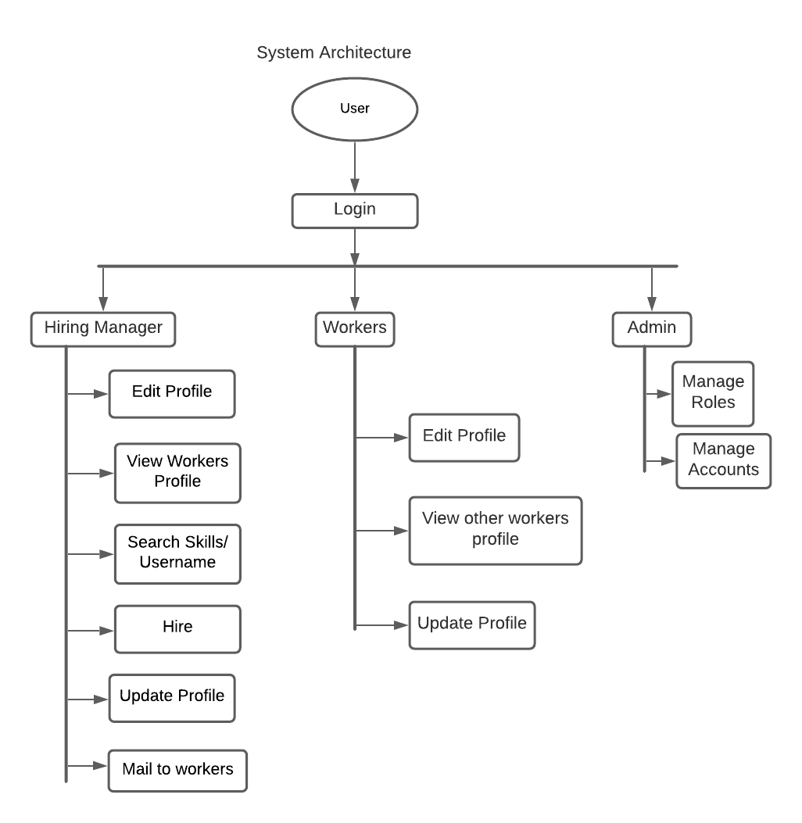

Fig 1: System Architecture

## 4.2 Context Diagram and Data Flow Diagram

### Context Diagram

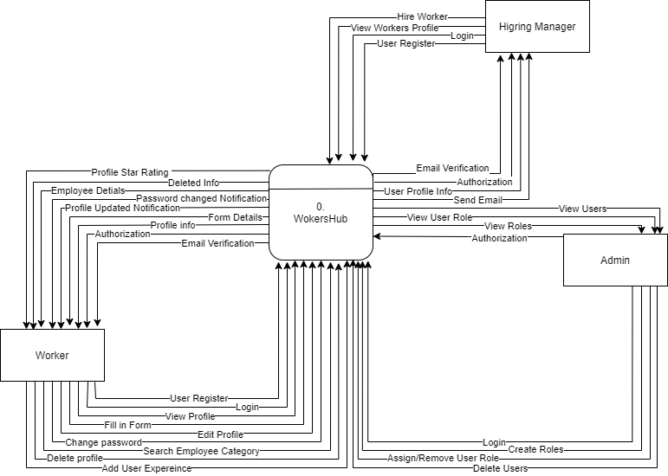

Fig 2: DFD Level 0 Diagram

### DFD Level 1 diagram

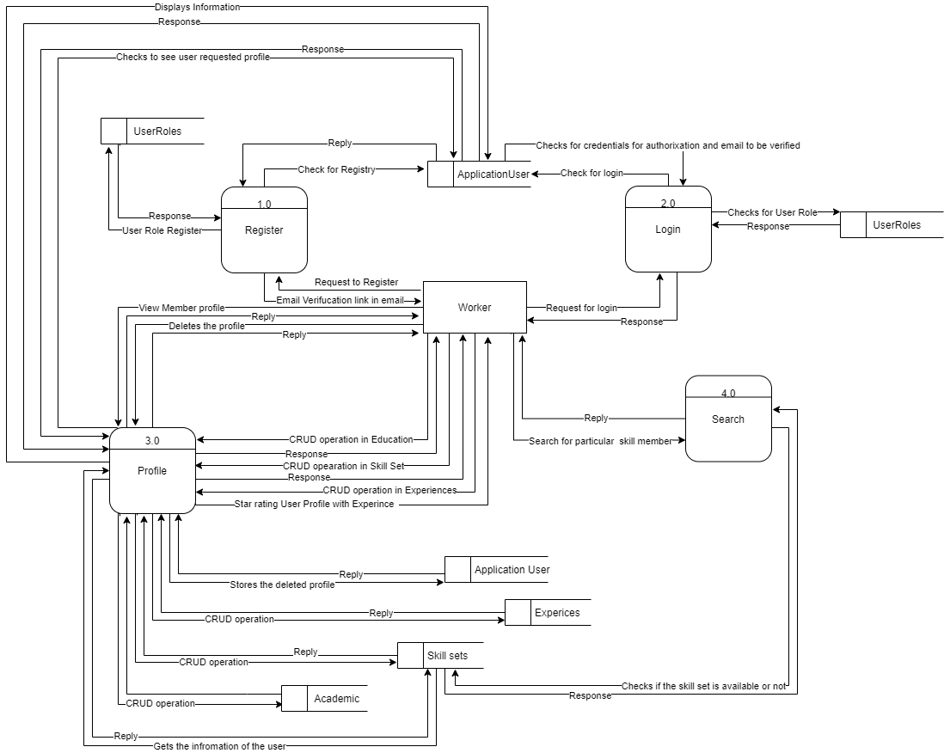

Fig 3: DFD Level 1 Diagram of Worker

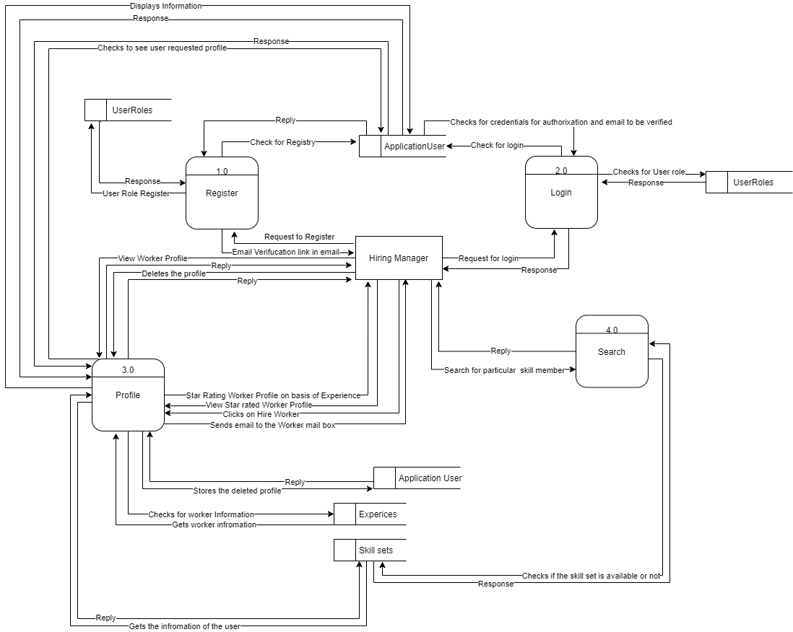

Fig 4: DFD Level 1 Diagram of Hiring Manager

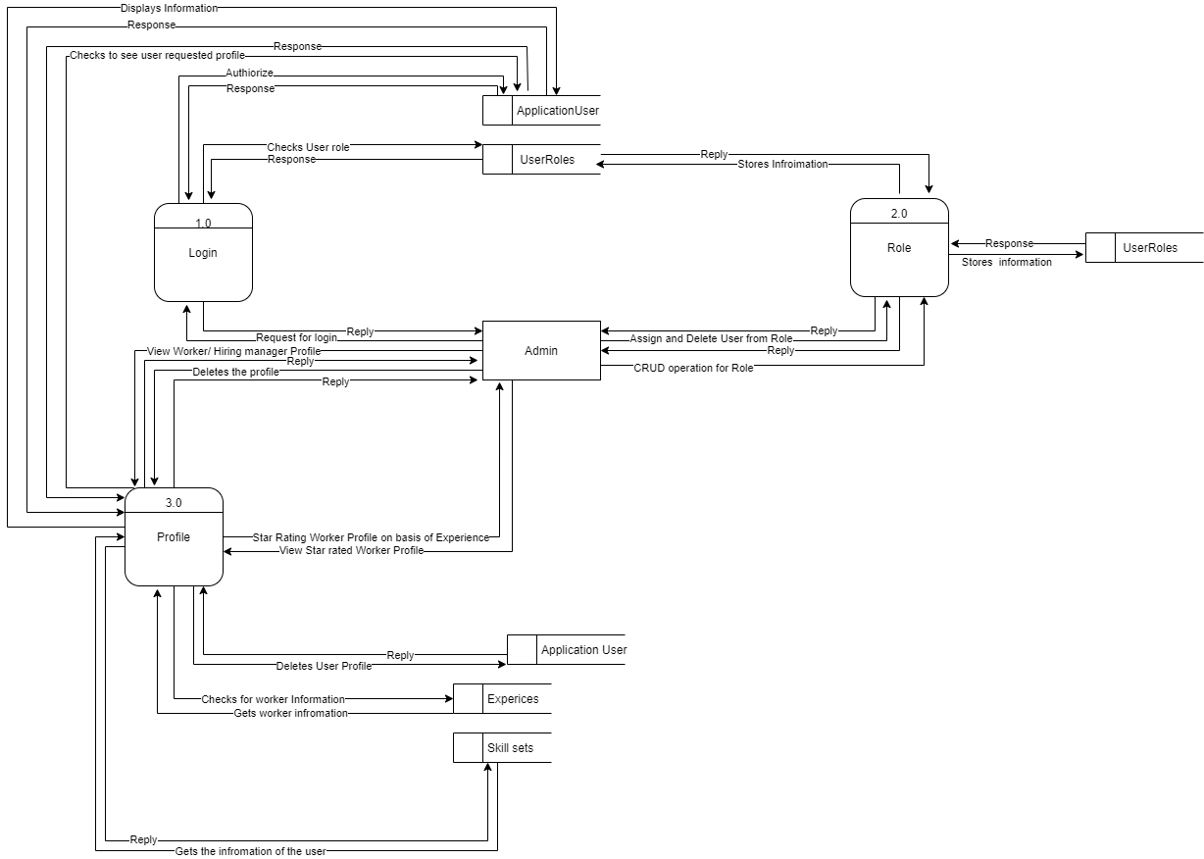

Fig 5: DFD Level 1 Diagram of Admin

## 4.3 Use Case Diagram

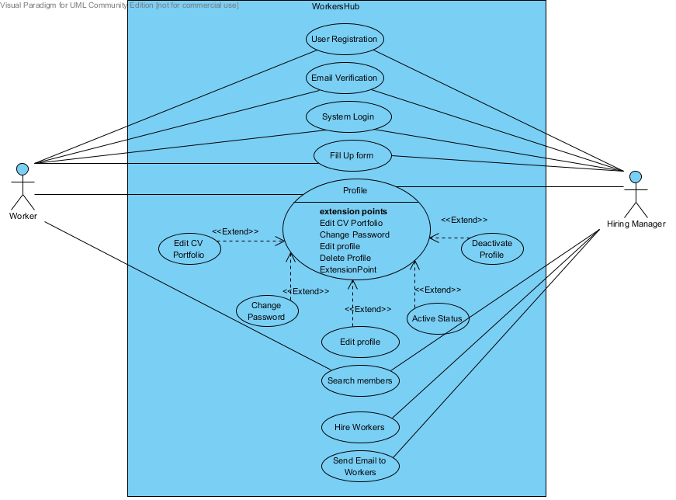

Fig 6: Use Case Diagram of Worker and Hiring manager

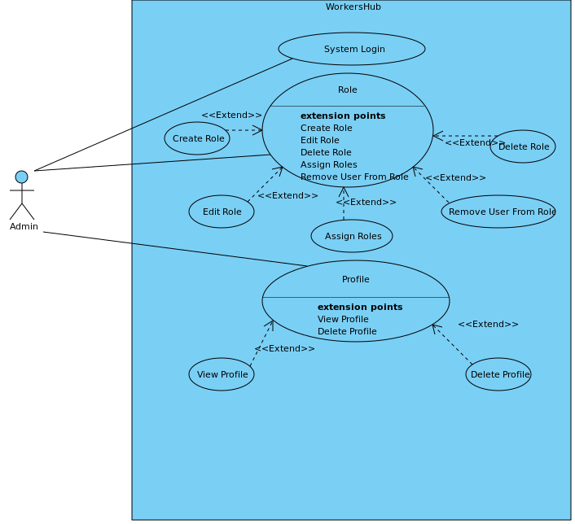

Fig 7: Use case diagram of Admin

## 4.4 Sequence Diagram

### 4.4.1 User Login Sequence Diagram

Member

Fig 8. Member Login Sequence Diagram

GUI of Home page

:SessionManager

User info

Login status

1.user

Boolean(yes/no)

Verifylogin (userId/emailUsers,password)

Getuser(uidUsers/emailUsers)

(uidUsers/emailUsers,password)

## 4.5 Activity Diagram

### 4.5.1 Activity diagram of Admin

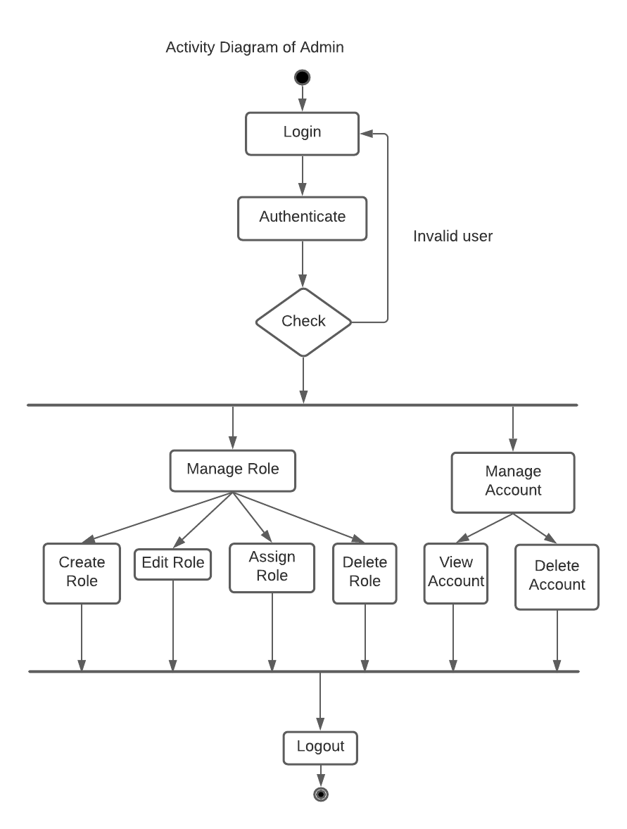

Fig 7: Activity diagram of Admin

### 4.5.2 Activity diagram of worker

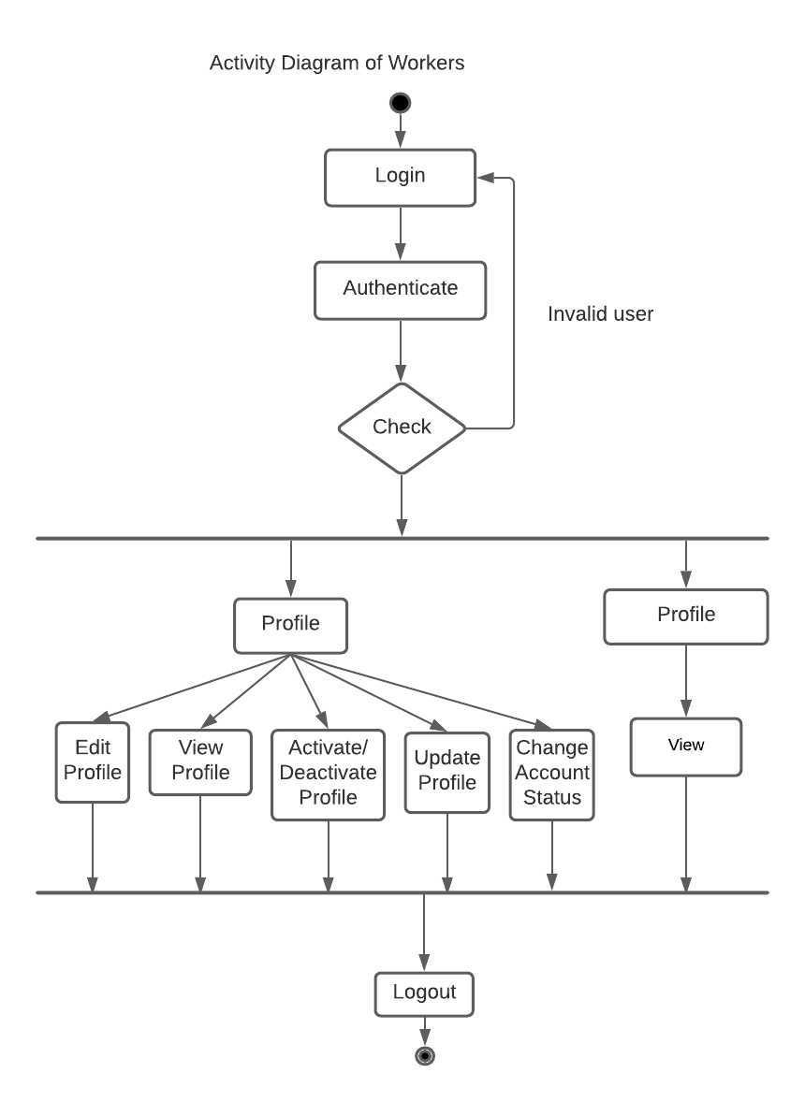

Fig 8: Activity diagram of Worker

### 4.5.3 Activity diagram for hiring manager

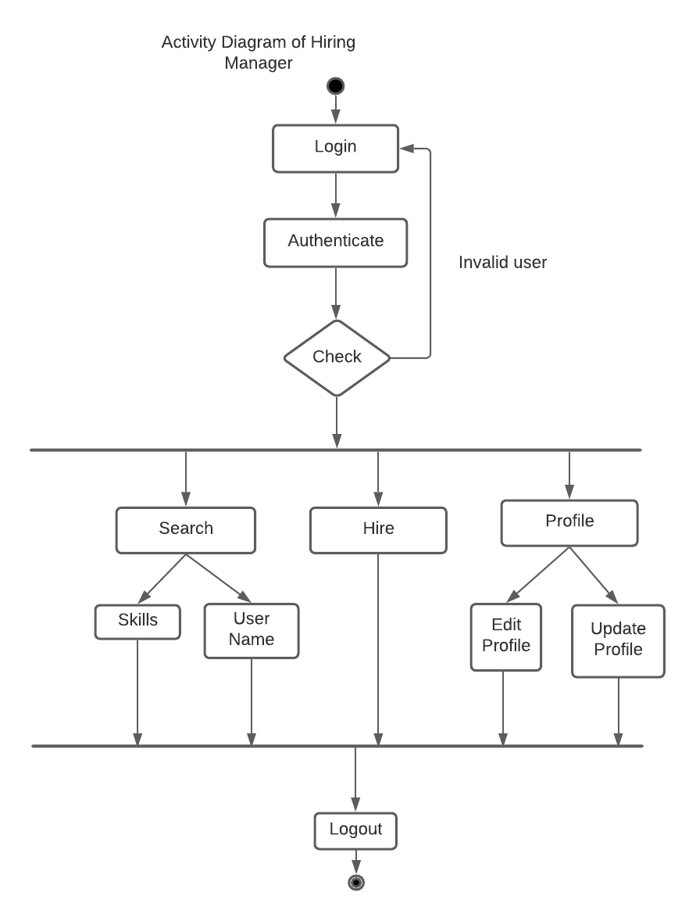

Fig 9: Activity diagram of hiring manager

## 4.6 Database Design

### 4.6.1 Entity Relationship Diagram

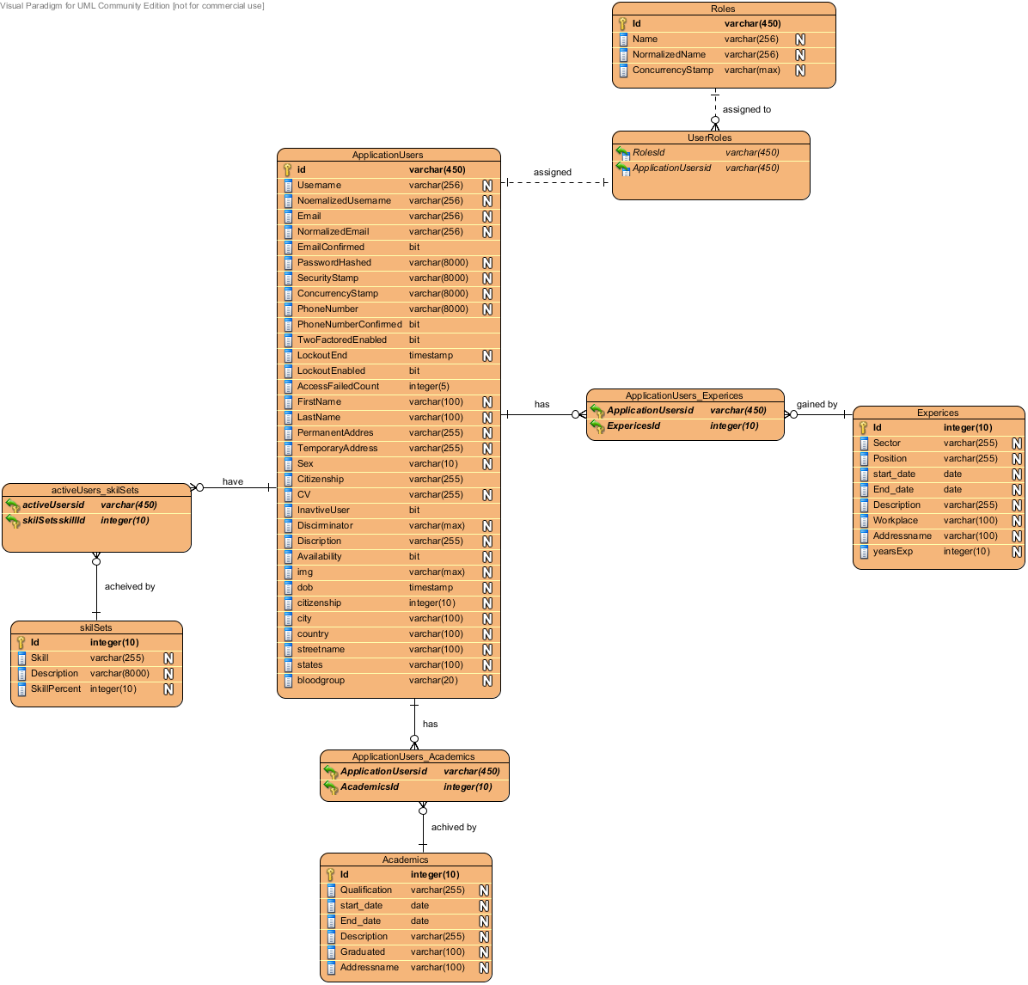

Fig 10: Entity Relational diagram

### 4.6.2 Relational Data Structure

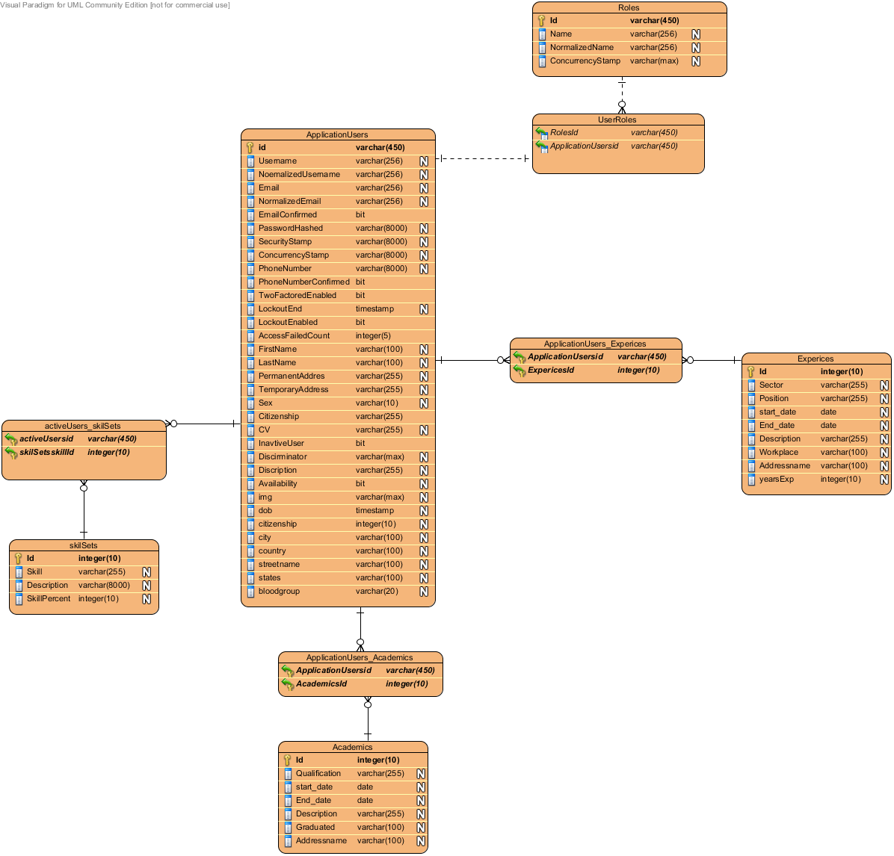

Fig 11: Relational Data Structure

### 4.6.3 Data Dictionary

|  |  |  |  |  |
| --- | --- | --- | --- | --- |
| S.N | Table name | Attribute | Type | Null |
| 1 | Application users | Id  Username  NormalizedUsername  Email  NormalizedEmail  Email confirmed  PasswordHashed  SecurityStamp  ConcurrencyStamp  PhoneNumber  PhoneNumberConfirmed  TwoFactoredEnabled  LockoutEnd  LockoutEnabled  AccessFailedCount  FirstName  LastName  PermanentAddress  TemporaryAddress  Sex  Citizenship  CV InactiveUser  Discriminator  Description  Availability  Img  Dob  Citizenship  City country  Streetname  States  bloodgroup | Varchar(256)  Varchar(256)  Varchar(256)  Varchar(256)  Varchar(256)  Bit  Varchar(8000)  Varchar(8000)  Varchar(8000)  Varchar(8000)  Bit  Bit  Timestamp  Bit  Integer(5)  Varchar(100)  Varchar(100)  Varchar(255)  Varchar(255)  Varchar(10)  Varchar(255)  Varchar(255)  Bit  Varchar(max)  Varchar(255)  Bit  Varchar(max)  Timestamp  Integer(10)  Varchar(100)  Varchar(100)  Varchar(100)  Varchar(100) | Pk not null  Not null  Not null  Not null  Not null  Not null  Not null  Not null  Not null  Not null  Not null  Not null  Not null  Not null  Not null  Not null  Not null  Not null  Not null  Not null  Not null  Not null  Not null  Not null  Not null  Not null  Not null  Not null  Not null  Not null  Not null  Not null |
| 2 | ActiveUsers_skillsets | activeUsersid  skillSetsSkillid | Varchar(450)  Integer(10) | Not null  Not null |
| 3 | SkillSets | Id  Skill  Description  SkillPercent | Integer(10)  Varchar(255)  Varchar(8000)  Integer(10) | Pk not null  Not null  Not null  Not null |
| 4 | Roles | Id  Name  normalizedName  concurrencyStamp | Varchar(450)  Varchar(256)  Varchar(256)  Varchar(max) | Pk not null  Not null  Not null  Not null |
| 5 | UserRoles | RolesId  ApplicationUsersId | Varchar(450)  Varchar(450) | Not null  Not null |
| 6 | ApplicationUsers_Experiences | ApplicationUsersId  ExperiencesId | Varchar(450)  Integer(10) | Not null  Not null |
| 7 | Experiences | Id  Sector  Position  Start_date  End_date  Description  Workplace  Addressname  yearsExp | Integer(10)  Varchar(255)  Varchar(255)  Date  Date  Varchar(255)  Varchar(100)  Varchar(100)  Integer(10) | Not null  Not null  Not null  Not null  Not null  Not null  Not null  Not null  Not null |
| 8 | ApplicationUsers_Academics | ApplicationUsersId  AcademicsId | Varchar(450)  Integer(10) | Not null  Not null |
| 9 | Academics | Id  Qualifications  Start_date  End_date  Description  Graduated  Addressname | Integer(10)  Varchar(255)  Date  Date  Varchar(255)  Varchar(100)  Varchar(100) | Not null  Not null  Not null  Not null  Not null  Not null  Not null |

Table 6: Data dictionary

# CHAPTER 5: SYSTEM DEVELOPMENT AND IMPLEMENTATION

## 5.1 Programming platform and implementation (Tools and technologies)

a. Front-End WEB DEVELOPMENT

* Mark-up Language-HTML
* Dynamic Programming Language-JavaScript
* jQuery
* Bootstrap
* Razor Pages
* Font awesome

b. Back-end web development

* C#.Net

c. Development tools: Visual Studio2019, SSMS

d. Interface: Web application

e. Software Architecture: MVC (Model View Controller)

f. Framework: ASP.NET core

g. Database: SQL Server

## 5.2 Operating Environment

1. Software Requirements:

* XAMPP (Localhost)
* Web browsers like chrome, Internet Explorer, Firefox

1. Hardware Specification:

* RAM: 2GB
* Processor: i3 or above
* Storage: 2GB

## 5.3 Testing and Debugging

Test 01: Home page testing

|  |  |
| --- | --- |
| Test case | Home page |
| Test objective | To check whether program runs or not |
| Test data | Running the program |
| Expected result | Main screen should display properly |
| Test result | Main screen appears correctly |
| Conclusion | Expected result matches actual result |

Table 7: Home Page Testing

Test 02: Login page testing

|  |  |
| --- | --- |
| Test case | Login |
| Test objective | To check whether login is successful |
| Test data | Entering username/email and password |
| Expected result | User should be logged into the system |
| Test result | User is logged in to the system |
| Conclusion | Expected result matches actual result |

Table 8: Login Page Testing

Test 03: To check whether the account will register or not

|  |  |
| --- | --- |
| Test case | Account register |
| Test objective | To check whether the user will be able to receive verification link in his/her email to register the account or not |
| Test data | Click on the register button |
| Expected result | User’s valid email should receive verification link |
| Test result | User’s valid email received the verification link |
| Conclusion | Expected result matches actual result |

Table 9: Account register testing

Test 04: To check if hire button works or not

|  |  |
| --- | --- |
| Test case | Check if hire button works or not |
| Test objective | To check whether worker receives email or not when hiring manager hires particular worker. |
| Test data | Click on the hire button |
| Expected result | Worker should receive email from the hiring manager |
| Test result | Worker received the email from the hiring manager. |
| Conclusion | Expected result matches actual result |

Table 10: Hire button test

Test 05: To check if search bar works or not

|  |  |
| --- | --- |
| Test case | Search skill or username in search bar. |
| Test objective | To check if result of searched keyword is displayed or not. |
| Test data | Keyword “Electrician” is searched. |
| Expected result | Profile of the workers with the Electrician skill should be displayed. |
| Test result | Profile of the workers with the Electrician skill is displayed. |
| Conclusion | Expected result matches actual result. |

Table 11: Search bar testing

Test 06: Profile updating test

|  |  |
| --- | --- |
| Test case | Profile updating |
| Test objective | To check whether profile is updated or not? |
| Test data | Profile update details |
| Expected result | Profile details should be shown in UI interface |
| Test result | Profile details was shown successfully |
| Conclusion | Expected result matches actual result |

Table 12: Profile Update Testing

## 5.4 Implementation and Result Analysis

Implementation is the stage where the theoretical design is turned into a working system. The system can be implemented only after thorough testing is done and if it is found to work according to the specification. The implementation phase comprises of several activities. The hardware and software requisition is carried out. Implementation of a computer system is by replacing a manual system. The problems encountered are game sounds movement sounds, coding section.

Pre implementation and Post implementation are the two major types in Implementation procedure, pre-implementation is the first stage after testing phase is completed under this stage some types of error may occur at the time of installation. The error is collected and analysed individually. In our project Workers Hub online in pre implementation phase we had faced database schema problems. Each and every step should be taken in rectification of errors, that software should be implemented thoroughly that we call as Post implementation.

A post-implementation review measures the performance against predefined requirements. A post-implementation review determines how well the system continues to meet performance specifications. A post-implementation review is an evaluation of a system in terms of the extent to which the system accomplished stated objectives and actual project costs exceed initial estimates.

In our project post implementation we implemented the error occurred in pre implementation i.e. database schema management and difficulties in making CV adding and posting smooth and working properly. Pre elimination phase is usually a review of major problems that need converting and those that surfaced during the implementation phase.

|  |  |  |
| --- | --- | --- |
| **S.no** | **Test objectives** | **Remarks** |
| 1 | To check whether the website runs or not | Successful |
| 2 | To check whether the signup button works or not | Successful |
| 3 | To check whether the login button works or not | Successful |
| 4 | To check whether the CURD operation can be performed or not. | Successful |
| 5 | To check whether the profile picture can be uploaded or not | Successful |
| 6 | To check whether the search bar is working or not. | Successful |

Table 13: Implementation and result analysis

# CHAPTER 6: CONCLUSION AND FUTURE ENHANCEMENT

## 6.1 Conclusions

The website “Workers Hub” has been successfully design and developed as the best and flexible website within the available resources. This website has been developed for the retired workers to find the suitable job related to their skillset.

## 6.2 Limitation

Due to theoretical and practical limitations, we were unable to implement the following points:

* There is no chatting system is implemented in this website.
* Location is not implemented.
* Admin and employees don’t have different login access.
* Admin and Employee have to sit on the same pc.
* No network connection.

## 6.3 Future Enhancement

We have the following points to be enhanced in the near future so that our system could be of some commercial and practical use:

* We will implement chat system in the future.
* We will work on GPS system for location.

# REFERENCES

# Appendixes

# Appendix 1: Screenshots

1. Home page

# Appendix 2: Project Completion Gantt chart

## Gantt chart:

|  |  |  |  |  |  |  |  |  |  |  |  |
| --- | --- | --- | --- | --- | --- | --- | --- | --- | --- | --- | --- |
| SN | Work | 1 | 2 | 3 | 4 | 5 | 6 | 7 | 8 | 9 | 10 |
| 1 | Research and Analysis |  |  |  |  |  |  |  |  |  |  |
| 2 | Requirement  Gathering |  |  |  |  |  |  |  |  |  |  |
| 3 | System Design |  |  |  |  |  |  |  |  |  |  |
| 4 | Coding |  |  |  |  |  |  |  |  |  |  |
| 5 | Testing |  |  |  |  |  |  |  |  |  |  |
| 6 | Documentation |  |  |  |  |  |  |  |  |  |  |

Fig 12: Gantt chart