***PROJECT TITLE :* FAKE NEWS DETECTION USING NATURAL LANGUAGE PROCESSING (NLP)**

***PROJECT DONE BY* : SUJI B**

***MAIL ID* : suji17062004@gmail.com**

***AIM OF THE PROJECT***

The aim of fake news detection using NLP is to develop robust and accurate automated systems that can:

1. ***Identify Misleading Information*** ***:*** Detect news articles or content that contains false or misleading information.

2. ***Prevent Dissemination:*** Prevent the spread of fake news by identifying it at an early stage.

3. ***Promote Trust:*** Build trust among news consumers by providing reliable and accurate information sources.

4. ***Protect Democracy:*** Safeguard democratic processes by reducing the impact of misinformation on public opinion and elections.

5. ***Provide Real-time Detection:*** Offer real-time detection and alerts to help users make informed decisions when consuming news.

6. ***Adapt to Emerging Trends:***  Stay up-to-date with evolving tactics used by fake news creators and adapt detection methods accordingly.

7. ***Balance Precision and Recall:*** Achieve a balance between high precision (minimizing false positives) and high recall (minimizing false negatives) to ensure effective detection without overly censoring legitimate content.

8. ***User Education:*** Educate users about the risks of fake news and provide tools to verify information.

9. ***Ethical Considerations:*** Address ethical concerns related to censorship and user privacy in the context of fake news detection.

10. ***Continuous Improvement:*** Continuously refine and improve detection algorithms and models based on user feedback and evolving techniques in NLP and machine learning.

***ABSTRACT***

Fake news is information that is false or misleading but is reported as news. The tendency for people to spread false information is influenced by human behaviour; research indicates that people are drawn to unexpected fresh events and information, which increases brain activity. Additionally, it was found that motivated reasoning helps spread incorrect information. This ultimately encourages individuals to repost or disseminate deceptive content, which is frequently identified by click-bait and attention-grabbing names. The proposed study uses machine learning and natural language processing approaches to identify false news specifically, false news items that come from unreliable sources.

The dataset used here is ISOT dataset which contains the Real and Fake news collected from various sources. Web scraping is used here to extract the text from news website to collect the present news and is added into the dataset. Data pre-processing, feature extraction is applied on the data. It is followed by dimensionality reduction and classification using models such as Rocchio classification, Bagging classifier, Gradient Boosting classifier and Passive Aggressive classifier. To choose the best functioning model with an accurate prediction for fake news, we compared a number of algorithms.

***INTRODUCTION***

In today's digital age, the rapid dissemination of information has brought about unprecedented access to news and content from various sources. While this accessibility empowers individuals to stay informed, it has also given rise to a pressing challenge – the proliferation of fake news. Fake news, often characterized by misinformation, disinformation, and misleading narratives, poses a substantial threat to the integrity of information ecosystems, public trust, and even democratic processes.

As fake news continues to infiltrate online platforms and social media networks, there is a growing urgency to develop effective mechanisms for its detection and mitigation. Natural Language Processing (NLP), a branch of artificial intelligence (AI) dedicated to the understanding and processing of human language, has emerged as a promising tool in the battle against fake news. This paper delves into the realm of "Fake News Detection Using Natural Language Processing," aiming to shed light on the methods and strategies employed to identify and combat this pervasive issue.

This introduction sets the stage for a comprehensive exploration of how NLP techniques are leveraged to detect fake news. It begins by highlighting the significance of the problem, emphasizing the consequences of fake news for individuals, society, and the media landscape. Subsequently, it outlines the key objectives of this research, the methodology employed, and the importance of achieving a balance between precision and recall in fake news detection.

***DESIGN*** 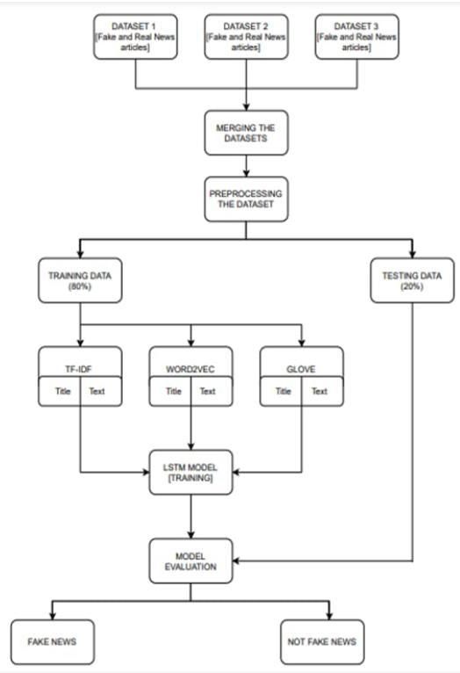

***PROBLEMS IN FAKE NEWS DETECTION***

Detecting fake news using Natural Language Processing (NLP) is a complex task that comes with several challenges and potential problems:

*1.* ***Data quality and Quantity:*** Reliable labeled data for training NLP models is crucial. However, there may be limited labeled data available, and it can be biased or outdated, making it challenging to train accurate models.

2. ***Context Understanding:***  NLP models may struggle to grasp the context and subtleties of language, leading to misinterpretation of sarcasm, irony, or nuanced language in news articles.

3. ***Evolving Language:***  Language is constantly evolving, and NLP models can become outdated quickly, especially if they are not updated regularly to understand new phrases, slang, or cultural references.

4. ***Multilingual Challenges:***  Fake news is not limited to a single language. Multilingual models can face difficulties in accurately analyzing and classifying misinformation in various languages.

5. ***Source Verification:***  Determining the credibility of news sources can be challenging. NLP models may not have access to external databases or real-time information to verify the authenticity of a source.

6. ***Adversarial Attacks:*** Malicious actors may intentionally craft fake news to deceive NLP models. They can employ techniques like adversarial perturbations to bypass detection systems.

7. ***Confirmation Bias:***  NLP models can inadvertently reinforce users' existing beliefs by providing them with information that aligns with their biases, making it harder to change their perspectives.

8. ***Privacy Concerns:*** Analyzing the content of news articles can raise privacy concerns, especially if personal information is inadvertently extracted or if users' data is used without consent.

Addressing these challenges in fake news detection using NLP often requires a combination of advanced machine learning techniques, continuous model updates, human oversight, and collaboration with domain experts and fact-checking organizations. It's an ongoing effort to improve the reliability and effectiveness of these systems**.**

**WAYS TO FIX THESE PROBLEMS**

There are several ways to improve fake news detection using Natural Language Processing (NLP). Here are some strategies:

1. ***Better Data Collection :*** Collect a diverse and comprehensive dataset of both real and fake news articles. This data should cover various topics and writing styles to make the model more robust.

2. ***Feature Engineering :*** Develop better features to represent text. Consider using word embeddings to capture semantic meaning and TF-IDF for keyword-based features.

3. ***Advanced Models :*** Utilize more advanced NLP models, such as BERT, GPT, or their variants, which are pre-trained on large text corpora. Fine-tune these models on your fake news dataset for better performance.

4. ***Ensemble Learning :*** Combine predictions from multiple models or algorithms. Ensemble methods, like Random Forests or stacking, can often improve accuracy.

5. ***Linguistic Analysis :*** Analyze linguistic patterns in the text, such as sentence structure, grammar, and sentiment. Fake news articles may exhibit different linguistic characteristics compared to real news.

6. ***Fact-Checking Integration :*** Incorporate fact-checking databases or services into your pipeline to verify claims made in news articles. Cross-reference information with trusted sources.

7. ***User and Source Reputation :*** Consider the reputation of the source and the user sharing the news. If a source is known for spreading misinformation, it could be a red flag. Similarly, user history can be indicative of credibility.

***WORKS TO BE DONE IN FUTURE***

One potential direction for a university undergraduate machine learning project involving fake news detection could be to explore the use of natural language processing (NLP) techniques to automatically identify fake news articles. This could involve training a machine learning model on a dataset of known fake and real news articles, and then using the model to make predictions on new, unseen articles. The model could be evaluated using various metrics, such as accuracy and precision, to determine its effectiveness at detecting fake news. Another potential direction for the project could be to focus on the development of an interactive system that allows users to input a news article and receive feedback on its credibility.

This could involve the use of natural language understanding (NLU) techniques to analyze the content of the article and provide users with a credibility score or other indicators of its veracity. The system could also incorporate other features, such as the ability to flag potentially fake news articles for further review by human experts. In the near future we could also take care of the visual and audio news so that the scope can be increased. The dataset bias should also be handled as models can be made inclined to a certain dataset. So next time we will also use different datasets in the near future

***CONCLUSION***

Fake news have increased in recent years and it has caused a lot of harm to the society. This research project aimed to develop a model using the techniques of NLP and ML to detect if a news article/headline is fake or not and identify which methods give better output. In this paper, we have presented six LSTM models and three different methods were used for feature extraction.

We have used different attributes like the title and text of the news to perform fake news detection. For future work we can work on larger dataset and also future research can be done on images , videos which can help in improving the models. The version of this template is V2. Most of the formatting instructions in this document have been compiled by Causal Productions from the IEEE LaTeX style files. Causal Productions offers both A4 templates and US Letter templates for LaTeX and Microsoft Word. The LaTeX templates depend on the official IEEEtran.cls and IEEEtran.bst files, whereas the Microsoft Word templates are self-contained. Causal Productions has used its best efforts to ensure that the templates have the same appearance.

Causal Productions permits the distribution and revision of these templates on the condition that Causal Productions is credited in the revised template as follows: “original version of this template was provided by courtesy of Causal Productions.