**VCS TASK**

**Task Description:**

Establish a new directory, populate it with script files, initiate an empty repository on GitHub, convert the local directory into a Git repository, and link it to GitHub for pushing the code into the repository.Perform merge, rebase, stash commands in following github repo.

**Techstacks needs to be used :**

* Shell (AWS, WSL, Vbox)
* Git (Gitbash)

STEPS:

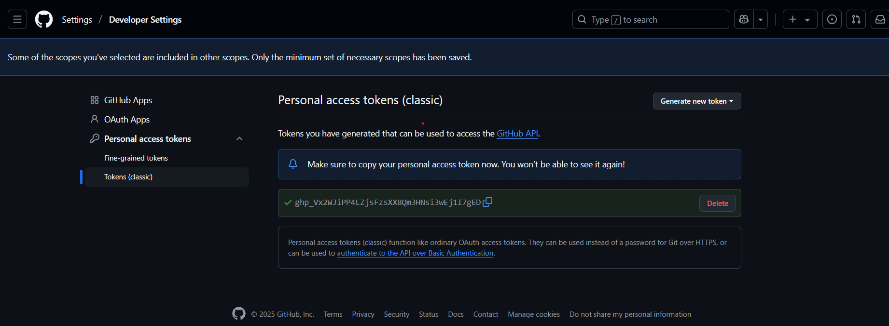

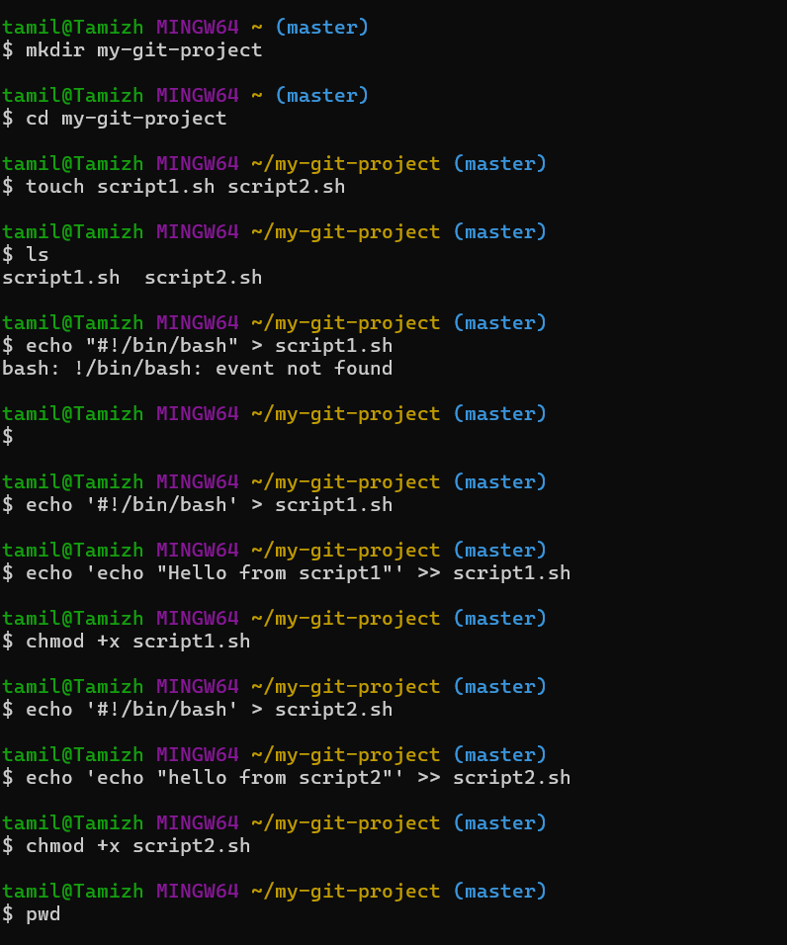

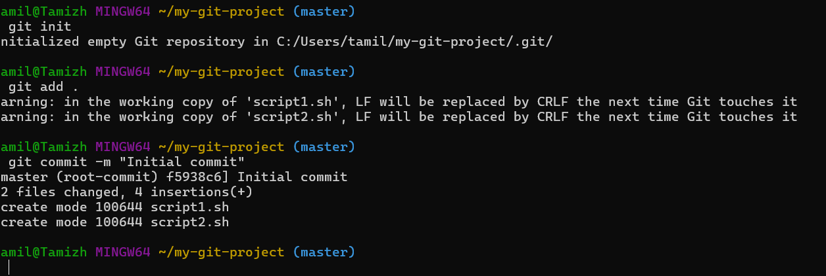

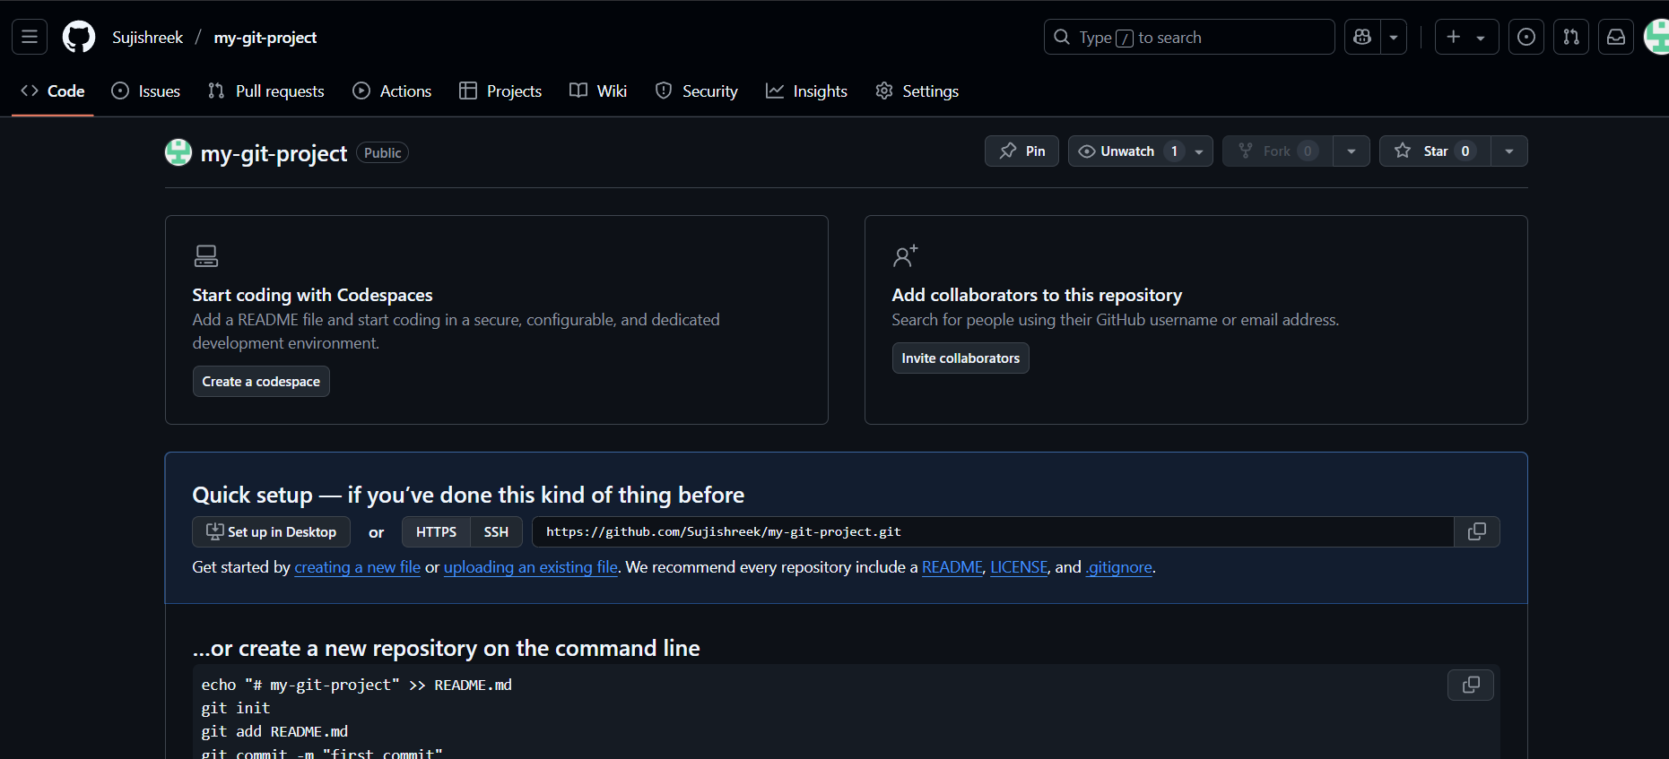

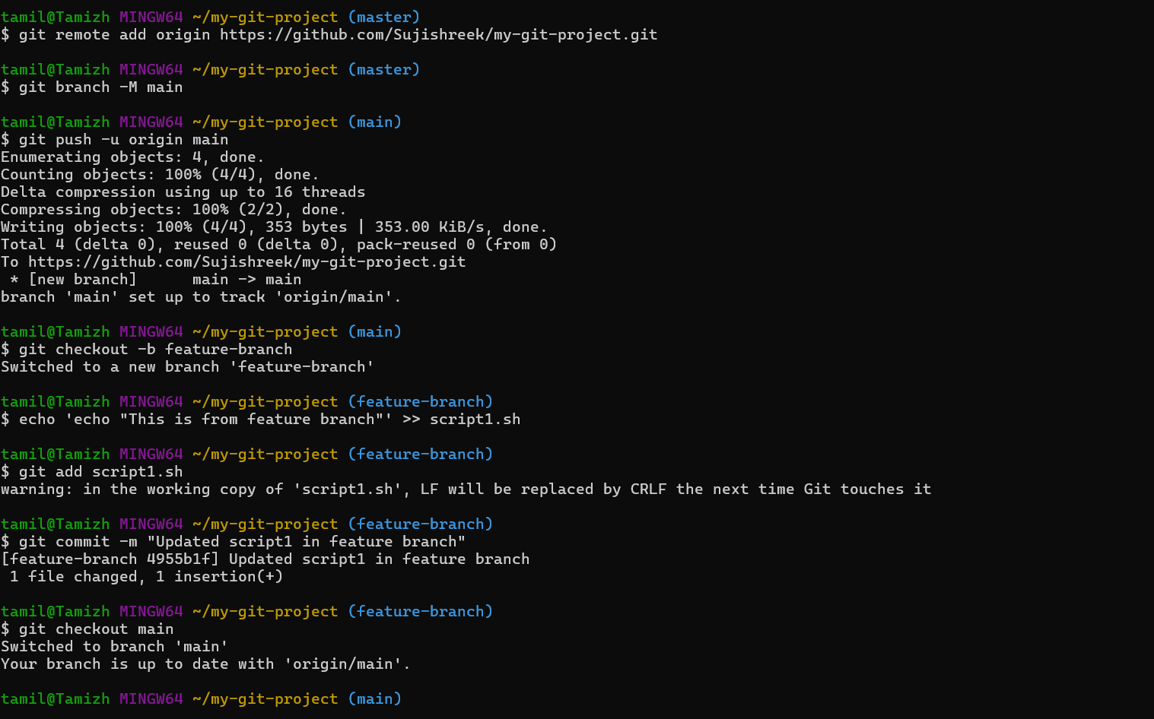

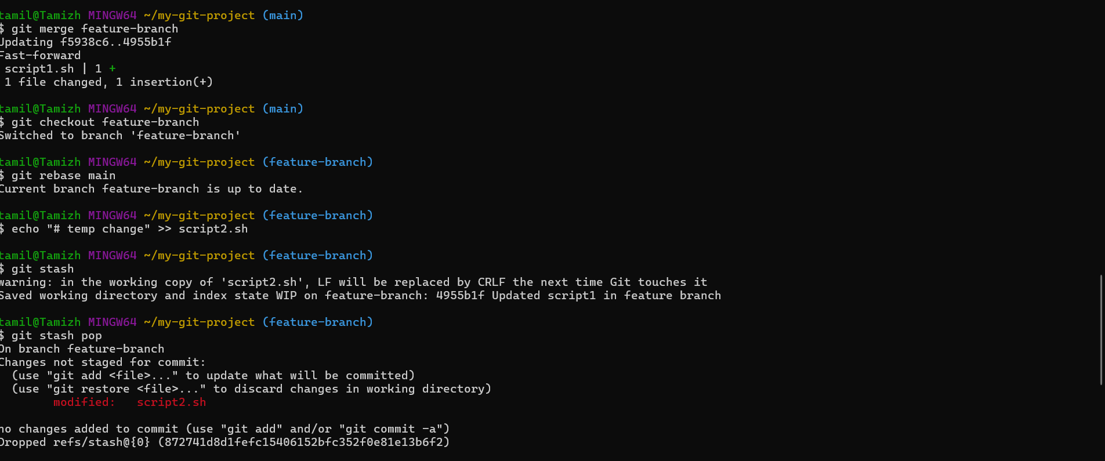

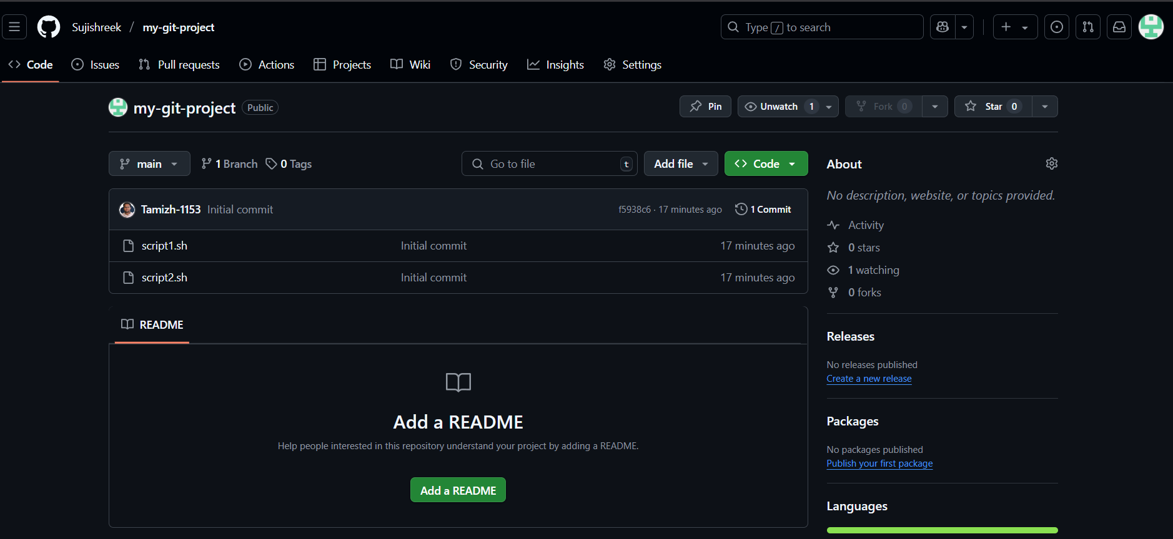

OVERALL COMMANDS:

