Cart_Controller :-

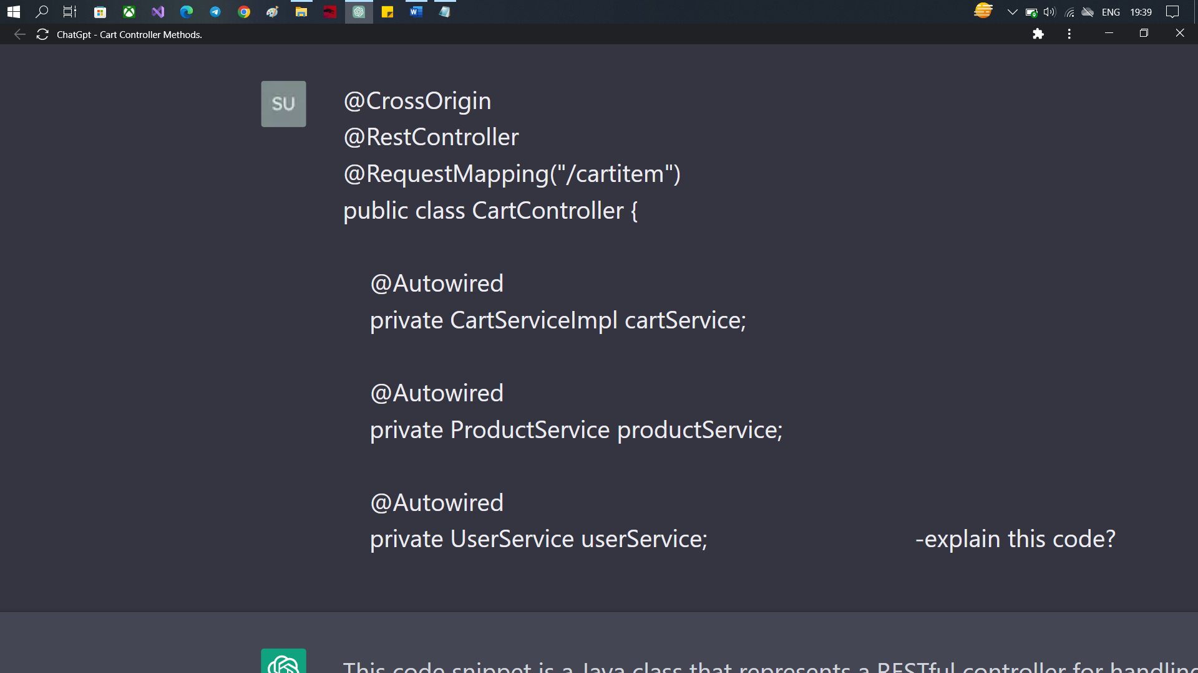

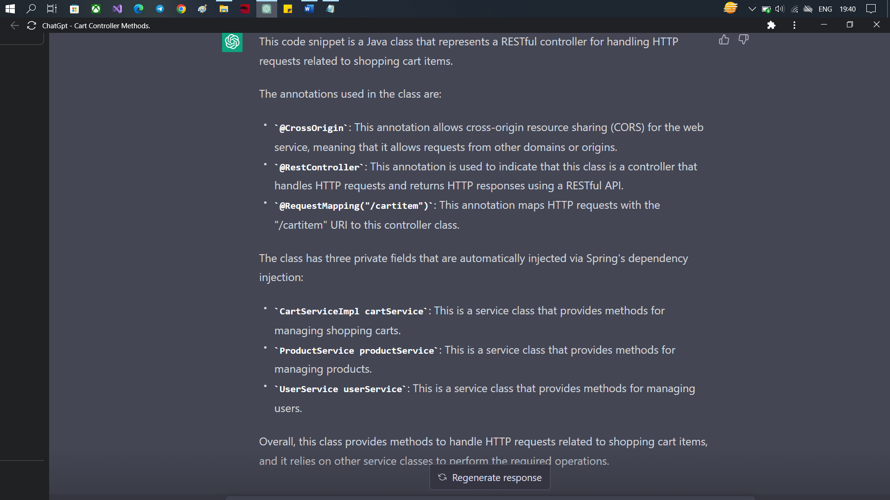

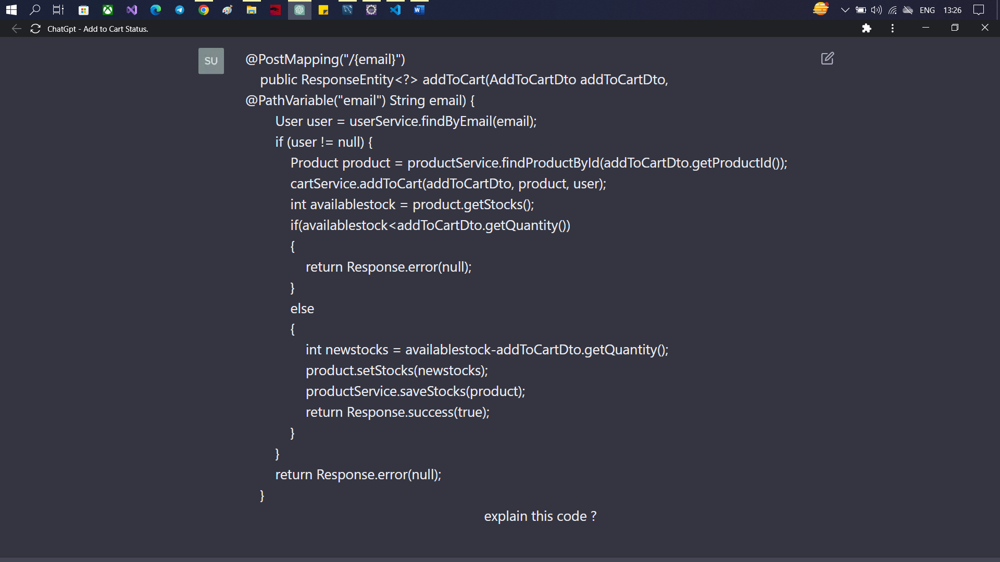

:-

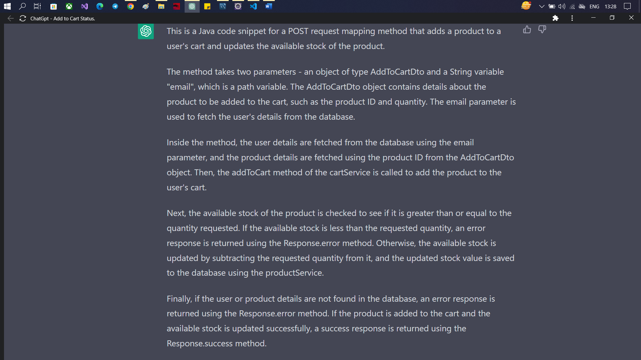

====================================================

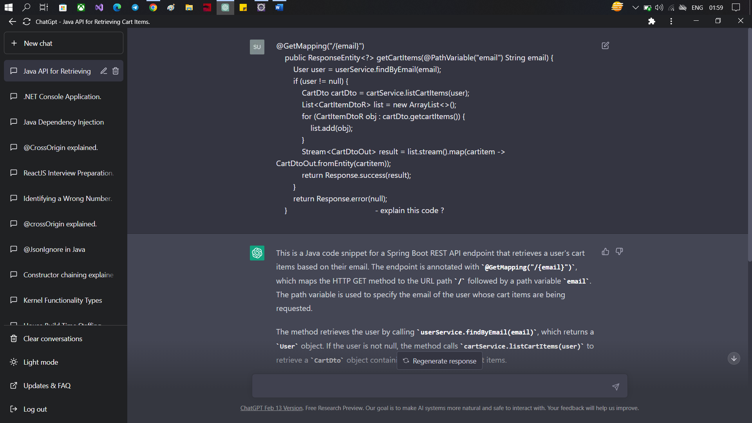

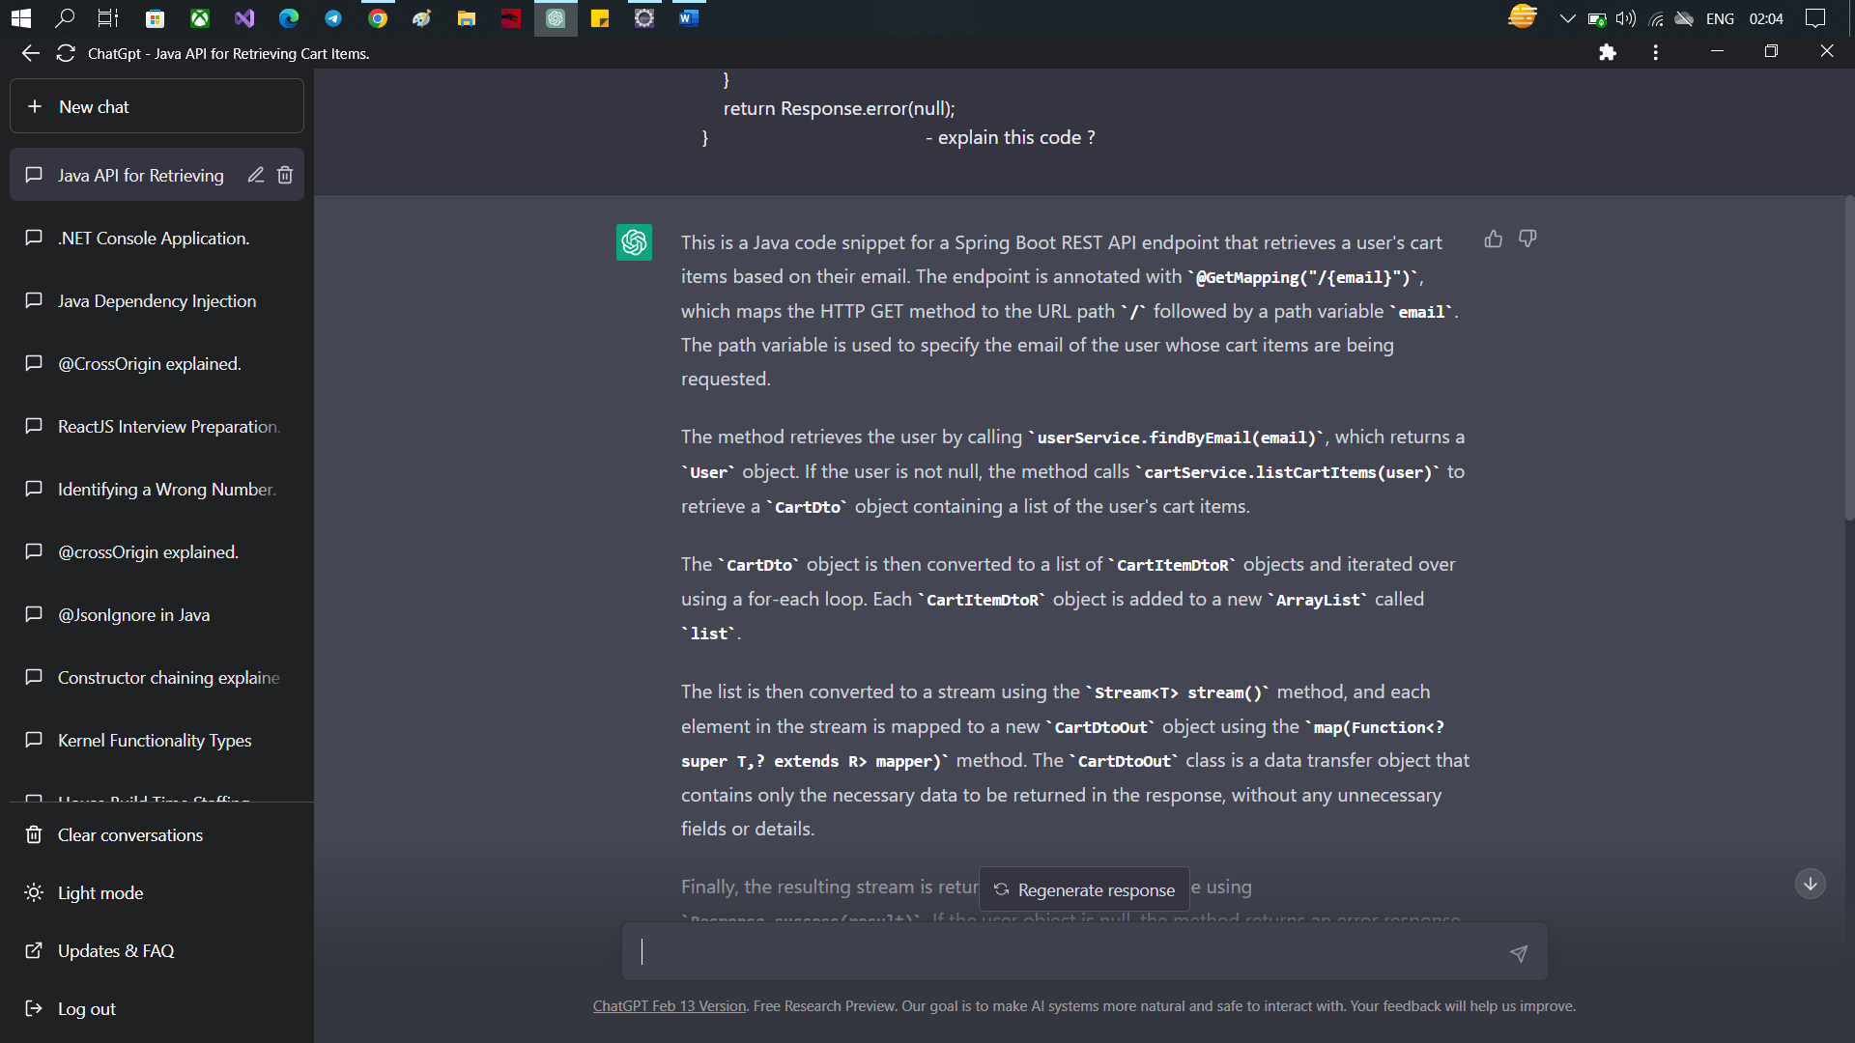

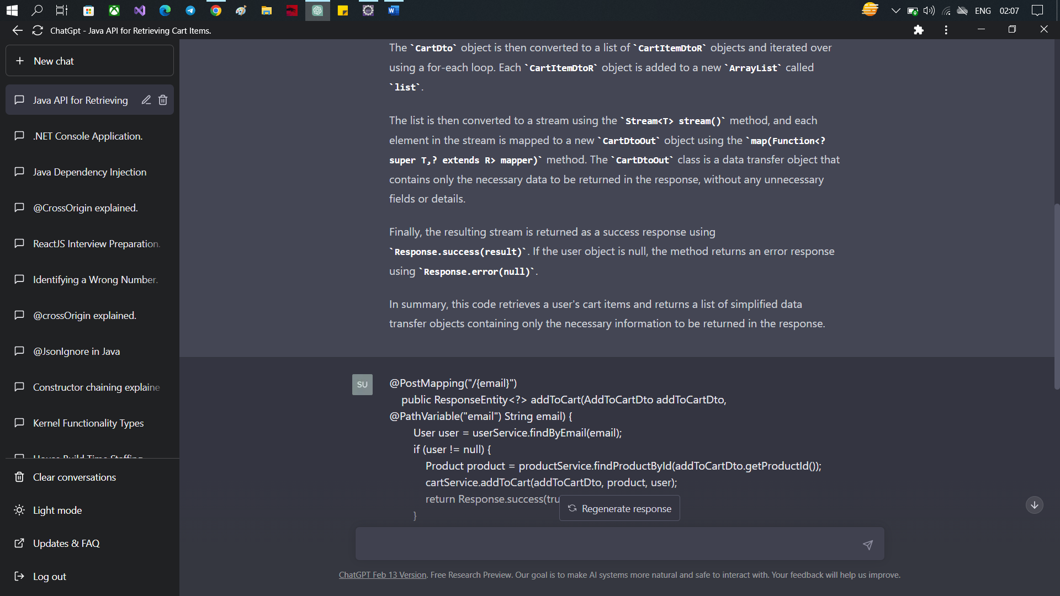

============================================================

@GetMapping("/countitem/{email}")

**public** ResponseEntity<?> getCartItemsCount(@PathVariable("email") String email) {

User user = userService.findByEmail(email);

**if** (user == **null**)

**throw** **new** RuntimeException("User is empty");

Integer count = cartService.cartItemCount(user);

// System.out.println("Count of Cart items:"+count);

**return** Response.*success*(count);

}

:-

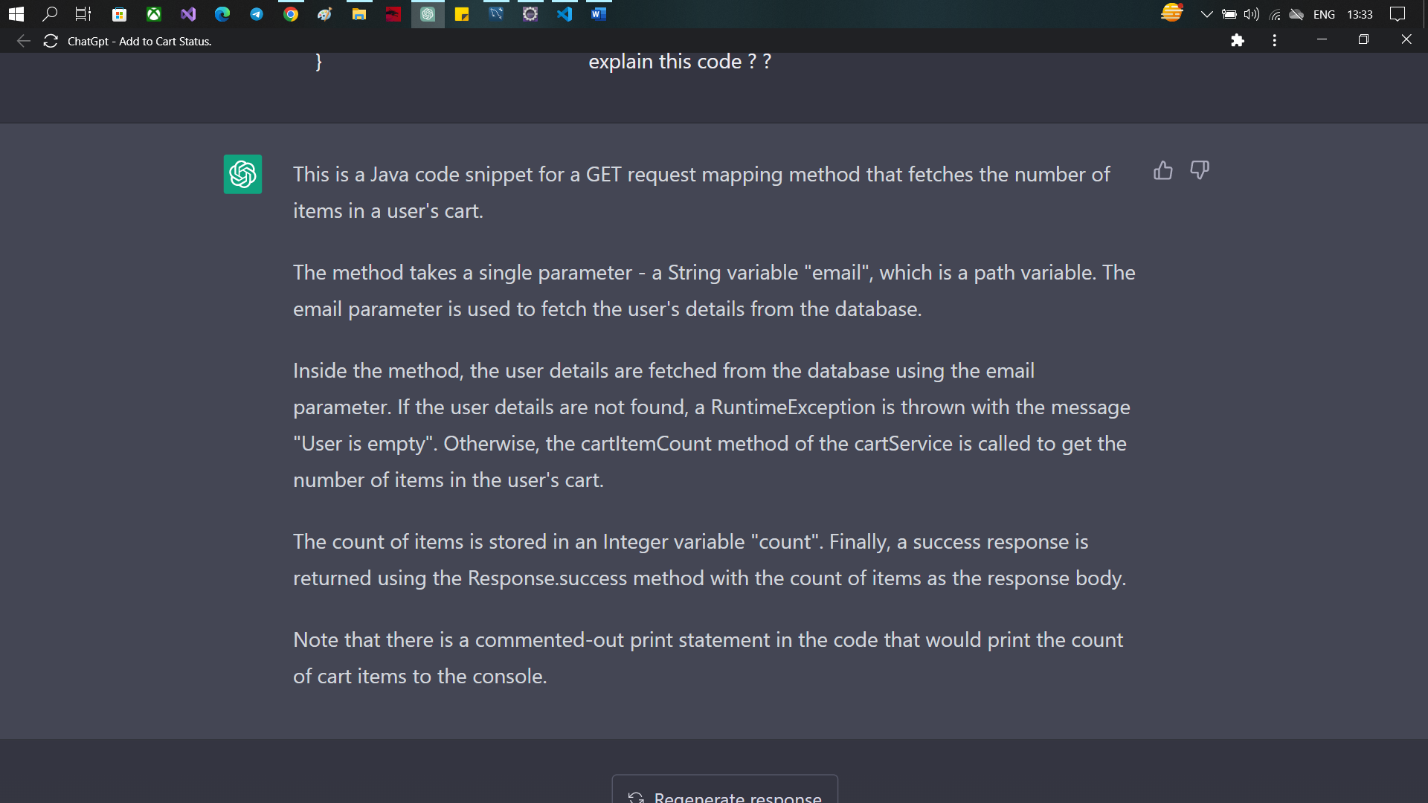

=================================================

@RequestMapping(value = "", method = RequestMethod.***DELETE***)

**public** ResponseEntity<?> deleteByCartIdAndProductId(@RequestParam("cartItemId") String cartItemId,

@RequestParam("email") String email) {

**int** id = Integer.*parseInt*(cartItemId);

User user = userService.findByEmail(email);

**if** (user != **null**) {

cartService.deleteCartItem(id, user.getUserId());

**return** Response.*success*(**true**);

}

**return** Response.*error*(**null**);

}

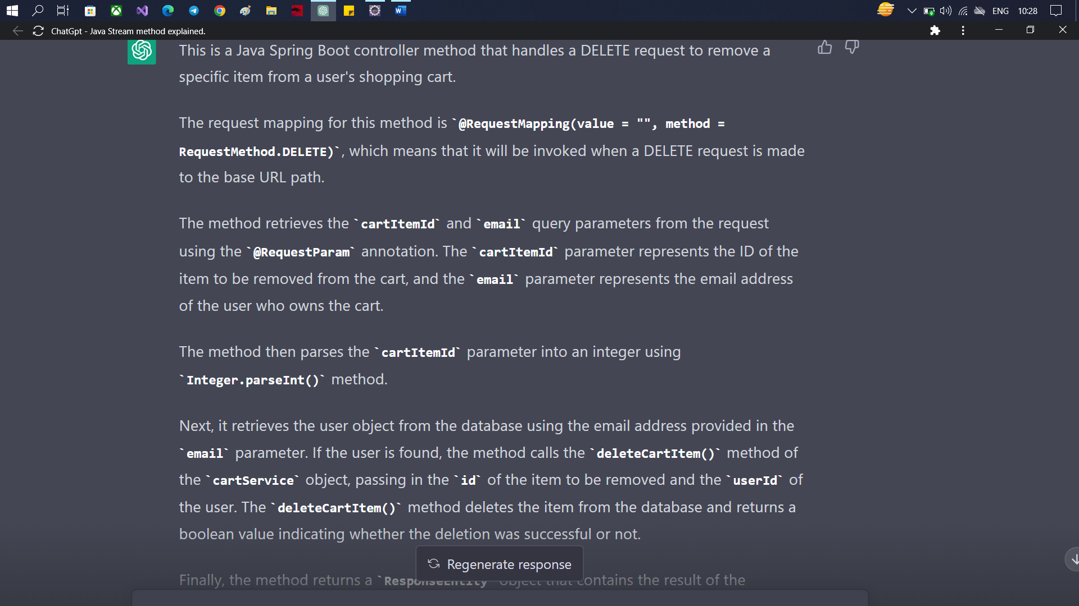

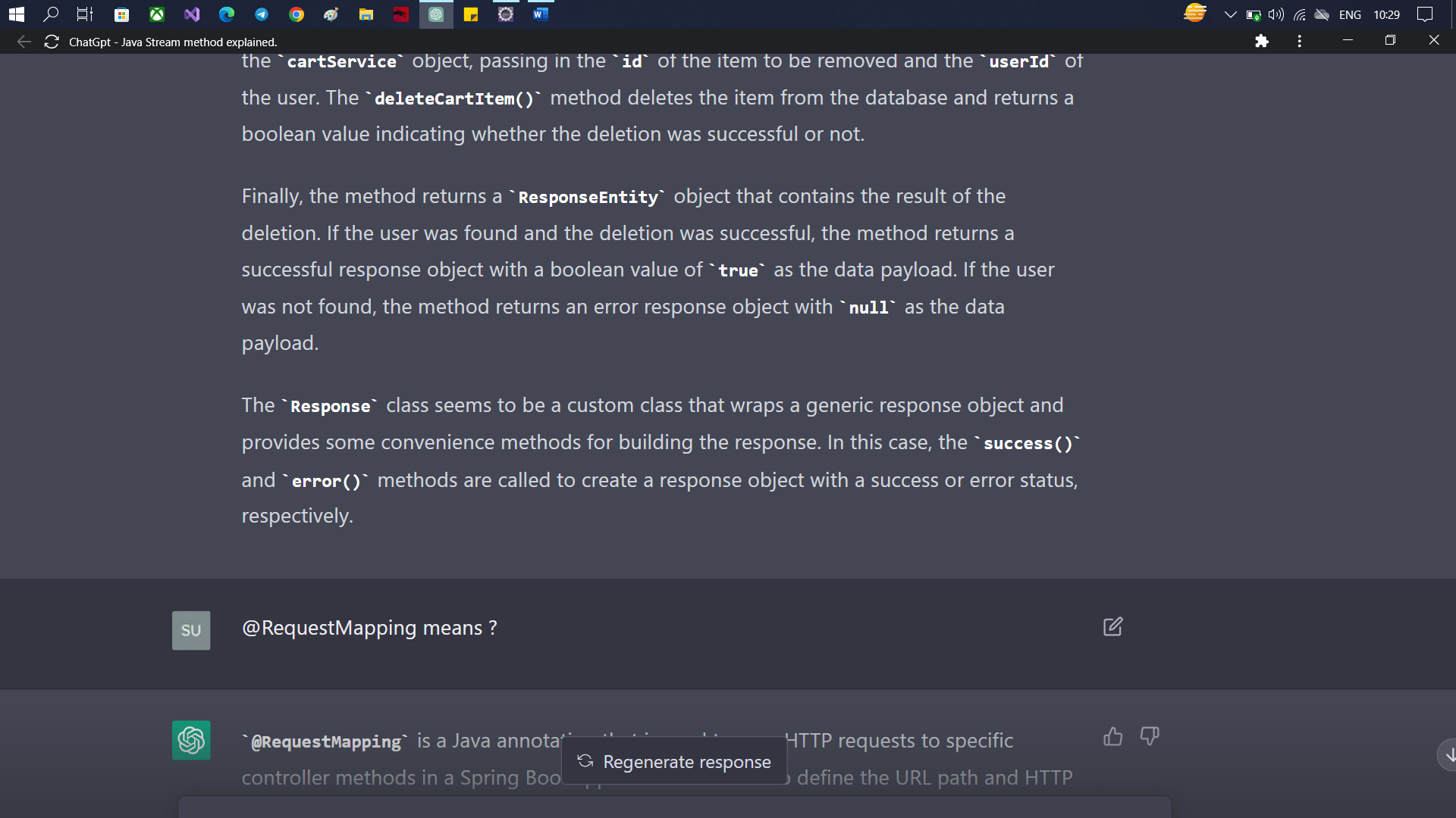

@DeleteMapping("/{email}")

**public** ResponseEntity<?> deleteByUserId(@PathVariable("email") String email) {

User user = userService.findByEmail(email);

cartService.deleteUserCartItems(user);

**return** Response.*success*(**true**);

}

