Name : Sujit Ravindra Pawar

PRN: 230945920072

Set2 TIMESHEET MANAGEMENT SYSTEM

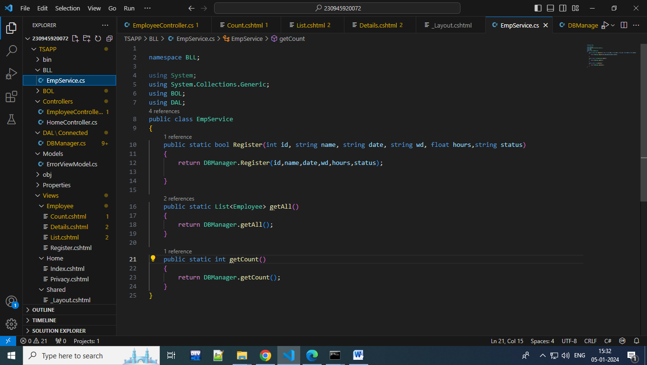

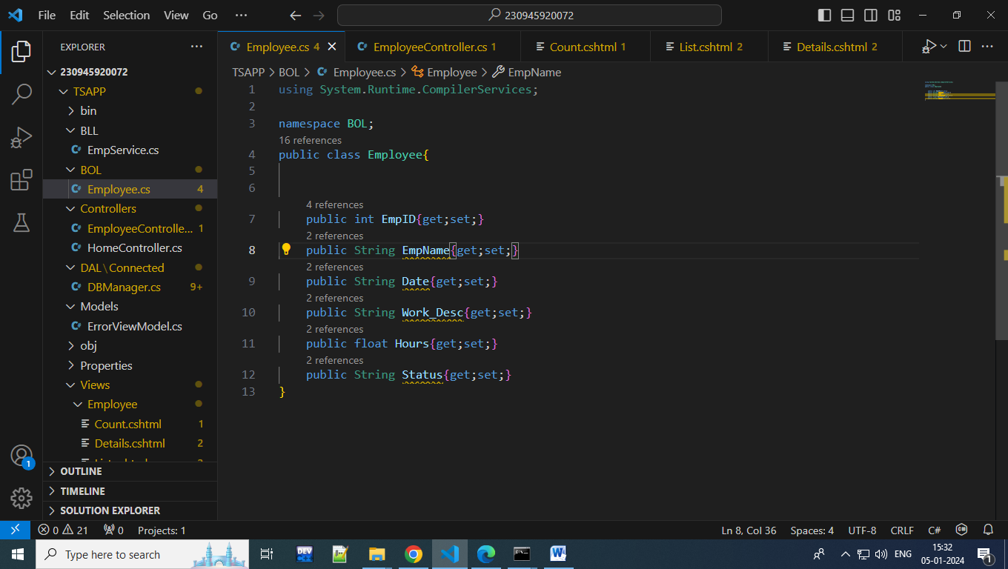

namespace DAL;

using BOL;

using MySql.Data.MySqlClient;

using System;

using System.Collections.Generic;

using System.Data;

public class DBManager

{

    public static string conString= @"server=192.168.10.150 ; port =3306; user= dac13; password = welcome; database=dac13;";

    private static int n;

    public static bool Register(int id, string name, string date, string wd, float hours,string status)

    {

        MySqlConnection con = new MySqlConnection();

        con.ConnectionString = conString;

        string query="insert into Employee values(@id,@name,@date,@wd,@hours,@status)";

         try

        {

            con.Open();

            MySqlCommand cmd= new MySqlCommand(query,con);

            cmd.Parameters.AddWithValue("@id",id);

            cmd.Parameters.AddWithValue("@name",name);

              cmd.Parameters.AddWithValue("@date",date);

            cmd.Parameters.AddWithValue("@wd",wd);

            cmd.Parameters.AddWithValue("@hours",hours);

            cmd.Parameters.AddWithValue("@status",status);

          int n= cmd.ExecuteNonQuery();

          if(n>0){

            return true;

          }

    }

     catch(Exception ee){

            Console.WriteLine(ee.Message);

        }

        finally

        {

            con.Close();

        }

            return false;

    }

    public static List<Employee> getAll(){

        List<Employee> list = new List<Employee>();

        MySqlConnection con = new MySqlConnection();

        con.ConnectionString = conString;

        string query = "select * from Employee";

        try

        {

            con.Open();

            MySqlCommand cmd= new MySqlCommand();

            cmd.Connection=con;

            cmd.CommandText=query;

            MySqlDataReader reader = cmd.ExecuteReader();

            while(reader.Read()) {

                int id = int.Parse((reader["Id"]).ToString());

                string name = reader["name"].ToString();

                string date = reader["date"].ToString();

                string wd= reader["work_desc"].ToString();

                float hours = float.Parse((reader["hours"]).ToString());

                string status = reader["status"].ToString();

            Employee e= new Employee{

                EmpID=id,

                EmpName=name,

                Date=date,

                Work_Desc=wd,

                Hours=hours,

                Status=status

            };

            list.Add(e);

            }

        }

        catch(Exception ee){

            Console.WriteLine(ee.Message);

        }

        finally

        {

            con.Close();

        }

        return list;

        }

    public static int getCount()

    {

         MySqlConnection con = new MySqlConnection();

        con.ConnectionString = conString;

        string query = "select count(*) from employee;";

        try

        {

            con.Open();

            MySqlCommand cmd= new MySqlCommand();

            cmd.Connection=con;

            cmd.CommandText=query;

            MySqlDataReader reader = cmd.ExecuteReader();

             while(reader.Read()) {

                int n = int.Parse((reader["Id"]).ToString());

             }

             return n;

    }catch(Exception ee){

            Console.WriteLine(ee.Message);

        }

        finally

        {

            con.Close();

        }

        return n;

        }

    // public Boolean Update(Employee e){

    //     MySqlConnection con = new MySqlConnection();

    //     con.ConnectionString = conString;

    //     // string query = "update ";

    //     return true;

    // }

}

EmployeeController

using System.Diagnostics;

using BOL;

using BLL;

using Microsoft.AspNetCore.Mvc;

using TSAPP.Models;

namespace TSAPP.Controllers;

public class EmployeeController : Controller

{

    private readonly ILogger<EmployeeController> _logger;

    public EmployeeController(ILogger<EmployeeController> logger)

    {

        _logger = logger;

    }

    [HttpGet]

    public IActionResult Register()

    {

        return View();

    }

    [HttpPost]

    public IActionResult Register(int id,string name,string date,string wd,float hours,string status)

    {

        bool flag=EmpService.Register(id,name,date,wd,hours,status);

        return View();

    }

    public IActionResult List()

    {

        List<Employee> list = new List<Employee>();

        list=EmpService.getAll();

        ViewData["list"]=list;

        return View();

    }

    public IActionResult Details(int id)

    {

        List<Employee> list = new List<Employee>();

        list=EmpService.getAll();

        Employee e=list.Find((emp)=>emp.EmpID==id);

        ViewData["emp"]=e;

        return View();

    }

    public IActionResult Privacy()

    {

        return View();

    }

    public IActionResult Count()

    {

        int n=EmpService.getCount();

        ViewData["cnt"]= n.ToString() ;

        return View();

    }

    [ResponseCache(Duration = 0, Location = ResponseCacheLocation.None, NoStore = true)]

    public IActionResult Error()

    {

        return View(new ErrorViewModel { RequestId = Activity.Current?.Id ?? HttpContext.TraceIdentifier });

    }

}

VIEWS

Register.cshtml

<h2>Sumbit Timesheet Form</h2>

<form method="post">

    Enter EmployeeId: <input type="number" name="id"> <br><br>

    Enter Your Name : <input type="text" name="name"><br><br>

    Enter work date : <input type="text" name="date"><br><br>

    Work Description : <input type="text" name="wd"><br><br>

    Enter working Hours :<input type="number" name="hours"><br><br>

    Enter work status :<input type="text" name="status"><br><br>

    <button type="submit">Submit Timesheet</button>

</form>

List.cshtml

@using BOL;

<h2>List of Timesheet submitted </h2>

<div>

<table class="table table-bordered table-light">

    <thead>

        <tr>

            <th>EmployeeId</th>

            <th>EmployeeName</th>

            <th>Date Of Work</th>

            <th>Details</th>

        </tr>

    </thead>

    <tbody>

    @{

        List<Employee> list = (List<Employee>) ViewData["list"];

        foreach(Employee e in list){

        <tr>

            <td>@e.EmpID</td>

            <td>@e.EmpName</td>

            <td>@e.Date</td>

            <td><a href="/Employee/Details/@e.EmpID">Details</a></td>

         </tr>

        }

    }

    </tbody>

</table>

</div>

@using BOL;

<h2>Details of Timesheet submitted </h2>

<div>

<table class="table table-bordered table-light">

    <thead>

        <tr>

            <th>Work Desc</th>

            <th>Hours</th>

            <th>Status</th>

        </tr>

    </thead>

    <tbody>

     @{

        Employee e =ViewData["emp"] as Employee;

        <tr>

            <td>@e.Work_Desc</td>

            <td>@e.Hours</td>

            <td>@e.Status</td>

         </tr>

        }

    }

    </tbody>

</table>

    @* <a asp-area="" asp-controller="Employee" asp-action="Update">Update</a> *@

</div>

@{

    String  n= ViewData["cnt"] as String;

}

<b>No of employees submitted timesheet = @n</b>

Layout file

<!DOCTYPE html>

<html lang="en">

<head>

    <meta charset="utf-8" />

    <meta name="viewport" content="width=device-width, initial-scale=1.0" />

    <title>@ViewData["Title"] - TSAPP</title>

    <link rel="stylesheet" href="~/lib/bootstrap/dist/css/bootstrap.min.css" />

    <link rel="stylesheet" href="~/css/site.css" asp-append-version="true" />

    <link rel="stylesheet" href="~/TSAPP.styles.css" asp-append-version="true" />

</head>

<body>

    <header>

        <nav class="navbar navbar-expand-sm navbar-toggleable-sm navbar-light bg-white border-bottom box-shadow mb-3">

            <div class="container-fluid">

                <a class="navbar-brand" asp-area="" asp-controller="Home" asp-action="Index">TSAPP</a>

                <button class="navbar-toggler" type="button" data-bs-toggle="collapse" data-bs-target=".navbar-collapse" aria-controls="navbarSupportedContent"

                        aria-expanded="false" aria-label="Toggle navigation">

                    <span class="navbar-toggler-icon"></span>

                </button>

                <div class="navbar-collapse collapse d-sm-inline-flex justify-content-between">

                    <ul class="navbar-nav flex-grow-1">

                        <li class="nav-item">

                            <a class="nav-link text-dark" asp-area="" asp-controller="Home" asp-action="Index">Home</a>

                        </li>

                        <li class="nav-item">

                            <a class="nav-link text-dark" asp-area="" asp-controller="Home" asp-action="Privacy">Privacy</a>

                        </li>

                         <li class="nav-item">

                            <a class="nav-link text-dark" asp-area="" asp-controller="Employee" asp-action="List">List</a>

                        </li>

                        <li class="nav-item">

                            <a class="nav-link text-dark" asp-area="" asp-controller="Employee" asp-action="Count">No Of Timesheet submitted</a>

                        </li>

                    </ul>

                </div>

            </div>

        </nav>

    </header>

    <div class="container">

        <main role="main" class="pb-3">

            @RenderBody()

        </main>

    </div>

    <footer class="border-top footer text-muted">

        <div class="container">

            &copy; 2024 - TSAPP - <a asp-area="" asp-controller="Home" asp-action="Privacy">Privacy</a>

        </div>

    </footer>

    <script src="~/lib/jquery/dist/jquery.min.js"></script>

    <script src="~/lib/bootstrap/dist/js/bootstrap.bundle.min.js"></script>

    <script src="~/js/site.js" asp-append-version="true"></script>

    @await RenderSectionAsync("Scripts", required: false)

</body>

</html>

