***FACE RECOGNITION lOGIN sYSTEM***

***by***

|  |  |  |
| --- | --- | --- |
| Name | Roll No. | Registration No: |
| *SHREYA SHAH* | *11700318044* | 181170110338 OF 2018-2019 |
| *SOHOM DAS* | *11700318037* | 181170110345 OF 2018-2019 |
| *SUJIT SINHA* | *11700318020* | 181170110362 OF 2018-2019 |

*A comprehensive project report has been submitted in partial fulfillment of the requirements for the degree of*

**Bachelor of Technology**

*in*

**ELECTRONICS & COMMUNICATION ENGINEERING**

*Under the supervision of*

**Mr. Sujoy Mondal**

Assistant Professor



**Department of Electronics & Communication Engineering**

**RCC INSTITUTE OF INFORMATION TECHNOLOGY**

**Affiliated to Maulana Abul Kalam Azad University of Technology, WestBengal CANAL SOUTH ROAD, BELIAGHATA, KOLKATA – 700015**

**May,2018**

# CERTIFICATE OF APPROVAL



This is to certify that the project titled “**ACOUSTIC ENVIRONMENT DETECTION**” carried out by

|  |  |  |
| --- | --- | --- |
| Name | Roll No. | Registration No: |
| *Avranil Roy* | *117003* | 141170110209 of 2014 |
| *Trinanjana* | *117003141* | 141170110300 of |
|  |  |  |

for the partial fulfillment of the requirements for B.Tech degree in **Electronics and Communication Engineering** from **Maulana Abul Kalam Azad University of Technology, West Bengal** is absolutely based on his own work under the supervision

of Mr. . The contents of this thesis, in full or in parts, have not been submitted to

any other Institute or University for the award of any degree or diploma.

|  |  |
| --- | --- |
| Optional in case of External Supervisor  .........................................................  Designation and Department Institute | .........................................................  **Mr. Sujoy Mondal**  Asst. Professor , Dept. of ECE  RCC Institute of Information Technology |

…

.......................................................

**Dr. Abhishek Basu**

Head of the Department (ECE)

RCC Institute of Information Technology

**DECLARATION**



“We Do hereby declare that this submission is our own work conformed to the norms and guidelines given in the Ethical Code of Conduct of the Institute and that, to the best of our knowledge and belief, it contains no material previously written by another neither person nor material (data, theoretical analysis, figures, and text) which has been accepted for the award of any other degree or diploma of the university or other institute of higher learning, except where due acknowledgement has been made in the text.”

|  |  |
| --- | --- |
| ..........................................................  **ABHISHEK SARKAR**  Registration No: 141170110186 of 2014-2015  Roll No: 11700314004 | ..........................................................  **ANKITA DAS**  Registration No: 141170110202 of 2014-2015  Roll No: 11700314020 |
| ..........................................................  **TRINANJANA CHAUDHURI**  Registration No: 141170110300 of 2014-2015  Roll No: 11700314118 | ..........................................................  **AVRANIL ROY**  Registration No: 141170110209 of 2014-2015  Roll No: 11700314027 |

Date: 10.09.2018

Place: KOLKATA

**CERTIFICATE of ACCEPTANCE**



This is to certify that the project titled “**ACOUSTIC ENVIRONMENT DETECTION**” carried out by

|  |  |  |
| --- | --- | --- |
| Name | Roll No. | Registration No: |
| **ABHISHEK SARKAR** | *117003140* | 141170110186 of 2014-  2015 |
| ***TRINANJANA*** | *117003141* | 141170110300 of |
| ***AVRANIL ROY*** | *117003140* | 141170110209 of |

is hereby recommended to be accepted for the partial fulfillment of the requirements for B.Tech degree in **Electronics and Communication Engineering** from **Maulana Abul Kalam Azad University of Technology, West Bengal**

**Name of the Examiner Signature with Date**

1. ……………………………………………………………………

2.……………………………………..……………………………..

3.……………………………………………………………………

4. …………………………………….………………………………

ABSTRACT

Now a days with the unprecedented growth of science, we can recognize the environment someone is belonging to without the physical presence, even without the image of the surroundings. It is being possible with the help of sound.

That is why Acoustic Environment Detection is going to be a great matter of concern in case of determination of an environment by means of surrounding sounds or noise.

Here in this project we have the problem to detect the environment of the test sound such that we have to determine in which environment the sound has been captured.

We have collected twelve sample sounds of twelve different environments and determined so by matching the test sound with the previously stored ones. We have firstly used Fast Fourier Transform to divide the test signal into several small parts so that the matching can be done easily. Then using Multilayer Perceptron Concept we did the matching by creating models for each type of sound. Then with the help of Confusion Matrix we have determined whether we are getting the desired output or not.

Thus doing so we have determined the environment using sound. With the use of several parameters we have calculated the accuracy, hit rate, misdetection and false alarms of the detection. From the Receiver Operating Characteristics curve we have determined these.

With the help of this project without consuming a huge data the environment can be detected easily by using the surrounding sounds. It has a great future prospect in case of criminal activity detection and with help of this project we get to know sometimes noise also can be a very useful tool for detection.

**ACKNOWLEDGEMENT**

The success and final outcome of this project i.e **“ACOUSTIC ENVIRONMENT DETECTION**” required a lot of guidance and assistance from many people and I am extremely privileged to have got this all along the completion of our project. All that we have done is only due to such supervision and assistance and I would not forget to thank them.

We respect and heartily thank **Mr. Sujoy Mondal** , **Asst.Professor, ECE, RCCIIT** for providing us an opportunity to do the project work in college premises and giving us all support and guidance which made us complete the project duly. We are extremely thankful to him for providing such a nice support and guidance, although he had busy schedule managing the corporate affairs.

We owe our deep gratitude to our project guide, who took keen interest on our project work and guided us all along, till the completion of our project work by providing all the necessary information for developing a good system.

We are thankful to and fortunate enough to get constant encouragement, support and guidance from all our friends, family who helped us in successfully completing our project work. Also, we would like to extend our sincere esteems to all staff in laboratory for their timely support.

CONTENTS

CERTIFICATE OF APPROVAL 2

DECLARATION 3

CERTIFICATE OF ACCEPTANCE… 4

ABSTRACT 5

ACKNOWLEDGEMENT 6

CONTENT 7

LIST OF ABBREVIATIONS 8

LIST OF FIGURES 9

LIST OF TABLES 10

INTRODUCTION 11

ANALYSIS 14

FLOW DIAGRAM.......................................................................................................................22

SCREENSHOTS 29

CONCLUSION AND FUTURE SCOPE… 42

REFERENCE 45

LIST OF ABBREVIATIONS

|  |  |
| --- | --- |
| **MLP** | **Multi Layer Perceptron** |
| **FA** | **False Alarm** |
| **MD** | **Mis Detection** |
| **TP** | **True Positive** |
| **TN** | **True Negative** |
| **FP** | **False Positive** |
| **FN**  **Acc ROC** | **False Negative Accuracy Receiver_Operating**  **Characteristic** |

LIST OF FIGURES

|  |  |  |
| --- | --- | --- |
| SL NO. | TOPIC | PAGE |
| 1.1 | Process of acoustic environment detection | 13 |
| 2.1(A) | Machine learning and Data mining | 14 |
| 2.1(B) | Mark I Perceptron | 15 |
| 2.4 | MLP Diagrammatic Representation | 20 |
| 3.3 | Sample Confusion Matrix (1) | 23 |
| 3.4 | Sample Confusion Matrix (2) | 27 |
| 4.5(A) | Formation of Feature Matrix | 33 |
| 4.5(B) | Feature Matrix | 33 |
| 4.6.1 | SPECTRUM OF FIRST CLASS (COCKPIT 1) | 36 |
| 4.6.2 | SPECTRUM OF SECOND CLASS (COCKPIT 2) | 36 |
| 4.6.3 | SPECTRUM OF THIRD CLASS (COCKPIT 3) | 37 |
| 4.6.4 | SPECTRUM OF FOURTH CLASS (ENGINE 1) | 37 |
| 4.6.5 | SPECTRUM OF FIFTH CLASS (ENGINE 2) | 38 |
| 4.6.6 | SPECTRUM OF SIXTH CLASS (FACTORY 1) | 38 |
| 4.6.7 | SPECTRUM OF SEVENTH CLASS (FACTORY 2) | 39 |
| 4.6.8 | SPECTRUM OF EIGHTH CLASS (MACHINE GUN) | 39 |
| 4.6.9 | SPECTRUM OF NINTH CLASS (VOLVO BUS) | 40 |
| 4.6.10 | SPECTRUM OF TENTH CLASS ( WHITE NOISE) | 40 |
| 4.6.11 | SPECTRUM OF ELEVENTH CLASS(CLASSROOM BABEL NOISE) | 41 |
| 4.6.12 | SPECTRUM OF TWELEVETH CLASS (HIGH FREQUENCY CHANNEL) | 41 |
| 6.1 | ROC CURVE A | 45 |
| 6.2 | ROC CURVE B | 47 |
| 6.3 | ROC CURVE C | 48 |
| 6.4 | ROC CURVE D | 50 |
| 6.5 | ROC DIAGNOSIS | 50 |
| 6.6 | ROC SUPPLY | 51 |
| 6.7 | ROC TEST CURVE | 54 |
| 6.8 | ROC SPACE CURVE | 55 |
| 6.9 | OUTPUT ROC CURVE | 59 |

LIST OF TABLES

|  |  |  |
| --- | --- | --- |
| SL NO | TOPIC | PAGE NO |
| Table 1 | Confusion Matrix Cases | 26 |
| Table 2 | Cases of Rate | 53 |
|  |  |  |
|  |  |  |
|  |  |  |
|  |  |  |
|  |  |  |

**Introduction**

**ANALYSIS**

Requirements analysis is critical to the success or failure of a systems or software project. The requirements should be documented, actionable, measurable, testable, traceable, related to identified business needs or opportunities, and defined to a level of detail sufficient for system design.

|  |  |
| --- | --- |
| NAME OF COMPONENT | SPECIFICATION |
| Operating System | Windows XP or higher, Linux,MacOs |
| Language | HTML,, CSS, JavaScript,Flask |
| Database | MySQL Server |
| Browser | Any of Internet Explorer, Google Chrome, Mozilla Firefox |
| Web Server | WAMP Server |
| SOFTWARES | Cmake , Pycharm |
| Python | Above 3.7 |

**MINIMUM SOFTWARE REQUIREMENTS TO DEVELOP THE SYSTEM :**

**MINIMUM HARDWARE REQUIREMENTS TO DEVELOP THE SYSTEM :**

|  |  |
| --- | --- |
| NAME OF COMPONENT | SPECIFICATION |
| Processor | Core i3 and above |
| RAM | 2 GB and Above |
| HARD DISK | 200 GB |
| MONITOR | Any SIZE |
| Gadgets | WebCam |
| Keyboard | 122 Keys |

**FUNCTIONAL REQUIREMENTS :**

* HTML has been used for creating the layout of the web application.
* CSS has been used for creating the designing of the web pages.
* JavaScript scripting language has been implemented on the system for performing all the Client Side Server Validation.
* MySQL database has been used for storing the data of the website.
* Face Recognition Library has been used for Face Recognition.
* Flask has been used for DataBase Connection.

**FLOW DIAGRAM**

**SCREENSHOTS**

* 1. Registration Form

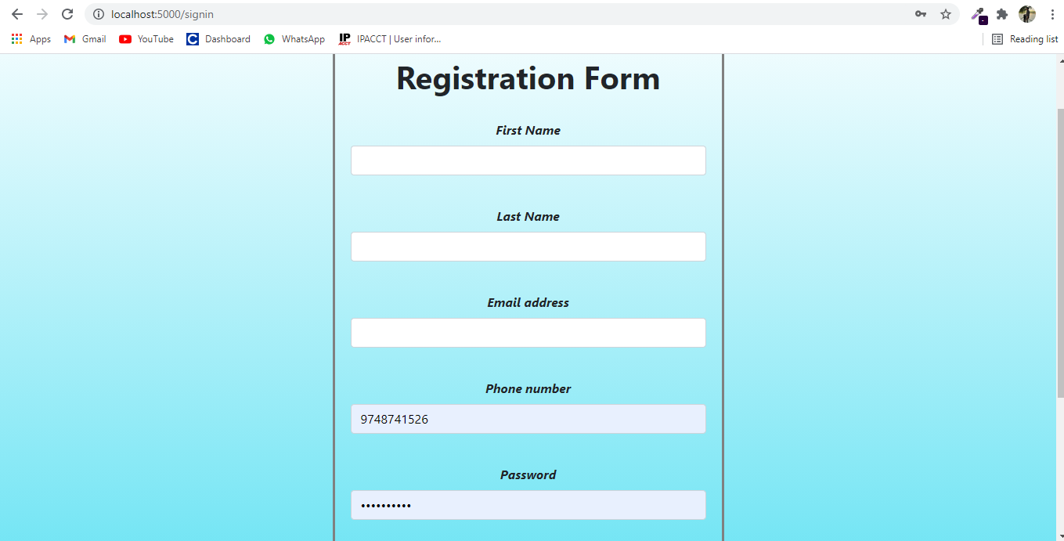

1.2 Photo Capture Form

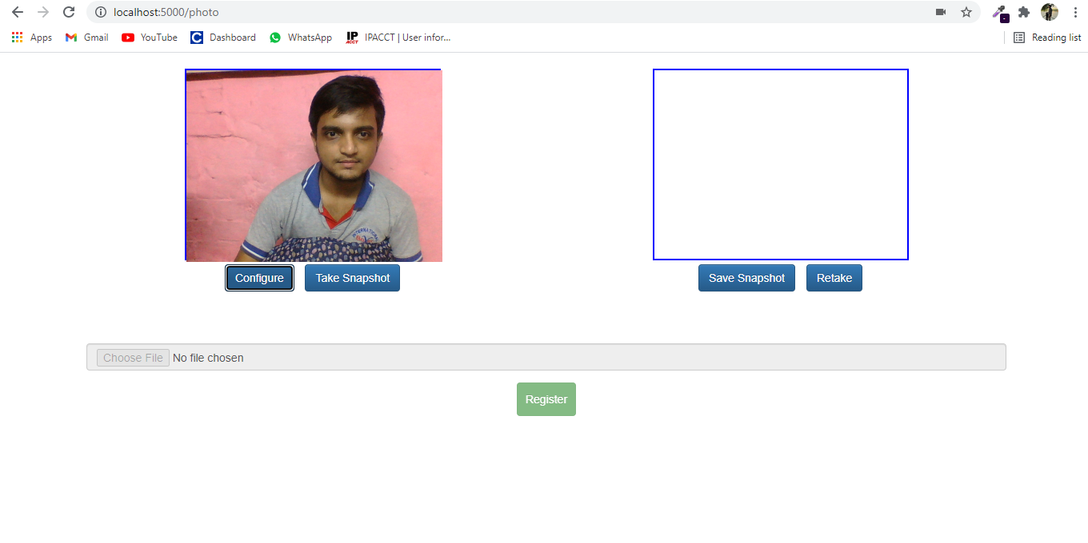

* 1. LogIn Form

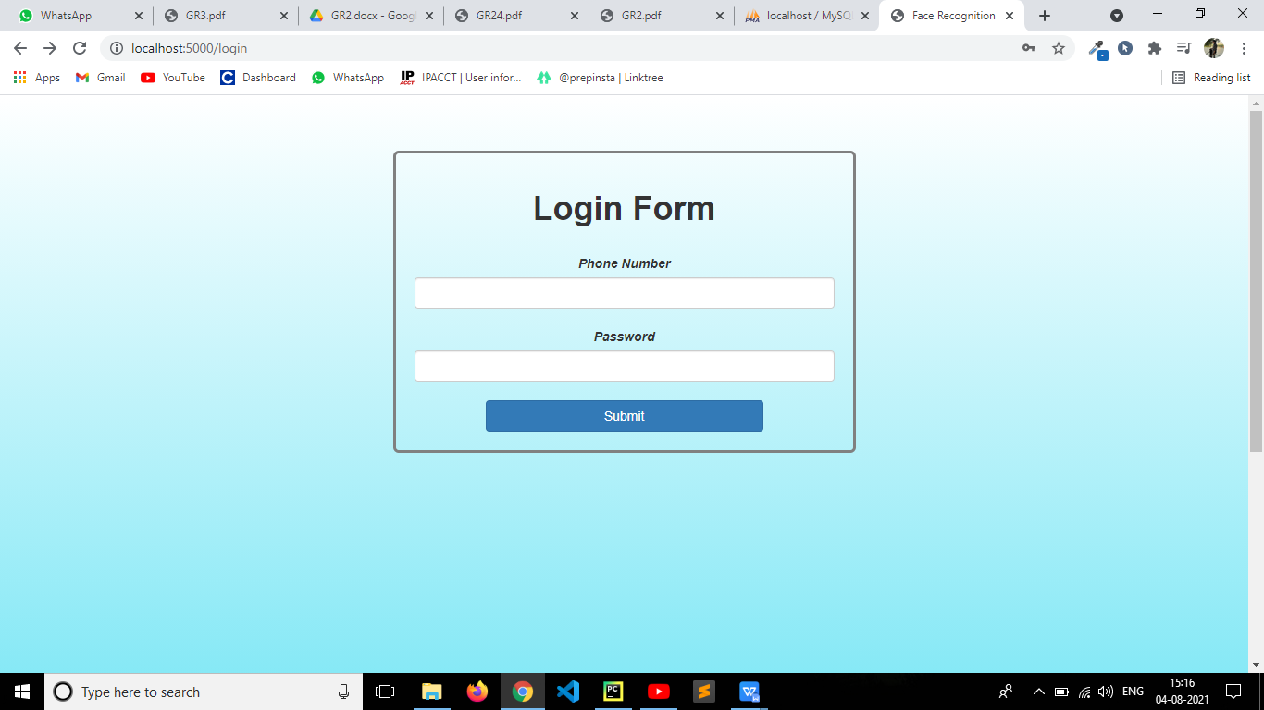

* 1. Output

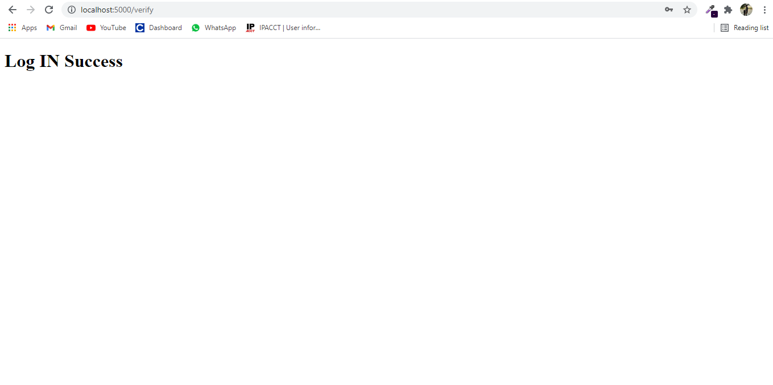

**CONCLUSION AND FUTURE SCOPE**

**REFERENCE**

**THANK YOU……….**