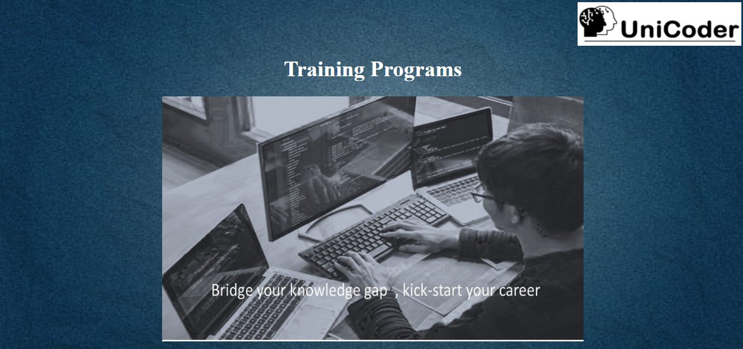

**Welcome to Unicoder**

UniCoder is an industry – academia collaboration initiated by Techciti Software Consulting Private Limited . It is one -of-a -kind platform to help young, aspiring programmers make it big in the world of algorithms and computer programming .We mainly aim on developing the technical and software and application development skills of students and professionals in new age technologies and making them “industry – ready “ . The parent company Techciti Software Consulting Private Limited. mainly is into developing enterprise - based software solutions , customized web product and application development ,mobile based application development , technology consulting , web- publishing and maintenance-services

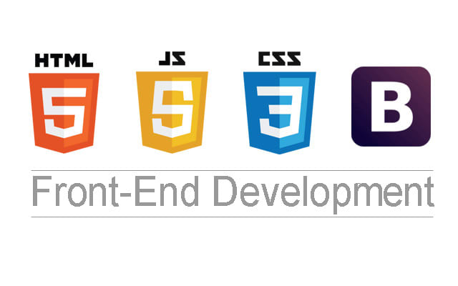

HTML

* Web Programming Introduction
* Architecture of a website
* Different technologies in making the website
* Web Development Introduction
* HTML-Introduction
  + History of HTML
  + What you need to do to get going and make your first HTML page
  + What are HTML Tags and Attributes?
  + HTML Tag vs. Element
  + HTML Attributes
* HTML-Basic Formatting Tags
  + HTML Basic Tags
  + HTML Formatting Tags
  + HTML Color Coding
* HTML-Grouping Using Div Span
  + Div and Span Tags for Grouping
* HTML-Lists
  + Unordered Lists
  + Ordered Lists
  + Definition list
* HTML-Images
  + Image and Image Mapping
* HTML-Hyperlink
  + URL - Uniform Resource Locator
  + URL Encoding
* HTML-Table
* HTML-Iframe
  + Using Iframe as the Target
* HTML-Form
* HTML-Headers
* Title
* Base
* Link
* Styles
* Script
* Meta

**CSS:**

* CSS-Introduction
* Benefits of CSS
* CSS Versions History
* CSS Syntax
* External Style Sheet using < link >
* Multiple Style Sheets
* Value Lengths and Percentages
* CSS-Syntax
* CSS Syntax
* single Style Sheets
* Multiple Style Sheets
* Value Lengths and Percentages
* CSS-Selectors
* ID Selectors
* Class Selectors
* Grouping Selectors
* Universal Selector
* Descendant / Child Selectors
* Attribute Selectors
* CSS - Pseudo Classes
* CSS-Color Background Cursor
* background-image
* background-repeat
* background-position
* CSS Cursor
* CSS-Text Fonts
* color
* background-color
* text-decoration
* text-align
* vertical-align
* text-indent
* text-transform
* white space
* letter-spacing
* word-spacing
* line-height
* font-family
* font-size
* font-style
* font-variant
* font-weight
* CSS-Lists Tables
* list-style-type
* list-style-position
* list-style-image
* list-style
* CSS Tables
* border
* width & height
* text-align
* vertical-align
* padding
* Color
* Box Model
* Borders & Outline
* Margin & Padding
* Height and width
* CSS Dimensions
* CSS-Display Positioning
* CSS Visibility
* CSS Display
* CSS Scrollbars
* CSS Positioning
* Static Positioning
* Fixed Positioning
* Relative Positioning
* Absolute Positioning
* CSS Layers with Z-Index
* CSS Floats
* The float Property
* The clear Property
* The clear fix Hack

**JAVASCRIPT:**

* Understand the JavaScript language & the Document Object Model. • Alter, show, hide and move objects on a web page. •
* Check information inputted into a form. •
* Javascript allows programming to be performed without server interaction. Javascript can respond to events, such as button clicks. •
* Javascript can validate data before sending out a request. •
* Javascript can adjust an HTML document for special effects

**MYSQL:**

* Introduction to MySql
* SQL Syntax
* How To Create Database and Tables
* SQL Select, Select Distinct
* SQL Where
* SQL AND, OR
* SQL Order By
* SQL Insert, Update, Delete
* SQL Functions(Min, Max, Count, Sum, Avg)
* Day 5:
* SQL Like
* SQL In Operator
* SQL Between
* SQL Aliases
* SQL Joins(Inner Join, Left Outer Join, Right Outer Join)
* SQL Group By
* SQL Having
* SQL Drop Database and Tables
* Core Java Introduction
* History of Java
* Features of Java
* Introduction to JDE, JRE, JVM
* Java Variable and Data types
* Operators and Keywords
* Control Statements(if, if—else, if---else--if nested if, switch, Break, Continue)
* Looping Statements(For, while, Do—while)

**CORE JAVA:**

* Detail Explanation of Java OOPs Concepts
* Constructor
* Static and this Keyword
* Abstract Class and Interface
* Access Modifiers
* Super and Final Keyword
* Exception Handling
* Multithreading
* Java Collection
* Java JDBC

**J2EE/SERVLET:**

* Introduction to Servlet
* Servlet Life Cycle
* Servlet Example
* Servlet Using Netbeans
* Servlet Request
* Request Dispatcher
* Send Redirect
* Servlet Config
* Servlet Context
* Session Tracking
* Cookies in Servlet
* Hidden Form Field
* Url Rewriting
* HTTP Session
* Data Registration Example
* Data Updating Example
* Data Deleting Example
* Fetching the record from Database
* Login Form Example
* Uploading File
* Downloading File
* Servlet Sending Email

**JSP:**

* JSP Scriptlet Tag
* JSP Expression Tag
* JSP Declaration Tag
* JSP Request, Response
* JSP Page Directive
* JSP Include Directive
* JSP: forward
* JSP: include
* Registration form
* Login Form
* JSP CRUD Example

**Kotlin**

* KOTLIN Introduction
* History of KOTLIN
* Features of KOTLIN
* Introduction to JDK, JRE, JVM
* KOTLIN Variable and Data types
* Operators and Keywords
* Control Statements(if, if—else, if---else--if nested if, switch, Break, Continue)
* Looping Statements(For, while, Do—while)
* Detail Explanation of KOTLIN OOPs Concepts
* Constructors
* Static and this Keyword
* Abstract Class and Interface
* Access Modifiers
* Super and Final Keyword
* Exception Handling
* Multi Threading
* KOTLIN Null Safety
* KOTLIN Collection
* KOTLIN Annotation
* KOTLIN Reflection
* KOTLIN Ranges
* KOTLIN Interoperablitiy
* KOTLIN Regex
* Kotlin JDBC

**Android**

* Introduction To Mobile Apps
  + Why we Need Mobile Apps  
    II. Different Kinds of Mobile Apps  
    III. Briefly about Android
* Introduction Android
  + History Behind Android Development  
    II. What is Android?  
    III. Pre-requisites to learn Android  
    IV. Brief Discussion on Java Programming
* Android Architecture
  + Overview of Android Stack  
    II. Android Features  
    III. Introduction to OS layers
* Deep Overview in Android Stack
  + Linux Kernel  
    II. Libraries  
    III. Android Runtime  
    IV. Application Framework  
    V. Dalvik VM
* Installing Android Machine
  + Configuring Android Stack  
    II. Setting up Android Studio  
    III. Working with Android Studio  
    IV. Using Older Android Tools
* Creating First Android Application
  + Creating Android Project  
    II. Debugging Application through DDMS  
    III. setting up environment  
    IV. AVD Creation  
    V. Executing Project on Android Screen
* Android Components
  + Activities  
    II. Services  
    III. Broadcast Receivers  
    IV. Content Providers
* Hello World App
  + Creating your first project  
    II. The manifest file  
    III. Layout resource  
    IV. Running your app on Emulator
* Building UI with Activities
  + Activities  
    II. Views, layouts and Common UI components  
    III. Creating UI through code and XML  
    IV. Activity lifecycle  
    V. Intents  
    VI. Communicating data among Activities
* Advanced UI
  + Selection components (GridView, ListView, Spinner )  
    II. Adapters, Custom Adapters  
    III. Complex UI components  
    IV. Building UI for performance  
    V. Menus  
    VI. Creating custom and compound Views
* Notifications
  + Toast, Custom Toast  
    II. Dialogs  
    III. Status bar Notifications
* Styles And Themes
  + Creating and Applying simple Style  
    II. Inheriting built-in Style and User defined style  
    III. Using Styles as themes
* Resources and Assets
  + Android Resource  
    II. Using resources in XML and code  
    III. Localization  
    IV. Handling Runtime configuration changes
* Intent, Intent Filters and Broadcast Receivers
  + Role of filters  
    II. Intent-matching rules  
    III. Filters in your manifest  
    IV. Filters in dynamic Broadcast Receivers  
    V. Creating Broadcast receiver
* Receiving System Broadcast
* VI. Understanding Broadcast action, category and data  
  VII. Registering Broadcast receiver through code and through XML  
  VIII. Sending Broadcast
* Data Storage
  + Shared Preferences  
    II. Android File System  
    III. Internal storage  
    IV. External storage  
    V. SQLite
    - IntroducingSQLite  
      b. SQLiteOpenHelper and creating a database  
      c. Opening and closing adatabase  
      d. Working with cursors Inserts, updates, and deletes  
      VI. Network
* Content Providers
  + Accessing built in content providers  
    II. Content provider MIME types  
    III. Searching for content  
    IV. Adding, changing, and removing content  
    V. Creating content provider  
    VI. Working with content files
* 18)Services
* Overview of services in Android  
  II. Implementing a Service  
  III. Service lifecycle  
  IV. Inter Process Communication (AIDL Services)

**Core Python**

* Introduction
* Data types and Variables
* Operators
* Decision Making Statements
* Looping Statements
* Control Statements
* String Manipulations
* Lists
* Tuples
* Dictionaries
* Functions
* Modules- Input and Output Files
* Exception Handling
* OOPs Concepts

**Django**

* Django Framework Introduction
* Installation, Configuration¬ & Environment Setup Admin Interface
* Simple Django Application
* Django MVT (MVC)
* URL Mapping
* File Handling¬ Model Forms,
* Django Admin Configuration
* Django Forms¬ & Validation File Upload¬
* Sqlite Database Connectivity¬
* Request and Response¬

**DATA SCIENCE**

* Introduction Data Science Project Lifecycle
* Introduction to Types of Analytics- Project life cycle
* Introduction To Python Basic Statistics
* High-Level overview of Data Science / Machine Learning project• management methodology The various Data Types namely continuous, discrete, categorical,• count, qualitative, quantitative and its identification and application. Further classification of data in terms of Nominal, Ordinal, Interval and Ratio types Random Variable and its definition•
* Data and its types
* Probability and Probability Distribution – Continuous probability• distribution / Probability density function and Discrete probability distribution / Probability mass function.
* Population• What is Sampling Funnel, its application and its components• Sampling frame• Simple random sampling• Sample• Measure of central tendency• Mean / Average• Median• Mode• Measure of Spread• Variance• Standard Deviation• Range•
* Various graphical techniques to understand data• Bar plot• Histogram• Box plot• Installation of Python IDE• Scatter plot• Anaconda and Spyder• Working with Python with some basic commands
* Machine learning Introuduction
* Types of Machine learning
* Supervised learning
* Unsupervised learning
* Reinforcement learning
* Linear Regression
* Introduction to Simple Linear Regression
* Multiple Linear Regression
* Mean Squared error
* Ordinary least squares•
* Splitting the data into training, validation and testing datasets•
* Understanding Overfitting (Variance) vs Underfitting (Bias)•
* Generalization error and Regularization techniques•
* Machine learning Classifiers and regressors
* Logistic Regression•
* Multiple Logistic Regression•
* Confusion matrix•
* False Positive, False Negative•
* True Positive, True Negative•
* Naïve Bayes Algorithm
* Bayes Theorem
* Decision Tree
* Random Forest
* K-Nearest neighbor
* Support Vector Machine
* Unsupervised Learning
* K-Means Clustering
* Reinforcement Learning
* Supervised vs Unsupervised learning
* Real time example dataset prediction
* Weather Forecasting
* Disease prediction
* Credit card fraud analysis
* Stock market prediction

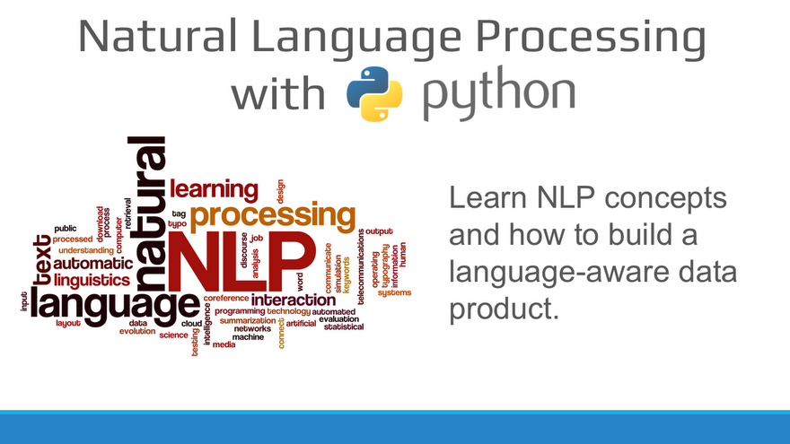

**NATURAL LANGUAGE PROCESSING**

* Python Text Basics Introduction to Python Text Basics
* Working with Text Files with Python
* Working with PDFs
* Regular Expressions
* Natural Language Processing Basics
* Introduction to Natural Language Processing
* Nltk Setup and Overview¬
* What is Natural Language Processing?
* Tokenization
* Stemming
* Lemmatization
* Phrase Matching and Vocabulary
* Stop Words¬
* Tfid Transformer and Vectorizer
* Text Classification Introduction to Text Classification¬ Machine Learning Overview¬ Classification Metrics
* Confusion Matrix-How to Use SciKit-Learn
* Text Feature Extraction Overview Sentiment Analysis
* Sentiment Analysis Overview¬ Sentiment Analysis with NLTK

**MACHINE LEARNING**

* Python Introduction Python Basics
* Python Programming Fundamentals
* Working with Data in Python
* Working with NumPy arrays
* Machine Learning Data Science Overview
* Data Analytics Overview
* Statistical Analysis and Business Applications
* Python Environment Setup and Essentials
* Mathematical Computing with Python (NumPy)
* Scientific computing with Python (Scipy)
* Data Manipulation with Pandas
* Machine Learning with Scikit–Learn
* Introduction to Artificial Intelligence and Machine Learning Data
* Data Visualization in Python using matplotlib
* Preprocessing Supervised Learning
* Supervised Learning-Classification
* Supervised learning algorithm
* Linear Regression
* Logistic regression
* Naïve Bayes
* Support Vector machine
* Decision Tree
* Random Forest
* K-Nearest Neighbor
* Unsupervised learning
* Reinforcement Learning

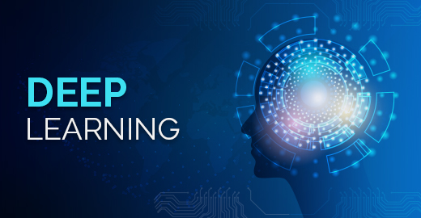

**DEEP LEARNING**

* Python Basics
* Machine learning basics
* Types of Ml
* Supervised Learning algorithms
* What exactly is Deep Learning?
* Why is Deep Learning so popular these Days?
* Biological Neural Networks
* Artificial Neural Networks
* Neural Network Architecture
* Layer Connections
* Learning Process in a Neural Network
* Loss Functions
* Gradient Descent



**PHP**

* Introduction to WebApplication
* HTML andJavaScript
* Introduction toPHP
* WAMP Server usingPHP
* PHPTokens(5)
* Echo and PrintStatements
* Decision Making andLooping
* Arrays
* Functions
* String and MathFunctions
* FormHandling
* Superglobals
* Session andCookies
* ISSETMethods
* Redirecting a page inPHP
* ExceptionHandling
* FileHandling
* Filters inPHP
* PHP with MySQLDatabase

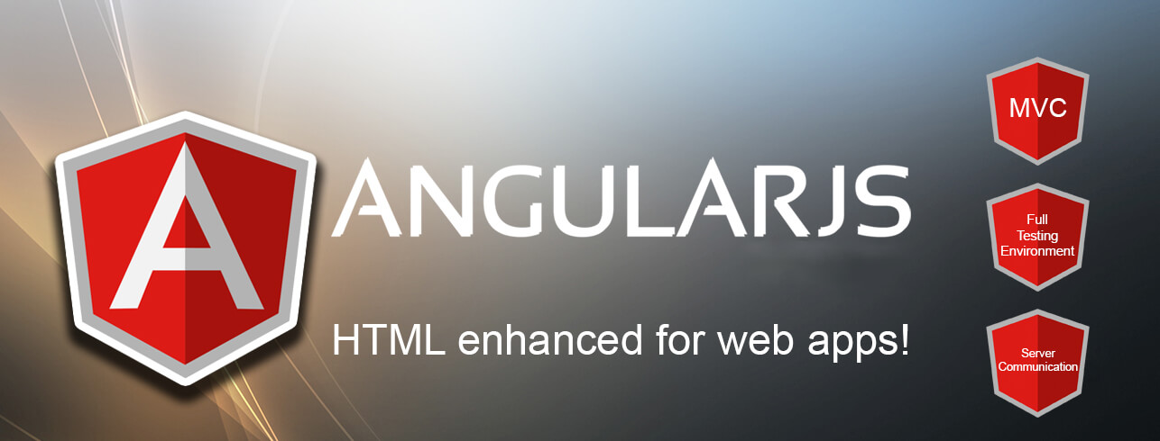

**Angular**

* What isAngular?
* New features of Angular5
* Angular CLI
* NodeJSIntroduction(NPM)
* Visual Studio(VS) CodeEditor
* AppComponents
* CreatingComponents
* ComponentTemplates
* NestedComponents
* Databinding
* Directives
* Services
* AppModule
* Changing pages withRouting
* UnderstandingObservables
* Template & Reactive Forms
* Interact withHTTPClient
* RestAPI(Express.JS)
* Connect with Mongodb and RestAPI



**Node Js**

* Introduction toNodeJS
* Text Plain and Text HTML in Express.JS RESTAPI
* Use URLParameters
* NodeJSIntroduction(NPM)
* Convert Object to/fromJSON
* Convert Objects List to/fromJSON
* Use POST, PUT, DELETEMethods
* Find documents with conditions and by id inMongoDB
* CRUD Operations in Express.JS REST API withMongoDB
* Security RESTAPI

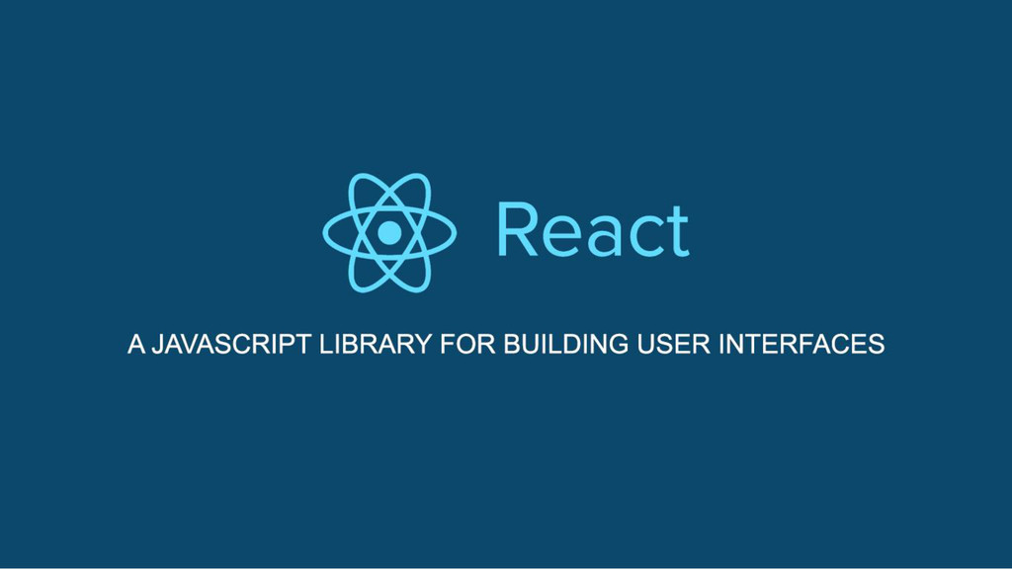

**React JS**

* Create New Component in ReactJS
* Use CSS in Component in ReactJS
* Create Nested Components in ReactJS
* Pass values, Object and Objects List to Parameters
* Use Single Values, Object and Objects List in State
* Event Handling
* onClick
* onChange
* onSubmit
* Form Controls in Component
* Forms Validation in Component
* Use Refs, Router, Local Storage in Component
* Call GET, POST, PUT, DELETE HTTP Method with Express.JS Web
* API and MongoDB



**SQL**

* Introduction to SQL
* Data Definition Language(DDL)
* Data Manipulation Language(DML)
* SQL Operators
* Transaction Control Language(TCL)
* Aggregate Functions
* String & Date Functions
* Sub Queries
* Group by Statements
* Key Constraints
* Joining Queries
* Set Operators

**PL/SQL**

* Introduction to PL/SQL
* Variables
* Constants
* Decision Making Statements
* Looping Statements
* Procedure
* Function
* Exception
* User Defined Exception
* Trigger
* Packages



**Cross Platform Mobile Application Development**

* This course teaches students to develop cross platform mobile using easy to use
* scripting languages like HTML5,JavaScript, jQuery, and Mobile frame works
* like Cordova / PhoneGap
* Contents
* Introduction to Mobile Apps
* Introduction to Cordova/ PhoneGap
* History
* Architecture
* Introduction to HTML & CSS
* Basics
* Simple website making
* Styling using CSS
* Adding functionalities using jQuery/JavaScript
* Setting up of environment
* Downloading and installing PhoneGap
* Installing PhoneGap in IDE’s
* Making hello world
* Introduction and usage of Cordova/PhoneGap Build Services
* User Interface Development with jQuery Mobile
* Creating Pages
* GUI making
* Navigation bar, buttons, grids and Other Controls
* Persisting data between jQuery Mobile pages
* PhoneGap/Cordova API
* Movement and Location
* Detecting device movement using the accelerometer
* Obtaining device geolocation sensor information
* Retrieving map data through geolocation coordinates File System,
* Storage, and Local Databases
* Saving a file to device storage
* Opening a local file from device storage o
* Displaying the contents of a directory
* Creating a local SQLite database Working with Audio, Images, and
* Video
* Recording audio within your application
* Playing audio files from the local filesystem
* Capturing video using the devices video recording Application
* Loading a photograph from the device’s camera

## Contact Us

For more information on course details, contact us at:

9148984674 / 9148984676