1.

WITHDRAW_MONEY Use Case Description: Main Flow

|  |  |
| --- | --- |
| **User Action** | **System Response** |
| 1. User types in PIN into main screen | 1. System checks validity of PIN and presents options to user on another screen |
| 1. User selects type of account (ex. - checking/saving/retirement) from which he/ she wants to withdraw money. | 1. System presents the options to enter the amount |
| 1. User enter the amount and press enter | 1. System provides cash if there is enough balance in the account otherwise show message that account has no enough balance. System also asks for receipt. |
| 1. User press yes/no for receipt request | 1. If yes then system provide a receipt and return the card otherwise system only returns the card |

2.

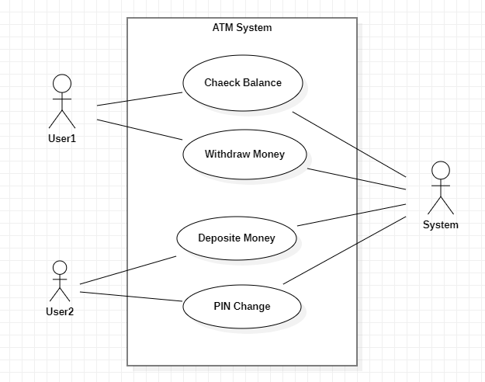

3.

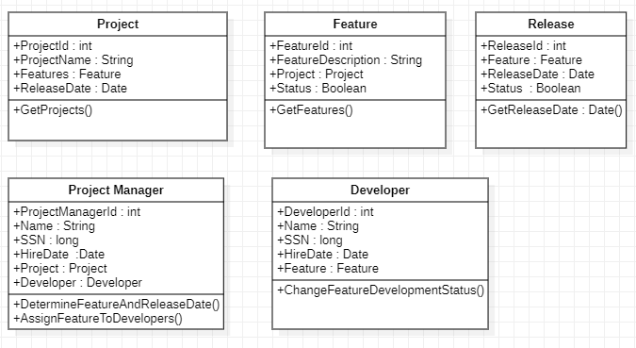

4. 