Annotations
Main Topic | Layer / Responsibility | Annotations Used (with 1-line purpose) | Functions / Methods Used (with purpose)
MVC Architecture | Overall application design | @Controller – Handles requests and returns views@RestController – Handles REST requests and returns JSON | model.addAttribute() – Sends data to view
Application Flow | End-to-end execution | MVC flow | Request → Controller → Service → Repository → DB → Response
Dependency Injection | Inject required objects | @Autowired – Inject bean  @Component – Generic Spring bean  @Configuration – Configuration class  @Bean – Manual bean creation | Constructor injection – Preferred DI method
Web Layer  Presentaion layer | Handles HTTP requests & responses | @RequestMapping – Base URL mapping  @GetMapping – Handle GET requests  @PostMapping – Handle POST requests  @PutMapping – Handle PUT requests  @PatchMapping – Handle PATCH requests  @DeleteMapping – Handle DELETE requests | Controller methods – Entry point for API calls
Request Handling | Read incoming request data | @PathVariable – Read value from URL path  @RequestParam – Read query parameters  @RequestBody – Convert JSON to Java object | Automatic data binding by Spring  @PathVariable  @Requestparam  name used in Dynamic URLs  required=true/false
Response Handling | Send response to client | @ResponseBody – Convert Java object to JSON  ResponseEntity<T> – Control response body and status | ok() – 200 OK  notFound() – 404 NOT FOUND  badRequest() – 400 BAD REQUEST
Service Layer | Business logic processing | @Service – Marks business logic layer | Service methods – Implement core logic
Persistence Layer | Database interaction | @Repository – DAO layer  JpaRepository – Provides CRUD operations | 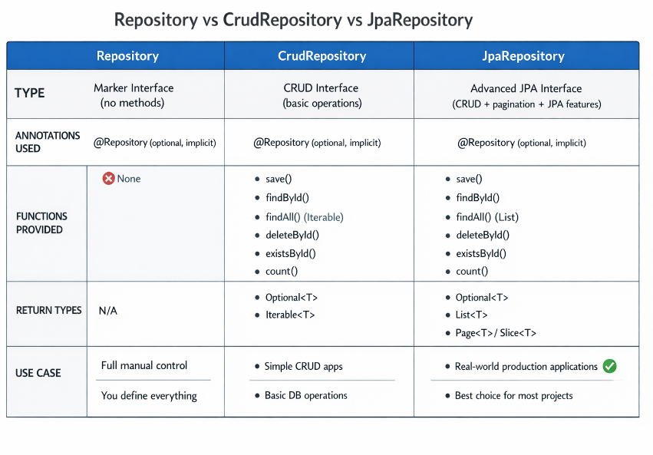
Entity Layer | Map Java class to DB table | @Entity – Marks DB entity  @Table – Custom table name  @Id – Primary key  @GeneratedValue(GenerationType=IDENTITY/AUTO/SEQUENCE)  @Column(name=”” , nullable=” “ , length=50 ) , used for specific variable  @CreationStamp @UpdationStamp | Entity getters/setters – Access DB fields
DTO Layer | Data transfer between layers | DTO (POJO class) – No Spring annotation  @NotNull - Field must not be null  @NotBlank - Field must not be empty  @Email - Email validation  @Size - Field length constraint  @JsonProperty - JSON field mapping  @JsonIgnore- Exclude field from JSON | Getter/setter – Carry request/response data
ModelMapper | Conversion Between DTO and Entity |  | .map()  . getConfiguration().setSkipNullEnabled(true) –  Prevents null values from overwriting existing data during mapping.  . typeMap(EmployeeDTO.class, EmployeeEntity.class) – Defines a custom mapping configuration between a source DTO and a target Entity class.  .addMapping(EmployeeDTO::getFullName, EmployeeEntity::setName) –  Maps a source field with a different name to a target field explicitly.
Object Mapping | Convert Entity ↔ DTO | ModelMapper – Automatic object mapping | map(source, target) – Convert objects
JSON Serialization | Control JSON structure | @JsonProperty – Custom JSON field name  @JsonIgnore – Exclude field from JSON  @JsonFormat – Format dates | Jackson auto serialization/deserialization
Validation | Validate input data | @Valid – Enable validation  @NotNull, @Email, @Size – Validation rules | Validation before controller execution
Optional Handling | Handle null safely | Optional<T> – Avoid null values | map() – Transform value  orElse() – Default value  orElseThrow() – Throw exception
Exception Handling | Error handling mechanism | @ExceptionHandler – Local exception handler  @ControllerAdvice – Global exception handler | Custom error responses
PATCH Handling | Partial update logic | No annotation (logic based) | ReflectionUtils.findField() – Find field  setAccessible(true) – Access private field  ReflectionUtils.setField() – Update value

Bean validation

Annotation | Use / Purpose | Important Parameters
@NotNull | Field must not be null | message
@NotEmpty | Must not be null and size > 0 (String, Collection, Map, Array) | message
@NotBlank | String must not be null and must contain non-whitespace characters | message
@Size | Validates size/length range | min, max, message
@Min | Number must be ≥ given value | value, message
@Max | Number must be ≤ given value | value, message
@Email | Valid email format | regexp, message
@Pattern | Must match given regex | regexp, message
@Positive | Number must be > 0 | message
@PositiveOrZero | Number must be ≥ 0 | message
@Negative | Number must be < 0 | message
@NegativeOrZero | Number must be ≤ 0 | message
@Past | Date must be in the past | message
@PastOrPresent | Date must be past or present | message
@Future | Date must be in the future | message
@FutureOrPresent | Date must be future or present | message
@Digits | Controls number of integer & fraction digits | integer, fraction, message
@DecimalMin | Decimal number must be ≥ value | value, inclusive, message
@DecimalMax | Decimal number must be ≤ value | value, inclusive, message
@AssertTrue | Boolean must be true | message
@AssertFalse | Boolean must be false | message
@Valid | Triggers validation on nested objects | (no parameters)

EXCEPTIN HANDELLING

Annotation / Function | Use
@RestControllerAdvice | handle exceptions globally across all REST controllers and automatically return JSON responses.
@ControllerAdvice | handle exceptions globally across all controllers, mainly for MVC applications.
@ExceptionHandler | handle a specific type of exception inside a controller or global advice class.
@Data | @Data = @Getter + @Setter + @ToString + @EqualsAndHashCode + @RequiredArgsConstructor
@Builder | allowing you to create objects step by step in a clean and readable way without writing boilerplate code.

@Table
Belongs To | Annotation / Function | Brief Use
— | @Table | Defines table-level configuration for an entity
@Table | name() | Sets the database table name
@Table | schema() | Sets the schema in which the table exists
@Table | catalog() | Sets the database/catalog name , catalog(schema(table)))
@Table | uniqueConstraints() | Holds one or more @UniqueConstraint annotations
@Table | indexes() | Holds one or more @Index annotations
@Table.uniqueConstraints() | @UniqueConstraint | Defines a composite unique constraint
@UniqueConstraint | name() | Name of the unique constraint
@UniqueConstraint | columnNames() | Columns that must be unique together
@Table.indexes() | @Index | Defines an index for performance
@Index | name() | Name of the index
@Index | columnList() | Column(s) included in the index
@Index | unique() | Whether the index enforces uniqueness
@Table
├─ name()
├─ schema()
├─ catalog()
├─ uniqueConstraints()
│ └─ @UniqueConstraint
│ ├─ name()
│ └─ columnNames()
└─ indexes()
└─ @Index
├─ name()
├─ columnList()
└─ unique()

@Table is used to map an entity class to a specific database table name and constraints.
It lets you control the table name, schema, indexes, and unique constraints instead of relying on Hibernate’s default naming.

Spring Data JPA – Query Method Rules & Keywords
Category | Rule / Keyword | Used In | Meaning / Use | Example
Basic Rule | findBy | Method name | Starts SELECT query | findByTitle(String title)
 | readBy | Method name | Same as findBy | readBySku(String sku)
 | getBy | Method name | Same as findBy, expects one result | getById(Long id)
 | queryBy | Method name | Same behavior, rarely used | queryByPrice(BigDecimal price)
Entity Fields | Field names | Method name | Must match entity fields | findByQuantity(Integer quantity)
AND / OR | And | Method name | Combines using AND | findByTitleAndPrice(String t, BigDecimal p)
 | Or | Method name | Combines using OR | findByTitleOrSku(String t, String s)
Comparison | Is, Equals | Method name | Equality check | findByTitleIs(String title)
 | GreaterThan | Method name | > comparison | findByPriceGreaterThan(BigDecimal price)
 | GreaterThanEqual | Method name | >= comparison | findByPriceGreaterThanEqual(BigDecimal price)
 | LessThan | Method name | < comparison | findByQuantityLessThan(Integer qty)
 | LessThanEqual | Method name | <= comparison | findByQuantityLessThanEqual(Integer qty)
Null Checks | IsNull | Method name | Field IS NULL | findBySkuIsNull()
 | IsNotNull | Method name | Field IS NOT NULL | findBySkuIsNotNull()
Boolean | True | Method name | Field = true | findByActiveTrue()
 | False | Method name | Field = false | findByActiveFalse()
Like / String | Like | Method name | SQL LIKE | findByTitleLike("%Biscuit%")
 | NotLike | Method name | SQL NOT LIKE | findByTitleNotLike("%Old%")
 | Containing | Method name | LIKE %value% | findByTitleContaining("Parle")
 | StartingWith | Method name | LIKE value% | findByTitleStartingWith("Par")
 | EndingWith | Method name | LIKE %value | findByTitleEndingWith("G")
 | IgnoreCase | Method name | Case-insensitive | findByTitleIgnoreCase(String title)
Collection | In | Method name | SQL IN | findBySkuIn(List<String> skus)
 | NotIn | Method name | SQL NOT IN | findBySkuNotIn(List<String> skus)
Between | Between | Method name | BETWEEN values | findByPriceBetween(BigDecimal p1, BigDecimal p2)
Order / Sort | OrderBy | Method name | ORDER BY clause | findByOrderByPriceDesc()
 | Asc | Method name | Ascending order | findByOrderByTitleAsc()
 | Desc | Method name | Descending order | findByOrderByQuantityDesc()
Count / Exists | countBy | Method name | Returns count | countByActiveTrue()
 | existsBy | Method name | Returns boolean | existsBySku(String sku)
Delete / Update | deleteBy | Method name | Deletes rows | deleteBySku(String sku)
Top / First | Top, First | Method name | Limit results | findTop3ByOrderByPriceDesc()
JPQL Annotation | @Query | Annotation | Custom JPQL | @Query("select p from ProductEntity p")
JPQL Params | :paramName | @Query | Named parameters | @Query("from ProductEntity p where p.title=:t")
Native Query | nativeQuery=true | @Query | Raw SQL | @Query(value="select * from product", nativeQuery=true)
Pagination | Pageable | Method param | Pagination | findAll(Pageable pageable)
Sorting | Sort | Method param | Dynamic sorting | findAll(Sort.by("price"))
Return Types | Optional<T> | Method return | Single safe result | Optional<ProductEntity> findBySku(String sku)
 | List<T> | Method return | Multiple results | List<ProductEntity> findByActiveTrue()
 | Page<T> | Method return | Paginated | Page<ProductEntity> findAll(Pageable p)
 | Slice<T> | Method return | Partial pagination | Slice<ProductEntity> findByPrice(BigDecimal p, Pageable pg)
Projection | Interface / DTO | Return type | Partial columns | List<ProductView> findByPrice(BigDecimal p)
Rules | Method parsing | Spring Data | Left → right parsing | findByTitleAndPriceOrSku(...)
Important Rule | Entity field name | Everywhere | Never DB column | findByTitle() ❌ findByTITLE_X()

