**Comparison between the optimal portfolio with SPY using the following parameters**

Start Date: 2008-06-01, End Date: 2009-06-01, Symbols: [‘IBM’, ‘X’, ‘GLD’, ‘JPM’].

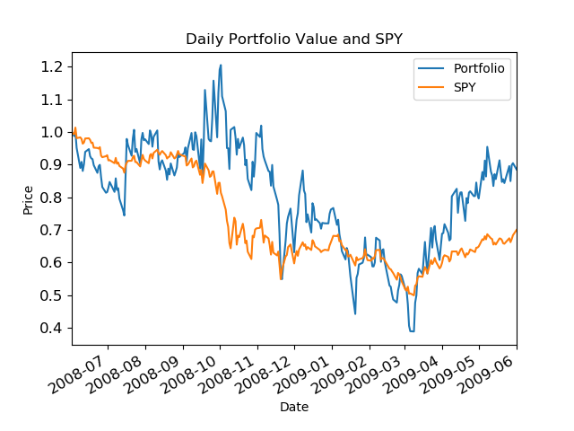

**Statistics of Optimized Portfolio:**

Allocations:[1.66533454e-16 0.00000000e+00 1.11022302e-16 1.00000000e+00]

Sharpe Ratio: 0.42310717924180163

Volatility (stdev of daily returns): 0.06891106884929614

Average Daily Return: 0.0018367037394021767

Cumulative Return: -0.1148090815273477