**Part 1: Indicator Overview**

The following three indicators have been used to devise our Strategy Learner and Manual Strategy.

* Price per SMA (Price/SMA)
* Bollinger Band Percentage (BB%)
* Commodity Channel Index (CCI):

1. **Price per SMA (Price/SMA)**

A SMA is a moving average that is calculated by summing the adjusted close price for a “n” number of time periods and then dividing by the number of time periods (n).

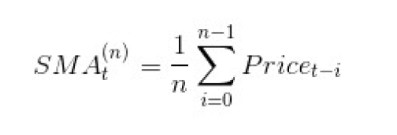

It is an indicator that smoothens the price curve volatility and demonstrates the lagged characteristics of the stock price movement.

In this project, I have considered a “price per 20-day SMA” calculation.

“Price/20-day SMA” represents today’s adjust close price of the stock divided by SMA of the past 20 days.

For our Manual trading strategy, we have used the following threshold of the Price/SMA for determining a LONG/SHORT/CASH signal:

* value below 0.95 can be used to enter a Long position.
* value above 1.083 can be a signal to enter a Short position.
* Otherwise, Hold

1. **Bollinger Band Percentage (BB%):**

Bollinger Band is another Divergence based market indicator where it shows divergence between the stock and the market.

There are three lines that compose Bollinger Bands: A simple moving average (middle band) and an upper and lower band.

* Upper band (2 standard deviations above SMA)
* Middle band (n-Day SMA)
* Lower band (2 standard deviations below SMA)

It is believed that the closer the prices move to the upper band, the more overbought the market, and the closer the prices move to the lower band, the more oversold the market.

In our project we can use a different aspect of the Bollinger Band called Bollinger Band Percentage (BB %) as it returns a quantitative measure that can be used to build a trading strategy.

For our Manual trading strategy, we have used the following threshold of the BB% for determining a LONG/SHORT/CASH signal:

* If BB% greater than 0.75 then it’s a Long position.
* If BB% lower than 0.18 then it’s a Short position.
* Otherwise, Hold

1. **Commodity Channel Index (CCI):**

The Commodity Channel Index (CCI) is a versatile indicator which can be employed to identify a new trend or warn sign of extreme conditions.

The CCI Indicator can be calculated using the below formula:

CCI = (Prices – 20-DAY SMA) / (.015 * Standard_Dev(Prices))

* CCI shall be relatively high when prices are far above their average level (overbought).
* On the other hand, CCI shall be relatively low when prices are quiet below their average level (oversold).
* CCI can be used in this way to identify overbought and oversold levels.

For our Manual trading strategy, we have used the following threshold of the CCI value for determining a LONG/SHORT/CASH signal:

* If the value of CCI indicator is above +80, it reflects strong price action that can signal the start of an uptrend (Bullish). So, we take a Long position.
* If the value of CCI indicator is below -80, it reflects weak price action that can signal the start of a downtrend (Bearish). So, we take a Short position.

We have created strategies combining the above three indicators and the details of the strategies shall be discussed in detail in the sections for Manual Strategy and Strategy Learner below.

**Part 2: Manual Strategy**

The purpose of this section is to build a Rule-Based strategy based on self-intuition with the following three indicators.

* Price/20-Day SMA
* Bollinger Band Percentage
* Commodity Channel Index

We had to determine the threshold value for each of these indicators which shall be used to build the rules for determining the LONG/SHORT/CASH signal.

|  |  |  |  |
| --- | --- | --- | --- |
|  | **Price/SMA** | **BB%** | **CCI** |
| **Threshold chosen for LONG** | Less than 0.95 | Less than 0.18 | More than +80 |
| **Threshold chosen for SHORT** | More than 1.083 | More than 0.75 | Less than -80 |

First we check if both Price/SMA and BB% conforms to any of the LONG or SHORT signal. If not then we use the CCI indicator logic to make the signal decision.

Hence, Price/SMA and BB% are used in conjunction. If that doesn’t work then we do a final check for LONG/SHORT using the CCI individually.

**Comparison of Manual Strategy v/s Benchmark on in-sample data**

In-Sample date range: 01-01-2008 to 12-31-2009

Symbol: JPM

Benchmark: Starting with $100,000 cash, investing in 1000 shares and holding that position.

The below plot shows that the performance (increase in normalized portfolio value) of the Manual Strategy (Red line) highly exceeds that of Benchmark strategy (Green line).

The vertical lines show BUY (Blue line) and SELL (Black line).

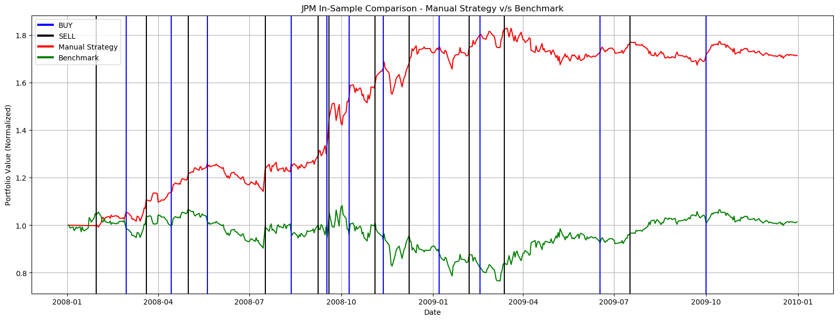

**Comparison of Manual Strategy v/s Benchmark on out of sample data**

Out of Sample date range: 01-01-2010 to 12-31-2011

Symbol: JPM

Benchmark: Starting with $100,000 cash, investing in 1000 shares and holding that position.

Please note that NO tweaking or modification was done to the Manual Strategy approach on the out of sample data.

The below plot shows that the performance (increase in normalized portfolio value) of the Manual Strategy (Red line) beats that of Benchmark strategy (Green line).

The vertical lines show BUY (Blue line) and SELL (Black line).

Though the Manual Strategy performs better than the Benchmark on the out of sample data too, but the performance is not that great on the out of sample data as it was on the in-sample data.

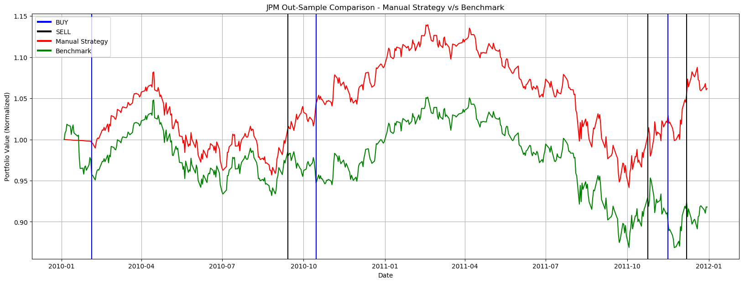

**Summarization**

The below table summarizes the performance statistics of the Manual v/s Benchmark strategy for both In Sample and Out of Sample.

We can see the for In-sample, our Manual Strategy has out-performed the Benchmark. The normalized CR of Manual Strategy is 50 times that of the Benchmark.

Though for out of sample, our Manual Strategy has still out-performed the Benchmark but it’s overall performance is pretty poor which is understandable.

This is because the strategy was built and the indicator threshold values were determined based on the performance on In-Sample data and it is very specific to the market conditions for the in-sample duration.

|  |  |  |  |  |  |
| --- | --- | --- | --- | --- | --- |
| **Sampling Type** | **Strategy** | **Cumulative Return** | **Standard Deviation** | **Mean of Daily Return** | **Sharpe Ratio** |
| In Sample  01/01/2008 - 12/31/2009 | Manual Strategy | 0.7156 | 0.0108 | 0.0011 | 1.6654 |
| Benchmark | 0.0142 | 0.0170 | 0.0002 | 0.1607 |
| Out of Sample  01/01/2010 - 12/31/2011 | Manual Strategy | 0.0618 | 0.0077 | 0.0001 | 0.3072 |
| Benchmark | -0.0820 | 0.0085 | -0.0001 | -0.2505 |

**Part 3: Strategy Learner**

This Machine Learning based approach is a two-step process. First, we need to build a strategy by selecting a specific Learner. Secondly, to train the Learner.

Here, we have used a Q-Learner (reinforcement learning) and devised an approach to mould the trading problem around the Q-Learner in the following way.

* There shall be 3 actions (or signal) LONG, SHORT and CASH.
* Transform the continuous value space of the Indicators into discrete value space. This helps in categorizing the indicator values and also combine them somehow to correspond to Q-Learner States.
* Since we decided to discretize the indicators into 10 buckets (using Python qcut command) and there are 3 actions. Hence the number of Q States shall be POW(10, 3) i.e., 1000.
* Now build a set of 1000 states by combining all the 10 discretized values for each of the 3 indicators. <100 * Bollinger + 10 * SMA + CCI>
* Now we have to come up with a way to calculate the reward. Reward can be the return from our portfolio based on the change is stock price and current holding. It needs to be adjusted with commissions and market impact.
* The next step would be to tune the hyper parameters of the Q-Learning algorithm like “Random Action Rate”. I have set it value of 0.60 so that we do not use random actions too much and maintain a balance with picking the highest probability action from the Q table.

Q-Learner Parameters:

* Number of States: 1000
* Number of actions = 3
* Alpha = 0.2
* Gamma = 0.9
* RAR = 0.60,
* RADR = 0.999
* Dyna = 0

Hence, following the above-mentioned steps we tried to frame the trading problem to fit it into a learning problem.

**Part 4: Experiment 1**

In this experiment we are going to compare the performance of our ML based Strategy Learner v/s Manual Strategy v/s the Benchmark on in-sample data.

**Experiment Parameters:**

In-Sample date range: 01-01-2008 to 12-31-2009

Symbol: JPM

Commission: $9.95

Impact: 0.005

Benchmark: Starting with $100,000 cash, investing in 1000 shares and holding that position.

Here we are assuming that the Strategy Learner shall perform better than the Manual Strategy and through this experiment we are going to see if that assumption holds true.

|  |  |  |  |  |  |
| --- | --- | --- | --- | --- | --- |
| **Sampling Type** | **Strategy** | **Cumulative Return** | **Standard Deviation** | **Mean of Daily Return** | **Sharpe Ratio** |
| In Sample  01/01/2008 - 12/31/2009 | Strategy Learner | 2.4379 | 0.0080 | 0.0025 | 4.9329 |
| Manual Strategy | 0.7157 | 0.0108 | 0.0011 | 1.6654 |
| Benchmark | 0.0142 | 0.0170 | 0.0001 | 0.1607 |

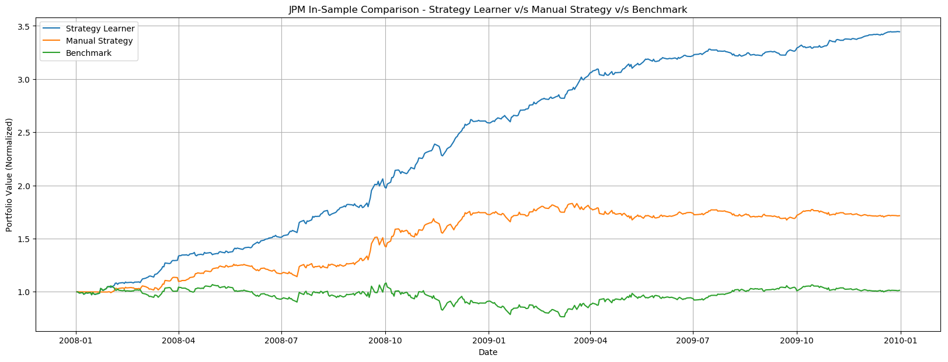

From the above table statistics and plot we can see that the performance(Benchmark) < performance (Manual Strategy) < performance (Strategy Learner).

Also, if we compare the Cumulative Return and Sharpe Ratio of the three strategies, it proves our assumption (that Strategy Learner will out-perform) is true and we are able to build a fairly decent strategy that gives an in-sample Sharpe Ratio of 4.9329.

We would expect this similar relative behavior every time we run this experiment on in-sample data. Any correct learner should out-perform on in-sample data as it has been trained on the same set of data. Also. A properly chosen manual strategy represents an active portfolio management should perform better than “buy & hold” benchmark strategy as this is more a passive portfolio management.

**Part 5: Experiment 2**

In this experiment we are solely going to focus on Strategy Learner and the effect of market Impact on the trading behavior and performance.

Here we are going to run our Strategy Learner with commission=0.0 but with three different Impact values (0.0, 0.005 and 0.05). So, we are going to gradually increase the market impact.

**Experiment Parameters:**

In-Sample date range: 01-01-2008 to 12-31-2009

Symbol: JPM

Commission: $0

Impact: 0.0, 0.005 and 0.05

We are going to start this experiment with a hypothesis and test if the hypothesis stands true based on two metrics – 1) Cumulative Return and 2) Number of trades.

Hypothesis: The performance of a Strategy Learner in terms of portfolio return is greatly influenced by the impact as input to the model. Also, impact can affect on the number of trades being executed by the ML based model.

|  |  |  |  |  |
| --- | --- | --- | --- | --- |
| **Sampling Type** | **Impact** | **Cumulative Return** | **Sharpe Ratio** | **Number of trades** |
| In Sample  01/01/2008 - 12/31/2009 | 0.0 | 2.4535 | 4.7154 | 180 |
| 0.005 | 2.3534 | 4.5299 | 126 |
| 0.05 | 0.0689 | 0.2587 | 29 |

* So, from the above table we can infer that the cumulative return decreased with the increase in Impact. This is because impact reduces the net return of the portfolio.
* Also, the number of trades executed greatly reduced as the Impact increased since the ML based model shall reject trades with very small price increase as the very small increase in price can be overwhelmed by the “cost of trading due to higher impact”.

